*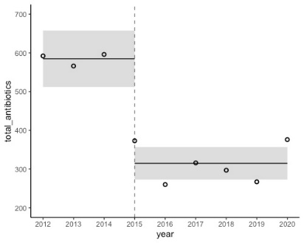*

*Supplemental Figure 1: Comparison of antibiotic use in neonates before and after implementation of antimicrobial stewardship using segmental regression interrupted time series analysis. DOT: Days of therapy.*