**Supplementary Material**

|  |  |
| --- | --- |
| **Supplementary Table 1. Demographic Characteristics of Survey Respondents** | |
| **Respondent Type** ---no.(%) | 37 |
| MD | 30 (81) |
| PharmD | 4 (10.8) |
| Other | 3 (8.1) |
| **Respondent Years of experience working in stewardship** ---no.(%) | 37 |
| <1 year | 1 (2.7) |
| 1-2 years | 3 (8) |
| 3-5 years | 5 (13.5) |
| 5-10 years | 8 (21.6) |
| >10 years | 20 (51.4) |
| **Hospital type** ---no.(%) | 36 |
| Academic | 25 (69) |
| Community with academic affiliation | 5 (13.8) |
| Federal non-military | 3 (8.3) |
| Other | 3 (8.3) |
| **Hospital Bed Number---no.(%)** | 35 |
| <100 beds | 2 (5.7) |
| 100-249 beds | 4 (11.4) |
| 250-499 beds | 12 (34.3) |
| 500+ beds | 17 (48.6) |
| **Number of employees working in antimicrobial stewardship ---**no.(%) | 36 |
| 1 | 3 (8.3) |
| 2 | 4 (11.1) |
| 3 | 8 (22.2) |
| 4+ | 21 (58.3) |
| **FTE allocated to stewardship** |  |
| Programs with FTE ---no.(%) | 32 (86.5) |
| Median FTE (Range) | 2 (0-4.8) |
| **Type of IT support** ---no.(%).  Note: there was overlap as respondents could chose more than one option |  |
| Analytical surveillance software | 21 (50) |
| Local Electronic Medical Record (EMR) linked system | 28 (69.4) |
| **Ability to report to NHSN** ---no.(%) | 37 |
| Yes | 28 (75.7) |
| No | 8 (21.6) |
| Does not know | 1 (2.7) |
| **Facility Geographic Distribution** ---no.(%) | 29 |
| Midwest | 11 (37.9) |
| Northeast | 8 (27.6) |
| West | 6 (20.7) |
| South | 4 (13.8) |



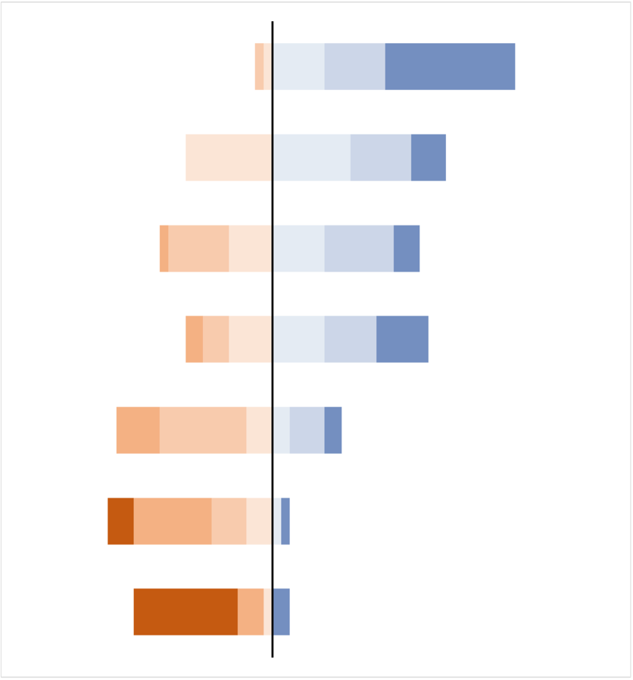

Highest Rank

Lowest Rank

**Supplementary Figure 1. Ranking of Potential Uses and Goals of a Harm Metric**Respondents ranked seven possible uses of a harm metric from highest to lowest priority. Overall ranking was determined by a weighted score that combined the ranking level with the frequency of the ranking selection.  
*Full answer choice in the survey: *“communicate directly with clinicians to advocate for decreased antibiotic prescribing or advocate for de-escalation.”*

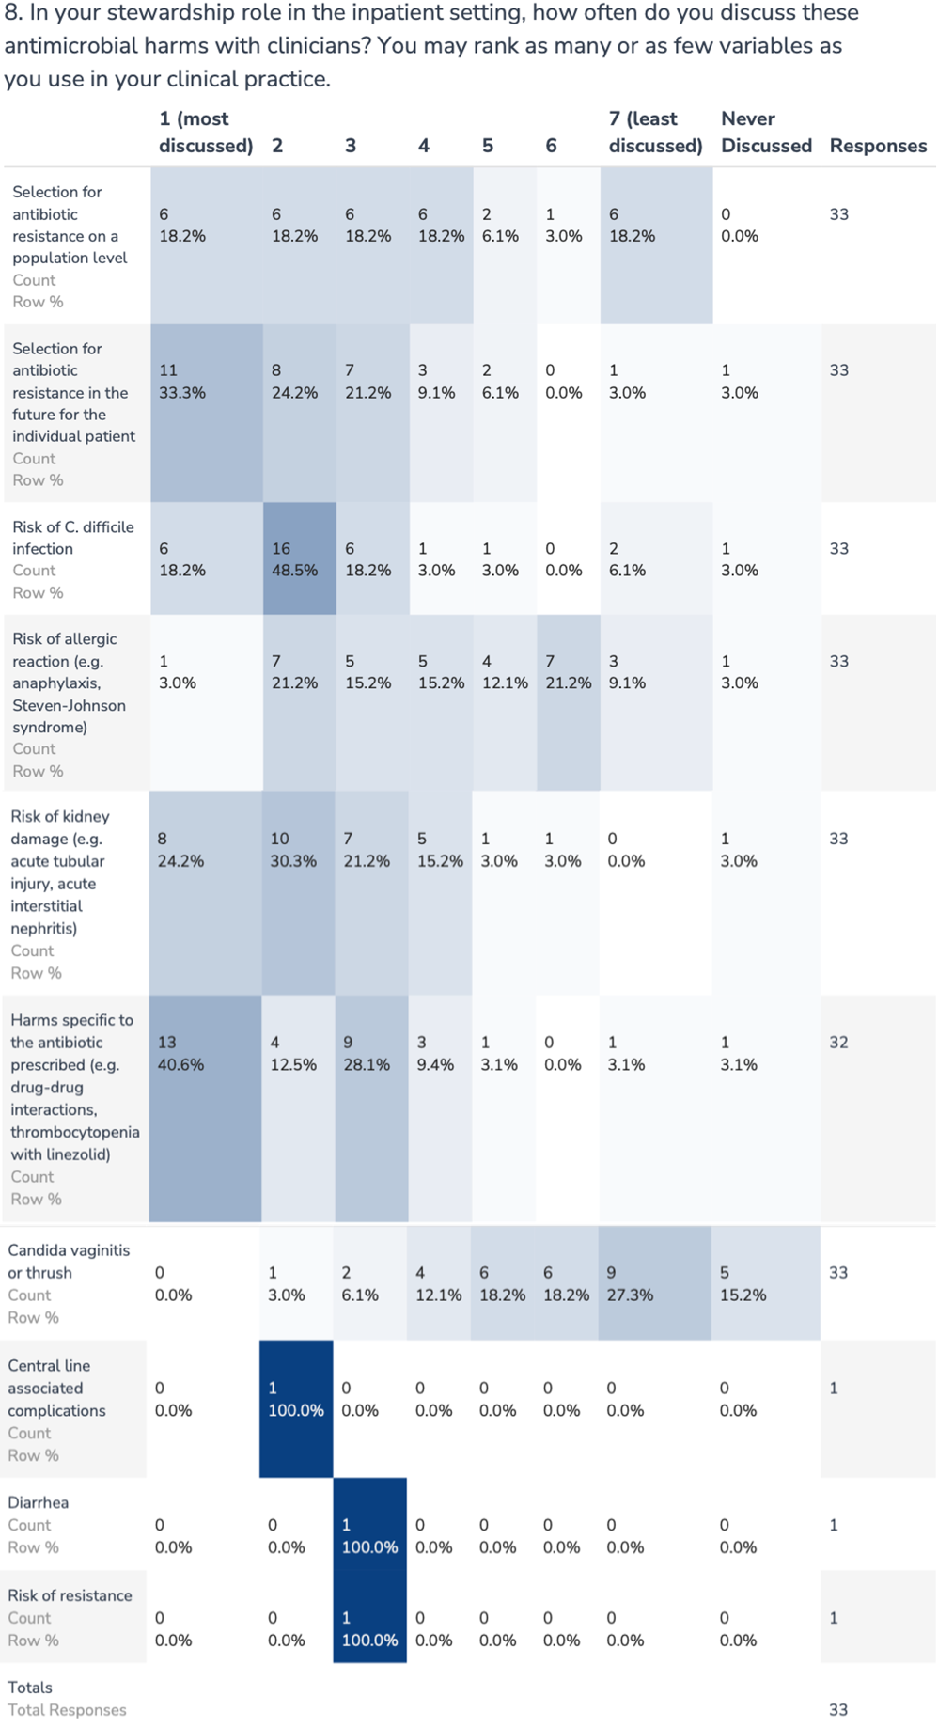

**Supplementary Figure 2. Adverse Drug Events (ADE) Most Often Discussed in Antimicrobial. Stewardship Practice**Respondents ranked the above ADEs from most to least discussed in their daily stewardship practice in the inpatient setting.



**Supplementary Figure 3. Ranking of Harm Surveillance System Structure**

Respondents ranked different ways to structure a harm surveillance system with the most useful and feasible ranked as first. Overall ranking was determined by a weighted score that combined the ranking level with the frequency of the ranking selection. The choice “other” was also offered but not included in the figure as it was only selected twice for ranking.

**Supplementary Figure 4. Comparing Feedback on Four Proposed Harm Surveillance System Components: Dermatological Adverse Events, Hematological Adverse Events, Drug Associated Livery Injury and Antimicrobial Resistance (AMR).**

Respondents ranked each variable on a Likert scale with regards to usefulness, feasibility, and impact on patient outcomes. The Likert scale went from 1 to 9. 1 is the lowest (e.g. least useful) and 9 is the highest (e.g. most useful). The colored whiskers mark the range of responses. The entire scale range was selected by the respondents for each variable. The center line denotes the median value (50th percentile), while the box contains the 25th to 75th percentiles. Each variable was defined in the survey; drug associated liver injury and hematological were primarily based on laboratory obtained data points (see supplementary material for full definitions).

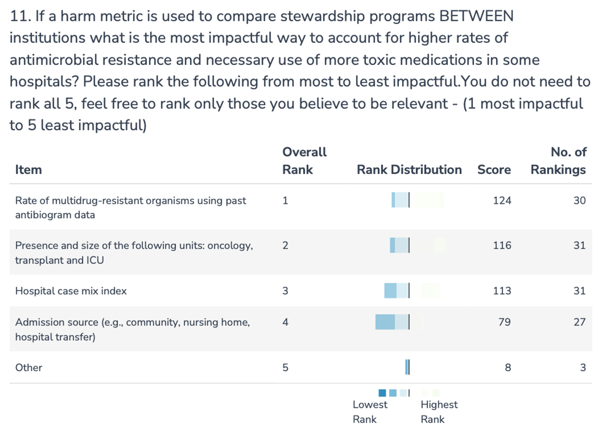

**Supplementary Figure 5**. **Ranking ways to account for differences in local epidemiology when using a harm metric results to compare different hospitals.** Rank 1= most impactful, 5= least impactful)

**Survey Questions**

**Note:** The final survey was administered using the Alchemer platform. Thus, there were changes in the final survey appearance and formatting by the SHEA research network (SRN) to adapt it to the Alchemer platform.

**Introduction**

Most existing antimicrobial stewardship metrics center around antibiotic use and risk of resistance in future patients, rather than measuring the direct impact on the patients receiving the antibiotics (e.g. drug associated kidney injury or allergic reactions). **The aim of this survey is to collect feedback on the feasibility and structure of having antibiotic stewardship metric that tracks antibiotic adverse events within the inpatient setting.** Feedback about feasibility, acceptability, and appropriateness of different measurement strategies will be used to inform the development of a preliminary tool for assessing direct patient harms associated with receipt of antimicrobial medications.

**Participation**

The survey should be completed by **one person** per SHEA Research Network (SRN) site. The person completing the survey would ideally be the medical or pharmacy director of stewardship and if neither are present, the facility stewardship champion. This survey focuses on your opinions and feedback about the feasibility, acceptability, and appropriateness of different measurement strategies; thus, **patient-level data will NOT be collected as part of this survey and is NOT required for participation**. Demographic information collected will be general and not will not include participant identifying variables.

**Survey layout**

The survey is divided into four sections and we anticipate that it will take **approximately 30 minutes** to complete the full survey. We note that there are multiple possible ways to structure such a harms metric (e.g. adverse events per drug, adverse events by organ system affected or having a composite metric for all adverse events). We address this by eliciting from participants which structure(s) would be most practical and useful (section 2 & 3). In section 4, we separately take one of the possible structures as an example to expand on some variables.

* **Section 1:** General Demographics and Characteristics of Participants and Facility (6 questions)
* **Section 2:** Current Stewardship Practices and Potential Applications of a Harm Metric (3 questions)
* **Section 3:** Structure of a Harm Metric (3 questions)
* **Section 4:** Proposed Harm Metric (4 variables)

**Section 1 (6 questions): General Demographics and Characteristics of Participants and Facility**

1. Please select what type of practitioner best describes you?*(Select one)*
   1. MD (Doctor of Medicine) or DO (Doctor of Osteopathic Medicine)
   2. PharmD (Doctor of Pharmacy)
   3. NP (Nurse Practitioner)
   4. Other (Free text)
2. How many years of experience do you have working in antimicrobial stewardship? *(Select one)*
   1. <1 year
   2. 1-2 years
   3. 3-5 years
   4. 5-10 years
   5. >10 years
3. How many employees are in your antimicrobial stewardship team?

*(Select one)*

* 1. 0
  2. 1
  3. 2
  4. 3
  5. 4+

1. A) Do you have designated full-time equivalent (FTE) employees to antimicrobial stewardship in your program?

*(Select one)*

* 1. Yes
  2. No

B) If yes, please indicate how many FTEs are designated to antimicrobial stewardship. *(This question should only show up if the participant answered Yes in the previous question).*

Answer: (Free text - number)

1. What type of Information Technology (IT) support do you have to support stewardship operations in your program?

*(Select all that apply)*

* 1. Analytical surveillance software (e.g. WHONET®, MedMined®, VigiLanz®, TheraDoc®, Pharmacy OneSource®, Bugsy®)
  2. Local Electronic Medical Record (EMR) linked system
  3. Other *(please include a free-text box with this option)*

1. Does your institution have the capability to report to the National Healthcare Safety Network (NSHN)?
   1. Yes
   2. No
   3. Uncertain

**Section 2 (3 questions): Current Stewardship Practices and Potential Applications of a Harm Metric**

***NOTE:*** *We consider antibiotic harms as unfavorable symptoms, signs, abnormal labs, superinfections or selection for drug resistance. Other terms that convey the concept antibiotic harms for the purposes of this survey:*

* + *Antibiotic side effects*
  + *Antibiotic toxicity*
  + *Antibiotic adverse event*
  + *Antibiotic complication*
  + *Antibiotic morbidity*

1. Rank the antimicrobials harms you most often discuss with clinicians in the inpatient setting within your stewardship role.  *(1= most often discussed; 6= least often discussed)* 
   * Selection for antibiotic resistance on a population level
   * Selection for antibiotic resistance in the future for the individual patient
   * Risk of *Clostridioides difficile* infection
   * Risk of allergic reaction (e.g. anaphylaxis, Steven-Johnson syndrome)
   * Risk of kidney damage (e.g. acute tubular injury, acute interstitial nephritis)
   * Harms specific to the antibiotic prescribed (e.g. drug-drug interactions, thrombocytopenia with linezolid)
   * Candida vaginitis or thrush
   * Other *(Free text)*

|  |  |
| --- | --- |
| **Antibiotic harms** | **Ranking** |
| Selection for antibiotic resistance on a population level |  |
| Selection for antibiotic resistance in the future for the individual patient |  |
| Risk of *Clostridioides difficile* infection |  |
| Risk of allergic reaction (e.g. anaphylaxis, Steven -Johnson syndrome) |  |
| Risk of kidney damage (e.g. acute tubular injury, acute interstitial nephritis) |  |
| Harms specific to the antibiotic prescribed (e.g. drug-drug interactions, thrombocytopenia with linezolid) |  |
| Candida vaginitis or thrush |  |
| Other: free text |  |

1. When developing an antibiotic harm metric, which of the following goals should be prioritized?

*(Select all that apply)*

* 1. Monitor impact of local stewardship interventions
  2. Monitor trends of antibiotic adverse events
  3. Inform local recommendations for empiric therapy
  4. Communicate directly with clinicians to advocate for decreased antibiotic prescribing or advocate for de-escalation
  5. Compare antimicrobial use and harms WITHIN a healthcare facility
  6. Compare antimicrobial use and harms BETWEEN healthcare facilities
  7. Use as a clinical trial endpoint
  8. Other (Free text)

1. If a harm metric is used to compare stewardship programs BETWEEN institutions, what is the most impactful way to account for higher rates of antimicrobial resistance and necessary use of more toxic medications in some hospitals? Please rank the following from most to least impactful

*(1= most impactful; 5= least impactful)*

* + Adjust based on a hospital’s case mix index
  + Adjust based on rate of multi-drug resistant organisms using past antibiogram data
  + Adjust based on admission source (e.g. community vs. nursing homes vs. hospital transfer)
  + Adjust based on presence & size of the following units: oncology, transplant and ICU
  + Other: free text

|  |  |
| --- | --- |
|  | **Ranking** |
| * Adjust based on a hospital’s case mix index |  |
| * Adjust based on rate of multi-drug resistant organisms using past antibiogram data |  |
| * Adjust based on admission source (e.g. community vs. nursing homes vs. hospital transfer) |  |
| * Adjust based on presence & size of the following units: oncology, transplant and ICU |  |
| * Other (free text) |  |

**Section 3 (4 questions): Structure of a harm metric**

1. Benefits of antibiotics are often clear and directed at one outcome (e.g. resolution of infection). Whereas adverse events are often a collection of multiple distinct outcomes. As a result, there are multiple possible ways to structure such a harms metric (e.g. adverse events by drug, adverse events by organ system affected or having a composite metric for all adverse events). Please rank the following possible harm metric structures with the most useful and feasible as first.

*(1= most useful/feasible; 4= least useful/feasible)*

* Group antibiotic harms by **ANTIMICROBIAL TYPE** *(e.g. cefepime related adverse events; linezolid related adverse events)*
* Group antibiotic harms by **ORGAN SYSTEM affected** regardless of antibiotic type (e.g. hematology adverse events, gastrointestinal adverse evets)
* One **all-encompassing** metric score that includes the rate of all types of antibiotic adverse events from all types of antibiotics
* Other (free text)

|  |  |
| --- | --- |
|  | **Ranking** |
| Group antibiotic harms by **ANTIMICROBIAL TYPE** *(e.g. cefepime related adverse events; linezolid related adverse events)* |  |
| Group antibiotic harms by **ORGAN SYSTEM affected** regardless of antibiotic type (e.g. hematology adverse events, gastrointestinal adverse evets) |  |
| One **all-encompassing** metric score that includes the rate of all types of antibiotic adverse events from all types of antibiotics |  |
| Other: free text |  |

1. An ideal metric is one that balances feasibility with being comprehensive. Considering this, how should **severe** or **irreversible** antibiotic harms (e.g*. Stevens-Johnson Syndrome or “SJS”)* be accounted for in the development antibiotic harm metric? *(Select one)*
   1. Group all harm outcomes together regardless of severity
   2. Exclude severe and irreversible harms
   3. Create a separate composite harm metric to specifically assess the rate of severe adverse reactions regardless of antibiotic type or organ system involved
   4. Assign differential weighting based on severity (using Quality-Adjusted Life-Year “QALY”) and increase the weighting of a more severe consequence (e.g. a case of mild hives would score 1 whereas a case of SJS would score 4)
   5. Other suggestion (Free text)
2. Some **rare**\* antibiotic adverse outcomes may be challenging to monitor in routine hospital surveillance systems. Considering this, how should **rare** antibiotic associated adverse events be accounted for in the context of an antibiotic harm metric? *(Select one)*

*\*Rare= Rate of occurrence of less than <0.1% (e.g. Daptomycin-induced Acute Eosinophilic Pneumonia)*

* 1. Group all adverse events together – regardless of how common/rare they are
  2. Exclude very rare adverse events
  3. Include rare adverse events only if they meet a threshold of high morbidity (are also severe or irreversible)
  4. Create a separate composite harm metric to specifically assess rare adverse events
  5. Other: free text

**Section 4(4 variables): Proposed Harm Metric**

**We provide an example of a composite antibiotic harm metric and selected the following 4 possible variables that would be comprised that metric** (modified from *Tamma et al., 2017):*

* 1. Dermatologic/immunologic adverse
  2. Hematologic adverse events
  3. Drug associated liver injury
  4. Antimicrobial resistance patterns

1. Are there additional variables/adverse events besides what we proposed above that should be included in a composite antibiotic harm metric? *(free text)*
2. Please answer the following questions about each proposed variable:

|  |  |  |  |  |  |  |  |  |  |
| --- | --- | --- | --- | --- | --- | --- | --- | --- | --- |
| **Outcome** | **Rate of dermatologic and immunologic adverse effects** | | | | | | | | |
| **Proposed Definition** | *Rash or allergic reaction temporally associated with antibiotic administration of all severity (e.g. hives, morbilliform rash, vancomycin infusion reaction, DRESS, SJS, anaphylaxis, asymptomatic eosinophilia)* | | | | | | | | |
| Q1: | On a 1-9 scale, how **useful** is this variable in targeting antimicrobial stewardship efforts? | | | | | | | | |
| A1: | 1 Not useful at all | *2* | *3* | *4* | *5* | *6* | *7* | *8* | 9 Very useful |
| Q2: | When considering **informatics,** how would you rate the **feasibility of monitoring this variable** on a 1-9 scale? | | | | | | | | |
| A2: | 1 Not feasible at all | *2* | *3* | *4* | *5* | *6* | *7* | *8* | 9 Very feasible |
| Q3: | On a 1-9 scale, how much would monitoring this variable affect **patient outcomes?** | | | | | | | | |
| A3: | 1 Not affect patient outcomes at all | *2* | *3* | *4* | *5* | *6* | *7* | *8* | 9 Significantly alter patient outcomes |
| Q4: | On a 1-9 scale, how important is it to separate this variable into severe and non-severe when monitoring outcomes? (e.g. separate Steven Johnsons Syndrome from hives) | | | | | | | | |
| A4: | 1 Not important | *2* | *3* | *4* | *5* | *6* | *7* | *8* | 9 Very important |
| Q5: | Please include any additional suggestion, including any proposed modifications to the outcome definition. | | | | | | | | |
| A5: | FREE TEXT | | | | | | | | |

|  |  |  |  |  |  |  |  |  |  |
| --- | --- | --- | --- | --- | --- | --- | --- | --- | --- |
| **Outcome** | **Rate of hematologic complications** | | | | | | | | |
| **Proposed Definition** | Rate of anemia, leukopenia or thrombocytopenia below the patient’s baseline in the absence of other myelosuppresive therapies such as chemotherapy. | | | | | | | | |
| Q1: | On a 1-9 scale, how **useful** is this variable in targeting antimicrobial stewardship efforts? | | | | | | | | |
| A1: | 1 Not useful at all | *2* | *3* | *4* | *5* | *6* | *7* | *8* | 9 Very useful |
| Q2: | When considering **informatics,** how would you rate the **feasibility of monitoring this variable** on a 1-9 scale? | | | | | | | | |
| A2: | 1 Not feasible at all | *2* | *3* | *4* | *5* | *6* | *7* | *8* | 9 Very feasible |
| Q3: | On a 1-9 scale, how much would monitoring this variable affect **patient outcomes?** | | | | | | | | |
| A3: | 1 Not affect patient outcomes at all | *2* | *3* | *4* | *5* | *6* | *7* | *8* | 9 Significantly alter patient outcomes |
| Q4: | Please include any additional suggestion, including any proposed modifications to the outcome definition. | | | | | | | | |
| A4: | FREE TEXT | | | | | | | | |

|  |  |  |  |  |  |  |  |  |  |
| --- | --- | --- | --- | --- | --- | --- | --- | --- | --- |
| **Outcome** | **Rate of antibiotic associated liver injury** | | | | | | | | |
| **Proposed Definition** | Cholestasis (total bilirubin level >3 mg/dL or increase in alkaline phosphatase >3 times a patient’s baseline) or transaminitis (aspartate transaminase or alanine transaminase level >3 times patient’s baseline) in the absence of existing hepatobiliary disease or recent biliary instrumentation. | | | | | | | | |
| Q1: | On a 1-9 scale, how **useful** is this variable in targeting antimicrobial stewardship efforts? | | | | | | | | |
| A1: | 1 Not useful at all | *2* | *3* | *4* | *5* | *6* | *7* | *8* | 9 Very useful |
| Q2: | When considering **informatics,** how would you rate the **feasibility of monitoring this variable** on a 1-9 scale? | | | | | | | | |
| A2: | 1 Not feasible at all | *2* | *3* | *4* | *5* | *6* | *7* | *8* | 9 Very feasible |
| Q3: | On a 1-9 scale, how much would monitoring this variable affect **patient outcomes?** | | | | | | | | |
| A3: | 1 Not affect patient outcomes at all | *2* | *3* | *4* | *5* | *6* | *7* | *8* | 9 Significantly alter patient outcomes |
| Q4: | Please include any additional suggestion, including any proposed modifications to the outcome definition. | | | | | | | | |
| A4: | FREE TEXT | | | | | | | | |

|  |  |  |  |  |  |  |  |  |  |
| --- | --- | --- | --- | --- | --- | --- | --- | --- | --- |
| **Outcome** | **Local antimicrobial resistance** | | | | | | | | |
| **Proposed Definition** | Prevalence of multi-drug resistant organisms (e.g. carbapenem-resistant *enterbacterales*) | | | | | | | | |
| Q1: | On a 1-9 scale, how **useful** is this variable in targeting antimicrobial stewardship efforts? | | | | | | | | |
| A1: | 1 Not useful at all | *2* | *3* | *4* | *5* | *6* | *7* | *8* | 9 Very useful |
| Q2: | When considering **informatics,** how would you rate the **feasibility of monitoring this variable** on a 1-9 scale? | | | | | | | | |
| A2: | 1 Not feasible at all | *2* | *3* | *4* | *5* | *6* | *7* | *8* | 9 Very feasible |
| Q3: | On a 1-9 scale, how much would monitoring this variable affect **patient outcomes?** | | | | | | | | |
| A3: | 1 Not affect patient outcomes at all | *2* | *3* | *4* | *5* | *6* | *7* | *8* | 9 Significantly alter patient outcomes |
| Q4: | Please include any additional suggestion, including any proposed modifications to the outcome definition. | | | | | | | | |
| A4: | FREE TEXT | | | | | | | | |