Online ELECTRONIC supplementary material

Infection Control & Hospital Epidemiology

Antibiotic spectrum coverage scoring as a potential metric for evaluating the antimicrobial stewardship team activity: a single center study.

Kazutaka Oda *, Hideyuki Hayashi, Keiichi Yamamoto, Shoji Kondo, Tomomi Katanoda, Shinichiro Okamoto, Toshikazu Miyakawa, Eisaku Iwanaga, Kisato Nosaka, Tatsuya Kawaguchi, and Hirotomo Nakata.

*Corresponding author:

Kazutaka Oda;
E-mail address: kazutakaoda@kuh.kumamoto-u.ac.jp;
Tel: +81-96-373-7457.

Supplementary Text S1. Summary of antibiotic spectrum scoring
In the original study by Kakiuchi et al. [1], organisms were classified into two domains: wild-type organisms without acquired resistance and commonly detected resistant organisms. The wild-type domain includes 11 organisms, such as methicillin-susceptible Staphylococcus aureus, Streptococcus species (groups A and B), Enterococcus faecalis, oral anaerobes (Peptostreptococcus, Fusobacterium, Veillonella spp.), Bacteroides fragilis, Moraxella catarrhalis, Haemophilus influenzae, Escherichia coli, Klebsiella pneumoniae, Enterobacter, Serratia, Citrobacter spp. (representing AmpC-producing organisms), Pseudomonas aeruginosa, Acinetobacter baumannii, and atypical organisms (Rickettsia, Chlamydophila, Mycoplasma, Legionella spp.). The commonly detected resistant organisms include 5 groups: extended-spectrum β-lactamase–producing Enterobacteriaceae, methicillin-resistant S. aureus (due to mecA), penicillin-resistant Streptococcus pneumoniae (due to mutations in penicillin-binding proteins), vancomycin-resistant Enterococcus spp. (due to vanA or vanB), and carbapenem-resistant Enterobacteriaceae (due to class A carbapenemases like K. pneumoniae carbapenemase). They evaluated 77 antibiotics commercialized in the United States and other agents available internationally. The activities of these antibiotics against the 16 organisms were assessed through literature searches and major textbooks, and dichotomous classifications were determined for each antibiotic-organism relation. Where the method of determination did not provide a clear answer, a consensus was reached at an expert meeting. A wild-type organism that is generally susceptible in vitro but likely to acquire resistance in vivo was still given a score of 1 (e.g. third-generation cephalosporins and AmpC-producing Enterobacteriaceae). For simplicity, the ASC score does not consider pharmacokinetics, pharmacodynamics or toxicity. The theoretical maximum ASC score is 16, but no such antibiotics exist. Therefore, the scores range from 2 (the narrowest) to 15 (the broadest).

Supplementary Text S2. Weekly working hours of antimicrobial stewardship team (AST) and full-time equivalent (FTE), and activities
We initiated a preliminary launch of the AST at our 845-bed hospital in April 2016. Until March 2018, the AST functioned without any dedicated full-time staff. Two pharmacists collectively contributed a FTE of 0.5 to AST activities, and a physician added an FTE of 0.2, summing up to a total team FTE of 0.7. The full AST programs commenced in April 2018, marked by the assignment of one pharmacist to work full-time on AST initiatives with an FTE of 1.0. This adjustment raised the pharmacists’ total FTE contribution to 1.2, considering the involvement of two additional pharmacists. The FTE contribution from physicians remained steady at 0.2, with other staff members, including nurses and microbiologists, contributing an FTE of 0.1, culminating in a total AST FTE of 1.5.
Operational hours for the AST were established from 8:30 AM to 5:15 PM on weekdays. Each morning, the pharmacist dedicated approximately two hours to attending conferences in the intensive care units, advising on appropriate antibiotic usage for individual cases. The pharmacist’s programming proficiency facilitated efficient data management, including record-keeping, data retrieval, and the generation of demographic graphs. A focused one-hour meeting convened every Tuesday afternoon, predominantly reviewing cases with positive blood culture results.
Our ASP included prospective audit and feedback (PAF) for broad-spectrum antibiotics, encompassing all registered carbapenems (meropenem, doripenem, panipenem/betamipron, imipenem/cilastatin, imipenem/cilastatin/relebactam), tazobactam/piperacillin, tazobactam/ceftolozane, glycopeptides (vancomycin, teicoplanin), colistin, daptomycin, linezolid, and tedizolid. Throughout this period, panipenem/betamipron and imipenem/cilastatin were phased out from the hospital formulary, whereas imipenem/cilastatin/relebactam, tazobactam/ceftolozane, and tedizolid were introduced. Prescriptions for colistin, imipenem/cilastatin/relebactam, daptomycin, linezolid, and tedizolid required prior approval from AST physicians. PAF procedures mandated immediate review of patients prescribed these antibiotics, with follow-ups conducted either on the same day or by the next day at the latest. Any concerns identified were promptly addressed through telephone consultations or ward rounds, with all interventions documented in the medical records system. The primary focus of the PAF has been on eliminating redundant antibiotic use and de-escalating from broader to narrower antibiotics, which are intended to reduce DOT and DASC metrics, respectively. Additionally, PAF was systematically applied to all patients with positive blood cultures, with recommendations for antibiotic de-escalation, therapeutic drug monitoring, and transitioning from parenteral to oral therapy (step-down therapy) as integral components of the process. These and other activities, along with the relevant cost analysis, were summarized in Supplementary Table S3, where time-driven activity-based costing, including non-personnel costs, was visualized based on a previous report by Cidav et al. [2]. Regarding outpatient antibiotic use, we allocated a modest amount of FTE staffing, less than 0.1 FTE. These programs indirectly influenced outpatient by facility-specific clinical practice guidelines, as well as feedback and interventions for individual cases in hospitalized patients.

Supplementary Text S3. Discussion for full-time equivalent (FTE).
The ITS analyses in Figures 1-3 suggest that an FTE of less than 1.0 may be insufficient to alter the antibiotics usage trend. An FTE of more than approximately 3.0, in a hospital with more than 1,000 beds, has been suggested by various associations [3-6]. As mentioned in the Methods section, our aggregate FTE was 1.5, which may be smaller than recommended. The efficient working style facilitated by programming skills may reduce the required FTE value. Sawada et al. reported a significant impact of AST programs with an FTE of 1.4 on the length of stay in their 313-bed hospital [7]. The FTE information has been included as part of the implementation bundle description necessary to launch the program, emphasizing that substantial on-the-ground support is required.
Moreover, the use of artificial intelligence is expected to further decrease the required FTE. Bystritsky et al. reported the development of a prediction model for patients administered broad-spectrum antibiotics needing interventions by machine learning technology, although they concluded that further refinement is needed [8]. Maillard et al. studied the potential of ChatGPT-4 using training data to suggest management plans for patients with positive blood culture results, though they concluded its use remains hazardous [9]. Taken together, recent advancements in technology may continue to decrease the required value of FTE.

Supplementary Table S1. Antibiotic spectrum coverage scores derived for this study.
 |  | Wild type |  |  |  |  |  |  |  |  |  |  | Acquired resistance
 | ASC score | S.aureus | Streptoroccus spp. | E.faecalis | Anaerobes (Oral) | B.fragilis | Moraxella/H.influenzae | E.coli/K.pneumoniae | Enterobacter/Serratia/Citrobacter | P.aeruginosa | A.baumannii | Atypical | ESBL | MRSA | PRSP | VRE | CRE
Benzathine benzylpenicillin | 3 | 0 | 1 | 1 | 1 | 0 | 0 | 0 | 0 | 0 | 0 | 0 | 0 | 0 | 0 | 0 | 0
Spiramycin | 4 | 1 | 1 | 0 | 0 | 0 | 0 | 0 | 0 | 0 | 0 | 1 | 0 | 0 | 1 | 0 | 0
Roxithromycin | 5 | 1 | 1 | 0 | 0 | 0 | 1 | 1 | 0 | 0 | 0 | 1 | 0 | 0 | 0 | 0 | 0
Ampicillin-cloxacillin | 6 | 1 | 1 | 1 | 1 | 0 | 1 | 1 | 0 | 0 | 0 | 0 | 0 | 0 | 0 | 0 | 0
Sultamicillin | 7 | 1 | 1 | 1 | 1 | 1 | 1 | 1 | 0 | 0 | 0 | 0 | 0 | 0 | 0 | 0 | 0
Arbekacin [10] | 7 | 1 | 0 | 0 | 0 | 0 | 1 | 1 | 1 | 1 | 0 | 0 | 1 | 1 | 0 | 0 | 0
Dibekacin | 8 | 1 | 0 | 0 | 0 | 0 | 1 | 1 | 1 | 1 | 1 | 0 | 1 | 1 | 0 | 0 | 0
Streptomycin | 8 | 1 | 0 | 0 | 0 | 0 | 1 | 1 | 1 | 1 | 1 | 0 | 1 | 1 | 0 | 0 | 0
Isepamicin | 8 | 1 | 0 | 0 | 0 | 0 | 1 | 1 | 1 | 1 | 1 | 0 | 1 | 1 | 0 | 0 | 0
Ampicillin + clarithromycin | 8 | 1 | 1 | 1 | 1 | 0 | 1 | 1 | 0 | 0 | 0 | 1 | 0 | 1 | 0 | 0 | 0
Ampicillin + metronidazole | 8 | 1 | 1 | 1 | 1 | 1 | 1 | 1 | 0 | 0 | 0 | 0 | 0 | 0 | 0 | 0 | 0
Faropenem [11] | 10 | 1 | 1 | 1 | 1 | 1 | 1 | 1 | 1 | 0 | 0 | 0 | 1 | 0 | 1 | 0 | 0
Tebipenem [12] | 10 | 1 | 1 | 1 | 1 | 1 | 1 | 1 | 1 | 0 | 0 | 0 | 1 | 0 | 1 | 0 | 0
Pazufloxacin [13, 14] | 12 | 1 | 1 | 1 | 0 | 0 | 1 | 1 | 1 | 1*3 | 1*5 | 1 | 1 | 1*3 | 1 | 0 | 0
Lascufloxacin [15] | 12 | 1 | 1 | 1 | 1 | 1 | 1 | 1 | 1 | 0 | 0 | 1 | 1 | 1*1 | 1 | 0 | 0
Prulifloxacin [16] | 13 | 1 | 1 | 1 | 1 | 1 | 1 | 1 | 1 | 1*4 | 0 | 1 | 1 | 1*4 | 1 | 0 | 0

Supplementary Table S2. Antibiotic spectrum coverage scores for all antibiotics in this study.
ASC score | Advocated by the original article. [1] | Mentioned by Kanda et al. [17] | Mentioned by this study.
1 | None
2 | Dicloxacillin, nafcillin, oxacillin, metronidazole, tinidazole
3 | Penicillin G, penicillin V, cefadroxil, cefazolin, cefixime, cephalexin, erythromycin |  | Benzathine benzylpenicillin
4 | Aztreonam, cefdinir, cefpodoxime, cefprozil, cefuroxime | Cefotiam, cefditoren, cefcapene, cefteram | Spiramycin
5 | Quinupristin-dalfopristin, rifampin, amoxicillin, ampicillin, cefiderocol, clarithromycin, dalbavancin, telavancin, vancomycin | Teicoplanin | Roxithromycin
6 | Polymyxin B, colistin, linezolid, tedizolid, azithromycin, daptomycin, clindamycin, oritavancin, cefotetan, cefoxitin, ceftazidime, ceftriaxone, cefotaxime | Cefmetazole, flomoxef | Ampicillin-cloxacillin
7 | Tetracycline, doxycycline, lefamulin, piperacillin, nitrofurantoin, sulfamethoxazole-trimethoprim, ceftaroline, clavulanate/amoxicillin |  | Sultamicillin, arbekacin
8 | Minocycline, fosfomycin, cefepime, tazobactam/ceftolozane, avibactam/ceftazidime, sulbactamampicillin, amikacin, amikacin  liposomal | Cefozopran | Dibekacin, streptomycin, isepamicin, ampicillin/clarithromycin, ampicillin/metronidazole
9 | Chloramphenicol, ofloxacin, norfloxacin, ciprofloxacin, ertapenem, tobramycin, plazomicin, gentamicin
10 | Clavulanate/ticarcillin |  | Tebipenem, faropenem
11 | Gemifloxacin, tazobactam/piperacillin | Biapenem, sulbactam/cefoperazone, panipenem-betamipron
12 | Doripenem, imipenem-cilastatin, meropenem, levofloxacin | Garenoxacin, tosufloxacin | Pazufloxacin, lascufloxacin
13 | Relebactam/imipenem-cilastatin, moxifloxacin, vaborbactam/meropenem |  | Prulifloxacin
14 | Delafloxacin | Sitafloxacin
15 | Eravacycline, omadacycline, tigecycline
16 | None

Supplementary Table S3. Time-driven activity-based costing including non-personnel costs in activities of antimicrobial stewardship team [18].
Implementation strategy | Actions | Temporality | Actors | Action frequency | Action unit duration (hours) | Total time spent on action (hours) | Actor wage rate (JPY/hour)ª | Total cost  (JPY)
Initial training of partners | On-the-job training in an intensive care unit | Every morning | 1 certified pharmacist | 245 | 4 | 980 | 3237 | 3,172,260
 | On-the-job training in a meeting | Once a week | 1 certified pharmacist | 52 | 2 | 104 | 3237 | 336,648
Ongoing administrative support | Preauthorization | Sustainment | 5 infection control doctors | 12 | 0.2 | 2.4 | 9189 | 110,268
 | Preauthorization | Sustainment | 1 certified pharmacist | 12 | 0.5 | 6 | 3237 | 19,422
 | Prospective audit | Sustainment | 1 certified pharmacist | 245 | 1.5 | 367.5 | 3237 | 1,189,597.5
 | Prospective audit | Sustainment | 2 training pharmacists | 245 | 0.5 | 122.5 | 3237 | 793,065
 | Feedback and interventions | Sustainment | 1 certified pharmacist | 245 | 1.5 | 367.5 | 3237 | 1,189,597.5
 | Feedback and interventions | Sustainment | 2 training pharmacists | 245 | 0.5 | 122.5 | 3237 | 793,065
 | Therapeutic drug monitoring service | Sustainment | 1 certified pharmacist | 245 | 0.5 | 122.5 | 3237 | 396,532.5
 | Therapeutic drug monitoring service | Sustainment | 2 training pharmacists | 245 | 0.5 | 122.5 | 3237 | 793,065
 | Microbiological testing | Sustainment | 3 microbiologists | 245 | 4 | 1960 | 3237 | 9,516,780
 | Infection prevention management | Sustainment | 3 nurses | 245 | 1 | 245 | 3237 | 2,379,195
Remote consultation | Summarizing patient data | Sustainment | 1 certified pharmacist | 245 | 0.5 | 122.5 | 3237 | 396,532.5
 | Summarizing patient data | Sustainment | 2 training pharmacists | 245 | 0.1 | 24.5 | 3237 | 158,613
 | Consultation meeting | Once a week | 1 certified pharmacist | 52 | 2 | 104 | 3237 | 336,648
 | Consultation meeting | Once a week | 3 infection control doctors | 52 | 1 | 52 | 9189 | 1433,484
 | Consultation meeting | Once a week | 1 microbiologist and 2 nurses | 52 | 1 | 52 | 3237 | 233,064
 | Development of facility-specific clinical practice guidelines | 2 months a year | 3 pharmacists | 24 | 1 | 24 | 3237 | 233,064
Fidelity review | Participation in national surveillance for antibiotic consumption | 4 times a year | 1 certified pharmacist | 4 | 2 | 8 | 3237 | 25,896
Total personnel time costs: \23,506,797
Non-personnel costs | Travel |  |  |  |  |  |  | 500,000
 | IT tools |  |  |  |  |  |  | 500,000
 | Development of facility-specific clinical practice guidelines |  |  |  |  |  |  | 200,000
A total of 245 days per year were counted, excluding holidays in Japan. Sum of the \ 24,206,797 was calculated.
ª The wage data was sourced from Average Salary Survey (https://www.averagesalarysurvey.com).
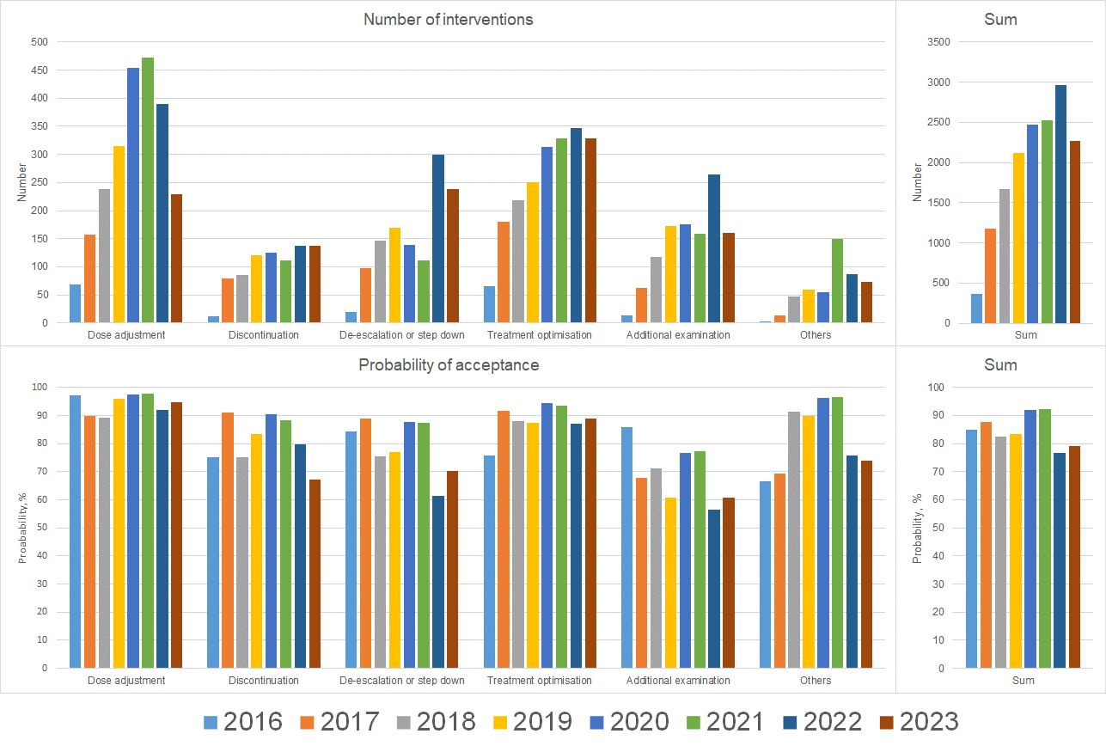
Supplementary Figure S1. Number of interventions (upper panels) and their probability of acceptance (lower panels).

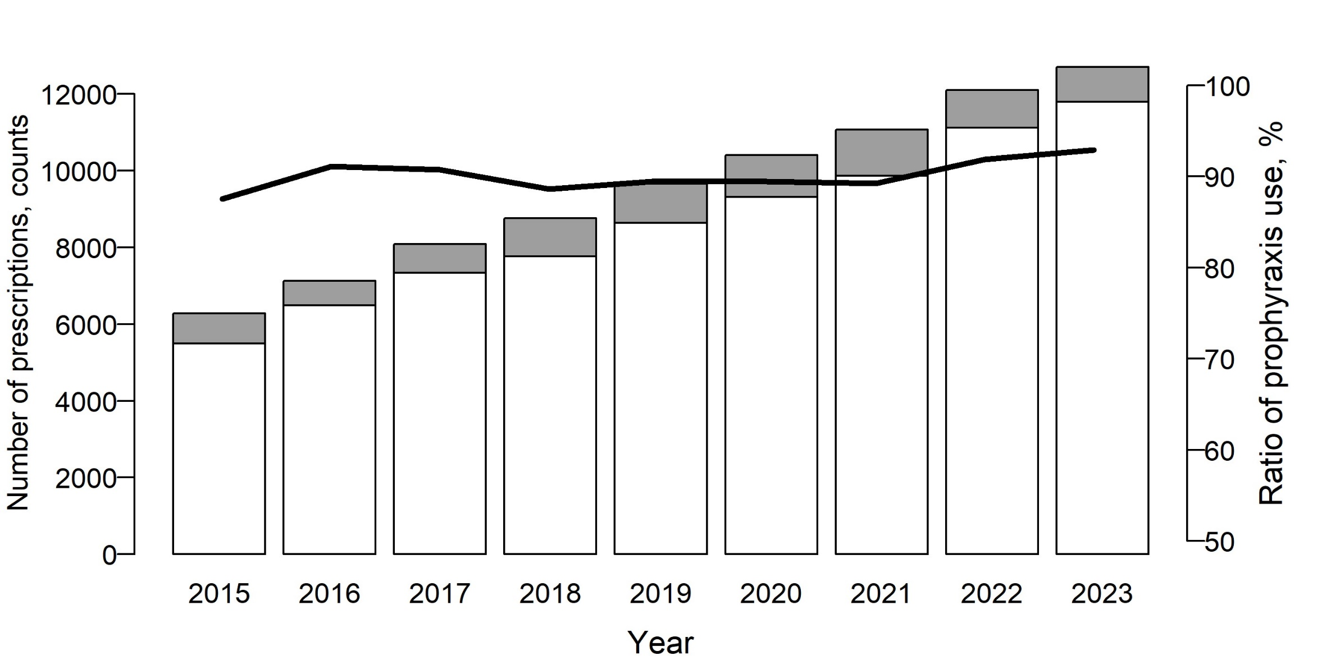
Supplementary Figure S2. Number of prescriptions for sulfamethoxazole/trimethoprim in outpatients.
White bars indicate the number of prescriptions with dosages of 80 mg/day or less, while grey bars represent prescriptions with higher dosages. The black polyline denotes the ratio of prophylactic use, specifically corresponding to the prescriptions represented by the white bars (trimethoprim dosages of 80 mg/day or less). It was considered that approximately 90% of ST prescriptions were for prophylactic use.

Supplementary Figure S3. Impact of antimicrobial stewardship team (AST) programs on days of therapy (DOT), days of antibiotic spectrum coverage (DASC), and DASC/DOT ratio based on antibiotic spectrum coverage (ASC) scores across all antibiotics in inpatients.
The panels in the upper (a-c), middle (d-f), and lower (g-i) rows display total (parenteral and oral), parenteral, and oral antibiotics, respectively. The panels in the left (a, d, g), center (b, e, h), and right (c, f, i) columns represent for DOT, DASC, and DASC/DOT ratio, respectively. The lines and grey areas represent the data fitted to the model and the corresponding 95% confidence interval by interrupted time series analysis, with the interruption set at 40 months for the full AST programs. The vertical dotted and continuous lines signify the preliminary and full AST programs at 16 months (with a full-time equivalent (FTE) of 0.7) and 40 months (with an FTE of 1.5) after January 2015, respectively.

Supplementary Figure S4. Impact of antimicrobial stewardship team (AST) programs on days of therapy (DOT) stratified by antibiotic spectrum coverage (ASC) scores across all antibiotics in inpatients.
The panels in the upper (a-c), middle (d-f), and lower (g-i) rows display total (parenteral and oral), parenteral, and oral antibiotics, respectively. The panels in the left (a, d, g), center (b, e, h), and right (c, f, i) columns correspond to antibiotics with ASC scores > 10, 6-10, and < 6, respectively The lines and grey areas represent the data fitted to the model and the corresponding 95% confidence interval by interrupted time series analysis, with the interruption set at 40 months. The vertical dotted and continuous lines signify the preliminary and full AST programs at 16 months (with a full-time equivalent (FTE) of 0.7) and 40 months (with an FTE of 1.5) after January 2015, respectively. Stratification details are depicted on the top-left of each panel.
Supplementary Figure S5. Impact of antimicrobial stewardship team (AST) programs on days of therapy (DOT), days of antibiotic spectrum coverage (DASC), and DASC/DOT ratio based on antibiotic spectrum coverage (ASC) scores across all antibiotics in outpatients.
The panels in the upper (a-c), middle (d-f), and lower (g-i) rows represent the results for total oral antibiotics (DOT, DASC, and DASC/DOT ratio), DOT stratified by ASC scores (>10, 6-10, and <6), and the results excluding sulfamethoxazole/trimethoprim (DOT, DASC, and DASC/DOT ratio), respectively. The lines and grey areas represent the data fitted to the model and the corresponding 95% confidence interval by interrupted time series analysis, with the interruption set at 40 months. The vertical dotted and continuous lines signify the preliminary and full AST programs at 16 months (with a full-time equivalent (FTE) of 0.7) and 40 months (with an FTE of 1.5) after January 2015, respectively. Stratification by ASC scores are depicted on the top-left of panels d-f. Panels g-i exclude sulfamethoxazole/trimethoprim.

Supplementary Figure S6. Outcomes of antimicrobial stewardship team (AST) programs on infection onset and antibiotic susceptibilities.
a. Onset of Clostridioides difficile infection (CDI) per 1,000 patient days. b. Onset of candidemia per 1,000 patient days, based on 6,000 blood culture bottles. c. Trends in susceptibilities of Pseudomonas aeruginosa to imipenem/cilastatin (represented by a continuous line and black circles, with values denoted by 'I.PA' on the right shoulder) and Escherichia coli to cefotaxime (represented by a dashed line and white circles, with values denoted by 'CTX.EC' on the right shoulder). The continuous lines and grey areas represent the data fitted to the model and the corresponding 95% confidence interval by interrupted time series analysis (specifically for 'I.PA' for panel c), with the interruption set at 40 months. In panel c, the dashed bold lines, along with the upper and lower dashed thin lines represent the data for 'CTX.EC'.
The vertical dotted and continuous lines signify the AST programs at 16 months (with a full-time equivalent (FTE) of 0.7) and its acceleration at 40 months (with an FTE of 1.5) after January 2015, respectively.
Definition and calculations
- The onset rate of Clostridioides difficile infection (CDI), expressed per 1,000 patient-days.
$$CDI onset= \frac{Number of patients with positive result of CD toxin×1,000}{Number of patient days in a specified year }$$
- The onset rate of candidemia, calculated both per 1,000 patient-days and per 6,000 blood culture bottles—the latter figure approximating the annual usage of blood culture bottles in our hospital.
$$Candidemia onset= \frac{Number of patients with positive blood culture of Candida species×1,000×6,000}{Number of patient days ×total blood culture bottles in a specified year}$$
The onset of candidemia was determined by the isolation of Candida species from at least one blood culture bottle, with the rate standardized to the total number of blood culture bottles used within a specified year.
- The susceptibilities of Pseudomonas aeruginosa to imipenem (representing carbapenems) and Escherichia coli to cefotaxime (representing third-generation cephalosporins) for selected years.
We assessed the susceptibilities of Pseudomonas aeruginosa and Escherichia coli by analyzing our medical database, categorizing these susceptibilities in accordance with the guidelines established by the Clinical & Laboratory Standards Institute (CLSI). The minimum inhibitory concentrations (MICs) were determined using the microdilution method. The breakpoint values for categorizing a strain as sensitive were defined as ≤ 2 μg/mL for imipenem/cilastatin against Pseudomonas aeruginosa and ≤ 1 μg/mL for cefotaxime against Escherichia coli. Efforts were made to ensure the exclusion of duplicate patient records within the specified timeframe.

References for Supplementary Information
- Kakiuchi S, Livorsi DJ, Perencevich EN, et al. Days of Antibiotic Spectrum Coverage: A Novel Metric for Inpatient Antibiotic Consumption. Clin Infect Dis 2022;75(4):567-576.
- Cidav Z, Mandell D, Pyne J, Beidas R, Curran G, Marcus S. A pragmatic method for costing implementation strategies using time-driven activity-based costing. Implement Sci 2020;15(1):28.
- Doernberg SB, Abbo LM, Burdette SD, et al. Essential Resources and Strategies for Antibiotic Stewardship Programs in the Acute Care Setting. Clin Infect Dis 2018;67(8):1168-1174.
- Le Coz P, Carlet J, Roblot F, Pulcini C. Human resources needed to perform antimicrobial stewardship teams' activities in French hospitals. Med Mal Infect 2016;46(4):200-6.
- Morris AM, Rennert-May E, Dalton B, et al. Rationale and development of a business case for antimicrobial stewardship programs in acute care hospital settings. Antimicrob Resist Infect Control 2018;7:104.
- Maeda M, Muraki Y, Kosaka T, et al. Essential human resources for antimicrobial stewardship teams in Japan: Estimates from a nationwide survey conducted by the Japanese Society of Chemotherapy. J Infect Chemother 2019;25(9):653-656.
- Sawada K, Inose R, Goto R, Nakatani T, Kono S, Muraki Y. Effectiveness of Noncertified Pharmacist-Led Antimicrobial Stewardship Programs in a Medium-Sized Hospital Without an Infectious Disease Specialist: A Retrospective Pre-Post Study. Open Forum Infect Dis 2023;10(3):ofad116.
- Bystritsky RJ, Beltran A, Young AT, Wong A, Hu X, Doernberg SB. Machine learning for the prediction of antimicrobial stewardship intervention in hospitalized patients receiving broad-spectrum agents. Infect Control Hosp Epidemiol 2020;41(9):1022-1027.
- Maillard A, Micheli G, Lefevre L, et al. Can Chatbot artificial intelligence replace infectious disease physicians in the management of bloodstream infections? A prospective cohort study. Clin Infect Dis 2023:ciad632.
- Hongbin Chen, Zhanwei Wang, Henan Li, et al. In Vitro Analysis of Activities of 16 Antimicrobial Agents against Gram-Negative Bacteria from Six Teaching Hospitals in China. Jpn J Infect Dis 2015; 68:263–267.
- Ishikawa K, Uehara Y, Mori N, et al. In Vitro Activity and Clinical Efficacy of Faropenem against Third-Generation Cephalosporin-Resistant Escherichia coli and Klebsiella pneumoniae. Antimicrob Agents Chemother 2022;66(6):e0012522.
- Asempa TE, Bobenchik AM, Bourassa L, et al. Antimicrobial Activity of Tebipenem and Comparators against Enterobacterales from diverse Outpatient Centers and Nursing Homes in the United States. Int J Antimicrob Agents 2023;61(3):106733.
- Yamashiro Y, Takahata M, Minami S. Bactericidal activity of pazufloxacin mesilate against Pseudomonas aeruginosa and MRSA in an in vitro dynamic model. Jpn J Chemother 2002;50(5):273-279.
- Sun C, Hao J, Dou M, Gong Y. Mutant prevention concentrations of levofloxacin, pazufloxacin and ciprofloxacin for A. baumannii and mutations in gyrA and parC genes. J Antibiot (Tokyo) 2015;68(5):313-7.
- Kishii R, Yamaguchi Y, Takei M. In Vitro Activities and Spectrum of the Novel Fluoroquinolone Lascufloxacin (KRP-AM1977). Antimicrob Agents Chemother 2017;61(6):e00120-17.
- Uno T. In vitro activity of prulifloxacin against clinical isolates causing otorhinolaryngological infections. Jpn J Chemother 2005;53(9):512-525.
- Kanda N, Ohbe H, Jo T, et al. Trends in inpatient antimicrobial consumption using days of therapy and days of antibiotic spectrum coverage: A nationwide claims database study in Japan. J Infect Chemother 2023:S1341-321X(23)00257-X.
- Barlam TF, Cosgrove SE, Abbo LM, et al. Implementing an Antibiotic Stewardship Program: Guidelines by the Infectious Diseases Society of America and the Society for Healthcare Epidemiology of America. Clin Infect Dis 2016;62(10):e51-77.

