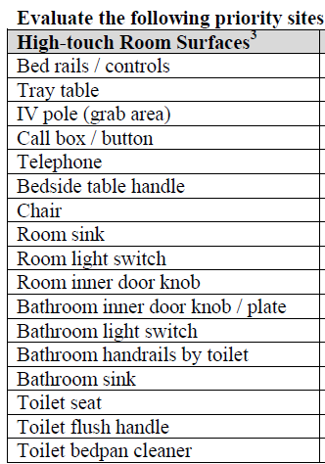 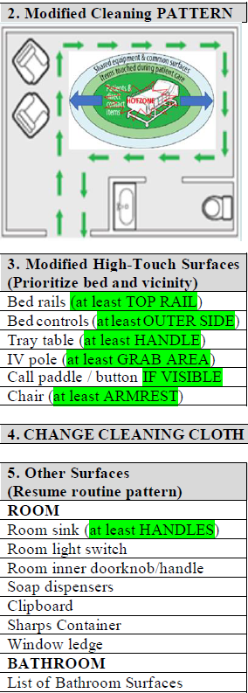

**CDC Checklist Modified Checklist**

**Figure 3.** Comparison of CDC and Modified Checklists