**Supplemental material**

**Title: Evaluation of a wall-mounted far ultraviolet-C light device used for continuous air and surface decontamination in a dental office during routine patient care**

**Figure 1**. Picture of the GermBuster Channel 250-Watt far UV-C device

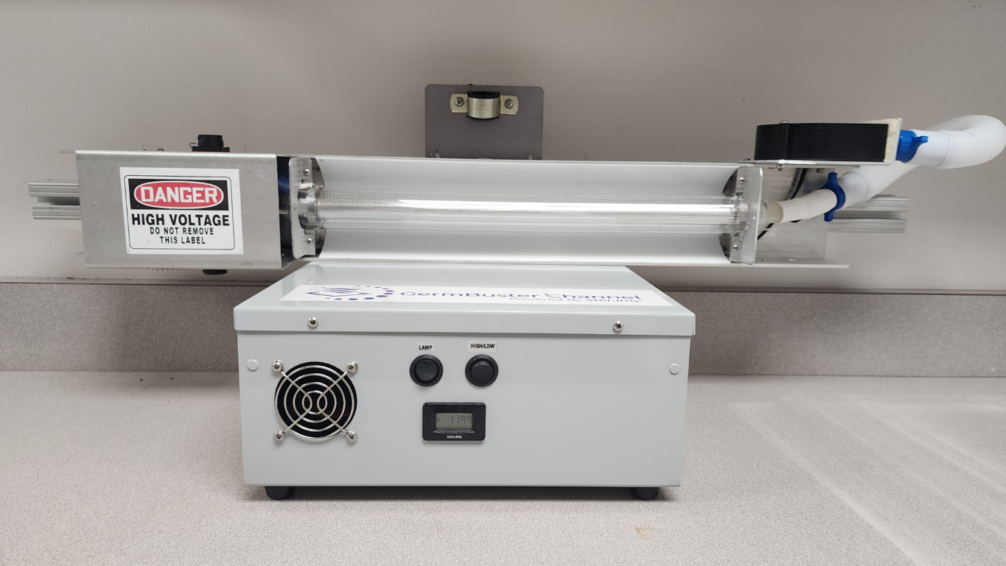

**Figure 2**. Picture of the dental room used for testing with the far UV device in place

**Figure 3.** Diagram of the dental procedure room with numbers indicating the 20 test sites and the position of the far UV device

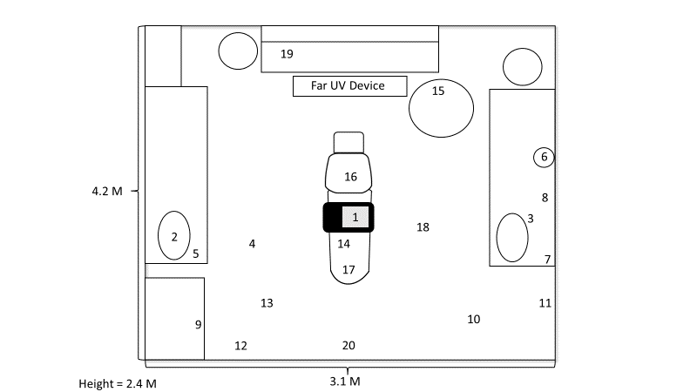

**Figure 4**. Pictures of the colorimetric indicator cards

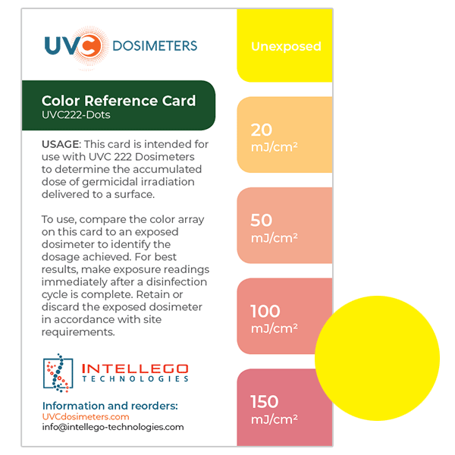

Pictures of far UV-C dosimeter cards after 2 hours in selected sites in a dental treatment room

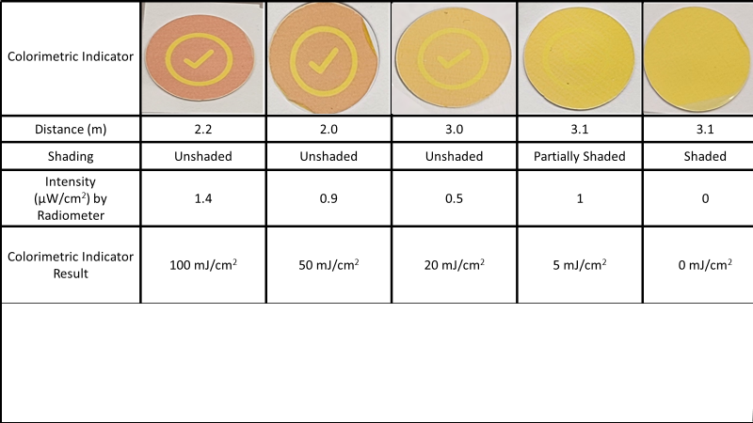

**Figure 5. Mean (SE) Log10 reductions in MRSA in unshaded, partially shaded, and shaded sites in a dental procedure room after 2 hours of far UV exposure and irradiance readings at the test sites (red line)**

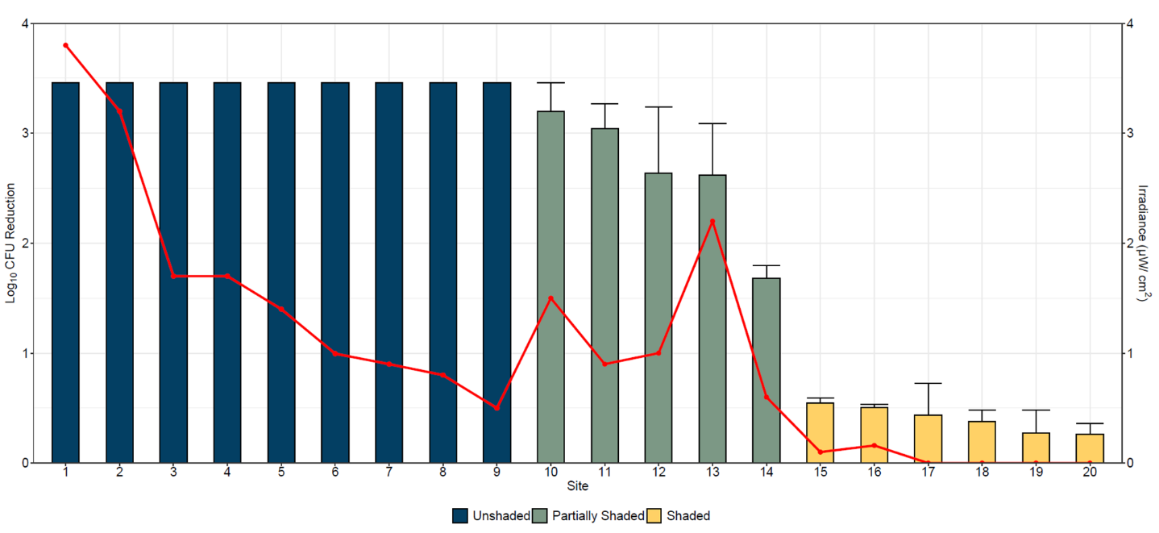

**Interview questions for dental staff**

1). Do you feel safe working with the far UV-C device on?

2). Have you noticed any adverse effects (e.g., visual changes, skin irritation) when working with the devices on?

3). Have any patients expressed concern about the safety of the devices after reading the informational materials? What kinds of comments have patients had about the devices?

4). Have any of your co-workers expressed concerns about safety of the technology or noted adverse effects?

5). Did you receive education about the technology? Who provided the education and what was provided?

6). When are the devices used? How many hours per day are the devices on? How much time during a typical workday would you be in the room while the device is operating?

7). What type of PPE do you wear while in the rooms with the device on?

8). Have you noticed any odor when the device is used?

9). Have you noticed any damage or discoloration of equipment or surfaces in the rooms?