**Supplementary Figure 1**. Results of multi-database linkage between Carbapenem-resistant *Enterobacterales* surveillance data stored in the National Disease Surveillance System (NEDDS) Base System (NBS) and Vital Records Death Certificate data using exact and fuzzy matching.

**Supplementary Figure 2:** Directed Acyclic Graph (DAG) Evaluating Covariates as Potential Confounders

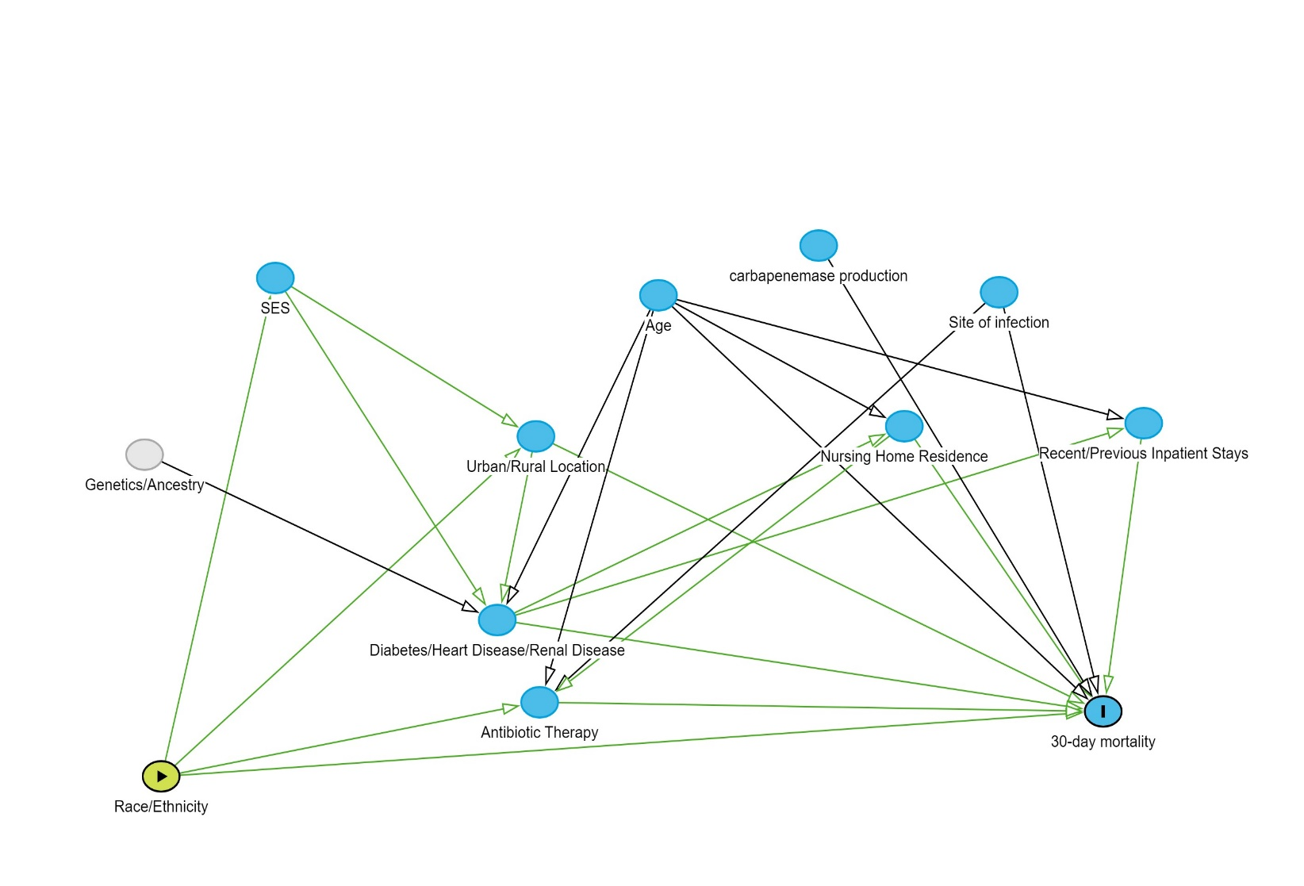

Abbreviations: SES; Socioeconomic Status.

References:

1. Gao, Y., Chen, M., et al. (2022). An analysis of risk factors for carbapenem-resistant Enterobacteriaceae infection. *Journal of Global Antimicrobial Resistance*, 30, 191-198. [doi:10.1016/j.jgar.2022.04.005](https://pubmed.ncbi.nlm.nih.gov/35429666/)
2. Rebold N, Lagnf AM, Alosaimy S, et al. Risk Factors for Carbapenem-Resistant *Enterobacterales* Clinical Treatment Failure. *Microbiol Spectr*. 2023;11(1):e0264722. doi:10.1128/spectrum.02647-22
3. CDC. Antibiotic Resistance Threats in the United States, 2019. Atlanta, GA: U.S. Department of Health and Human Services, CDC; 2019. <http://dx.doi.org/10.15620/cdc:82532>

Abbreviations: CP-CRE; carbapenemase-producing carbapenem-resistant Enterobacterales, CI; confidence interval, UL; upper limit, L; lower limit.

*Because bias squared < Δ variance, the precision gained when removing the variables exceeds the validity lost by showing the crude model. Table was based on the coefficient for race when using non-Hispanic White patients as the referent group compared to non-Hispanic Black patients.

1Bias Squared calculated from (ΒFullModel - ΒCrudeMode)^2

2Calculated from =((LN(ULFull))-(LN(LLFull))/3.92)^2

3Calculated from =((LN(ULCrude))-(LN(LLCrude))/3.92)^2

4Calculated from =Variance Full Model-Variance Crude Model

**Supplementary Table 1:** Bias-Precision Tradeoff Analysis for final model selection

|  |  |  |  |  |  |  |  |  |  |  |
| --- | --- | --- | --- | --- | --- | --- | --- | --- | --- | --- |
| Covariates | ΒFullModel | ΒCrudeModel | 1Bias Squared | 95% CI LL  (Full Model) | 95% CI UL (Full Model) | 95% CI LL (Crude Model) | 95% CI UL (Crude Model) | 2Variance Full Model | 3Variance Crude Model | 4ΔVariance |
| Age,  CP-CRE, Specimen Type | 0.3022 | 0.3177 | 0.00024025 | 1.0021 | 1.8264 | 1.029 | 1.8344 | 0.362177279 | 0.359310012 | 0.002867267 |

**Supplementary Table 2:** Proportion of all-cause 30-day Mortality by Primary Specimen Source and Race and Ethnicity

|  |  |  |  |  |
| --- | --- | --- | --- | --- |
| Proportion of Deaths by Specimen Type | N deaths/ N patients (%) by race and specimen source | | | |
| Blood  n= 123 | Other Normally Sterile Sites  n= 299 | Normally  Nonsterile Site  n= 2058 | Rectal  n=28 |
| NH White | 21/82 (26) | 42/214 (20) | 94/1547 (6) | 0/22 (0) |
| NH Black | 10/37 (27) | 19/69 (28) | 36/455 (8) | 0/1 (0) |
| Hispanic and NH other | 0/4 (0) | 3/16 (19) | 3/56 (5) | 0/5 (0) |
| All Races | 31/123 (25) | 64/299 (21) | 133/2058 (6) | 0/28 (0) |

Note: all data are expressed as number of deaths within 30 days of CRE diagnosis/number of patients by primary specimen source and race/ethnicity (%). Specimen sources were not mutually exclusive. Therefore, primary specimen sources were prioritized based on severity. If a patient had a blood and urine specimen, blood was selected as the primary specimen source. Other normally sterile sites are defined as blood, cerebral spinal fluid, pleural fluid, peritoneal fluid, pericardial fluid, bone, joint, and internal body sites. Blood was excluded from the other normally sterile sites category since it was presented separately. Normally non-sterile sites include soft tissue and respiratory.

Abbreviations: NH; Non-Hispanic