Supplementary Materials
Supplemental Figure 1. Urinary tract infection testing algorithm
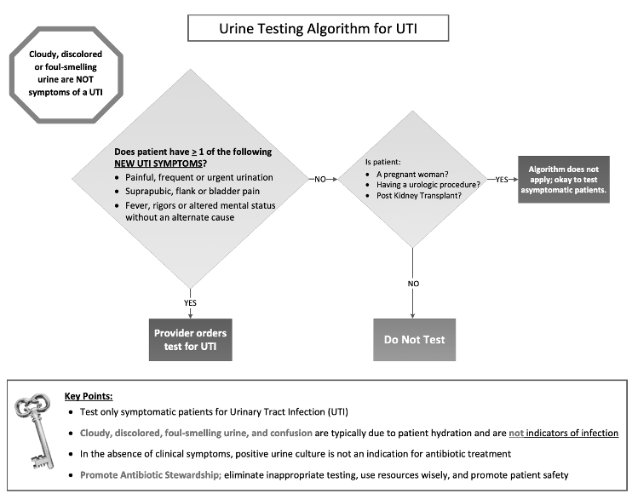

Supplemental Figure 2. Inpatient and outpatient non-blood order menus
Pre-September 2019 Post-September 2019
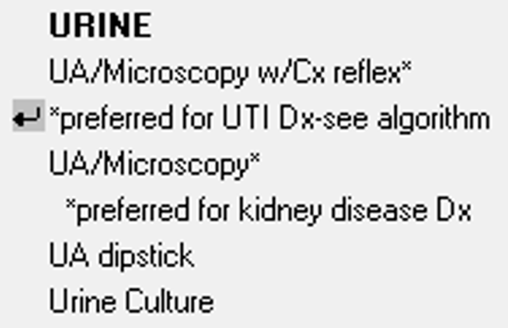
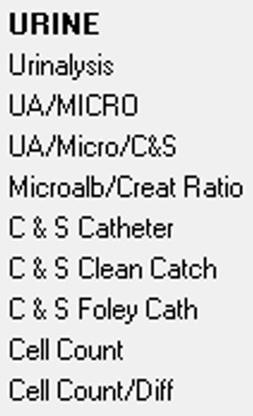
Supplemental Figure 3. Outpatient blood testing order menu
Pre-September 2019 Post-September 2019
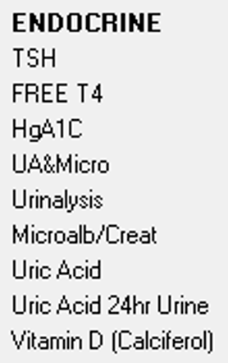

Supplemental Figure 4. Emergency department order menu changes
Pre-September 2019 Post-September 2019
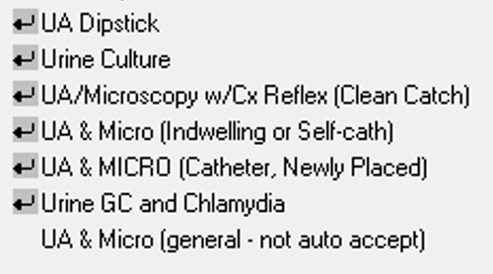
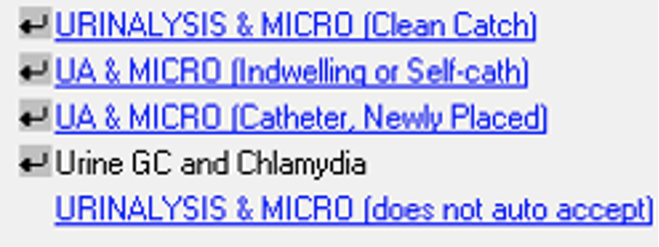

Supplemental Figure 5. Urine testing orders
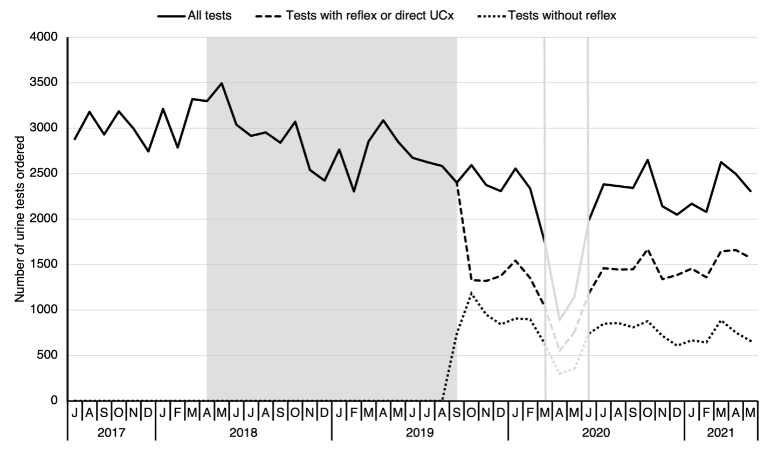
Data are plotted by month and number of urine tests ordered including urinalysis dipstick (UA), urine microscopy (UA + micro), conditional urine reflex to culture (CURCx) and direct UCxs. The solid line represents the monthly order total. The dashed line represents orders that could have proceeded to UCx. The dotted line represents the UAs and UA + micros that could not proceed to UCx, regardless of the result. The beginning of the shaded region depicts the timing of the UTI algorithm distribution (April 2018) and ends with the order menu and laboratory protocol changes (September 2019). Data for March to May 2020 were omitted due to possible COVID-19 pandemic-related influences.

Supplemental Figure 6. Monthly urine cultures performed and percent positivity
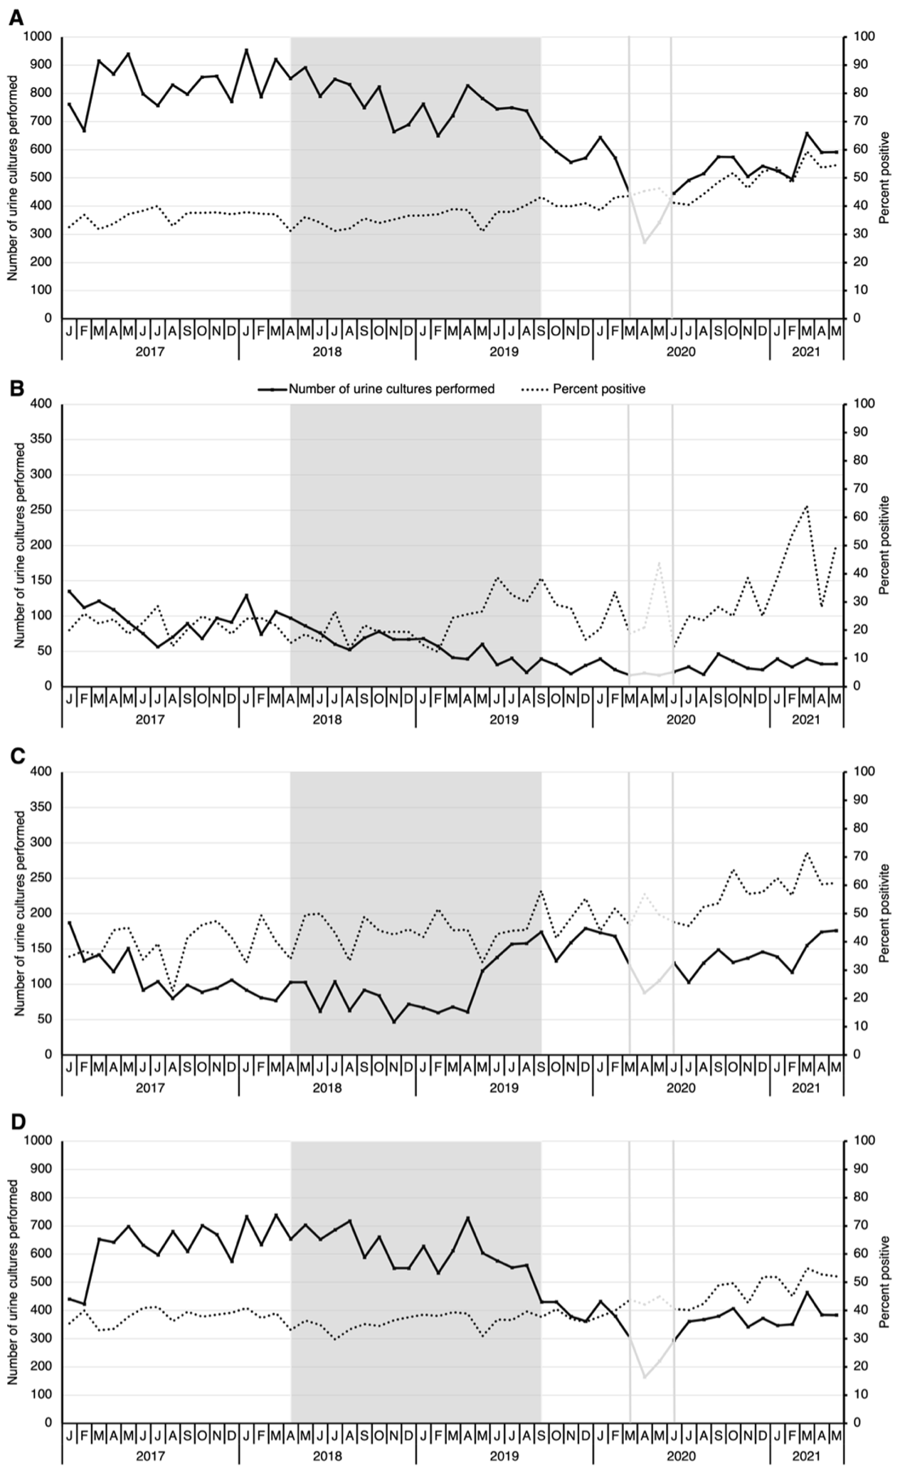
Data are plotted by month and number of urine cultures (UCx) performed on the first y-axis. The second Y-axis depicts percent positivity of UCxs. The graphs are separated into the following: A) overall (facility-wide), B) all inpatient areas, C) the emergency department, and D) all outpatient areas. The monthly total UCxs performed between January 2017 and May 2021 are represented by the solid line. The dotted line represents the UCx percent positivity. The shaded region depicts the timing of the UTI algorithm distribution (April 2018) and ends with the order menu and laboratory protocol changes (September 2019). Data for March to May 2020 were omitted due to possible COVID-19 pandemic-related influences.

Supplemental Table 3. CAUTI rate descriptive statistics by study period
Measure | Period 1ª | Period 2^{b} | Period 3^{c}
Number of values | 5 | 4 | 8
Rate per 1,000 urinary catheter days | 1.38 | 0.72 | 0.56
Std. deviation | 0.85 | 0.43 | 0.60
Std. error of mean | 0.38 | 0.21 | 0.21
95% Confidence interval | 0.33-2.44 | 0.04-1.40 | 0.06-1.07
ªJanuary 2017 to March 2018, pre-intervention
^{b}May 2019 to August 2020, between interventions (March, April and May 2020 excluded from analysis)
^{c}October 2020 to May 2021, post-interventions

Supplemental Table 4. Infectious diseases e-consult counts descriptive statistics by study period
Measure | Period 1ª | Period 2^{b} | Period 3^{c}
Number of values | 19 | 12 | 20
Mean | 6.37 | 7.25 | 7.05
Std. deviation | 2.61 | 2.96 | 3.00
Std. error of mean | 0.60 | 0.85 | 0.67
95% Confidence interval | 5.11-7.63 | 5.37-9.13 | 5.65-8.45
ªJanuary 2017 to March 2018, pre-intervention
^{b}May 2019 to August 2020, between interventions (March, April and May 2020 excluded from analysis)
^{c}October 2020 to May 2021, post-interventions

