Supplementary Materials

This simple multifacility SIS model assumed $N$ constant occupancy facilities (hospitals, nursing homes, the community) linked through patient transfer, where the prevalence $v_{a}$ and $v_{a}^{'}$ of patients under normal and enhanced infection control, respectively, at facility $a$ are governed by
$$\frac{dv_{a}}{dt}=(β_{a}v_{a}+β_{a}^{'}v_{a}^{'})(1-v_{a}-v_{a}^{'})-(γ+\frac{1}{τ_{a}}+\frac{1}{t_{P,a}})v_{a}+\frac{1}{τ_{a}}\sum_{b=1}^{N}{\left(\frac{T_{ba}^{(00)}n_{ba}}{n_{a}}v_{b}+\frac{T_{ba}^{(10)}n_{ba}}{n_{a}}v_{b}^{'}\right)}$$
$$\frac{dv_{a}^{'}}{dt}=\frac{1}{t_{P,a}}v_{a}-(γ+\frac{1}{τ_{a}})v_{a}^{'}+\frac{1}{τ_{a}}\sum_{b=1}^{N}{\left(\frac{T_{ba}^{(01)}n_{ba}}{n_{a}}v_{b}+\frac{T_{ba}^{(11)}n_{ba}}{n_{a}}v_{b}^{'}\right)}$$
$β_{a}$ and $β_{a}^{'}$ is the transmissibility, at facility $a$, under normal and enhanced infection prevention and control (IPC), respectively. $τ_{a}$ is the average length of stay at facility a, $t_{P,a}$ is the testing periodicity (corresponding to periodic screening) or timescale, at facility $a$. ${n_{ba}}/{n_{a}}$ represents the fraction of admissions $n_{a}$ at facility a that are transfers $n_{ba}$ from facility b and $T_{ba}^{(10)}$ is the proportion of the patients under enhanced infection control (first superscript, 1) at facility $b$ transferred to facility $a$, who are placed under normal infection control (second superscript, 0) on admission at facility $a$; etc.

Infectious individuals were further delineated as those under enhanced IPC and those who were not. Person-to-person transmissions in the model occurred within a facility or in the community at rates characterized by setting-specific transmissibility. Facility-level CRE transmissibility values were based on analyses of data from the National Healthcare Safety Network (NHSN) and SNF and vSNF outbreaks and are similar to other reported findings (16, 17). Short-stay hospitals (ACHs and CAH) had the highest transmissibility in the model, followed by LTACH, vSNF, and SNF. Other facility types and the community were assigned low transmissibility. Regional outbreaks were initiated with one infectious patient at the largest ACH in the region. Regional spread occurred through transfer of patients among facilities and the community.

Some facility-level characteristics were examined to elucidate the role of individual facilities in regional spread. Patient flow at a facility was characterized by the diversity of originating and destination facilities among admitted and discharged patients, and by the rate of dispersal through discharge and subsequent transfer of patients, quantified using Shannon entropy (18). Recovery rate ($γ)$, setting-specific transmissibility ($β)$, and mean length of stay ($τ)$ were used to estimate the probability of onward transmission, defined as transmission to at least one other individual, before recovery, either at that facility or at any of the facilities subsequently transferred to, and a closely related measure, the facility reproductive number (R_{H}).
In an unmitigated setting, the facility reproductive number, $R_{H}$, may be defined as
$$R_{H}=\frac{β}{1/τ+γ}.$$
Below the critical threshold $R_{H}=1$, endemicity will not be supported (without steady importation). If screening test results are used to target infection control, the probability that an infectious individual will test positive (before discharge or recovery) is
$$p=\frac{1/τ_{T}}{1/τ+γ+1/τ_{T}},$$
so that the effective transmissibility is
$$β_{eff}=\left(1-p\right)β+p\left(1-ϵ_{i}\right)β=\left(1-pϵ_{i}\right)β=\left(1-\frac{ϵ_{i}/τ_{T}}{1/τ+γ+1/τ_{T}}\right)β.$$
$τ_{T}$ is the periodicity of screening tests and $ϵ_{i}$ is the effectiveness of targeted infection control measures. For substantial impact, $τ_{T}$ and $ϵ_{i}$ should be such that $β_{eff}/\left(1/τ+γ\right)<1$ while $R_{H}>1$; the critical combination of intervention parameters is
$$ϵ_{i}=\left(1-1/R_{H}\right)\left(1+τ_{T}/γ+τ_{T}/τ\right).$$
Table A1: Model parameters
Parameter | Value | Source
Disease parameters
Recovery rate, $γ$ | 1/387 per day | Reference [1]
Transmissibility, $β$
Acute care hospital (ACH) and Critical access hospital (CAH) | 0.104 per day | Reference [2]
Long-term acute care hospitals (LTACH) | 0.042 per day | Reference [2]
Ventilator-capable skilled nursing facility (vSNF) | 0.02 per day | Estimated (NHSN, CMS claims)
Skilled nursing facilities (SNF) | 0.0042 per day | Estimated (NHSN, CMS claims)
Other facilities and the community | 0.001 per day | Estimated (NHSN, CMS claims)
Intervention parameters
Point prevalence survey (PPS) periodicity, $t_{P}$ | 90 or 180 days  (Implemented as 1/90 or 1/180 probability of being screened on any day) | Informed estimate (CDC)
Admission screening | Patient transfer from an LTACH or vSNF to an ACH  Patient transfer to an LTACH or vSNF | Informed estimate (CDC)
Transmissibility under enhanced IPC, $β'$
ACH and CAH | 0.0312 per day (-70%) | Reference [1, 3], Informed estimate (CDC)
LTACH | 0.0126 per day (-70%),  0.021 per day (-50%) | Reference [1, 3], Informed estimate (CDC)
vSNF | - per day (-50%),  0.013 per day (-35%),  0.015 per day (-25%) | Informed estimate (CDC)
SNF | 0.00315 per day (-25%) | Informed estimate (CDC)
Other facilities and the community | 0.001 per day (no change) | Informed estimate (CDC)
Interfacility communication | 100% or 0%
Table references:
1. Toth DJA, Khader K, Slayton RB, et al. The Potential for Interventions in a Long-term Acute Care Hospital to Reduce Transmission of Carbapenem-Resistant Enterobacteriaceae in Affiliated
Healthcare Facilities. Clinical Infectious Diseases 2017; 65(4): 581-7.
2. Centers for Disease Control and Prevention. Interim guidance for a public health response to
contain novel or targeted multidrug-resistant organisms (MDROs). Atlanta, GA: US Department
of Health and Human Services, 2017.
4. DalBen MdF, Teixeira Mendes E, Moura ML, et al. A Model-Based Strategy to Control the Spread
of Carbapenem-Resistant Enterobacteriaceae: Simulate and Implement. Infection Control &
Hospital Epidemiology 2016; 37(11): 1315-22.
Results:
Regional Healthcare Network
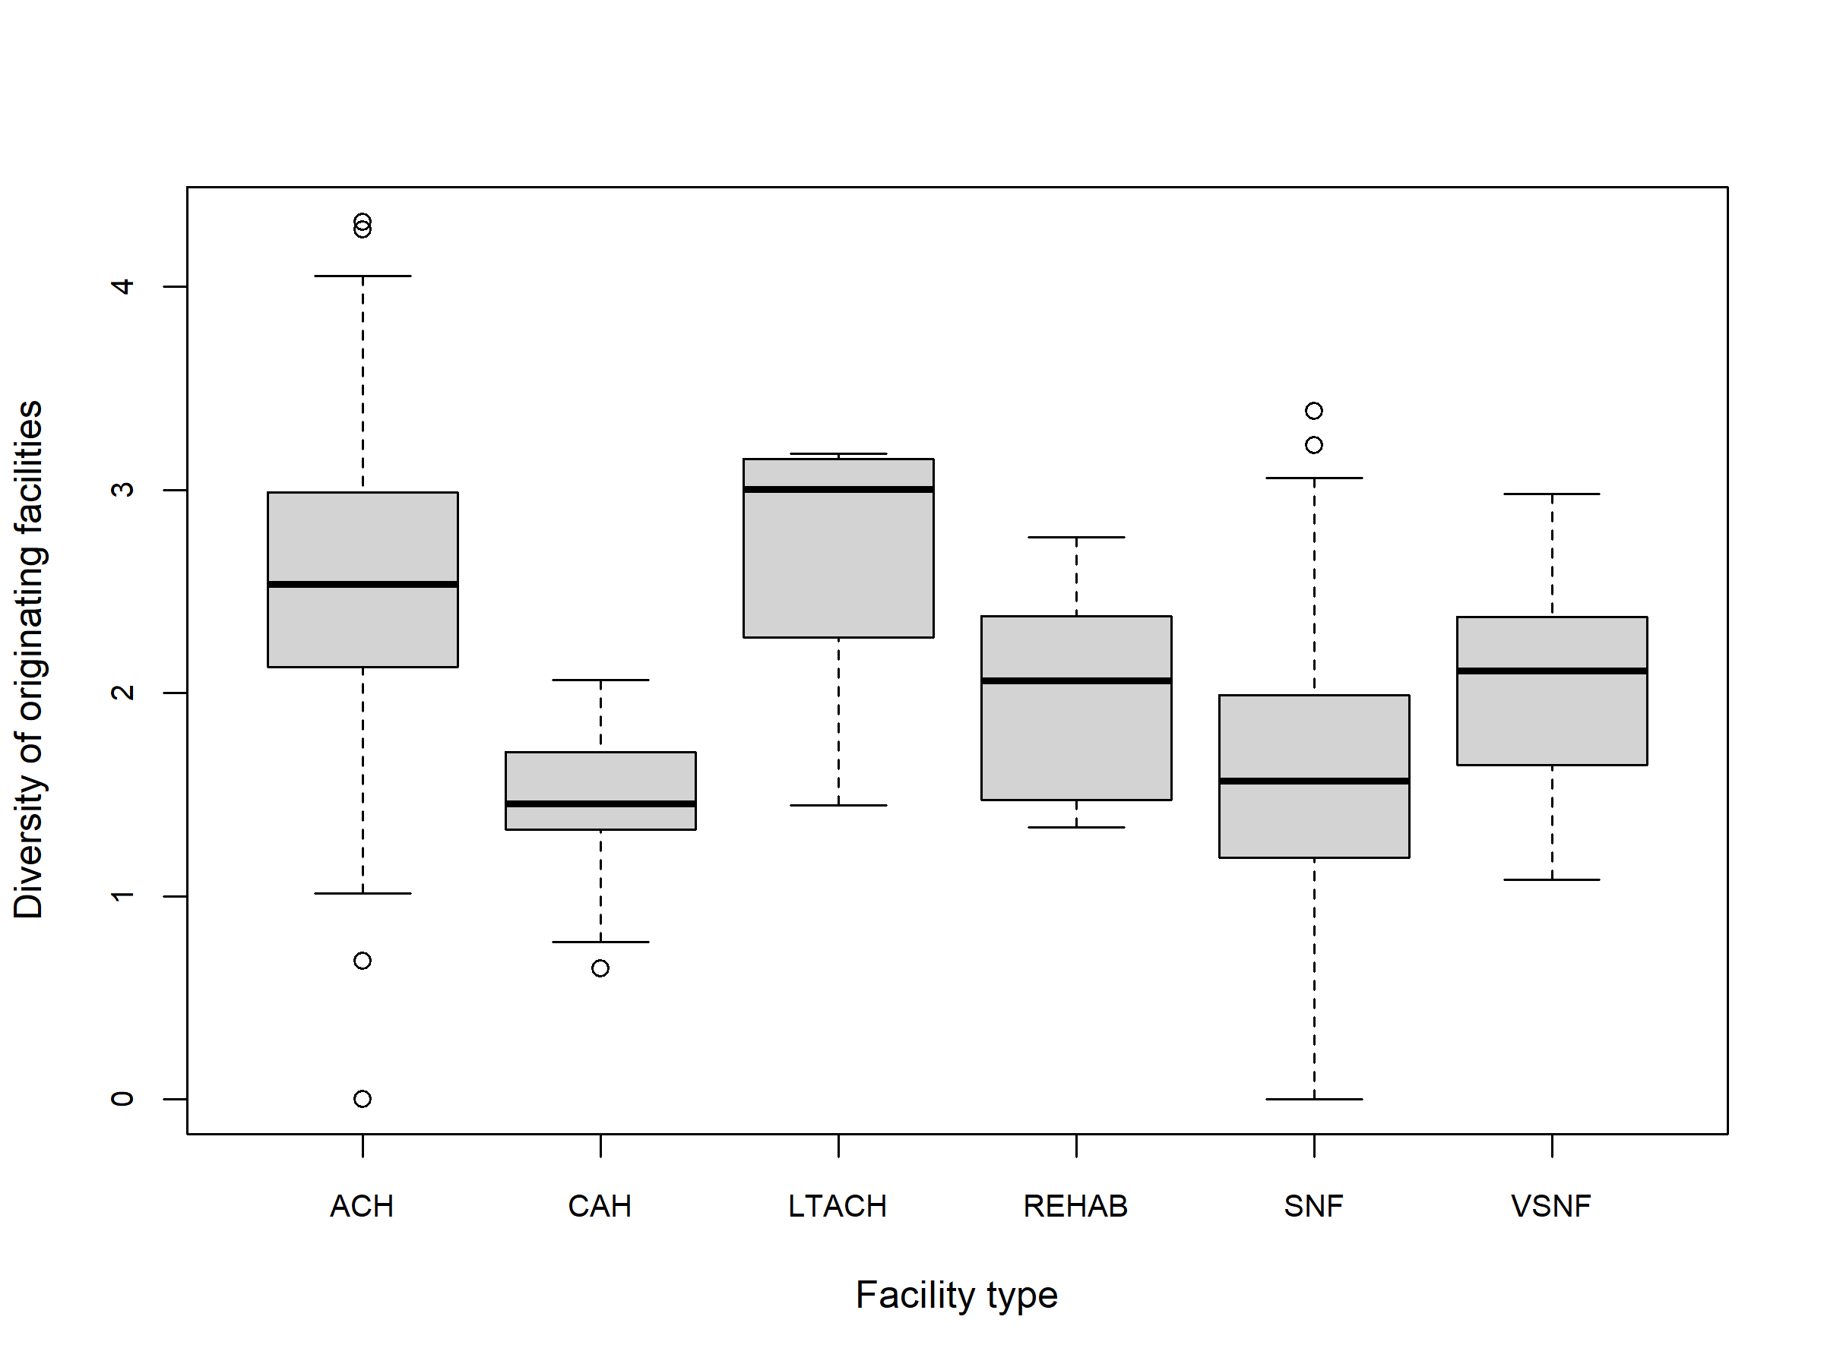
Figure A1 Diversity of originating facilities by facility type for the Illinois network excluding the community. (Shannon diversity applied to the probability distribution among admitted patients)
Abbreviations: ACH, acute care hospital; CAH, critical access hospital; LTACH, long-term acute care hospital; REHAB, Rehabilitation inpatient facility; SNF, skilled nursing facility; vSNF, ventilator-capable skilled nursing facility.

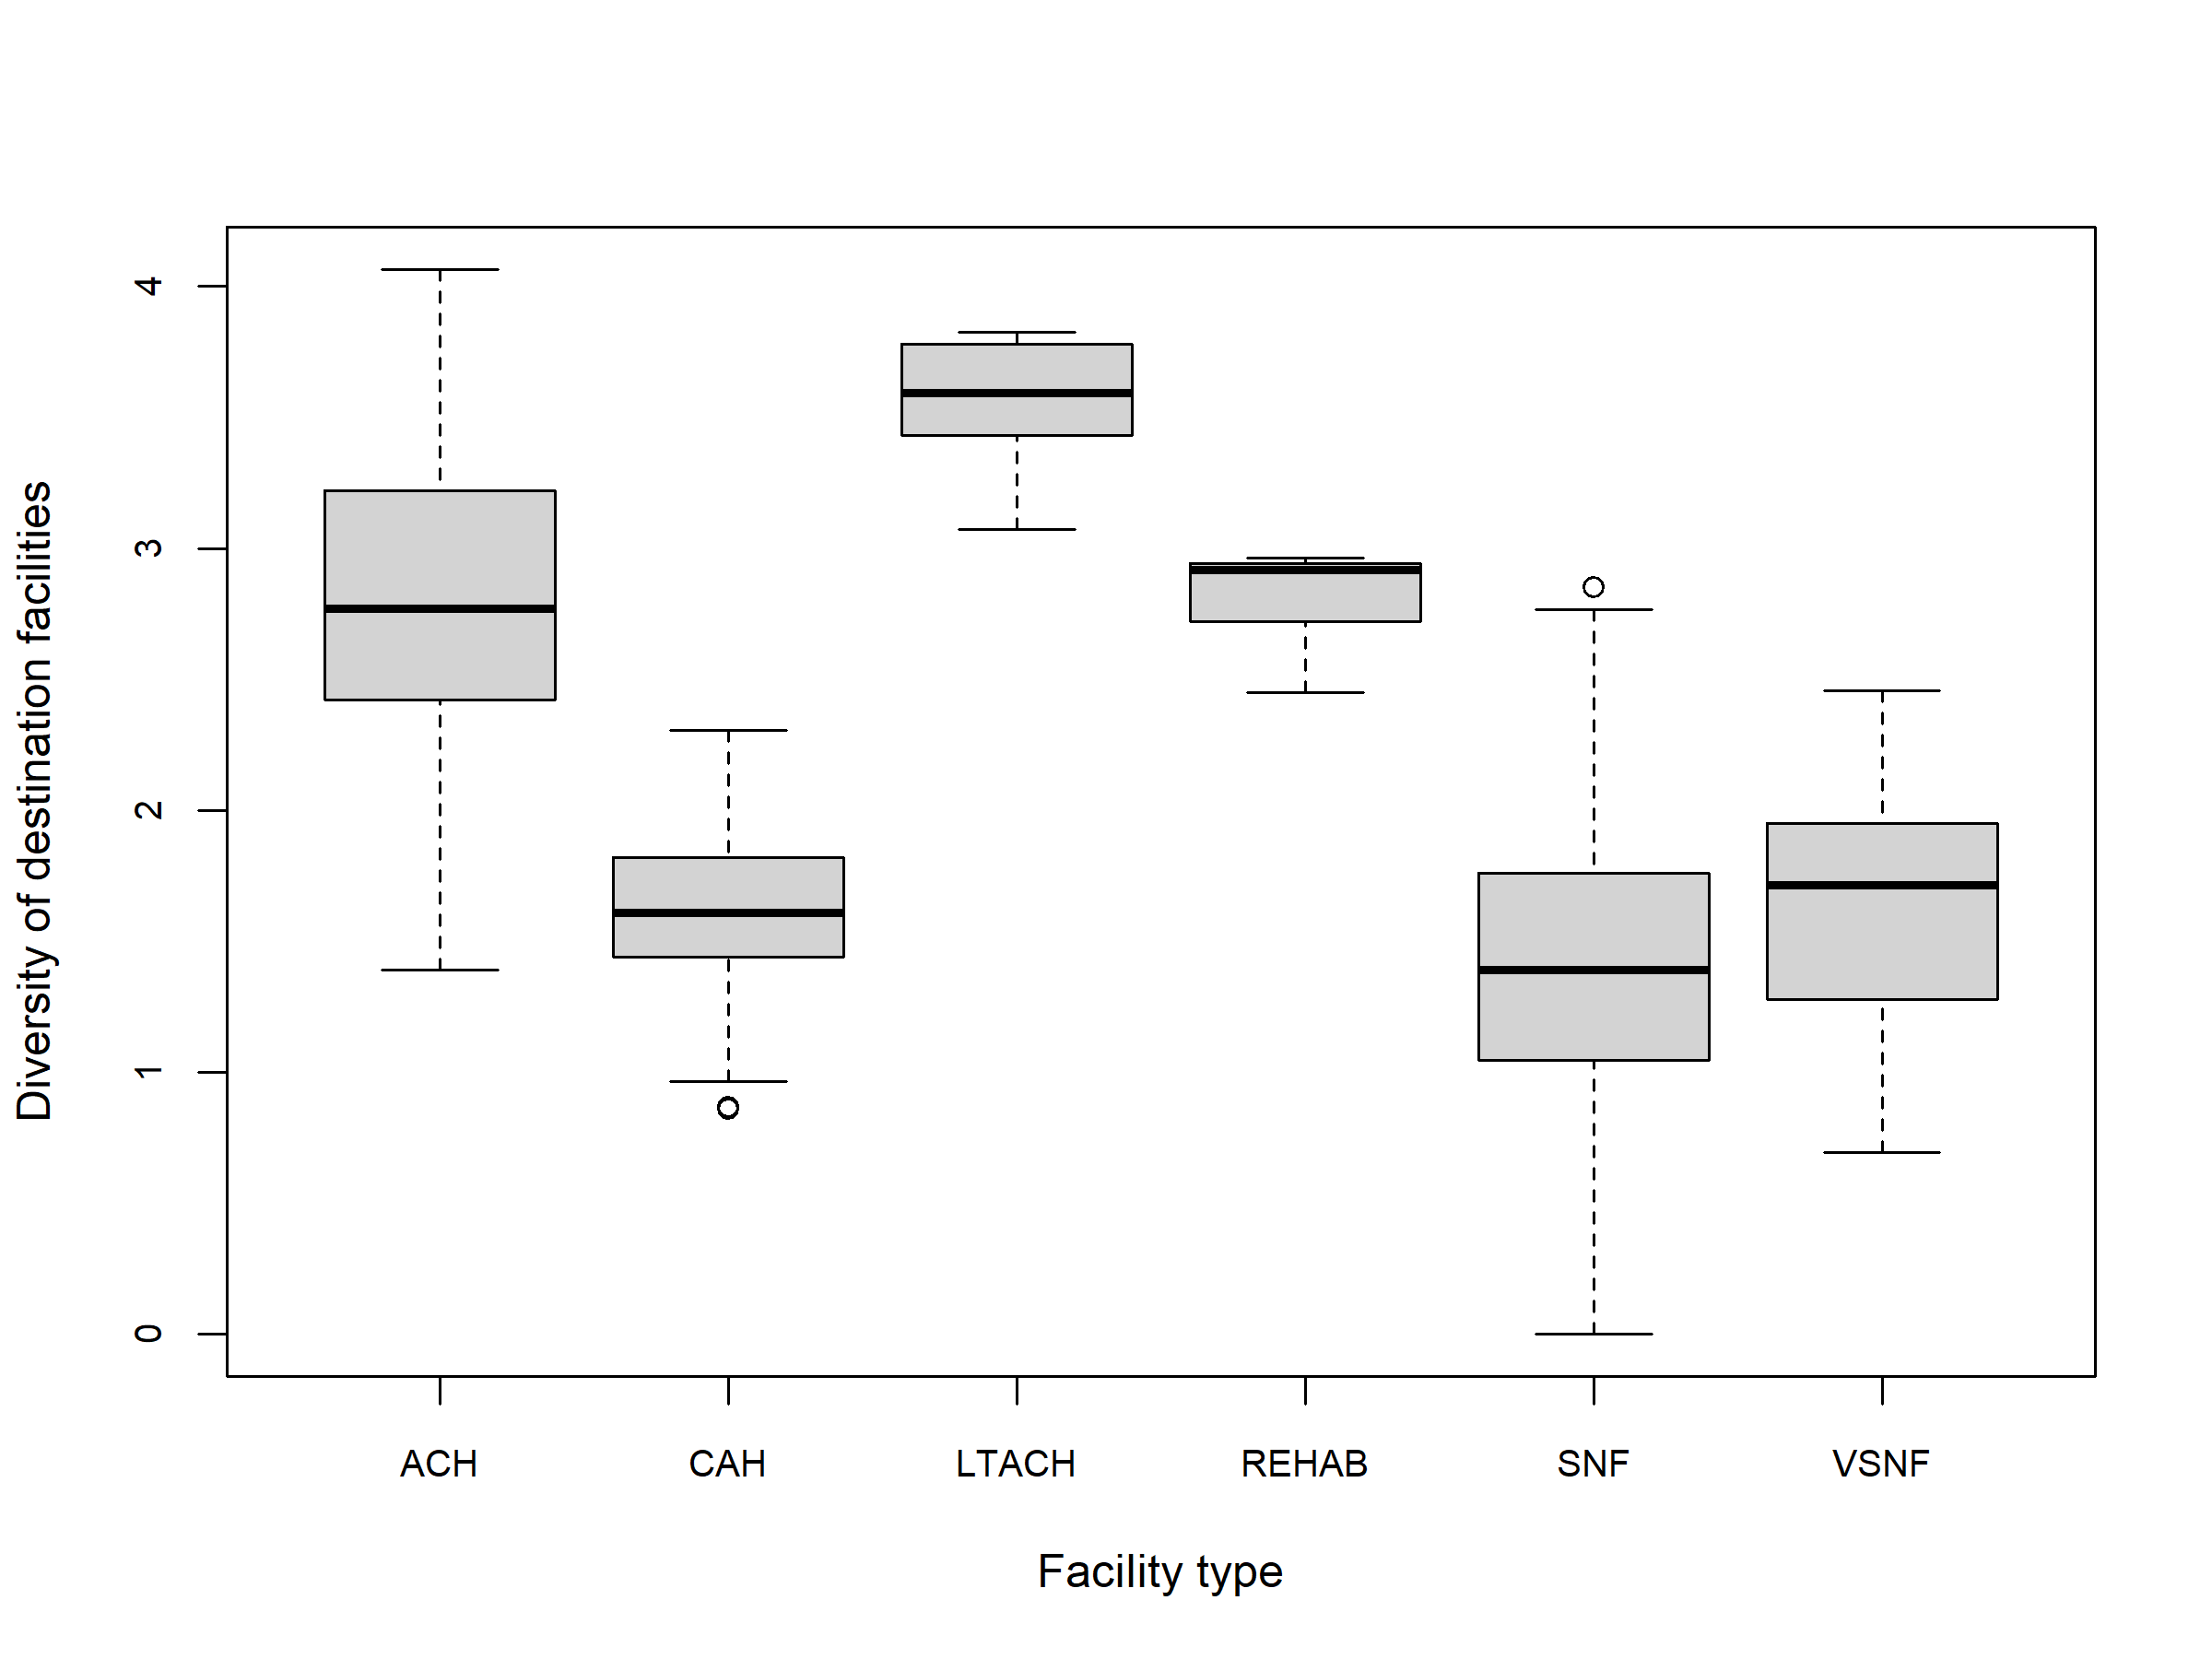
Figure A2 Diversity of destination facilities by facility type for the Illinois network excluding the community. (Shannon diversity applied to the probability distribution among discharged patients).
Abbreviations: ACH, acute care hospital; CAH, critical access hospital; LTACH, long-term acute care hospital; REHAB, Rehabilitation inpatient facility; SNF, skilled nursing facility; vSNF, ventilator-capable skilled nursing facility.
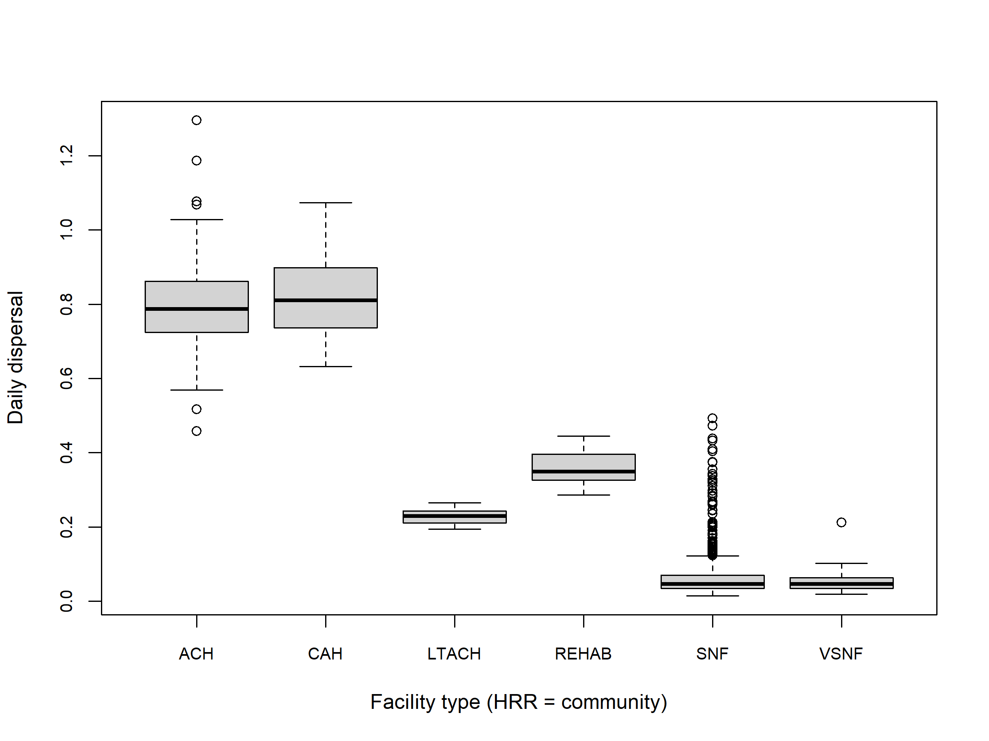
Figure A3 Daily dispersal by facility type for the Illinois network.
Abbreviations: ACH, acute care hospital; CAH, critical access hospital; LTACH, long-term acute care hospital; Rehab, Rehabilitation inpatient facility; SNF, skilled nursing facility; vSNF, ventilator-capable skilled nursing facility.
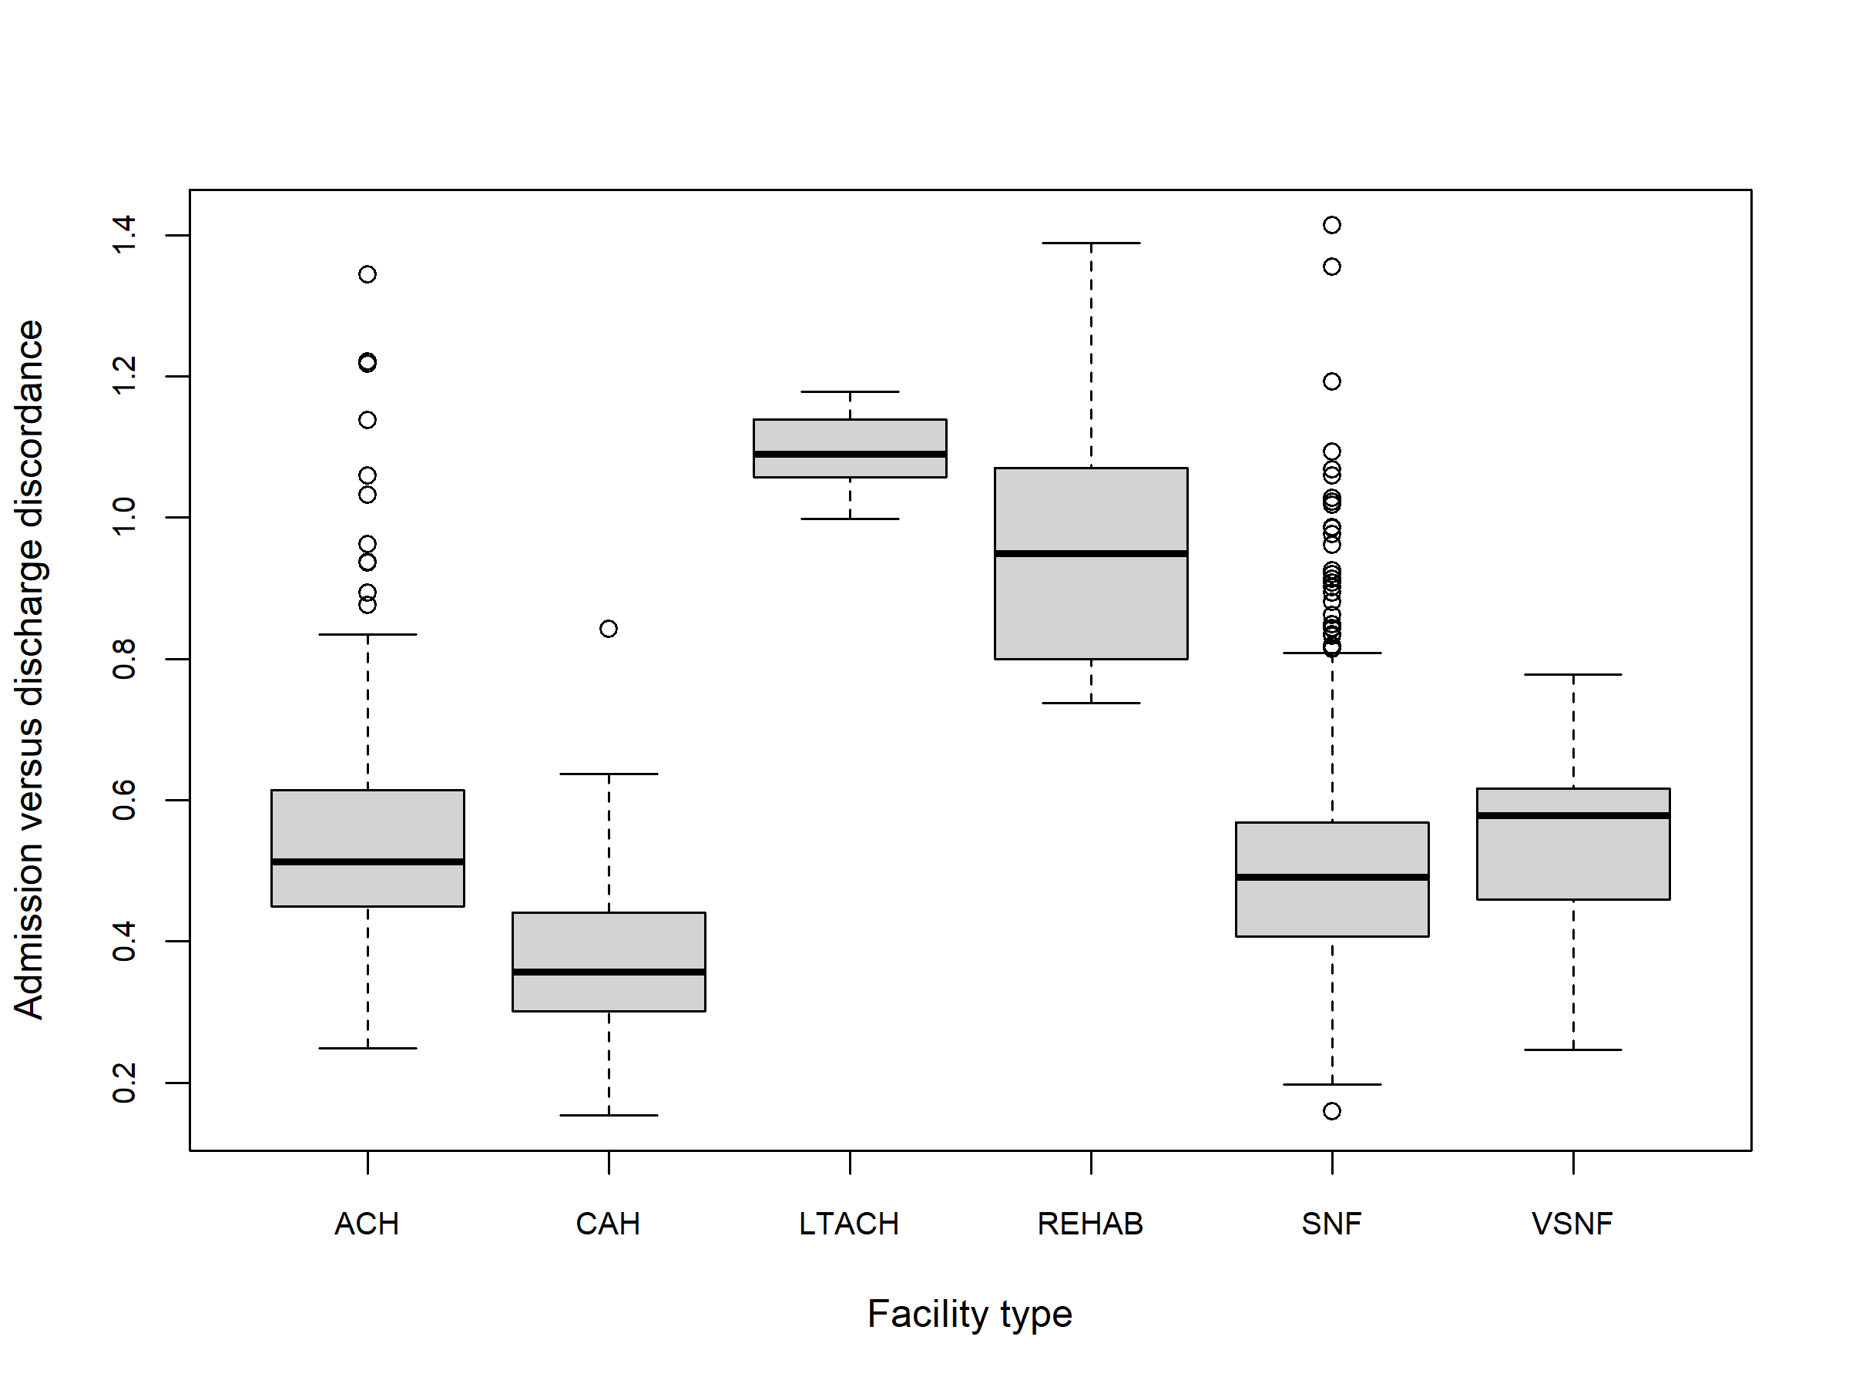
Figure A4 Discharge discordance (discharging to a different facility than admitted from) by facility type for the Illinois network excluding the community.
Abbreviations: ACH, acute care hospital; CAH, critical access hospital; LTACH, long-term acute care hospital; REHAB, Rehabilitation inpatient facility; SNF, skilled nursing facility; vSNF, ventilator-capable skilled nursing facility.

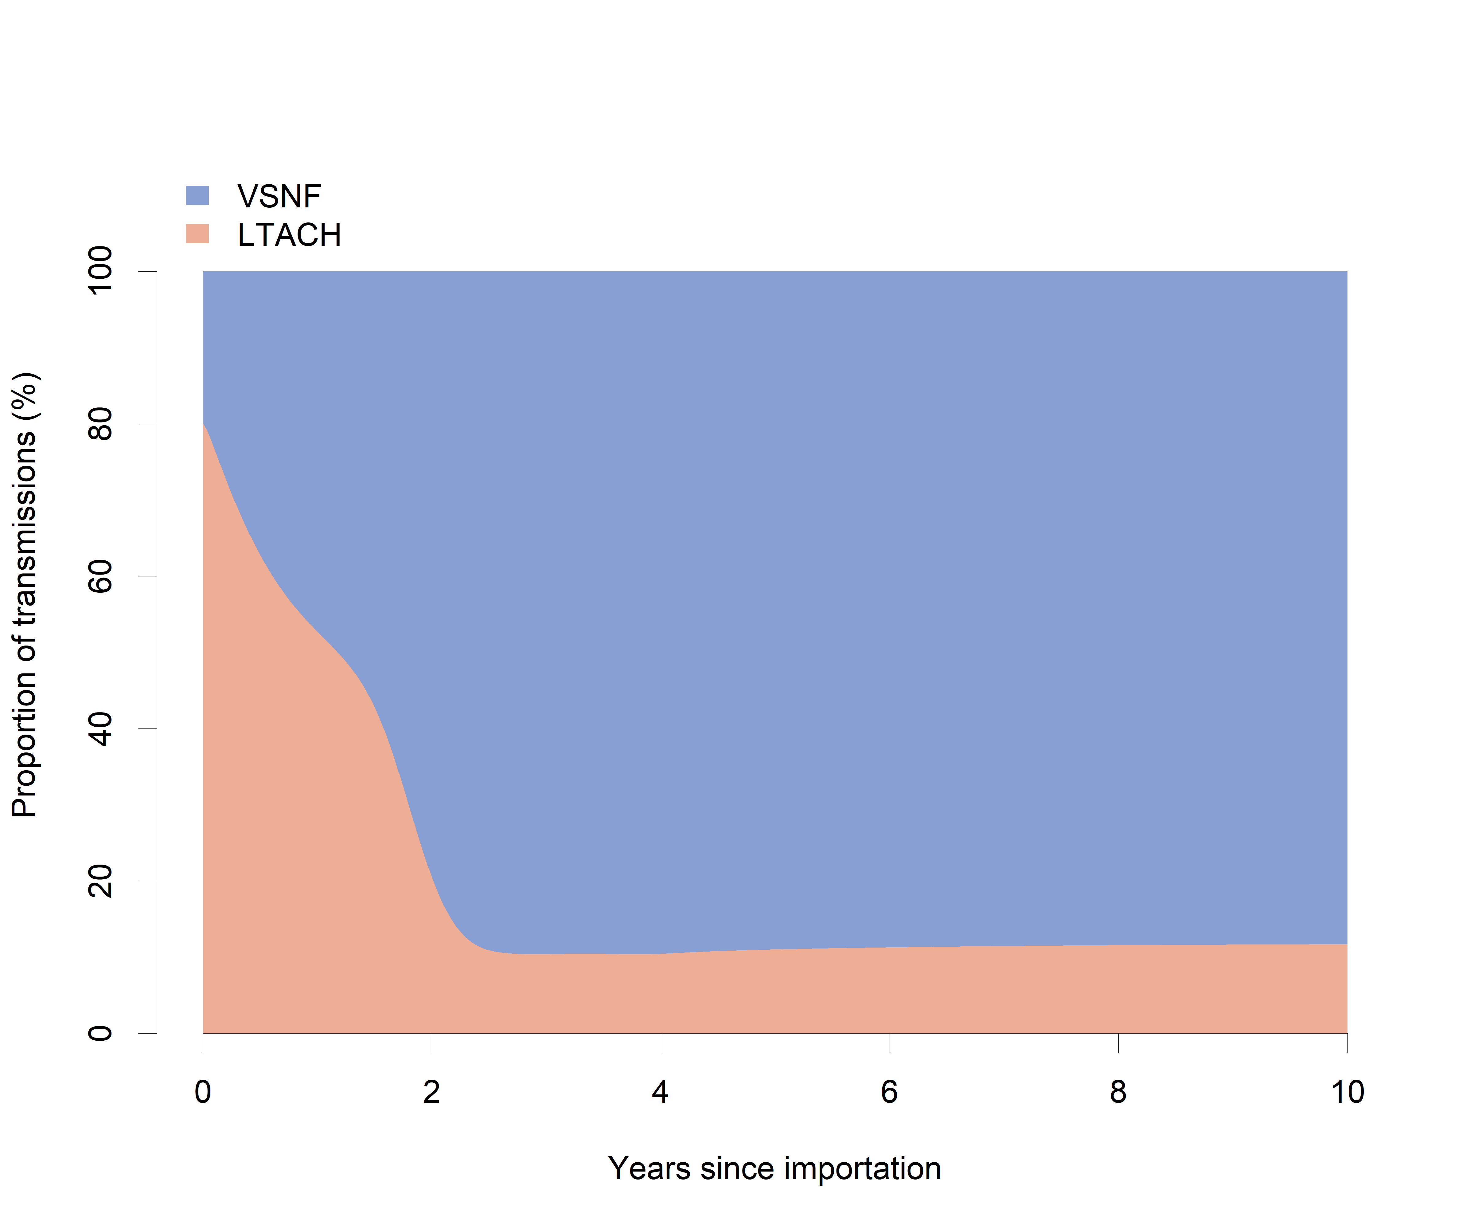
Figure A5 Among vSNFs and LTACHs, the proportion of daily transmissions occurring in each facility type over a ten-year period following introduction of CRE to the Illinois network.
Abbreviations: LTACH, long-term acute care hospital; vSNF, ventilator-capable skilled nursing facility.
Impact of interventions
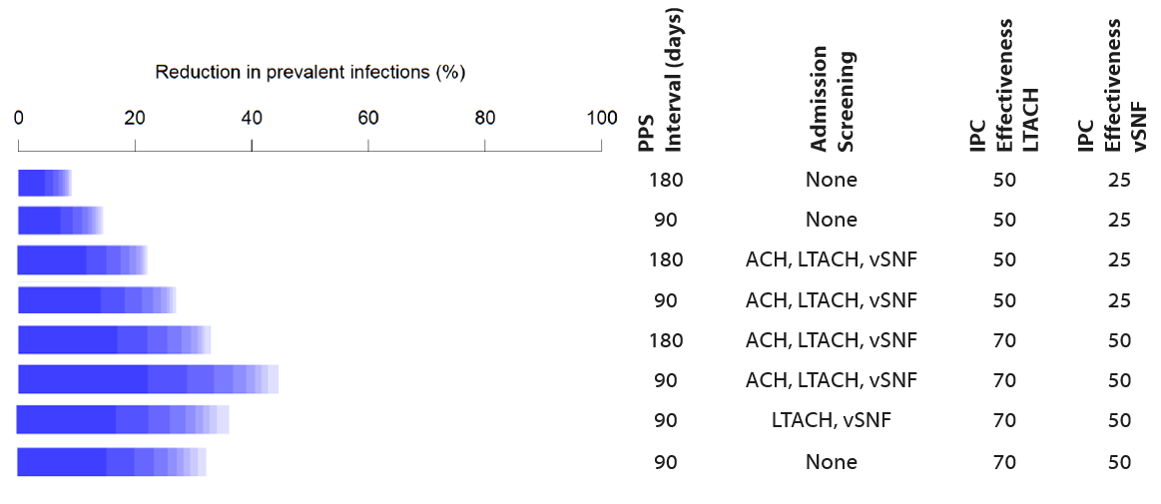
Figure A6 Percent reduction of prevalent infections by combination of interventions in the Illinois network. PPS occurs in vSNF and LTACH; Admission screening (Adm Sc) occurs when a patient transfers from an LTACH or vSNF to an ACH or when a patient transfers from any facility type to an LTACH or vSNF; IPC effectiveness of 70% in ACH, 70% in CAH, 0% in HRR, 25% in SNF; interfacility communication of 100%.
Abbreviations: ACH, acute care hospital; LTACH, long-term acute care hospital; REHAB, Rehabilitation inpatient facility; vSNF, ventilator-capable skilled nursing facility; IPC, infection prevention and control; PPS, point prevalence survey.

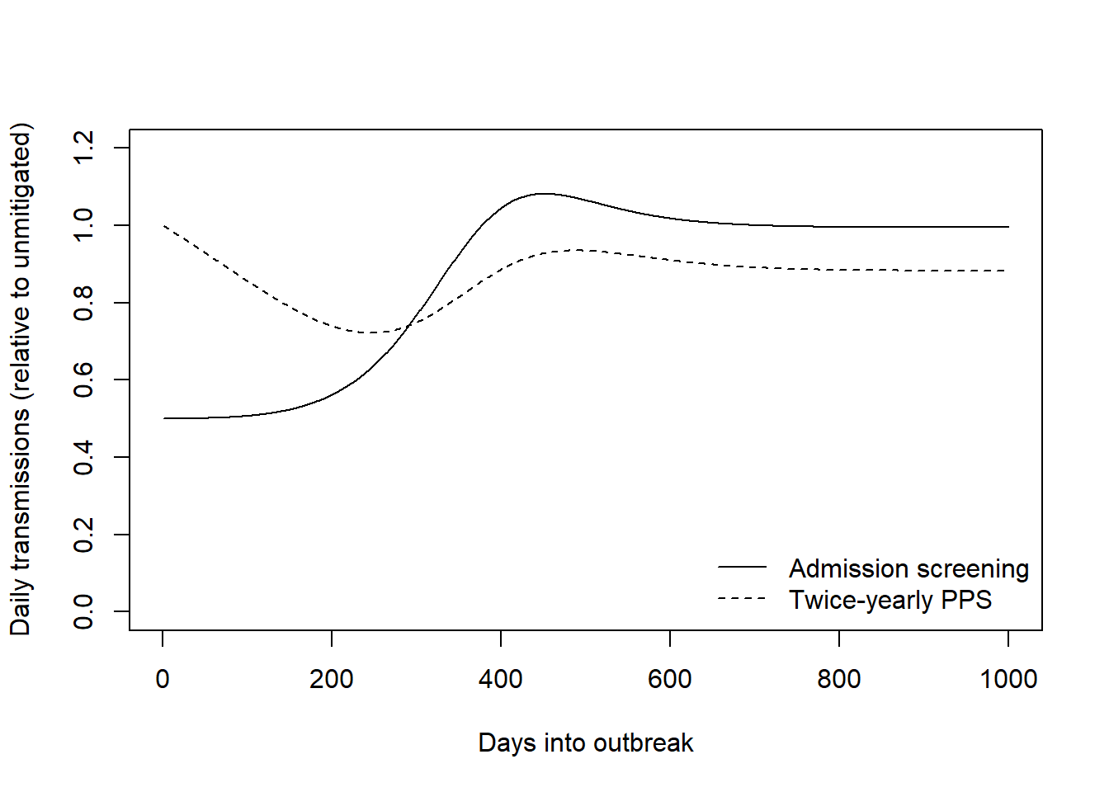
Figure A7 Admission screening and point prevalence survey effectiveness following seeding of an infectious individual at the largest ACH in the Illinois network.
Figure A8 Illinois network, all intervention scenarios
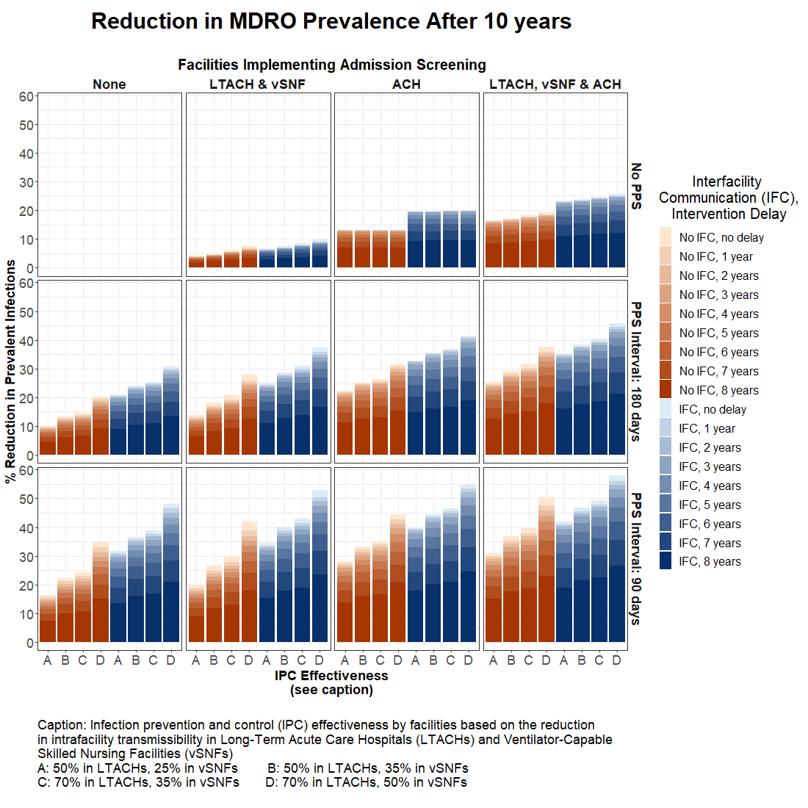

Figure A9 California (Los Angeles County and Orange County) network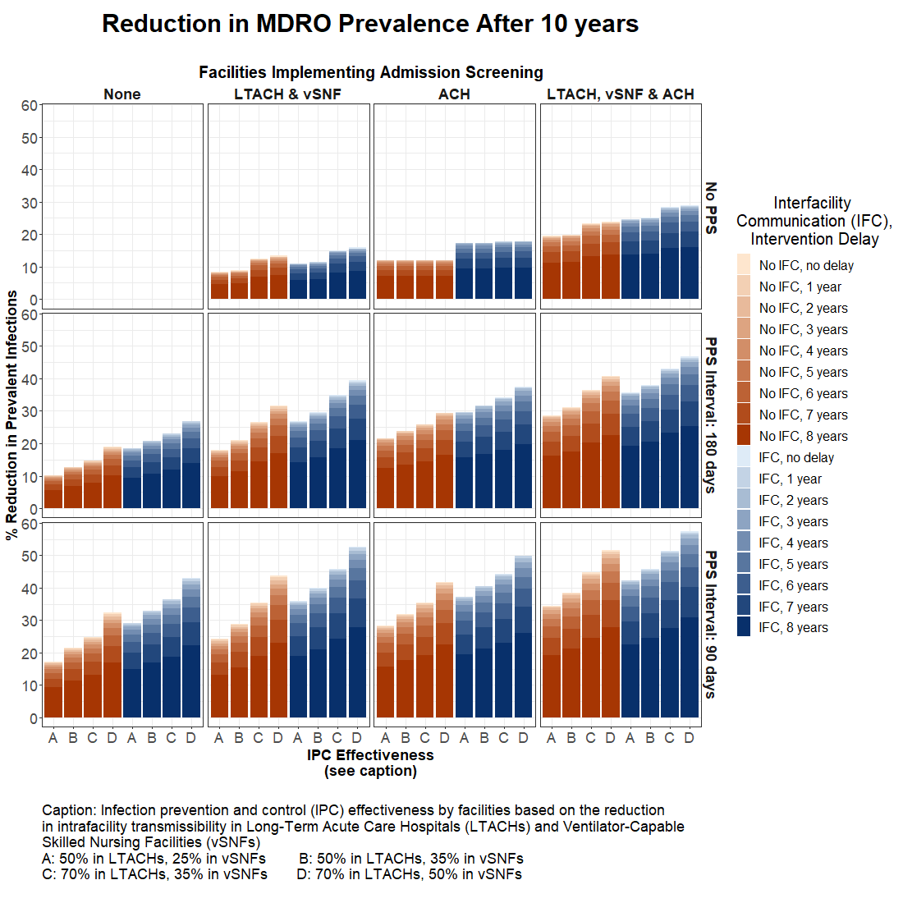
Figure A10 New Jersey network
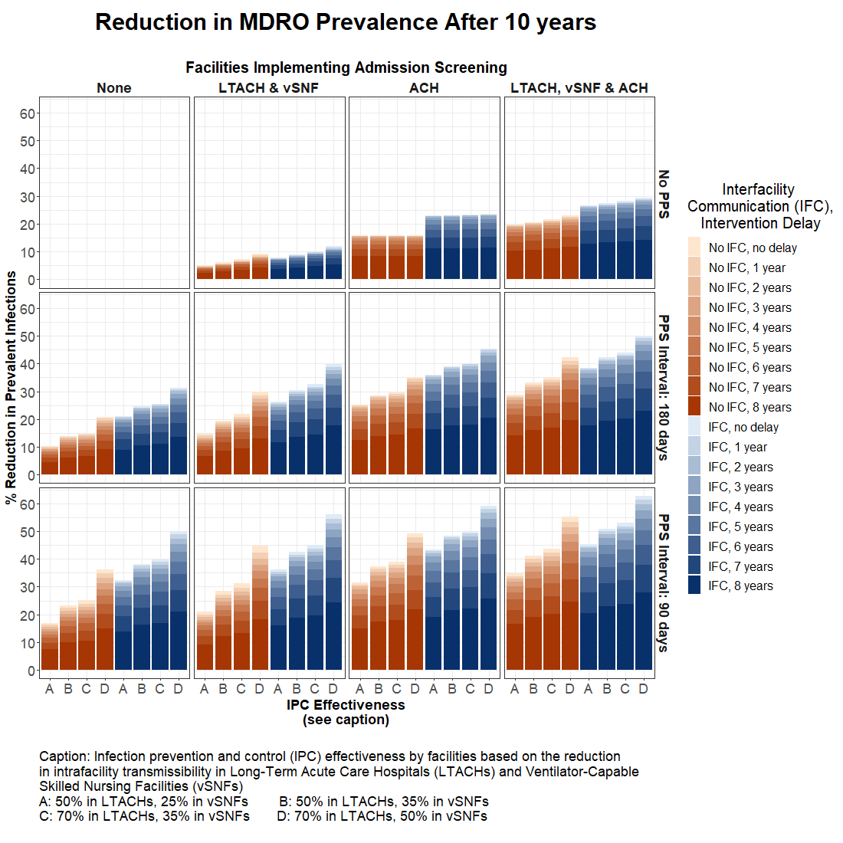

Figure A11 New York network
