Appendix A: Temporal and Geographic Availability of State-Level Platforms, 1980-2017

Figure A.1: Temporal Availability of State-Level Democratic and Republican Platforms, 1980-2017.
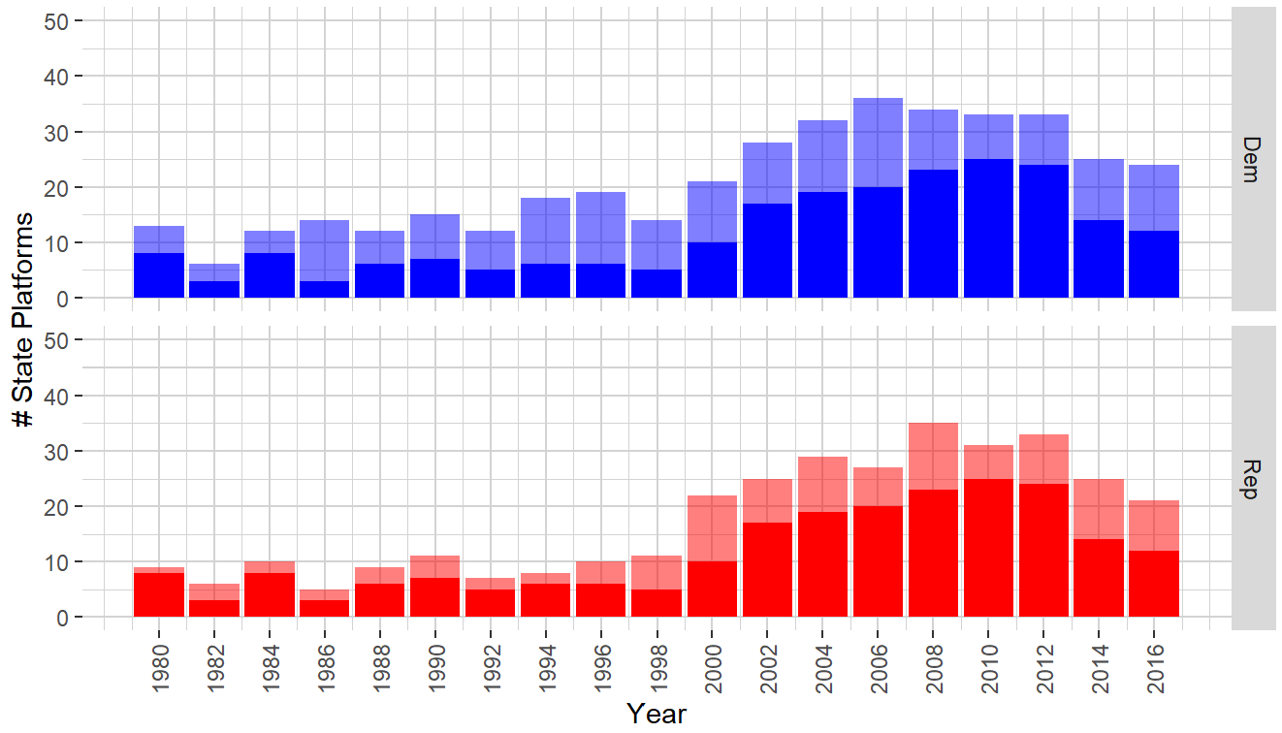
Note: Platforms released in odd years are assigned to the previous even year. Darker colors indicate the number of paired platforms and lighter colors indicate the number of additional unpaired platforms available in each year.
Figure A.2: Geographic Coverage of State-Level Democratic Platforms, 1980-2017
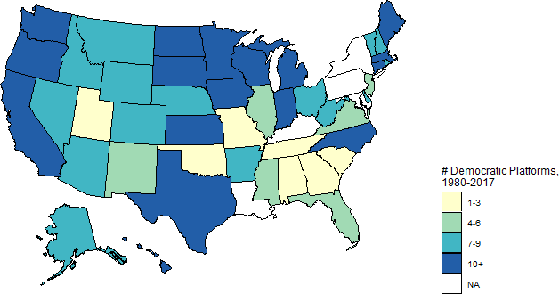
Figure A.3: Geographic Coverage of State-Level Paired and Unpaired Republican Platforms, 1980-2017
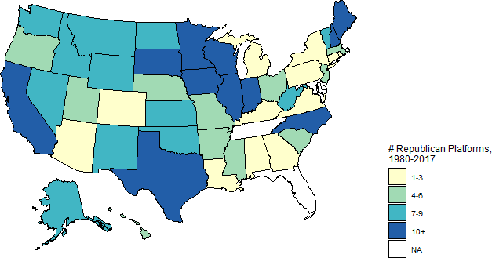

Appendix B: Comparing Analyses of Paired Platforms to Analyses of All Platforms
Figure B.1: Comparing Attention to Immigration in Paired and All State and National Democratic and Republican Platforms, 1980-2017
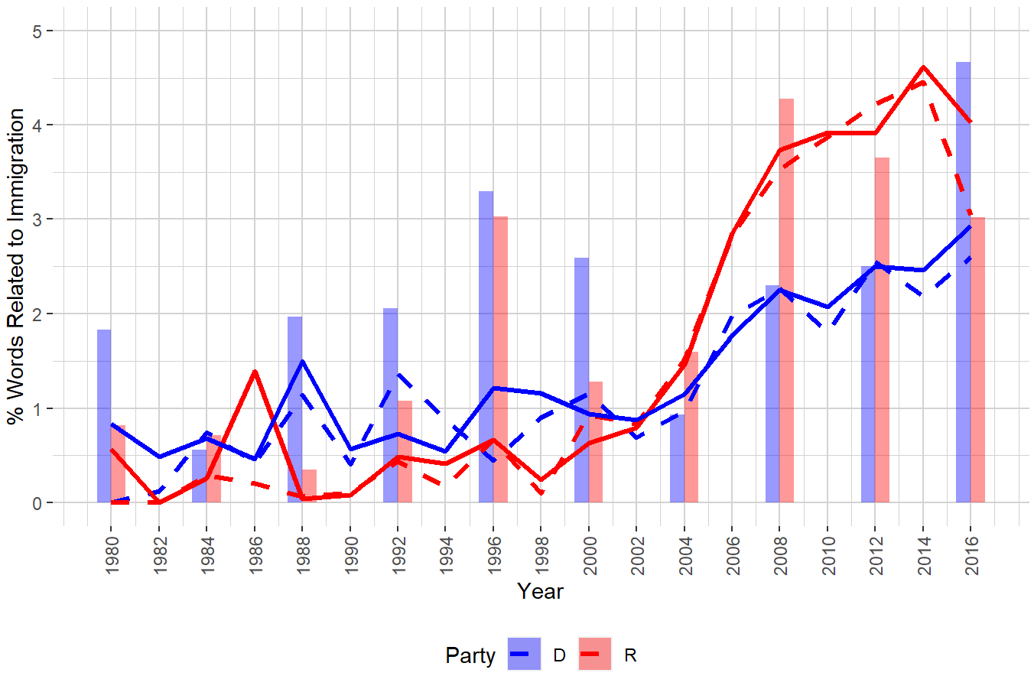
Note: Platforms released in odd years are assigned to the previous even year. Line charts track the percentage of words related to immigration in Republican and Democratic state paired platforms. Dashed lines indicate attention to immigration within paired state party platforms. Solid lines indicate attention to immigration within all state party platforms, both paired and unpaired. Clustered bar plots indicate the percentage of words related to immigration in Republican and Democratic national platforms.

Figure B.2: Comparing Inclusionary Democratic References and Restrictionist Republican References to Immigration in Paired and All State and National Platforms, 1980-2017
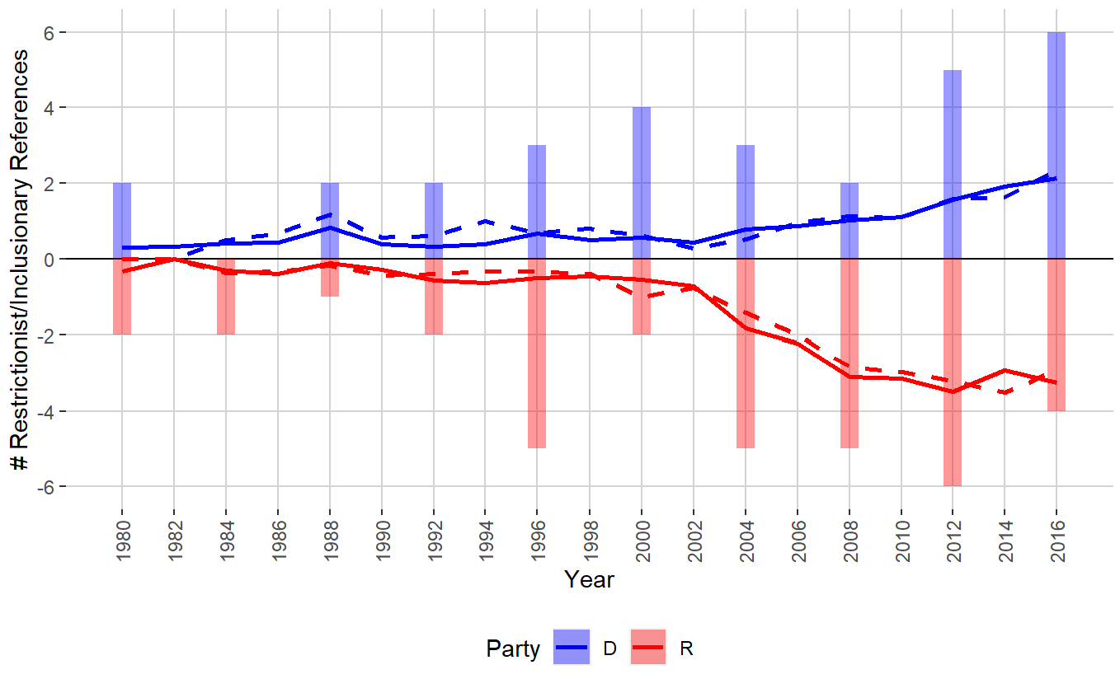
Note: Platforms released in odd years are assigned to the previous even year. Negative values indicate the number of references to restrictionism in Republican platforms and positive values indicate the number of references to inclusion in Democratic platforms. Dashed lines indicate the mean number of references within paired state platforms. Solid lines indicate the mean number of references to immigration within all state platforms. Clustered bar plots indicate the number of references to restrictionism and inclusion in Republican and Democratic national platforms, respectively.
Appendix C: Alternative Measures of Attention to Immigration and Countervailing Trends in References to Immigration

Figure C.1: Attention to Immigration in Available State Democratic and Republican Platforms, 1980-2017
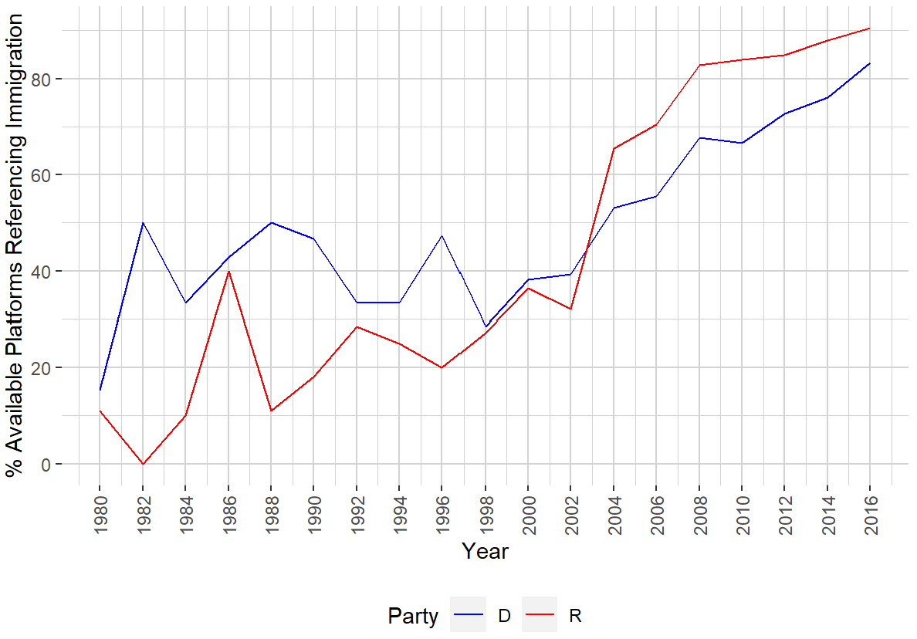
Note: Both paired and unpaired platforms are included. Platforms released in odd years are assigned to the previous even year.

Figure C.2: Comparing Restrictionist Democratic References and Inclusionary Republican References to Immigration in State and National Platforms, 1980-2017
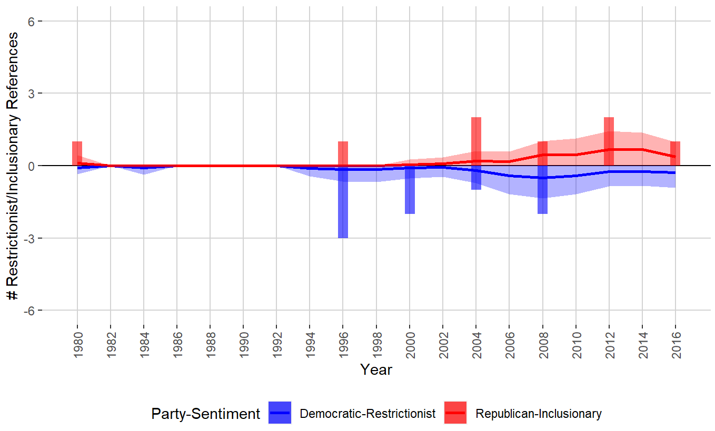
Note: Both paired and unpaired platforms are included. Platforms released in odd years are assigned to the previous even year. Negative values indicate the number of references to restrictionism in Democratic platforms and positive values indicate the number of references to inclusion in Republican platforms. Line charts track the mean number of references in Democratic and Republican state platforms to restrictionism and inclusion respectively. Ribbons indicate values within one standard deviation of this across-state mean and are truncated to have a minimum value of 0 – reflecting the support of the plotted index. Clustered bar plots indicate the number of references to restrictionism and inclusion in Democratic and Republican national platforms.

