Online-Appendix
  - Alternative Difference-in-Difference Specifications 2
  - Alternative GOP Vote Share Figures 6
  - Noninterpolated AUSAs and Commissioners 8
  - Enforcement Expenses by Category 9
  - Cruikshank Indictment 10
  - Southern Convictions, Wang’s (1997) Data 13

A Alternative Difference-in-Difference Specifications
Table A.1: Effect of the Reese Decision on GOP Vote Share in State Versus Federal Elections (1870-1890). Omitting Election Year 1872 from the Analysis.

GOP Vote Share

 | Model 1 | Model 2 | Model 3 | Full Model
 | (1) | (2) | (3) | (4)
Reese:State Election | -0.10∗ (0.05) | -0.10∗ (0.05) | -0.10∗ (0.05) | -0.10∗ (0.05)
Reese | -0.09∗∗ (0.04) | -0.09∗∗ (0.04) | -0.09∗∗ (0.04) | -0.09∗∗ (0.04)
State Election | 0.02(0.05) | 0.02(0.05) | 0.02(0.05) | 0.02(0.05)
Recession |  | 0.004(0.02) |  | 0.004(0.02)
Republican President Constant | 0.41∗∗∗ (0.04) | 0.41∗∗∗ (0.04) | 0.01(0.02)  0.41∗∗∗ (0.04) | 0.005(0.02)  0.40∗∗∗ (0.05)
Observations | 310 | 310 | 310 | 310
R2 | 0.11 | 0.11 | 0.11 | 0.11
Adjusted R2 | 0.10 | 0.10 | 0.10 | 0.10
Sig: 0.1 *; 0.05 **; 0.01 ***
Source: Inter-university Consortium for Political and Social Research. Candidate Name and Constituency Totals (Version 5). Notes: All general elections in the former-Confederacy and border states. Federal Elections include all races for Congress and the presidency. State races include races for governor. The year 1872 is dropped because of the Liberal Republican movement running Horace Greeley for president against Grant. All models use two-way fixed effects and robust standard errors.

Table A.2: Effect of the Reese Decision on GOP Vote Share in State Versus Federal Elections (1870-1890). Omitting Races for President from the Analysis.

GOP Vote Share

 | Model 1 | Model 2 | Model 3 | Full Model
 | (1) | (2) | (3) | (4)
Reese:State Election | -0.09∗ (0.05) | -0.09∗ (0.05) | -0.09∗ (0.05) | -0.09∗ (0.05)
Reese | -0.13∗∗∗ (0.03) | -0.13∗∗∗ (0.03) | -0.13∗∗∗ (0.03) | -0.13∗∗∗ (0.03)
State Election | 0.03(0.04) | 0.03(0.04) | 0.03(0.04) | 0.03(0.04)
Recession |  | -0.002(0.02) |  | -0.002(0.02)
Republican President Constant | 0.42∗∗∗ (0.03) | 0.42∗∗∗ (0.03) | 0.001(0.03)  0.42∗∗∗ (0.04) | 0.001(0.03)  0.42∗∗∗ (0.04)
Observations | 273 | 273 | 273 | 273
R2 | 0.17 | 0.17 | 0.17 | 0.17
Adjusted R2 | 0.16 | 0.15 | 0.15 | 0.15
Sig: 0.1 *; 0.05 **; 0.01 ***
Source: Inter-university Consortium for Political and Social Research. Candidate Name and Constituency Totals, 1788-1990 (Version 5). Notes: All general elections in the former-Confederacy and border states. Federal Elections include all races for Congress but not the presidency. State races include races for governor. All models use two-way fixed effects and robust standard errors.

Table A.3: Effect of the Reese Decision on GOP Vote Share in State Versus Federal Elections (1870-1890). Omitting Border States from the Analysis.

GOP Vote Share

 | Model 1 | Model 2 | Model 3 | Full Model
 | (1) | (2) | (3) | (4)
Reese:State Election | -0.08(0.05) | -0.08∗ (0.05) | -0.08(0.05) | -0.08∗ (0.05)
Reese | -0.16∗∗∗ (0.03) | -0.15∗∗∗ (0.03) | -0.16∗∗∗ (0.03) | -0.15∗∗∗ (0.03)
State Election | -0.01(0.04) | -0.01(0.04) | -0.01(0.04) | -0.01(0.04)
Recession |  | -0.02(0.02) |  | -0.02(0.02)
Republican President Constant | 0.47∗∗∗ (0.03) | 0.47∗∗∗ (0.03) | 0.02(0.03)  0.45∗∗∗ (0.04) | 0.02(0.03)  0.46∗∗∗ (0.04)
Observations | 261 | 261 | 261 | 261
R2 | 0.24 | 0.24 | 0.24 | 0.24
Adjusted R2 | 0.23 | 0.23 | 0.23 | 0.22
Sig: 0.1 *; 0.05 **; 0.01 ***
Source: Inter-university Consortium for Political and Social Research. Candidate Name and Constituency Totals, 1788-1990 (Version 5). Notes: All general elections in the former-Confederacy, omitting border states (and omitting West Virginia). Federal Elections include all races for Congress and the presidency. State races include races for governor. All models use two-way fixed effects and robust standard errors.

Table A.4: Effect of the Reese Decision on GOP Vote Share in State Versus Federal Elections (1870-1890). Excluding West Virginia in the Analysis.

GOP Vote-Share

 | Model 1 | Model 2 | Model 3 | Full Model
 | (1) | (2) | (3) | (4)
Reese:State Election | -0.09∗∗ (0.04) | -0.09∗∗ (0.04) | -0.09∗∗ (0.04) | -0.09∗∗ (0.04)
Reese | -0.12∗∗∗ (0.03) | -0.12∗∗∗ (0.03) | -0.12∗∗∗ (0.03) | -0.12∗∗∗ (0.03)
State Election | 0.01(0.03) | 0.01(0.03) | 0.01(0.03) | 0.01(0.03)
Recession | - | -0.01(0.02) | - | -0.01(0.02)
Republican President | - | - | 0.01(0.02) | 0.01(0.02)
Constant | 0.44∗∗∗ (0.02) | 0.45∗∗∗ (0.02) | 0.44∗∗∗ (0.03) | 0.44∗∗∗ (0.03)
Observations | 348 | 348 | 348 | 348
R2 | 0.18 | 0.18 | 0.18 | 0.18
Adjusted R2 | 0.17 | 0.17 | 0.17 | 0.16
Sig: 0.1 *; 0.05 **; 0.01 ***
Source: Inter-university Consortium for Political and Social Research. Candidate Name and Constituency Totals, 1788-1990 (Version 5). Notes: All general elections in the former-Confederacy and border states, excluding West Virginia. West Virginia separated from the State of Virginia during the Civil War and gained statehood in June of 1863. Federal Elections include all races for Congress and the presidency. State races include races for governor. All models use two-way fixed effects and robust standard errors.

B Alternative GOP Vote Share Figures
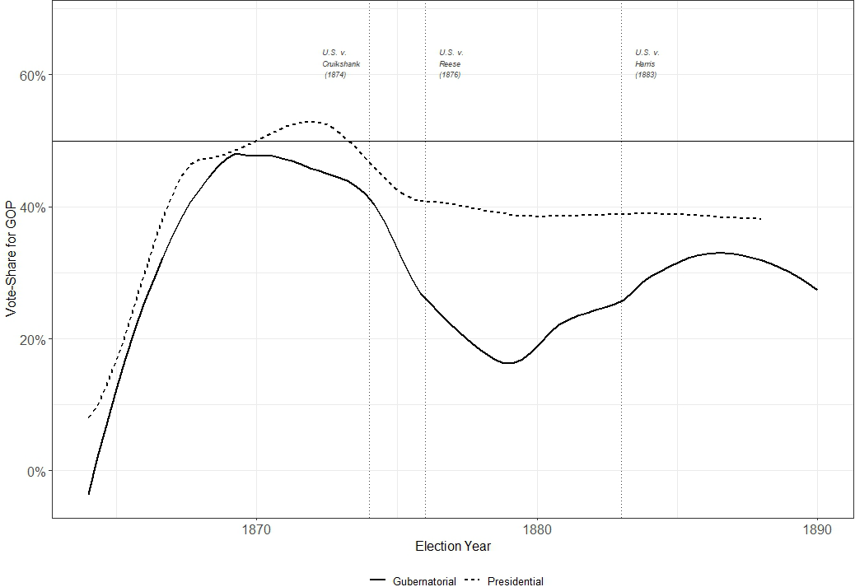
Figure B.1: Average GOP Vote Share in Southern Elections 1870-1890. Span = 0.5
Source: Inter-university Consortium for Political and Social Research. Candidate Name and Constituency Totals, 1788-1990 (Version 5). Notes: All general elections in the former-Confederacy and border states. Federal elections include all races for Congress and the presidency. State elections include races for governor. Lines represent localized moving averages with spans of 0.5.

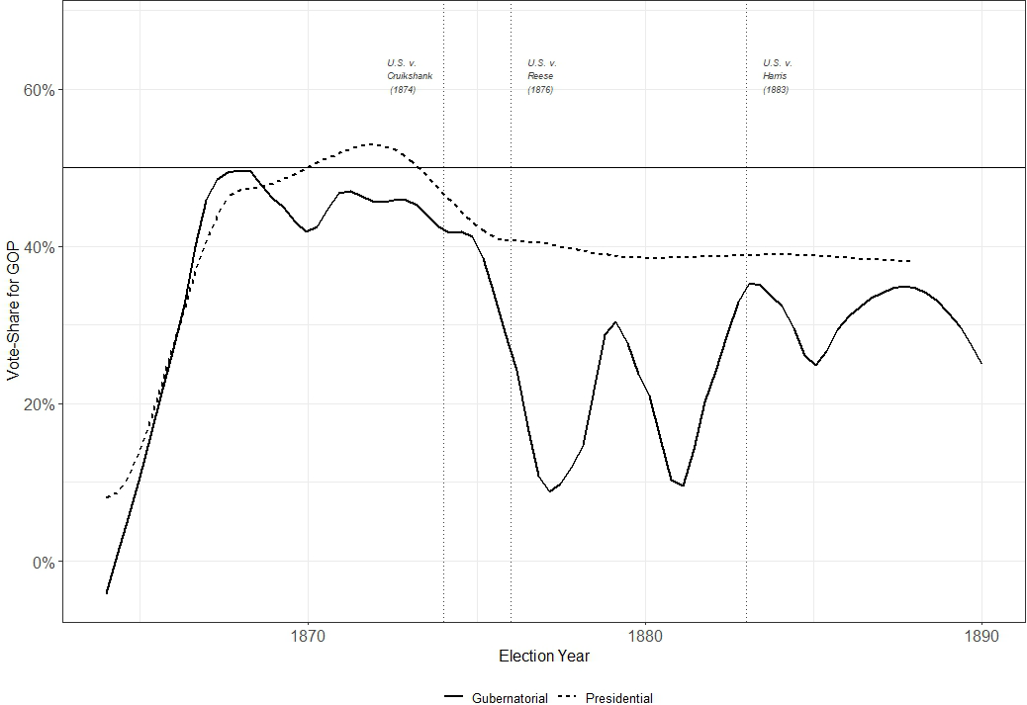
Figure B.2: Average GOP Vote Share in Southern Elections 1870-1890. Span = 0.285
Source: Inter-university Consortium for Political and Social Research. Candidate Name and Constituency Totals, 1788-1990 (Version 5). Notes: All general elections in the former-Confederacy and border states. Federal elections include all races for Congress and the presidency. State elections include races for governor. Lines represent localized moving averages with spans of 0.285.

C Non-interpolated AUSAs and Commissioners
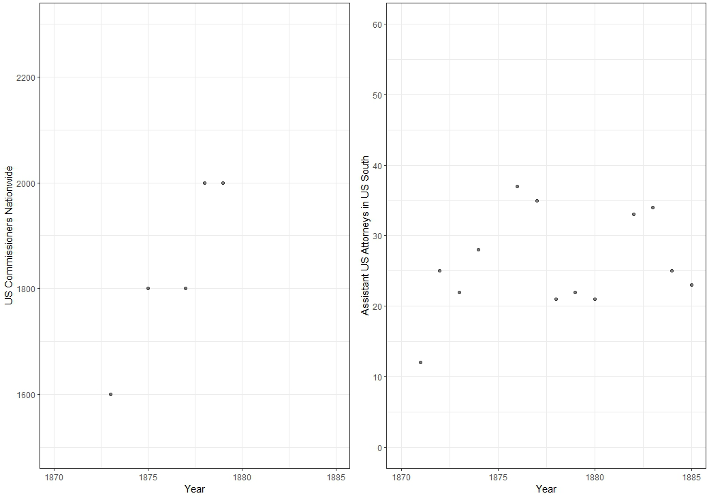
Figure C.3: Non-interpolated Count, Southern AUSAs and US Commissioners (1870-1885). Source: Annual Report[s], House Comm. on App., Department of Justice Register 1871. Notes: Southern States include the former-Confederacy and Border States - this regional restriction is only possible for ASUAs, commissioner data is reported nationally. Data on commissioners from Annual Reports of the AG. Data on AUSAs from Annual Reports, except for 1871, when the data come from the DOJ Register. AUSAs include “regular assistants” and “special assistants” with assignments discernibly related to enforcement (i.e., “special assistant for enforcement,” “special assistant for elections cases,” “special assistant for Ellenton Riots,” etc.).

D Enforcement Expenses by Category
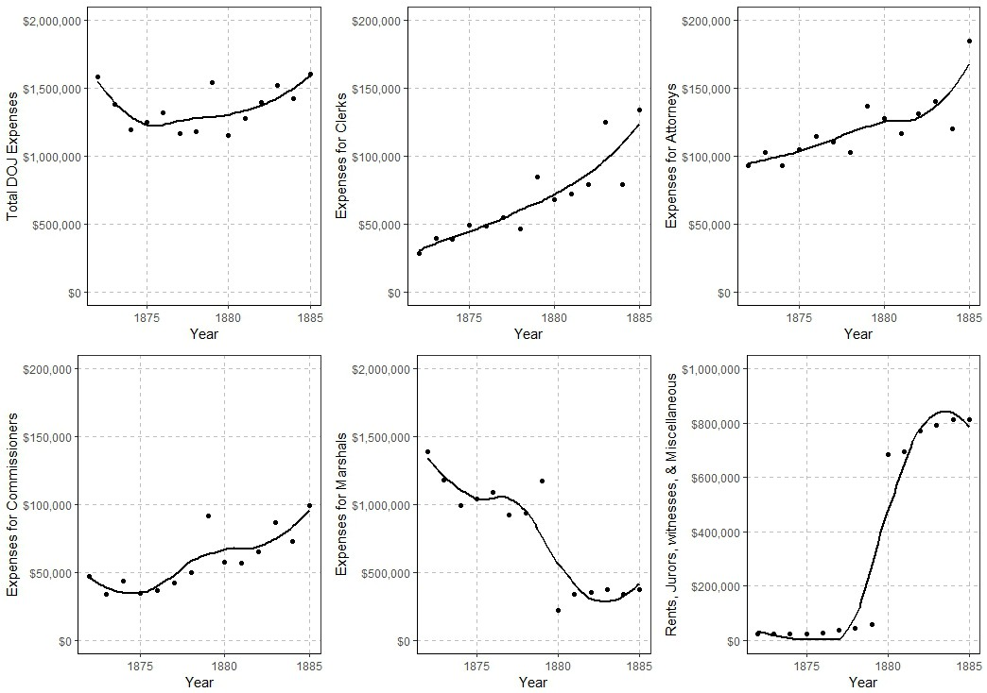
Figure D.1: DOJ Expenses by Category. US South (1870-1885).
Source: Annual Report[s]. Notes: Southern states include ex-Confederacy and Border States. After 1880, expenses previously registered under marshals are counted under miscellaneous, particularly as juror and witness expenses. Continuities in funding before and after this re-characterization are evident in the total DOJ expenses.

E Cruikshank Indictment
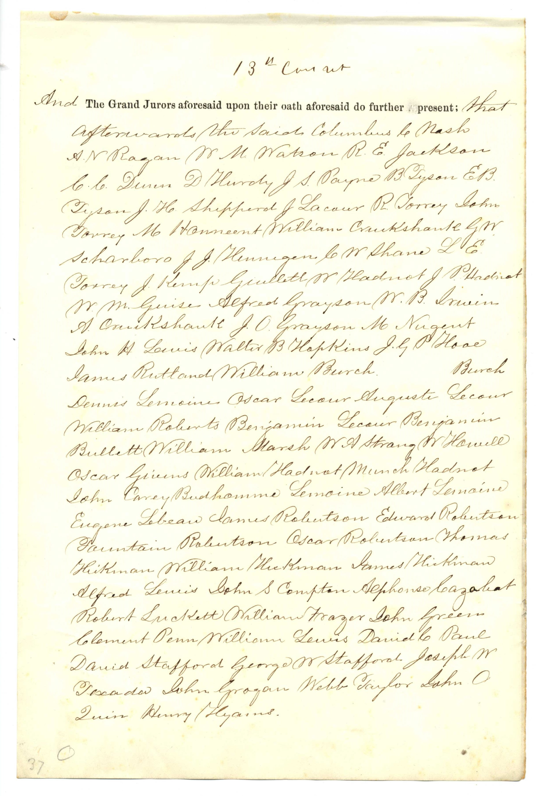

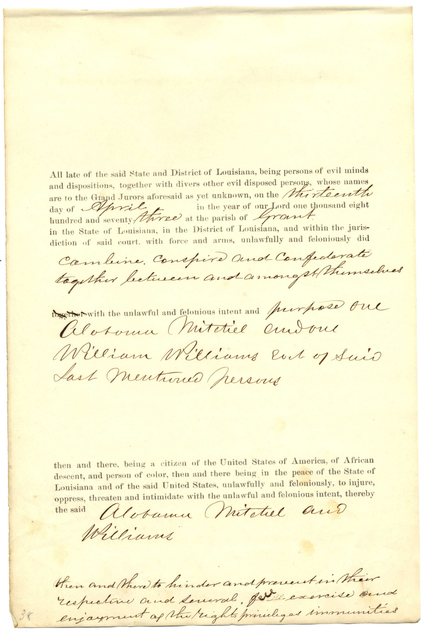

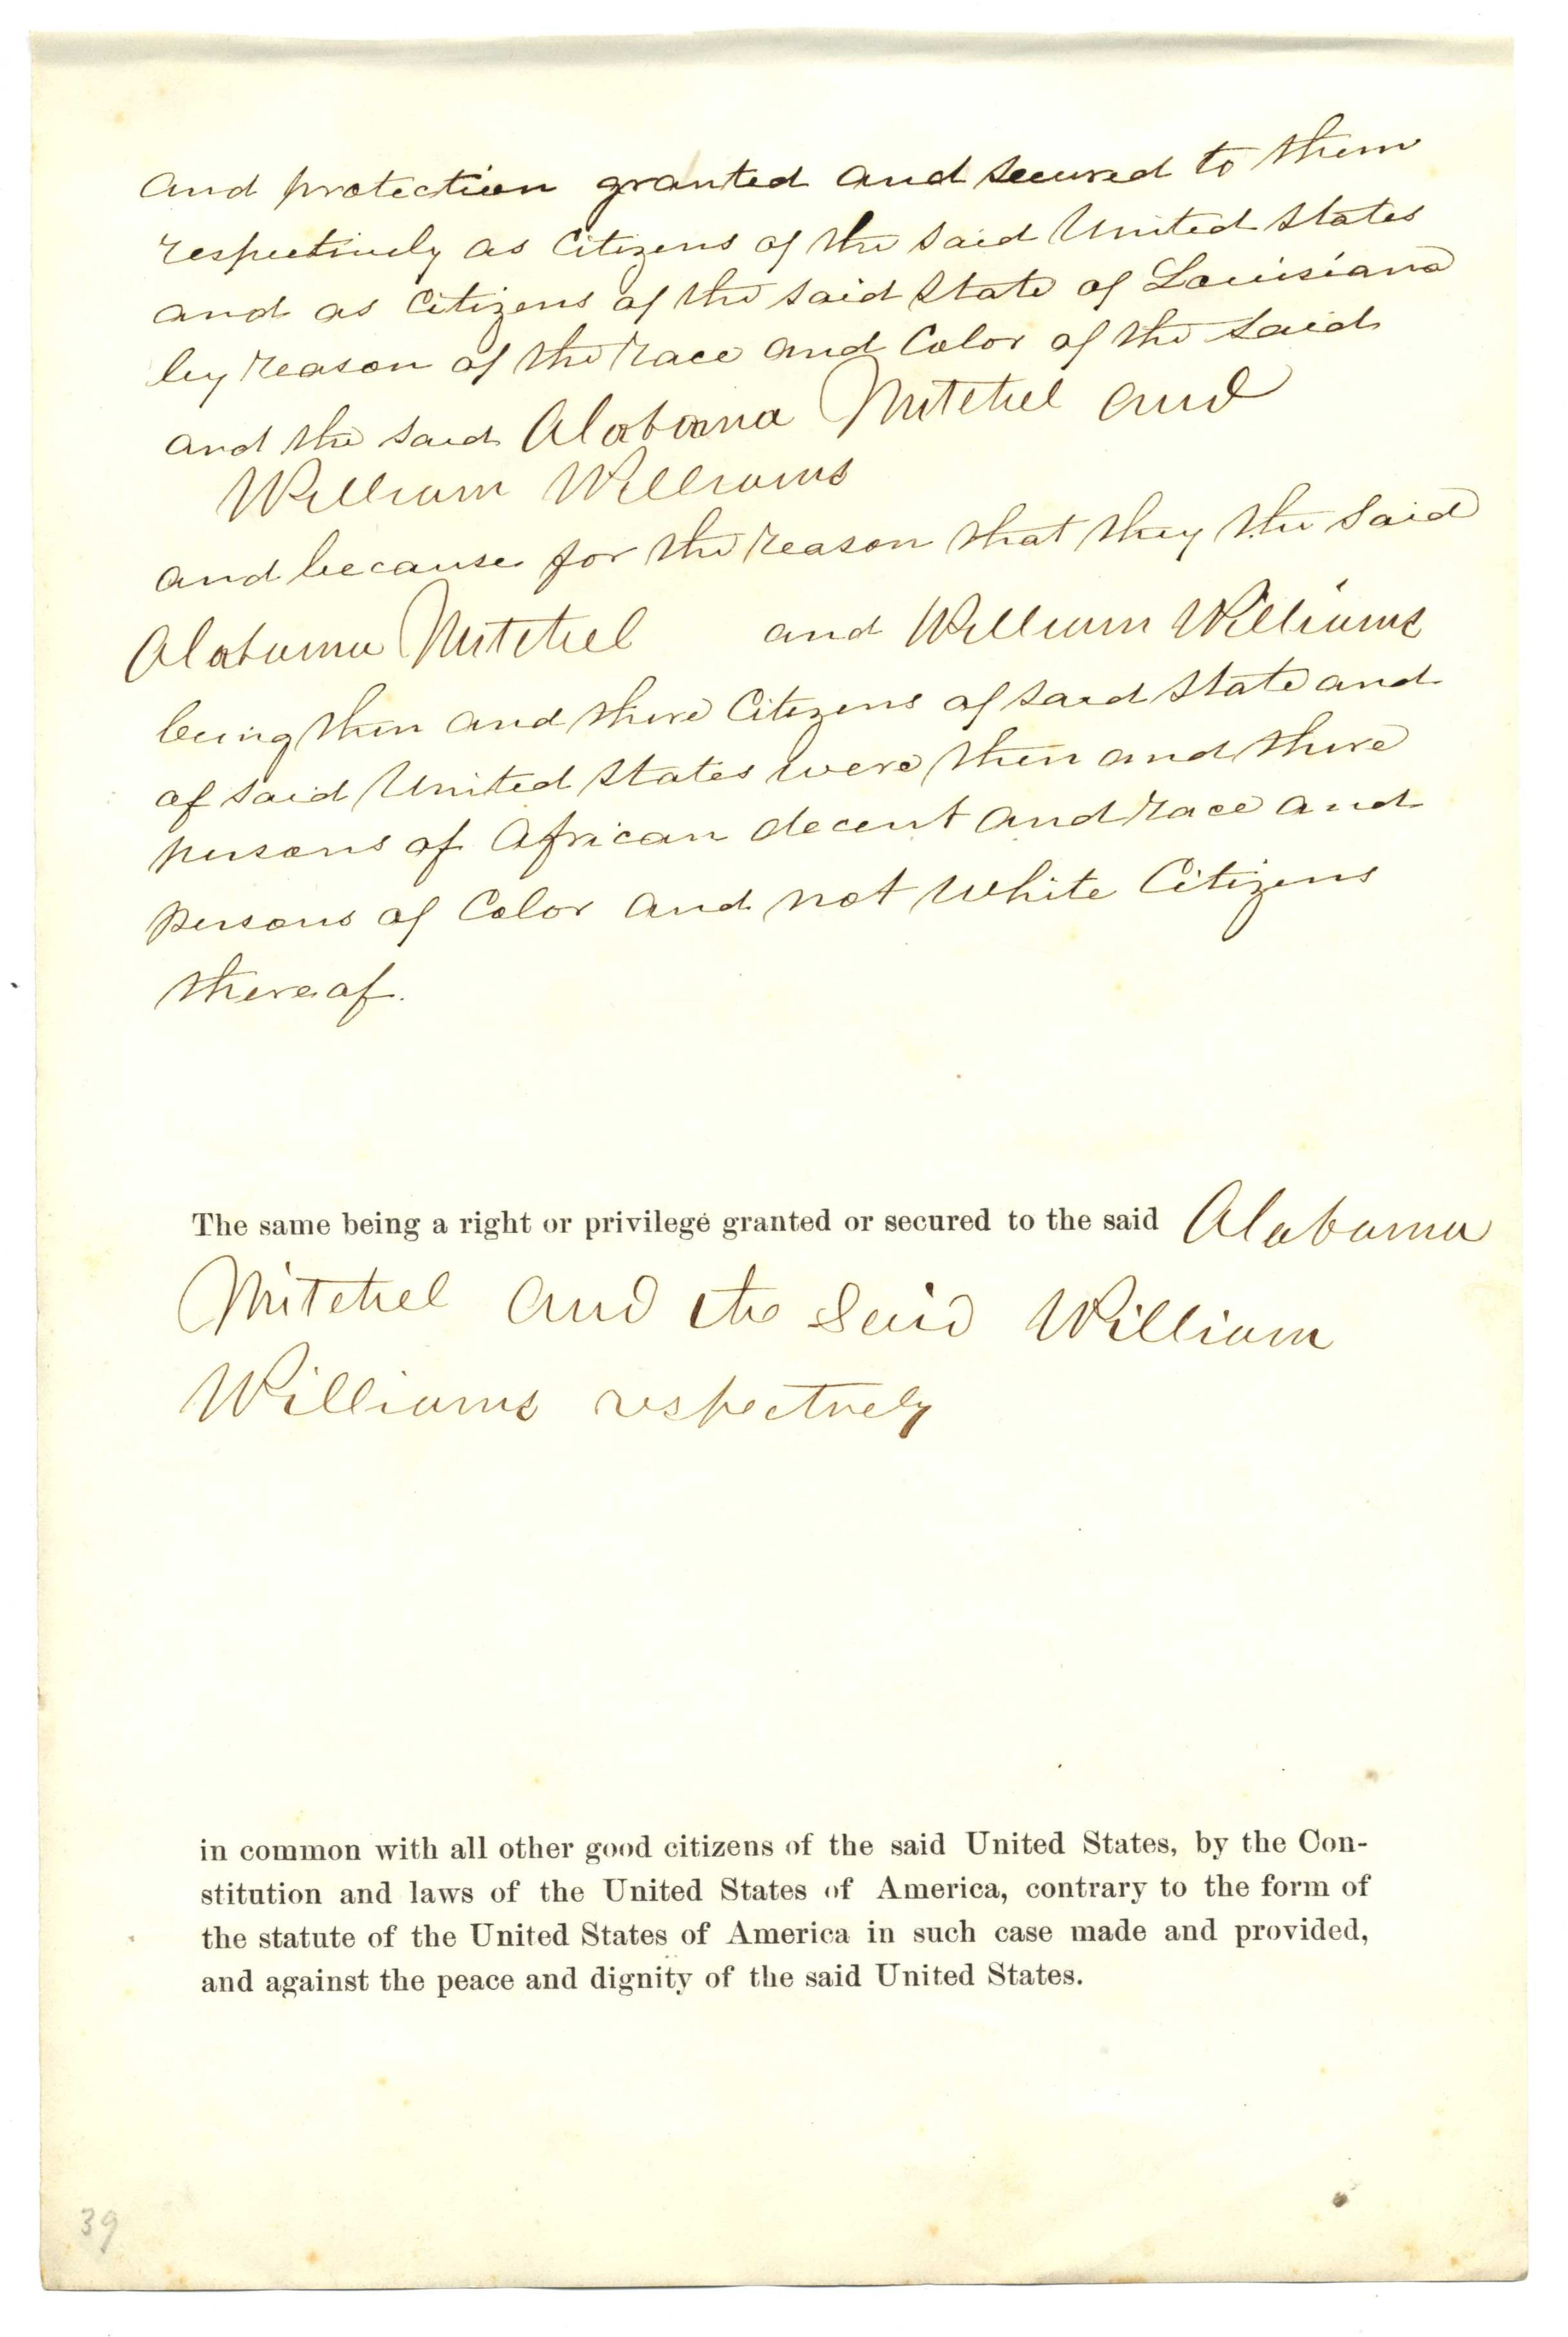

F Southern Convictions, Wang’s (1997) Data
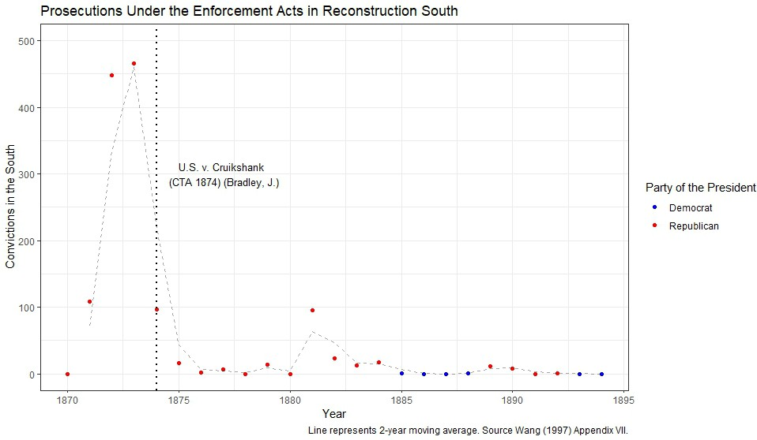
Figure F.1: Southern Convictions under the Enforcement Act (Wang’s Data).
Source: Wang, Trial of Democracy, 300. Notes: Wang uses a different set of states as “South.” He includes only the states of Alabama, Arkansas, Florida, Georgia, Louisiana, Mississippi, North Carolina, South Carolina, Texas, and Virginia. In either categorization, our results are largely similar.

