Appendix
Table A1. Interactions analysis (logistic model): Little Rock Traffic Court and Pulaski County District Court

Court | Little Rock | Little Rock | Pulaski County | Pulaski County
(Intercept) | –0.58*** | –0.78*** | –1.72*** | –1.57***
 | (0.08) | (0.16) | (0.15) | (0.19)
Remote proceeding | –0.12* | 0.13 | 0.21* | –0.16
 | (0.05) | (0.17) | (0.09) | (0.28)
Race: white vs. others | 0.41*** | 0.69*** | 0.04 | –0.10
 | (0.05) | (0.11) | (0.09) | (0.13)
Age | 0.01*** | 0.01 | -0.00 | –0.01*
 | (0.00) | (0.00) | (0.00) | (0.01)
Gender: male vs. female | –0.26*** | 0.04 | 0.09 | 0.35**
 | (0.04) | (0.10) | (0.09) | (0.13)
Remote* race |  | –0.36** |  | 0.32
 |  | (0.12) |  | (0.19)
Remote* age |  | 0.00 |  | 0.02**
 |  | (0.00) |  | (0.01)
Remote* gender |  | –0.38*** |  | –0.58**
 |  | (0.11) |  | (0.18)
AIC | 12,154.80 | 12,138.50 | 3,567.90 | 3,554.42
BIC | 12,190.41 | 12,195.47 | 3,599.47 | 3,604.93
Log likelihood | –6072.40 | –6,061.25 | –1,778.95 | –1,769.21
Deviance | 12,144.80 | 12,122.50 | 3,557.90 | 3,538.42
Number of observations | 9,144 | 9,144 | 4,083 | 4,083
Notes: ***p < 0.001; **p < 0.01; *p < 0.05. Results of a logistic model. Dependent variable is whether the charge was dismissed. Coefficients are in log-odds. Standard errors in parenthesis. Ordinary least square regression yields similar results. The Little Rock sample includes all charges from January 1, 2020, to October 10, 2020, when physical hearings resumed. The Pulaski County sample includes all charges from January 1, 2020, to March 30, 2021, when physical hearings resumed.

Table A2. Demographic profile of defendants in Little Rock Traffic Court and Pulaski County District Court

 | Little Rock Traffic Court |  |  | Pulaski County District Court
 | Pre-COVID-19 | Post-COVID-19 | Difference (%) | Pre-COVID-19 | Post-COVID-19 | Difference (%)
Senior (> 60 years) | 47/647  (7%) | 92/1799  (5%) | 1.90 | 42/961  (4.2%) | 29/758  (3.7%) | 0.50
Female | 311/567  (45%) | 826/1462  (43%) | 1.60 | 352/844 (41.7%) | 242/644 (37.6%) | 0.40
non-white | 456/627  (72.7%) | 440/1614  (72.7%) | 0 | 651/928  (70%) | 478/708 (67.5%) | 2.60
Attorney | 11/670  (1.6%) | 49/1756  (2.7%) | 1.10 | 8/1020  (1%) | 38/772  (5%) | 3.9***

Notes: Stars indicate the p-value of the difference in proportions test. If a p-value is less than 0.05, it is flagged with one asterisk (*). If a p-value is less than 0.01, it is flagged with two asterisks (**). If a p-value is less than 0.001, it is flagged with three asterisks (***). The sample includes all cases from January 1, 2020, to October 10, 2020. All demographic variables were not available for all cases.

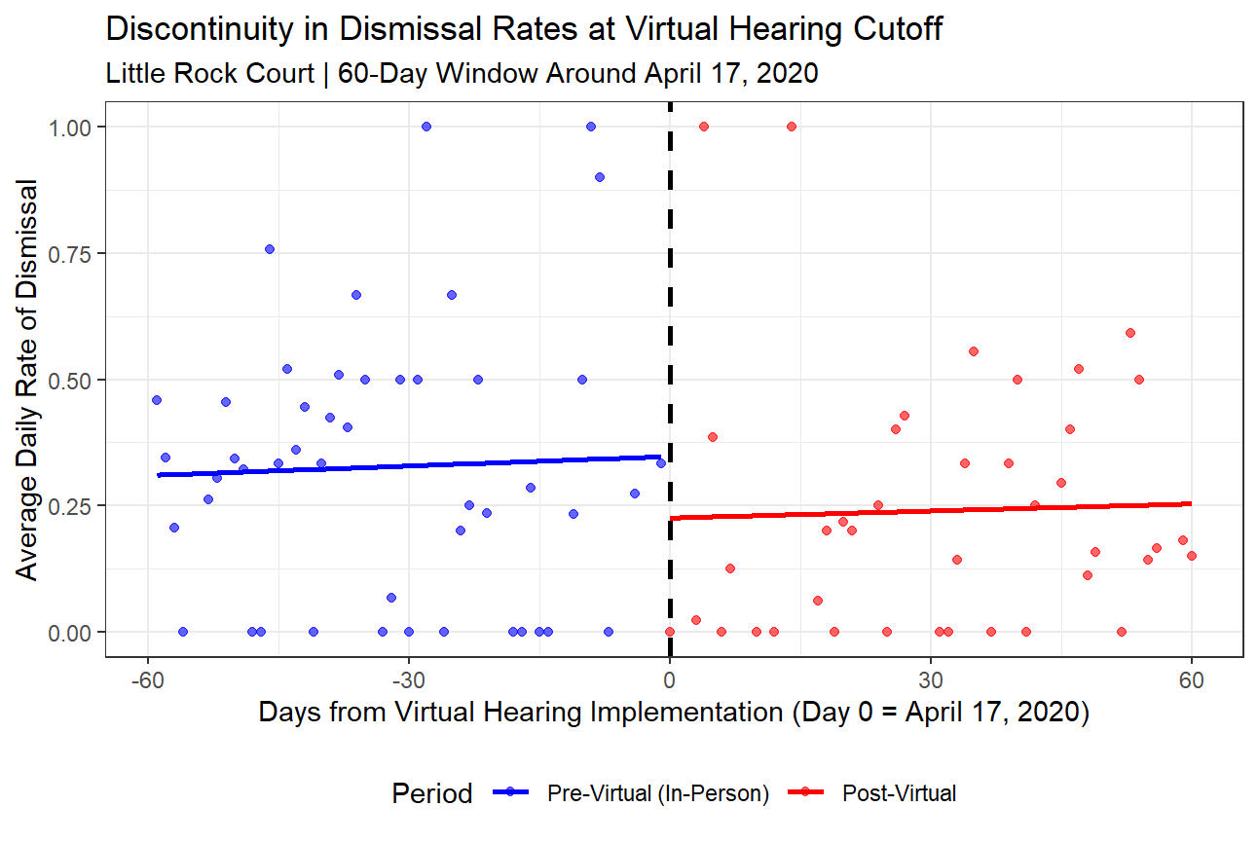
Figure A1. Discontinuity in average daily dismissal rates at virtual hearing cutoff. The figure displays the results of an analysis for the Little Rock Traffic Court, focusing on a 120-day window around the April 17, 2020, implementation of fully remote hearings. The analysis is restricted to cases where the offense occurred before the pandemic to ensure a homogenous sample. Each point represents the average dismissal rate for a single day. The solid lines are linear regression models fit separately to the daily averages on each side of the cutoff. The sharp drop between the two regression lines at the cutoff (Day 0) indicates a significant negative effect of the switch to virtual hearings on dismissal rates.

Table A3. Regression model of case dismissal at the virtual hearing cutoff
Independent variables | Model
(Intercept) | –0.08
 | (0.14)
Days from cutoff | 0.01*
 | (0.00)
Treatment | –1.06***
 | (0.26)
AIC | 2,712.69
BIC | 2,729.60
Number of observations | 2,070
Notes: ***p < 0.001; **p < 0.01; *p < 0.05. Results from a logistic regression model predicting the likelihood of a case being dismissed. The dependent variable is whether the charge is dismissed. The key variable—treatment—is a dummy variable equal to 1 for hearings on or after the cutoff date. Days from cutoff controls for a linear time trend. Coefficients are presented as log-odds with standard errors in parentheses.

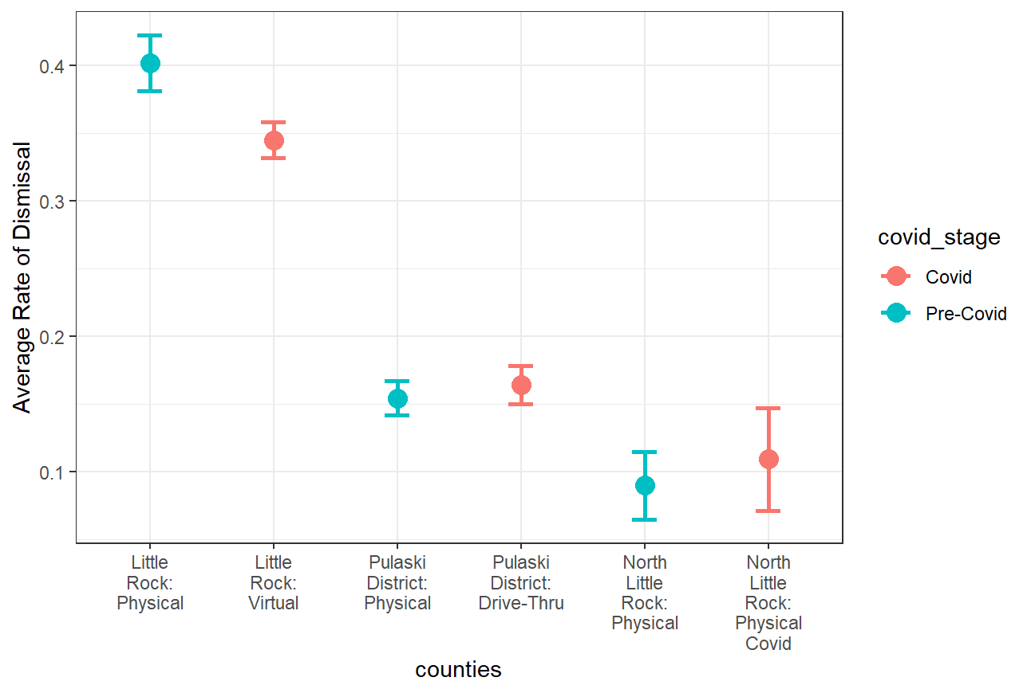
Figure A2. DiD analysis (linear probability model), Pulaski County District Court
.

Table A4. DiD analysis (linear probability model), Pulaski County (varying periods)
Period | Until end of drive-thru hearings | Until end of drive-thru hearings without June cases in NLR | Until end of emergency measures | Until end of emergency measures without June cases in NLR
(Intercept) | 0.09*** | 0.09*** | 0.09*** | 0.09***
 | (0.02) | (0.02) | (0.02) | (0.02)
Remote proceeding | 0.10*** | 0.02 | 0.52*** | 0.52***
 | (0.02) | (0.03) | (0.02) | (0.02)
Little Rock Traffic Court | 0.31*** | 0.31*** | 0.31*** | 0.31***
 | (0.02) | (0.02) | (0.02) | (0.02)
Pulaski County District Court | 0.06** | 0.06** | 0.06** | 0.06**
 | (0.02) | (0.02) | (0.02) | (0.02)
Remote* Little Rock Traffic Court (DiD 1) | –0.16*** | –0.08* | –0.56*** | –0.56***
 | (0.02) | (0.03) | (0.02) | (0.02)
Remote* Pulaski County District Court (DiD 2) | –0.09*** | –0.01 | –0.48*** | –0.48***
 | (0.02) | (0.03) | (0.02) | (0.02)
R2 | 0.06 | 0.06 | 0.12 | 0.12
Adj. R2 | 0.06 | 0.06 | 0.12 | 0.12
Number of observations | 13,612 | 13,525 | 38,104 | 38,011
Notes: ***p < 0.001; **p < 0.01; *p < 0.05. Results of a linear probability regression model through ordinary least squares. Dependent variable is whether charge was dismissed. The reference category for the courts is North Little Rock District Court. Standard errors in parenthesis. Logistic regression yields similar results. The sample for the period “until the end of drive-thru hearings” includes all cases from January 1, 2020, to October 10, 2020. The sample for the period “until the end of emergency measures” includes all cases from January 1, 2020, to June 9, 2021.

Table A5. Interactions analysis for Orange County

Independent variables | Orange County
(Intercept) | 0.1338***
 | (0.00)
Remote proceeding | –0.0665***
 | (0.00)
Age | –0.0004***
 | (0.00)
Race: white vs. others | 0.0422***
 | (0.00)
Gender: male vs. female | 0.0402***
 | (0.00)
Remote* race | 0.0144***
 | (0.00)
Remote* age | 0.0008*
 | (0.00)
Remote* gender | 0.0024
 | (0.00)
R² | 0.011
Adj. R² | 0.011
Number of observations | 297,604
Notes: ***p < 0.001; **p < 0.01; *p < 0.05. Results of a linear probability regression model through ordinary least squares. Dependent variable is whether charge was dismissed. Standard errors in parenthesis. Logistic regression yields similar results.

