**ONLINE APPENDIX**

**Electoral Pressure, Reputational Risks, and Coalition Politics: How Established Parties Respond to The Rise of Anti-Immigrant Parties**

**Ezgi Elçi Deniz Sert Evren Balta**

**Özyeğin University**

**Table A1: Holistic grading rubric**

|  |  |
| --- | --- |
| **ANTI-IMMIGRATION** | **PRO-IMMIGRATION** |
| Anti-immigration: opposed to immigrants or immigration; characterized by or expressing opposition to or hostility toward immigrants (Merriam-Webster). | Multiculturalism: cultural pluralism or diversity; a multicultural social state or a doctrine or policy that promotes or advocates such a state (Merriam-Webster). |
| **Restricting Immigration**  The speaker openly supports restricting immigration and/or return migration. They see it as the only way to end immigration. Support for restricting migration is a significant dimension of anti-immigration because it is necessary to protect the essential characteristics of the host nation. | **Open-border policies – Integration of migrants**  The speaker openly supports open-border policies and/or the integration of immigrants.  Support for open-border policies can be framed as a moral duty of humans to protect their brothers/sisters. Integration of immigrants can enrich the cultural diversity of the host country. |
| **Anti-immigration frames**  **1) Cultural and religious frame**  Immigrants are portrayed as a threat to Turkey’s cultural homogeneity.  According to this view, immigrants threaten long-term, established traditions, values, and institutional arrangements that delineate a specific community, its culture, and identity.  Immigrants’ culture and identity are incompatible with the host community.  **2) Security frame**  Immigrants are portrayed as a threat to security, responsible for petty crime and/or terrorism.  According to the security frame, immigrants increase crime rates and commit crimes more than the host population, and those crimes could be prevented if they were not allowed in the country. Some immigrants are also linked to terrorism or terrorist activities.  **3) Economic frame**  Immigrants are depicted as an economic and financial burden for Turkey. They take jobs away from native citizens and exploit social benefits.  The economic frame has two dimensions. The first one is related to the job market. According to this view, immigrants take jobs away from native-born workers and increase labor market competition, given that immigration suppresses the wages of those workers most exposed to competition from migrant labor. The second one is welfare chauvinism. For welfare chauvinists, immigrants (especially the low-skilled ones) pay lower or no taxes while receiving more social benefits and/or services than the natives. In turn, immigrants drain the welfare state.  **4) Political frame**  Immigrants are depicted as the tools of sinister political forces.  According to the political frame, politicians allow immigrants into the country to strengthen their opposition at the expense of native people. From this perspective, immigrants become the minions of the ruling elites. | **Pro-immigration frames**  Immigrants are portrayed as the cultural richness of a country. For Turkey. the coreligiosity of Syrians is also a positive characteristic regarding their integration into Turkish culture and traditions. The immigrants’ culture and identity are compatible with the host community.  Immigrants are not framed as a threat to security. Instead, they are the victims of domestic racist and xenophobic attacks or the oppressive regime in Syria.  Immigrants are not portrayed as an economic threat or financial burden. Instead, their entrance into the job market generated new job opportunities. They are also beneficial, especially to the local economy. Turkey receives international aid thanks to the immigrants.  Immigrants are not the minions of politicians. Instead, politicians help them to survive in the host country. |
| **Us-versus-them rhetoric**  The speaker depicts the native population and immigrants as two separate homogeneous groups.  The speaker frames this dichotomy as a struggle, fight, or conflict between two homogeneous groups. | The speaker does not evaluate local and immigrant populations as homogeneous groups. They accept their differences.  The speaker claims there is a false dichotomy in that there is no struggle, fight, or conflict between two groups. |
| **Please grade the speech based on the rubric.**  2 A speech in this category is extremely anti-immigrant and comes very close to the ideal anti-immigrant discourse. Specifically, the speech carries all or nearly all elements of the ideal anti-immigrant discourse with few elements that could be considered pro-immigrant.  1 A speech in this category includes strong, clearly anti-immigrant themes but either does not use them consistently or softens them by including pro-immigrant elements. Thus, a speech may cover the frames of anti-immigration but supports the right of refugees to live in humane conditions and/or does not make an us-versus-them distinction between the native and refugee populations.  0 A speech in this category uses few if any anti-immigrant elements. It also predominantly carries pro-immigrant elements.   |  |  |  |  |  |  |  |  |  | | --- | --- | --- | --- | --- | --- | --- | --- | --- | | 0 – Extremely pro-immigrant | 0.1 | … | 0.9 | 1 | 1.1 | … | 1.9 | 2 – Extremely anti-immigrant | | |

**Table A2: Information about the political parties contesting the 2023 elections (Data: The Supreme Election Council of Turkey)**

|  |  |  |  |  |
| --- | --- | --- | --- | --- |
| **Party** | **Alliance Name** | **Leaders** | **Vote share** | **Party position / Ideology** |
| **AKP** | **People’s Alliance**  **(*Cumhur İttifakı*)** | Recep Tayyip Erdoğan | 35.6% | Right-wing / Islamism |
| **MHP** | Devlet Bahçeli | 10.1% | Right-wing / Turkish nationalism |
| **CHP** | **Nation Alliance**  **(*Millet İttifakı*)** | Kemal Kılıçdaroğlu | 25.4% | Center-left / Social democracy |
| **İYİP** | Meral Akşener | 9.7% | Center-right / Turkish nationalism |
| **HDP** | **Labor and Freedom Alliance (*Emek ve Özgürlük İttifakı*)** | Pervin Buldan and Mithat Sancar | 8.8% | Left / Kurdish nationalism |
| **ZP** | **Ancestry Alliance (*Ata İttifakı*)** | Ümit Özdağ | 2.2% | Far right / Anti-immigrant / Turkish nationalism |

## **Table A3: Distribution of speeches**

|  |  |  |  |  |  |  |
| --- | --- | --- | --- | --- | --- | --- |
| **Year** | **AKP** | **CHP** | **HDP** | **IYI** | **MHP** | **Total** |
| **2011** | 5 | 5 |  |  | 9 | **19** |
| **2012** | 22 | 20 |  |  | 28 | **70** |
| **2013** | 27 | 20 |  |  | 32 | **79** |
| **2014** | 14 | 18 | 19 |  | 25 | **76** |
| **2015** | 17 | 12 | 11 |  | 14 | **54** |
| **2016** | 15 | 33 | 14 |  | 32 | **94** |
| **2017** | 18 | 31 | 26 |  | 21 | **96** |
| **2018** | 25 | 30 | 26 | 11 | 18 | **110** |
| **2019** | 10 | 25 | 23 | 21 | 6 | **85** |
| **2020** | 10 | 25 | 17 | 22 | 15 | **89** |
| **2021** | 14 | 31 | 28 | 27 | 28 | **128** |
| **2022** | 11 | 38 | 31 | 32 | 32 | **144** |
| **2023** | 6 | 8 | 10 | 11 | 10 | **45** |
| **Total** | **194** | **296** | **205** | **124** | **270** | **1089** |

**Figure A1: Tone and saliency of the Syrian refugee issue in speeches by party and year**

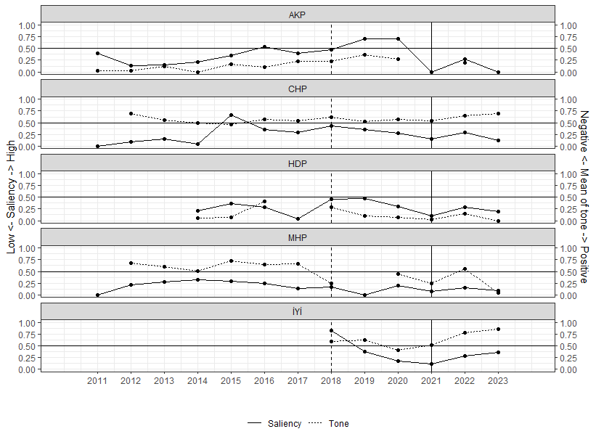

**Note: The horizontal black line indicates the midpoint of the scale. The dashed vertical line indicates the establishment of the People’s Alliance. The vertical solid black line indicates the establishment of the ZP. Missing tone values indicate that speeches in that period mentioned Syrian refugees non-evaluatively (neither positive nor negative) or the speaker did not mention Syrian refugees so there is no measurable tone.**

**Figure 2: Saliency and tone before and after ZP’s establishment**

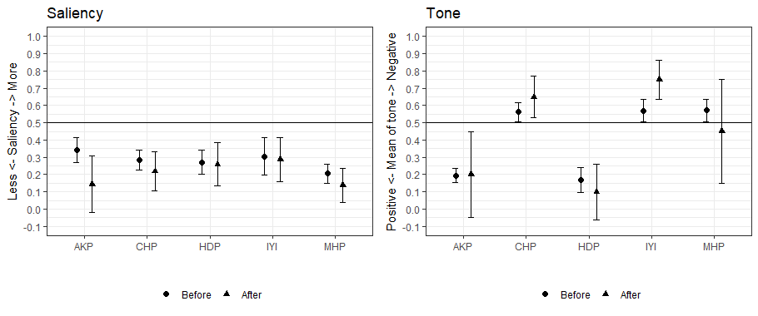

**Note: Darker horizontal black lines indicate scale midpoints. 95% confidence intervals are reported.**

**Figure A3: Violin plot of tone across political parties**

