|  |  |  |  |  |
| --- | --- | --- | --- | --- |
| Supplementary Table 1. Parameter estimates for the nominal logistic regression of weeds. Parameter estimates can be used to calculate the predicted likelihood to treat a weed with the predictors.a | | | | |
| Parameter [level] | Estimates | Standard error | χ2 | P > χ2 |
| Intercept | 4.15373 | 0.17911 | 537.80 | < 0.0001 |
| Crop [corn] | 0.00972 | 0.08731 | 0.01 | 0.9113 |
| Crop [cotton] | 0.10127 | 0.08146 | 1.55 | 0.2138 |
| Weed density | -0.01097 | 0.01716 | 0.41 | 0.5227 |
| Decision threshold (sensitivity setting) | -4.39193 | 0.20862 | 443.21 | < 0.0001 |
| Aggregate species [decumbent broadleaf] | 0.61023 | 0.15097 | 16.34 | < 0.0001 |
| Aggregate species [Malvaceae] | 0.32145 | 0.13999 | 5.27 | 0.0217 |
| Aggregate species [Convolvulaceae] | 0.81978 | 0.10393 | 62.22 | < 0.0001 |
| Aggregate species [Amaranthaceae] | -0.45614 | 0.08792 | 26.92 | < 0.0001 |
| Aggregate species [Poaceae] | 0.02780 | 0.12808 | 0.05 | 0.8282 |
| Weed height | 0.06283 | 0.02358 | 7.10 | 0.0077 |
| Weed width | 0.13976 | 0.01963 | 50.70 | < 0.0001 |
| Weed position [in-row] | -0.14604 | 0.04638 | 9.91 | 0.0016 |
| a  where *Xi1*, *Xi2*, *Xi3*, and *Xi4* is the *i*th observation of sensitivity, weed width, weed height, and weed density, respectively, with $i=1, …, 7165$*.*  The variables $Z_{i}^{p}$, $Z_{ij}^{c}$, and $Z_{ij}^{s}$ are binary dummy variables corresponding to the categorical predictors: weed position, crop, and aggregated weed species, respectively. The variables are explained as follows: $Z_{i}^{p}=1$  * if the weed position is in-row and 0 otherwise. $Z_{i1}^{c}=1$* if the crop is corn and 0 otherwise. $Z_{i2}^{c}=1$* if the crop is cotton and 0 otherwise. $Z_{i1}^{s}=1$* if the aggregated weed species is decumbent broadleaf and 0 otherwise. $Z_{i2}^{s}=1$* if the aggregated weed species is Malvaceae and 0 otherwise. $Z_{i3}^{s}=1$* if the aggregated weed species is Poaceae and 0 otherwise. $Z_{i4}^{s}=1$* if the aggregated weed species is Amaranthaceae and 0 otherwise. $Z_{i5}^{s}=1$* if the aggregated weed species is yellow nutsedge and 0 otherwise. | | | | |

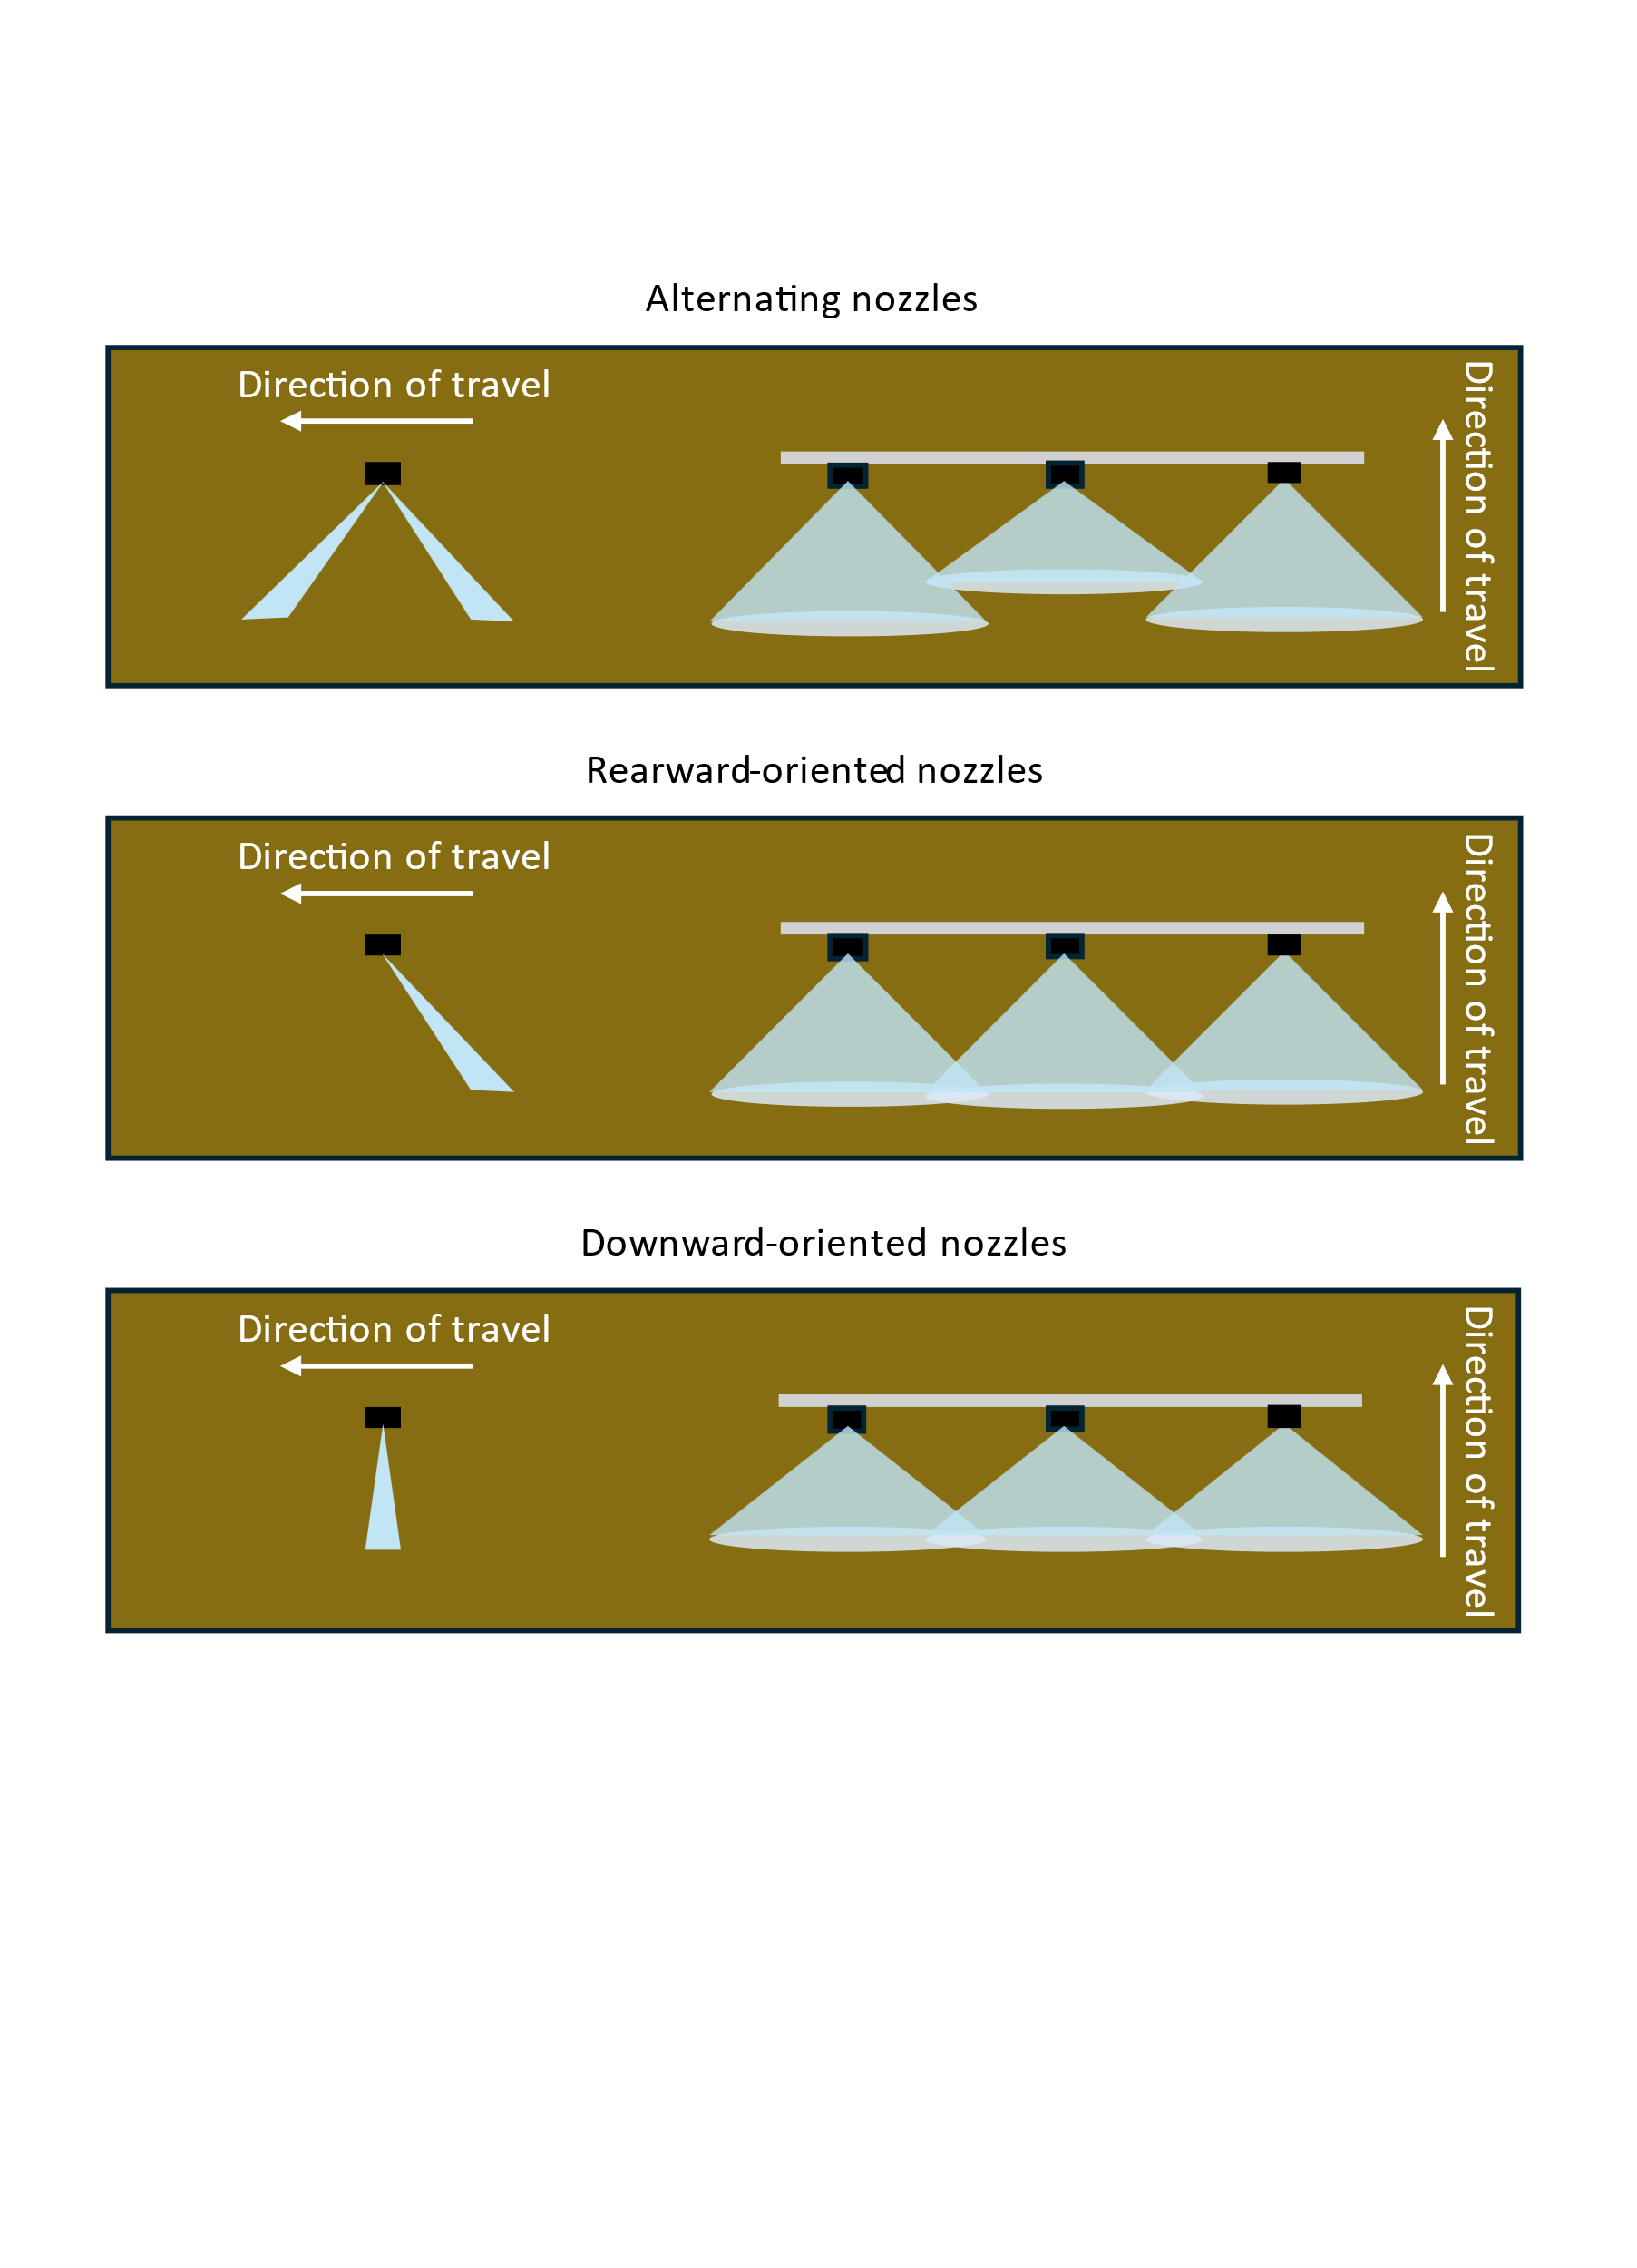

Supplementary Figure 1. Representation of the different nozzle arrangements for broadcast applications with alternating or downward-oriented nozzles. The rearward-orientation is used only for targeted applications.

Supplementary Figure 2. Distributions of the weed sizes (cm) for each aggregate class. Figure generated using JMP Pro 18.0 (SAS Institute, Cary, NC).