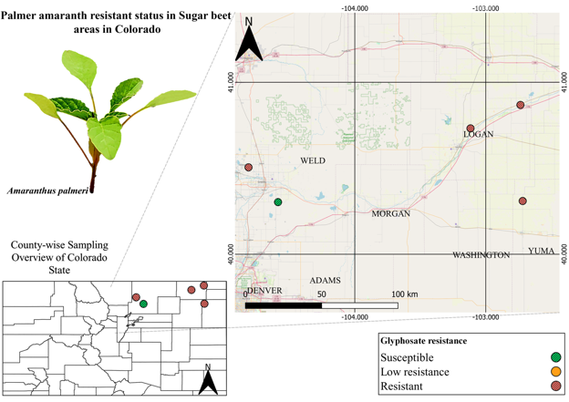
Supplementary Figure S1. Geo-referenced map illustrating the Palmer amaranth populations collected in Colorado during the fall of 2021. The dots on the map represent the locations of Palmer amaranth populations, and their color signifies their response to glyphosate treatment. In the bottom left corner, a separate map illustrates the distribution of the collected populations. On the right side, a close-up map focuses on the main counties where the samples were collected. Populations classified as resistant are represented by red dots, while yellow dots indicate low resistance, and green dots represent susceptible populations.
Supplementary Figure S2. Geo-referenced map illustrating the common lambsquarters populations collected in Colorado during the fall of 2021. Glyphosate, dicamba and glufosinate provided 100% of control (indicated by green dots on the map for susceptible populations). In the bottom left corner, a separate map illustrates the distribution of the collected populations. On the right side, a close-up map focuses on the main counties where the samples were collected.
Supplementary Figure S3. Geo-referenced map illustrating the redroot pigweed populations collected in Colorado during the fall of 2021. Glyphosate, dicamba and glufosinate provided 100% of control (indicated by green dots on the map for susceptible populations). In the bottom left corner, a separate map illustrates the distribution of the collected populations. On the right side, a close-up map focuses on the main counties where the samples were collected.
Supplementary Figure S4. Geo-referenced map illustrating the Palmer amaranth populations collected in Nebraska during the fall of 2020. The dots on the map represent the locations of Palmer amaranth populations, and their color signifies their response to glyphosate treatment. In the bottom left corner, a separate map illustrates the distribution of the collected populations. On the right side, a close-up map focuses on the main counties where the samples were collected. Populations classified as resistant are represented by red dots, while yellow dots indicate low resistance, and green dots represent susceptible populations.

Supplementary Figure S5. Geo-referenced map illustrating the common lambsquarters populations collected in Nebraska during the fall of 2020. The dots on the map represent the locations of common lambsquarters populations, and their color signifies their response to glyphosate treatment. In the bottom left corner, a separate map illustrates the distribution of the collected populations. On the right side, a close-up map focuses on the main counties where the samples were collected. Populations classified as resistant are represented by red dots, while yellow dots indicate low resistance, and green dots represent susceptible populations.
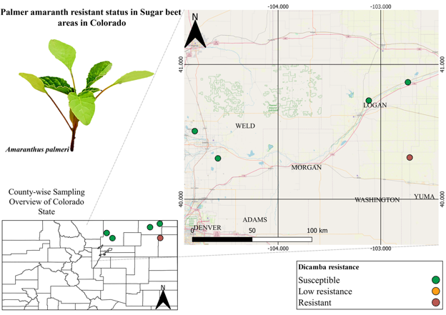
Supplementary Figure S6: Geo-referenced map illustrating the Palmer amaranth populations collected in Colorado during the fall of 2021. The dots on the map represent the locations of kochia populations, and their color signifies their response to dicamba treatment. In the bottom left corner, a separate map illustrates the distribution of the collected populations. On the right side, a close-up map focuses on the main counties where the samples were collected. Populations classified as resistant are represented by red dots, while yellow dots indicate low resistance, and green dots represent susceptible populations.
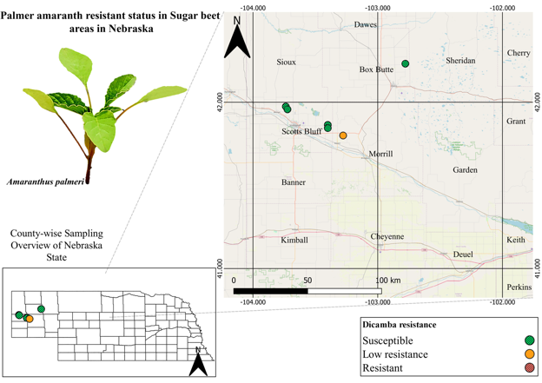
Supplementary Figure S7. Geo-referenced map illustrating the Palmer amaranth populations collected in Nebraska during the fall of 2020. The dots on the map represent the locations of Palmer amaranth populations, and their color signifies their response to dicamba treatment. In the bottom left corner, a separate map illustrates the distribution of the collected populations. On the right side, a close-up map focuses on the main counties where the samples were collected. Populations classified as resistant are represented by red dots, while yellow dots indicate low resistance, and green dots represent susceptible populations.

