1. Case study 1a. No hormesis - no increase in response

#Line 01
library(drc)
Load and activate the drc package in RStudio.

#Line 02
dataname <- read.csv("filename.csv")
Reads a CSV file named ‘filename.csv’ into RStudio and stores it in a data frame. The assigned name for the resulting data frame is ‘dataname’, which can be replaced with a preferred object name. Make sure that the ‘filename.csv’ is in the working directory of R project, otherwise the full path to the file should be specified. ‘Filename’ is the name of the excel - .csv file in which the data is stored (e.g. ‘myexperiment.csv’).

#Line 03
head(dataname)
Dose Plant relative.dm
1 0.0 CONAR 100.00
2 0.0 CONAR 100.00
3 0.0 CONAR 100.00
4 224.7 CONAR 91.24
5 224.7 CONAR 315.19
6 224.7 CONAR 80.58
This code line displays the initial 6 lines of the dataset, as a valuable verification step to ensure accurate data reading.

#Line 04
tail(dataname)
Dose Plant relative.dm
67 2310.0 MEUOF 36.36
68 2310.0 MEUOF 37.50
69 2310.0 MEUOF 23.53
70 2887.5 MEUOF 27.27
71 2887.5 MEUOF 25.00
72 2887.5 MEUOF 24.15
This code line displays the last 6 lines of the dataset, as a valuable verification step to ensure accurate data reading.

#Line 05
wh.bc4 <- drm(relative.dm~Dose, subset=Plant=="AMATU", fct=BC.4 (fixed =c(NA,NA,NA,NA)), data=dataname)
This line is utilized to fit a four-parameter Brain-Cousens hormesis model to dataset. The object with user-assigned name ‘wh.bc4’ will contain all information pertaining to the model generated by the drm function. The response variable is relative.dm (y-axis), while Dose is explanatory variable (x-axis). The subset condition ‘subset = Plant == “AMATU”’, ensures that the model is specifically fitted for the “AMATU” data. The function ‘fct = BC.4(fixed = c(NA, NA, NA, NA))’ specifies the use of a four-parameter Brain-Cousens model, and the ‘data = dataname’ argument identifies the name of the dataset. Executing this code will not produce any output. Instead, all information regarding the model fit is stored within the object (‘wh.bc4’ in this case) for subsequent analysis or visualization.

#Line 06
modelFit(wh.bc4)
Lack-of-fit test
ModelDf RSS Df F value p value
ANOVA 16 901.06
DRC model 20 997.58 4 0.4285 0.7860
The ‘modelFit’ function performs a lack-of-fit test, comparing the chosen dose-response model to a more general ANOVA model using an approximate F-test. Lack of fit test (BC.4 model) yields a p-value of 0.7860 which is not significant at 5%, indicating that the non-linear model provides acceptable description of data.

#Line 07
summary(wh.bc4)
Model fitted: Brain-Cousens (hormesis) with lower limit fixed at 0 (4 parms)
Parameter estimates:
Estimate Std. Error t-value p-value
b:(Intercept) 1.62359 0.26696 6.0817 6.058e-06 ***
d:(Intercept) 100.01411 4.07809 24.5248 < 2.2e-16 ***
e:(Intercept) 52.85457 215.77728 0.2449 0.8090
f:(Intercept) 2.20602 16.92466 0.1303 0.8976
---
Signif. codes: 0 '***' 0.001 '**' 0.01 '*' 0.05 '.' 0.1 ' ' 1
Residual standard error:
7.062507 (20 degrees of freedom)
The ‘summary’ function provides parameter estimates with corresponding standard errors and p-values. Parameters b and e do not have a direct interpretation, while d is the upper horizontal asymptote (upper limit). Parameter of high interest is f, determining the size of hormesis effect. As shown, the p-value of f estimate is highly insignificant, indicating the lack of evidence that it is different from 0. Provided are also standard errors of the parameters and an approximate t-test with associated p-value that is testing the hypothesis that the parameters are equal to 0.

#Line 08
wh.ll4 <- drm(relative.dm~Dose, subset=Plant=="AMATU", fct=LL.4 (fixed =c(NA,NA,NA,NA)), data=dataname)
Same comment as in Line 5. Note that in this case, ‘fct = LL.4’ is essentially fitting log-logistic model with four parameters, instead of ‘fct = BC.4’ in Line 5 which fitted Brain-Cousens model with 4 parameters.

#Line 09
modelFit(wh.ll4)
Lack-of-fit test
ModelDf RSS Df F value p value
ANOVA 16 901.06
DRC model 20 1028.50 4 0.5658 0.6911
Same comment as in Line 6. Lack of fit test (LL.4 model) yields a p-value of 0.6911 which is not significant at 5%, indicating that the non-linear model provides acceptable description of data.

#Line 10
summary(wh.ll4)
Model fitted: Log-logistic (ED50 as parameter) (4 parms)
Parameter estimates:
Estimate Std. Error t-value p-value
b:(Intercept) 1.17088 0.45407 2.5787 0.01794 *
c:(Intercept) 5.98446 7.71843 0.7753 0.44721
d:(Intercept) 100.10651 4.13177 24.2285 2.459e-16 ***
e:(Intercept) 210.70442 35.25308 5.9769 7.621e-06 ***
---
Signif. codes: 0 '***' 0.001 '**' 0.01 '*' 0.05 '.' 0.1 ' ' 1
Residual standard error:
7.171135 (20 degrees of freedom)
Same comment as in Line 7. Parameter estimates in the four-parameter log-logistic model. Parameters b is the slope, c is the lower asymptote (lower limit – minimum response level), d is the upper asymptote (upper limit – maximum response level) and e is ED50 (inflection point).

#Line 11
x11(width=6, height=5)
par(mar = c(4.5, 6, 2, 2), mgp = c(4, 0.75, 0))
plot(wh.ll4, col = "black", lty = 1, pch = 21, type = "average",
cex.axis = 1.6, cex.lab = 2.0, cex = 1.4,
xlab = "", ylab = "",
xlim = c(0, 10000), ylim = c(0, 150), xtsty = "standard", main = "",
lwd = 3)
plot(wh.bc4, add=T, col = "black", lty = 2, pch = 21, type = "average",
cex.axis = 1.8, cex.lab = 2.1, cex = 1.4,
xlab = "", ylab = "",
xlim = c(0, 10000), ylim = c(0, 150), xtsty = "standard", main = "",
lwd = 3)
title(xlab = expression(paste("Glyphosate dose (g ae ha "^"-1",")")),
ylab = expression(paste("Relative dry matter (%)")),
cex.axis = 1.6, cex.lab = 2.0, cex = 1.4, line = 3.4)
legend("topright", legend = c("LL.4 model", "BC.4 model"),
text.col = "black", lty = c(1,2), lwd = 3, col = "black",
inset = -0.02, cex = 1.6, bty = "n")
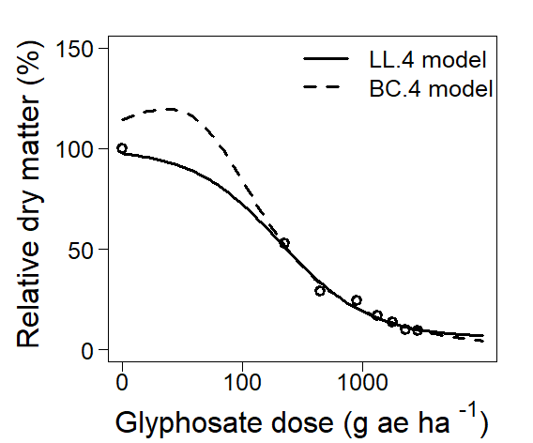
The ‘x11(width=6, height=5)’ initiates a graphics device with a specified width and height (in inches). The ‘par’ function sets the margins and general parameters for the subsequent plots. Following this, the ‘plot’ function is employed to create the first plot (plotting object wh.ll4), specifying parameters such as color (‘col = “black”’), line type (‘lty = 1 – solid line’), plot symbol (‘pch = 21’), and type of plot (‘type = “average”’ – mean response values). The axes labels, limits, and formatting details are adjusted accordingly. A second plot (plotting object wh.bc4) is added to the existing plot using ‘add=T’ argument. The parameters for this plot are similar to the first one, with variations in line type (‘lty = 2’ – dashed line'). Finally, the ‘legend’ function is utilized to include a legend in the top-right corner of the plot. The legend text is set as “LL.4 model” and “BC.4 model” with formatting parameters controlling its appearance. Visit http://www.R-project.org, for additional information on how to do produce graphs within R environment.

#Line 12
ED(wh.ll4, c(50,90), type="relative")
Estimated effective doses
Estimate Std. Error
e:1:50 210.704 35.253
e:1:90 1378.201 223.965
The ‘ED()’ function provides effective doses calculations for the levels 50% and 90% (specified by ‘c(50, 90)’) relative to the maximum response. The model is specified by the first argument (‘wh.ll4’). Argument ‘type=“relative”’ indicates that effective doses are calculated as percent change in response relative to the estimated upper and lower limits (minimum and maximum).

2. Case study 1b. No hormesis – no statistical significance despite visual evidence of increase in response.

#Line 01
fb.bc4 <- drm(relative.dm~Dose, subset=Plant=="CONAR", fct=BC.4 (fixed=c(NA,NA,NA,NA)), data=dataname)
This line is utilized to fit a four-parameter Brain-Cousens hormesis model to dataset. The object with user-assigned name ‘fb.bc4’ will contain all information pertaining to the model generated by the drm function. The response variable is relative.dm (y-axis), while Dose is explanatory variable (x-axis). The subset condition ‘subset = Plant == “CONAR”’, ensures that the model is specifically fitted for the “CONAR” data. The function ‘fct = BC.4(fixed = c(NA, NA, NA, NA))’ specifies the use of a four-parameter Brain-Cousens model, and the ‘data = dataname’ argument identifies the name of the dataset. Executing this code will not produce any output. Instead, all information regarding the model fit is stored within the object (‘fb.bc4’ in this case) for subsequent analysis or visualization.

#Line 02
modelFit(fb.bc4)
Lack-of-fit test
ModelDf RSS Df F value p value
ANOVA 16 49577
DRC model 20 50909 4 0.1075 0.9782
The ‘modelFit’ function performs a lack-of-fit test, comparing the chosen dose-response model to a more general ANOVA model using an approximate F-test. Lack of fit test (BC.4 model) yields a p-value of 0.9782 which is not significant at 5%, indicating that the non-linear model provides acceptable description of data.

#Line 03
summary(fb.bc4)
Model fitted: Brain-Cousens (hormesis) with lower limit fixed at 0 (4 parms)
Parameter estimates:
Estimate Std. Error t-value p-value
b:(Intercept) 1.72289 0.42741 4.0310 0.0006544 ***
d:(Intercept) 100.32358 29.14311 3.4424 0.0025762 **
e:(Intercept) 434.57333 415.58856 1.0457 0.3081824
f:(Intercept) 0.49334 0.59438 0.8300 0.4163334
---
Signif. codes: 0 '***' 0.001 '**' 0.01 '*' 0.05 '.' 0.1 ' ' 1
Residual standard error:
50.45263 (20 degrees of freedom)
The ‘summary’ function provides parameter estimates with corresponding standard errors and p-values. Parameter estimates in the four-parameter Brain-Cousens model, b and e do not have a direct interpretation, while d is the upper horizontal asymptote (upper limit). Parameter of high interest is f, determining the size of hormesis effect. As shown, the p-value of f estimate is highly not significant (0.4163), indicating the lack of evidence that it is different from 0, thus no hormesis occurred. Provided are also standard errors of the parameters and an approximate t-test with associated p-value that is testing the hypothesis that the parameters are equal to 0.

#Line 04
fb.CRS4 <- drm(relative.dm ~ Dose, subset = Plant == "CONAR", fct = CRS.4b(), data = dataname)
Same comment as in Line 1. Note that in this this case ‘fct = CRS.4b’ is essentially fitting The Cedergreen-Ritz-Streibig hormesis model with alpha = 0.5 (b extension).

#Line 05
modelFit(fb.CRS4)
Lack-of-fit test
ModelDf RSS Df F value p value
ANOVA 16 49577
DRC model 20 51087 4 0.1218 0.9726
Same comment as in Line 2. Lack of fit test (CRS.4b model) yields a p-value of 0.9762 which is not significant at 5%, indicating that the non-linear model provides acceptable description of data.

#Line 06
summary(fb.CRS4)
Model fitted: Cedergreen-Ritz-Streibig with lower limit 0 (alpha=.5) (4 parms)
Parameter estimates:
Estimate Std. Error t-value p-value
b:(Intercept) 1.3781 1.0157 1.3567 0.189991
d:(Intercept) 99.9409 29.1789 3.4251 0.002681 **
e:(Intercept) 1547.2521 849.2629 1.8219 0.083464 .
f:(Intercept) 81.1751 62.2686 1.3036 0.207168
---
Signif. codes: 0 '***' 0.001 '**' 0.01 '*' 0.05 '.' 0.1 ' ' 1
Residual standard error:
50.54061 (20 degrees of freedom)
Same comment as in Line 3. Parameter estimates in the four-parameter Cedergreen-Ritz-Streibig model. Parameter d is the upper limit, b and e have no direct interpolation, while f determines the size of hormesis effect. Corresponding p-value for f estimate is 0.207168, which is not significant, indicating the lack of statistical evidence that it is different from 0. Provided are also standard errors of the parameters and a t-test with associated p-value that is testing the hypothesis that the parameters are equal to 0.

#Line 07
x11(width=6, height=5)
par(mar = c(4.5, 6, 2, 2), mgp = c(4, 0.75, 0))
plot(fb.bc4, col = "black", lty = 1, pch = 21, type = "average",
cex.axis = 1.6, cex.lab = 2.0, cex = 1.4,
xlab = "", ylab = "",
xlim = c(0, 10000), ylim = c(0, 300), xtsty = "standard", main = "",
lwd = 3)
plot(fb.CRS4, add=T, col = "black", lty = 2, pch = 21, type = "average",
cex.axis = 1.6, cex.lab = 2.0, cex = 1.4,
xlab = "", ylab = "",
xlim = c(0, 10000), ylim = c(0, 300), xtsty = "standard", main = "",
lwd = 3)
title(xlab = expression(paste("Glyphosate dose (g ae ha "^"-1",")")),
ylab = expression(paste("Relative dry matter (%)")),
cex.axis = 1.6, cex.lab = 2.0, cex = 1.4, line = 3.4)
legend("topright", legend = c("BC.4 model", "CRS.4b model"),
text.col = "black", lty = c(1,2), lwd = 3, col = "black",
inset = -0.02, cex = 1.6, bty = "n")
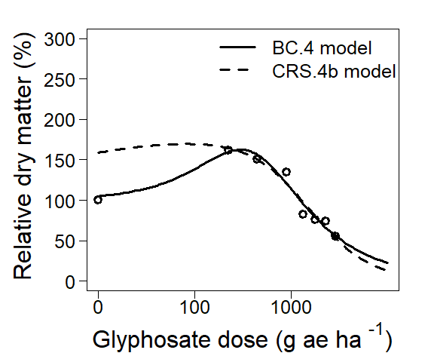

The ‘x11(width=6, height=5)’ initiates a graphics device with a specified width and height. The par function sets the margins and general parameters for the subsequent plots. Following this, the plot function is employed to create the first plot (plotting object fb.bc4), specifying parameters such as color (‘col = “black”’), line type (‘lty = 1 – solid line’), plot symbol (‘pch = 21’), and type of plot (‘type = “average”’ – mean response values). The axes labels, limits, and formatting details are adjusted accordingly. A second plot (plotting object fb.CRS4) is added to the existing plot using ‘add=T’ argument. The parameters for this plot are similar to the first one, with variations in line type (‘lty = 2 – dashed line’). Finally, the ‘legend’ function is utilized to include a legend in the top-right corner of the plot. The legend text is set as “BC.4 model” and “CRS.4b model” with formatting parameters controlling its appearance. Visit http://www.R-project.org, for additional information on how to do produce graphs within R environment.

3. Case study 1c. Hormesis confirmed with both statistical and visual evidence.

#Line 01
cl.ll4 <- drm(relative.dm ~ Dose, subset = Plant == "MEUOF", fct = LL.4 (fixed = c(NA,NA,NA,NA)), data = dataname)
This line is utilized to fit a four-parameter log-logistic model to dataset. The object with user-assigned name ‘cl.ll4 will contain all information pertaining to the model generated by the ‘drm’ function. The response variable is relative.dm (y-axis), while Dose is explanatory variable (x-axis). The subset condition ‘subset = Plant == “MEUOF”’, ensures that the model is specifically fitted for the “MEUOF” data. The function ‘fct = LL.4(fixed = c(NA, NA, NA, NA))’ specifies the use of a four-parameter log-logistic model, and the ‘data = dataname’ argument identifies the name of the dataset. Executing this code will not produce any output. Instead, all information regarding the model fit is stored within the object (‘cl.ll4’ in this case) for subsequent analysis or visualization.

#Line 02
modelFit(cl.ll4)
Lack-of-fit test
ModelDf RSS Df F value p value
ANOVA 16 25736
DRC model 20 45561 4 3.0811 0.0465
The ‘modelFit’ function performs a lack-of-fit test, comparing the chosen dose-response model to a more general ANOVA model using an approximate F-test. Lack of fit test (LL.4 model) yields a p-value of 0.0465, which is significant at 5%, indicating that the log-logistic model fitted in Line 2 does not provides acceptable description of data. This suggests that there may be significant unexplained variability in the model, warranting further investigation and consideration of alternative models.

#Line 03
cl.BC5 <- drm(relative.dm ~ Dose, subset = Plant == "MEUOF", fct = BC.5 (fixed = c(NA, NA, NA, NA, NA)), data = dataname)
Same comment as in Line 1. Note that in this this case, ‘fct = BC.5’ is essentially fitting the Brain-Cousens hormesis model with 5 parameters.

#Line 4
modelFit(cl.BC5)
Lack-of-fit test
ModelDf RSS Df F value p value
ANOVA 16 25737
DRC model 19 27224 3 0.3083 0.8190
The ‘modelFit’ function performs a lack-of-fit test, comparing the chosen dose-response model to a more general ANOVA model using an approximate F-test. Lack of fit test (BC.5 model) yields a p-value of 0.8190 which is not significant at 5%, indicating that the Brain-Cousens model fitted in Line 3 provides acceptable description of data.
#Line 05
summary(cl.BC5)
Model fitted: Brain-Cousens (hormesis) (5 parms)
Parameter estimates:
Estimate Std. Error t-value p-value
b:(Intercept) 4.20406 1.77789 2.3646 0.028846 *
c:(Intercept) 32.41379 15.26363 2.1236 0.047058 *
d:(Intercept) 99.79724 21.82526 4.5726 0.000208 ***
e:(Intercept) 465.52142 65.00170 7.1617 8.329e-07 ***
f:(Intercept) 0.48473 0.17114 2.8323 0.010647 *
---
Signif. codes: 0 '***' 0.001 '**' 0.01 '*' 0.05 '.' 0.1 ' ' 1
Residual standard error:
37.85311 (19 degrees of freedom)
The ‘summary’ function provides parameter estimates with corresponding standard errors and p-values. Parameter estimates in the five-parameter Brain-Cousens model. Parameter d is the upper limit, c is the lower limit, b and e have no direct interpolation, while f determines the size of hormesis effect. The corresponding p-value for the f estimate is 0.010647, which is significant, indicating sufficient evidence that it is different from 0. Thus, hormesis occurred. Provided are also standard errors of the parameters and an approximate t-test with an associated p-value that tests the hypothesis that the parameters are equal to 0.

#Line 06
AIC(cl.ll4)
[1] 259.279
#Line 7
AIC(cl.BC5)
[1] 248.9205
The AIC (Akaike Information Criterion) values for two different models are calculated to assess the goodness of fit for each model (cl.ll4 and cl.BC5). Lower AIC values suggests a model describes the data better. The AIC values obtained from fitting the LL.4 and BC.5 models are 259.279 and 248.9205.

#Line 08
anova(cl.ll4, cl.BC5)
1st model
fct: LL.4(fixed = c(NA, NA, NA, NA))
2nd model
fct: BC.5(fixed = c(NA, NA, NA, NA, NA))
ANOVA table
ModelDf RSS Df F value p value
1st model 20 45561
2nd model 19 27224 1 12.797 0.002
The ‘anova’ function within drc is comparing two regression models (cl.ll4 and cl.bc5). It assesses the statistical significance of the differences in model fits, aiding in model selection and interpretation. The F value of 12.797 with a corresponding p-value of 0.002 indicates a statistically significant difference between the two models. The BC.5 model provides a better fit than the LL.4 model, supported by a significant reduction in RSS and a lower AIC value. This suggests that including a hormesis term improves the model's description of the dose-response relationship.

#Line 09
mselect(cl.ll4, list(LL.3(), LL.4(), BC.4(), BC.5(), CRS.4a(), CRS.5a(), CRS.6()))
Warning in sqrt(diag(varMat)): NaNs produced
logLik IC Lack of fit Res var
BC.5 -118.4603 248.9205 8.190346e-01 1432.858
CRS.5a -118.6166 249.2332 7.671447e-01 1451.645
BC.4 -119.6237 249.2475 6.273195e-01 1499.802
CRS.4a -120.4184 250.8369 4.453656e-01 1602.489
LL.4 -124.6395 259.2790 4.645579e-02 2278.034
LL.3 -126.6419 261.2837 2.522046e-02 2563.535
CRS.6 -146.1426 306.2851 6.164382e-09 15189.392
The ‘mselect()’ function performs the model selection based on various criteria: their maximum log likelihood value, AIC, estimated residual variance and the p-value derived from lack-of-fit test. The first argument is an object of drc class, followed by the list of models to be compared. In the output, each row corresponds to a different model, and the values in each column provide information about how well each model fits the data and how complex it is. Log-likelihood (logLik) of the model measures the goodness of fit, with higher values indicating better fit. A lower vale of information criterion (IC) indicates a better trade-off between goodness of fit and model complexity. Lack of fit provides the p-value derived from the lack-of-fit test with lower values indicating a better fit. Residual variance (Res var) measures the variability of the residuals around the fitted model with lower values indicate a better fit.

#Line 10
x11(width=6, height=5)
par(mar = c(4.5, 6, 2, 2), mgp = c(4, 0.75, 0))
plot(cl.ll4, col = "black", lty = 2, pch = 21, type = "average",
cex.axis = 1.6, cex.lab = 2.0, cex = 1.4,
xlab = "", ylab = "",
xlim = c(0, 10000), ylim = c(0, 300), xtsty = "standard", main = "",
lwd = 3)
plot(cl.BC5, add=T, col = "black", lty = 1, pch = 21, type = "average",
cex.axis = 1.6, cex.lab = 2.0, cex = 1.4,
xlab = "", ylab = "",
xlim = c(0, 10000), ylim = c(0, 300), xtsty = "standard", main = "",
lwd = 3)
title(xlab = expression(paste("Glyphosate dose (g ae ha "^"-1",")")),
ylab = expression(paste("Relative dry matter (%)")),
cex.axis = 1.6, cex.lab = 2.0, cex = 1.4, line = 3.4)
legend("topright", legend = c("BC.5 model","LL.4 model"),
text.col = "black", lty = c(1,2), lwd = 3, col = "black",
inset = -0.02, cex = 1.6, bty = "n")
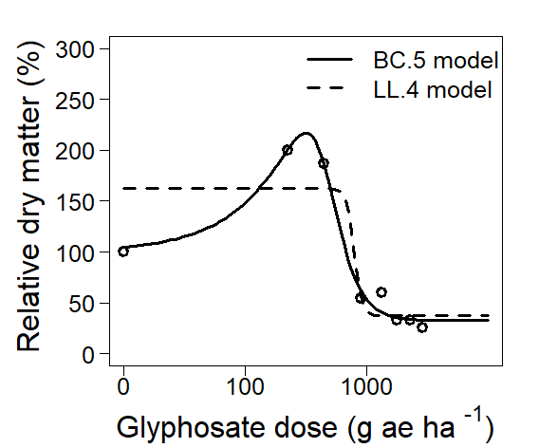
The ‘x11(width=6, height=5)’ initiates a graphics device with a specified width and height (in inches). The par function sets the margins and general parameters for the subsequent plots. Following this, the ‘plot’ function is employed to create the first plot (plotting object cl.ll4), specifying parameters such as color (‘col = “black”’), line type (‘lty = 2’ – dashed line), plot symbol (‘pch = 21’), and type of plot (‘type = “average”’ – mean response values). The axes labels, limits, and formatting details are adjusted accordingly. A second plot (plotting object cl.BC5) is added to the existing plot using ‘add=T’ argument. The parameters for this plot are similar to the first one, with variations in line type (‘lty = 1’ – solid line). Finally, the ‘legend’ function is utilized to include a legend in the top-right corner of the plot. The legend text is set as “LL.4 model” and “BC.5 model” with formatting parameters controlling its appearance. Visit http://www.R-project.org, for additional information on how to do produce graphs within R environment.

4. Case study 2a. Estimating NOAEL.

#Line 01
noael <- drm(IR21DAT ~ dose1, fct = LL.4 (fixed = c(NA,NA,NA,NA)), data = dataname)
This line is utilized to fit a four-parameter log-logistic model to dataset. The object with user-assigned name, ‘noael’, will contain all information pertaining to the model generated by the drm function. The response variable is IR21DAT (injury 21 days after exposure) (y-axis) (specify the response of interest), while Dose is explanatory variable (x-axis). The function ‘fct = LL.4(fixed = c(NA, NA,NA, NA))’ specifies the use of a four-parameter log-logistic model, and the ‘data = dataname’ argument identifies the name of the dataset. Executing this code will not produce any output. Instead, all information regarding the model fit is stored within the object (’noael) in this case) for subsequent analysis or visualization.

#Line 02
modelFit(noael)
Lack-of-fit test
ModelDf RSS Df F value p value
ANOVA 30 403.23
DRC model 36 423.71 6 0.6260 0.7081
The ‘modelFit’ function performs a lack-of-fit test, comparing the chosen dose-response model to a more general ANOVA model using an approximate F-test.

#Line 03
summary(noael)
Model fitted: Log-logistic (ED50 as parameter) (4 parms)
Parameter estimates:
Estimate Std. Error t-value p-value
b:(Intercept) -0.729273 0.093025 -7.8395 2.686e-09 ***
c:(Intercept) -4.120624 2.614623 -1.5760 0.1237760
d:(Intercept) 87.394178 3.947524 22.1390 < 2.2e-16 ***
e:(Intercept) 296.634297 71.616343 4.1420 0.0001988 ***
---
Signif. codes: 0 '***' 0.001 '**' 0.01 '*' 0.05 '.' 0.1 ' ' 1
Residual standard error:
6.444522 (36 degrees of freedom)
The ‘summary’ function provides parameter estimates with corresponding standard errors and p-values. Parameter estimates in the four-parameter log-logistic model. Parameter b is the slope, d is the upper limit, c is the lower limit and e is the ED50. Provided are also standard errors of the parameters and an approximate t-test with associated p-value that is testing the hypothesis that the parameters are equal to 0.

#Line 04
x11(width=6, height=5)
par(mar = c(4.5, 6, 2, 2), mgp = c(4, 0.75, 0))
plot(noael,col = "black", lty = 1, pch = 21, type = "average",
cex.axis = 1.6, cex.lab = 2.0, cex = 1.4,
xlab = "", ylab = "",
xlim = c(0, 500), ylim = c(0, 100), xtsty = "standard", main = "",
lwd = 3)
title(xlab = expression(paste("Dicamba dose (g ae ha "^"-1",")")),
ylab = expression(paste("Visual injury (%)")),
cex.axis = 1.6, cex.lab = 2.0, cex = 1.4, line = 3.4)
legend("topleft", legend = c("LL.4 model"),
text.col =c("black","black"), lty = c(1), lwd = 3, col = c("black"),
inset = -0.02, cex = 1.6, bty = "n")
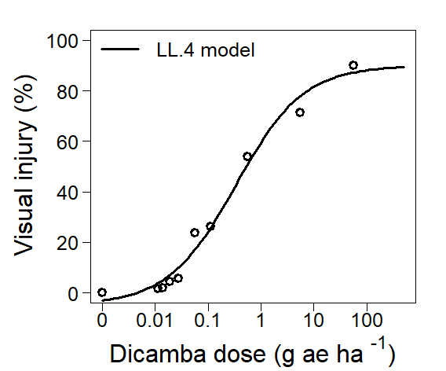
The ‘plot’ function is employed to visualize the fitted model stored in the object ‘noael’. The ‘col = “black”’ parameter determines the color of the curve. The ‘lty’ and ‘pch’ parameters control the line type and plot symbol for the curve, respectively. The ‘type = “average”’ specifies that the plot displays the mean response for each dose level. Axis ranges are set with ‘xlim’ and ‘ylim’. Subsequently, the ‘title’ function is utilized to add axis labels to the plot and formatting parameters like ‘cex.axis’, ‘cex.lab’, and ‘cex’ control the size of the axis labels. Visit http://www.R-project.org, for additional information on how to do produce graphs within R environment.
#Line 05
ED(noael,c(1,2.5,5), type = "relative", interval = "delta")
Estimated effective doses
Estimate Std. Error Lower Upper
e:1:1 0.32174 0.06170 0.19683 0.44665
e:1:2.5 1.48163 0.28414 0.90642 2.05685
e:1:5 4.81645 0.92367 2.94656 6.68634
The function ‘ED()’ is utilized to estimate effective doses (ED) for the fitted model represented by the object ‘noael’. The effective doses are calculated at three specified response levels: 1%, 2.5%, and 5%. The ‘type = “relative”’ argument indicates that these doses are expressed relative to the maximum response observed in the dataset (calculated as percent change in response between 0 and 87% as estimated upper limit). Additionally, the ‘interval = “delta”’ parameter is employed to compute the confidence intervals for the estimated effective doses. This means that the output will include the uncertainty associated with each effective dose estimate, providing a range within which the true effective dose is likely to fall. ED1, 2.5 and 5, corresponding standard errors and 95% confidence interval, shown in mg ha⁻¹ for readability. For example, ED1 is estimated to be 0.32 (±0.06) mg ae ha-1. The associated 95% confidence interval, spanning from 0.191 to 0.47 mg ae ha-1, suggests that in 95% of cases, the true value for ED1 is expected to fall within this range.

#Line 06
ED(noael,c(1,2.5,5), type = "absolute", interval = "delta")
Estimated effective doses
Estimate Std. Error Lower Upper
e:1:1 0.35223 0.06755 0.21549 0.48898
e:1:2.5 1.62437 0.31151 0.99374 2.25499
e:1:5 5.29360 1.01518 3.23847 7.34873
Contrary to Line 5, argument ‘type = “absolute”’ will estimate the ED value considering the upper limit of 100%, regardless of the estimation of 87%. ED1, 2.5 and 5, corresponding standard errors and 95% confidence interval, shown in mg for readability.

5. Case study 2b. Estimating LOAEL.

#Line 01
corn.ll4 = drm(Yield ~ Dose, fct = LL.4 (fixed = c(NA,NA, NA, NA)), data = dataname)
This line is utilized to fit a four-parameter log-logistic model to dataset. The object with user-assigned name ‘corn.ll4’ will contain all information pertaining to the model generated by the ‘drm’ function. The response variable is Yield (y-axis), while Dose is explanatory variable (x-axis). The function ‘fct = LL.4(fixed = c(NA, NA, NA, NA))’ specifies the use of a four-parameter log-logistic model, and the ‘data = dataname’ argument identifies the name of the dataset. Executing this code will not produce any output. Instead, all information regarding the model fit is stored within the object (‘corn.ll4’ in this case) for subsequent analysis or visualization.

#Line 02
modelFit(corn.ll4)
Lack-of-fit test
ModelDf RSS Df F value p value
ANOVA 27 483.18
DRC model 32 535.23 5 0.5817 0.7136
The ‘modelFit’ function performs a lack-of-fit test, comparing the chosen dose-response model to a more general ANOVA model using an approximate F-test. Lack of fit test (LL.4 model) yields a p-value of 0.7136, which is not significant at 5%, indicating that the log-logistic model fitted in Line 1 provides acceptable description of data.

#Line 03
summary(corn.ll4)
Model fitted: Log-logistic (ED50 as parameter) (4 parms)
Parameter estimates:
Estimate Std. Error t-value p-value
b:(Intercept) 4.71764 0.47806 9.8684 3.132e-11 ***
c:(Intercept) 8.17314 2.33702 3.4973 0.001403 **
d:(Intercept) 99.35358 0.83563 118.8969 < 2.2e-16 ***
e:(Intercept) 13.89762 0.40409 34.3928 < 2.2e-16 ***
---
Signif. codes: 0 '***' 0.001 '**' 0.01 '*' 0.05 '.' 0.1 ' ' 1
Residual standard error:
4.089751 (32 degrees of freedom)
The ‘summary’ function provides parameter estimates with corresponding standard errors and p-values. Parameter b is the slope, d is the upper limit, c is the lower limit, and e is the ED50. Provided are also standard errors of the parameters and an approximate t-test with associated p-value that is testing the hypothesis that the parameters are equal to 0.

#Line 04
x11(width=6, height=5)
par(mar = c(4.5, 6, 2, 2), mgp = c(4, 0.75, 0))
plot(corn.ll4, col = "black", lty = 1, pch = 21, type = "average",
cex.axis = 1.6, cex.lab = 2.0, cex = 1.4,
xlab = "", ylab = "",
xlim = c(0, 100), ylim = c(0, 150), xtsty = "standard", main = "",
lwd = 3)
title(xlab = expression(paste("Clethodim dose (g ae ha "^"-1",")")),
ylab = expression(paste("Relative yield (%)")),
cex.axis = 1.6, cex.lab = 2.0, cex = 1.4, line = 3.4)
legend("topright", legend = c("LL.4 model"),
text.col = "black", lty = c(1), lwd = 3, col = "black",
inset = -0.02, cex = 1.6, bty = "n")
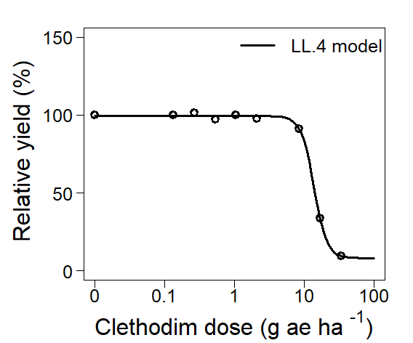
The ‘plot’ function is employed to visualize the fitted model stored in the object ‘corn.ll4’. The ‘col = “black”’ parameter determines the color of the curve. The ‘lty’ and ‘pch’ parameters control the line type and plot symbol for the curve, respectively. The ‘type = “average”’ specifies that the plot displays the mean response for each dose level. Axis ranges are set with ‘xlim’ and ‘ylim’. Subsequently, the ‘title’ function is utilized to add axis labels to the plot and formatting parameters like ‘cex.axis’, ‘cex.lab’, and ‘cex’ control the size of the axis labels. Visit http://www.R-project.org, for additional information on how to do produce graphs within R environment.

#Line 05
ED(corn.ll4, c(1,2.5,5), type = "relative",interval = "delta")
Estimated effective doses
Estimate Std. Error Lower Upper
e:1:1 5.36102 0.11388 5.12959 5.59244
e:1:2.5 6.53621 0.13884 6.25405 6.81837
e:1:5 7.61684 0.17628 7.28804 7.94565
The effective doses are calculated for the response levels 1, 2.5 and 5% (specified by ‘c(1, 2.5, 5)’) relative to the maximum response (‘type=”relative”’). The model is specified by the first argument (’corn.ll4). Argument ‘interval = “delta”’ will include the 95% confidence intervals in the output. For example, ED1 is estimated to be 5.3 (±0.1) g ae ha⁻¹. The associated 95% confidence interval, spanning from 5.1 to 5.5 g ae ha⁻¹, suggests that in 95% of cases, the true value for ED1 is expected to fall within this range.

