X-ray powder diffraction data for Mosapride Dihydrogen Citrate Dihydrate

Analio J. Dugarte-Dugarte1, Robert A. Toro2, José Antonio Henao2,

Graciela Díaz de Delgado1, José Miguel Delgado1

*1Laboratorio de Cristalografía-LNDRX, Departamento de Química, Facultad de Ciencias, Universidad de los Andes, Mérida 5101, Venezuela.*

*2Grupo de Investigación en Química Estructural (GIQUE), Escuela de Química, Facultad de Ciencias, Universidad Industrial de Santander, Bucaramanga, Colombia.*

**Supplementary Material**

Tables S1 and S2 summarize the bond distances and angles in Mdcd.

**Table S1.** Bond distances in Mdcd.

|  |  |
| --- | --- |
| **Bond** | **Distance (Å)** |
| Cl1A-C11A | 1.714(8) |
| F1A-C19A | 1.332(9) |
| O1A-C1A | 1.417(9) |
| O1A-C4A | 1.424(8) |
| O2A-C6A | 1.246(8) |
| O3A-C8A | 1.351(9) |
| O3A-C13A | 1.444(9) |
| N1A-C2A | 1.512(7) |
| N1A-C3A | 1.485(7) |
| N1A-C15A | 1.524(6) |
| N2A-C5A | 1.444(8) |
| N2A-C6A | 1.346(7) |
| N3A-C10A | 1.369(9) |
| C1A-C2A | 1.535(8) |
| C1A-C5A | 1.524(7) |
| N1A-H1N | 0.953(11) |
| O1B-C1B | 1.2398(16) |
| N2A-H2N | 0.949(10) |
| O2B-C1B | 1.265(3) |
| C3A-C4A | 1.514(8) |
| N3A-H3N1 | 0.953(12) |
| N3A-H3N2 | 0.952(13) |
| O4B-C3B | 1.422(7) |
| O5B-C5B | 1.236(7) |
| C6A-C7A | 1.460(7) |
| O6B-C5B | 1.302(6) |
| C7A-C8A | 1.401(8) |
| C7A-C12A | 1.388(9) |
| C13A-H13A2 | 0.949(11) |
| C13A-H13A1 | 0.949(12) |
| C14A-H14A3 | 0.954(12) |
| C14A-H14A2 | 0.953(11) |
| C14A-H14A1 | 0.955(12) |
| C15A-H15A1 | 0.954(10) |
| C15A-H15A2 | 0.957(11) |
| C17A-H17A | 0.953(11) |
| C18A-H18A | 0.952(10) |
| C20A-H20A | 0.955(10) |
| C21A-H21A | 0.949(10) |
| C1B-C2B | 1.546(2) |
| O7B-C6B | 1.208(7) |
| C8A-C9A | 1.379(9) |
| O8B-C6B | 1.334(6) |
| C9A-C10A | 1.400(8) |
| C10A-C11A | 1.374(8) |
| C11A-C12A | 1.351(9) |
| C13A-C14A | 1.516(7) |
| C15A-C16A | 1.509(7) |
| C16A-C17A | 1.388(7) |
| C16A-C21A | 1.412(7) |
| C17A-C18A | 1.395(7) |
| C18A-C19A | 1.370(8) |
| C19A-C20A | 1.382(8) |
| C20A-C21A | 1.390(7) |
| C1A-H1A | 0.946(11) |
| C2A-H2A1 | 0.953(10) |
| C2A-H2A2 | 0.956(12) |
| C3A-H3A1 | 0.956(10) |
| C3A-H3A2 | 0.952(11) |
| C4A-H4A1 | 0.951(12) |
| C4A-H4A2 | 0.954(10) |
| O4B-H4O | 0.943(11) |
| C5A-H5A1 | 0.955(12) |
| C5A-H5A2 | 0.952(10) |
| O6B-H6O | 0.954(11) |
| O8B-H8O | 0.950(11) |
| C9A-H9A | 0.954(12) |
| C12A-H12A | 0.942(12) |
| C2B-C3B | 1.523(3) |
| C3B-C4B | 1.529(4) |
| C3B-C5B | 1.522(3) |
| C4B-C6B | 1.556(5) |
| O1W-H1W2 | 0.952(16) |
| O1W-H1W1 | 0.952(18) |
| C2B-H2B1 | 0.948(10) |
| C2B-H2B2 | 0.943(11) |
| C4B-H4B2 | 0.954(10) |
| C4B-H4B1 | 0.955(12) |
| O2W-H2W2 | 0.941(13) |
| O2W-H2W1 | 0.95(2) |

**Table S2.** Bond angles in Mdcd.

|  |  |
| --- | --- |
| **Atoms** | **Angle (°)** |
| C1A-O1A-C4A | 110.5(5) |
| C8A-O3A-C13A | 120.2(6) |
| C2A-N1A-C3A | 110.4(4) |
| C2A-N1A-C15A | 113.8(4) |
| C3A-N1A-C15A | 112.7(4) |
| C5A-N2A-C6A | 121.6(5) |
| O1A-C1A-C2A | 110.6(4) |
| O1A-C1A-C5A | 108.3(5) |
| C2A-C1A-C5A | 111.4(4) |
| C3A-N1A-H1N | 107.1(9) |
| C15A-N1A-H1N | 108.5(9) |
| C2A-N1A-H1N | 103.8(7) |
| N1A-C2A-C1A | 109.7(4) |
| C5A-N2A-H2N | 120.1(7) |
| C6A-N2A-H2N | 118.3(8) |
| N1A-C3A-C4A | 109.9(4) |
| C10A-N3A-H3N1 | 120.9(9) |
| C10A-N3A-H3N2 | 119.4(9) |
| H3N1-N3A-H3N2 | 119.7(12) |
| O1A-C4A-C3A | 110.9(5) |
| N2A-C5A-C1A | 110.0(4) |
| O2A-C6A-N2A | 119.7(5) |
| O2A-C6A-C7A | 124.0(5) |
| N2A-C6A-C7A | 116.2(5) |
| C8A-C7A-C12A | 116.5(6) |
| C6A-C7A-C8A | 127.4(5) |
| C6A-C7A-C12A | 116.0(5) |
| O3A-C8A-C9A | 121.7(5) |
| C1A-C2A-H2A2 | 109.6(8) |
| H2A1-C2A-H2A2 | 107.8(11) |
| N1A-C3A-H3A1 | 109.2(9) |
| N1A-C3A-H3A2 | 110.1(8) |
| C4A-C3A-H3A1 | 109.6(8) |
| C4A-C3A-H3A2 | 109.9(9) |
| H3A1-C3A-H3A2 | 108.1(10) |
| O1A-C4A-H4A1 | 109.3(9) |
| O1A-C4A-H4A2 | 109.7(7) |
| C3A-C4A-H4A1 | 108.6(8) |
| C3A-C4A-H4A2 | 110.1(9) |
| H4A1-C4A-H4A2 | 108.1(11) |
| C3B-O4B-H4O | 105.8(11) |
| N2A-C5A-H5A1 | 110.3(8) |
| C1A-C5A-H5A1 | 109.7(9) |
| C1A-C5A-H5A2 | 109.8(7) |
| N2A-C5A-H5A2 | 109.3(9) |
| H5A1-C5A-H5A2 | 107.6(11) |
| C5B-O6B-H6O | 108.4(8) |
| C6B-O8B-H8O | 109.1(7) |
| C10A-C9A-H9A | 118.7(9) |
| C8A-C9A-H9A | 118.8(9) |
| C11A-C12A-H12A | 118.4(9) |
| C7A-C12A-H12A | 118.8(9) |
| O3A-C13A-H13A1 | 110.8(8) |
| O3A-C13A-H13A2 | 110.3(8) |
| C14A-C13A-H13A1 | 110.0(8) |
| C14A-C13A-H13A2 | 109.3(8) |
| C2B-C3B-C5B | 107.6(2) |
| O4B-C3B-C2B | 111.0(3) |
| C3B-C4B-C6B | 110.5(2) |
| O6B-C5B-C3B | 114.4(3) |
| O5B-C5B-O6B | 121.8(5) |
| O5B-C5B-C3B | 123.9(4) |
| O7B-C6B-O8B | 122.4(4) |
| O7B-C6B-C4B | 125.6(4) |
| O8B-C6B-C4B | 112.1(4) |
| H1W2-O1W-H1W1 | 108.2(15) |
| C1B-C2B-H2B2 | 107.8(7) |
| C7A-C8A-C9A | 119.9(6) |
| O3A-C8A-C7A | 118.3(6) |
| C8A-C9A-C10A | 122.4(5) |
| N3A-C10A-C9A | 120.9(5) |
| C9A-C10A-C11A | 116.3(5) |
| N3A-C10A-C11A | 122.9(5) |
| Cl1A-C11A-C10A | 118.3(5) |
| Cl1A-C11A-C12A | 119.7(5) |
| C10A-C11A-C12A | 121.9(5) |
| C7A-C12A-C11A | 122.8(5) |
| O3A-C13A-C14A | 108.0(5) |
| N1A-C15A-C16A | 112.8(4) |
| C15A-C16A-C17A | 120.5(5) |
| C15A-C16A-C21A | 120.0(4) |
| C17A-C16A-C21A | 119.4(5) |
| C16A-C17A-C18A | 119.8(5) |
| C17A-C18A-C19A | 118.7(5) |
| F1A-C19A-C18A | 117.8(6) |
| F1A-C19A-C20A | 118.0(6) |
| C18A-C19A-C20A | 124.2(5) |
| C19A-C20A-C21A | 116.5(5) |
| C16A-C21A-C20A | 121.4(4) |
| O1A-C1A-H1A | 108.6(9) |
| C2A-C1A-H1A | 109.2(10) |
| C5A-C1A-H1A | 108.7(8) |
| N1A-C2A-H2A1 | 109.4(7) |
| N1A-C2A-H2A2 | 109.9(8) |
| C1A-C2A-H2A1 | 110.5(9) |
| H13A1-C13A-H13A2 | 108.4(11) |
| C13A-C14A-H14A2 | 109.5(8) |
| H14A1-C14A-H14A3 | 109.5(10) |
| C13A-C14A-H14A3 | 109.2(9) |
| H14A1-C14A-H14A2 | 109.4(11) |
| C13A-C14A-H14A1 | 109.7(8) |
| H14A2-C14A-H14A3 | 109.5(10) |
| C16A-C15A-H15A2 | 109.0(8) |
| H15A1-C15A-H15A2 | 106.8(11) |
| C16A-C15A-H15A1 | 109.4(7) |
| N1A-C15A-H15A1 | 109.3(9) |
| N1A-C15A-H15A2 | 109.3(7) |
| C16A-C17A-H17A | 120.2(7) |
| C18A-C17A-H17A | 120.0(7) |
| C17A-C18A-H18A | 120.6(8) |
| C19A-C18A-H18A | 120.6(8) |
| C21A-C20A-H20A | 121.7(7) |
| C19A-C20A-H20A | 121.8(7) |
| C16A-C21A-H21A | 119.2(8) |
| C20A-C21A-H21A | 119.4(8) |
| O1B-C1B-O2B | 128.24(16) |
| O1B-C1B-C2B | 119.92(16) |
| O2B-C1B-C2B | 111.84(15) |
| C1B-C2B-C3B | 116.41(16) |
| O4B-C3B-C5B | 111.2(3) |
| O4B-C3B-C4B | 103.9(3) |
| C4B-C3B-C5B | 109.3(2) |
| C2B-C3B-C4B | 113.87(19) |
| C3B-C2B-H2B1 | 109.1(7) |
| C1B-C2B-H2B1 | 108.9(6) |
| H2B1-C2B-H2B2 | 106.3(10) |
| C3B-C2B-H2B2 | 108.0(7) |
| C3B-C4B-H4B1 | 109.4(8) |
| C3B-C4B-H4B2 | 110.3(7) |
| C6B-C4B-H4B2 | 110.2(8) |
| H4B1-C4B-H4B2 | 107.8(10) |
| C6B-C4B-H4B1 | 108.7(7) |
| H2W2-O2W-H2W1 | 108.1(16) |

The structure of mosapride dihydrogen citrate dihydrate is governed by extensive hydrogen bonding (Table S3, Figure S1). The oxygen atoms of the water molecules and of the dihydrogen citrate (H2Cit−) moiety, as well as the nitrogen atoms of mosapride (Msp+), participate in strong hydrogen bonds. Msp+ moieties oriented in a head-to-tail fashion are connected by homomolecular hydrogen bonds and by hydrogen bonds involving two water molecules, forming dimers (Figure S2). The dimers, in turn, connect with other dimers through C2A-H2A1⋯F1A contacts, and extend along the *b*-axis forming a network that alternates with two-dimensional layers of the H2Cit− counterion. The layers are formed by hydrogen bonds between H2Cit− units and cooperative hydrogen bonds with water molecules. The structure also reveals the presence of a displaced face-to-face π⋯π interaction between the C-rings of two Msp+ moieties which contribute to the formation of the dimer.

**Table S3.** Geometry of hydrogen bonds and π⋯π interactions in Mdcd.

|  |  |  |  |  |  |
| --- | --- | --- | --- | --- | --- |
| **Atoms D–H⋯A** | **D–H (Å)** | **H⋯A (Å)** | **D⋯A (Å)** | **D–H⋯A (°)** | **Symmetry operation** |
| N3A-H3N1-O2W | 0.953(12) | 2.005(15) | 2.951(12) | 171.7(10) | 1-x,-y,1-z |
| N1A-H1N-O1W | 0.953(11) | 1.906(13) | 2.845(10) | 168.2(11) | x,1/2-y,-1/2+z |
| N3A-H3N2-Cl1A | 0.952(13) | 2.536(12) | 2.953(7) | 106.7(9) | . |
| N3A-H3N2-O1W | 0.952(13) | 2.233(16) | 3.120(10) | 154.9(11) | 1-x,-1/2+y,3/2-z |
| N2A-H2N-O3A | .949(10) | 1.837(12) | 2.611(9) | 136.9(9) | . |
| O4B-H4O-O1B | 0.943(11) | 2.054(14) | 2.819(6) | 137.2(13) | . |
| O6B-H6O-O2B | 0.954(11) | 1.953(10) | 2.816(5) | 149.2(9) | 2-x,-1/2+y,3/2-z |
| O8B-H8O-O2B | 0.950(11) | 1.562(9) | 2.497(5) | 167.4(11) | x,1/2-y,1/2+z |
| O1W-H1W2-O2A | 0.952(16) | 1.66(2) | 2.592(10) | 165(3) | . |
| O1W-H1W1-O4B | 0.952(18) | 2.171(13) | 2.895(9) | 132.0(15) | . |
| O1W-H1W1-O7B | 0.952(18) | 2.10(2) | 2.912(9) | 142.4(14) | . |
| O2W-H2W2-O1B | 0.941(13) | 2.13(2) | 2.790(9) | 126.4(19) | . |
| O2W-H2W1-O5B | 0.95(2) | 2.25(2) | 3.165(11) | 161(2) | 2-x,-1/2+y,3/2-z |
| C1A-H1A-N3A | 0.946(11) | 2.616(12) | 3.444(8) | 146.5(8) | 1-x,-y,1-z |
| C15A-H15A1-O5 | 0.954(10) | 2.540(10) | 3.441(7) | 157.6(9) | 2-x,1/2+y,3/2-z |
| C2A-H2A1-F1A | 0.953(10) | 2.429(12) | 3.307(9) | 153.1(12) | x,3/2-y,1/2+z |
| C12A-H12A-O2A | 0.942(12) | 2.432(13) | 2.774(10) | 101.3(9) | . |
| C20A-H20A-O2W | 0.955(10) | 2.536(15) | 3.451(12) | 160.5(12) | x,1/2-y,-1/2+z |
| **π⋯π**a | ***d* (Å)** | **α/β / γ (°)** | **CgI Perp/**  **CgJ_Perp (Å)** | **Slippage (Å)** |  |
| *C*g(C)⋯*C*g(C) | 4.610(3) | 0.0(3)/ 41.0/ 41.0 | 3.481(3))/ 3.481(3) | 3.022 | 1-x,-y,1-z |

The geometry of the contacts is defined in PLATON [Spek, 2020] by the following parameters: a*C*g(C) is the centroid of ring C, defined in Figure 4; ***d*** = *C*gI···*C*gJdistance; **α** = dihedral angle between Planes I and J; **β** = angle between the *C*g(I)→*C*g(J) vector and the normal to plane I; **γ** = angle between the *C*g(I)→*C*g(J) vector and the normal to plane J; ***C*gI Perp** = perpendicular distance of Cg(I) on ring J; ***Cg*J_Perp** = Perpendicular distance of Cg(J) on ring I; **Slippage** = distance between *C*g(I) and perpendicular projection of *C*g(J) on ring I.

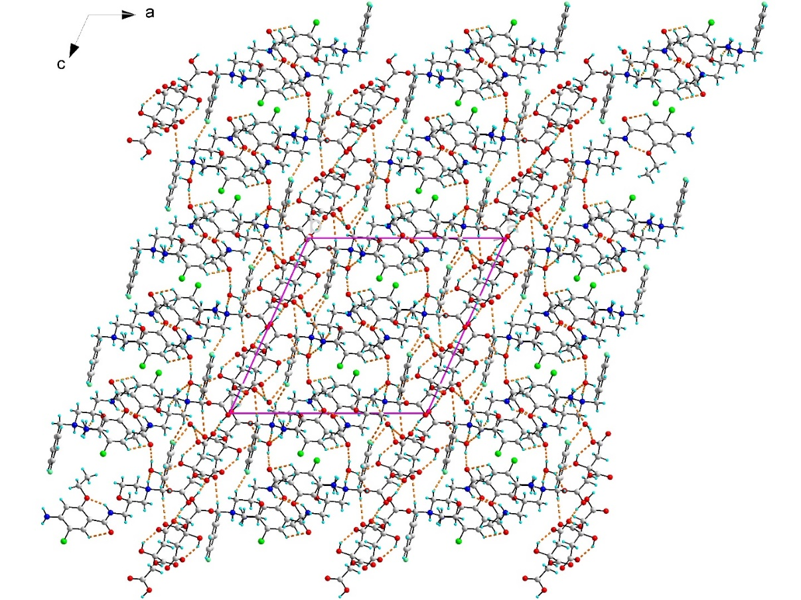

Figure S1. Packing arrangement of mosapride dihydrogen citrate dihydrate along the *b*-axis.

D:\VARIOS\ROBERT\ARTÍCULOS\MOSAPRIDE CITRATO\FIGURAS\ENLACES-H-3.tif

Figure S2. Dimers formed by hydrogen bonds and π⋯π interactions along the *b* axis.

The Hirshfeld surface (HS) mapped onto *d*norm, shape index, and curvedness for Mdcd are shown in Figure S3. The Hirshfeld surface have a volume of Vs= 728.98 Å3, corresponding to 97.79% of the occupied volume of the unit cell, indicating that there are few interstices in the packing. The HS shows intense red spots corresponding to the hydrogen bonds shown in Table S1. The shape index surfaces of Mdcd show the surface dents as red spots which are associated with the hydrogen bond acceptors while the bumps are shown in blue and correspond to the hydrogen bond donor atoms. The surfaces mapped with curvedness show few flat areas except for a small area of one of the faces of the C-ring (red circle, Figure S3c), where the *C*g(C)⋯*C*g(C) interaction occurs, indicating that the molecules are not stacked one on top of the other; H2Cit− presents few flat areas on the surface due to hydrogen bonds with water molecules (blue circles, Figure S3f) and with other H2Cit− moieties (magenta circles, Figure S3f). On the other hand, the surfaces of the water molecules show several flat areas due to the participation in short contacts with Msp+ (yellow circles, Figure S3c) and with the dihydrogen citrate counterion.

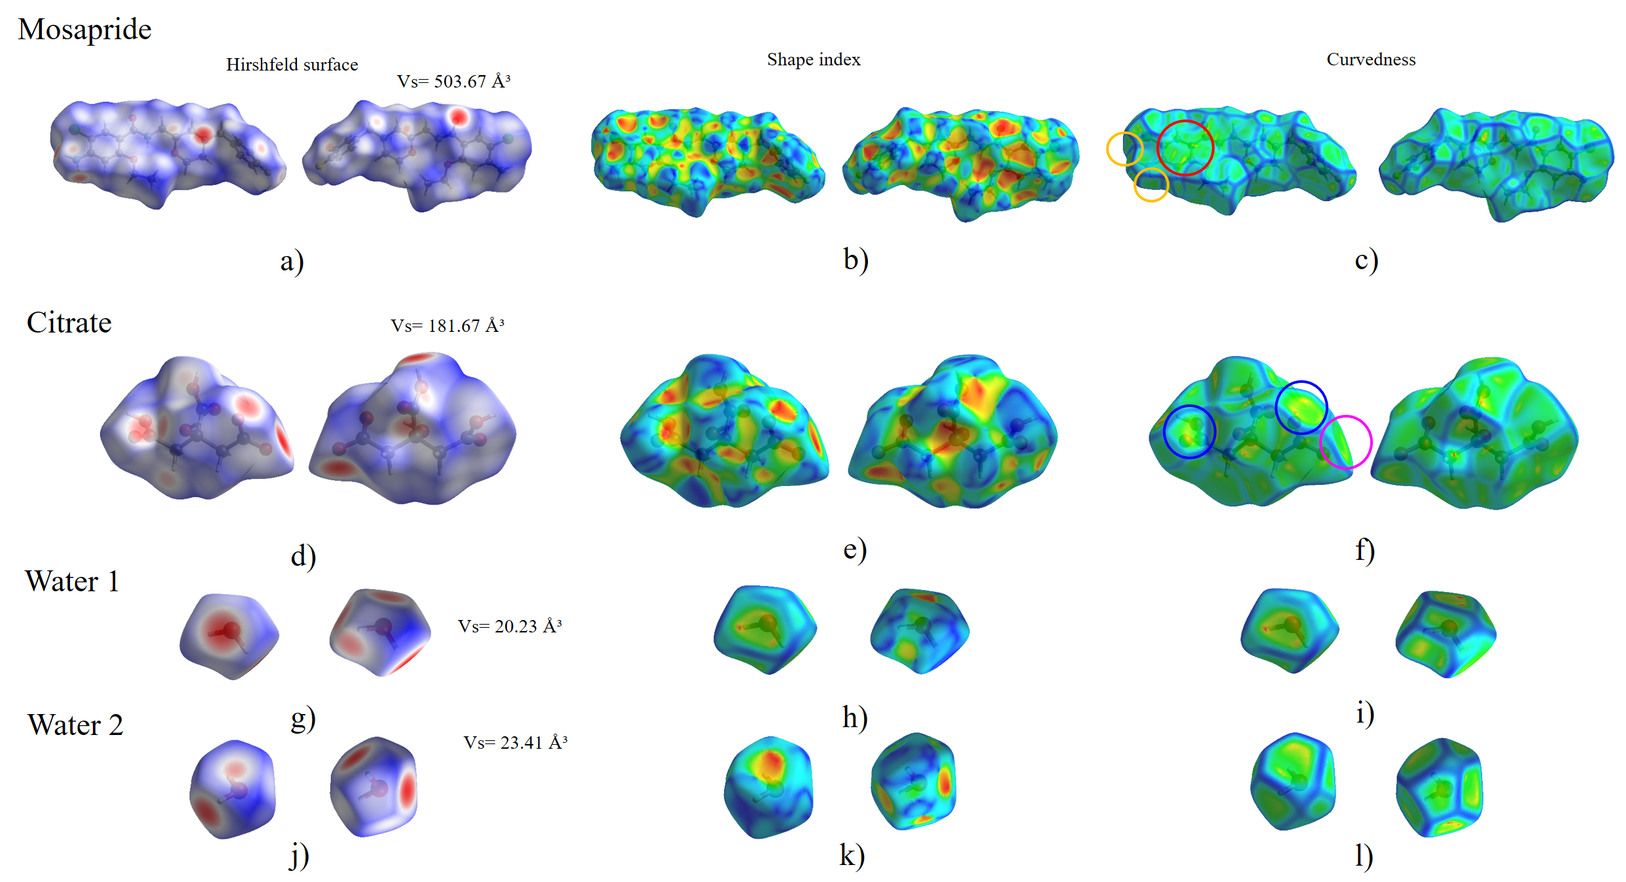

Figure S3. *d*norm, shape index, and curvedness mapped onto the HS for Mdcd.

The contributions of short-distance contacts in the structure of Mdcd are shown in the fingerprint plots of Figure S4. The O⋯H/H⋯O interactions represent the largest contribution on the surfaces of the H2Cit− and the water molecules, while in Msp+ it is the H⋯H contact followed by the O⋯H/ H⋯O and C⋯H/ H⋯C contacts. This indicates that hydrogen bonds are more important in the dihydrogen citrate ion and water molecules while dispersive forces are more relevant in Msp+. Additionally, H⋯Hal/Hal⋯H contacts (Hal = Cl, F) are also important in Msp+.

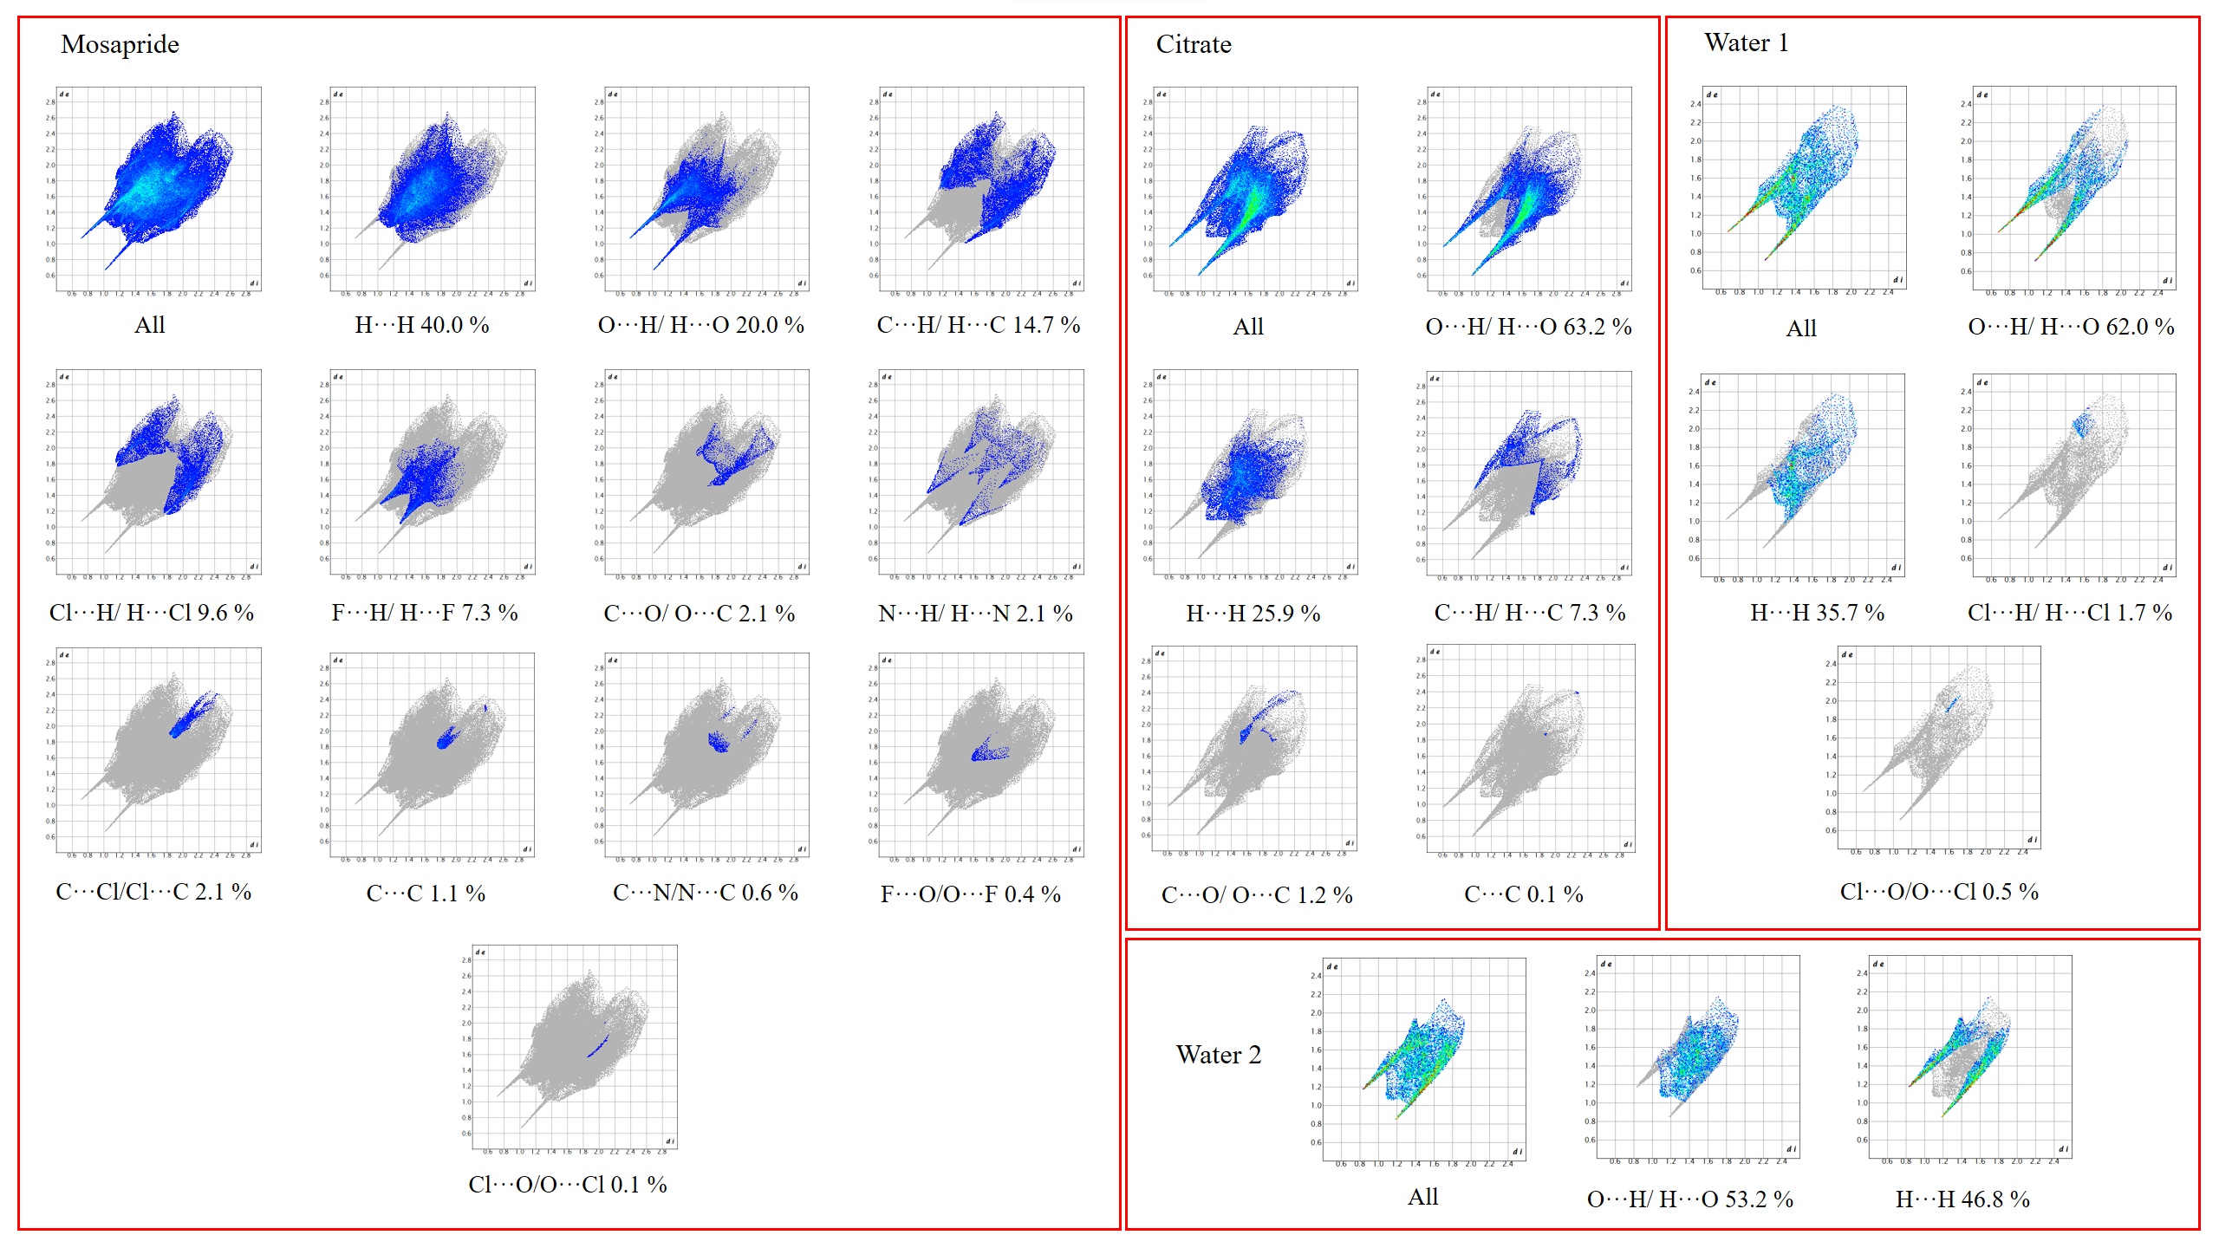

Figure S4. Fingerprint plots for Msp+, H2Cit−, and water molecules and % contributions from specific pairs of interatomic interactions.