Supplementary Material for
Crystal structure of rilpivirine hydrochloride, N₆H₁₉C₂₂Cl
Petr Buikin,^{1,2} Alexander Korlyukov,¹ Roman Svetogorov,³ Nadezhda Bakuleva,³ Roman Novikov,⁴ and Anna Vologzhanina^{1,a)}
¹ A. N. Nesmeyanov Institute of Organoelement Compounds RAS, Vavilova str. 28, 119334 Moscow, Russia
² Institute of General and Inorganic Chemistry RAS, Leninsky Prosp. 31,119991, Moscow, Russia.
³ Kurchatov Institute, National Research Center, Pl. Akad. Kurchatova 1, 123182 Moscow, Russia
⁴ N. D. Zelinsky Institute of Organic Chemistry, RAS. Leninsky Prosp. 47, 119991 Moscow, Russia.

Figure S1. Unit cells of the optimized (blue) and refined (model I, red) models.

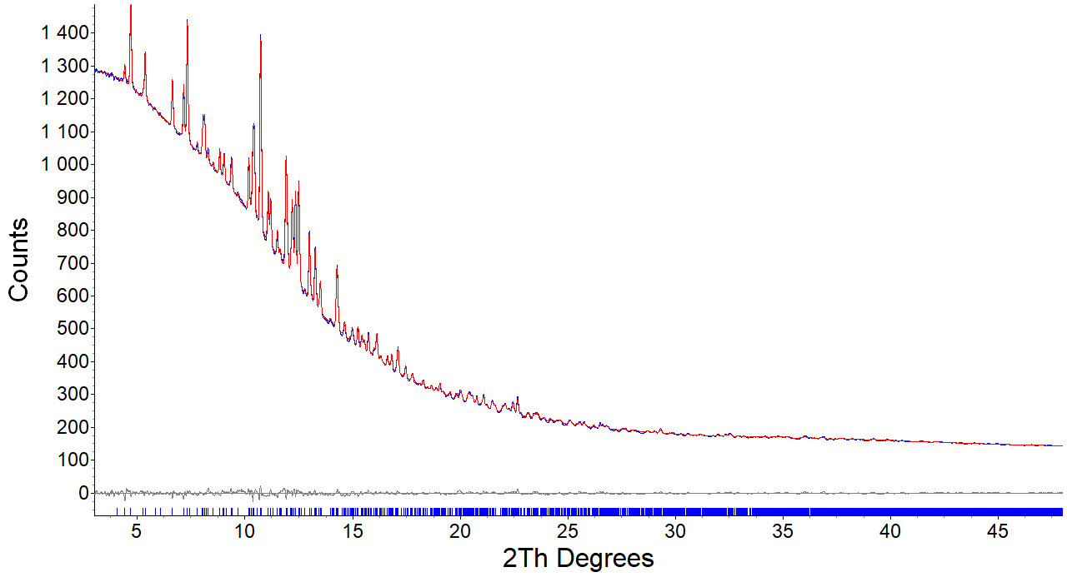
a
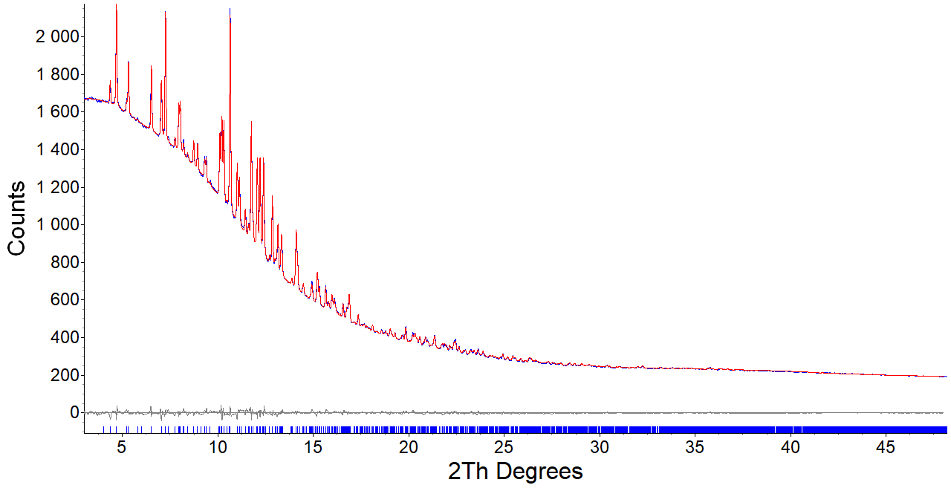
b
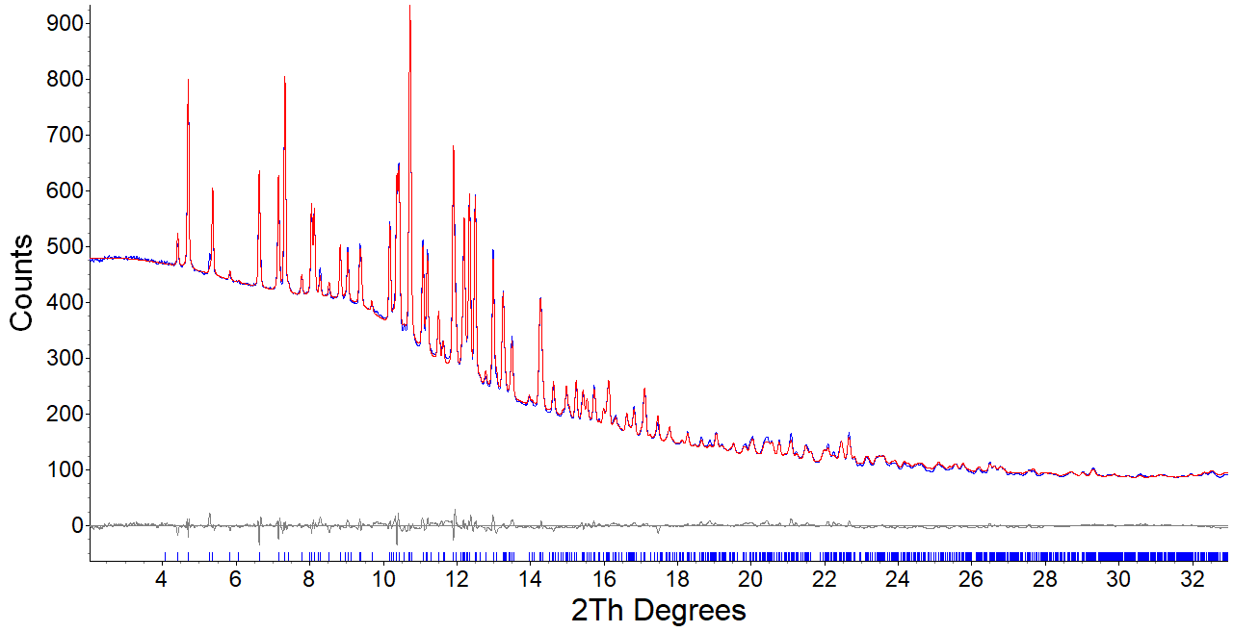
c
Figure S2. XRD patterns of I (a), II and III. Red and blue lines correspond to the calculated profile and experimental pattern respectively. The bottom trace shows the difference curve.
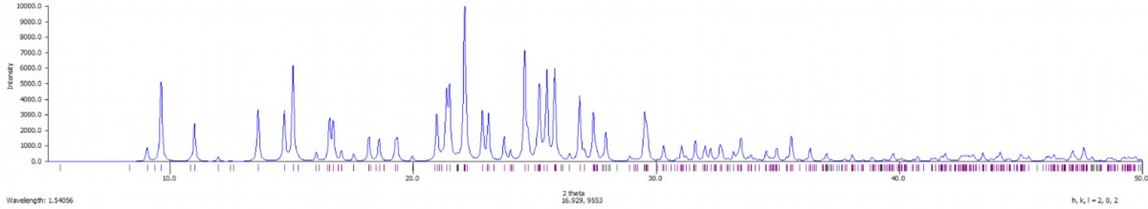
Figure S3. Theoretical XRD pattern for IV for CuKα-radiation.
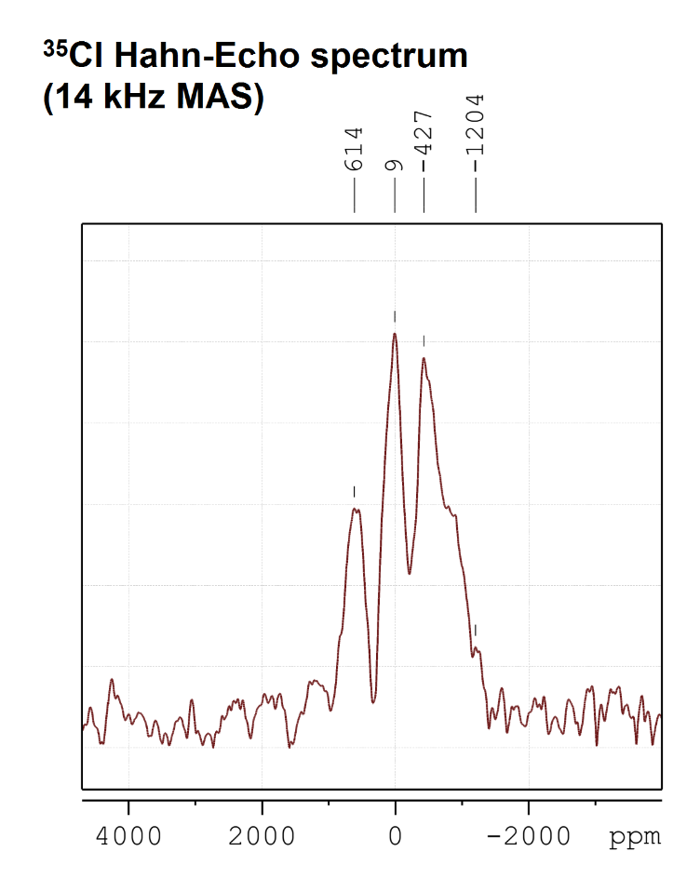
Figure S4. ³⁵Cl Hahn-Echo solid-state NMR spectrum (14 kHz MAS) of powder Rilpivirin-HCl.

Table S1. Characteristic peak positions and intensities for sample II (λ = 0.75 Å)
H | K | L | d_{obs} (Å) | d_{calc} (Å) | ∆d | 2θ_{obs} (°) | 2θ_{calc} (°) | ∆2θ | I/Io
1 | 1 | 0 | 10.7026 | 10.8500 | 0.1474 | 4.0159 | 3.9600 | -0.0559 | 0.77
1 | -1 | -1 | 9.8463 | 9.8400 | -0.0063 | 4.3653 | 4.3700 | 0.0047 | 0.81
2 | 0 | 0 | 9.1604 | 9.1500 | -0.0104 | 4.6923 | 4.7000 | 0.0077 | 1.00
1 | 1 | 1 | 8.2209 | 8.2000 | -0.0209 | 5.2290 | 5.2400 | 0.0110 | 0.78
0 | 0 | 2 | 8.0840 | 8.0800 | -0.0040 | 5.3176 | 5.3200 | 0.0024 | 0.87
2 | 0 | -2 | 7.4013 | 7.3900 | -0.0113 | 5.8085 | 5.8200 | 0.0115 | 0.73
0 | 2 | 0 | 6.5933 | 6.5800 | -0.0133 | 6.5210 | 6.5300 | 0.0090 | 0.85
0 | 2 | 1 | 6.1052 | 6.1000 | -0.0052 | 7.0430 | 7.0500 | 0.0070 | 0.80
1 | 1 | 2 | 5.9220 | 5.9100 | -0.0120 | 7.2611 | 7.2700 | 0.0089 | 0.99
3 | 1 | 0 | 5.5415 | 5.5300 | -0.0115 | 7.7604 | 7.7700 | 0.0096 | 0.68
2 | -2 | -1 | 5.4023 | 5.4000 | -0.0023 | 7.9607 | 7.9700 | 0.0093 | 0.76
2 | 2 | 0 | 5.3513 | 5.3500 | -0.0013 | 8.0367 | 8.0400 | 0.0033 | 0.77
1 | -1 | -3 | 5.2388 | 5.2400 | 0.0012 | 8.2097 | 8.2100 | 0.0003 | 0.68
0 | 2 | 2 | 5.1094 | 5.1100 | 0.0006 | 8.4179 | 8.4200 | 0.0021 | 0.64
2 | -2 | -2 | 4.9232 | 4.9200 | -0.0031 | 8.7370 | 8.7400 | 0.0030 | 0.67
3 | 1 | 1 | 4.8161 | 4.8100 | -0.0061 | 8.9315 | 8.9500 | 0.0185 | 0.67
3 | -1 | -3 | 4.6213 | 4.6200 | -0.0013 | 9.3090 | 9.3200 | 0.0111 | 0.63
4 | 0 | 0 | 4.5802 | 4.5800 | -0.0002 | 9.3926 | 9.3900 | -0.0026 | 0.63
1 | 1 | 3 | 4.4774 | 4.4800 | 0.0026 | 9.6088 | 9.6100 | 0.0012 | 0.57
2 | 0 | -4 | 4.2564 | 4.2500 | -0.0064 | 10.1090 | 10.1200 | 0.0110 | 0.69
1 | -3 | -1 | 4.2137 | 4.2100 | -0.0037 | 10.2116 | 10.2100 | -0.0016 | 0.72
0 | 2 | 3 | 4.1727 | 4.1700 | -0.0027 | 10.3122 | 10.3200 | 0.0078 | 0.72
0 | 0 | 4 | 4.0420 | 4.0400 | -0.0020 | 10.6467 | 10.6500 | 0.0033 | 1.00
4 | -2 | -1 | 3.9063 | 3.9100 | 0.0037 | 11.0175 | 11.0200 | 0.0025 | 0.60
3 | -1 | -4 | 3.8668 | 3.8600 | -0.0068 | 11.1306 | 11.1400 | 0.0094 | 0.58
4 | 2 | 0 | 3.7617 | 3.7600 | -0.0017 | 11.4427 | 11.4500 | 0.0073 | 0.50
5 | -1 | -1 | 3.7049 | 3.0000 | -0.7049 | 11.6186 | 11.6300 | 0.0115 | 0.47
1 | 3 | 2 | 3.6632 | 3.6600 | -0.0032 | 11.7513 | 11.7600 | 0.0087 | 0.70
3 | 3 | 0 | 3.5675 | 3.5700 | 0.0025 | 12.0675 | 12.0700 | 0.0025 | 0.62
3 | -3 | -2 | 3.5261 | 3.5200 | -0.0061 | 12.2098 | 12.2200 | 0.0102 | 0.62
2 | 2 | 3 | 3.4753 | 3.4700 | -0.0053 | 12.3890 | 12.4000 | 0.0111 | 0.63
3 | 1 | 3 | 3.3872 | 3.3900 | 0.0029 | 12.7128 | 12.7200 | 0.0072 | 0.39
3 | 3 | 1 | 3.3498 | 3.3500 | 0.0002 | 12.8553 | 12.8600 | 0.0047 | 0.53
1 | -1 | -5 | 3.2763 | 3.2800 | 0.0037 | 13.1449 | 13.1500 | 0.0051 | 0.46

Table S2. Characteristic peak positions and intensities for sample IV (λ = 0.75 Å)
H | K | L | d_{obs} (Å) | d_{calc} (Å) | ∆d | 2θ_{obs} (°) | 2θ_{calc} (°) | ∆2θ | I/Io
1 | -1 | -1 | 9.8036 | 9.8000 | -0.0036 | 4.3843 | 4.3800 | -0.0043 | 0.50
2 | 0 | 0 | 9.1651 | 9.1600 | -0.0051 | 4.6899 | 4.7000 | 0.0101 | 0.82
1 | 1 | 1 | 8.1938 | 8.1900 | -0.0038 | 5.2463 | 5.2500 | 0.0037 | 0.47
0 | 0 | 2 | 8.0674 | 8.0700 | 0.0026 | 5.3285 | 5.3300 | 0.0015 | 0.60
0 | 2 | 0 | 6.5472 | 6.5400 | -0.0072 | 6.5670 | 6.5700 | 0.0030 | 0.61
0 | 2 | 1 | 6.0667 | 6.0600 | -0.0067 | 7.0877 | 7.0900 | 0.0023 | 0.59
1 | 1 | 2 | 5.9066 | 5.9000 | -0.0066 | 7.2802 | 7.2900 | 0.0098 | 0.81
3 | 1 | 0 | 5.5370 | 5.5400 | 0.0030 | 7.7669 | 7.7600 | -0.0069 | 0.43
2 | -2 | -1 | 5.3772 | 5.3800 | 0.0028 | 7.9980 | 8.0000 | 0.0020 | 0.56
2 | 2 | 0 | 5.3275 | 5.3300 | 0.0025 | 8.0728 | 8.0700 | -0.0027 | 0.57
1 | -1 | -3 | 5.2239 | 5.2200 | -0.0039 | 8.2331 | 8.2300 | -0.0031 | 0.45
0 | 2 | 2 | 5.0837 | 5.0800 | -0.0037 | 8.4606 | 8.4600 | -0.0006 | 0.41
2 | -2 | -2 | 4.9018 | 4.9000 | -0.0018 | 8.7751 | 8.7800 | 0.0049 | 0.48
3 | 1 | 1 | 4.8116 | 4.7900 | -0.0216 | 8.9400 | 8.9800 | 0.0400 | 0.49
3 | -1 | -3 | 4.6135 | 4.6100 | -0.0035 | 9.3248 | 9.3300 | 0.0053 | 0.47
4 | 0 | 0 | 4.5826 | 4.5800 | -0.0026 | 9.3877 | 9.3900 | 0.0023 | 0.63
1 | 1 | 3 | 4.4670 | 4.4700 | 0.0030 | 9.6312 | 9.6300 | -0.0012 | 0.39
2 | 0 | -4 | 4.2484 | 4.2500 | 0.0016 | 10.1280 | 10.1300 | 0.0021 | 0.56
1 | -3 | -1 | 4.1863 | 4.1900 | 0.0037 | 10.2788 | 10.2800 | 0.0012 | 0.59
0 | 2 | 3 | 4.1559 | 4.1600 | 0.0042 | 10.3542 | 10.3600 | 0.0058 | 0.61
0 | 0 | 4 | 4.0420 | 4.0300 | -0.0120 | 10.6467 | 10.6700 | 0.0233 | 1.00
4 | -2 | -1 | 3.8981 | 3.9000 | 0.0019 | 11.0408 | 11.0400 | -0.0008 | 0.52
3 | -1 | -4 | 3.8594 | 3.8600 | 0.0006 | 11.1520 | 11.1500 | -0.0020 | 0.49
4 | 2 | 0 | 3.7543 | 3.7500 | -0.0043 | 11.4651 | 11.4600 | -0.0051 | 0.38
5 | -1 | -1 | 3.7049 | 3.7000 | -0.0049 | 11.6186 | 11.6200 | 0.0014 | 0.33
1 | 3 | 2 | 3.6437 | 3.6400 | -0.0037 | 11.8144 | 11.8200 | 0.0056 | 0.62
3 | 3 | 0 | 3.5517 | 3.5500 | -0.0017 | 12.1217 | 12.1200 | -0.0017 | 0.53
3 | -3 | -2 | 3.5100 | 3.5100 | 0.0000 | 12.2663 | 12.2700 | 0.0038 | 0.59
2 | 2 | 3 | 3.4653 | 3.4600 | -0.0053 | 12.4249 | 12.4300 | 0.0051 | 0.57
3 | 1 | 3 | 3.3827 | 3.3800 | -0.0027 | 12.7298 | 12.7300 | 0.0002 | 0.27
3 | 3 | 1 | 3.3361 | 3.3400 | 0.0039 | 12.9082 | 12.9100 | 0.0018 | 0.46
1 | -1 | -5 | 3.2684 | 3.2700 | 0.0017 | 13.1769 | 13.1800 | 0.0031 | 0.41

Atomic coordinates of the optimized model
CELL 0.71075 19.430542 13.094307 17.102518 90 109.393692 90
LATT 7
SYMM -X,+Y,0.5-Z
Cl2 0.39352 0.15220 0.34729
N8 0.21437 0.50969 0.45734
N11 0.12136 0.50352 0.51697
N24 0.19848 0.59550 0.33595
N28 0.64558 0.35317 0.36761
N37 0.22971 0.41657 0.57857
N47 0.53189 0.13362 0.61798
C3 0.18935 0.47761 0.51573
C16 0.07601 0.55953 0.45350
C24 0.09788 0.59123 0.38966
C32 0.17048 0.56582 0.39398
C40 0.27145 0.56859 0.34189
C42 0.28304 0.47680 0.30511
C50 0.35444 0.44799 0.31529
C64 0.41381 0.50929 0.36027
C72 0.40000 0.60160 0.39411
C80 0.32921 0.63255 0.38633
C82 0.22001 0.40997 0.25889
C96 0.31624 0.72887 0.42668
C101 0.48887 0.48123 0.37175
C108 0.51171 0.38859 0.35487
C116 0.58535 0.37012 0.36305
C125 0.29468 0.36577 0.58518
C133 0.33360 0.32346 0.66297
C141 0.39525 0.26458 0.67331
C149 0.41968 0.24704 0.60563
C157 0.38191 0.29151 0.52827
C165 0.32042 0.35063 0.51819
C173 0.48149 0.18469 0.61360
H3 0.10419 0.47401 0.56373
H16 0.02234 0.57746 0.45656
H24 0.06138 0.63471 0.33855
H32 0.16411 0.62546 0.28043
H34 0.36336 0.37700 0.28688
H48 0.44574 0.64986 0.42873
H50 0.17733 0.45216 0.21135
H58 0.19373 0.37823 0.30141
H66 0.23839 0.34626 0.22935
H80 0.31397 0.71200 0.48881
H88 0.26451 0.76568 0.39176
H96 0.36108 0.78276 0.43374
H102 0.52985 0.54077 0.39613
H108 0.47422 0.32410 0.33396
H117 0.20341 0.39404 0.61947
H125 0.31478 0.33670 0.71550
H133 0.42397 0.23102 0.73362
H141 0.39972 0.27697 0.47512
H149 0.29189 0.38462 0.45837
Table S3. Calculated and experimental chemical shifts for sample IV.

Atom label | ISO c.s., ppm | Standard value, ppm | δ_{calc}, ppm | δ_{exp}, ppm | δ_{calc}^{corr}, ppm
N4 | 226.7 | 16.4 | 210.2 | 201.4 | 212.4
N6 | 156.3 | 16.4 | 139.8 | 132.3 | 139.1
N10 | 151.3 | 16.4 | 134.8 | 126.4 | 132.9
N22 | 297.0 | 16.4 | 280.5 | 262.5 | 277.2
N23 | 137.5 | 16.4 | 121.0 | 111.4 | 117.0
N31 | 291.5 | 16.4 | 275.1 | 258.3 | 272.7
C5 | 182.5 | 32.1 | 150.4 | 162.7 | 171.4
C7 | 180.8 | 32.1 | 148.7 | 145.0 | 152.6
C8 | 135.7 | 32.1 | 103.6 | 99.7 | 104.6
C9 | 194.2 | 32.1 | 162.1 | 150.4 | 158.3
C11 | 178.0 | 32.1 | 145.9 | 138.5 | 145.7
C16 | 175.8 | 32.1 | 143.7 | 137.4 | 144.6
C15 | 164.1 | 32.1 | 132.0 | 131.6 | 138.4
C14 | 169.9 | 32.1 | 137.8 | 132.8 | 139.7
C13 | 169.3 | 32.1 | 137.2 | 128.9 | 135.5
C12 | 178.3 | 32.1 | 146.2 | 137.0 | 144.1
C18 | 53.7 | 32.1 | 21.6 | 18.3 | 18.3
C17 | 50.3 | 32.1 | 18.3 | 19.7 | 19.8
C19 | 19.4 | 32.1 | 159.3 | 148.6 | 156.4
C20 | 131.8 | 32.1 | 99.7 | 97.2 | 101.9
C21 | 161.7 | 32.1 | 129.6 | 118.3 | 124.3
C24 | 177.5 | 32.1 | 145.5 | 141.7 | 149.1
C25 | 156.9 | 32.1 | 124.8 | 120.5 | 126.6
C26 | 170.3 | 32.1 | 138.3 | 131.6 | 138.4
C27 | 138.0 | 32.1 | 105.9 | 104.4 | 109.6
C28 | 172.8 | 32.1 | 140.8 | 131.6 | 138.4
C29 | 156.0 | 32.1 | 124.0 | 120.5 | 126.6
C30 | 163.5 | 32.1 | 131.4 | 118.3 | 124.3

ISO c.s. – calculated isotropic chemical shift
Standard value – the value of ISO c.s. calculated for ¹³C (orthorhombic SiMe₄) and ¹⁵N (crystalline ammonia)
δ_{calc} – chemical shift calculated as ISO c.s. - Standard value
δ_{exp} – experimental value of chemical shift
δ_{calc}^{corr} – the values of δ_{calc} corrected with linear regression (Fig. S5)

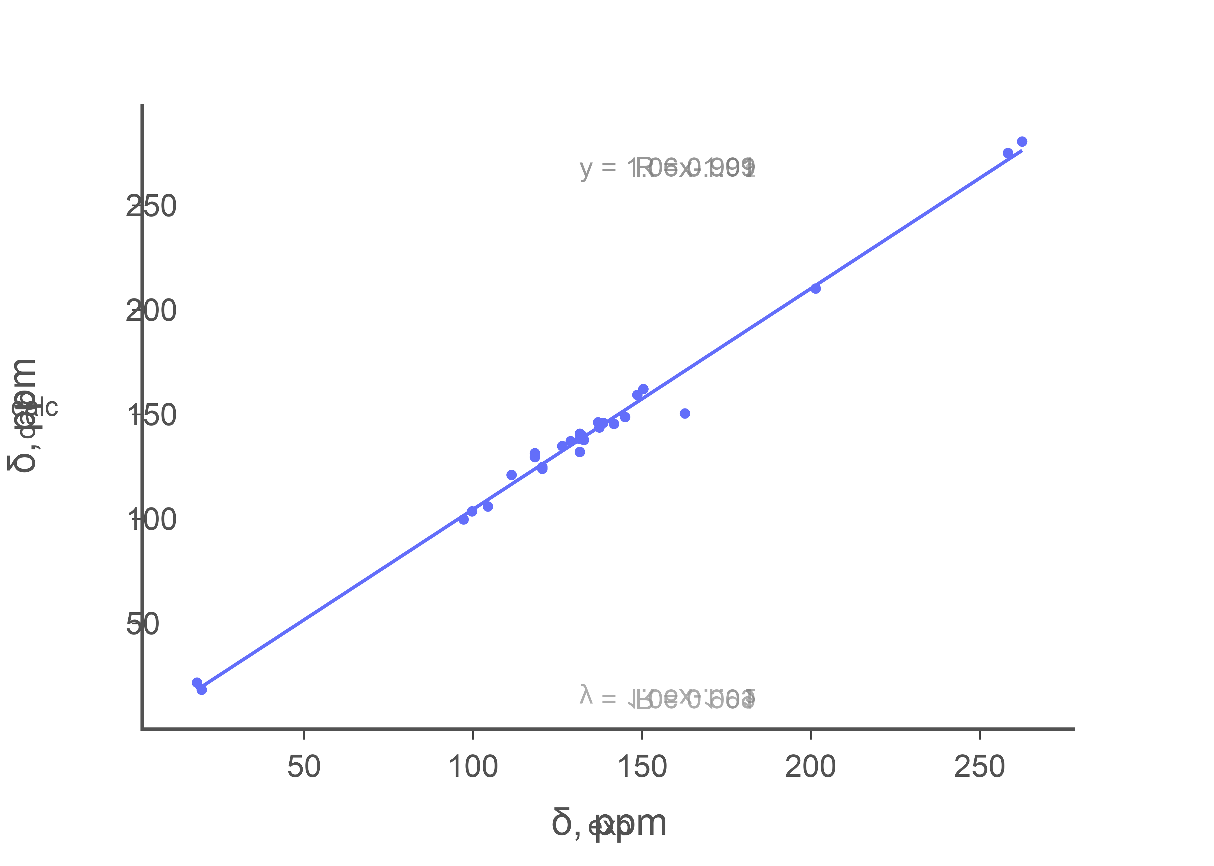
Figure S5. δ_{exp} vs δ_{calc} plot.

