Supplementary information file
  - Experimental details of Laboratory XRD measurements and data analysis using pseudo-Voigt function:
Laboratory XRD measurements were performed using Bruker D8 powder diffractometer (copper Kα radiations) on the two Si powders in 2θ range from 25º - 120º. XRD data acquisition time at each step (step size and rotation speed) was 4 s (0.015º @ 100 rpm) and 7 s (0.022º @ 50 rpm) for SRM 640d and as-received Si powder, respectively. These XRD patterns were analysed using the WPPF and WPPM approaches similar to the analysis of synchrotron data for comparing IRF effects. The angular dependence of FWHM of the diffraction peaks of both the Si powders were modelled using pV peak profile function. It (pV) is derivative of the original formula proposed by Caglioti, Paoletti and Ricci (Caglioti, Paoletti, and Ricci 1958). The mathematical expressions for FWHM (H) of observed peak profile (isotropic case) are represented as following (FullProf Manual, July 2001, https://www.psi.ch/sinq/dmc/ManualsEN/fullprof.pdf):
$H^{2}=U\tan^{2}θ+Vtanθ+W$ (S1)
η = η₀+X.2θ (S2)
Here U, V, W (units in degrees square) and η₀ & X (unitless) are refinable quantities.The diffraction patterns of both Si powders were fitted using the Rietveld method (as per Eqs. S1 and S2) and resulting values of the FWHM and Lorentzian fraction, η, are shown in Figure S1 (a & b). Intensity ratio of Cu K_{α1} (1.540593 Å) and Cu K_{α2} (1.544427 Å) were kept fixed as 2:1 (Hölzer et al. 1997) and linear variation of η (η₀ + X×2θ) parameter was constrained for preparing IRF as per FullProf manual. IRF was prepared using SRM 640d Si powder and the purpose of choosing this SRM (having linear attenuation co-efficient identical to that of as-received Si powder) was to minimize the effects of micro-absorption, transparency etc. arises due to different choices of SRM which is valid for both laboratory and synchrotron XRD data. Observed large values of η >1 for various diffraction peaks of as-received Si powder indicating super-Lorentzian nature of peak profile are highlighted with yellow region in Figure S1(b). The FWHM and IB of 111 reflection of SRM 640d are found to be about 0.052°and 0.072°, respectively, for lab source and about 0.017° and 0.023° for BL-02, Indus-2 synchrotron source (Gupta et al. 2021), respectively. Thus, instrumental resolution of BL-02 is more than 3 times narrower than lab (Cu Kα) source.
Figure S1. Comparison of angular dependency of (a) FWHM and (b) η parameters derived from Rietveld refinement of laboratory XRD data of SRM 640d Si powder and Si powder sample using pV profile.

  - Microstructural characterization using TCH profile function and the Rietveld Method(WPPF approach):
Laboratory XRD pattern of Si powder sample was analyzed using isotropic unimodal and bimodal microstructural approaches (as per Eqs. 1 and 2) and the Rietveld method. Resulting profile fittings are shown in Figure S2 and S3. Insets show quality of fitting for three Bragg peaks across the full diffraction pattern for clarity. Profile fitting is improved using bimodal approach and derived parameters are given in Table 1. During bimodal WPPF analysis it was observed that the refined value of Lorentzian size parameter Y was close to zero for narrow profile and value of Gaussian size parameter I_{G} was going negative for broad profile. This observation was found to be the same for both laboratory and synchrotron XRD data. Therefore, these values were kept fixed at zero as advised by Balzar et al. (Balzar et al. 2004) and the resulting nature of size broadening contributions of narrow and broad profiles of Si were found to be almost Gaussian (η = 0) and almost Lorentzian (η = 1), respectively. It is interesting to note that the negative value of I_{G} parameter of the broad profile indicates the possibility of super-Lorentzian (η> 1) peak shapes (this is also concluded from the WPPM result). But TCH formulation restricts maximum value of η to be 1(Bhakar, Taxak, and Rai 2023), therefore, hinder its applicability for super-Lorentzian case and not probed further in this approach. Modified March’s function was used as an approximation to account preferred orientation in the [111] direction (March 1932; Dollase 1986). Only one parameter G₁ of March’s function was refined during Rietveld refinements and the second parameter G₂ was kept fixed at zero. Adequate profile fitting was obtained by considering the same value of G₁ parameter for narrow and broad profiles during bimodal WPPF analysis of laboratory or synchrotron XRD patterns of Si powder. Since the value of G₁ = 1 corresponds to random orientation of the powder, therefore the refined value of G₁ parameter ~ 0.9 indicate small preferred orientation.

Figure S2. Unimodal Rietveld refinement of laboratory XRD data of Si powder sample using TCH peak profile function. Insets show the quality of fitting of three Bragg peaks 111, 331 and 531 across the full diffraction pattern. Laboratory XRD data is represented by red circles, fitted and difference curve are shown using black and blue lines, respectively. Positions of Bragg peaks are represented by green vertical ticks. Rietveld R-factors (not corrected to background) are: R_{p}: 3.85%, R_{wp}: 5.01%, R_{exp}: 2.22% and χ²: 5.1.

Figure S3. Bimodal Rietveld refinement of laboratory XRD data of Si powder sample using TCH peak profile function. Insets show the quality of fitting of three Bragg peaks 111, 331 and 531 across the full diffraction pattern.Laboratory XRD data is represented by red circles, fitted and difference curve are shown using black and blue lines, respectively. Positions of Bragg peaks are represented by green vertical ticks. Rietveld R-factors (not corrected to background) are: R_{p}: 3.12%, R_{wp}: 4.25%, R_{exp}: 2.22% and χ²: 3.67.

  - Microstructural characterization using WPPM approach:
Laboratory XRD pattern of Si powder sample was analyzed using unimodal and bimodal microstructural WPPM approaches as per section 3.4. In order to account for low angle asymmetry of diffraction peaks due to axial /instrument divergence, TCH like peak profile was considered as reported by Tseng (Tseng 2017). The lognormal size distribution of spherical crystallites and dislocations were considered as the main source of peak broadening due to sample effects. Resulting profile fittings are shown in Figure S4 and S5 and parameters obtained from bimodal WPPM analysis are given in Table 1. Here it is important to note that profile fitting is improved marginally using a bimodal approach as could be seen from insets of Figure S4 and S5. Contrary to this result pronounced differences are clearly visualized between unimodal and bimodal WPPM and WPPF fittings of synchrotron XRD data and these differences are clearly observed from Figure 4 and 8. This shows the importance of high q-range data of synchrotron source to quantify inhomogeneous microstructures of Si powder. Contribution from faulting was considered during WPPM analysis (as visible in Figure S7) and refined values are comparable to those reported in the literature (Matěj et al. 2014).
In WPPM analysis peak intensities are treated as free parameters. This leads to strong correlations among all overlapping Bragg peaks (due to almost equal unit cell parameters) of narrow and broad microstructural components. In order to estimate reliable phase fraction of both microstructural components of bimodal approach, the procedure followed was the same as reported for bimodal WPPM analysis of Fe powder (Bhakar et al. 2021). Wherein peak intensities of one microstructural component were refined and linked with respective peak intensities of the second microstructural component using a suitable scheme of weight fraction. It is applicable in the present case also. This is because intensity ratios of different Bragg peaks of a diffraction pattern depend upon structural parameters of materials (i.e. atom type (composition), atomic positions in unit cell and ADPs). Rietveld refinement method considers these factors appropriately. During bimodal Rietveld refinement of Si powder (in section § 3.2) atomic positions of Si in fcc unit cell were kept the same and fixed at 8a (1/8, 1/8, 1/8) Wyckoff positions and it was observed that equal values of preferred orientation, ADPs and unit cell parameters of both microstructural components (narrow and broad) are appropriate for adequate bimodal WPPF analysis. Therefore, relative peak intensity ratios for all respective Bragg peaks of broad and narrow profiles of Si powder (with same hkl) shall be equal and constant. This situation is similar to bimodal WPPM analysis of Fe powder which is being pursued in this work.

Figure S4. Unimodal WPPM fitting of laboratory XRD data of Si powder sample. Insets show the quality of fitting of three Bragg peaks 111, 331 and 531 across the full diffraction pattern. Laboratory XRD data is represented by red circles, fitted and difference curve are shown using black and blue lines, respectively. R-factors: WSS: 22160, R_{wp}: 5.08%, R_{exp}: 2.22% and χ²: 5.24.

Figure S5. Bimodal WPPM fitting of laboratory XRD data of Si powder. Insets show the quality of fitting of three Bragg peaks 111, 331 and 531 across the full diffraction pattern. Laboratory XRD data is represented by red circles, fitted and difference curve are shown using black and blue lines, respectively. R-factors: WSS: 17900,R_{wp}: 4.57%, R_{exp}: 2.22% and χ²: 4.24.

S4. DLS result:
DLS measurement was carried out using Malvern Zetasizer Nano-S (4 mW, 632.8 nm ‘red’ laser). Si powder was dispersed in distilled water and ultrasonicated for half an hour. Bigger particles remain settled at the bottom of beaker. Adequate amount of solution was gently poured into a disposable cuvette using pipette and measurement was carried out. Observed particle size distribution is shown in Figure S6 which indicates that the estimated mean size is about 350 nm.
Figure S6. Particle size distribution of Si powder (portion of output file generated by.Malvern Zetasizer Nano-S.

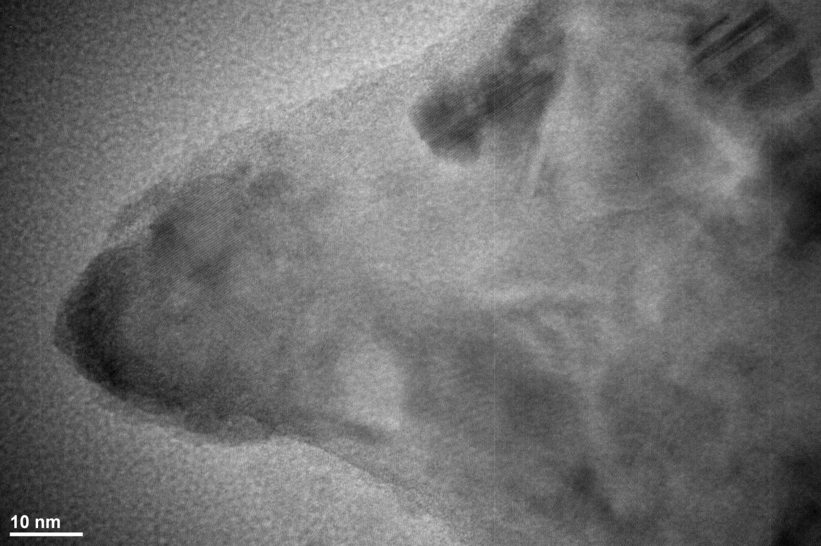
Figure S7. A representative TEM High resolution (HR) image of Si powder. The HR lattice fringes can be seen in some regions of few tens of nanometres sizes, indicating these regions to be isolated single crystals. Some crystal defects can also be seen in the top most particles as marked by blue color arrows. The alternate bright/dark bands suggest the presence of stacking faults. Some dislocations are also visible as indicated by intermittently discontinued lattice fringes.

References
Balzar, D., N. Audebrand, M. R. Daymond, A. Fitch, A. Hewat, J. I. Langford, A. Le Bail, et al. 2004. “Size–Strain Line-Broadening Analysis of the Ceria Round-Robin Sample.” Journal of Applied Crystallography 37 (6): 911–24. https://doi.org/10.1107/S0021889804022551.
Bhakar, Ashok, Pooja Gupta, P N Rao, M K Swami, Pragya Tiwari, Tapas Ganguli, and S K Rai. 2021. “Line Profile Analysis of Synchrotron X-Ray Diffraction Data of Iron Powder with Bimodal Microstructural Profile Parameters.” Journal of Applied Crystallography 54 (2): 498–512. https://doi.org/10.1107/S1600576721000601.
Bhakar, Ashok, Manju Taxak, and Sanjay Kumar Rai. 2023. “Significance of Diffraction Peak Shapes in Determining Crystallite Size Distribution: A Peak Shape Analysis Procedure for Pseudo-Voigt Profiles and Its Application.” Journal of Applied Crystallography 56 (5): 1466–79. https://doi.org/10.1107/S1600576723007367.
Caglioti, G., A. Paoletti, and F.P. P. Ricci. 1958. “Choice of Collimators for a Crystal Spectrometer for Neutron Diffraction.” Nuclear Instruments 3 (4): 223–28. https://doi.org/10.1016/0369-643X(58)90029-X.
Dollase, W. A. 1986. “Correction of Intensities for Preferred Orientation in Powder Diffractometry: Application of the March Model.” Journal of Applied Crystallography 19 (4): 267–72. https://doi.org/10.1107/S0021889886089458.
Gupta, Pooja, P. N. Rao, M. K. Swami, A. Bhakar, Sohan Lal, S. R. Garg, C. K. Garg, et al. 2021. “BL-02: A Versatile X-Ray Scattering and Diffraction Beamline for Engineering Applications at Indus-2 Synchrotron Source.” Journal of Synchrotron Radiation 28 (4): 1193–1201. https://doi.org/10.1107/S1600577521004690.
Hölzer, G., M. Fritsch, M. Deutsch, J. Härtwig, and E. Förster. 1997. “Kα1,2 and Kβ1,3 x-Ray Emission Lines of the 3d Transition Metals.” Physical Review A 56 (6): 4554–68. https://doi.org/10.1103/PhysRevA.56.4554.
March, Artur. 1932. “Mathematische Theorie Der Regelung Nach Der Korngestah Bei Affiner Deformation.” Zeitschrift Für Kristallographie - Crystalline Materials 81 (1–6): 285–97. https://doi.org/10.1524/zkri.1932.81.1.285.
Matěj, Z., A. Kadlecová, M. Janeček, L. Matějová, M. Dopita, and R. Kužel. 2014. “Refining Bimodal Microstructure of Materials with MSTRUCT.” Powder Diffraction 29 (S2): S35–41. https://doi.org/10.1017/S0885715614000852.
Tseng, J. C. 2017. “Microstructure Analysis of Nanosized Materials Based on X-Ray Diffraction Study : A Practical Protocol.” Ruhr-Univertität Bochum.

