Tables and Plates for: Jane Ohlmeyer, Women and Sexual Violence in the “1641 Depositions”

Table 1: Status of women who deposed (as recorded in 1641 Depositions)
 | Women Total | Unknown | Married | Unmarried | “Spinster” | Widows
Total | 959 | 85 [9%] | 297 [31%] | 26 [3%] | 39 [4%] | 512 [53%]

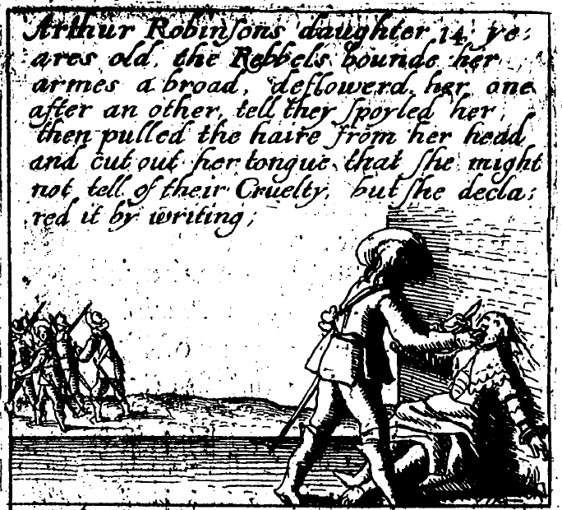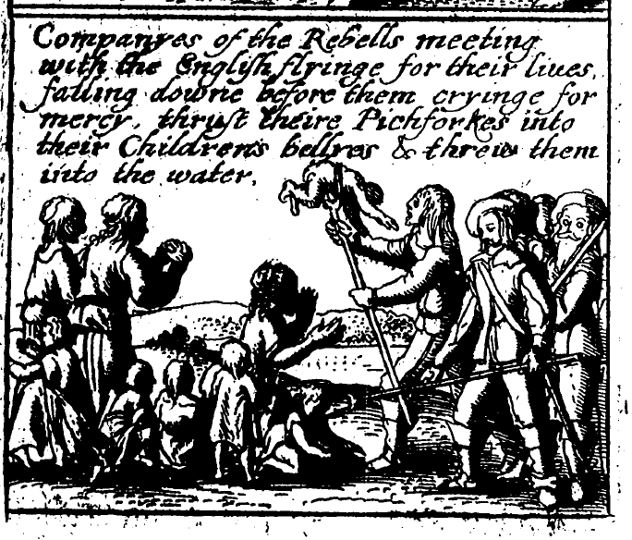
Plates 1 and 2: James Cranford, Teares of Ireland… (London, 1642)

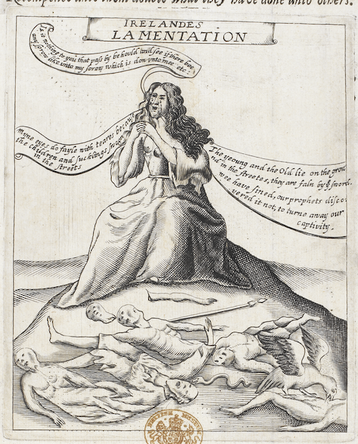
Plate 3: A Prospect of Bleeding Irelands Miseries (London, 1647)

Table 2: 1641 Depositions by widows that appeared in print
 | Total Depositions | Women | Widows
Jones (1642) | 91 | 24 | 20 (21.98%)
Morley (1644) | 80 | 25 | 18 (22.50%)
Temple (1646) | 94 | 33 | 25 (26.60%)

