Supplementary Material

Tax Delegation Workflows
This appendix provides diagrams which illustrate the various ways that an older adult can delegate tax preparation and filing to someone else (either a close other friend or relative or an official CVITP volunteer).

Workflow 1: No official delegation
Creating a RepID and using the Represent a Client or Authorize a Representative services is not required for a close other to file taxes on behalf of an older adult – an older adult can simply give the close other all of their tax forms on paper or through email, and the close other can use tax software to file the older adult’s taxes without ever directly accessing the older adult’s CRA My Account. This workflow is illustrated in Figure 1.
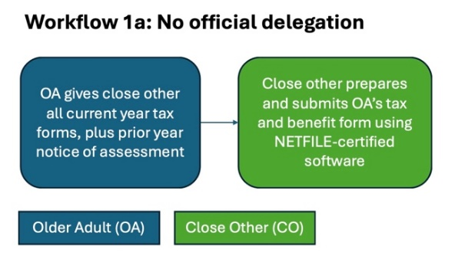
Figure 1: Close other completes older adult's taxes without accessing the older adult's CRA My Account but must enter all information manually.
In this process, the onus is on the older adult to provide their close other with all records, including their previous year’s Notice of Assessment (NoA), and the close other delegate then must manually enter all information from the documents the older adult provides. In this workflow, the close other gets no access at all to the older adult’s CRA My Account and is unable to use the Autofill My Return service.

Workflow 1b – Credential Sharing
The Terms of Service for the CRA My Account disallow sharing of login credentials, which means that older adults should not be sharing their CRA My Account usernames and passwords with someone they delegate to help them with taxes. However, it is possible that older adults are sharing CRA My Account credentials with a close other, so that the close other can access the older adult’s tax forms. In this workflow (illustrated in Appendix Figure 2), the close other can use AutoFill my Return, but also has unfettered access to all data and actions in the CRA My Account. This means they are able to see all previous tax returns and can take actions such as updating the older adult’s mailing address or direct deposit information. Because the close other is using the older adult’s login credentials, CRA is unable to tell that it is not the older adult taking actions in the account.

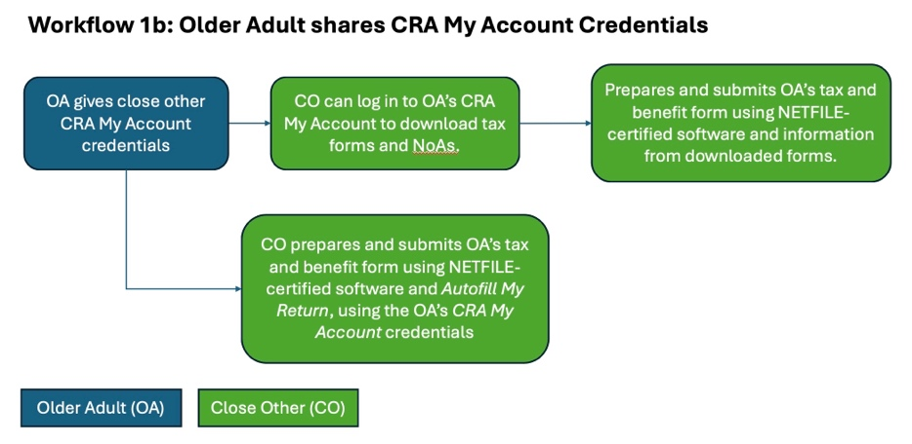
Figure 2: If older adult shares their CRA My Account credentials with their close other delegate, the delegate can log in and download tax forms to complete the OA's taxes or can use the AutoFill My Return function in NETFILE-certified tax software.

Workflow 2: Older Adult Authorizes Close Other
Authorize a Representative allows an individual to give anyone with a RepID varying levels of access to their tax accounts: The Represent a Client mechanism allows any individual to register and get a RepID, which they can then share with an older adult who wants assistance. The older adult who wants assistance can then explicitly use the Authorize a Representative mechanism to authorize the close other when they log in to CRA My Account (as illustrated in Figure 3).
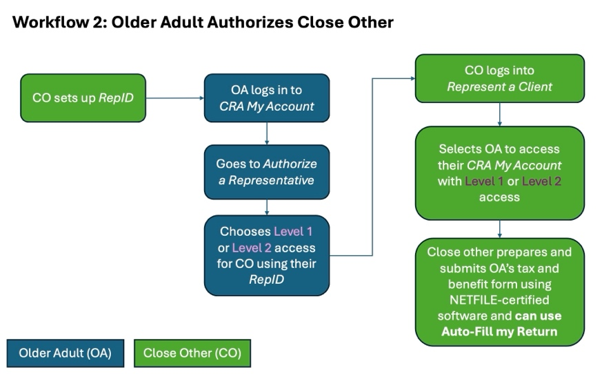
Figure 3: An older adult can log in to CRA My Account and explicitly authorize a close other who has registered with CRA and received a RepID.

Workflow 3a: Close Other Represents with RepID
Alternatively, a close other can log in to Represent a Client and provide the older adult’s name, social insurance number and the previous year’s Notice of Assessment to get access to the older adult’s CRA My Account. This requires the close other to print an authorization form, which the older adult has to sign before the close other can upload this form to complete the process (see Figure 4). This enables the close other to access the older adult’s CRA My Account and use AutoFill My Return. This option does not allow Level 3 delegation, meaning the close other cannot make any changes to the older adult’s mailing address or direct deposit information.
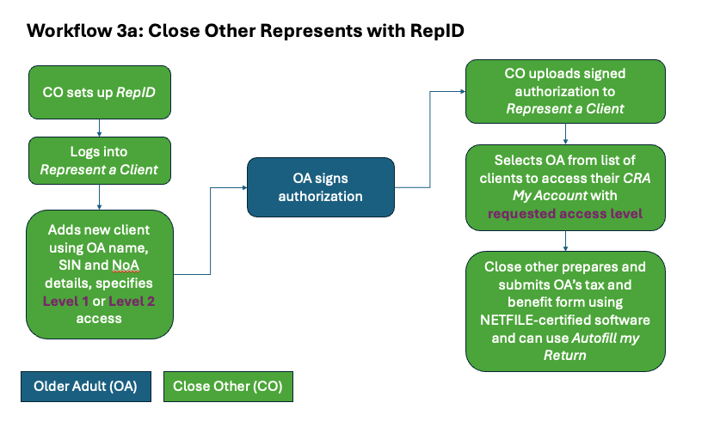
Figure 4: Close other can use information from the older adult to acquire authorization, though this requires uploading a signed authorization form.

Workflow 3b: Close Other Requests Authorization
The close other can also log in to Represent a Client and send an authorization request to the older adult. This then prompts the older adult (via an email notification, if that is set up) to authorize the close other and choose a level of access (see Figure 5). This is similar to the previous workflow but gives the older adult more direct control over choosing the level of access that the close other will have.
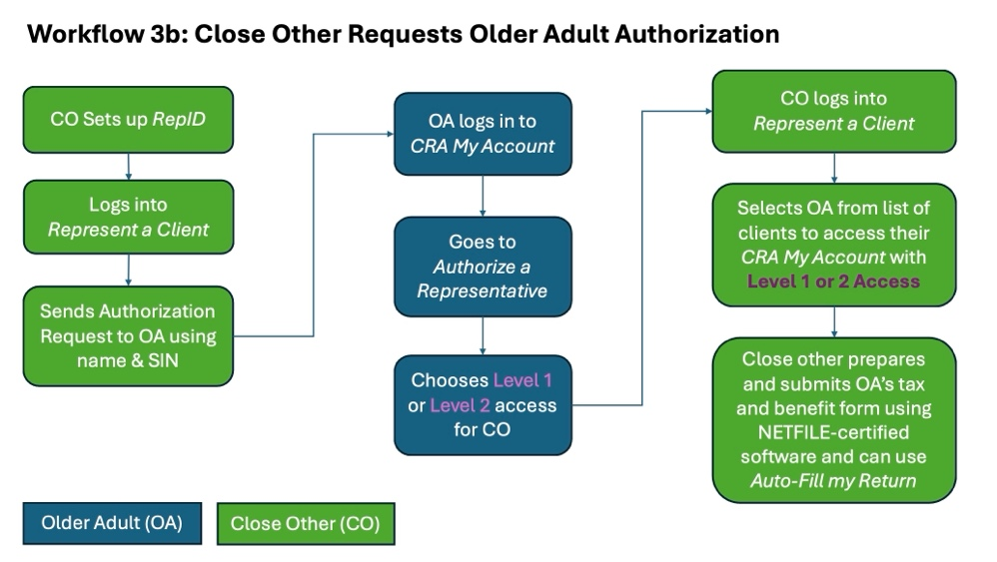
Figure 5: A close other can send an older adult an authorization request from the Represent a Client system. The authorization request will show up when the older adult logs into their CRA My Account and they can then choose the close other's level of access.

Workflow 4a: Tax Volunteer uses Federal Authorization
Tax volunteers and professionals can use the Federal Authorization mechanism that is built into UFILE software to gain access to a client’s CRA My Account. This workflow, which is illustrated in Figure 6, gives the tax volunteer Level 1 access and that access only lasts until midnight the day the authorization is granted. This allows the tax volunteer to download forms or use the AutoFill My Return function to prepare and file taxes for a client.
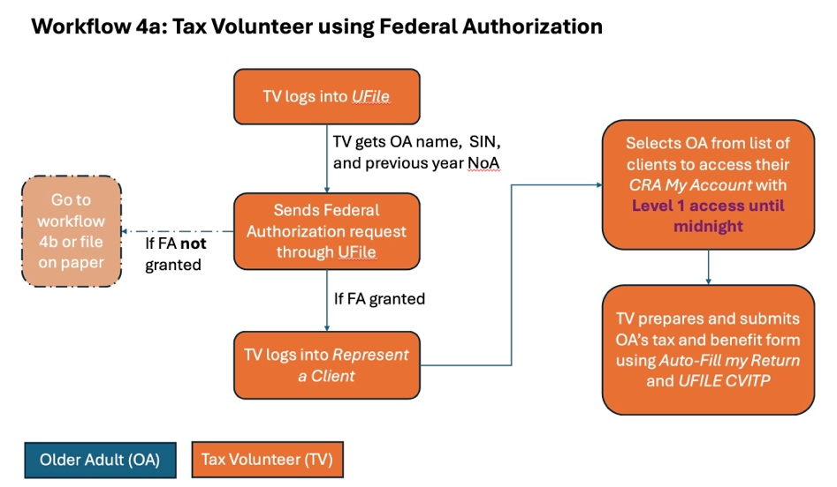
Figure 6: Tax volunteers can use the Federal Authorization process built into UFILE CVITP to request authorization, provided that they have the older adult's name, SIN, and their previous year Notice of Assessment. This gives them Level 1 access until midnight.

Workflow 4b: Tax Volunteer Requests OA Authorization
If the information provided by the client does not match and the federal authorization is not granted, tax volunteers can instead send an authorization request to the older adult. This can happen if the older adult does not have their previous year Notice of Assessment. However, this requires the older adult to log in to their CRA My Account and approve the authorization request, as shown in Figure 7.
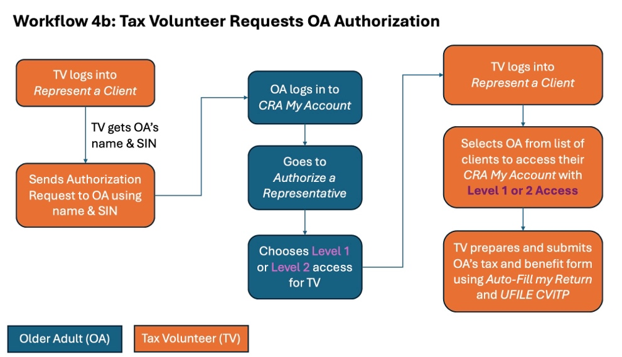
Figure 7: A tax volunteer can request authorization to an older adult's CRA My Account, which requires the older adult to log in to CRA My Account and grant access.

Workflow 4c: Tax Volunteer Files on Paper
In some cases, an older adult may not give consent for a tax volunteer to access their CRA My Account, or the access may not be possible due to technical issues matching the older adult’s information with what is stored in the CRA system. In these cases, the tax volunteer cannot use Autofill My Return and must enter all information manually. In the case of technical issues matching the older adult to a CRA account, the tax form would have to be printed and mailed to CRA. Even if the older adult does not consent to CRA My Account access, the tax volunteer can still electronically file the older adult’s tax and benefit return.
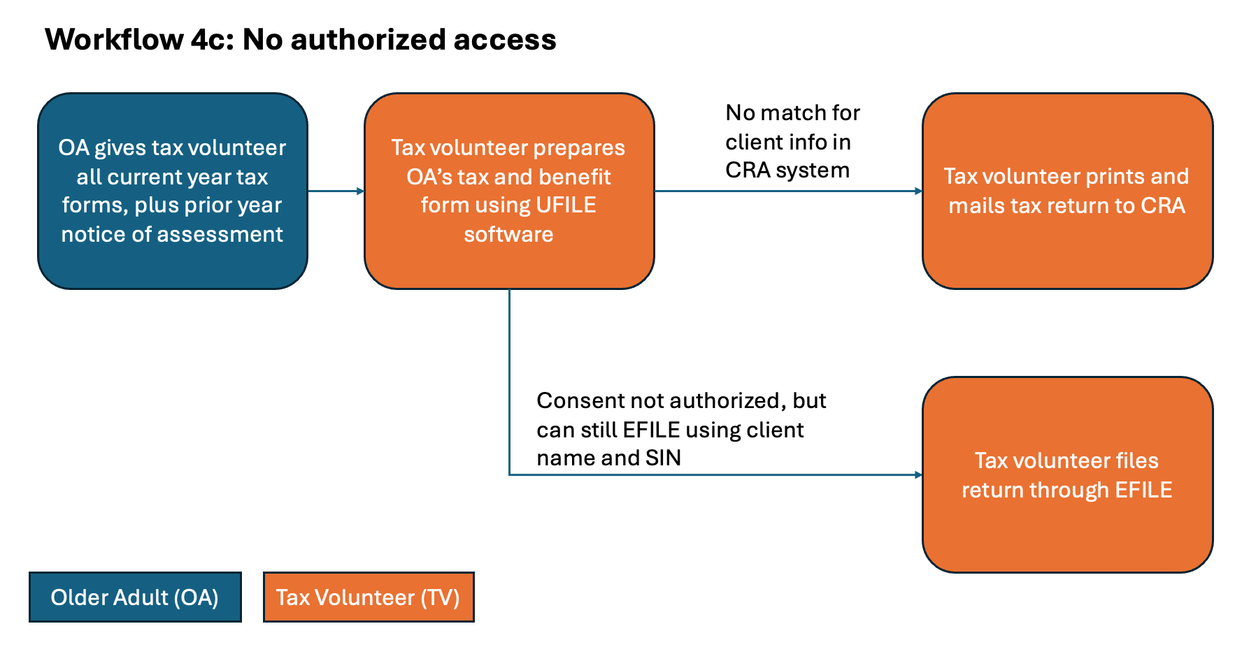
Figure 8: If the older adult does not give consent for CRA My Account access or if there is an issue matching the Older Adult's info to get access, then the tax volunteer must enter all information manually.

