Appendix S1.
This supplement accompanies Multi-species approaches are necessary to optimise conservation: Integrating a genetic algorithm with stochastic models in the Murray-Darling Basin (Australia).
Rupert Mathwin, Aaron Zecchin, Skye Wassens, Matthew S. Gibbs, Kate Mason and Corey J. A. Bradshaw.
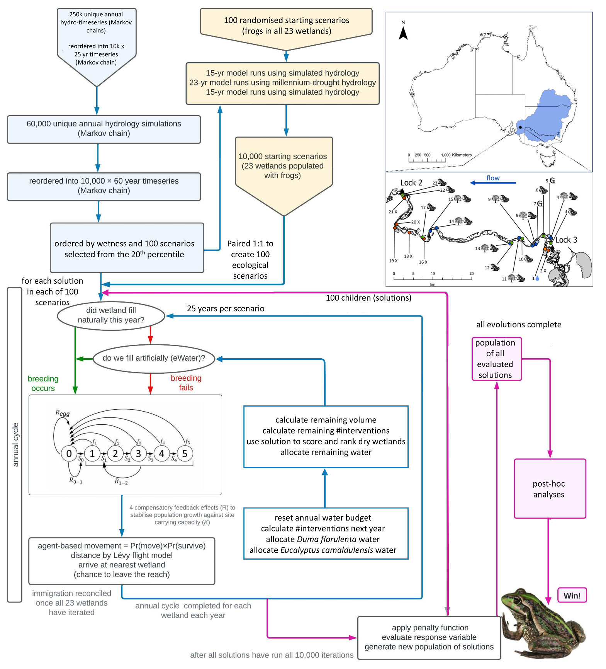
Appendix S1 Figure S1 A conceptual diagram of the integrated systems model which paired a stochastic hydroecological metapopulation model within a genetic algorithm.

Hydrological time series
We modelled the hydrological time-series using the approach outlined in Mathwin et al. 2024 Appendix S2 with one modification. Our previous approach modelled river height at the upstream end of the reach (Lock 3). For this model iteration we used river height relationships along the reach that were generated using the MIKE FLOW model (McCullough et al. 2017, Montazeri and Gibbs 2018) to model the change in river height along the reach at 14 flow bands from 2.5-100 GL/d (Appendix S1 Figure S2). We used a fourth order polynomial to model this relationship and applied it the inlet of each wetland to calculate river height at the inlet.
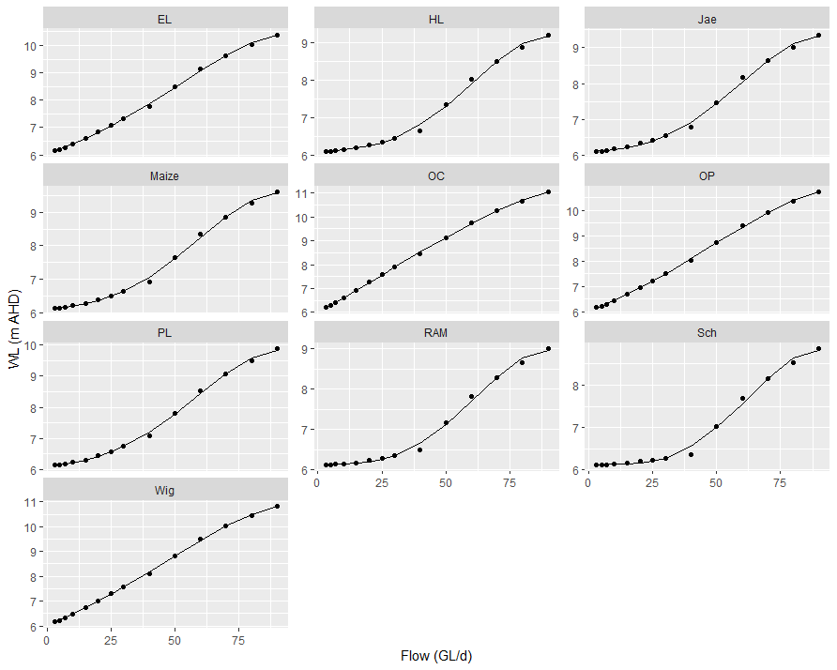
Appendix S1 Figure S2 To estimate the river height for each wetland along the 70 km river reach we used comparative height benchmarks that were generated by MIKE FLOOD (plotted points) (McCullough et al. 2017, Montazeri and Gibbs 2018) and used a fourth order polynomial equation to model these relationships (plotted lines). The modelled river height at the upstream end of the reach was modified for each wetland using this relationship.

Genetic algorithm
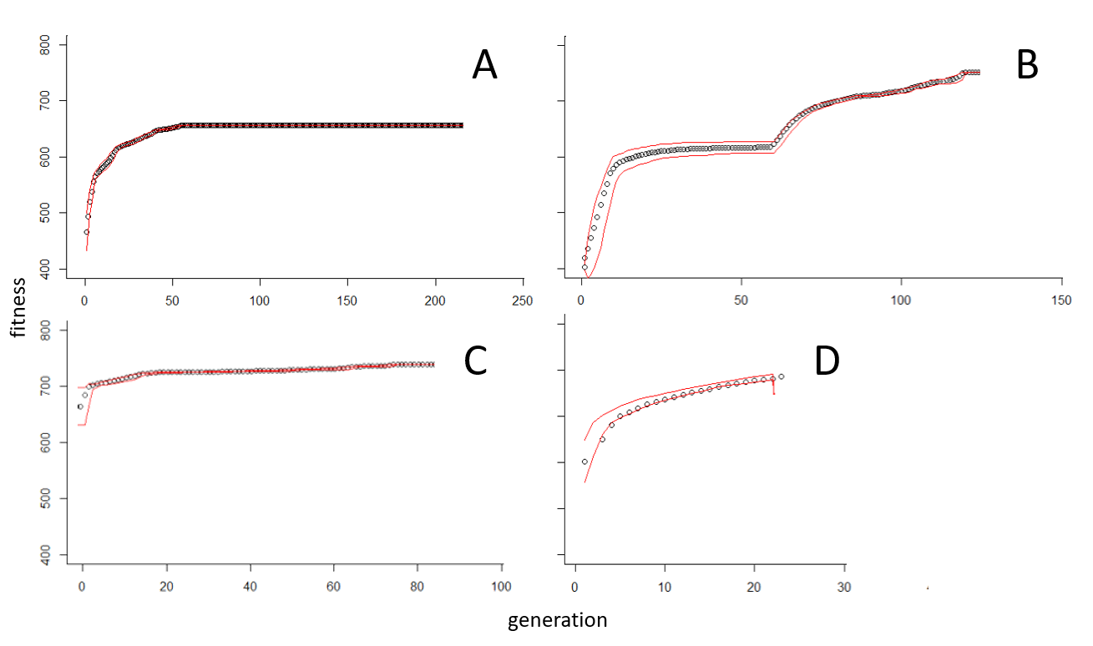
Appendix S1 Figure S3 The objective function (sum of surviving Ranoidea raniformis subpopulations) of the fittest 100 solutions from each generation showed that all four islands reached convergence or near convergence within their respective runtimes. The red lines are one standard deviation from the mean. Plot A was completed on a high-performance computer, and the remaining islands were seeded at various timesteps using the fittest available solutions (from all islands). Plot B was initially seeded with the 100 least fit solutions, and we immigrated the fittest 50 solutions after the initial convergence (generation 58).

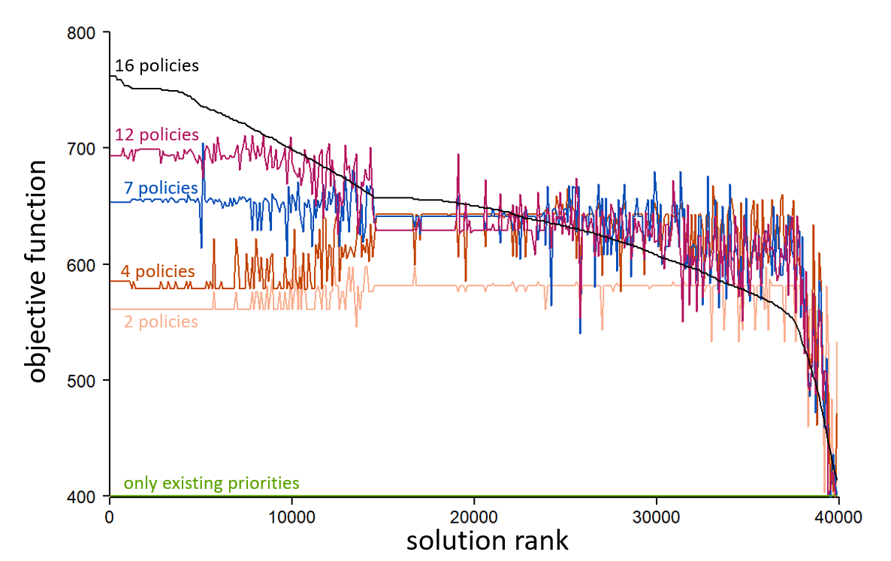
Appendix S1 Figure S4 The two attribute weights with the highest relative influence (51.09% and 21.66%) performed poorly in isolation. We trialled a range of attribute weight combinations to further explore these effects. The number of attribute weights (labelled above as policies) always represented the most influential subset.

To explore the co-dependency of the attribute weights we reran every hundredth solution in models that were modified to consider only a subset of the 16 weights (labelled in Appendix S1 Figure S4 as ‘policys’). All combinations of fewer than 16 attribute weights performed worse that the combined solutions regardless of the relative influence that was exerted by the excluded weights.

References
McCullough DP, Montazeri M, Esprey L. 2017. Update and calibration of Pike and Katarapko floodplain flexible mesh models. DEWNR Technical note 2017/11, Government of South Australia, Department of Environment, Water and Natural Resources, Adelaide.
Montazeri M, Gibbs M. 2020. Production of 80,000 ML/day flood inundation map for the South Australian section of River Murray. DEW Technical Note 2020/01, Government of South Australia, Department for Environment and Water, Adelaide.

