# InVEST Model

**Application of the InVEST Model for Carbon Storage Assessment in Beijing**

This study is based on the InVEST model and selects three specific sub-models: the **Carbon Storage and Sequestration** model, the **Habitat Quality** model, and the **Annual Water Yield** model to conduct a comprehensive assessment of ecosystem services in Beijing's urban areas. These models have been widely used in various research projects, with extensive data availability and well-established methodologies. The 2022 land use data used throughout this manuscript were obtained from <https://www.gscloud.cn/>.

## Water yield

Select InVEST Model's Water Yield Module for Simulation. The core algorithm is based on the water balance principle, integrating climate, soil, and land use types to calculate the water supply amount for each grid cell in the study area. The fundamental principle is to disregard surface runoff, subsurface flow, and baseflow, assuming that the water yield from each grid cell is entirely collected as runoff at the watershed outlet. It calculates the water yield by subtracting the actual evapotranspiration from the precipitation in each grid cell, considering factors such as soil water content, litter water holding capacity, and canopy interception (Lu et al., 2013). The main algorithm of the model is as follows:

Eq(S1) $Y_{xj}=\left(1-\frac{AET_{xj}}{P_{x}}\right)×P_{x}$

Eq(S2) $\frac{AET_{xj}}{P_{x}}=\frac{1+ω_{x}R_{xj}}{1+ω_{x}R_{xj}+\frac{1}{R_{xj}}}$

Eq(S3) $ω_{x}=\frac{Z×AWC_{x}}{P_{x}}$

Eq(S4) $R_{xj}=\frac{K_{x}×ET_{0}}{P_{x}}$

Where: $Y_{xj}$ is the annual water yield of land use type $j$ in grid cell $x$; $AET_{xj}$ is the actual evapotranspiration of land use type j in grid cell x; $P_{x}$ is the precipitation of grid cell $x$; $ω_{x}$ is the dimensionless parameter representing natural climate-soil properties; $R_{xj}$ is the Budyko dryness index; $AWC_{x}$ is the available water content of soil in grid cell $x$; $K_{x}$ is the vegetation evapotranspiration coefficient of land use type $j$ in grid cell $x$; and $ET_{0}$ is the reference evapotranspiration.

Table S 1 Biophysical table of annual water yield model

|  |  |  |
| --- | --- | --- |
| Land use type | Root depth/mm | Vegetation Coefficient (Kc) |
| Cultivated land | 1000 | 1.02 |
| Forest land | 3500 | 0.9 |
| Grass land | 2000 | 0.74 |
| Water area | 10 | 1 |
| Urban and rural construction land | 10 | 0.25 |
| Unutilized land | 10 | 0.3 |

The water yield model calculation necessitates the input of seven data types: land use grid data, and precipitation data sourced from the National Tibetan Plateau Data Center (http://data.tpdc.ac.cn/). The precipitation data is monthly data with a resolution of 1km, which is then processed in ArcGIS to aggregate into annual precipitation data using raster calculation. Reference evapotranspiration data is obtained from the Geographic and Ecological Remote Sensing website (http://www.gisrs.cn/). Root depth data and available soil water content data are both derived from the National Cryosphere Desert Data Center (http://www.ncdc.ac.cn/). In ArcGIS, the soil depth corresponding fields are extracted and converted into raster files. Watershed data is acquired from publicly available data provided by the Beijing Water Authority. Biophysical parameter tables are compiled and categorized as shown in Table S 1, with references to prior literature (Li et al., 2013).

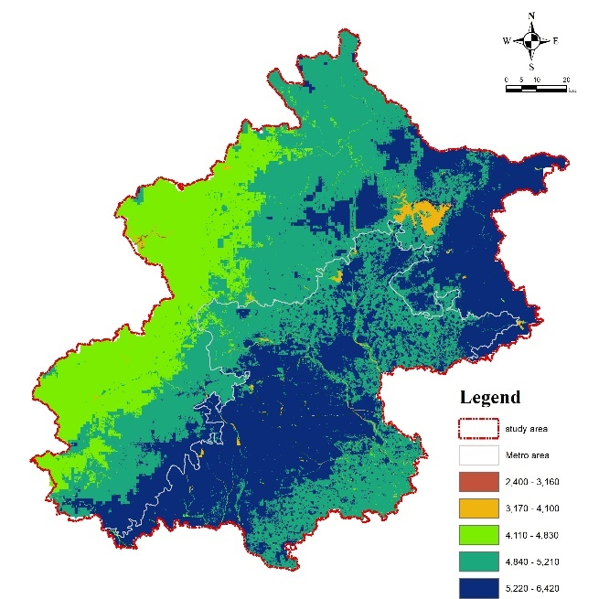

Figure S 1 Spatial distribution map of water yield service supply

## Urban Flood Risk Mitigation

This study utilizes the Urban Flood Risk Mitigation module within the InVEST model to evaluate the flood risk mitigation capacity of Beijing. The underlying principle is to calculate the runoff reduction, which is the comparison between the runoff volume retained by each pixel and the rainfall amount (Kadaverugu, Nageshwar Rao and Viswanadh, 2021). Primarily focused on assessing urban flooding disasters triggered by storm events, this model recognizes that natural environment facilities within urban areas, such as grasslands and woodlands, effectively reduce surface runoff caused by heavy rainfall and slow down flow velocity. This model enables the quantitative assessment of this mitigation capacity.

The main calculation formulas are as follows:

Eq(S5) $Q_{P,i}=\left\{\begin{aligned}\frac{{\left(P-λS_{max,i}\right)}^{2}}{P+\left(1-λ\right)S_{max,i}} if P>λ⋅S_{max,i} \\ 0 if P≤λ⋅S_{max,i}\end{aligned}\right.$

Eq(S6) $S_{max,i}=\frac{25400}{CN_{i}}-254$

Finally, the runoff mitigation coefficient for grid cell *i* is obtained based on the difference between rainfall and runoff volume:

Eq(S7) $R_{i}=1-\frac{Q_{P,i}}{P}$

Where: $Q_{P,i}$ is the runoff volume; $P$ is the precipitation; $λ$ is the soil infiltration coefficient; $CN_{i}$ is the curve number value; $S_{max,i}$ represents the maximum potential retention of grid cell $i$ before runoff generation, and its value is related to the $CN_{i}$ corresponding to the grid cell. The U.S. Soil Conservation Service classifies soils into four hydrologic soil groups (A, B, C, D), with soil infiltration capacity decreasing sequentially from group A to group D.

The calculation of the Urban Flood Risk Mitigation model requires inputting the following 5 data types: current land use grid data (LULC map), spatial vector data of watershed boundaries, extreme precipitation depth, soil hydrologic group table (Soil Hydrologic Groups, SHGs), and biophysical table.

According to the above requirements, the data sources used in the urban flood risk mitigation model are as follows:

Spatial vector data of watershed boundaries: Derived from open data of the Beijing Water Authority (<https://swj.beijing.gov.cn/>).

Soil Hydrologic Group (SHG) raster data: Obtained from the global general dataset published by the U.S. Department of Agriculture (<https://daac.ornl.gov/>). This dataset represents a globally consistent gridded dataset of hydrologic soil groups (HSG), with a projection resolution of approximately 250m.

Biophysical parameter table: Based on the research of (Fu et al., 2013), and then average values are calculated based on the land use classification in this paper to obtain the data as shown in Table S 2.

Table S 2 Biophysical table of InVEST Urban Flood Risk Mitigation model.

|  |  |  |  |  |
| --- | --- | --- | --- | --- |
| LULC | CN_A | CN_B | CN_C | CN_D |
| Cropland | 53.15 | 76.55 | 76.55 | 76.55 |
| Woodland | 34.3 | 74.36 | 74.36 | 74.36 |
| Grassland | 34.2 | 70.75 | 70.75 | 70.75 |
| Water | 0.00 | 0.00 | 0.00 | 0.00 |
| Wetland | 0.00 | 0.00 | 0.00 | 0.00 |
| Urban and rural construction land | 52.07 | 64.64 | 64.64 | 64.64 |
| Unused land | 69.8 | 69.8 | 69.8 | 69.8 |

Curve number (CN_A\CN_B\CN_C\CN_D): The curve number value for this LULC type in the soil group code A\B\C\D (Fu et al., 2013).

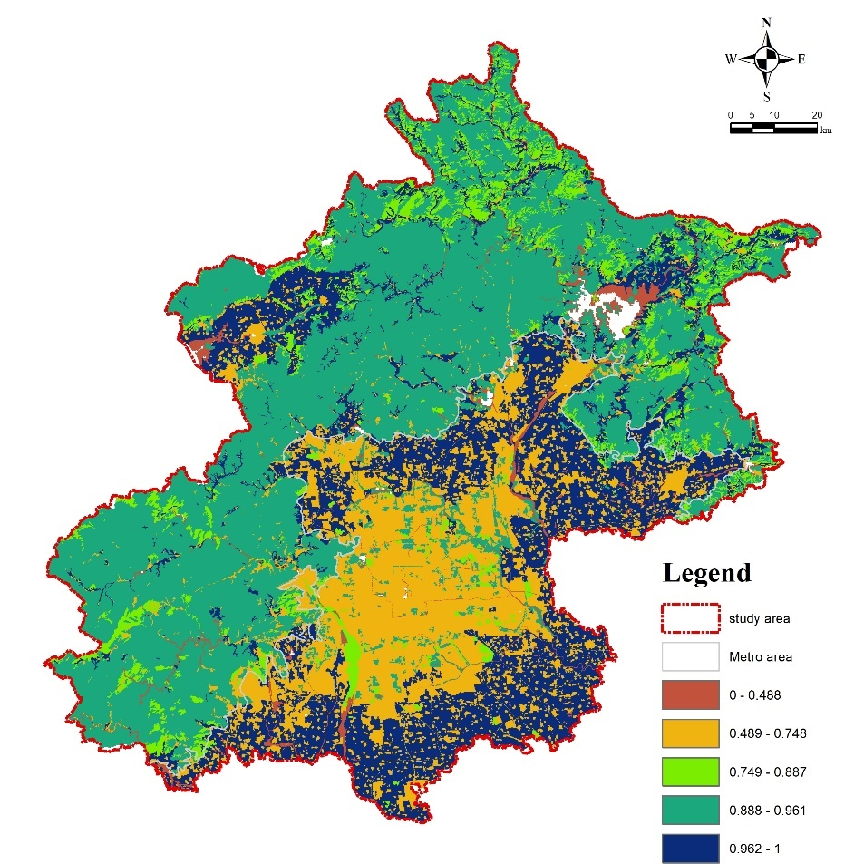

Figure S 2 Spatial distribution map of flood risk mitigation servise supply

## Urban cooling services

Utilizing the surface radiation energy balance principle, this study integrates synchronous ground-based measurements with MODIS satellite imagery to investigate urban surface energy fluxes. We applied the surface energy balance equation to retrieve key heat flux parameters, including latent and sensible heat fluxes. The accuracy of remotely sensed land surface temperature and heat flux parameters was validated through comparisons with in-situ observations. By spatially superimposing land use data with the retrieved heat flux parameters, we analyzed the relationships between different urban land use types and both land surface temperature and heat fluxes derived from remote sensing. This integrated methodology, combining traditional ground measurements and remote sensing, effectively represents surface energy balance fluxes across the urban area. Land surface temperature for various urban underlying surface types was retrieved using the split-window algorithm. The specific expression is provided below:

Eq(S8) $T_{S}=\left(C_{\text{32}}\left(B_{\text{31}}+ {\text{D}}_{\text{31}}\right)- {\text{C}}_{\text{31}}\left(D_{\text{32}}+ {\text{B}}_{\text{32}}\right)\right)/\left(C_{\text{32}}A_{\text{31}}- {\text{C}}_{\text{31}}A_{\text{32}}\right)$

where TS is the surface temperature; $A_{\text{31}}$, $A_{\text{32}}$, $B_{\text{31}}$, ${\text{B}}_{\text{32}}$, ${\text{C}}_{\text{31}}$, $C_{\text{32}}$, ${\text{D}}_{\text{31}}$, $D_{\text{32}}$ are Parameters determined by atmospheric transmittance and surface reflectance factors. The parameters are calculated as follows:

Eq(S9) $A_{31}=0.13834×ε_{31}×τ_{31}$

$$B_{31}=0.13834×T_{31}+31.80148×ε_{31}×τ_{31}-31.80148$$

$$C_{31}=\left(1-τ_{31}\right)×\left(1+\left(1-ε_{31}\right)×τ_{31}\right)×0.13834$$

$$D_{31}=\left(1-τ_{31}\right)×\left(1+\left(1-ε_{31}\right)×τ_{31}\right)×31.80148$$

$$A_{32}=0.11952×ε_{32}×τ_{32}$$

$$B_{32}=0.11952×T_{32}+26.80148×ε_{32}×τ_{32}-26.80148$$

$$C_{32}=\left(1-τ_{32}\right)×\left(1+\left(1-ε_{32}\right)×τ_{32}\right)×0.11952$$

$$D_{32}=\left(1-τ_{32}\right)×\left(1+\left(1-ε_{32}\right)×τ_{32}\right)×26.801488$$

Where $ε_{32}$: Reflectance of Band 32; $τ_{32}$: Atmospheric transmittance of Band 32; $ε_{31}$: Reflectance of Band 31; $τ_{31}$: Atmospheric transmittance of Band 31. T31 and T32 are the brightness temperature values of Band 31 and Band 32.

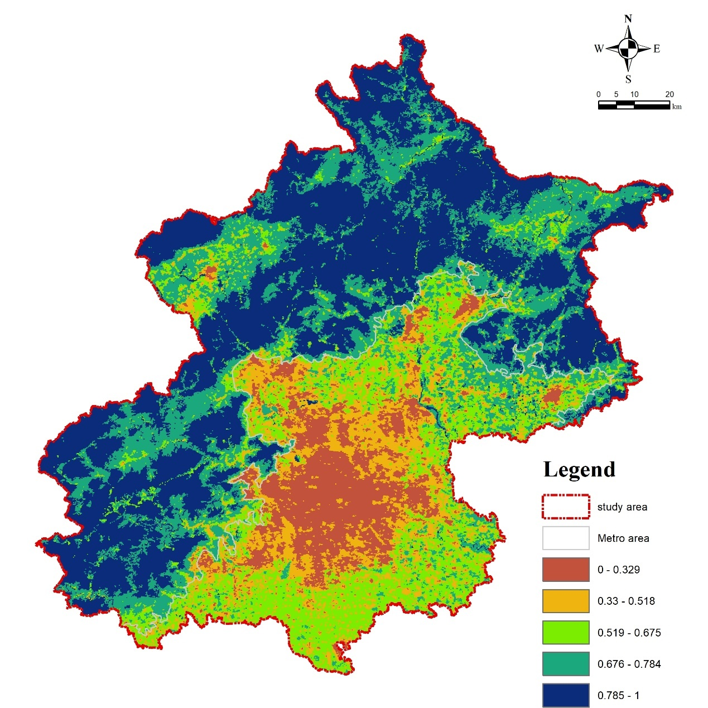

Figure S 3 Spatial distribution map of urban cooling service supply

## Carbon Storage

In this study, the **Carbon Storage and Sequestration** module of the InVEST model is applied to comprehensively evaluate Beijing’s carbon storage capacity. The fundamental principle is to assess land use types by estimating their carbon density, thereby calculating the total carbon storage in different land use categories.

The carbon storage model considers four types of carbon pools:

1. **Above-Ground Biomass Carbon:** Includes all living plant matter above the soil, such as trees, crops, and shrubs.
2. **Below-Ground Biomass Carbon:** Encompasses all living root biomass in the soil.
3. **Soil Organic Carbon:** Represents the carbon content in the soil's organic matter, which is the largest organic carbon pool.
4. **Dead Organic Matter Carbon:** Includes litter, fallen leaves, and deadwood.

For each land use type, at least one of these fundamental carbon pools must be accounted for, with units expressed as tons per hectare (t/ha). The model will eventually be used to estimate carbon storage across different land use types, generating a comprehensive carbon storage map.

To calculate carbon storage, the model requires two types of input data:

1. **Current Land Use Raster Data (LULC map)**
2. **Carbon Pool Density Data (Carbon Pool)**

Following these requirements, the carbon pool data was compiled based on relevant research findings, resulting in the dataset shown in Table S 3.

Table S 3 **InVEST Carbon Stock Model with Four Types of Carbon Pools**

| **Land Use Type** | **Above-Ground Biomass Carbon Density (C_above) (t/ha)** | **Below-Ground Biomass Carbon Density (C_below) (t/ha)** | **Soil Organic Carbon Density (C_soil) (t/ha)** | **Dead Organic Matter Carbon Density (C_dead) (t/ha)** | References |
| --- | --- | --- | --- | --- | --- |
| Cropland | 5.00 | 3.13 | 20.00 | 0.00 | (Kong *et al.*, 2019) |
| Forest | 20.04 | 4.63 | 36.24 | 1.94 | (Yang *et al.*, 2012) |
| Grassland | 12.97 | 4.09 | 27.12 | 0.94 | (Xu, Yu and He, 2019) |
| Shrubland | 10.00 | 4.00 | 27.12 | 0.94 | (Xu, Yu and He, 2019) |
| Wetland | 3.73 | 0.62 | 65.31 | 0.20 | (Xu, Yu and He, 2019) |
| Urban Built-up Land | 1.52 | 0.20 | 6.32 | 0.00 | (Xu, Yu and He, 2019) |
| Other Land Use | 6.34 | 0.86 | 27.12 | 0.42 | (Li *et al.*, 2020) |

Eq(S10) $C_{i}=C_{i,above}+C_{i,below}+C_{i,dead}+C_{i,soil}$

Where:

* $C_{i}$ represents the carbon density of land use type $i$.
* $C_{i,above}$ is the above-ground biomass carbon density of land use type $i$.
* $C_{i,below}$ is the below-ground biomass carbon density of land use type $i$.
* $C_{i,dead}$ is the dead organic matter carbon density of land use type $i$.
* $C_{i,soil}$ is the soil organic carbon density of land use type $i$.

Then, the model calculates the total ecosystem carbon storage based on the carbon density of each land use type and the land area data:

Eq(S11) $C_{i,total}=C_{i}×A_{i}$

Where:

* $C_{i,total}$ represents the total carbon storage in land use type i within a given region.
* $A_{i}$ is the area of land use type i.

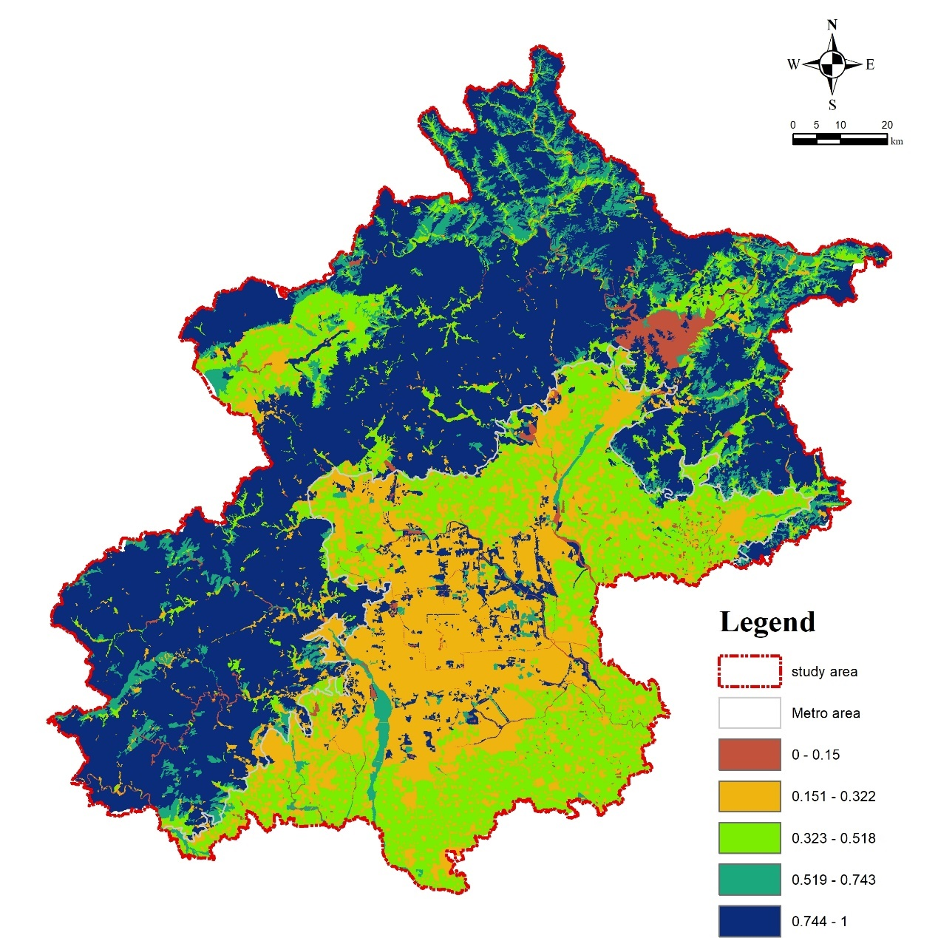

Figure S 4 Spatial distribution map of carbon storage service supply

## Air Quality Regulation Service

**Spatial Distribution Map of PM2.5 Concentration**

In this study, PM 2.5 dataset was from ChinaHighPM2.5 (Wei et al., 2021). This study investigates the purification effect of urban green spaces on PM2.5, focusing solely on the physical process of PM2.5 dry deposition while excluding the influence of PM2.5 wet deposition (where precipitation effectively reduces atmospheric particulate matter concentrations). A dry deposition model was employed to quantify this purification effect, with relevant reference coefficients for the model's equations detailed in Table S 5.

Eq(S12) $F_{i}=V_{i}×C_{i}$

Where: $F_{i}$ is the $PM_{2.5}$ deposition flux on the ith grid (g/m²/s); $V_{i}$ is the $PM_{2.5}$ dry deposition velocity on the ith grid (m/s); $C_{i}$ is the annual average background concentration of $PM_{2.5}$ on the ith grid (g/m³).

To parameterize the model across the study area, PM2.5 dry deposition velocities (Vi) and resuspension coefficients (K) were determined based on regional average wind speeds and corresponding values extracted from Table S 4. Linear interpolation was subsequently applied to extrapolate these parameters across the entire spatial domain.

Table S 4 Deposition velocities and percent resuspension by wind speed per unit leaf area (Nowak et al., 2013).

|  |  |  |
| --- | --- | --- |
| Wind speed (m s⁻¹) | Deposition velocity (Va) (cm s⁻¹) | Resuspension (%) |
|  | Average | Minimum |
| 0 | 0 | 0 |
| 1 | 0.03 | 0.006 |
| 2 | 0.09 | 0.012 |
| 3 | 0.15 | 0.018 |
| 4 | 0.17 | 0.022 |
| 5 | 0.19 | 0.025 |
| 6 | 0.2 | 0.029 |
| 7 | 0.56 | 0.056 |
| 8 | 0.92 | 0.082 |
| 9 | 0.92 | 0.082 |
| 10 | 2.11 | 0.57 |
| 11 | 2.11 | 0.57 |
| 12 | 2.11 | 0.57 |
| 13 | 2.11 | 0.57 |

The effective PM2.5 reduction time (T) was calculated using the following equation:

Eq(S13) $T=P×R_{\left(q<15mm,v<7m/s\right)}×r_{\left(d/D\right)}$ Where $T$ is the effective $PM_{2.5}$ reduction time (s); $P$ is the study duration (s); $R_{\left(q<15mm,v<7m/s\right)}$ is the percentage of study time with rainfall less than 15mm and wind speed less than 7m/s (%); $r_{\left(d/D\right)}$) is the ratio of vegetation leaf-on duration to the total study duration D (%).

For this study, with a total study duration (P) of 365 days, daily meteorological analysis of Beijing in 2023 revealed that conditions of rainfall less than 15mm and wind speed less than 17m/s occurred for 354 days. The vegetation foliage duration in Beijing for 2023 was determined to be 190 days.

The annual PM2.5 reduction quantity ($Q_{S}i$) for each grid cell was then calculated as follows:

Eq(S14) $Q_{S}i=F_{i}×LAI_{i}×T×\left(1-K_{res\left(PM_{2.5}\right)}\right)$ Where: $Q_{S}i$ is the annual reduction amount of $PM_{2.5}$ in the $i$ grid (g/m²/a); $F_{i}$ is the $PM_{2.5}$ deposition flux on the $i$ grid (g/m²/h); $LAI_{i}$ is the leaf area index on the $i$ grid (m²/m²); T is the effective $PM_{2.5}$ reduction time (h); $K_{res\left(PM_{2.5}\right)}$ is the $PM_{2.5}$ resuspension coefficient.

In this study, Leaf Area Index (LAI) are primarily derived using remote sensing retrieval methods. Employing data from the Moderate Resolution Imaging Spectroradiometer (MODIS), vegetation indices, specifically LAI, obtained through remote sensing retrieval, serve as indicators of plant growth vigor for analyzing ecosystem health and its variations. Remote sensing retrieval of ecosystem parameters relies on surface reflectance under clear-sky conditions as input. Therefore, pre-processing involves compositing multi-day surface reflectance data under clear-sky conditions, followed by cloud removal and noise reduction. An enhanced compositing algorithm, utilizing minimum visible wavelength selection, is employed to effectively mitigate cloud contamination, including the effects of cloud shadows. LAI and the fraction of absorbed photosynthetically active radiation (FPAR) are subsequently derived by inverting canopy radiative transfer equations, with the cloud-free composite surface reflectance data serving as the primary input.

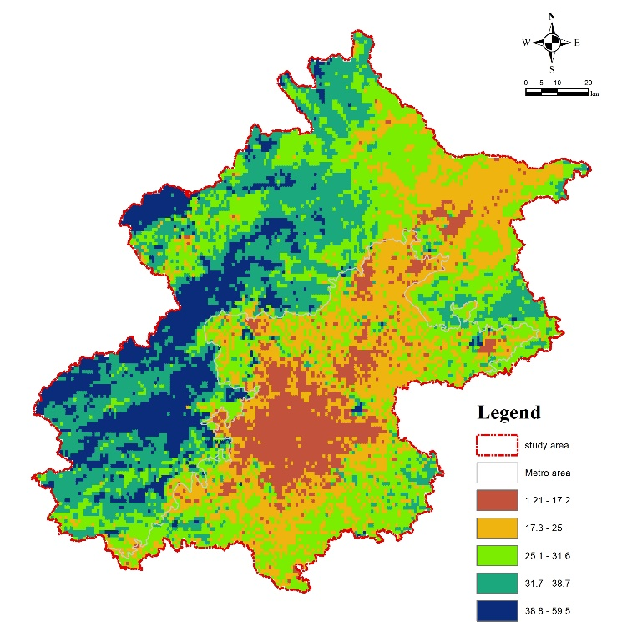

Figure S 5 Spatial distribution map of air quality service supply

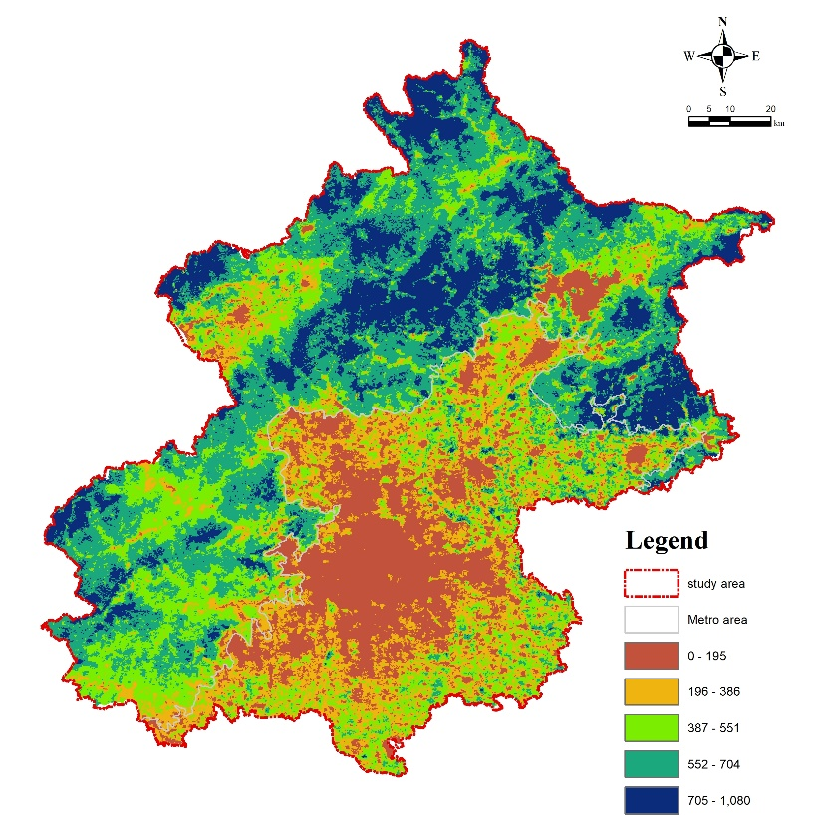

Figure S 6 Spatial distribution map of Vegetation Productivity Service Supply

# Landscape connectivity

The Minimum Cumulative Resistance (MCR) model, which takes into account landscape ‘sources’, distances, and the characteristics of the landscape resistance surface, was employed in this study. The formula is expressed as follows (Equation 1):

Eq(S15) $MCR=f_{\text{min}}\sum_{j=n}^{i=m}{\left(D_{ij}×R_{i}\right)}$

Where $D_{ij}$ represents the Euclidean distance from a landscape ‘source’ to a specific landscape unit in space. $R_{i}$ denotes the resistance coefficient of a particular landscape unit in space, signifying the degree of impedance to movement through it. Essentially, the MCR model quantifies and evaluates the accessibility of a certain landscape from a ‘source’ to a given point in space along a specific path. A lower resistance value indicates higher accessibility from the source to that point. Therefore, the resistance model effectively reflects the potential and trend of movement of landscape units, serving as an abstract representation of landscape change and providing an analytical basis for landscape functional characteristics. Concerning the protection and utilization of the municipal ecosystem, areas with a more stable ecosystem structure within the municipality facilitate the migration and diffusion of landscape units, thereby exhibiting lower resistance to such movement and diffusion. Conversely, greater resistance is offered to unit movement and diffusion in areas with less stable ecosystem structures.

Different landscape elements experience varying levels of resistance during movement and migration, and resistance coefficients are relative. While no universally standardized resistance coefficients exist, this study, informed by Zhang et al. (2018) and Zhang et al. (2017), The resistance factors primarily addressed in this study are land cover type, distance to roads, and distance to settlements. Resistance levels for the expansion of Beijing land use types were ranked based on ecological land nature, and corresponding resistance values were set. Table S 5 presents these values..

Table S 5 Land Use Resistance Coefficient

|  |  |
| --- | --- |
| Land Cover Type | Resistance Coefficient |
| Paddy Field | 100 |
| Dry Land | 300 |
| Forest Land | 1 |
| Shrubland | 10 |
| Open Woodland | 10 |
| Other Woodland | 20 |
| High Coverage Grassland | 20 |
| Medium Coverage Grassland | 30 |
| Low Coverage Grassland | 40 |
| Rivers (Canals) | 1 |
| Lakes | 1 |
| Reservoirs and Ponds | 10 |
| Mudflats/Tidal Flats) | 10 |
| Urban Built-up Land | 500 |
| Rural Settlements | 400 |
| Other Built-up Land | 400 |
| Bare Land | 100 |
| Bare Rock and Gravel | 100 |

For the purposes of this study, resistance values were categorized as follows: values below 1000 were classified as low resistance areas, values ranging from 1000 to 10,000 as lower resistance areas, values between 10,000 and 100,000 as medium resistance areas, values from 100,000 to 1,000,000 as higher resistance areas, and values exceeding 1,000,000 as high resistance areas (Zhang et al., 2017).

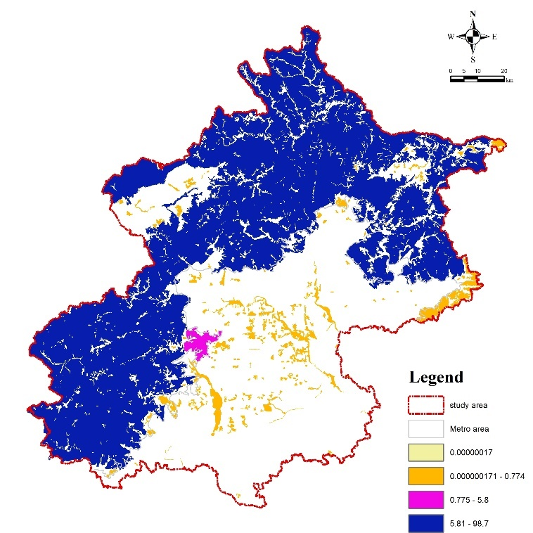

Figure S 7 Spatial distribution map of IIC

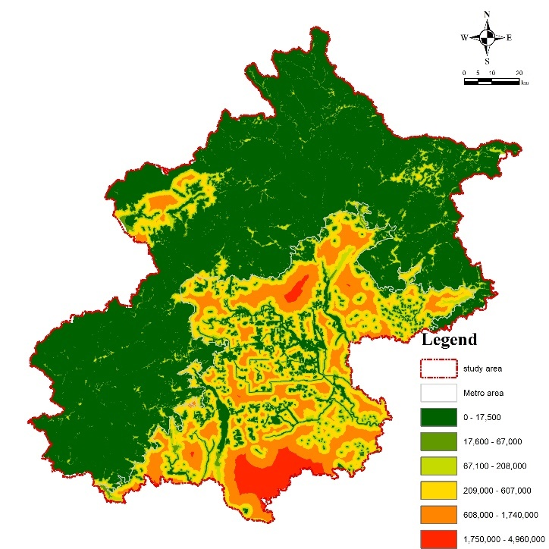

Figure S 8 Spatial distribution map of MCR

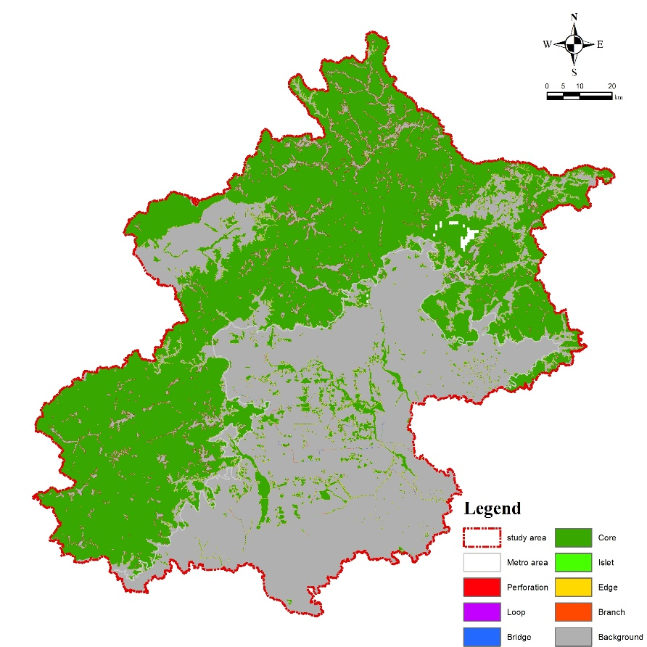

Figure S 9 Spatial distribution map of MSPA

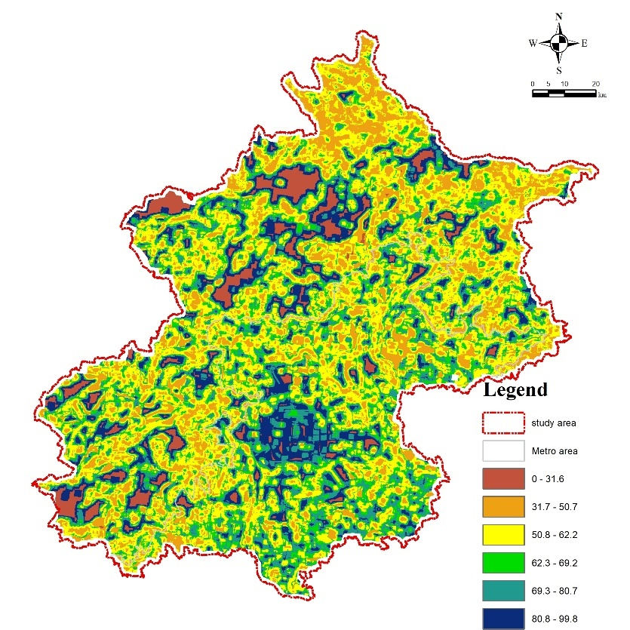

Figure S 10 Spatial distribution map of CONTAG

# Maxent

To construct a comprehensive dataset of key species in Beijing, we undertook a systematic approach encompassing species selection, data acquisition, and data refinement.

## Selection of Key Species

We began by compiling an exhaustive list of species present in Beijing. Utilizing authoritative sources the List of Key Protected Wild Plants in Beijing (2023) , List of Key Protected Wild Animals in Beijing (2023), and the Beijing Biodiversity Conservation Plan (2021-2035), we identified 596 terrestrial wild animal species and 80 wild plant species native to the region. Applying criteria that considered endangered status, protection level, and regional endemic, we selected 366 species as indicator species. This subset comprises 19 amphibians, 266 birds, 30 mammals, and 70 plants, representing the most vulnerable components of Beijing's ecosystem.

**Acquisition of Historical Spatial Distribution Data**

To map the historical distribution of these key species, we sourced occurrence data from several reputable databases:

* **Global Biodiversity Information Facility (GBIF)**: An international network providing open access to biodiversity data, including species occurrence records and datasets.
* **China Biodiversity Map**: Developed by the Institute of Zoology at the Chinese Academy of Sciences, this platform integrates species catalogs and distribution data to support scientific research and policy-making.
* **China Birdwatching Record Center**: A nationwide platform that aggregates bird observation data from citizen scientists, bird enthusiasts, and volunteers, serving as the most comprehensive avian database in China.

The compiled dataset includes essential information such as species codes, common and scientific names, conservation status, protection levels, endemism classifications, and historical spatial coordinates.

**Data Refinement and Validation:** Ensuring data accuracy involved several steps:

* **Geospatial Correction and Standardization**: We corrected and standardized the collected coordinates using Google Maps, ensuring consistency across all data points.
* **Duplicate Removal**: Redundant data entries were identified and eliminated to maintain dataset integrity.
* **Species Data Filtering**: We focused on species with a minimum of 10 recorded distribution points within Beijing's administrative boundaries, resulting in a refined dataset of 65 species: 7 amphibians, 19 birds, 23 mammals, and 15 plants.

The final dataset was formatted as a CSV file, facilitating its application in subsequent MaxEnt modeling to predict species distributions.

This structured methodology ensures a robust foundation for conservation efforts and ecological studies pertaining to Beijing's key species.

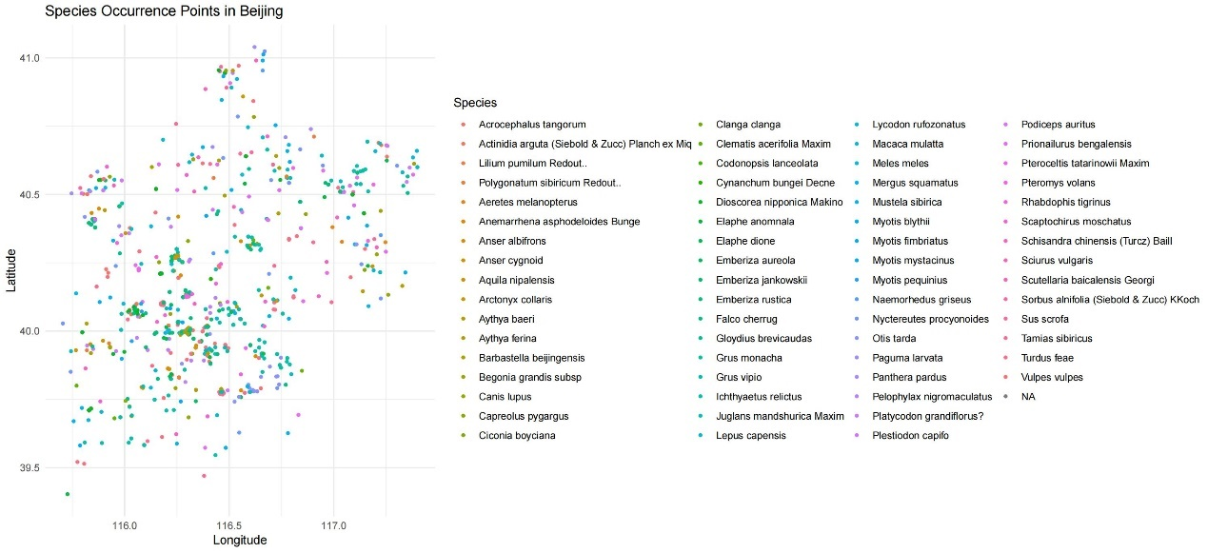

Figure S 11 map of visualizing sampling bias by plotting occurrence points

## Environmental variables

Drawing upon the methodology of Huang Yue et al., this study incorporated a total of 25 environmental factors, categorized into three distinct types. These included 19 bio-climatic variables, designed to characterize climatic variations such as precipitation and temperature within the study region. Additionally, four habitat environmental variables and two human impact variables were included (detailed in Table S 6 ). All datasets were spatial raster data and were processed using a Geographic Information System (GIS). The preprocessing steps included: unifying the geographic coordinate system, resampling to a uniform raster cell size, and clipping to a common geographic boundary extent. Finally, all processed datasets were exported to ASCII format for subsequent use in MaxEnt modeling.

Table S 6 A list data source

|  |  |  |  |
| --- | --- | --- | --- |
| variables | Data | Resolution | Source |
| Bioclimatic | Bio1 - Annual Mean Temperature  Bio2 - Mean Daily Temperature Range  Bio3 - Temperature Isothermality  Bio4 - Temperature Seasonality  Bio5 - Warmest Month Maximum Temperature  Bio6 - Coldest Month Minimum Temperature Bio7 - Annual Temperature Range  Bio8 - Wettest Quarter Mean Temperature  Bio9 - Driest Quarter Mean Temperature  Bio10 - Warmest Quarter Mean Temperature  Bio11 - Coldest Quarter Mean Temperature  Bio12 - Annual Precipitation  Bio13 - Wettest Month Precipitation  Bio14 - Driest Month Precipitation  Bio15 - Precipitation Seasonality  Bio16 - Wettest Quarter Precipitation  Bio17 - Driest Quarter Precipitation  Bio18 - Warmest Month Precipitation  Bio19 - Coldest Month Precipitation | 30″ | <https://worldclim.org>  (Fick and Hijmans, 2017) |
| habitat environmental | Digital Elevation Model | 90m | https://www.resdc.cn/ |
| slope | 90m | / |
| aspect | 90m | / |
| NDVI | 250m | <https://www.earthdata.nasa.gov/>  (Yang et al., 2019) |
| anthropogenic disturbances | Population Density | 1000m | <https://landscan.ornl.gov/>(A. Rose et al., 2021) |
| Nighttime light | 130m | http://59.175.109.173:8888/index.html |

## Model Simulation Result

After the model operation, it is necessary to conduct result validation to ensure the accuracy of the predicted results. In this study, the Receiver Operating Characteristic Curve (ROC curve) was employed to validate the model's predictive performance. On the ROC curve, the Y-axis represents the True Positive Rate (TPR), indicating the proportion of instances where the model correctly predicts presence when presence is also observed in reality. The X-axis represents the False Positive Rate (FPR), indicating the proportion of instances where the model predicts presence but presence is not observed in reality (Radosavljevic and Anderson, 2013). Typically, the Area Under Curve (AUC), which is the area enclosed by the ROC curve and the X-axis, is used to reflect the accuracy of the model's predictive performance. The AUC value ranges from 0 to 1, where 0.5 indicates that the model results are randomly distributed. A larger AUC value indicates higher model prediction accuracy and better performance.

In this study, the evaluation criteria for the ROC curve were referenced as follows: an AUC value less than 0.6 represents poor simulation accuracy, 0.6-0.7 is fair, 0.7-0.8 is moderate, 0.8-0.9 is good, and greater than 0.9 represents excellent simulation accuracy (Zheng et al., 2016). The results showed (Tables S7-10) that the simulation accuracy of all 65 species was good or excellent, meeting the requirements for further analysis.

Subsequently, the spatial distribution raster data of the model output predictions were analyzed. The values of the output spatial raster data range from 0 to 1, with larger values indicating a higher probability of species distribution in that space. Referring to the research of Huang et al., (2021) this study binarized the results in ArcGIS, reclassifying values from 0-0.5 as 0, representing unsuitable areas, and values from 0.5-1 as 1, representing suitable areas. These suitable areas are the most important spaces to be considered for species conservation (O’Connor et al., 2021). Potential habitat distribution maps for each of the 65 species were obtained from this process.

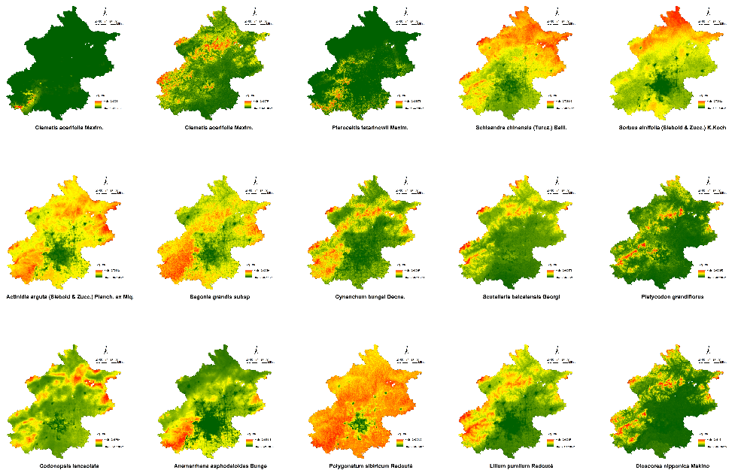

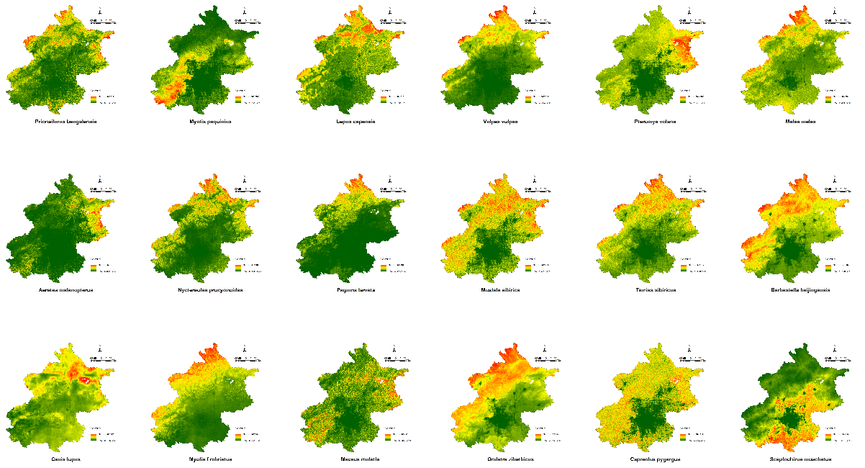

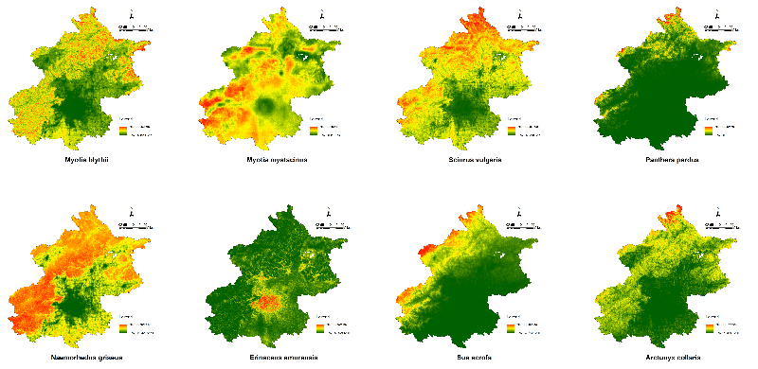

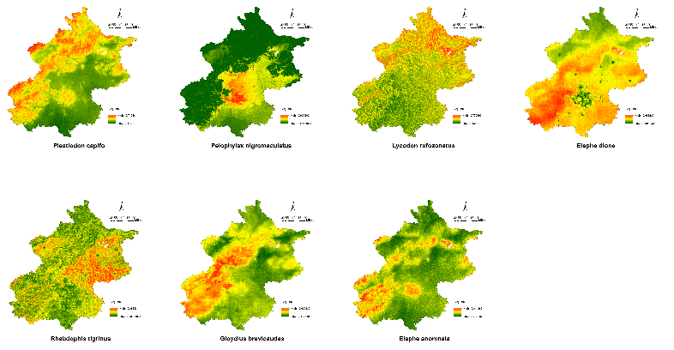

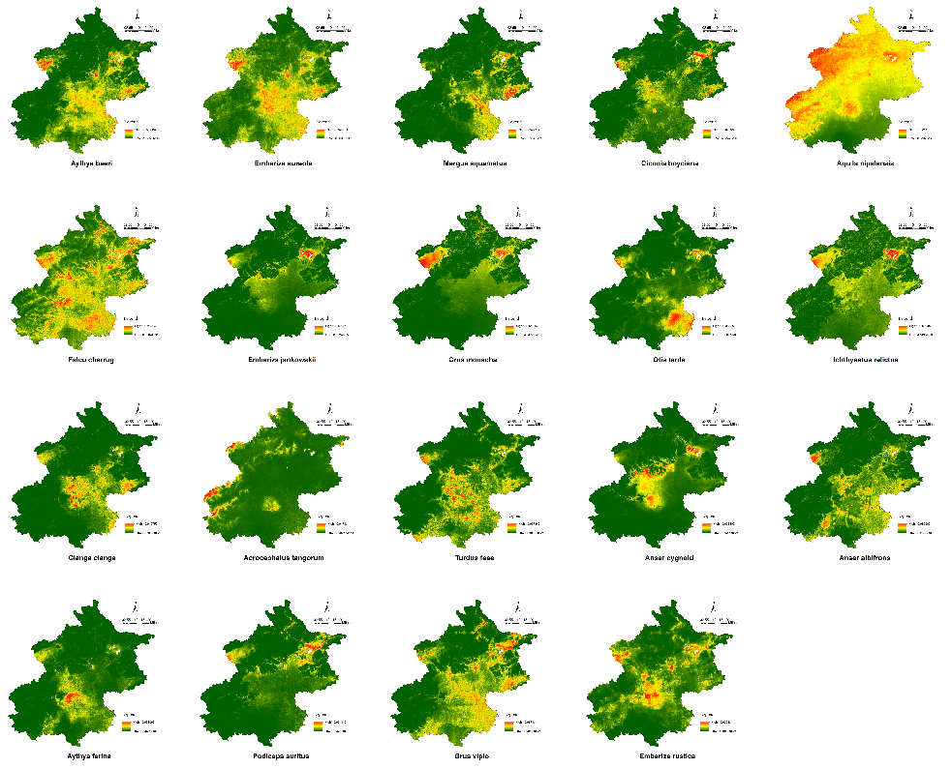

Figure S 12 Spatial Distribution of Habitat Potential for Threatened Species

Table S 7 AUC verification value of native key protected plants

|  |  |  |
| --- | --- | --- |
| **Latin name** | points | Mean AUC |
| *Clematis acerifolia Maxim.* | 26 | 0.995 |
| *Juglans mandshurica Maxim.* | 69 | 0.932 |
| *Pteroceltis tatarinowii Maxim.* | 10 | 0.991 |
| *Schisandra chinensis (Turcz.) Baill.* | 53 | 0.821 |
| *Sorbus alnifolia (Siebold & Zucc.) K.Koch* | 17 | 0.808 |
| *Actinidia arguta (Siebold & Zucc.) Planch. ex Miq.* | 48 | 0.761 |
| *Begonia grandis subsp* | 17 | 0.818 |
| *Cynanchum bungei Decne.* | 53 | 0.886 |
| *Scutellaria baicalensis Georgi* | 86 | 0.774 |
| *Platycodon grandiflorus* | 78 | 0.960 |
| *Codonopsis lanceolata* | 22 | 0.850 |
| *Anemarrhena asphodeloides Bunge* | 45 | 0.911 |
| *Polygonatum sibiricum Redouté* | 74 | 0.749 |
| *Lilium pumilum Redouté* | 67 | 0.840 |
| *Dioscorea nipponica Makino* | 98 | 0.935 |

Table S 8 AUC verification value of native key conservation mammal

|  |  |  |
| --- | --- | --- |
| **Latin name** | points | Mean AUC |
| *Prionailurus bengalensis* | 23 | 0.914 |
| *Myotis pequinius* | 5 | 0.979 |
| *Lepus capensis* | 21 | 0.904 |
| *Vulpes vulpes* | 11 | 0.887 |
| *Pteromys volans* | 6 | 0.916 |
| *Meles meles* | 20 | 0.840 |
| *Aeretes melanopterus* | 6 | 0.985 |
| *Nyctereutes procyonoides* | 22 | 0.916 |
| *Paguma larvata* | 8 | 0.956 |
| *Mustela sibirica* | 17 | 0.832 |
| *Tamias sibiricus* | 16 | 0.805 |
| *Barbastella beijingensis* | 10 | 0.854 |
| *Canis lupus* | 13 | 0.817 |
| *Myotis fimbriatus* | 8 | 0.835 |
| *Macaca mulatta* | 7 | 0.950 |
| *Ondatra zibethicus* | 8 | 0.834 |
| *Capreolus pygargus* | 8 | 0.880 |
| *Scaptochirus moschatus* | 6 | 0.926 |
| *Myotis blythii* | 8 | 0.926 |
| *Myotis mystacinus* | 5 | 0.847 |
| *Sciurus vulgaris* | 15 | 0.810 |
| *Sus scrofa* | 9 | 0.936 |
| *Panthera pardus* | 8 | 0.978 |
| *Arctonyx collaris* | 6 | 0.960 |
| *Naemorhedus griseus* | 8 | 0.829 |
| *Erinaceus amurensis* | 38 | 0.972 |

Table S 9 AUC verification value of native key amphibians

|  |  |  |
| --- | --- | --- |
| **Latin name** | points | Mean AUC |
| *Plestiodon capifo* | 10 | 0.867 |
| *Pelophylax nigromaculatus* | 17 | 0.967 |
| *Lycodon rufozonatus* | 12 | 0.752 |
| *Elaphe anomnala* | 13 | 0.917 |
| *Elaphe dione* | 22 | 0.770 |
| *Rhabdophis tigrinus* | 18 | 0.926 |
| *Gloydius brevicaudas* | 11 | 0.833 |

Table S 10 AUC verification value of native key conservation birds

|  |  |  |
| --- | --- | --- |
| **Latin name** | points | AUC |
| *Aythya baeri* | 34 | 0.963 |
| *Emberiza aureola* | 38 | 0.949 |
| *Mergus squamatus* | 19 | 0.982 |
| *Ciconia boyciana* | 32 | 0.973 |
| *Aquila nipalensis* | 16 | 0.809 |
| *Falco cherrug* | 48 | 0.909 |
| *Emberiza jankowskii* | 15 | 0.980 |
| *Grus monacha* | 14 | 0.964 |
| *Otis tarda* | 52 | 0.966 |
| *Ichthyaetus relictus* | 12 | 0.964 |
| *Clanga clanga* | 27 | 0.983 |
| *Acrocephalus tangorum* | 29 | 0.970 |
| *Turdus feae* | 139 | 0.955 |
| *Anser cygnoid* | 11 | 0.989 |
| *Anser albifrons* | 38 | 0.966 |
| *Aythya ferina* | 22 | 0.987 |
| *Podiceps auritus* | 23 | 0.976 |
| *Grus vipio* | 112 | 0.917 |
| *Emberiza rustica* | 42 | 0.965 |

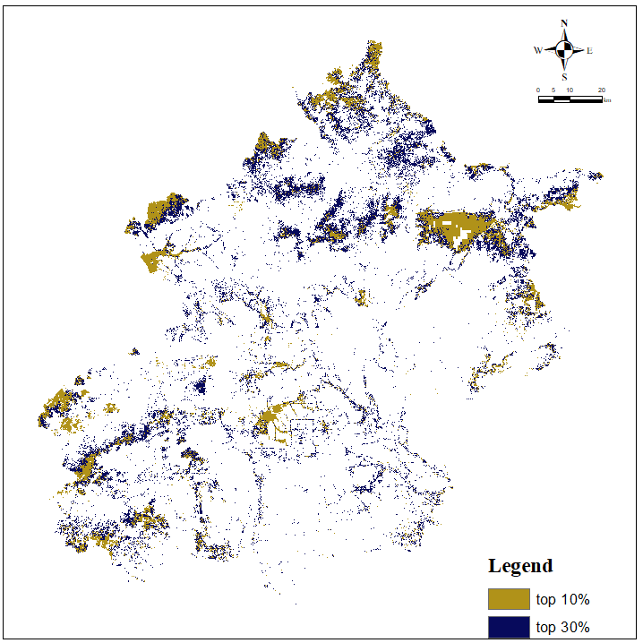

Figure S spatial congruency between ESP and priority zones of HPTS only scenario

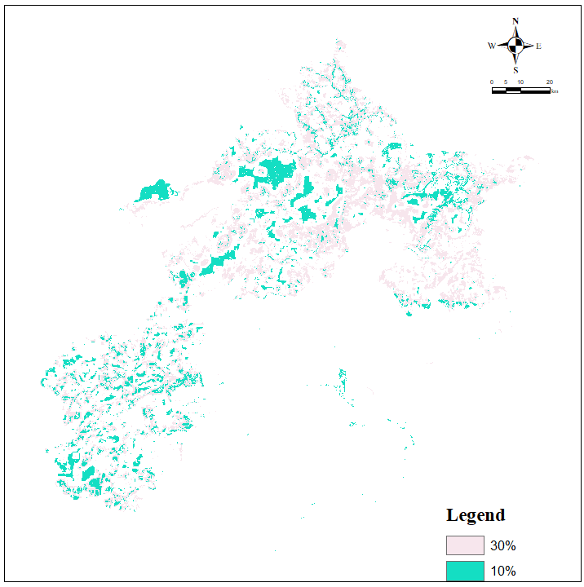

Figure S 14 Spatial congruency between ESP and priority zones of LC only scenario

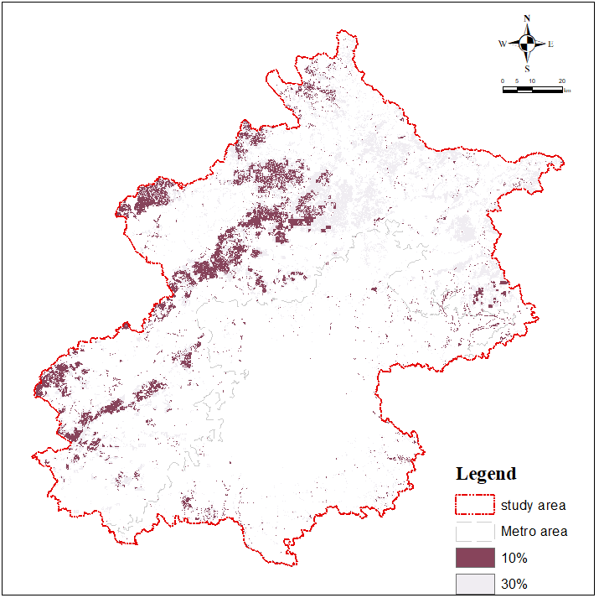

Figure S 15 Spatial congruency between ESP and priority zones of ESS only scenario

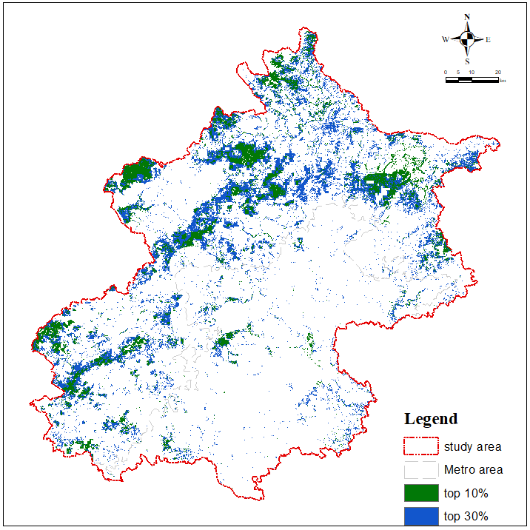

Figure S 16 Spatial congruency between ESP and priority zones of All equal scenario

1. References

Fu, S. et al. (2013) ‘The runoff curve number of SCS-CN method in Beijing’, Geographical Research, 32(5), pp. 797–807. Available at: https://doi.org/10.11821/yj2013050003.

Wei, J. et al. (2021) ‘Reconstructing 1-km-resolution high-quality PM2.5 data records from 2000 to 2018 in China: spatiotemporal variations and policy implications’, Remote Sensing of Environment, 252, p. 112136. Available at: https://doi.org/10.1016/j.rse.2020.112136.

Nowak, D.J. et al. (2013) ‘Modeled PM2.5 removal by trees in ten U.S. cities and associated health effects’, Environmental Pollution, 178(jul.), pp. 395–402. Available at: https://doi.org/10.1016/j.envpol.2013.03.050.

Zhang, J. et al. (2017) ‘Ecological land use planning for Beijing City based on the minimum cumulative resistance model’, Acta Ecologica Sinica, 37(19), p. 9. Available at: https://doi.org/10.5846/stxb201606121121.

Huang, Y. et al. (2021) ‘How to best preserve the irreplaceable habitats of threatened birds in Beijing?’, Biodiversity Science, 29(3), p. 11. Available at: https://link.cnki.net/urlid/11.3247.Q.20201103.1515.002.

Lu, N. et al. (2013) ‘Water yield responses to climate change and variability across the North–South Transect of Eastern China (NSTEC)’, Journal of Hydrology, 481, pp. 96–105. Available at: https://doi.org/10.1016/j.jhydrol.2012.12.020.

Li, Y. et al. (2013) ‘Impacts of land use change on ecosystem service functions: A case study of Miyun Reservoir watershed’, Acta Ecologica Sinica, 33(3), p. 11. Available at: https://doi.org/CNKI:SUN:STXB.0.2013-03-008.

Kadaverugu, A., Nageshwar Rao, C. and Viswanadh, G.K. (2021) ‘Quantification of flood mitigation services by urban green spaces using InVEST model: a case study of Hyderabad city, India’, Modeling Earth Systems and Environment, 7(1), pp. 589–602. Available at: https://doi.org/10.1007/s40808-020-00937-0.

Kong, X. et al. (2019) ‘Distribution and influencing factors of soil organic carbon of cultivated land topsoil in Beijing’, Resources Science, 41(12), pp. 2307–2315. Available at: https://doi.org/10.18402/resci.2019.12.14.

Yang, Z., Zhou, B., Yu, X., Fan, Dengxing, et al. (2012) ‘Biodiversity Analysis and Carbon Storage Assessments in Beijing Mountainous Areas’, Bulletin of Soil and Water Conservation [Preprint]. Available at: https://www.semanticscholar.org/paper/Biodiversity-Analysis-and-Carbon-Storage-in-Beijing-Qi/05d40fc44a39072f3de80a7ef70c50db0a50d672 (Accessed: 24 October 2024).

Xu, L., Yu, G. and He, N. (2019) ‘Increased soil organic carbon storage in Chinese terrestrial ecosystems from the 1980s to the 2010s’, Journal of Geographical Sciences, 29(1), pp. 49–66. Available at: https://doi.org/10.1007/s11442-019-1583-4.

Li, J. et al. (2020) ‘Evaluation of Carbon Storage on Terrestrial Ecosystem in Hebei Province Based on InVEST Model’, Journal of Ecology and Rural Environment, 36(7), pp. 854–861. Available at: https://doi.org/10.19741/j.issn.1673-4831.2019.0918.

Fick, S.E. and Hijmans, R.J. (2017) ‘WorldClim 2: new 1-km spatial resolution climate surfaces for global land areas’, International Journal of Climatology, 37(12), pp. 4302–4315. Available at: https://doi.org/10.1002/joc.5086.

Yang, J. et al. (2019) ‘Divergent shifts in peak photosynthesis timing of temperate and alpine grasslands in China’, Remote Sensing of Environment, 233, p. 111395. Available at: https://doi.org/10.1016/j.rse.2019.111395.

A. Rose et al. (2021) ‘LandScan Global 2020’. Oak Ridge National Laboratory, Oak Ridge, TN. Available at: https://doi.org/10.48690/1523378.

Radosavljevic, A. and Anderson, R.P. (2013) ‘Making better MAXENT models of species distributions: complexity, overfitting and evaluation’, Journal of Biogeography, 41(4), pp. 629–643. Available at: https://doi.org/10.1111/jbi.12227.

Zheng, H. et al. (2016) ‘Efficacy of conservation strategies for endangered oriental white storks (Ciconia boyciana) under climate change in Northeast China’, Biological Conservation, 204, pp. 367–377. Available at: https://doi.org/10.1016/j.biocon.2016.11.004.

O’Connor, L.M.J. et al. (2021) ‘Balancing conservation priorities for nature and for people in Europe’, Science, 372(6544), pp. 856–860. Available at: https://doi.org/10.1126/science.abc4896.