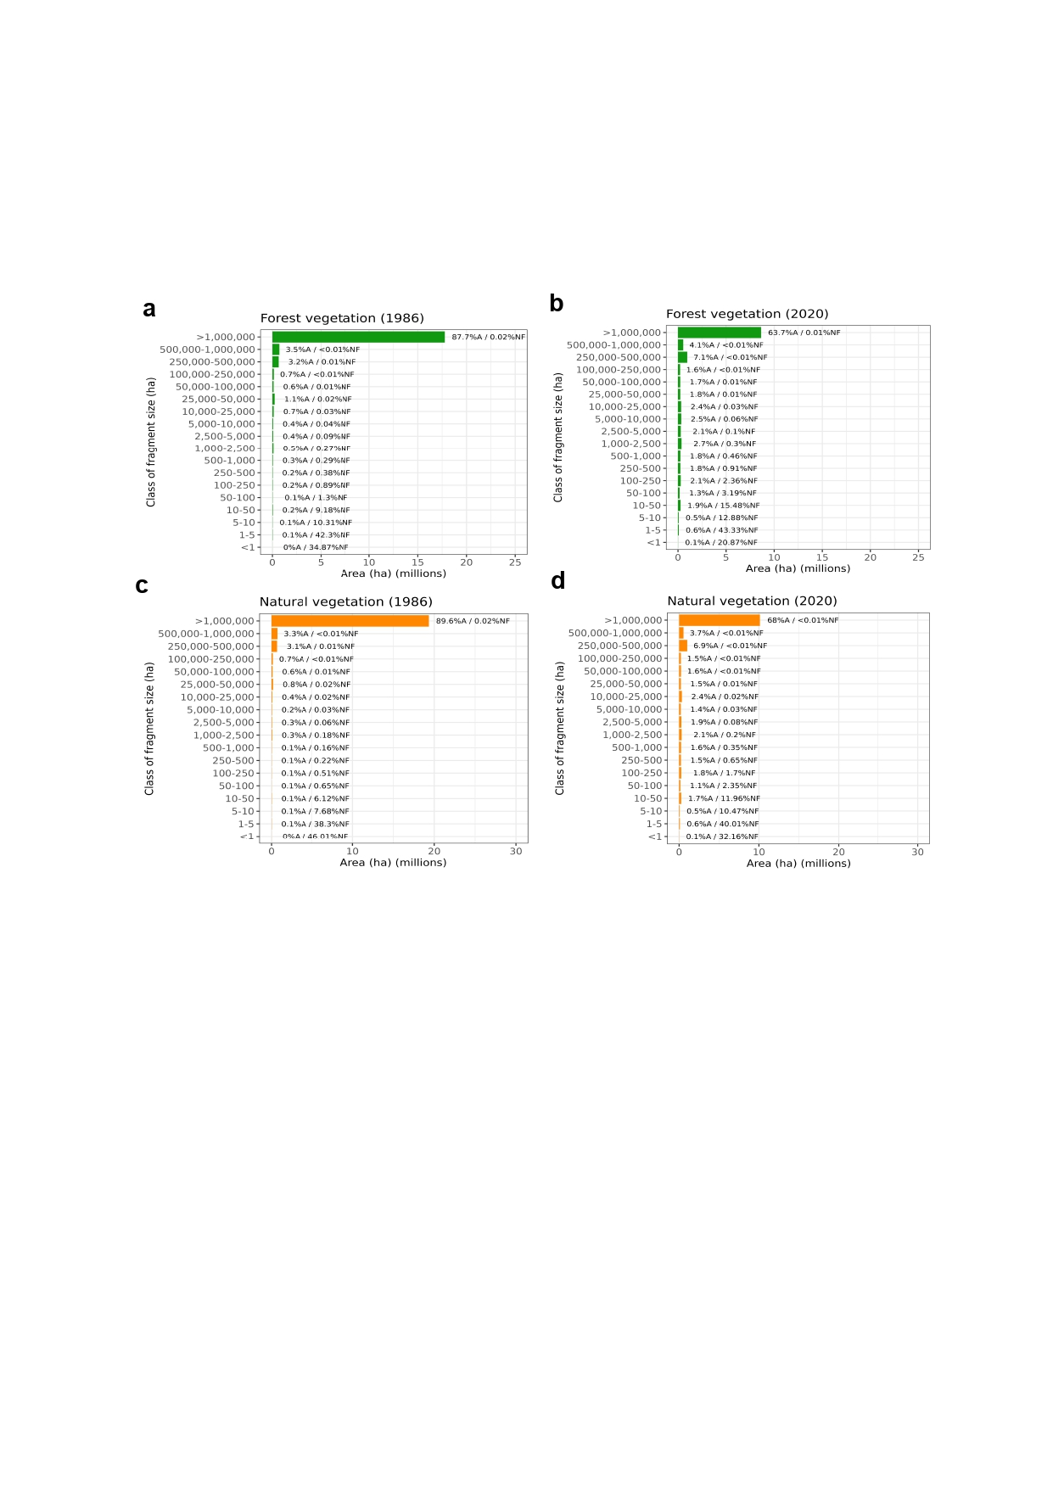
Figure S1. Distribution of the total areas of Forest Vegetation (FV) in 1986 (a) and 2020 (b) and Natural Vegetation (NV) fragments in 1986 (c) and 2020 (d) in Rondônia, where: %A = percentage of the total area; %NF = percentage of the number of fragments. Note the different scales in the x-axis between the FV and NV plots.

