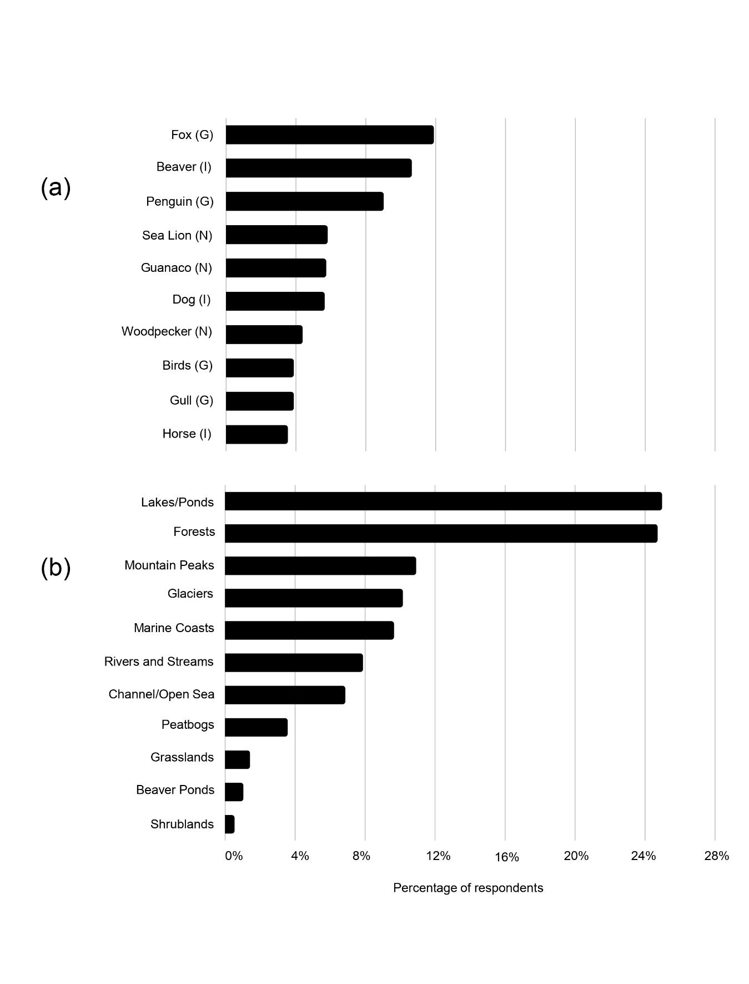Figure S1: Ranked responses by residents of Ushuaia, Argentina regarding their favorite (a) animals and (b) habitats. G = general term for a species or groups of species, N = native species to TDF, and I = introduced species.