**Supporting Information**

C:\Users\200597\OneDrive - UPEC\Recherche\Laos\Beetles\Org vs conv - 2023\updated_janv-2024\Figure2.tif

**Figure S1.** Non-metric multidimensional scaling (NMDS) showing on a 2D space the pairwise Bray-Curtis distance between beetle samples, collected in organic (green) and conventional (red) farms.

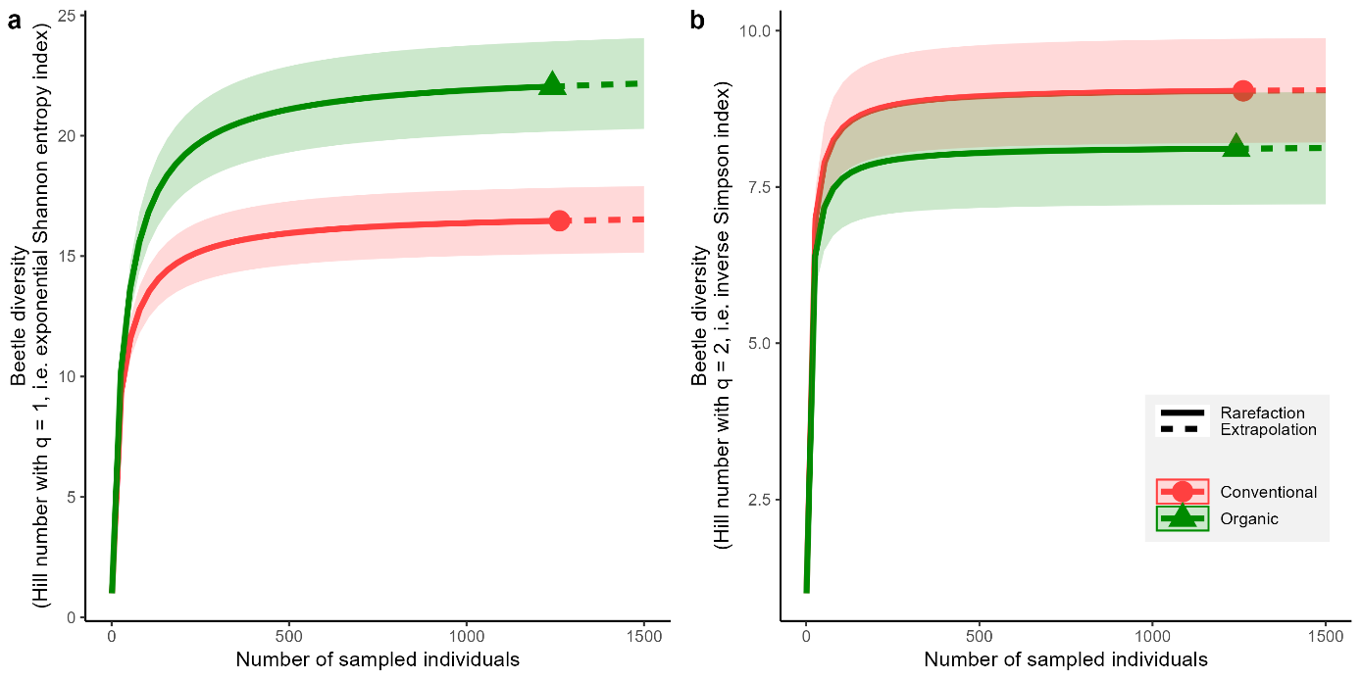

**Figure S2.** Rarefaction and extrapolation curves of beetle diversity for conventional and organic farms, computed using Hill numbers with q = 1 (a) and q = 2 (b), corresponding to the exponential Shannon index and the inverse Simpson index, respectively. As for species richness (see Figure 1 in the main text), diversity is higher in organic compared to conventional farms, although 95% CI overlapped when using the inverse Simpson index, showing the difference is driven by rare species, i.e. species that appear in low abundance.

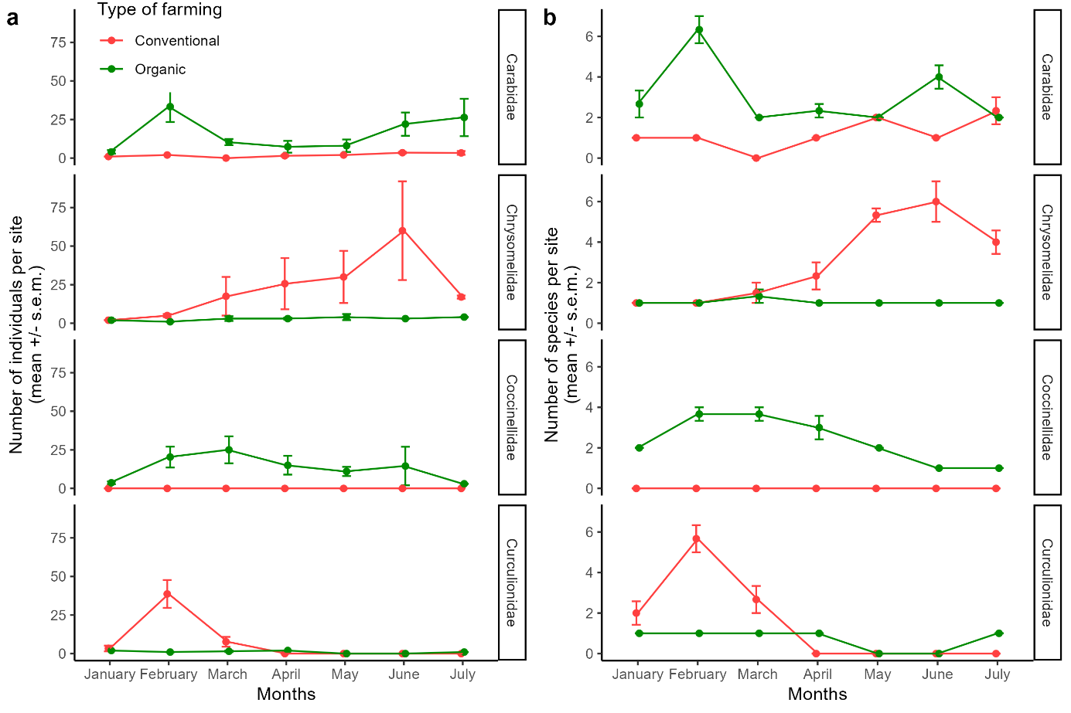

**Figure S3.** Mean (± standard error) abundance (a) and species richness (b) sampled in conventional (red) and organic (green) farms during the six months of sampling, shown separately for the four beetle families that featured > 100 individuals and > 10 species. The same patterns were found for total abundance and for richness: (i) Carabidae were almost always more diverse and abundant in organic farms, and showed two peaks of richness/abundance around February, then in June/July; (ii) Chrysomelidae, which were almost absent from both organic and conventional farms during the first months, increased in richness/abundance in conventional farms only, up to a peak in June; (iii) Coccinellidae were consistently absent from conventional farms, while they showed a maximum richness and abundance around February/March; (iv) Curculionidae were in very low abundance, and with one species maximum, in the organic farms, while they showed a peak in conventional farms in February.