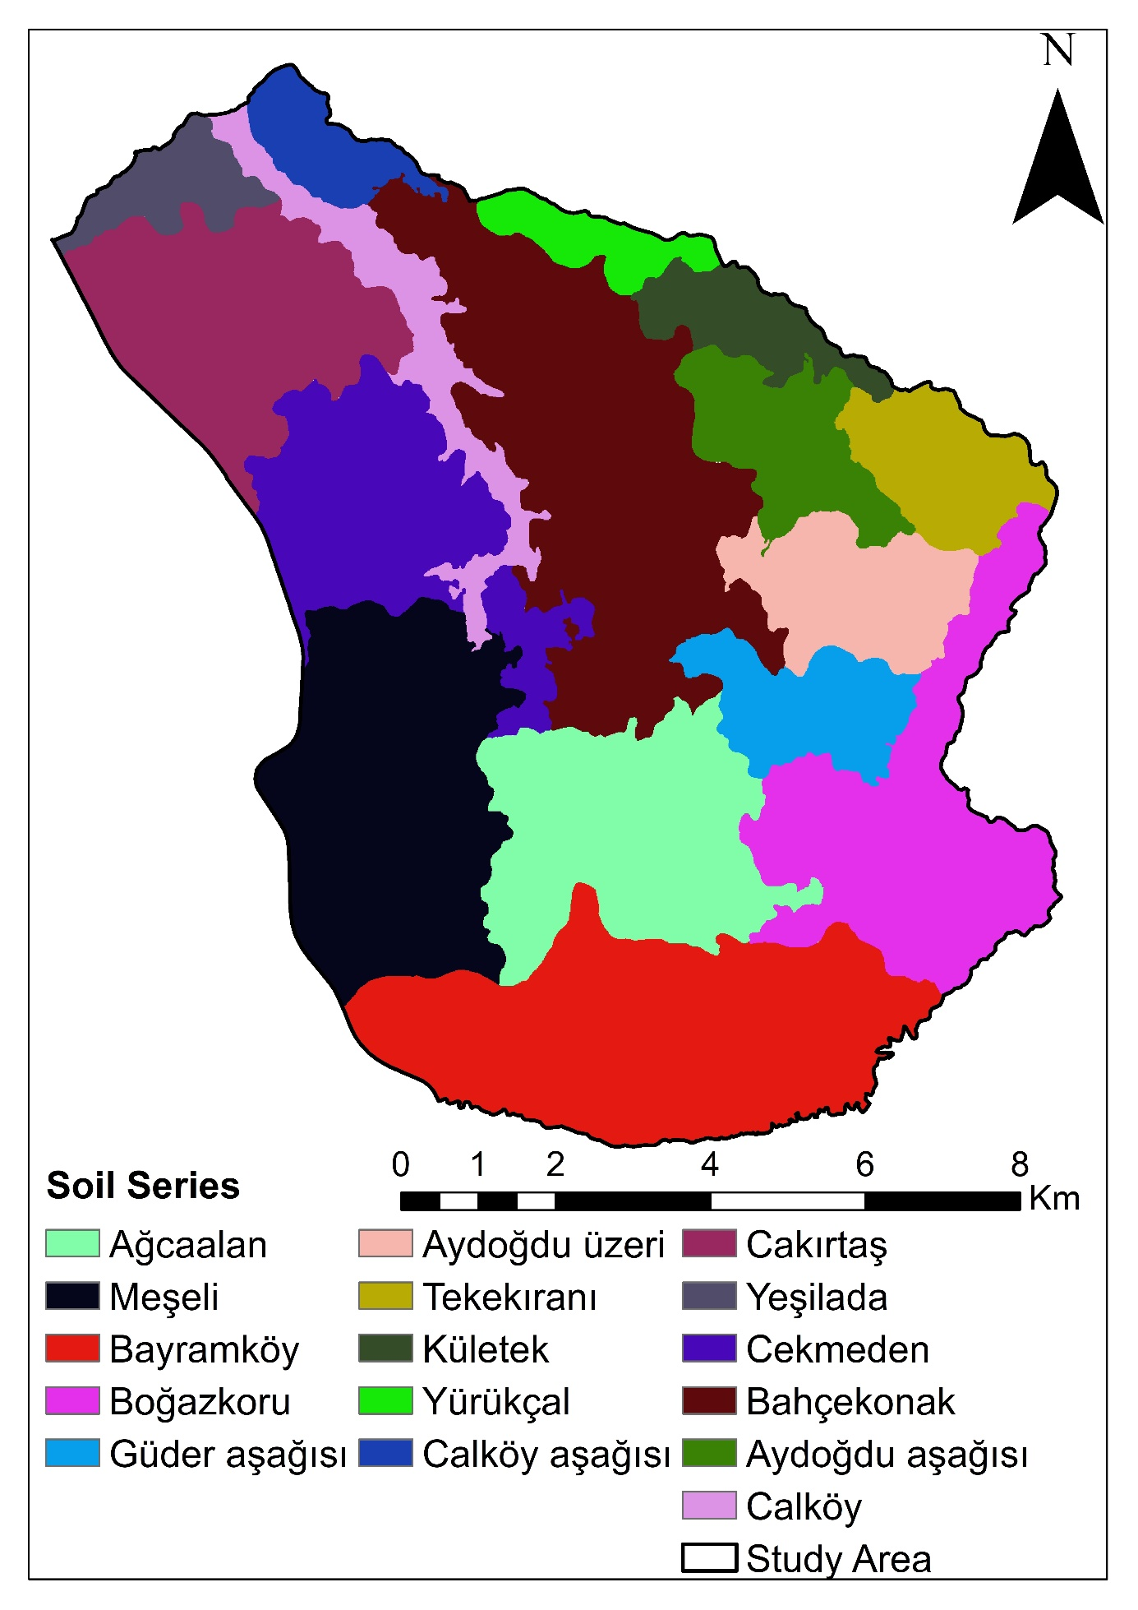

Figure S1. Soil series map of the study area (Saygın & Dengiz, 2023)

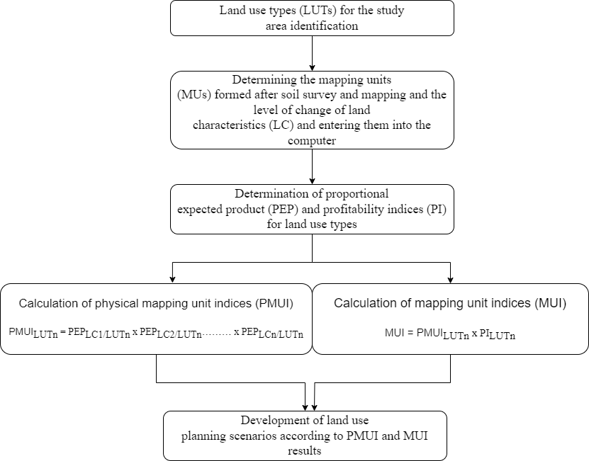

Figure S2. Methodology flowchart for land evaluation studies

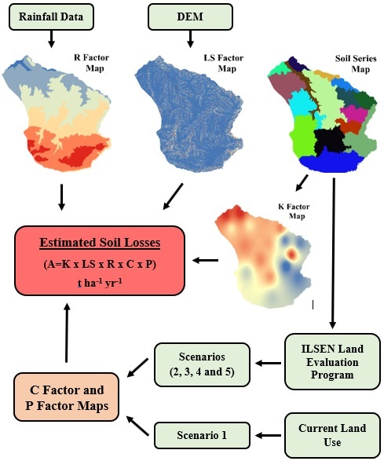

Figure S3. Methodology flowchart for erosion studies

**Reference**

Saygın F, Dengiz O (2023) Detailed soil mapping and classification study for sustainable agricultural land management; Samsun-Vezirköprü example. Soil Studies 12(1): 40-53.