**Appendix S1**

**Figure S1.** Satellite imagery of the sampling areas in 2016 (wetter conditions) and 2020 (drier conditions) at each area. Brighter greens indicate higher moisture content and vegetation density; orange and brown tones indicate drier areas and/or more sparse vegetation. C = control; P = prescribed burn; W = wildfire. White dots indicate processed soil cores which contributed data to this study; black dots indicate reference cores which were collected but not processed. Images sourced from Sentinel Playground (Sinergise Ltd; <http://apps.sentinel-hub/sentinel-playground/>).

**Table S1.** Size of each (user-defined) polygon used to generate WIT data.

|  |  |  |
| --- | --- | --- |
| **Area** | **Fire type** | **WIT polygon size (ha)** |
| 1 | Control | 3.62 |
| Prescribed | 1.97 |
| Wildfire | 2.93 |
| 2 | Control | 6.28 |
| Prescribed | 2.85 |
| Wildfire | 2.96 |
| 3 | Control | 3.70 |
| Wildfire | 5.92 |
| 4 | Control | 2.41 |
| Wildfire | 3.82 |

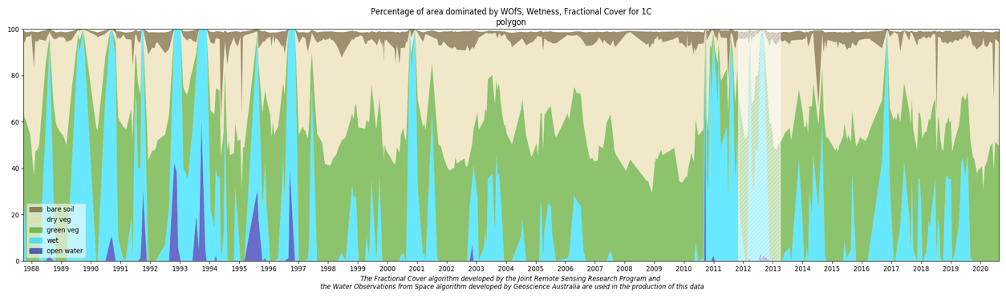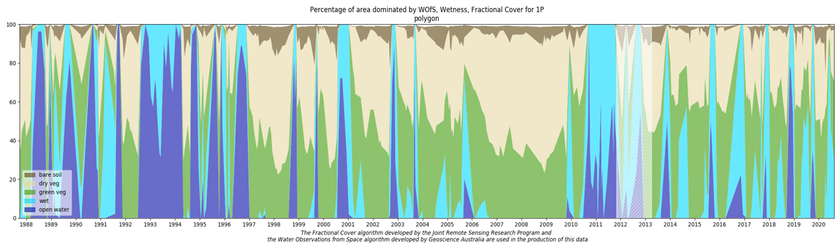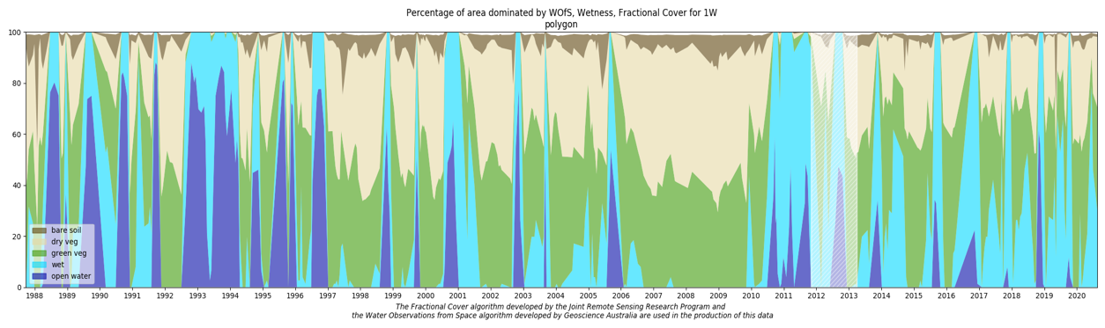

**Figure S2.** Wetlands Insight Tool (Dunn et al., 2023) Area 1 data from 1987-2020 at the control (top); prescribed burn (middle); and wildfire (bottom) floodplain areas.

**Figure S3.** Wetlands Insight Tool (Dunn et al., 2023) Area 2 data from 1987-2020 at the control (top); prescribed burn (middle); and wildfire (bottom) floodplain areas.

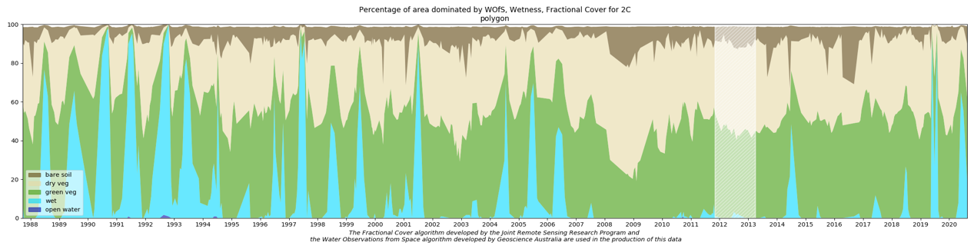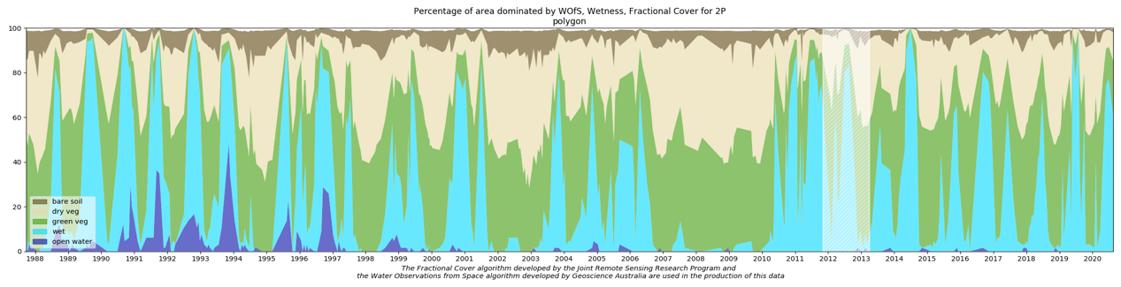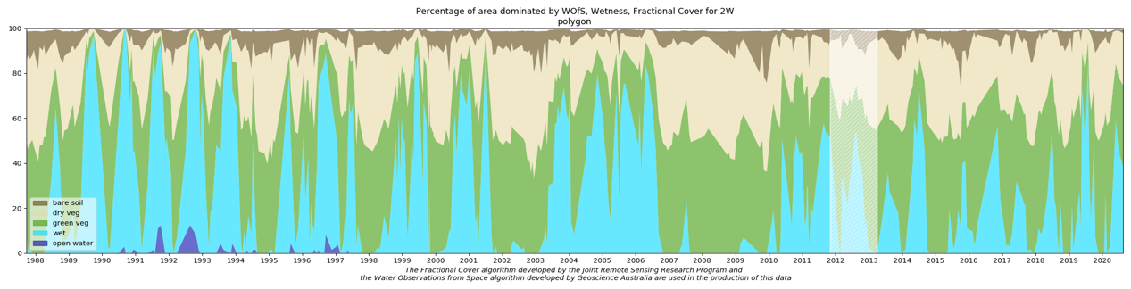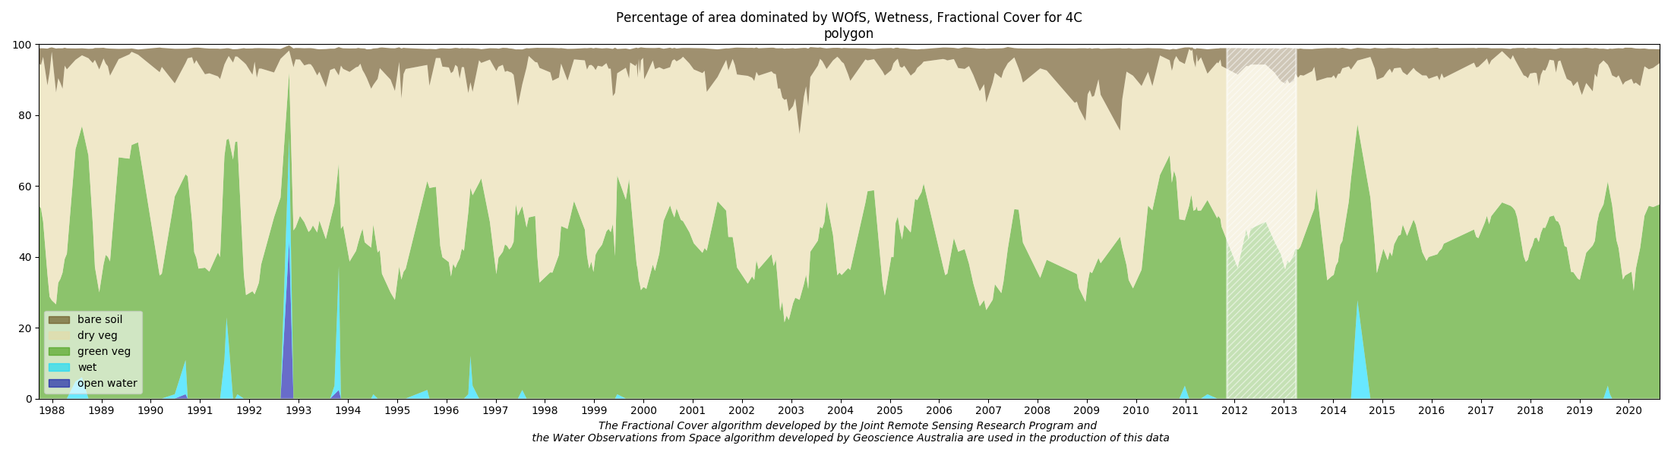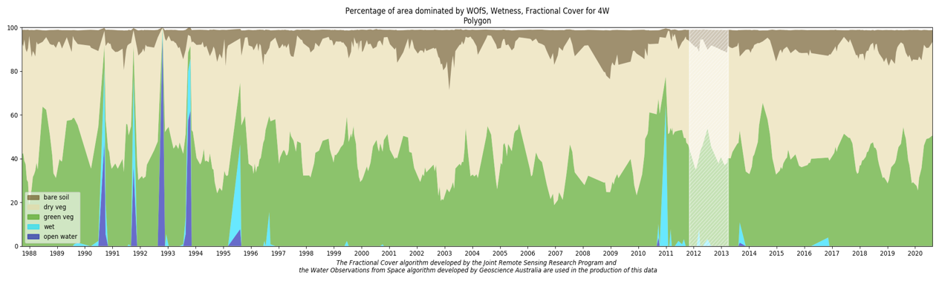

**Figure S4.** Wetlands Insight Tool (Dunn et al., 2023) Area 3 data from 1987-2020 at the control (top) and wildfire (bottom) floodplain areas.

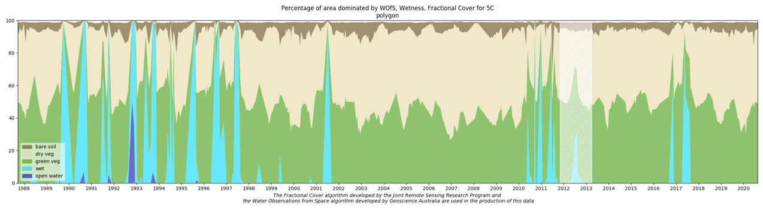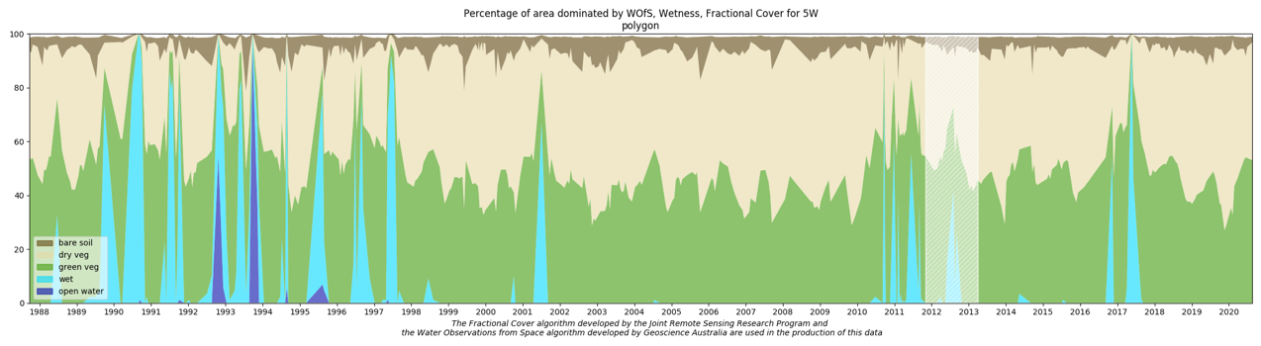

**Figure S5.** Wetlands Insight Tool (Dunn et al., 2023) Area 4 data from 1987-2020 at the control (top) and wildfire (bottom) floodplain areas.

**References**

Dunn, B., Ai, E., Alger, M. J., Fanson, B., Fickas, K. C., Krause, C. E., Lymburner, L., Nanson, R., Papas, P., Ronan, M., Thomas, R. F., 2023. Wetlands Insight Tool: Characterising the surface water and vegetation cover dynamics of individual wetlands using multidecadal Landsat satellite data. Applied Wetland Science 43. <https://doi.org/10.1007/s13157-023-01682-7>