Supplementary material

Title: Brazil's Iguaçu National Park: Economic risks of proposed road construction and downgrading

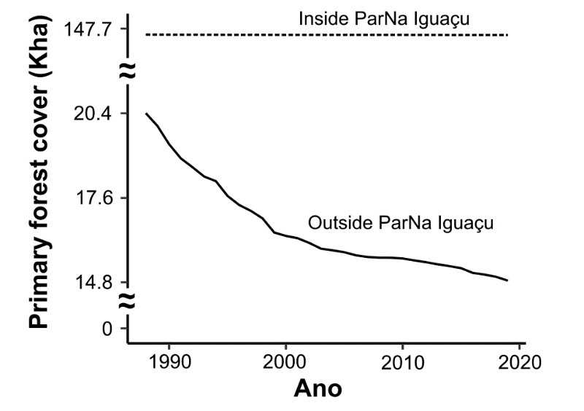
Figure S1. Primary forest cover outside and inside Iguaçu National Park from 1987 to 2021.

