Appendix S2
Figure A2 shows that the total number of monthly visitors estimated by KDDI was about half [0.399–0.947] the number of visitors counted by the local government (Wajima-City) with an automatic counter. In particular, the difference increases as the number of visitors increases; the increased variation of residential areas may cause the result seen (i.e., the increase in visitors living in a residential area where less than 10 visitors come). Otherwise, the visitor numbers were very similar, with an R-squared of 0.7991 (p < 0.001).

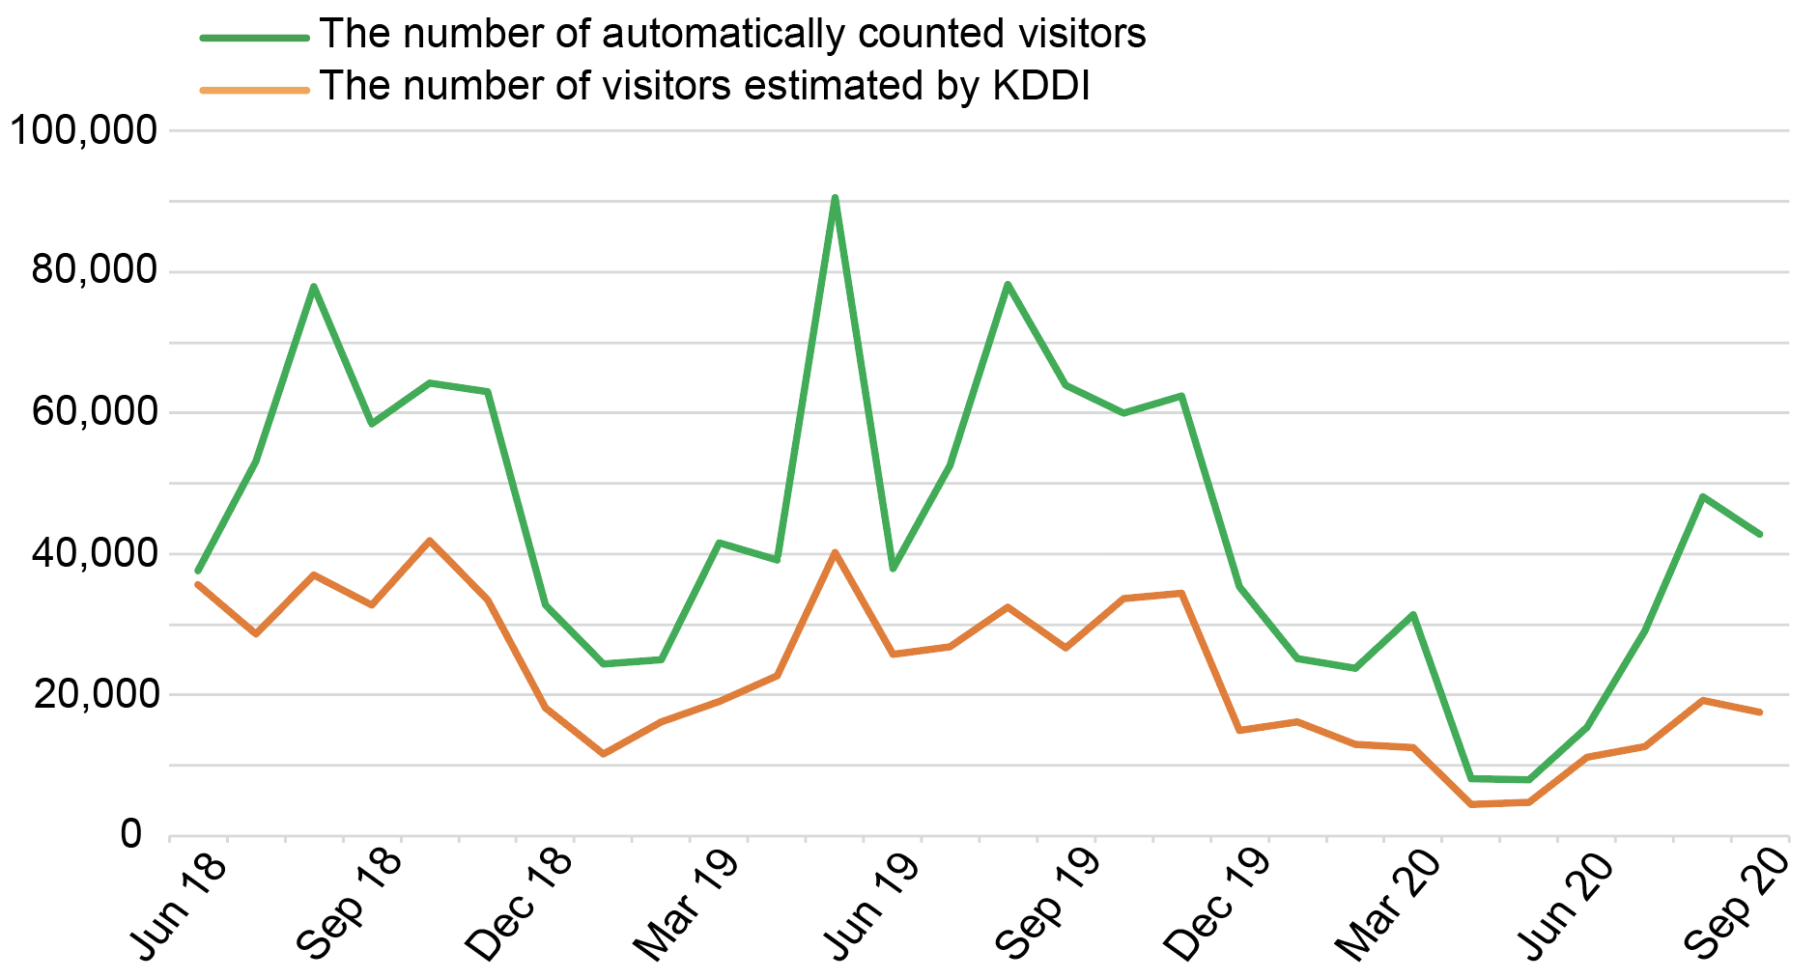
Figure A2. Number of visitors to Shiroyone terraced paddy land per month

