Supplementary material 2
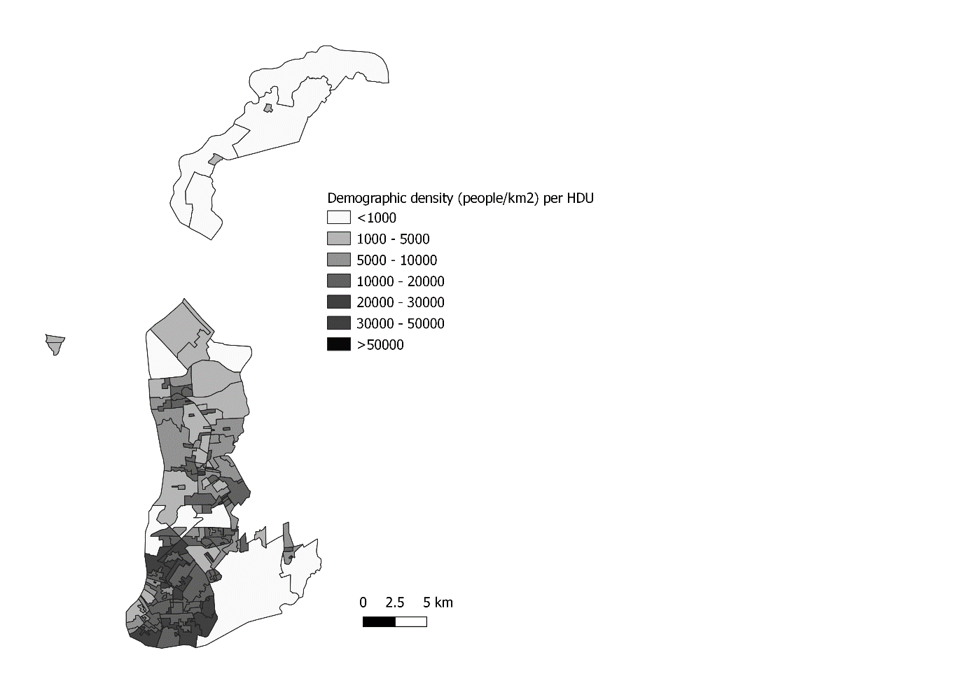
Figure S1: Demographic density per human development unit across the study area.
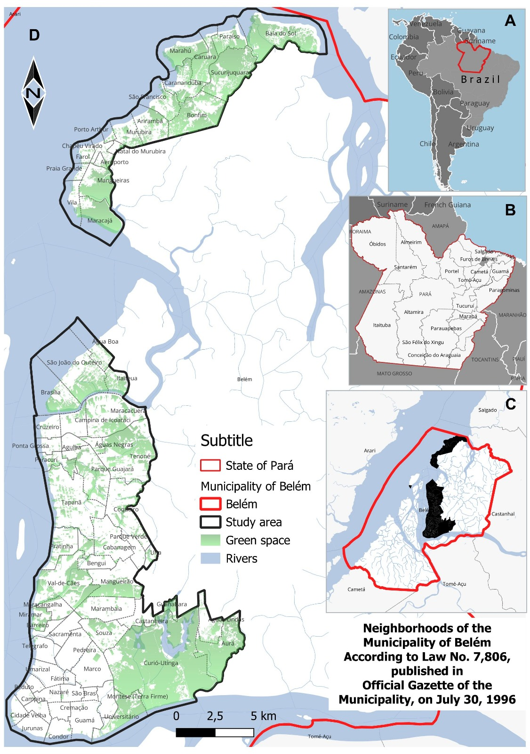
Figure S2: map of vegetation cover classified in the analyses carried out in this study.

