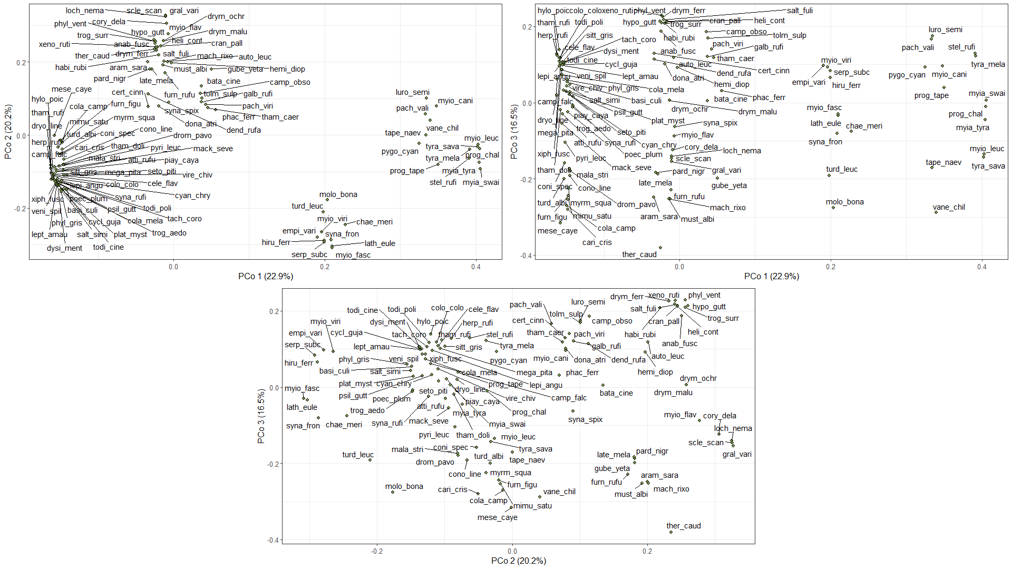
Figure S1. Figures containing the PCOA with the three axes used. It is possible to observe all species within the functional space.
Figure S2. PCOA with the three axes used. It is possible to observe all species within the functional space in a 3D environment.

