SUPPLEMENTARY MATERIAL

Table S1. Submodels of the probability of habitat use (Ψ) with the human footprint index of Martinuzzi et al. (2021) (HFI.Value) and submodels of the probability of detection (p) with the number of nights that camera traps were active (Effort) as explanatory variables of medium and large-size mammal species in Southern Yungas of Argentina. Shown in bold are the models selected based on the criteria that the Akaike Information Criterion corrected for small samples (AICc) had a difference of less than 2 (ΔAICc). Also shown is the relative weight of each model (AICcWt), the cumulative weight (CumWt), and the number of model parameters (k).
Species | Model names | AICc | ΔAICc | AICcWt | Cum.Wt | K
Cerdocyon thous | p(.)Ψ(.) | 452.24 | 0.00 | 0.43 | 0.43 | 2
 | p(Effort)Ψ(.) | 453.09 | 0.85 | 0.28 | 0.71 | 3
 | p(.)Ψ(HFI.Value) | 454.06 | 1.82 | 0.17 | 0.89 | 3
 | p(Effort)Ψ(HFI.Value) | 454.94 | 2.70 | 0.11 | 1.00 | 4
Dasyprocta punctata | p(Effort)Ψ(.) | 665.38 | 0.00 | 0.71 | 0.71 | 3
 | p(Effort)Ψ(HFI.Value) | 667.15 | 1.78 | 0.29 | 1.00 | 4
 | p(.)Ψ(.) | 681.05 | 15.67 | 0.00 | 1.00 | 2
 | p(.)Ψ(HFI.Value) | 682.83 | 17.46 | 0.00 | 1.00 | 3
Leopardus pardalis | p(.)Ψ(.) | 486.55 | 0.00 | 0.50 | 0.50 | 2
 | p(Effort)Ψ(.) | 488.05 | 1.50 | 0.23 | 0.73 | 3
 | p(.)Ψ(HFI.Value) | 488.53 | 1.99 | 0.18 | 0.91 | 3
 | p(Effort)Ψ(HFI.Value) | 490.04 | 3.50 | 0.09 | 1.00 | 4
Mazama gouazoubira | p(.)Ψ(HFI.Value) | 1169.70 | 0.00 | 0.63 | 0.63 | 3
 | p(Effort)Ψ(HFI.Value) | 1171.24 | 1.53 | 0.29 | 0.93 | 4
 | p(.)Ψ(.) | 1174.88 | 5.18 | 0.05 | 0.98 | 2
 | p(Effort)Ψ(.) | 1176.30 | 6.59 | 0.02 | 1.00 | 3
Pecari tajacu | p(Effort)Ψ(HFI.Value) | 580.79 | 0.00 | 0.28 | 0.28 | 4
 | p(.)Ψ(HFI.Value) | 580.99 | 0.20 | 0.25 | 0.54 | 3
 | p(Effort)Ψ(.) | 581.04 | 0.25 | 0.25 | 0.78 | 3
 | p(.)Ψ(.) | 581.32 | 0.53 | 0.22 | 1.00 | 2
Sylvilagus brasiliensis | p(.)Ψ(HFI.Value) | 926.30 | 0.00 | 0.39 | 0.39 | 3
 | p(.)Ψ(.) | 926.49 | 0.19 | 0.35 | 0.74 | 2
 | p(Effort)Ψ(HFI.Value) | 928.39 | 2.09 | 0.14 | 0.87 | 4
 | p(Effort)Ψ(.) | 928.56 | 2.25 | 0.13 | 1.00 | 3
Tapirus terrestris | p(.)Ψ(HFI.Value) | 860.71 | 0.00 | 0.68 | 0.68 | 3
 | p(Effort)Ψ(HFI.Value) | 862.81 | 2.10 | 0.24 | 0.91 | 4
 | p(.)Ψ(.) | 865.43 | 4.72 | 0.06 | 0.98 | 2
 | p(Effort)Ψ(.) | 867.48 | 6.77 | 0.02 | 1.00 | 3
Leopardus wiedii | p(Effort)Ψ(.) | 351.63 | 0.00 | 0.43 | 0.43 | 3
 | p(.)Ψ(.) | 352.35 | 0.71 | 0.30 | 0.74 | 2
 | p(Effort)Ψ(HFI.Value) | 353.71 | 2.08 | 0.15 | 0.89 | 4
 | p(.)Ψ(HFI.Value) | 354.41 | 2.78 | 0.11 | 1.00 | 3
Eira barbara | p(.)Ψ(.) | 332.21 | 0.00 | 0.35 | 0.35 | 2
 | p(Effort)Ψ(.) | 332.46 | 0.24 | 0.31 | 0.66 | 3
 | p(.)Ψ(HFI.Value) | 333.43 | 1.21 | 0.19 | 0.84 | 3
 | p(Effort)Ψ(HFI.Value) | 333.82 | 1.61 | 0.16 | 1.00 | 4
Mazama americana | p(.)Ψ(HFI.Value) | 174.12 | 0.00 | 0.45 | 0.45 | 3
 | p(Effort)Ψ(HFI.Value) | 174.91 | 0.79 | 0.30 | 0.75 | 4
 | p(.)Ψ(.) | 176.38 | 2.26 | 0.15 | 0.90 | 2
 | p(Effort)Ψ(.) | 177.09 | 2.97 | 0.10 | 1.00 | 3
Procyon cancrivorus | p(Effort)Ψ(HFI.Value) | 159.73 | 0.00 | 0.75 | 0.75 | 4
 | p(Effort)Ψ(.) | 161.97 | 2.24 | 0.24 | 0.99 | 3
 | p(.)Ψ(HFI.Value) | 169.29 | 9.56 | 0.01 | 1.00 | 3
 | p(.)Ψ(.) | 172.05 | 12.32 | 0.00 | 1.00 | 2
Panthera onca | p(.)Ψ(.) | 145.96 | 0.00 | 0.43 | 0.43 | 2
 | p(Effort)Ψ(.) | 147.01 | 1.05 | 0.26 | 0.69 | 3
 | p(.)Ψ(HFI.Value) | 147.46 | 1.50 | 0.20 | 0.89 | 3
 | p(Effort)Ψ(HFI.Value) | 148.74 | 2.77 | 0.11 | 1.00 | 4
Puma yagouaroundi | p(.)Ψ | 155.02 | 0.00 | 0.41 | 0.41 | 2
 | p(.)Ψ(HFI.Value) | 155.71 | 0.69 | 0.29 | 0.70 | 3
 | p(Effort)Ψ(.) | 156.35 | 1.33 | 0.21 | 0.92 | 3
 | p(Effort)Ψ(HFI.Value) | 158.21 | 3.19 | 0.08 | 1.00 | 4
Myrmecophaga tridactyla | p(.)Ψ(.) | no convergence
 | p(.)Ψ(HFI.Value)
 | p(Effort)Ψ(.)
 | p(Effort)Ψ(HFI.Value)

Table S2. Beta values of the best model (Estimate), standard error (Std.Error), p-value of significance (p <0.05 in bold) and 95% confidence intervals using the human footprint index of Martinuzzi et al. (2021) with 100 m resolution (HFI.Value) that affected the probability of habitat use (ψ) and the number of nights that camera traps were active (Effort) that affected the probability of detection (p) of medium and large-sized mammals in Southern Yungas of Argentina.
 |  |  |  |  | 95% confidence interval
Species | Parameter | Estimate | Std.Error | p | Lower limit | Upper limit
Cerdocyon thous | Ψ(Int) | -0.86 | 0.24 | <0.001 | -1.33 | -0.4
 | p(Int) | -1.5 | 0.2 | <0.001 | -1.89 | -1.1
 | p(Effort) | -0.23 | 0.21 | 0.28 | -0.64 | 0.18
 | Ψ(HFI.Value) | 0.09 | 0.21 | 0.67 | -0.32 | 0.49
Dasyprocta punctata | Ψ(Int) | -0.77 | 0.17 | <0.001 | -1.11 | -0.43
 | p(Int) | -0.35 | 0.12 | <0.001 | -0.58 | -0.12
 | p(Effort) | 0.66 | 0.16 | <0.001 | 0.34 | 0.98
 | Ψ(HFI.Value) | 0.1 | 0.17 | 0.57 | -0.24 | 0.43
Leopardus pardalis | Ψ(Int) | -0.58 | 0.25 | 0.02 | -1.08 | -0.09
 | p(Int) | -1.64 | 0.2 | <0.001 | -2.04 | -1.25
 | p(Effort) | -0.1 | 0.14 | 0.5 | -0.37 | 0.18
 | Ψ(HFI.Value) | 0.02 | 0.21 | 0.91 | -0.39 | 0.43
Mazama gouazoubira | Ψ(Int) | 0.72 | 0.19 | <0.001 | 0.35 | 1.09
 | Ψ(HFI.Value) | 0.53 | 0.22 | 0.01 | 0.1 | 0.96
 | p(Int) | -0.59 | 0.08 | <0.001 | -0.76 | -0.43
 | p(Effort) | -0.12 | 0.13 | 0.39 | -0.38 | 0.15
Pecari tajacu | Ψ(Int) | -0.37 | 0.23 | 0.1 | -0.82 | 0.08
 | Ψ(HFI.Value) | 0.28 | 0.19 | 0.14 | -0.09 | 0.66
 | p(Int) | -1.5 | 0.17 | <0.001 | -1.83 | -1.17
 | p(Effort) | -0.22 | 0.15 | 0.14 | -0.52 | 0.08
Sylvilagus brasiliensis | Ψ(Int) | -0.24 | 0.16 | 0.14 | -0.55 | 0.07
 | Ψ(HFI.Value) | 0.24 | 0.16 | 0.14 | -0.08 | 0.56
 | p(Int) | -0.1 | 0.09 | 0.27 | -0.28 | 0.08
 | p(Effort) | - | - | - | - | -
Tapirus terrestris | Ψ | -0.03 | 0.18 | 0.86 | -0.38 | 0.32
 | Ψ(HFI.Value) | -0.46 | 0.18 | 0.01 | -0.83 | -0.1
 | p(Int) | -0.91 | 0.1 | <0.001 | -1.12 | -0.69
 | p(Effort) | - | - | - | - | -
Leopardus wiedii | Ψ(Int) | -1.08 | 0.28 | <0.001 | -1.64 | -0.52
 | p(Int) | -1.74 | 27 | <0.001 | -2.88 | -1.21
 | p(Effort) | -0.55 | 0.35 | 0.1 | -1.22 | 0.11
 | Ψ(HFI.Value) | - | - | - | - | -
Eira barbara | Ψ(Int) | -0.34 | 0.51 | 0.5 | -1.34 | 0.65
 | p(Int) | -2.46 | 0.35 | <0.001 | -3.15 | -1.77
 | p(Effort) | -0.33 | 0.26 | 0.21 | -0.84 | 0.18
 | Ψ(HFI.Value) | 0.26 | 0.29 | 0.38 | -0.32 | 0.84
Mazama americana | Ψ(Int) | -1.88 | 0.48 | <0.001 | -2.82 | -0.95
 | Ψ(HFI.Value) | 0.65 | 0.36 | 0.07 | -0.05 | 1.35
 | p(Int) | -2.14 | 0.47 | <0.001 | -3.05 | -1.22
 | p(Effort) | -0.46 | 0.43 | 0.28 | -1.29 | 0.38
Procyon cancrivorus | Ψ(Int) | -2.62 | 0.46 | <0.001 | -3.52 | -1.71
 | Ψ(HFI.Value) | -0.96 | 0.57 | 0.09 | -2.08 | 0.16
 | p(Int) | -1.22 | 0.32 | <0.001 | -1.87 | -0.57
 | p(Effort) | 1.38 | 0.4 | <0.001 | 0.58 | 2.18
Panthera onca | Ψ(Int) | -0.53 | 1.55 | 0.73 | -3.58 | 2.52
 | p(Int) | -3.46 | 0.96 | <0.001 | -5.35 | -1.58
 | p(Effort) | 0.83 | 1.03 | 0.42 | -1.18 | 2.85
 | Ψ(HFI.Value) | -0.41 | 0.67 | 0.54 | -1.72 | 0.9
Puma yagouaroundi | Ψ(Int) | 1.07 | 3.38 | 0.75 | -5.56 | 7.69
 | p(Int) | -3.72 | 0.84 | <0.001 | -5.38 | -2.07
 | Ψ(HFI.Value) | 4.96 | 5.06 | 0.33 | -4.95 | 14.88
 | p(Effort) | 0.48 | 0.63 | 0.45 | -0.76 | 1.72

Table S3. Beta values of the best model (Estimate), standard error (Std.Error), p-value of significance (p <0.05 in bold) and 95% confidence intervals using the global human footprint index (Sanderson et al. 2022) with 300 m resolution (GlobalValue) that affected the probability of habitat use (ψ) and the number of nights that camera traps were active (Effort) that affected the probability of detection (p) of medium and large-sized mammals in Southern Yungas of Argentina.
 |  |  |  |  | 95% confidence interval
Species | Parameter | Estimate | Std. Error | p | Lower limit | Upper limit
Cerdocyon thous | Ψ(Int) | -0.86 | 0.24 | <0.01 | -1.32 | -0.39
 | p(Int) | -1.50 | 0.20 | <0.01 | -1.90 | -1.11
 | p(Effort) | -0.23 | 0.21 | 0.28 | -0.64 | 0.18
 | Ψ(GlobalValue) | - | - | - | - | -
Dasyprocta punctata | Ψ(Int) | -0.77 | 0.17 | <0.01 | -1.11 | -0.43
 | p(Int) | -0.35 | 0.12 | <0.01 | -0.58 | -0.11
 | p(Effort) | 0.66 | 0.16 | <0.01 | 0.34 | 0.98
 | Ψ(GlobalValue) | 0.13 | 0.17 | 0.47 | -0.21 | 0.46
Eira barbara | Ψ(Int) | -0.35 | 0.51 | 0.49 | -1.34 | 0.65
 | p(Int) | -2.46 | 0.35 | <0.01 | -3.15 | -1.77
 | p(Effort) | -0.33 | 0.26 | 0.21 | -0.84 | 0.18
 | Ψ(GlobalValue) | 0.22 | 0.27 | 0.41 | -0.30 | 0.75
Leopardus pardalis | Ψ(Int) | -0.59 | 0.26 | 0.02 | -1.09 | -0.09
 | Ψ(GlobalValue) | -0.35 | 0.23 | 0.13 | -0.80 | 0.10
 | p(Int) | -1.64 | 0.20 | <0.01 | -2.04 | -1.25
 | p(Effort) | -0.12 | 0.15 | 0.42 | -0.41 | 0.17
Mazama americana | Ψ(Int) | -1.81 | 0.44 | <0.01 | -2.67 | -0.95
 | p(Int) | -2.10 | 0.44 | <0.01 | -2.97 | -1.23
 | p(Effort) | -0.46 | 0.43 | 0.28 | -1.29 | 0.38
 | Ψ(GlobalValue) | 0.22 | 0.27 | 0.42 | -0.32 | 0.76
Mazama gouazoubira | Ψ(Int) | 0.67 | 0.18 | <0.01 | 0.32 | 1.02
 | p(Int) | -0.60 | 0.09 | <0.01 | -0.76 | -0.43
 | Ψ(GlobalValue) | 0.17 | 0.20 | 0.38 | -0.21 | 0.56
 | p(Effort) | -0.13 | 0.14 | 0.37 | -0.40 | 0.15
Panthera onca | Ψ(Int) | 1.53 | 6.41 | 0.81 | -11.03 | 14.09
 | Ψ(GlobalValue) | -3.53 | 6.81 | 0.60 | -16.87 | 9.82
 | p(Int) | -3.99 | 0.59 | <0.01 | -5.15 | -2.83
 | p(Effort) | 0.83 | 1.03 | 0.42 | -1.18 | 2.85
Pecari tajacu | Ψ(Int) | -0.36 | 0.23 | 0.11 | -0.81 | 0.09
 | p(Int) | -1.51 | 0.17 | <0.01 | -1.84 | -1.18
 | p(Effort) | -0.22 | 0.15 | 0.14 | -0.52 | 0.07
 | Ψ(GlobalValue) | -0.03 | 0.20 | 0.89 | -0.42 | 0.36
Procyon cancrivorus | Ψ(Int) | -2.40 | 0.39 | <0.01 | -3.17 | -1.64
 | Ψ(GlobalValue) | -0.65 | 0.48 | 0.18 | -1.60 | 0.30
 | p(Int) | -1.22 | 0.33 | <0.01 | -1.87 | -0.57
 | p(Effort) | 1.39 | 0.41 | <0.01 | 0.59 | 2.19
Puma yagouaroundi | Ψ(Int) | -0.22 | 1.73 | 0.90 | -3.60 | 3.17
 | p(Int) | -3.58 | 0.97 | <0.01 | -5.47 | -1.68
 | p(Effort) | 0.48 | 0.63 | 0.45 | -0.76 | 1.72
 | Ψ(GlobalValue) | 0.24 | 0.71 | 0.73 | -1.15 | 1.64
Sylvilagus brasiliensis | Ψ(Int) | -0.24 | 0.16 | 0.14 | -0.55 | 0.07
 | p(Int) | -0.10 | 0.09 | 0.27 | -0.28 | 0.08
 | Ψ(GlobalValue) | -0.07 | 0.16 | 0.67 | -0.38 | 0.25
 | p(Effort) | - | - | - | - | -
Tapirus terrestris | Ψ(Int) | -0.03 | 0.18 | 0.85 | -0.39 | 0.32
 | Ψ(GlobalValue) | -0.50 | 0.19 | 0.01 | -0.87 | -0.13
 | p(Int) | -0.92 | 0.11 | <0.01 | -1.14 | -0.70
 | p(Effort) | 0.23 | 0.13 | 0.07 | -0.02 | 0.48
Myrmecophaga tridactyla | Ψ(Int) | -0.04 | 1.84 | 0.98 | -3.65 | 3.57
 | p(Int) | -3.68 | 1.00 | <0.01 | -5.63 | -1.72
 | p(Effort) | -0.11 | 0.33 | 0.75 | -0.75 | 0.54
Leopardus wiedii | Ψ(Int) | -1.08 | 0.29 | <0.01 | -1.64 | -0.52
 | p(Int) | -1.77 | 0.28 | <0.01 | -2.31 | -1.23
 | p(Effort) | -0.54 | 0.34 | 0.11 | -1.21 | 0.13
 | Ψ(GlobalValue) | 0.18 | 0.21 | 0.39 | -0.23 | 0.59

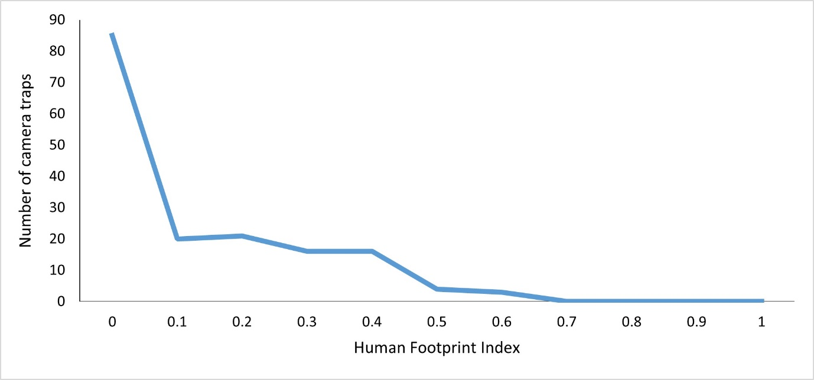
Figure S1. Number of camera traps placed according to the human footprint index (Martinuzzi et al. 2021) in the Southern Yungas of Argentina.

1) a. b. c.
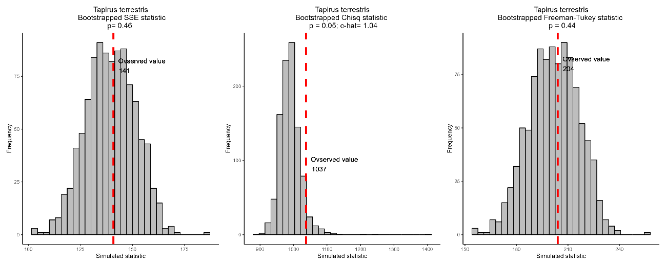
2) a. b. c.
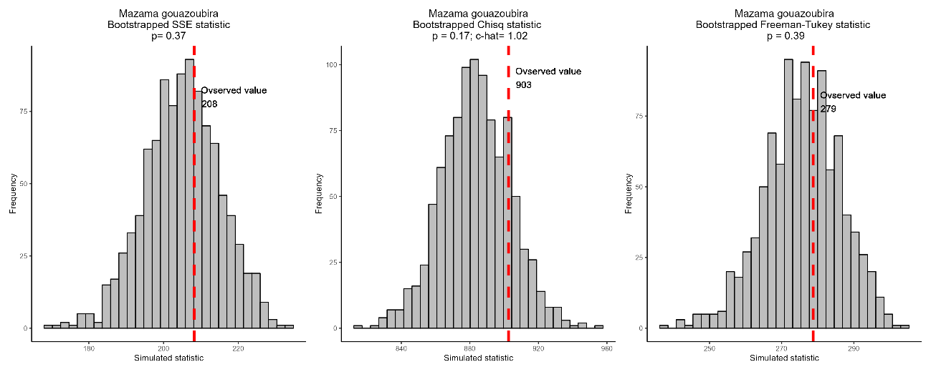
Figure S2. Goodness of fit tests for the best occupancy model for 1) Tapirus terrestris and 2) Mazama gouazoubira. a. sum of squared errors statistic; b. Chi-square statistic and c-hat; c. Freeman-Tukey.
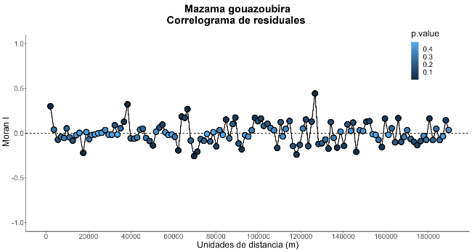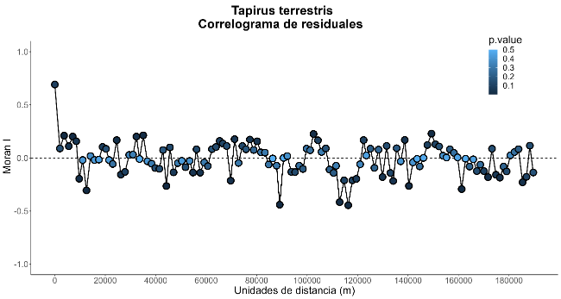
Figure S3. Moran's I spatial correlograms for single-species occupancy best model residuals for Mazama goauzoubira and Tapirus terrestris.

