Enhanced coarticulatory labialization of /t^{s}/ in Argentine Danish
Supplementary materials
Table A1. Mean CoG value (Hz) for all levels in the factor Context, with standard deviation and number of tokens for all levels. Dotted line = mean CoG. Data: Argentine Danish dataset.
Level (phoneme) | Mean CoG (Hz) | Standard deviation | Tokens
ɔ | 4,118 | 695.7 | 13
ø | 4,209 | 898.8 | 29
y | 4,245 | 941.5 | 189
o | 4,367 | 1,026.7 | 237
u | 4,424 | 1,006.2 | 108
œ | 4,605 | 1,111.6 | 28
ʌ | 4,690 | 1,040.2 | 104
ɑ | 4,915 | 1,001.5 | 96
ʁ | 5,164 | 1,149.2 | 336
e | 5,270 | 1,083.3 | 226
i | 5,310 | 1,001.4 | 356
ɑ | 5,367 | 1,135.4 | 315
ɛ | 5,445 | 1,036.0 | 245
Total | 5,005 |  | 2,282
Mean for rounded vowels /ɔ ø y o u œ ʌ/: 4,389 Hz (N = 708); mean for not rounded vowels /ɑ e i a ɛ/: 5,313 (N = 1,238).

Table A2. Mean CoG value (Hz) for both levels in the factor Gender. N = 2,282; mean CoG value = 5.005 Hz (dotted line). Data: Argentine Danish dataset.
Level | Mean CoG (Hz) | Standard deviation | Tokens
Man | 4,830 | 1,170.1 | 955
Woman | 5,131 | 1,097.6 | 1,327
Total | 5,005 |  | 2,282

Table A3. Mean CoG value (Hz) for all three levels in the factor Location. N = 2,282; mean CoG value = 5,005 Hz (dotted line). Data: Argentine Danish dataset.
Level | Mean CoG (Hz) | Standard deviation | Tokens
Eldorado | 4,701 | 1,265.5 | 383
Pampas | 5,013 | 1,131.1 | 1,358
Buenos Aires | 5,198 | 1,009.5 | 541
Total | 5,005 |  | 2,282

Table A4. Mean CoG value (Hz) for six age groups, with number of tokens for each group. Data: Argentine Danish dataset. (Context /ʁ/ excluded.)
Age group | Number of speakers | CoG | Tokens
62–69 | 5 | 4,892 | 264
70–74 | 16 | 4,858 | 673
75–79 | 9 | 5,195 | 395
80–84 | 4 | 5,510 | 221
85–89 | 7 | 4,821 | 329
90–94 | 1 | 4,189 | 64
Total | 42 | 5,005 | 1,946

Table A5. Argentine Danish men’s mean CoG value; mean CoG value = 4,830 Hz (dotted line), range 2,729 Hz. (One-way Anova: F = 32.68, p < 0.001, df = 15.)
Speaker | Location | Mean CoG (Hz) | Standard deviation | N
ROB | Eldorado | 3,824 | 935.4 | 45
CRA | Eldorado | 3,988 | 960.3 | 41
JOU | Pampas | 4,038 | 832.4 | 57
COM | Pampas | 4,101 | 952.5 | 70
CSO | Pampas | 4,196 | 482.3 | 50
ADH | Pampas | 4,351 | 1,209.4 | 45
HPJ | Eldorado | 4,680 | 1,179.3 | 56
EJS | Buenos Aires | 4,695 | 936.6 | 55
GDO | Buenos Aires | 4,824 | 785.9 | 97
OTB | Pampas | 4,858 | 1,018.5 | 72
ARL | Pampas | 4,952 | 979.1 | 83
REJ | Buenos Aires | 5,163 | 1,258.1 | 70
EST | Pampas | 5,256 | 663.6 | 52
EKA | Pampas | 5,576 | 1,138.2 | 41
ABO | Buenos Aires | 5,701 | 965.0 | 60
HWJ | Pampas | 6,553 | 728.7 | 61
Total |  | 4,830 |  | 955

Table A6. Argentine Danish, women’s mean CoG value; mean CoG value = 5,131 Hz (dotted line), range 3,017 Hz. (One-way Anova: F = 32.17, p < 0.001, df = 25.)
Speaker | Location | Mean CoG (Hz) | Standard deviation | N
EDS | Pampas | 3,808 | 635.8 | 54
AMO | Eldorado | 3,824 | 985.0 | 20
NOK | Pampas | 4,056 | 689.1 | 40
DOB | Eldorado | 4,159 | 676.4 | 71
IMM | Pampas | 4,383 | 718.6 | 37
NRA | Pampas | 4,608 | 1,076.8 | 51
EPN | Buenos Aires | 4,635 | 589.5 | 80
AIK | Pampas | 4,674 | 640.8 | 61
IGM | Pampas | 4,736 | 740.6 | 40
LSN | Pampas | 5,057 | 694.6 | 64
KPA | Buenos Aires | 5,102 | 636.6 | 70
EMD | Pampas | 5,116 | 1,069.1 | 74
DBU | Pampas | 5,194 | 743.3 | 58
CMK | Pampas | 5,231 | 868.5 | 68
SOO | Pampas | 5,247 | 837.3 | 39
MSK | Pampas | 5,373 | 1,093.2 | 42
GEJ | Eldorado | 5,375 | 1,079.7 | 46
AEA | Eldorado | 5,519 | 1,225.9 | 44
IEL | Pampas | 5,576 | 1,033.4 | 55
EON | Eldorado | 5,682 | 1,252.8 | 60
MUL | Pampas | 5,802 | 697.4 | 37
MEP | Buenos Aires | 5,957 | 908.4 | 48
BEB | Buenos Aires | 6,040 | 872.3 | 61
EEA | Pampas | 6,074 | 1,010.6 | 54
AKA | Pampas | 6,236 | 849.8 | 29
AHF | Pampas | 6,825 | 398.3 | 24
Total |  | 5,131 |  | 1,327

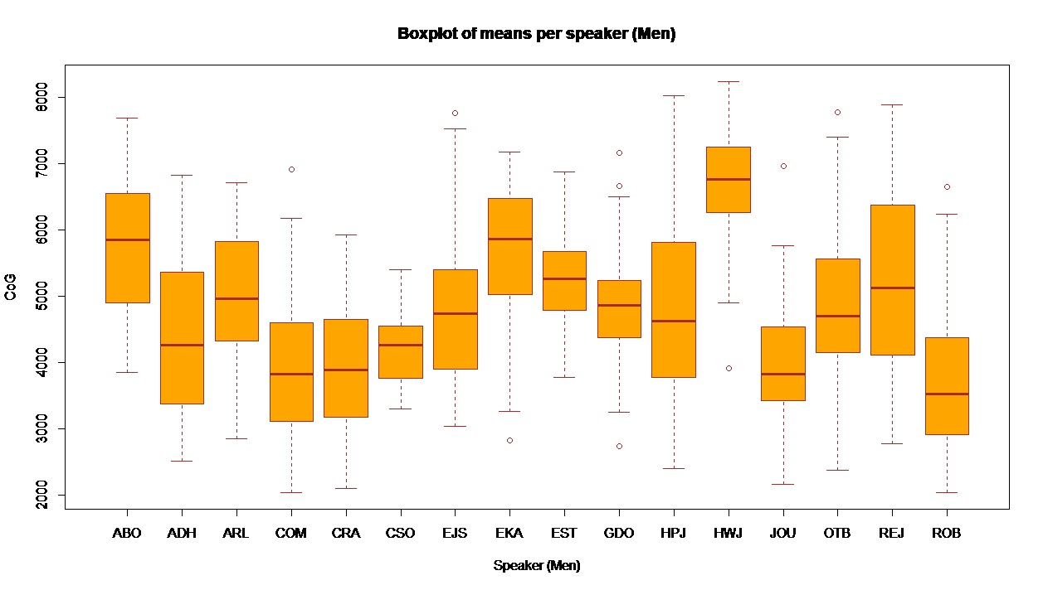
Figure A1. Boxplot of mean of CoG for men in the Argentine Danish dataset; range 2,729 Hz; mean 4,830 Hz; 955 tokens.
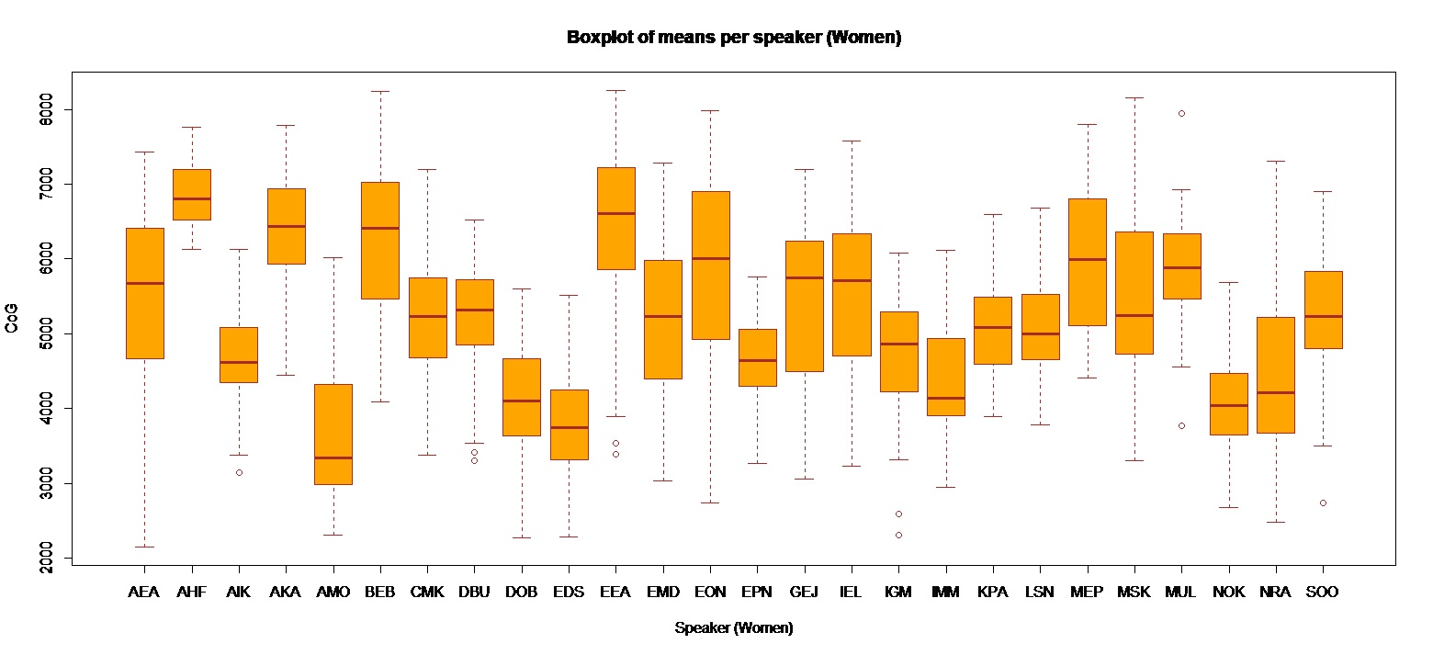
Figure A2. Boxplot of mean CoG women in the Argentine Danish dataset; range 3,017 Hz; mean 5,131 Hz; 1,327 tokens.

Table A7. Modern Danish dataset broken down into gender, location, and age. 34 speakers, 1,950 tokens.
 | Copenhagen | East Jutland | West Jutland | Zealand
Man | 3 | 7 | 1 | 5
Woman | 3 | 7 | 2 | 6
Total speakers | 6 | 14 | 3 | 11
Average age and age span | 55 (52–60) | 60 (40–70) | 42 (42) | 56 (39–63)
Tokens | 496 | 714 | 85 | 655

Table A8. Modern Danish. Mean CoG value (Hz) for all levels in the factor Context, with standard deviation and number of tokens for all levels. Dotted line = mean CoG. (Anova: F = 23.16, p < 0.001, df = 12). See Figure 1 for boxplot. Data: Modern Danish dataset.
Context | Mean CoG (Hz) | Standard deviation | N
u | 4,550 | 933.0 | x
ʌ | 4,563 | 778.3 | 117
o | 4,573 | 792.1 | 236
ɔ | 4,589 | 800.5 | 43
y | 4,615 | 811.0 | 176
œ | 4,722 | 858.9 | 50
ø | 4,995 | 1,007.4 | 46
ɑ | 5,139 | 857.9 | 141
a | 5,179 | 875.8 | 240
e | 5,195 | 890.6 | 254
ɛ | 5,232 | 920.7 | 234
i | 5,362 | 786.5 | 278
Total | 4,981 |  | 1,931

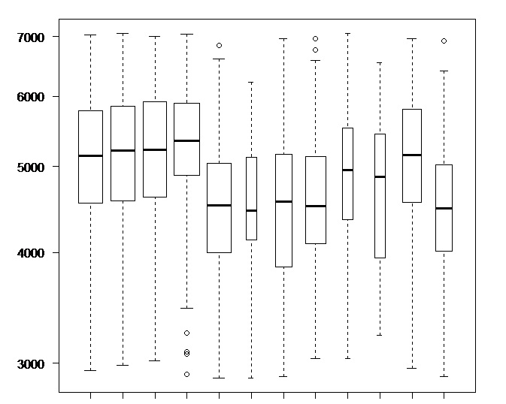
 | a | e | ɛ | i | o | ɔ | u | y | ø | œ | ɑ | ʌ
Figure A3. Boxplot of mean CoG for phonological context in Modern Denmark Danish; total no. 1,931; total mean 4,981 Hz. Data: Modern Danish dataset.

Table A9. Mean CoG value (Hz) for both levels in the factor Gender, with standard deviation and number of tokens for each level. (F = 140.2, p < 0.001, df = 1). See Figure 2 for boxplot. Data: Modern Danish dataset.
 | Mean CoG (Hz) | Standard deviation | N
Man | 4,737 | 849.4 | 934
Woman | 5,210 | 902.3 | 997
Total | 4,981 |  | 1,931

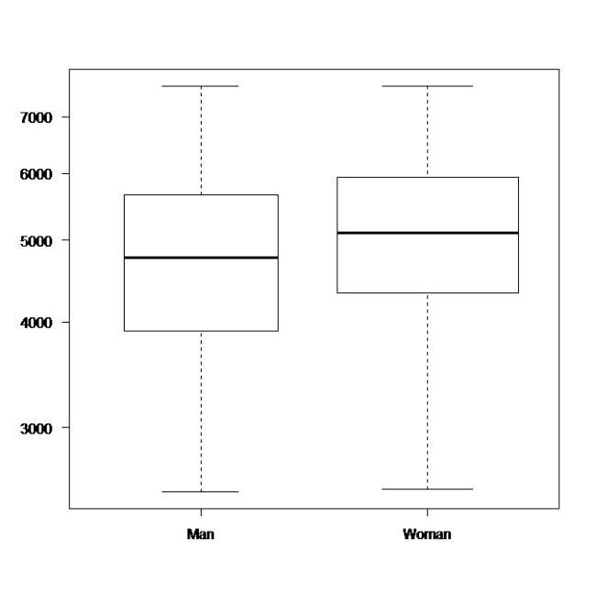
Figure A4. Boxplot of mean CoG (Hz) for gender in Modern Danish; total no. 1,931; total mean 4,981 Hz. Data: Modern Danish dataset.

Table A10. Mean CoG value (Hz) for all three levels in the factor Location, with standard deviation and number of tokens for each level. Dotted line = mean CoG value. (Anova: F = 1.737, p = 0.157, df = 3.) Data: Modern Danish dataset.
 | Mean CoG (Hz) | Standard deviation | N
Copenhagen | 4,947 | 832.9 | 489
East Jutland | 4,985 | 1,003.5 | 710
West Jutland | 4,810 | 748.5 | 85
Zealand | 5,025 | 869.2 | 647
Total | 4,981 |  | 1,931

Table A11. Modern Danish, men’s mean CoG value; CoG range 2,285 Hz; mean CoG 4,737 Hz (dotted line). (Anova: F = 27.74, p < 0.001, df = 15.) See Figure 4 for boxplot. Data: Modern Danish dataset.
Speaker | Mean CoG (Hz) | Standard deviation | N
FAN | 3,190 | 407.3 | 2
HJL | 4,152 | 381.7 | 67
KRO | 4,176 | 807.5 | 79
PNI | 4,203 | 624.3 | 54
TNI | 4,395 | 588.8 | 95
TCH | 4,518 | 730.3 | 51
SKA | 4,550 | 951.2 | 79
PTK | 4,567 | 689.7 | 65
FJE | 4,680 | 707.3 | 54
CNL | 4,829 | 465.8 | 30
ENI | 4,858 | 684.6 | 66
NGH | 4,960 | 1,128.3 | 22
ANN | 5,099 | 658.3 | 22
FRK | 5,143 | 911.7 | 54
NLI | 5,466 | 777.6 | 96
ASA | 5,475 | 520.9 | 98
Total | 4,737 |  | 934

Table A12. Modern Danish, women’s mean CoG value; CoG range 2,303 Hz; mean CoG 5,210 Hz (dotted line). (Anova: F = 17.96, p < 0.001, df = 17.) See Figure 4 for boxplot. Data: Modern Danish dataset.
Speaker | Mean CoG (Hz) | Standard deviation | N
AMJ | 3,843 | 626.0 | 27
UDA | 4,577 | 765.8 | 26
IMN | 4,702 | 279.0 | 14
BML | 4,805 | 627.4 | 61
ALH | 4,879 | 768.3 | 69
LAL | 4,917 | 872.8 | 64
MKC | 4,963 | 742.6 | 77
RFR | 4,986 | 707.6 | 76
GAN | 5,118 | 825.7 | 70
GKR | 5,220 | 826.1 | 40
VGR | 5,236 | 983.4 | 90
AJO | 5,398 | 876.2 | 84
LNL | 5,480 | 461.4 | 28
HKA | 5,514 | 875.7 | 52
MLA | 5,575 | 763.7 | 88
GSH | 5,624 | 988.8 | 28
HSI | 5,850 | 862.1 | 44
DDI | 6,146 | 639.1 | 59
Total | 5,210 |  | 997

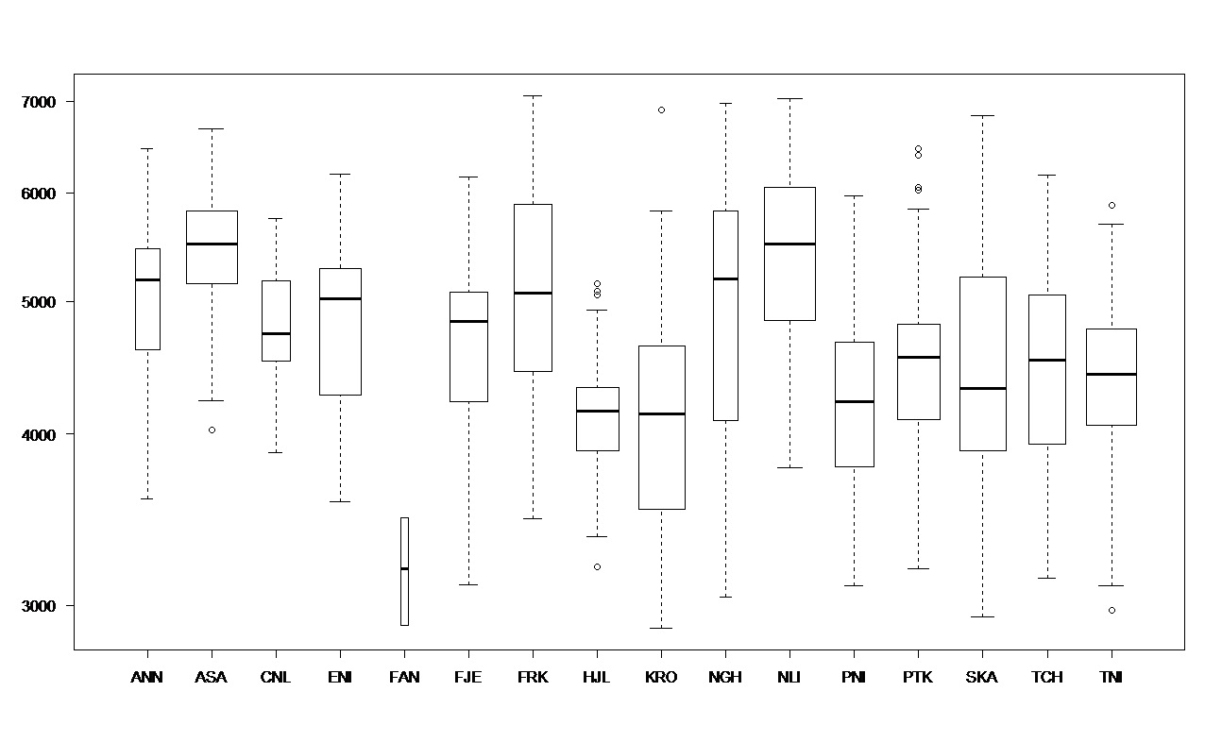
Figure A5. Inter-speaker variation among men in the Modern Danish dataset.
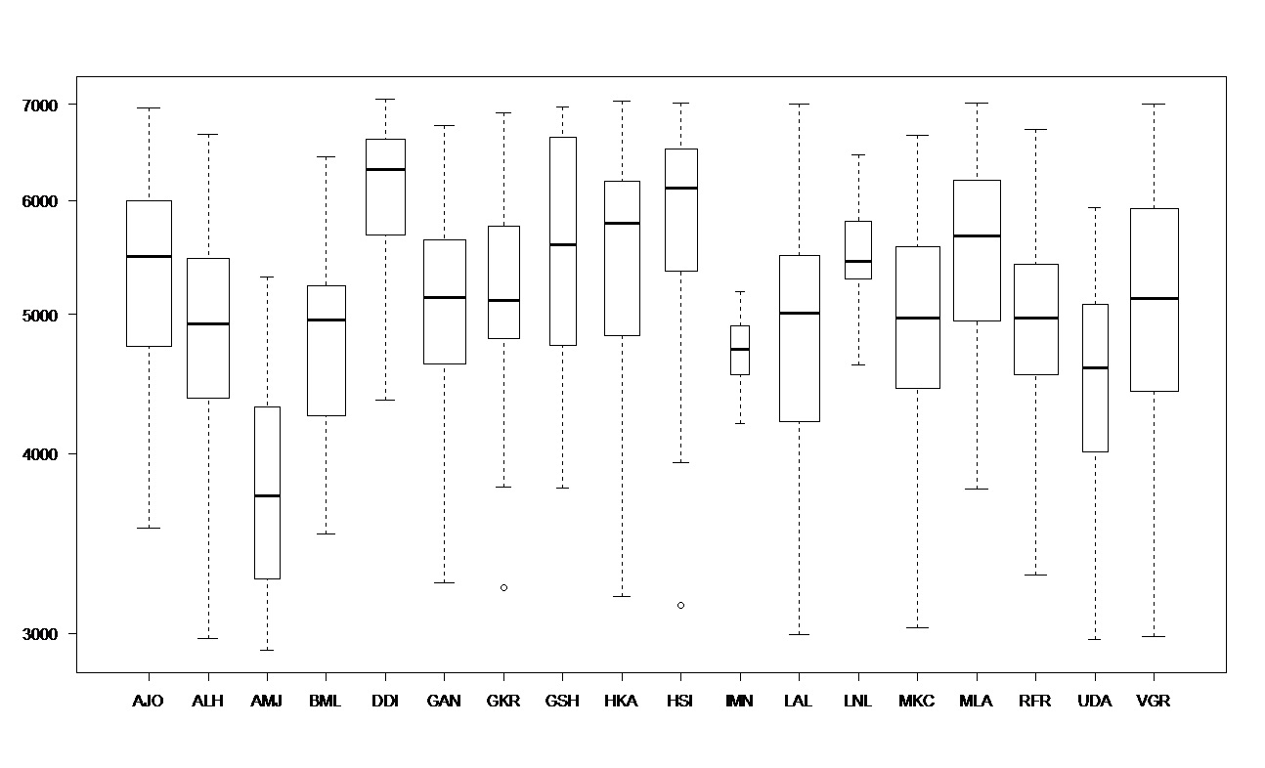
Figure A6. Inter-speaker variation among women in the Modern Danish dataset.

/ɒ/: CoG = 4,382 Hz; st.dev. = 499.6, N = 19. /ʁ/: CoG = 4881 Hz, st.dev. = 844.0, N = 257.

