SUPPLEMENTARY MATERIAL:

APPENDIX 1: SEARCH STRATEGIES

Medline: Database (s): Ovid MEDLINE (R) ALL
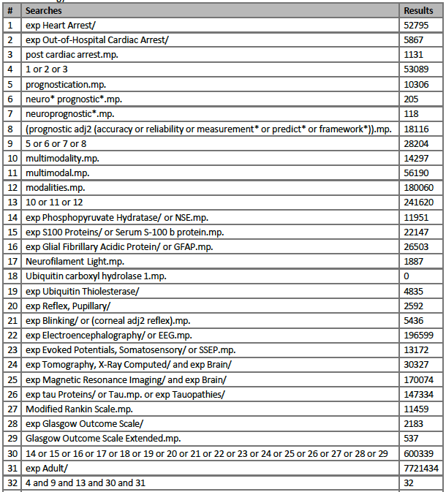

CINAHL (complete):

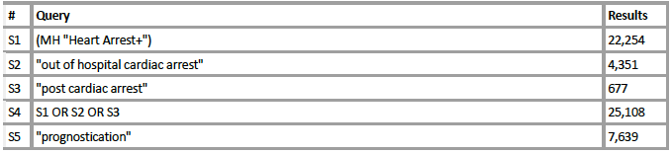
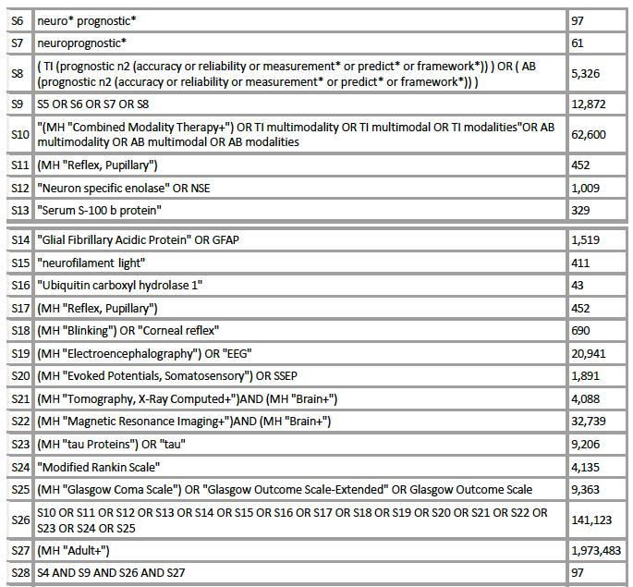

EMBASE:

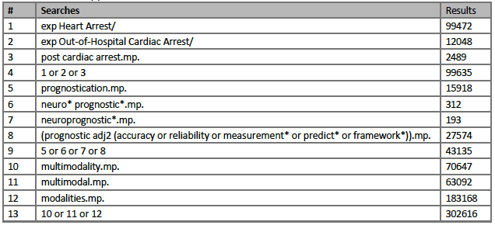
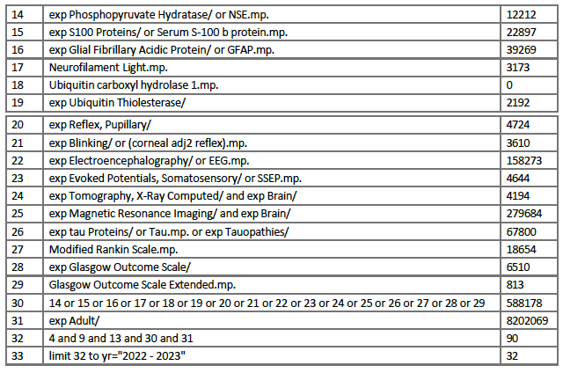

APPENDIX 2: MODALITIES OF INTEREST AND DEFINED THRESHOLDS PREDICTIVE OF A POOR PROGNOSIS

- Bilaterally absent pupillary light reflexes (PLR) (tested by either traditional means or via pupillometry) and/or bilaterally absent corneal reflexes (CR).
- Status myoclonus, ideally defined as the presence of unrelenting generalized or multifocal myoclonus lasting 30 minutes or more. Definitions or lack thereof in each study were tracked.
- GCS-motor score (GCS-M) ≤ 3 post-arrest was permitted in multimodal assessments but not as a unimodal assessment as contemporary guidelines no longer recommend GCS-M in isolation.
- CT head showing a large burden of hypoxic-ischemic brain injury (HIBI) as reduced differentiation between grey and white matter, diffuse cerebral edema and/or basal cistern effacement.
- MRI brain showing a large burden of HIBI as diffusion restriction affecting large portions of the cerebral cortex and/or deep grey matter.
- Bilaterally absent N20 potentials on SSEP.
- Serum NSE levels greater than 33 mcg/L
- Highly malignant patterns on EEG defined in accordance with the American Clinical Neurophysiology Society Critical Care EEG Terminology[14] including suppressed background (10 uV or less) with or without superimposed periodic discharges or burst-suppression.
  - Studies using EEG for neuroprognostication had to utilize American Clinical Neurophysiology Society (ACNS) Critical Care EEG Terminology or report their EEG findings in such a way that this could be extrapolated by a board certified electroencephalographer (JK) [14]. While it was ideal for studies to report EEG patterns individually, studies that grouped EEG patterns were only included if these groupings were comprised of highly malignant patterns and no others [8, 9]. However, as the ERC-ESCIM 2015 algorithm [23] was considered multimodal, a study assessing combination of modalities using EEG criteria employed in this guideline were also considered acceptable to include in the final analysis [20-22]. Studies assessing diagnostic accuracy of EEG reactivity as the main EEG criteria in predicting poor outcomes in their multimodal scheme were excluded. EEG patterns that could be included either individually or in combinations are summarized in Table S1.

Table S1: EEG patterns that could be included either individually or in combinations

List of patterns | ERC-ESCIM 2015 | ERC-ESCIM 2021 | AHA  2020 | CCS  2023 |  | NCS 2023
Suppressed background (< 10  mV) detected >24 hours post-arrest with or without superimposed generalized period discharges |  | X | X |  | X | X
Burst suppression detected > 24 hours post-arrest | X | X | X |  | X | X
Status Epilepticus at >24h post-arrest | X |  | X
X indicates pattern included in guidelines as suggestive of a poor prognosis

Table S2: Comparison of different guidelines approved in literature

Modalities | Timing post-ROSC | Guidelines and their specific threshold suggestive of a poor prognosis
 |  | ERC-ESCIM 2015 | ERC-ESCIM 2021 | AHA  2020 | CCS  2023 |  | NCS 2023
GCS-M | ≥72h | Entry criteria of  ≤ 2 in algorithm | Entry criteria of  ≤ 3 in algorithm | NR |  | NR | NR
PLR and CR | ≥72h | Bilaterally absent  No mention of pupillometry | Bilaterally absent  Supportive of pupillometry > 72hrs with no specific threshold provided | Bilaterally absent  Supportive of pupillometry >72 hours with no specific threshold provided |  | Bilaterally absent  Supportive of pupillometry >48hrs with no specific threshold provided | Bilaterally absent  No mention of pupillometry
Status myoclonus | variable | Present within 48hr | Present between 24-72hrs | Present between 24-72hrs |  | Present within first 7 days | Present within 48 hr
EEG | >24h  >72h | Burst suppression or status epilepticus | Burst suppression or suppression with or without GPD | Burst suppression or suppression with or without GPD or status epilepticus |  | Burst suppression  Suppressed background with GPD  Suppressed background | Burst suppression or suppression with or without GPD
SSEP | ≥24h  >48h | Bilateral absent N20 | Bilateral absent N20 | Bilateral absent N20 |  | Bilateral absent N20 | Bilateral absent N20

Table S2 (continued)

Modalities | Timing post-ROSC | Guidelines and their specific threshold suggestive of a poor prognosis
 |  | ERC-ESCIM 2015 | ERC-ESCIM 2021 | AHA  2020 | CCS  2023 | NCS  2023
NSE | 24-72h  48h and/or 72h | Recommended, but no threshold provided | >60 mcg/L | Recommended by no threshold provided | NR |  | NR
CT-head | < 24h  < 48h  < 72h | Diffuse and extensive anoxic injury | Diffuse and extensive anoxic injury | Reduced GWR | Low GWR in the cerebral cortex or at the level of the basal ganglia <1.15-1.2 |  | Diffuse pattern of loss of grey-white differentiation
Brain MRI | >24h  2-5 days  2-7 days | Diffuse and extensive anoxic injury | Diffuse and extensive anoxic injury | Extensive areas of restricted diffusion  Reduced apparent diffusion coefficient (ADC) | Large volume of restricted diffusion |  | Large volume of restricted diffusion

Table S3: The Cerebral Performance Category Score (CPC Score)

Scores | Description
1: Good Cerebral Performance | Conscious, alert, able to work and lead a normal life. Might have minor psychological or neurological deficits (mild dysphasia, non-incapacitating hemiparesis, or minor cranial nerve abnormalities).
2: Moderate Cerebral Disability | Conscious. Sufficient cerebral function for part-time work in sheltered environment or independent activities of daily life (dress, travel by public transportation, food preparation). Such patients may have hemiplegia, seizures, ataxia, dysarthria, dysphasia, or permanent memory or mental changes.
3: Severe Cerebral Disability | Conscious; patient dependent on others for daily support (in an institution or at home with exceptional family effort), because of impaired brain function. Has at least limited cognition. This category includes a wide range of cerebral abnormalities, from patients who are ambulatory, but have severe memory disturbance or dementia precluding independent existence, to those who are paralyzed and can communicate only with their eyes, as in the locked-in syndrome.
4: Coma/Vegetative State | Not conscious, unaware of surroundings, no cognition. No verbal and/or psychological interaction with environment.
5: Brain Death | Certified brain dead or dead by traditional criteria

APPENDIX 3: DATA COLLECTED

All the following data have been collected from each included paper:
- Publication info:
- Author name
- Year of publication
- Country of publication
- Study population data
- Age
- Sex
- In or out-of-hospital cardiac arrest
- Etiology of arrest:
- Cardiac vs non cardiac
- Rhythm shockable or not
- VT/Vfib
- PEA/asystole
- Causes of death/reasons for WLST and proportions of each:
- Neurologic
- Multi-organ failure
- Unsupportable shock
- Management data:
- Time to ROSC in minutes
- Targeted temperature management (TTM) yes or no
- Mean temperature achieved and duration in hours
- Modalities used as single test or in combination, their timing after ROSC and cut-off used for each individual combined modality:
- GSC-M
- Pupillary light reflex
- Corneal reflex
- EEG
- SSEP
- Brain CT
- Brain MRI
- NSE
- Neurologic outcome
- Timing of determination after arrest
- Scores used including their cut-off for poor prognostic
- Diagnostic accuracy of each modality for predicting poor neurologic outcome, alone or in combination:
- Sensitivity
- Specificity
- False positive rate
- False negative rate
- True positive rate
- True negative rate
- Positive predictive value
- Negative predictive value

Table S4: Confounding factors, causes of death and TTM characteristics of the included studies
Author, Year, Country | Mean TTM temp achieved (°C) | Mean TTM duration  (hours) | Confounding factors: medications | Confounding factors: metabolic disturbances | Confounding factors: organ dysfunction, hemodynamic instability | Causes of death:  WLSM*, brain death (BD),  cardiovascular instability (CVI)
Kim, Ji Hoon, et al, 2020, Korea [24] | No details provided | 26 (24.8-28) | No details provided | No details provided | No details provided | WLSM: 169 (23.6%)  CVI: 66 (9.2%)  Cerebral causes: 40 (5.6%)  MOF: 99 (13.8%)  Other: 38 (5.3%)
Zhou, Sonya E., et al, 2019, USA [22] | 32-34: 95 (70%)  36: 41 (30%) | No details provided | No details provided | No details provided | No details provided | WLSM: 118 (52%) prior to hospital discharge  Brain death: 26 (12%)  Cardiac death: 7 (3%)
Bongiovanni, Filippo, et al, 2020, Switzerland [20] | 33: 253 (52%)  36: 232 (48%) | 24 | Standard sedation-analgesia protocol was applied (midazolam 0.1-0.15 mg/kg/h and/or propofol 2-4 mg/kg/h + fentanyl 1-1.5 ug/kg/h)  NMBA in case of shivering with bolus of Rocuronium 0.6 mg/kg  Sedatives were weaned when normothermia achieved unless any medical intervention required maintaining sedation | No details provided | No details provided | 219 (45%) death, causes?  Decisions of WLSM when multimodal assessment indicative of a poor outcome, when 2 of the prognostic indicators present at 72h after CA

Author, Year, Country | Mean TTM temp  achieved (°C) | Mean TTM duration  (hours) | Confounding factors: medications | Confounding factors: metabolic disturbances | Confounding factors: organ dysfunction, hemodynamic instability | Causes of death:  WLSM*, brain death (BD), cardiovascular instability (CVI)
Moseby-Knappe, Marion, et al, 2020, Sweden [21] | 33: 279 (47.7%)  36: 306 (52.3%) | 36 (at 28h gradual rewarming to 37°C) | Exclusion of patients with sedation, so no patient was sedated more than 72h after ROSC  At 36h mandatory sedation was discontinued or tapered | No details provided | No details provided | WLSM: 168/585 (28.7%)  BD: 128/585 (21.9%)  CVI: 20/585 (3.4%)  MOF: 17/585 (2.9%)  Ethical: 28/585 (4.8%)  Medical comorbidities: 6/585 (1.0%)
Oddo, Mauro, et al, 2018, Switzerland [36] | 33: GO 85 (42%), PO 116 (58%)  36: GO 103 (40%), PO 152 (60%) | 24 (24-24) in GO and PO groups | Propofol dose at 48h in mg/h: GO 1.7 [1.1-2.4], PO 1.8 [1.3-3.7]  Midazolam dose at 48h in mg/kg/h: GO 0.08 [0.04-0.15], PO 0.11 [0.06-0.34]  Fentanyl dose at 48h in mcg/kg/h: GO 0.49 [0.26-1.4], PO 0.55 [0.14-1.4] | No details provided | Norepinephrine dose at 48h in mcg/min: GO 4.9 (1-1), PO 5.4 (1-15)  Norepinephrine dose at admission in mcg/min: GO 5.7 (2.4-10.), PO 5.9 (1.4-19) | No details provided
Pouplet, Caroline, et al, 2022, France [27] | 33 | 33°C for 24h, then rewarming for 24h | Confounded 72h after ROSC in total, n = 29 (59.1): Sedation n=28(57.1) at 72h post ROSC  Fever and sedation n=7(14.3) | One patient had fever at 72h (2%)  Mean elevated lactate of 2.4 (1.4; 4.4) and pH of 7.30 (7.22-7.35), timing unsure | Circulatory shock (BP < 90 mmHg for at least 30 mins or impaired end organ perfusion - cool extremities, mottling, urine output < 30cc/hr): n= 27 (55.1%) | 7 patients died from non-neurological causes:  MOF n=3 (6.1%)  CA recurrence: 2 (4.1%)  Care withdrawal with poor prognostic factors without meeting algorithm criteria or expressed refusal of unreasonable obstinacy.
Table S4 (continued):

Table S4 (continued):

Author, Year, Country | Mean TTM temp  achieved (°C) | Mean TTM duration  (hours) | Confounding factors: medications | Confounding factors: metabolic disturbances | Confounding factors: organ dysfunction, hemodynamic instability | Causes of death:  WLSM*, brain death (BD), cardiovascular instability (CVI)
Roger, Claire, et al, 2015, France [25] | 32-34 | 24 | Sedative drugs and myorelaxants (propofol and remifentanyl)  Propofol and remifentanyl used until passive rewarming reached 36°C  If shivering, cisatracurium added  Stop sedatives when temp > 35.5°C | RRT: 22 (17%)  Elevated liver enzymes and lactates at day 3 in most of the patients | Vasopressors: 115 (88%) ECLS and /or IABP: 15(12%)  Unclear if these measures were present at the time of prognostication | WLSM: 53 (40.8%)  Total death: 98
Scarpino, Maenia, et al, 2021, Italy [37] | 34: 84 (40.1%)  36: 10 (4.7%)  < 37.5 for 72h | 24 minimum (avoid fever until 72h after CA) | Choice of sedative, analgesics and NMBA at discretion of participating center  Unclear if none when patients assessed at 72h, but they mentioned short-acting agents were recommended | No details provided | No details provided | No WLSM, except if brain death
Ben-Hamouda, Nawfel, et al, 2022, Switzerland [38] | 35-36 | 24 | Propofol (3mg/kg/hr) and/or midazolam (0.1 mg/kg/hr) for sedation and fentanyl (1.5 mcg/kg/hr) for analgesia during the first 24-36h. NMBA given as needed | No details provided | Patients with MOF in the first 36h excluded | WLSM performed and no details provided  216 patients died but no cause mentioned

Table S4 (continued):

Author, Year,  Country | Mean TTM temp  achieved (°C) | Mean TTM duration  (hours) | Confounding factors:  medications | Confounding factors: metabolic disturbances | Confounding factors:  organ dysfunction, hemodynamic instability | Causes of death:  WLSM*, brain death (BD), cardiovascular instability (CVI)
Youn, Chun Song, et al, 2022, Korea [28] | 33 mostly in registry (between 32-37) | 24 mostly in registry (between 12-72) | Patient with sedation/NMBA at day 4 excluded, before patients could receive NMBA for shivering | No details provided | No details provided | Exclusion of patients with WLSM and those who died before day 4
Son, Seung Ha, et al, 2020, Korea [39] | 33 | 24 | Midazolam (0.05 mg/kg IV bolus followed by a titrated IV continuous infusion of 0.05-0.2 mg/kg/h) and cisatracurium (0.15 mg/kg IV bolus then IV infusion of 0.3 mg/kg) during TTM | No details provided | No details provided | No details provided
Bisschops, Lauren L.A., et al, 2011, Netherlands [26] | 32-34 | 24 | Most patients sedated with midazolam at day 3; 4 patients were still receiving midazolam  All patients sedated with midazolam and/or propofol to a Ramsay score of 6 and received analgesia using sufentanyl or morphine during hypothermia  If shivering: extra sedation, analgesia or rocuronium (no mention of doses) | No details provided | Renal failure: 17 (16.5%) Liver failure: 9 (8.7%) | Cause not specified  ICU mortality: 58/103 (56.3%) Hospital mortality: 65/103 (63.1%)
*WLSM means WLSM due to a perceived poor prognostic rather than WLSM due to other reasons.
Abbreviations: WLSM: Withdrawal of life-sustaining measures; temp: temperature; TTM: targeted temperature management; NMBA: Neuromuscular Blocking Agents; CA: cardiac arrest; RRT: renal replacement therapy; GO: good outcome; PO: poor outcome; MOF: multi-organ failure.

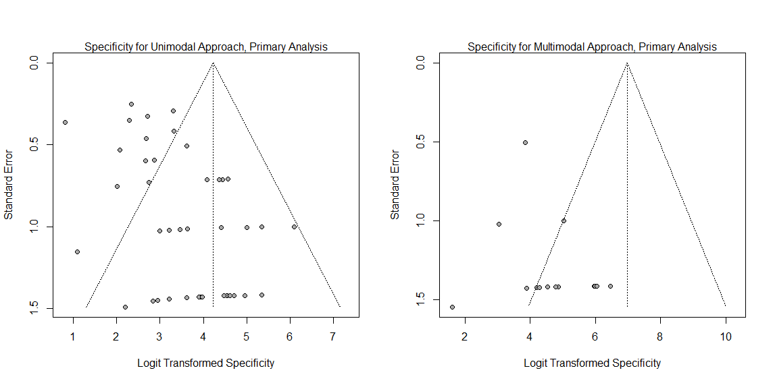
Unimodal:
Egger’s test, t = 4.55 p<0.001, Bias estimate = 1.55 (SE 0.34)
Begg’s test, z = -1.09, p=0.28, Bias estimate = 134.00 (SE 122.89)

Multimodal:
Egger’s test, t = 1.53, p=0.15, Bias estimate = 0.95 (SE 0.62)
Begg’s test, z = -2.86, p=0.004, Bias estimate = -69.00 (SE 24.15)

Figure S1: Funnel plots with Egger’s and Begg’s tests results for pooled specificity (primary analysis) in unimodal vs multimodal approaches

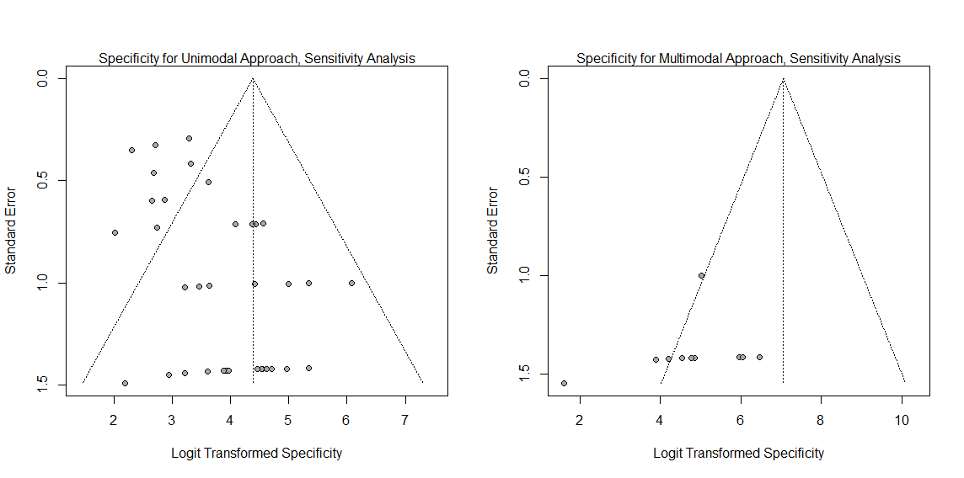
Unimodal:
Egger’s test, t = 4.35, p <0.001, Bias estimate = 1.28 (SE 0.30)
Begg’s test, z = -1.23, p=0.22, Bias estimate = -121.00 (SE 98.67)

Multimodal:
Egger’s test, t =-0.93, p=0.15, Bias estimate = -2.02 (SE 2.18)
Begg’s test, z = -4.01, p<0.001, Bias estimate = -58.00 (SE 14.45)

Figure S2: Funnel plots with Egger’s and Begg’s tests results for pooled specificity after excluding GCS-M (sensitivity analysis) in unimodal vs multimodal approaches

