Supplemental Material

S1. Search Strategy

Search completed March 24th, 2024

Embase

- Exp “national institutes of health stroke scale”/
- Exp Rankin scale
- mrs.mp.
- exp training/
- exp “maintenance of certification”/ or exp certification
- exp accreditation
- exp interprofessional education/ or exp residency education/ or exp education program/ or exp clinical education/ or exp masters education/ or exp adult education/ or exp nursing education/ or exp education/ or exp undergraduate education/ or exp physician assistant education/ or exp continuing education/ or exp health education/ or exp medical education/ or exp paramedical education/ or exp allied health education/ or exp graduate education/ or exp medical education research study quality instrument/ or exp emergency medical services education/ or exp interdisciplinary education/ or exp postgraduate education/ or exp doctoral education/
- exp learning/ or exp teaching/
- 1 or 2 or 3
- 4 or 5 or 6 or 7 or 8
- 9 and 10

Medline

- Nihss.mp.
- NIH stroke scale.mp.
- NIH stroke score.mp.
- National institute of health stroke scale.mp.
- National institute of health stroke scale.mp.
- National institutes of health stroke score.mp.
- Rankin scale.mp.
- Modified rankin scale.mp.
- mRS.mp
- training.mp.
- train.mp.
- exp certification/
- exp accreditation/
- exp Education, Medical, Undergraduate/ or exp Nursing Education Research/ or exp Interprofessional Education/ or exp Education, Graduate/ or exp Vocational Education/ or exp Mainstreaming, Education/ or exp Educational Department, Hospital/ or exp Education, Distance/ or exp Education, Nursing, Baccalaureate/ or exp Competency-Based Education/ or exp Education, Medical, Continuing/ or exp Education, Nursing/ or exp Health Education/ or exp Education, Nursing, Graduate/ or exp Education, Nursing, Continuing/ or exp Education, Medical/ or exp Education/ or exp Education, Nursing, Associate/ or exp Education, Medical, Graduate/ or exp Education, Continuing/
- exp teaching/
- learn.mp
- 1 or 2 or 3 or 4 or 5 or 6 or 7 or 8 or 9
- 10 or 11 or 12 or 13 or 14 or 15 or 16
- 17 and 18

CINAHL

- “nihss”
- (MH “NIH Stroke scale”)
- “NIH stroke score”
- “national institute of health stroke score”
- “national institute of health stroke scale”
- “national institutes of health stroke score”
- “nih stroke scale”
- “rankin scale”
- “modified rankin scale”
- “mRS”
- “training”
- “train”
- (MH “certification”)
- (MH “Accreditation”)
- (MH “Education”) OR (MH “outcomes of Education”) OR (MH “Education, Emergency Medical Services”) OR (MH “Education, Nursing, Diploma Programs”) OR (MH “Education, Nursing, Associate”) OR (MH “Education, Interdisciplinary”)
- (MH “teaching”) OR (MH “teaching methods”) OR (MH “teaching materials”)
- (MH “Learning”) OR (MH “Learning Methods”)
- (MH Credentialing Examinations”) OR (MH “Credentialing”) OR (MH “American Nurses Credentialing Center”)
- 1 OR 2 OR 3 OR 4 OR 5 OR 6 OR 7 OR 8 OR 9 OR 10
- 11 OR 12 OR 13 OR 14 OR 15 OR 16 OR 17 OR 18
- 19 AND 20

Supplemental Figure 1. Risk of bias assessment of included observational studies using the ROBINS-I tool.

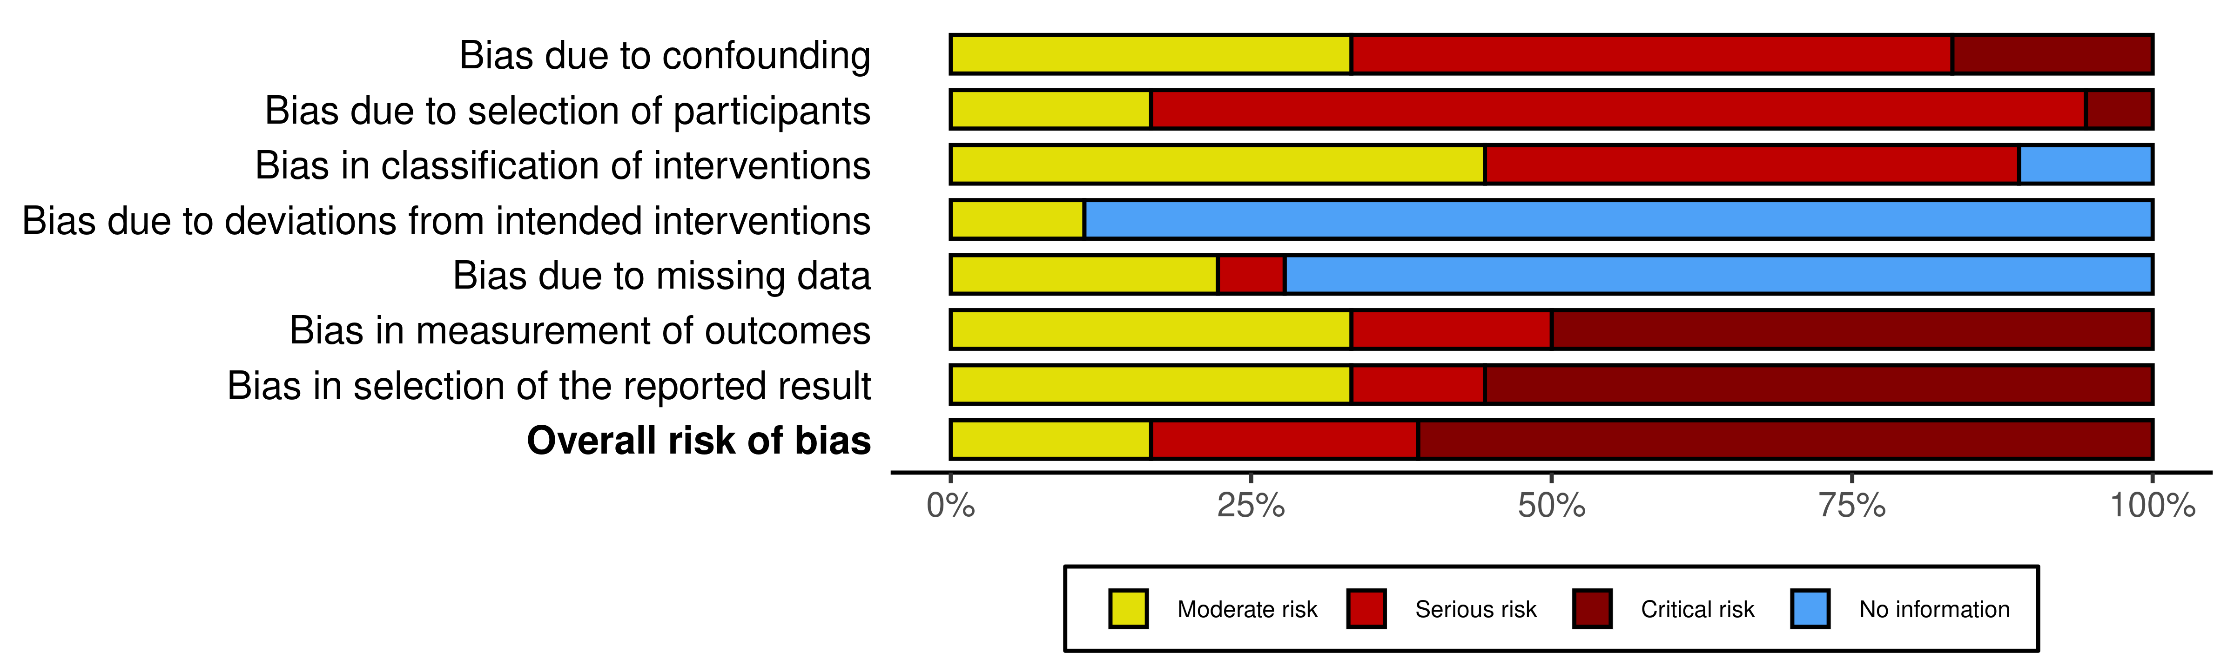

Supplemental Figure 2. Risk of bias assessment of included randomized control trials using the Cochrane ROB-2 tool.

