Supplementary material

Methods-PCR specifications
The genomic DNA was extracted from whole blood by salting out method. This DNA was used for polymerase chain reaction (PCR) to amplify the HTT locus using appropriate primers. DNA extracted from whole blood by salting out method was processed using polymerase chain reaction (PCR) with appropriate primers to amplify the HTT locus.
FP: 5’ -/5 HEX/ GGGATCGCGATGGCGACCCTGGAAAAGCTGATGAA 3’
RP: 5’ GGCGGTGGCGGCTGTTGCTGCTGCTGCTGC 3’
The occurrence of CAG expansions was identified by high resolution agarose gel electrophoresis (gel percentage is 2.5%) of the amplified products. For accurate estimation of amplicon size, fragment analysis was performed using ABITM 3500XL Genetic analyzer (Life TechnologiesTM, California, USA). Modal CAG repeat lengths for both alleles were determined using GeneMapperTM v3.5.

Results

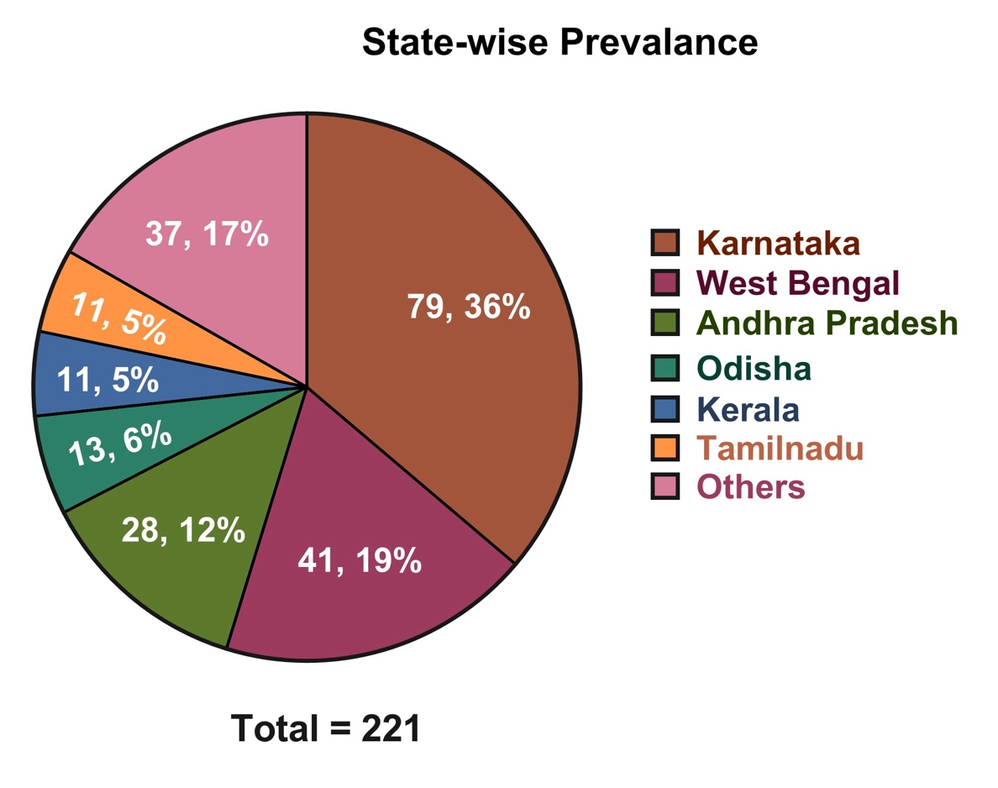

Supplementary Figure 1: State-wise distribution of the HD patients (n=220) (others: Bihar: 6 (2.7%), Uttar Pradesh: 4 (1.8%), Punjab: 4 (1.8%), Gujarat: 4 (1.8%), Assam: 4 (1.8%), Jharkhand: 3 (1.4%), Madhya Pradesh: 2 (1%), Maharashtra: 2 (1%), Tripura: 2 (1%), Delhi: 1 (0.5%), Five patients were from outside India, including 3 from Bangladesh and one each from Nepal and Iran

Table 1: Frequency distribution of the longer and shorter allele CAG repeat lengths of HD patients (n=220)

CAG repeat length | Count as longer allele | Count as shorter allele | Age at disease onset (years) mean ± SD (range)
Up to 26 (normal) | 0 | 217 | ..
27 – 35 (intermediate alleles) | 0 | 2 | ..
36 – 39 (reduced penetrance) | 11 | 1 | 54.4 ± 10.8 (33 – 66)
40 – 49 | 183 | 0 | 41.2 ± 10.2 (21 – 72)
50 – 59 | 15 | 0 | 25.8 ± 4.8 (16 – 32)
60 – 79 | 8 | 0 | 11.55 ± 3.1 (9 – 19)
80 and above | 3 | 0 | 6.0 ± 2.6 (4 – 9)

Table 2: Frequency distribution of the age at disease onset of HD patients (n=220)

Age at disease onset (years) | Number of patients | Longer allele CAG repeat mean ± SD (range)
< 10 | 5 | 84.4 ± 17.2 (68 -113)
11 – 20 | 9 | 64.1 ± 7.6 (52 – 77)
21 – 30 | 37 | 47.1 ± 4.5 (40 – 56)
31 – 40 | 76 | 44.5 ± 2.4 (39 – 50)
41 – 50 | 58 | 42.7 ± 1.8 (39 – 46)
51 – 60 | 22 | 41.1 ± 1.4 (39 – 44)
61 – 70 | 12 | 40.9 ± 2.2 (38 – 46)
71 – 80 | 1 | 41.0

Table 3: Details of parents and siblings of the HD cases without family history as informed by the patient/caregiver.
ID | CAG count | AAO | Max age attained in years + relevant clinical info |  | No. of siblings-status
 |  |  | Parent-1 | Parent-2
79 | 23/43 | 41-45 | 41-45 | 76-80 | 3-unaffected
64 | 18/42 | 51-55 | ~61-70 | ~61-70 | 5- unaffected
29 | 15/40 | 51-55 | 76-80 | 51-55 | 2-unaffected
50 | 16/44 | 41-45 | 96-100 | 71-75 | 4-unaffected
55 | 18/43 | 36-40 | 61-65 | 71-75 | 3-unaffected
46 | 19/44 | 36-40 | 56-60 | 56-60 | 3-unaffected (tested)
45 | 17/41 | 36-40 | 61-65 | 71-75 | -
22 | 22/41 | 46-50 | 91-95 | 96-100 | 5-unaffected
80 | 17/41 | 56-60 | 81-85 | 71-75 | 3-unaffected  1-suicide
44 | 17/40 | 46-50 | 66−70 | 66−70 | -
34 | 17/45 | 40-45 | 51-55 | 61-65 | 5-unaffected
74 | 17/41 | 51-55 | 66−70 | 66−70 | 7-unaffected  4- late onset ~60
57 | 20/41 | 56-60 | 86−90 (mental illness) | 66−70 (Cardiac arrest) | -
56 | 20/42 | 56-60 | 61-65 | 71-75 | 6-unaffected
23 | 17/45 | 31-35 | 46−50 | 76-80 | 2-affected  (but parents’ sibs unaffected)
66 | 18/42 | 46-50 | 56−60 | 56−60 | 2-unaffected
66 | 18/44 | 36-40 | 56−60 | 56−60 | 5-unaffected
24 | 17/41 | 51-55 | 66−70 | 46-50 | 6-unaffected
30 | 17/42 | 61-65 | 66−70 | 71−75 | 3-unaffected
55 | 18/43 | 66-50 | 66−70 | ∼6−80 | 3-unaffected
24 | 17/39 | 31-35 | 56−60* | 66−70 * | 4-unaffected
75 | 17/40 | 61-65 | 61-65 | 61-65 | 2-unaffected
24 | 20/40 | 36-40 | 71-75 | 81-85 | 6-unaffected
27 | 16/50 | 26-30 | 66−70 * | 41-45 | 3-unaffected
58 | 17/43 | 36-40 | 66−70 | 46-50 | 2-unaffected
66 | 17/39 | 51-55 | 66−70 | 61-65  (mental illness) | 4-unaffected
20 | 17/39 | 46-50 | 56−60 | 56−60 (mental illness) | 8-unaffected
30 | 17/48 | 21-25 | 66−70 * | 66−70 | 1-unaffected (17/32)
50 | 17/41 | 56-60 | 76-80 | 56−60 (mental illness) | 3-unaffected  1-substance abuse
26 | 17/43 | 36-40 | 66−70 * | 66−70* (CAG 19/32) | 1-unaffected
32 | 22/45 | 31-35 | 56-60* | 66−70 * | 2-unaffected
51 | 37/46 | 36-40 | 66−70 * | 31-35 (sudden death) | -
20 | 18/44 | 51-55 | 76-80 | 76-80 | 2-unaffected,  1-affected
21 | 17/44 | 36-40 | 66−70 * | 76-80* (CAG 17/30) | 3-unaffected
41 | 18/41 | 56-60 | 56−60 | ~26-30 (unknown cause) | 3-unaffected  1-dementia(died)
71 | 17/39 | 61-65 | 31-35 | 56−60 | 1-unaffected
65 | 17/39 | 66-70 | 66−70 (mental illness) | 66−70 | 8-unaffected  2-mental illness

Table 4: CAG-AAO trends in sibling pairs (n=23)
Sl. No | Inheritance pattern | Elder sib CAG length | Younger sib CAG length | 𝚫CAG* | Elder sib AAO | Younger sib AAO | 𝚫AAO#
1 | Paternal | 47 | 43 | -4 | 31-35 | 36-40 | 1
2 | Paternal | 43 | 41 | -2 | 51-55 | 41-45 | -9
3 | Paternal | 43 | 44 | 1 | 46-50 | 41-45 | -2
4 | Paternal | 46 | 49 | 3 | 31-35 | 31-35 | 0
5 | Paternal | 46 | 45 | -1 | 31-35 | 36-40 | 7
6 | Paternal | 63 | 77 | 4 | 16-20 | 11-15 | -1
7 | Paternal | 42 | 49 | 7 | 61-65 | 31-35 | -28
8 | Paternal | 49 | 49 | 0 | 26-30 | 21-25 | -5
9 | Paternal | 38 | 43 | 5 | 61-65 | 41-45 | -19
10 | Paternal | 41 | 41 | 0 | 71-75 | 66-70 | -2
11 | Paternal | 43 | 41 | -2 | 36-40 | 31-35 | -3
12 | Paternal | 50 | 59 | 9 | 21-25 | 16-20 | -9
13 | Paternal | 85 | 80 | -5 | 1-5 | 6-10 | 4
14 | Paternal | 45 | 44 | -1 | 26-30 | 31-35 | 7
15 | Maternal | 42 | 43 | 1 | 51-55 | 51-55 | 3
16 | Maternal | 43 | 41 | -2 | 51-55 | 41-45 | -12
17 | Maternal | 42 | 41 | -1 | 51-55 | 41-45 | -9
18 | Maternal | 44 | 44 | 0 | 31-35 | 31-35 | 0
19 | Maternal | 47 | 45 | -2 | 26-30 | 31-35 | 3
20 | Maternal | 45 | 47 | 2 | 36-40 | 26-30 | -9
21 | Maternal | 43 | 46 | 3 | 46-50 | 31-35 | -15
22 | Unknown | 43 | 43 | 0 | 41-45 | 41-45 | -2
23 | Paternal | 45 | 43 | -2 | 36-40 | NA | NA
 | Mean ± SD (range) | 46.7 ± 9.58 (38 - 85) | 47.73 ± 10.5 (41 – 80) |  | 40.18 ± 16.1 (5 – 72) | 35.6 ± 13.4 (9 – 70)
*Delta CAG = Younger sib CAG length – Elder sib CAG length
#Delta AAO = Younger sib AAO (years) – Elder sib AAO (years); AAO = Age at disease onset. Italicized are not included in analysis due to pre-manifest individuals in the pair

Table 5: CAG-AAO trends in parent-offspring pairs (n=13)
Sl. No | Inheritance pattern | Parent CAG length | Child CAG length | 𝚫CAG* | Parent AAO | Offspring AAO | 𝚫AAO #
1 | Paternal | 43 | 43 | 0 | 51-55 | 31-35 | -18
2 | Paternal | 44 | 64 | 20 | 41-45 | 16-20 | -25
3 | Paternal | 48 | 62 | 14 | 31-35 | 11-15 | -18
4 | Paternal | 42 | 45 | 3 | 61-65 | 21-25 | -39
5 | Paternal | 49 | 77 | 28 | 31-35 | 11-15 | -22
6 | Paternal | 49 | 63 | 24 | 31-35 | 16-20 | -15
7 | Paternal | 41 | 51 | 10 | 71-75 | 26-30 | -42
8 | Maternal | 50 | 69 | 19 | 26-30 | 11-15 | -16
9 | Maternal | 43 | 41 | -2 | 51-55 | 26-30 | -27
10 | Maternal | 44 | 45 | 1 | 41-45 | 31-35 | -7
11 | Paternal | 43 | 113 | 70 | NA | 1-5 | NA
12 | Maternal | 42 | 41 | -1 | 61-65 | NA | NA
13 | Maternal | 42 | 42 | 0 | 41-45 | NA | NA
 | Mean ± SD (range) | 45.1 ± 3.1 (41 - 50) | 61.1 ± 20.4 (41 – 113) |  | 45.6 ± 14.5 (30 – 72) | 21.0 ± 8.7 (11 – 35)
*Delta CAG = Offspring CAG length – Parent CAG length
#Delta AAO = Offspring AAO (years) – Parent AAO (years); AAO = age at disease onset
Italicized are not included in analysis due to pre-manifest individuals in the pair

Table 6: Intermediate allele (IA) carriers
s no | Intermediate allele carrier | Genotype
 |  | Longer allele | shorter allele
1 | Parent of a de novo expansion carrier | 32 | 19
2 | sibling of a de novo expansion carrier | 32 | 17
3 | HD phenocopy | 31 | 9
4 | Parent of a de novo expansion carrier | 30 | 17
5 | HD phenocopy | 30 | 16
6 | HD phenocopy | 30 | 16
7 | HD patient | 43 | 28
8 | HD patient | 47 | 27

