### Renal Scintigraphy

The sequential renal scintigraphy, with diuretic administration at the 20th minute, showed the left kidney as regular in position, with scintigraphic dimensions at the upper limits and regular morphology. It presents parenchymal fixation and preserved cortical thickness, with extraction capacity largely within normal limits. The pyelo-ureteral drainage phase, slightly prolonged, is spontaneous and valid, with a prompt and complete response to the diuretic administration at the 20th minute. The entire ureter is also visualized: in the mid-third section, it appears to have a tortuous aspect.

The corresponding radio-nephrographic curve shows a slightly reduced slope in phase III, with further decrease after the diuretic (the irregularities in the tracing are likely attributable to motion artifacts from the patient during dynamic acquisition). The right kidney is regular in position but presents scintigraphic dimensions at the upper limits and irregular morphology, with indirect signs of calyceal-pelvic dilation. Parenchymal fixation appears reduced, with slightly reduced cortical thickness, as well as reduced parenchymal extraction capacity. The calyceal cavities are visualized with delay: progressive accumulation of radiopharmaceutical is observed at the calyces, persisting and increasing after diuretic stimulation at the 20th minute. The pelvis is not visualized during the dynamic phase.

The relative radio-nephrographic curve shows a tendency for accumulation. At the end of the dynamic study, in the static image post-orthostatism and post-voiding, the right pelvis is also visualized, with severe calyceal-pelvic ectasia; however, the right ureter is visible up to the bladder. Minimal calyceal residue on the left side.

Separate functional contribution: left kidney: 72%; right kidney: 28%. Preserved renal flow (Figure 2).

In conclusion, the described findings show the left kidney to be morphofunctionally normal, with a regular pyelo-ureteral drainage phase and good response to the diuretic. The right kidney exhibits signs of parenchymal damage and reduced functionality, with severe obstructed drainage unresponsive to the diuretic, showing slight improvement post-orthostatism and voiding.

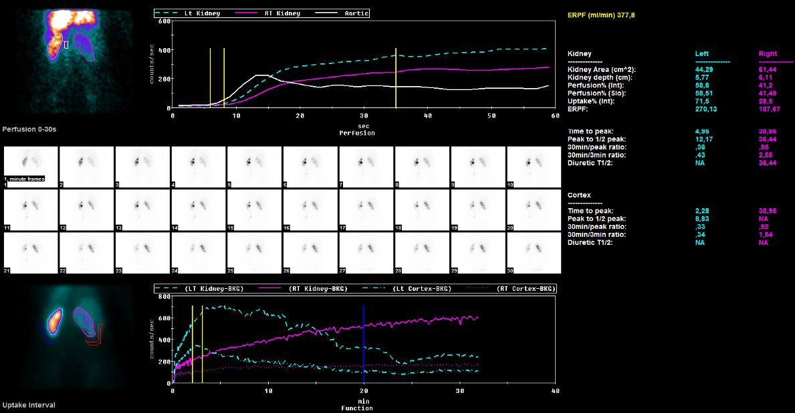

### Post-operative Computed Tomography

Post-operative computed tomography acquired 3 months after surgery. (A) Partial resorption of the meningocele, with air-fluid level, residual in the presacral space, and relocation of the pelvic organs. (B) Coronal maximum intensity projection reconstruction (MIP) showing partial resolution of the right side hydronephrosis, with an ureteral stent in place, and complete resolution of the dilatation of the left ureter.

