Supplementary Table 1. Case definitions used to identify individuals with stroke and treatments for spasticity.

|  |  |  |
| --- | --- | --- |
| **Condition / Treatment** | **Algorithm** | **Codes** |
| ***Health condition*** |  |  |
| Stroke | Had ≥1 hospitalization or emergency department visit with a stroke code in the most responsible diagnostic field. | ICD-10-CA: G08, I60, I61, I62.9, I63, I64, I67.6, or H34.1 |
|  |  |  |
| ***Spasticity treatment*** | |  |
| Baclofen, oral | Had ≥1 dispensation for oral baclofen from an outpatient pharmacy. | DIN: 00455881, 00636576, 02063735, 02063743, 02084449, 02084457, 02088398, 02088401, 02136090, 02136104, 02138271, 02138298, 02139332, 02139391, 02147556, 02147564, 02152584, 02152592, 02229936, 02229937, 02230033, 02230034, 02236507, 02236508, 02236963, 02236964, 02238445, 02238446, 02239075, 02239076, 02242150, 02242151, 02244644, 02244645, 02287021, 02287048, 02371413, 02371421, 02442140, 02442159 |
| Baclofen, intrathecal | Had ≥1 dispensation for intrathecal baclofen from an outpatient pharmacy. | DIN: 02413620, 02413639, 02413647, 02457059, 02457067, 02457075, 02485494, 02485508, 02485516, 02131048, 02131056, 02131064 |
| Tizanidine, oral | Had ≥1 dispensation for oral tizanidine from an outpatient pharmacy. | DIN: 02272059, 02239170, 02259885, 02259893 |
| Dantrolene, oral | Had ≥1 dispensation for oral dantrolene from an outpatient pharmacy. | DIN: 00452521, 00452513, 01997602, 01997653 |
| Chemodenervation | Had ≥1 health service procedure code for the injection of botulinum A toxin for the treatment of spasticity due to upper motor neuron injury or disease OR dispensation for botulinum toxin from an outpatient community pharmacy and no health service procedure code for the injection of botulinum toxin for other conditions occurring on or within 7-days after the dispensation. | Procedure code: 13.59K; Not procedure code: 13.59E, 13.59F, 13.59L, 13.59N, 13.59O, 23.99D, 43.0A, or 43.0B; DIN: 01981501, 02456117, 02460203, 02324032, 02371081 |
| Spasticity clinic visit | Initial treatment: first of ≥2 visits to an institution-based spasticity clinic in Calgary or Edmonton with no visit(s) occurring during the 2-years before the stroke; after post-stroke treatment initiation: had ≥1 visit to a spasticity clinic. | Visits were identified from scheduling software data (Millennium Scheduler and Virtual Address eXention). |
| Surgical intervention | Had ≥1 health service procedure code for tendon lengthening or shortening, gastrosoleus slide, or distal knee transfer or transplantation of tendon. | Procedure code: 95.76A, 95.76C, and 95.65F. As these codes are not specific for spasticity, surgical intervention was only identified among those who initiated spasticity treatment with baclofen, tizanidine, dantrolene, focal botulinum toxin, or a specialized spasticity tertiary clinic visit. |

Note that phenol/alcohol nerve block injections were not included as a spasticity treatment because they are not used in the contemporary era of spasticity treatment, and there is no reliable administrative based method for the identification of this treatment. Abbreviations: DIN = drug identification number; ICD-10-CA = International Classification of Disease - version 10 - Canadian Enhancement.

Supplementary Table 2. Annual spasticity treatment use after initiating post-stroke spasticity treatment.

|  |  |  |  |  |  |
| --- | --- | --- | --- | --- | --- |
|  | PSS treatment cohort  Years after receiving initial spasticity treatment | | | | |
|  |
|  | 1st* | 2nd | 3rd | 4th | 5th |
|  | (N = 1,079) | (N = 990) | (N = 843) | (N = 646) | (N = 432) |
| Had ≥1 dispensation/visit, n (%) |  |  |  |  |  |
| *Overall* |  |  |  |  |  |
| Received spasticity treatment | 1,079 (100) | 448 (45.3) | 352 (41.8) | 251 (38.9) | 153 (35.4) |
| Oral medication | 734 (68.0) | 279 (28.2) | 212 (25.2) | 158 (24.5) | 95 (22.0) |
| Baclofen | 722 (66.9) | 265 (26.8) | 205 (24.3) | 149 (23.1) | 89 (20.6) |
| Tizanidine | 24 (2.2) | 19 (1.9) | 15 (1.8) | 13 (2.0) | 10 (2.3) |
| Dantrolene | <10 (NA) | <10 (NA) | <10 (NA) | <10 (NA) | <10 (NA) |
| Botulinum toxin | 383 (35.5) | 218 (22.0) | 175 (20.8) | 117 (18.1) | 75 (17.4) |
| Visited a spasticity clinic | 253 (23.5) | 157 (15.9) | 129 (15.3) | 87 (13.5) | 58 (13.4) |
| Surgical intervention | <10 (NA) | <10 (NA) | <10 (NA) | <10 (NA) | <10 (NA) |
| *According to initial post-stroke spasticity treatment* |  |  |  |  |  |
| Oral medication | n=672 | n=608 | n=499 | n=367 | n=240 |
| Received spasticity treatment | 672 (100) | 228 (37.5) | 170 (34.1) | 118 (32.2) | 70 (29.2) |
| Oral medication | 672 (100) | 218 (35.9) | 160 (32.1) | 112 (30.5) | 63 (26.3) |
| Botulinum toxin | 34 (5.1) | 35 (5.8) | 29 (5.8) | 19 (5.2) | 17 (7.1) |
| Visited a spasticity clinic | 24 (3.6) | 22 (3.6) | 18 (3.6) | <10 (NA) | <10 (NA) |
| Surgical intervention | <10 (NA) | <10 (NA) | 0 (0.0) | <10 (NA) | <10 (NA) |
| Botulinum toxin | n=251 | n=231 | n=200 | n=151 | n=96 |
| Received spasticity treatment | 251 (100) | 123 (53.3) | 100 (50.0) | 69 (45.7) | 38 (39.6) |
| Oral medication | 38 (15.1) | 33 (14.3) | 30 (15.0) | 28 (18.5) | 18 (18.8) |
| Botulinum toxin | 251 (100.0) | 110 (47.6) | 82 (41.0) | 49 (32.5) | 26 (27.1) |
| Visited a spasticity clinic | 73 (29.1) | 56 (24.2) | 45 (22.5) | 26 (17.2) | 16 (16.7) |
| Surgical intervention | 0 (0.0) | 0 (0.0) | <10 (NA) | 0 (0.0) | 0 (0.0) |
| Visited a spasticity clinic | n=201 | n=195 | n=187 | n=157 | n=111 |
| Received spasticity treatment | 201 (100) | 126 (64.6) | 102 (54.6) | 74 (47.1) | 50 (45.1) |
| Oral medication | 30 (14.9) | 32 (16.4) | 26 (13.9) | 21 (13.4) | 16 (14.4) |
| Botulinum toxin | 143 (71.1) | 97 (49.7) | 81 (43.3) | 56 (35.7) | 35 (31.5) |
| Visited a spasticity clinic | 201 (100) | 108 (55.4) | 84 (44.9) | 57 (36.3) | 36 (32.4) |
| Surgical intervention | 0 (0.0) | <10 (NA) | <10 (NA) | <10 (NA) | <10 (NA) |
| Received more than one type of treatment | n=45 | n=44 | n=43 | n=29 | n=15 |
| Received spasticity treatment | 45 (100) | 29 (65.9) | 20 (46.5) | 10 (34.5) | <10 (NA) |
| Oral medication | <10 (NA) | <10 (NA) | <10 (NA) | <10 (NA) | <10 (NA) |
| Botulinum toxin | 45 (100) | 24 (54.6) | 17 (39.5) | <10 (NA) | <10 (NA) |
| Visited a spasticity clinic | 45 (100) | 29 (65.9) | 18 (41.9) | <10 (NA) | <10 (NA) |
| Surgical intervention | 0 (0.0) | 0 (0.0) | 0 (0.0) | 0 (0.0) | 0 (0.0) |

*Includes the initial PSS treatment. No one received intrathecal baclofen. Abbreviations: IQR = interquartile range; NA = not applicable; PSS = post-stroke spasticity; SD = standard deviation.

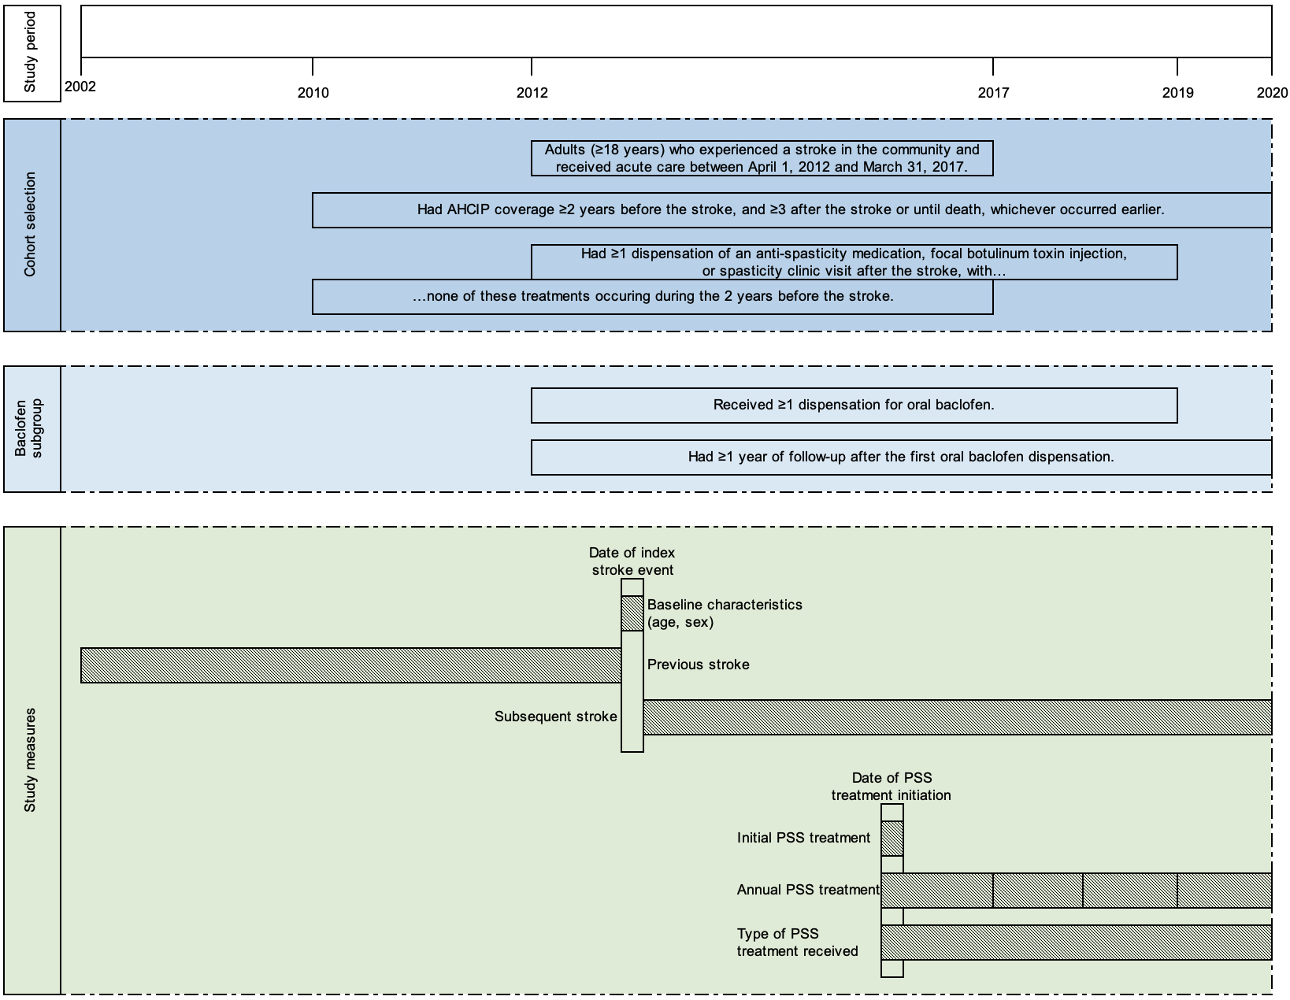

Supplementary Figure 1. Study design diagram. Abbreviations: AHCIP = Alberta Health Care Insurance Plan; PSS = Post-stroke spasticity.

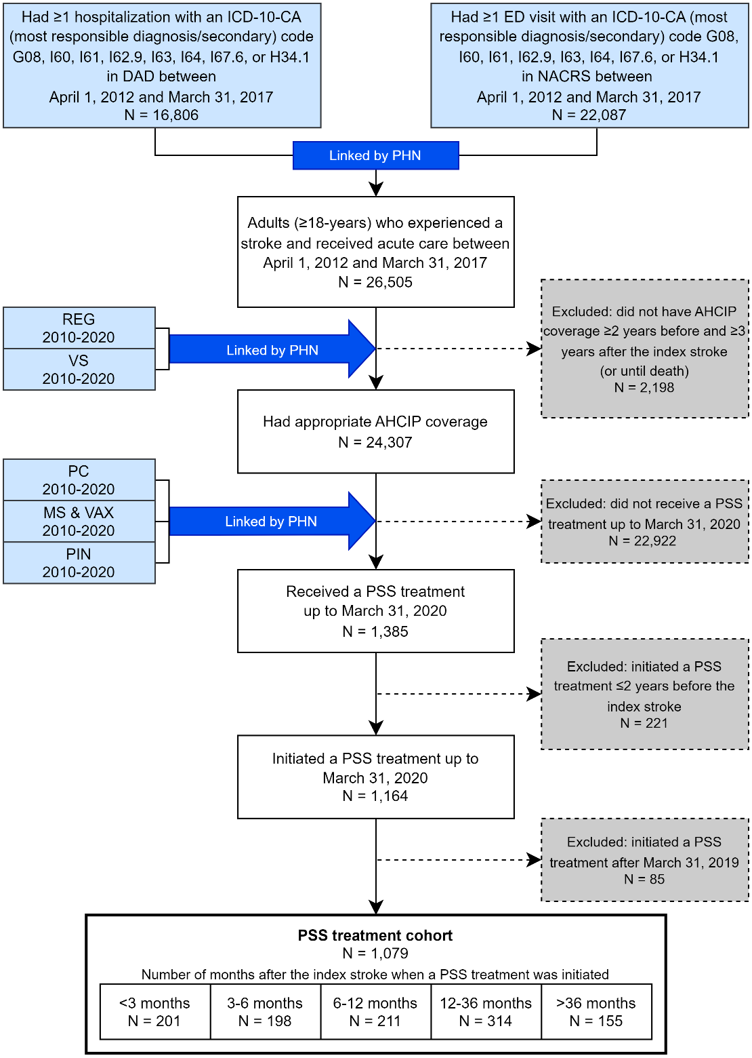

Supplementary Figure 2. Cohort selection flow diagram with associated data linkage. Abbreviations: AHCIP = Alberta Health Care Insurance Plan; DAD = Discharge Abstract Database; ED = emergency department; ICD-10-CA = International Classification of Disease – Version 10 – Canadian Enhancement; MS = Millennium Scheduler; NACRS = National Ambulatory Care Reporting System; PC = Practitioner Claims; PHN = Personal Health Number; PIN = Pharmaceutical Information Network; PSS = post-stroke spasticity, REG = Population Registry; VAX = Virtual Address eXtension; VS = Vital Statistics.