**Appendix 3**

**Evidence Synthesis of Data**

**3. 1.1 Atogepant in Episodic Migraine**

Two studies were found Ailani et al, 2021(30) and Goadsby et al, 2020(31).

**Migraine Day Reduction**

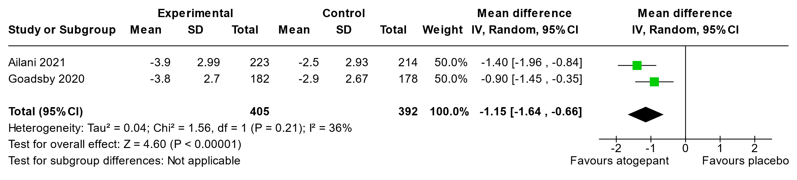

**50% Responder Rate**

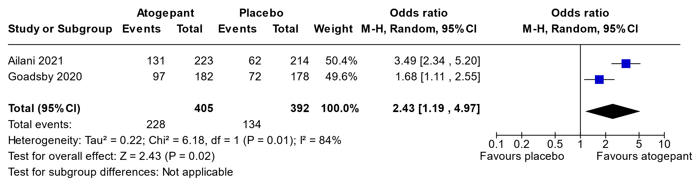

**Adverse Events**

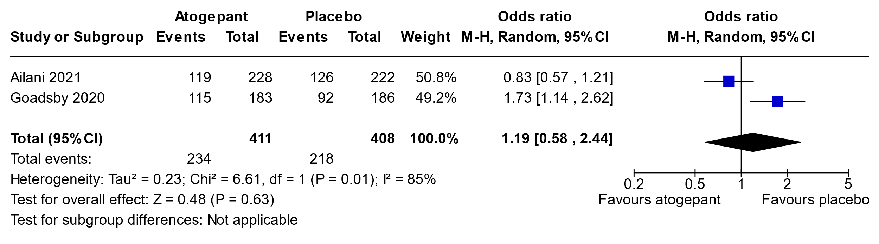

**Summary of findings table for Atogepant for Episodic Migraine**

**Question:** Atogepant compared to placebo for episodic migraine

| **Certainty assessment** | | | | | | | **№ of patients** | | **Effect** | | **Certainty** | **Importance** |
| --- | --- | --- | --- | --- | --- | --- | --- | --- | --- | --- | --- | --- |
| **№ of studies** | **Study design** | **Risk of bias** | **Inconsistency** | **Indirectness** | **Imprecision** | **Other considerations** | **atogepant** | **placebo** | **Relative (95% CI)** | **Absolute (95% CI)** |
| **Migraine day reduction (follow-up: mean 12 weeks; Scale from: -10 to 10)** | | | | | | | | | | | | |
| 2 | randomised trials | not serious | not seriousa | not serious | not serious | none | 399 | 392 | - | mean **1.2 days lower** (1.64 lower to 0.66 lower) | ⨁⨁⨁⨁ High | CRITICAL |
| **50% Responder Rate (follow-up: 12 weeks)** | | | | | | | | | | | | |
| 2 | randomised trials | not serious | seriousa | not serious | not serious | none | 228/405 (56.3%) | 134/392 (34.2%) | **OR 2.43** (1.19 to 4.97) | **19 more per 100** (from 4 more to 30 more) | ⨁⨁⨁◯ Moderate | CRITICAL |
| **Adverse Events (follow-up: 12 weeks)** | | | | | | | | | | | | |
| 2 | randomised trials | not serious | seriousa | not serious | not serious | none | 211/414 (51.0%) | 241/405 (59.5%) | **OR 1.19** (0.58 to 2.44) | **4 more per 100** (from 13 fewer to 19 more) | ⨁⨁⨁◯ Moderate | CRITICAL |

**CI:** confidence interval; **OR:** odds ratio

#### Explanations

1. p value significant for heterogeneity in meta-analysis and also very high heterogeneity

**3.1.2 Atogepant for Chronic Migraine**

A single study was found Pozo-Rosich et al 2023 (32).

**Question:** Atogepant compared to placebo for chronic migraine

| **Certainty assessment** | | | | | | | **№ of patients** | | **Effect** | | **Certainty** | **Importance** |
| --- | --- | --- | --- | --- | --- | --- | --- | --- | --- | --- | --- | --- |
| **№ of studies** | **Study design** | **Risk of bias** | **Inconsistency** | **Indirectness** | **Imprecision** | **Other considerations** | **atogepant** | **placebo** | **Relative (95% CI)** | **Absolute (95% CI)** |
| **Migraine day reduction (follow-up: mean 12 weeks)** | | | | | | | | | | | | |
| 1 | randomised trials | not serious | not serious | not serious | not serious | none | 256 | 246 | - | MD **1.8 days lower** (2.9 lower to 0.8 lower) | ⨁⨁⨁⨁ High | CRITICAL |
| **50% responder rate (follow-up: mean 12 weeks)** | | | | | | | | | | | | |
| 1 | randomised trials | not serious | not serious | not serious | not serious | none | 105/256 (41.0%) | 64/246 (26.0%) | **OR 1.98** (1.35 to 2.89) | **15 more per 100** (from 6 more to 24 more) | ⨁⨁⨁⨁ High | CRITICAL |
| **New outcome (follow-up: mean 12 weeks)** | | | | | | | | | | | | |
| 1 | randomised trials | not serious | not serious | not serious | not serious | none | 165/261 (63.2%) | 126/255 (49.4%) | **OR 1.76** (1.24 to 2.50) | **14 more per 100** (from 5 more to 22 more) | ⨁⨁⨁⨁ High | CRITICAL |

**CI:** confidence interval; **MD:** mean difference; **OR:** odds ratio

For side effects see above, although more common in higher dosing with chronic migraine

**3.2.1 Eptinezumab in Episodic Migraine**

A single study by Ashina et al, 2020 was found(34).

| **Certainty assessment** | | | | | | | **№ of patients** | | **Effect** | | **Certainty** | **Importance** |
| --- | --- | --- | --- | --- | --- | --- | --- | --- | --- | --- | --- | --- |
| **№ of studies** | **Study design** | **Risk of bias** | **Inconsistency** | **Indirectness** | **Imprecision** | **Other considerations** | **eptinezumab** | **placebo** | **Relative (95% CI)** | **Absolute (95% CI)** |
| **Migraine day reduction (follow-up: mean 12 weeks)** | | | | | | | | | | | | |
| 1 | randomised trials | not serious | not serious | not serious | seriousa | none | 221 | 222 | - | MD **1.11 day lower** (1.68 lower to 0.54 lower) | ⨁⨁⨁◯ Moderate | CRITICAL |
| **50% responder rate (follow-up: mean 12 weeks)** | | | | | | | | | | | | |
| 1 | randomised trials | not serious | not serious | not serious | not serious | none | 125/221 (56.6%) | 83/222 (37.4%) | **OR 2.16** (1.48 to 3.16) | **19 more per 100** (from 10 more to 28 more) | ⨁⨁⨁⨁ High | CRITICAL |
| **Adverse events (follow-up: mean 12 weeks)** | | | | | | | | | | | | |
| 1 | randomised trials | not serious | not serious | not serious | not serious | none | 129/224 (57.6%) | 132/222 (59.5%) | **OR 0.93** (0.64 to 1.35) | **2 fewer per 100** (from 11 fewer to 7 more) | ⨁⨁⨁⨁ High | CRITICAL |

**CI:** confidence interval; **MD:** mean difference; **OR:** odds ratio

#### Explanations

a. close to clinically meaningful limit of confidence interval

**3.2.2 Eptinezumab in Chronic Migraine**

Two studies were found, Dodick et al 2019 (35) and Lipton et al 2020 (36).

**Migraine Day Reduction**

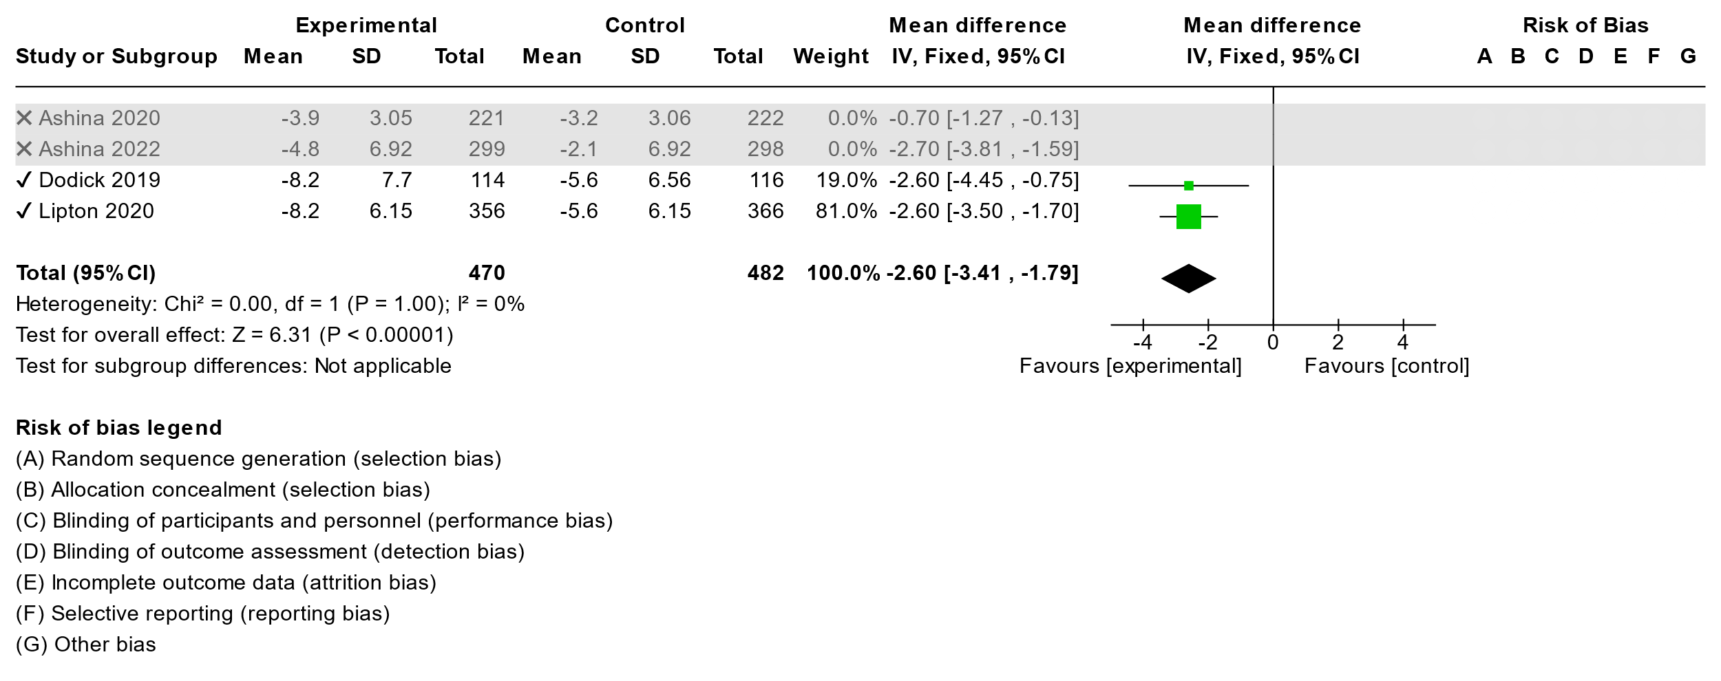

**50% Responder Rate**

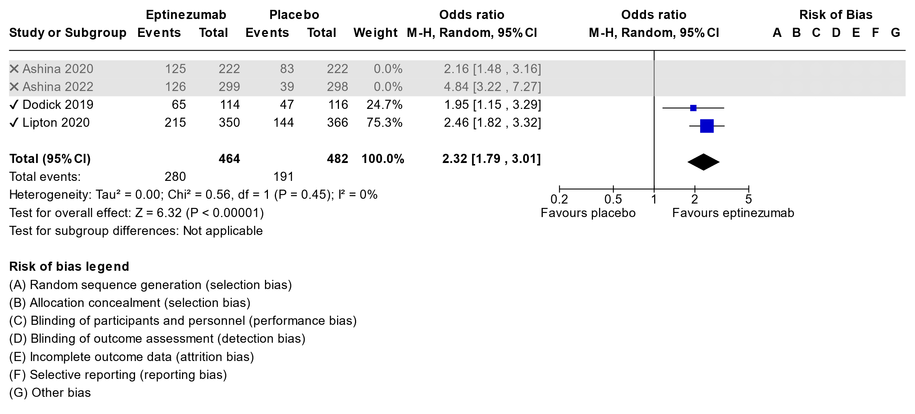

**Adverse Events**

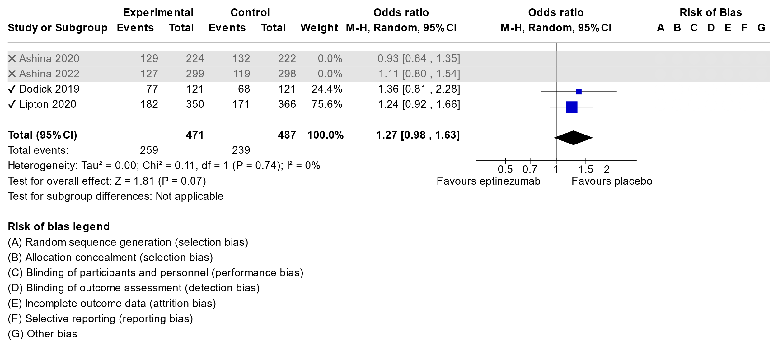

**Summary of findings table for Eptinezumab in Chronic Migraine**

| **Certainty assessment** | | | | | | | **№ of patients** | | **Effect** | | **Certainty** | **Importance** |
| --- | --- | --- | --- | --- | --- | --- | --- | --- | --- | --- | --- | --- |
| **№ of studies** | **Study design** | **Risk of bias** | **Inconsistency** | **Indirectness** | **Imprecision** | **Other considerations** | **Eptinezumab** | **placebo** | **Relative (95% CI)** | **Absolute (95% CI)** |
| **Migraine day reductions (follow-up: mean 12 weeks)** | | | | | | | | | | | | |
| 2 | randomised trials | not serious | not serious | not serious | not serious | none | 470 | 482 | - | MD **2.6 days lower** (3.41 lower to 1.79 lower) | ⨁⨁⨁⨁ High | CRITICAL |
| **50% responder rate (follow-up: mean 12 weeks)** | | | | | | | | | | | | |
| 2 | randomised trials | not serious | not serious | not serious | not serious | none | 280/464 (60.3%) | 191/482 (39.6%) | **OR 2.32** (1.79 to 3.01) | **21 more per 100** (from 14 more to 27 more) | ⨁⨁⨁⨁ High | CRITICAL |
| **Adverse events (follow-up: mean 12 weeks)** | | | | | | | | | | | | |
| 2 | randomised trials | not serious | not serious | not serious | not serious | none | 259/471 (55.0%) | 239/487 (49.1%) | **OR 1.27** (0.98 to 1.63) | **6 more per 100** (from 1 fewer to 12 more) | ⨁⨁⨁⨁ High | CRITICAL |

**CI:** confidence interval; **MD:** mean difference; **OR:** odds ratio

**3.3.1 Erenumab in Episodic Migraine**

We identified 5 studies: Dodick et al, 2018(38); Goadsby et al, 2017(39); Sakai et al, 2019(40); Sun et al, 2016(41); Wang et al, 2021(42).

One studyby Reuter at al, 2018(43) was in treatment resistant episodic migraine patients so because this is a separate population than other studies was left out of meta-analysis.

**Migraine Day Reduction**

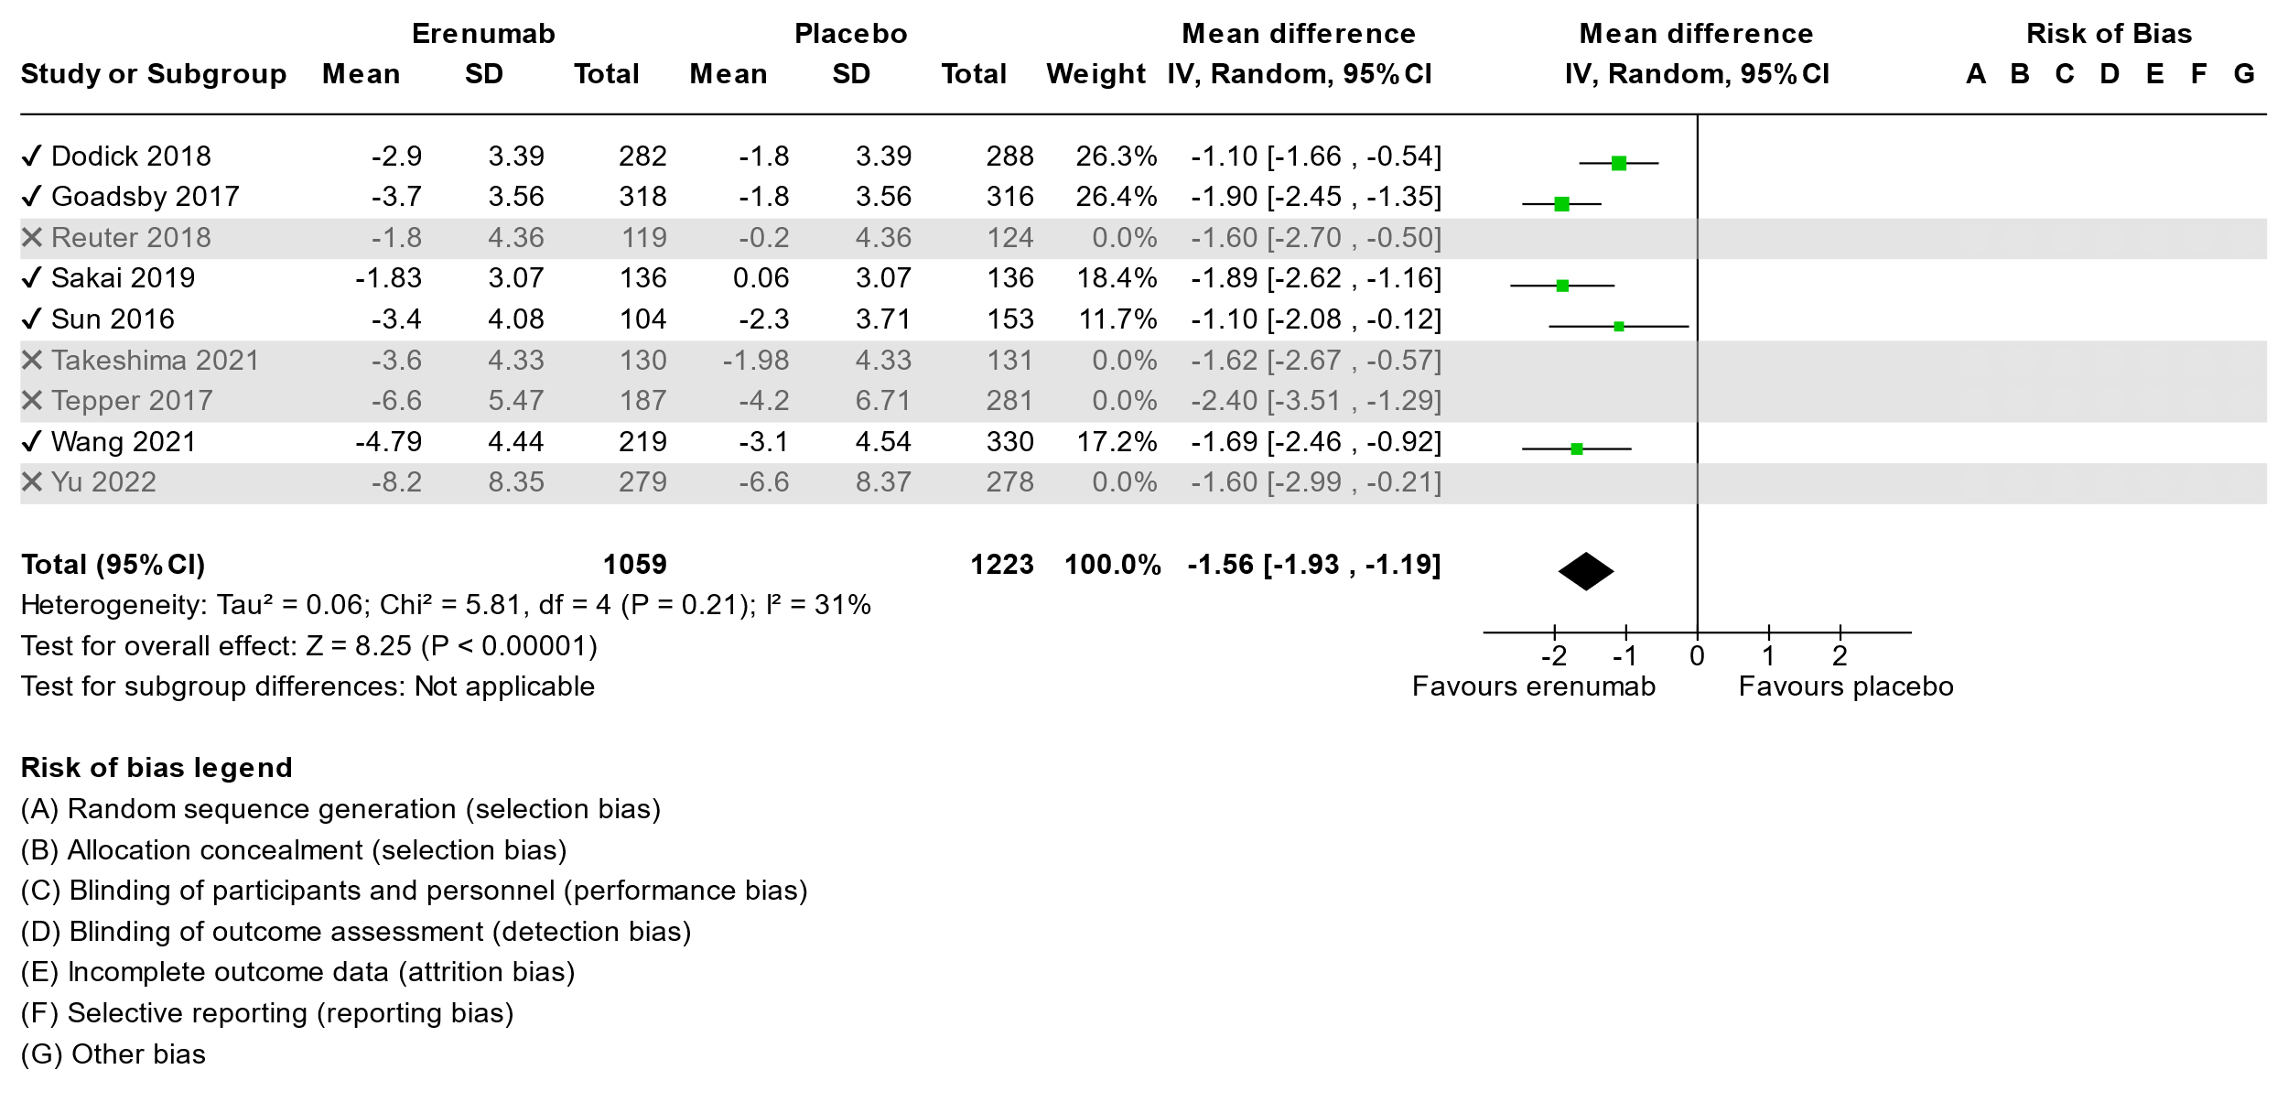

**50% Responder Rate**

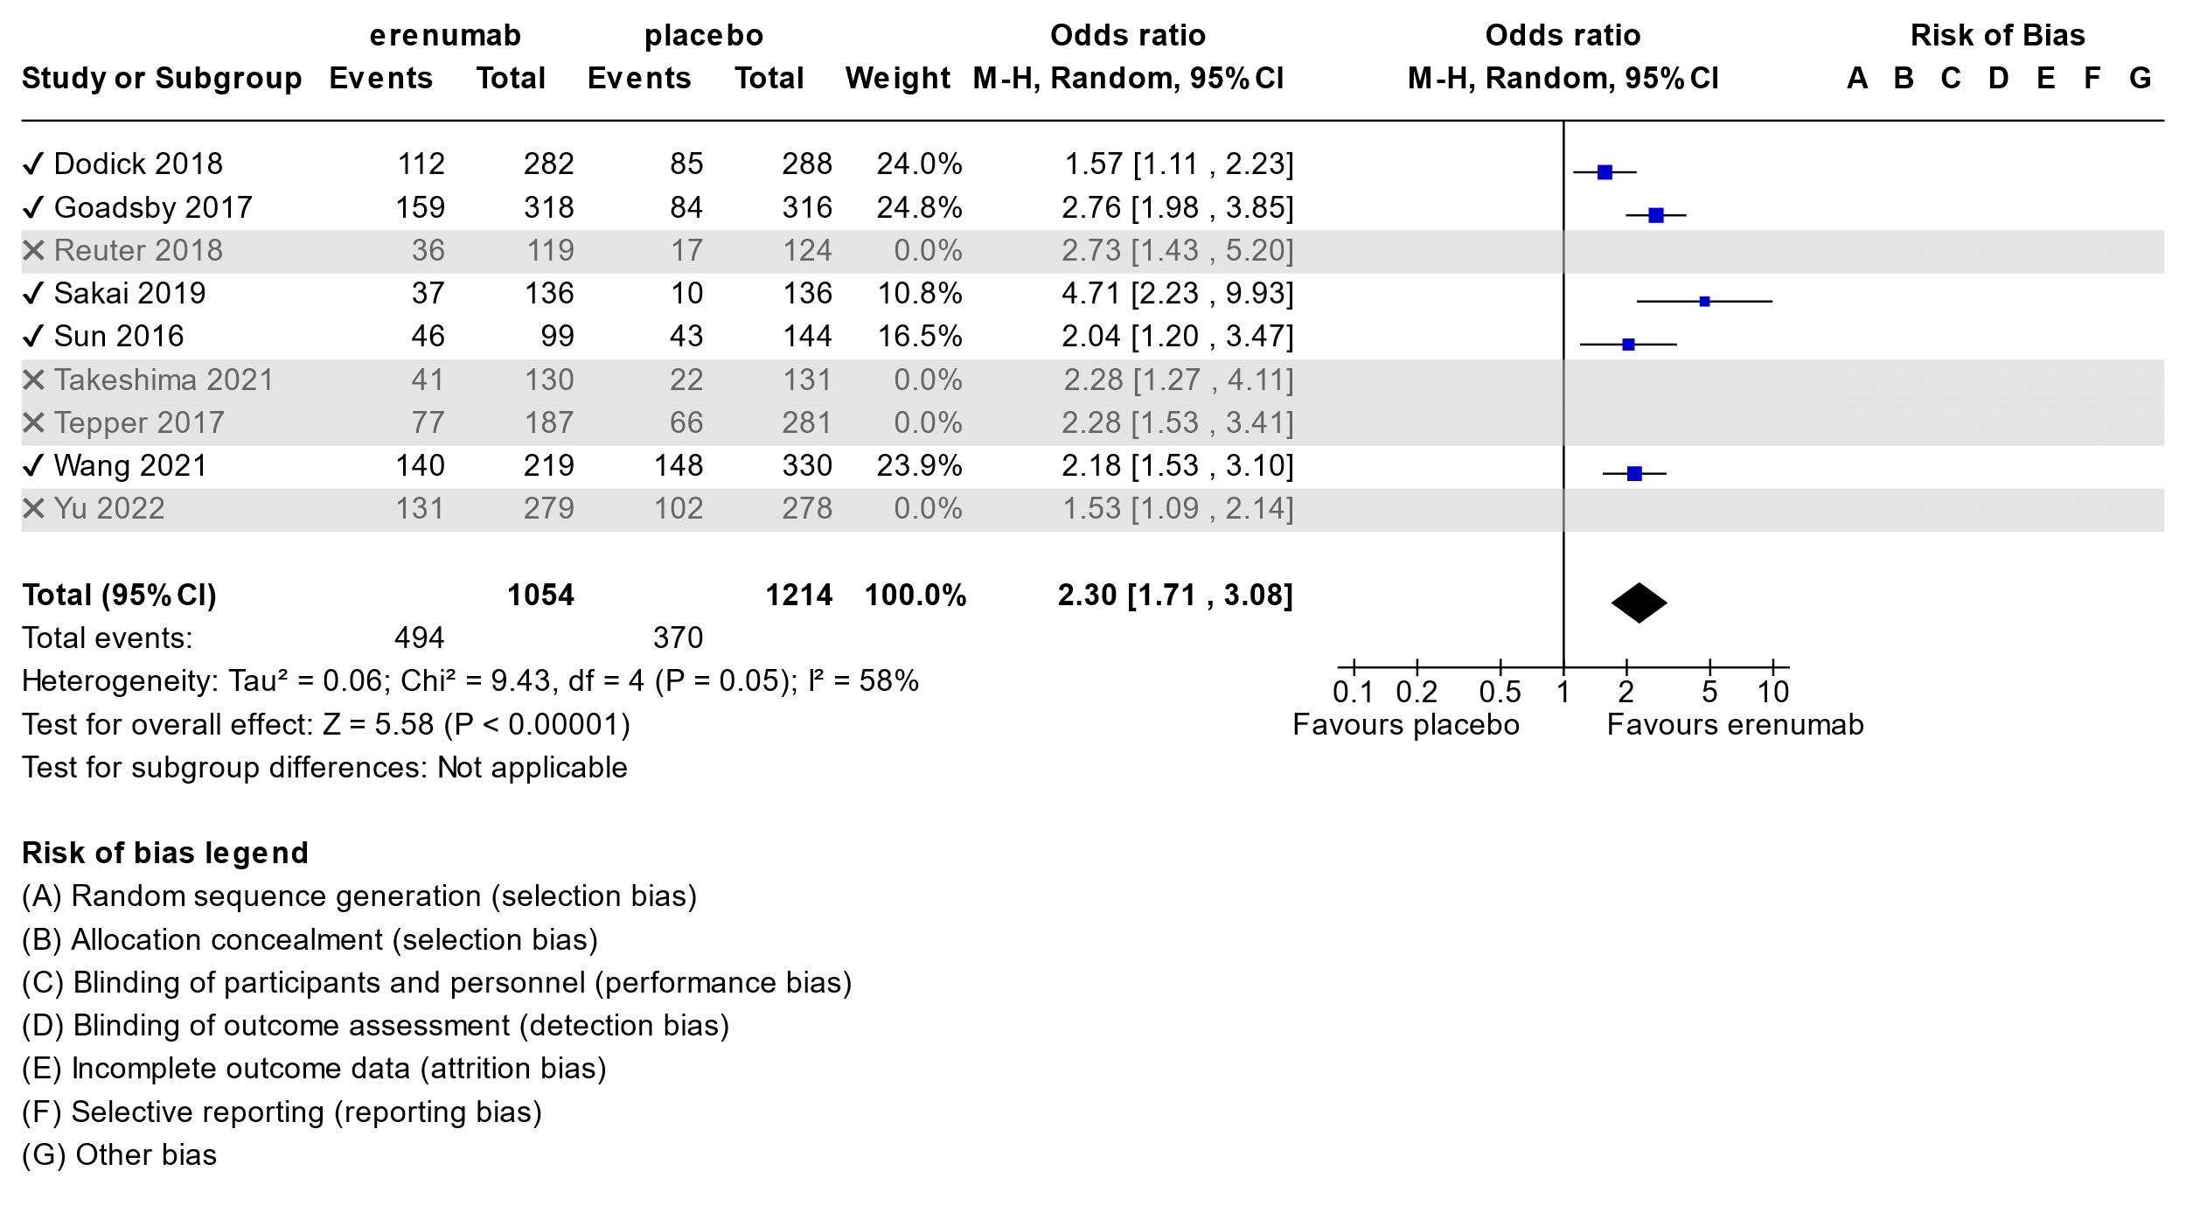

**Adverse Events**

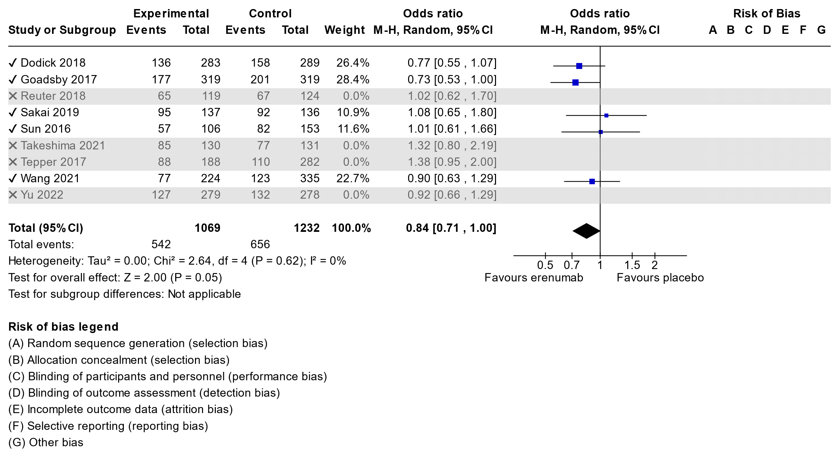

**Summary of findings table for Erenumab in Episodic Migraine**

Erenumab compared to placebo for episodic migraine

| **Certainty assessment** | | | | | | | **№ of patients** | | **Effect** | | **Certainty** | **Importance** |
| --- | --- | --- | --- | --- | --- | --- | --- | --- | --- | --- | --- | --- |
| **№ of studies** | **Study design** | **Risk of bias** | **Inconsistency** | **Indirectness** | **Imprecision** | **Other considerations** | **erenumab** | **placebo** | **Relative (95% CI)** | **Absolute (95% CI)** |
| **Migraine day reduction (follow-up: mean 12 weeks; Scale from: -10 to 10)** | | | | | | | | | | | | |
| 5 | randomised trials | not serious | not serious | not serious | not serious | none | 1158 | 1327 | - | MD **1.56 day lower** (1.93 lower to 1.19 lower) | ⨁⨁⨁⨁ High | CRITICAL |
| **50% responder rate (follow-up: mean 12 weeks)** | | | | | | | | | | | | |
| 5 | randomised trials | not serious | not serious | not serious | not serious | none | 530/1173 (45.2%) | 387/1338 (28.9%) | **OR 2.30** (1.71 to 3.08) | **19 more per 100** (from 12 more to 27 more) | ⨁⨁⨁⨁ High | CRITICAL |
| **Adverse events (follow-up: mean 12 weeks)** | | | | | | | | | | | | |
| 5 | randomised trials | not serious | not serious | not serious | not serious | none | 607/1188 (51.1%) | 723/1356 (53.3%) | **OR 0.84** (0.71 to 1.00) | **4 fewer per 100** (from 9 fewer to 0 fewer) | ⨁⨁⨁⨁ High | CRITICAL |

**CI:** confidence interval; **MD:** mean difference; **OR:** odds ratio

**3.3.2 Erenumab in Chronic Migraine**

Two studies were found Tepper et al 2017(124), and Yu et al 2022(125).

Migraine Day Reduction

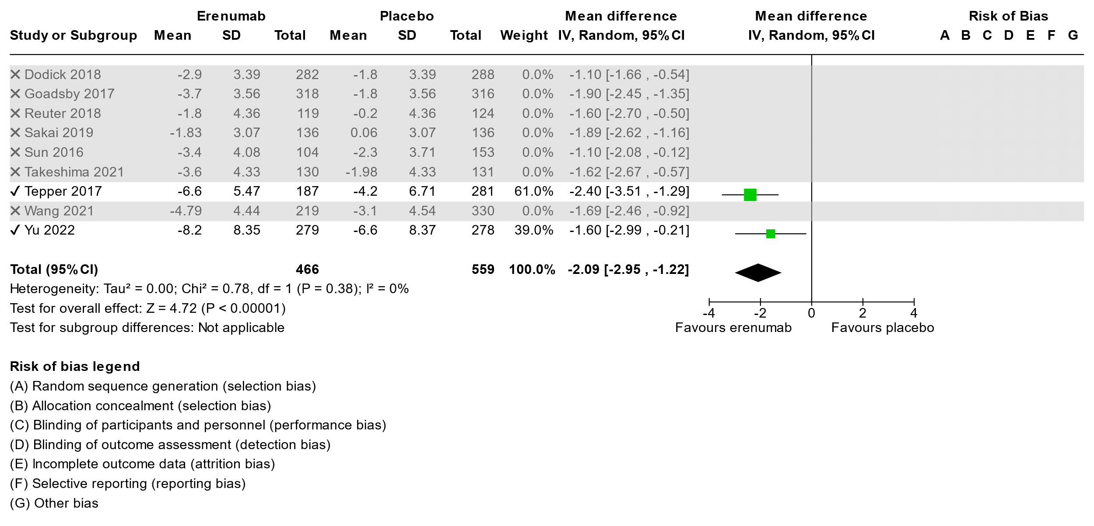

50% Responder Rate

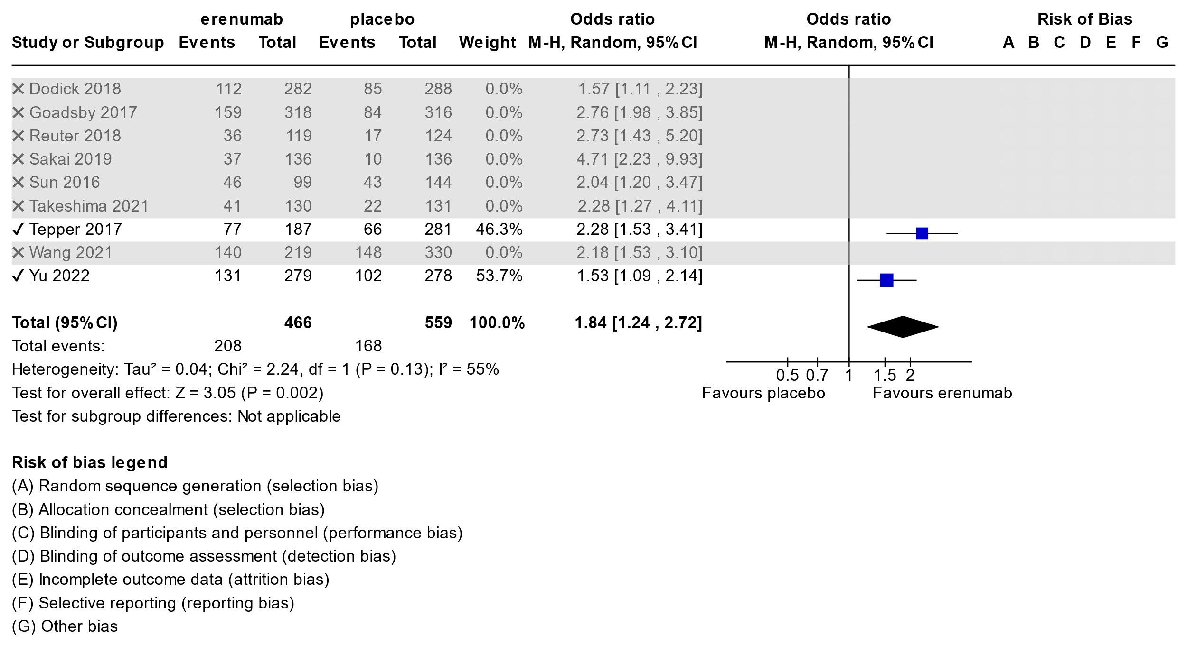

Adverse Events

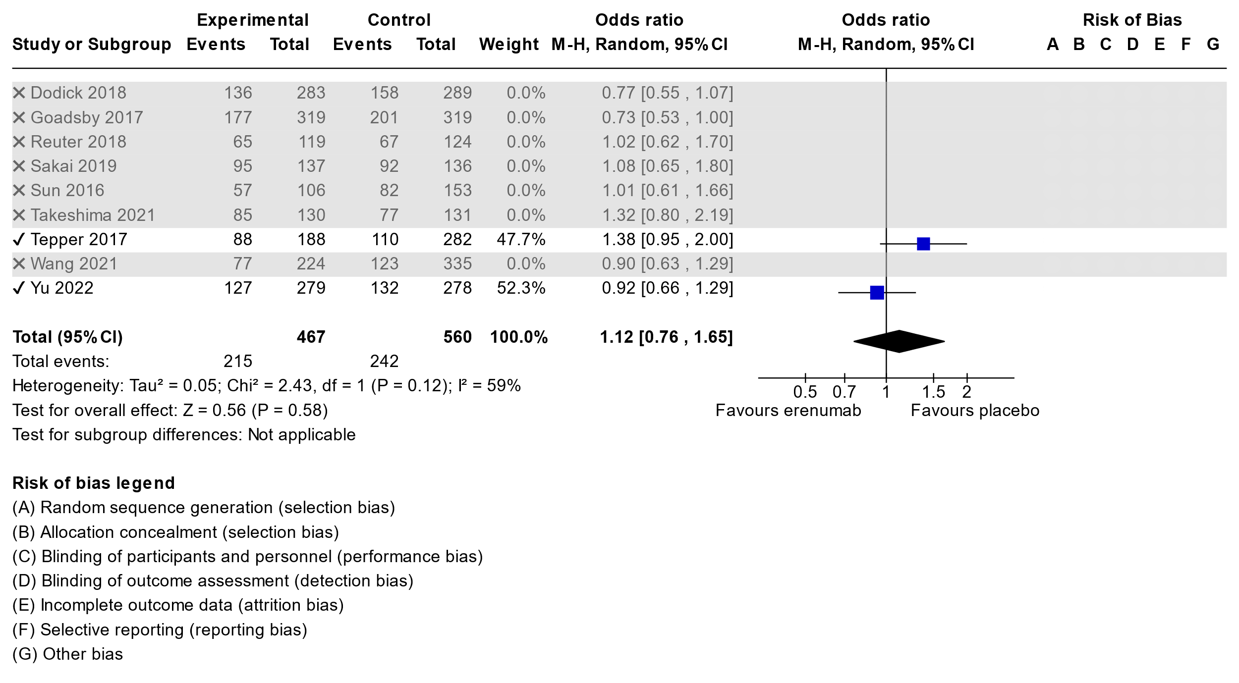

**Summary of findings table for Erenumab in Chronic Migraine**

**Question:** Erenumab compared to placebo for chronic migraine

| **Certainty assessment** | | | | | | | **№ of patients** | | **Effect** | | **Certainty** | **Importance** |
| --- | --- | --- | --- | --- | --- | --- | --- | --- | --- | --- | --- | --- |
| **№ of studies** | **Study design** | **Risk of bias** | **Inconsistency** | **Indirectness** | **Imprecision** | **Other considerations** | **erenumab** | **placebo** | **Relative (95% CI)** | **Absolute (95% CI)** |
| **Migraine day reduction (follow-up: mean 12 weeks)** | | | | | | | | | | | | |
| 2 | randomised trials | not serious | not serious | not serious | not serious | none | 457 | 555 | - | MD **2.09 days lower** (2.95 lower to 1.22 lower) | ⨁⨁⨁⨁ High |  |
| **50% responder rate (follow-up: mean 12 weeks)** | | | | | | | | | | | | |
| 2 | randomised trials | not serious | not serious | not serious | not serious | none | 208/446 (46.6%) | 168/559 (30.1%) | **OR 1.84** (1.24 to 2.72) | **14 more per 100** (from 5 more to 24 more) | ⨁⨁⨁⨁ High |  |
| **Adverse events (follow-up: mean 12 weeks)** | | | | | | | | | | | | |
| 2 | randomised trials | not serious | not serious | not serious | not serious | none | 215/467 (46.0%) | 242/560 (43.2%) | **OR 1.12** (0.76 to 1.65) | **3 more per 100** (from 7 fewer to 12 more) | ⨁⨁⨁⨁ High |  |

**CI:** confidence interval; **MD:** mean difference; **OR:** odds ratio

**3.4.1 Fremanezumab in Episodic Migraine**

Three studies were found: Bigal et al, 2015(44); Dodick et al, 2018(45) and Sakai et al 2021(46).

**Migraine Day Reduction**

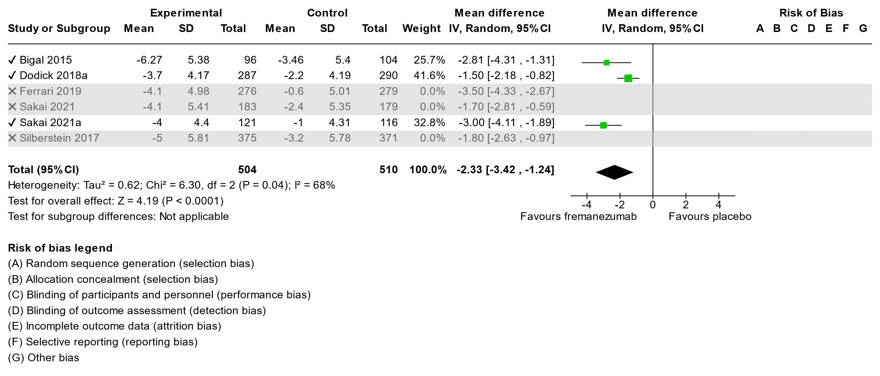

**50% Responder Rate**

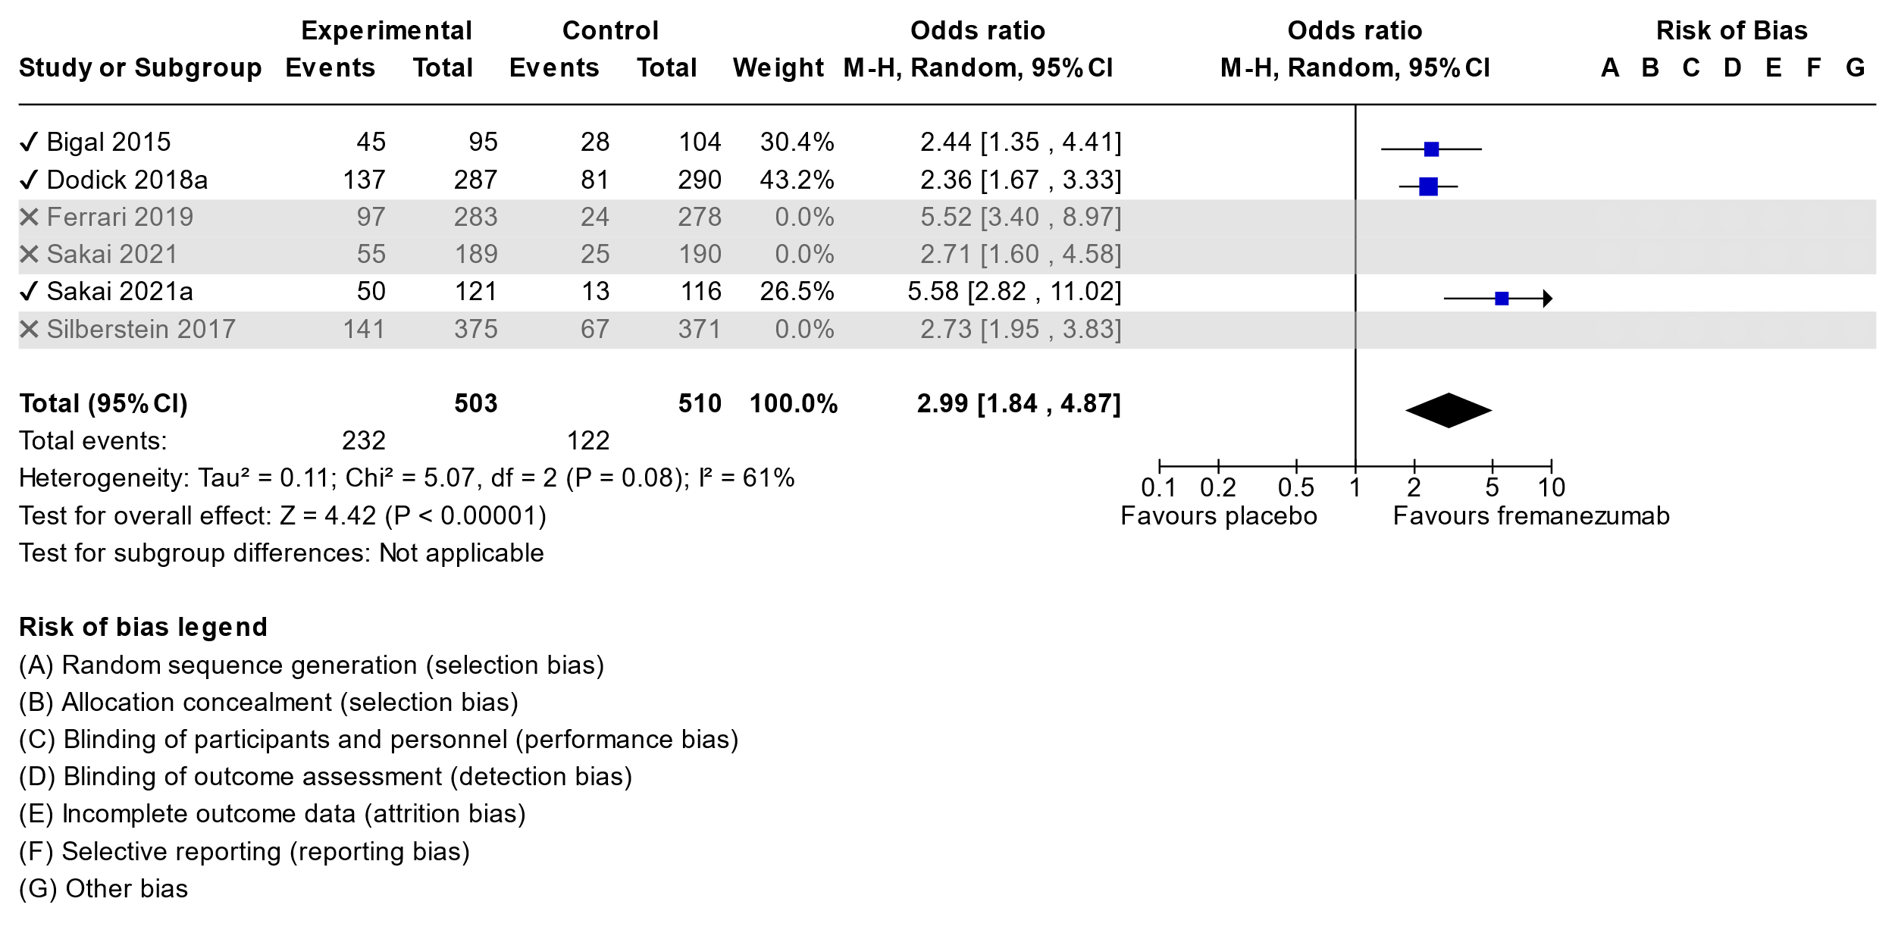

**Adverse Events**

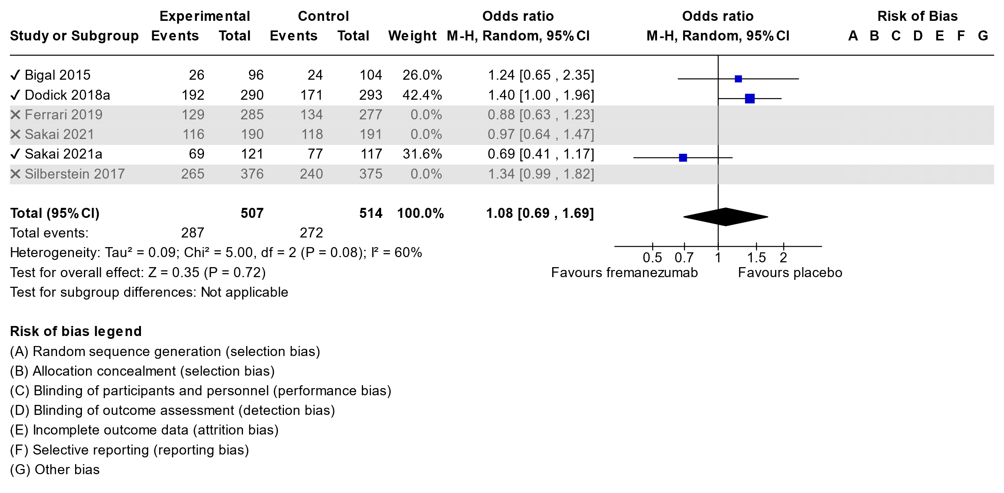**Summary of findings table for Fremanezumab in Episodic Migraine**

| **Certainty assessment** | | | | | | | **№ of patients** | | **Effect** | | **Certainty** | **Importance** |
| --- | --- | --- | --- | --- | --- | --- | --- | --- | --- | --- | --- | --- |
| **№ of studies** | **Study design** | **Risk of bias** | **Inconsistency** | **Indirectness** | **Imprecision** | **Other considerations** | **fremanezumab** | **placebo** | **Relative (95% CI)** | **Absolute (95% CI)** |
| **Migraine day reduction (follow-up: mean 12 weeks)** | | | | | | | | | | | | |
| 3 | randomised trials | not serious | seriousa | not serious | not seriousa | none | 504 | 510 | - | MD **2.33 days lower** (3.42 lower to 1.24 lower) | ⨁⨁⨁◯ Moderate |  |
| **50% responder rate (follow-up: mean 12 weeks)** | | | | | | | | | | | | |
| 3 | randomised trials | not serious | not serious | not serious | not serious | none | 232/503 (46.1%) | 122/510 (23.9%) | **OR 2.99** (1.84 to 4.87) | **25 more per 100** (from 13 more to 37 more) | ⨁⨁⨁⨁ High |  |
| **Adverse events** | | | | | | | | | | | | |
| 3 | randomised trials | not serious | not serious | not serious | not serious | none | 287/507 (56.6%) | 272/514 (52.9%) | **OR 1.08** (0.69 to 1.69) | **2 more per 100** (from 9 fewer to 13 more) | ⨁⨁⨁⨁ High |  |

**CI:** confidence interval; **MD:** mean difference; **OR:** odds ratio

#### Explanations

a. the Bigal 2015 results and Sakai 2021a results are much higher than dodick study wich is a larger study. Heterogeneity is significant

**3.4.2 Fremanezmab in Chronic Migraine**

There were 2 studies found: Sakai et al 2021(47), Silberstein et al 2017(48).

**Migraine Day Reduction**

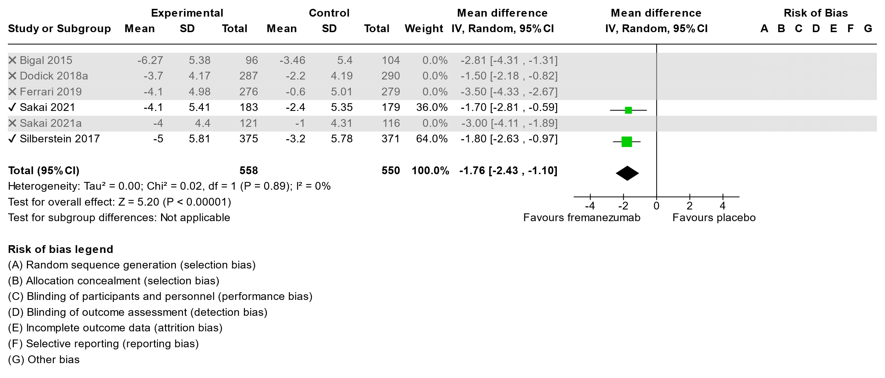

**50% Responder Rate**

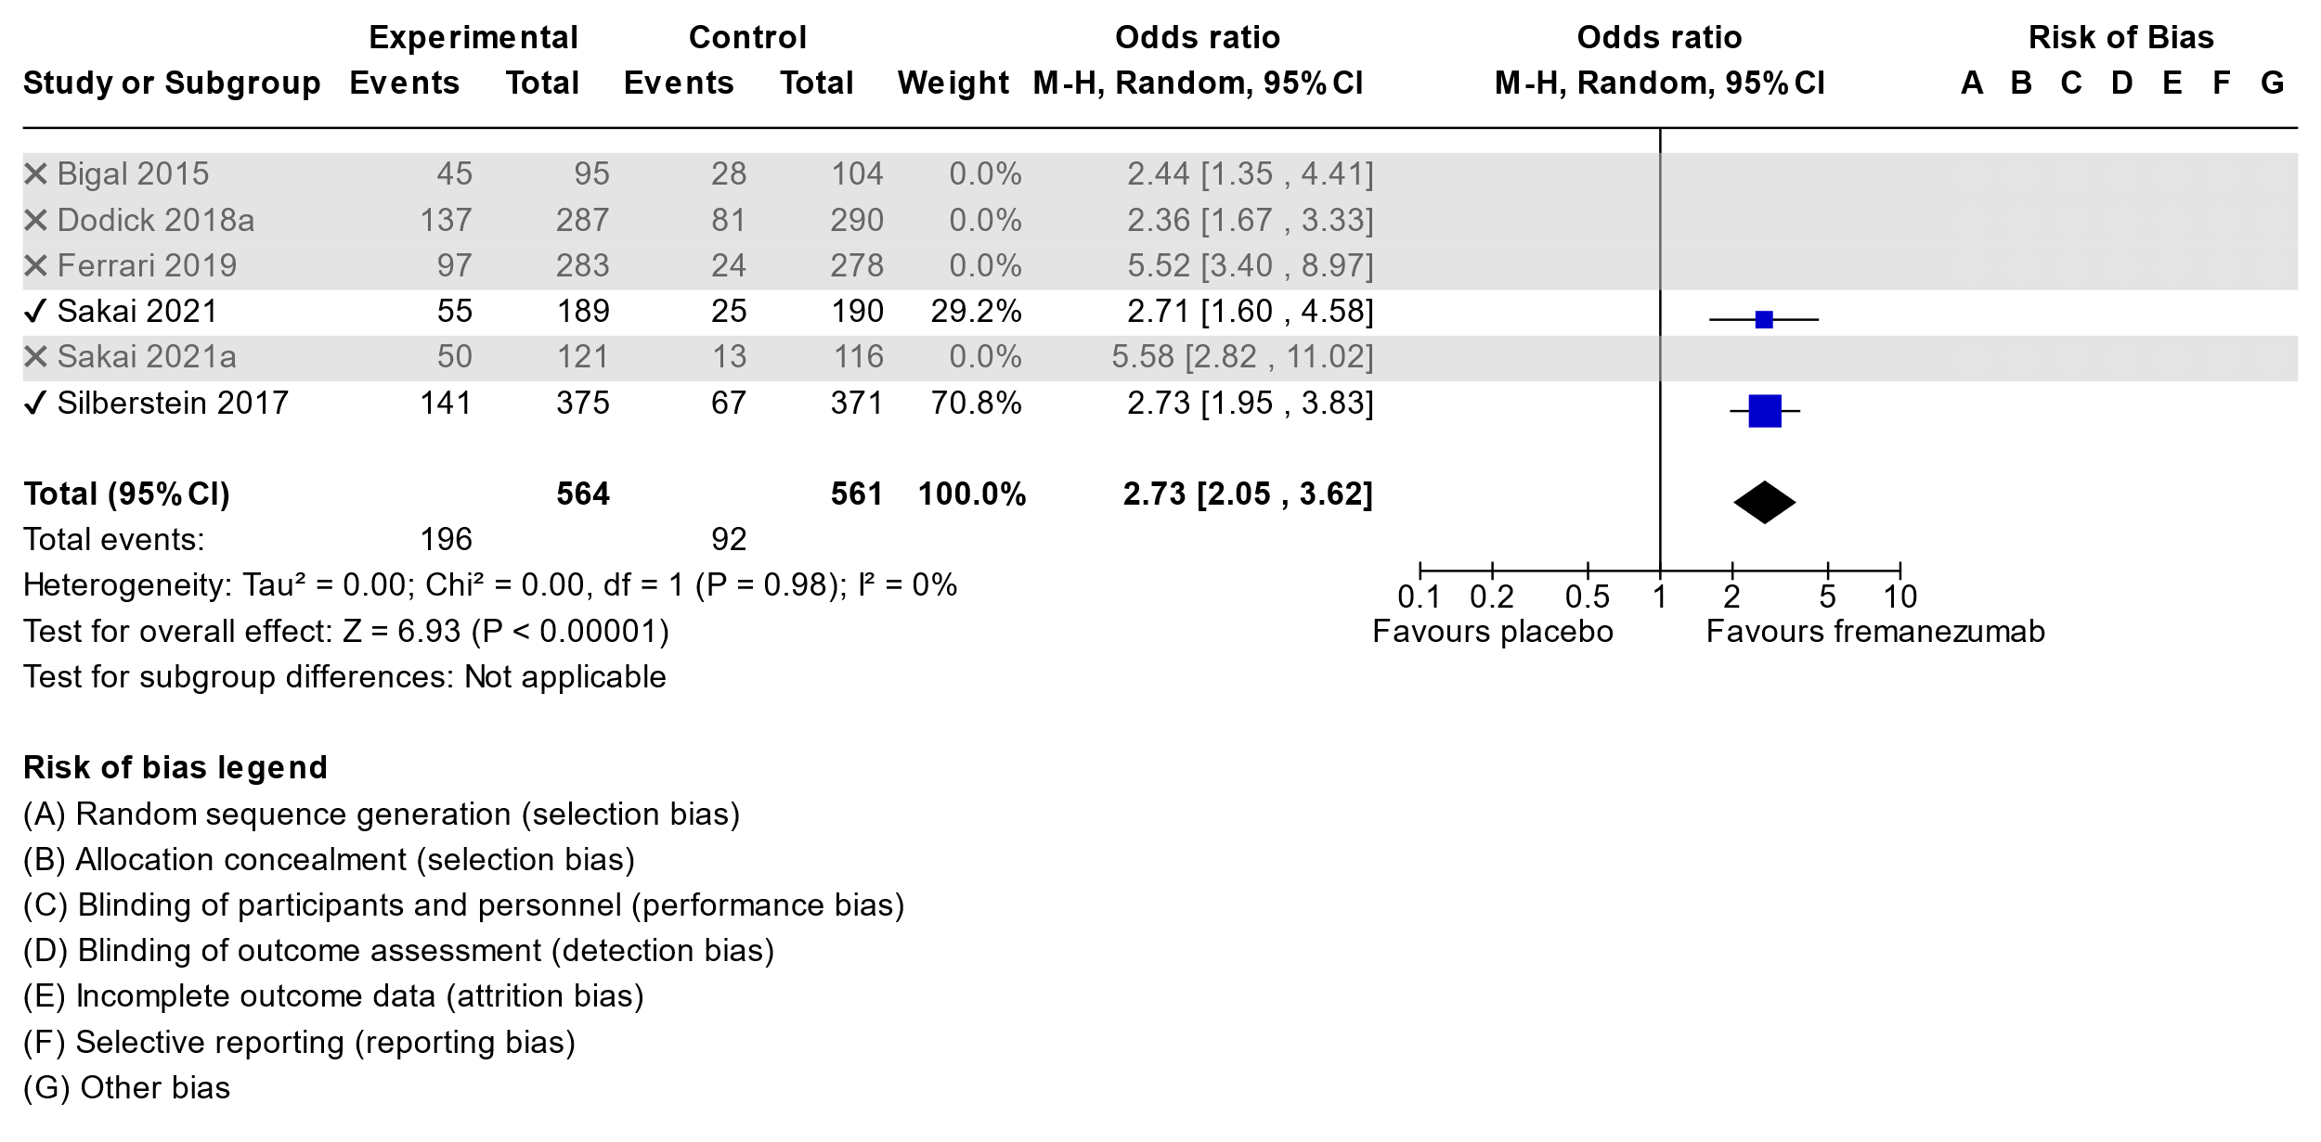

**Adverse Events**

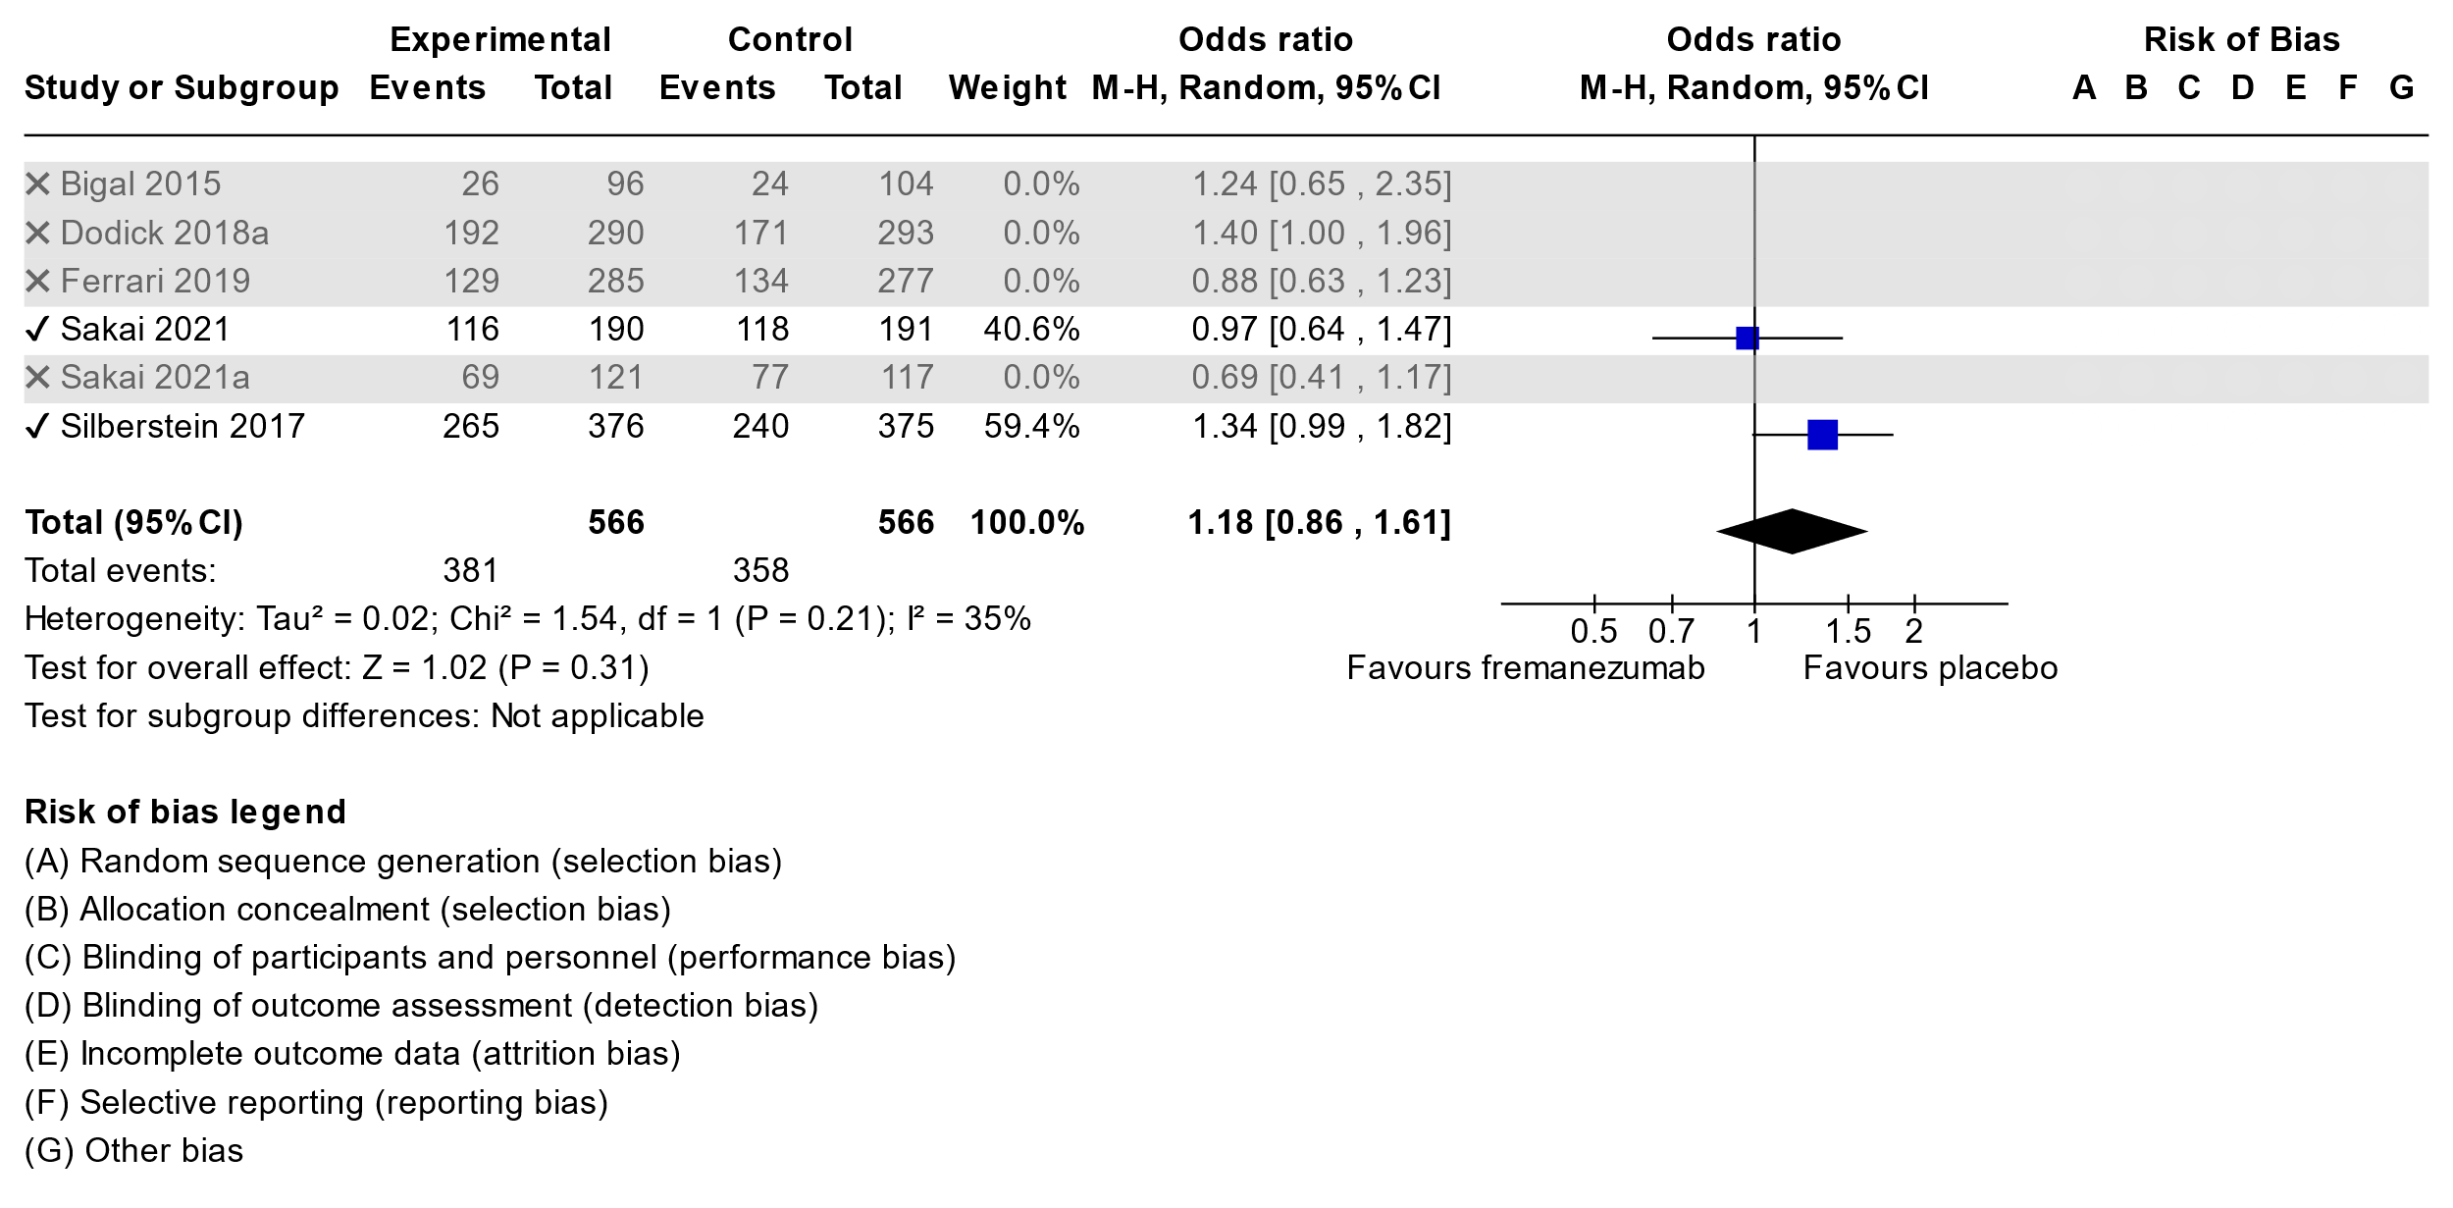

**Summary of findings table for Fremazenumab in Chronic Migraine**

**Question:** Fremanezumab compared to placebo for chronic migraine

| **Certainty assessment** | | | | | | | **№ of patients** | | **Effect** | | **Certainty** | **Importance** |
| --- | --- | --- | --- | --- | --- | --- | --- | --- | --- | --- | --- | --- |
| **№ of studies** | **Study design** | **Risk of bias** | **Inconsistency** | **Indirectness** | **Imprecision** | **Other considerations** | **fremanezumab** | **placebo** | **Relative (95% CI)** | **Absolute (95% CI)** |
| **Migraine day reduction (follow-up: mean 12 weeks)** | | | | | | | | | | | | |
| 2 | randomised trials | not serious | not serious | not serious | not serious | none | 564 | 561 | - | MD **1.76 day lower** (2.43 lower to 1.1 lower) | ⨁⨁⨁⨁ High |  |
| **50% responder rate (follow-up: mean 12 weeks)** | | | | | | | | | | | | |
| 2 | randomised trials | not serious | not serious | not serious | not serious | none | 196/554 (35.4%) | 92/561 (16.4%) | **OR 2.73** (2.05 to 3.62) | **18 more per 100** (from 12 more to 25 more) | ⨁⨁⨁⨁ High |  |
| **Adverse events (follow-up: mean 12 weeks)** | | | | | | | | | | | | |
| 2 | randomised trials | not serious | not serious | not serious | not serious | none | 381/566 (67.3%) | 358/566 (63.3%) | **OR 1.18** (0.86 to 1.61) | **4 more per 100** (from 4 fewer to 10 more) | ⨁⨁⨁⨁ High |  |

**CI:** confidence interval; **MD:** mean difference; **OR:** odds ratio

**3.5.1 Galcanezumab in Episodic Migraine**

There were 5 studies found: Hu et al, 2022(50); Sakai et al, 2021(53); Skljarevski et al, 2018 a and b(51,52); Stauffer et al, 2018(54).

**Migraine Day Reduction**

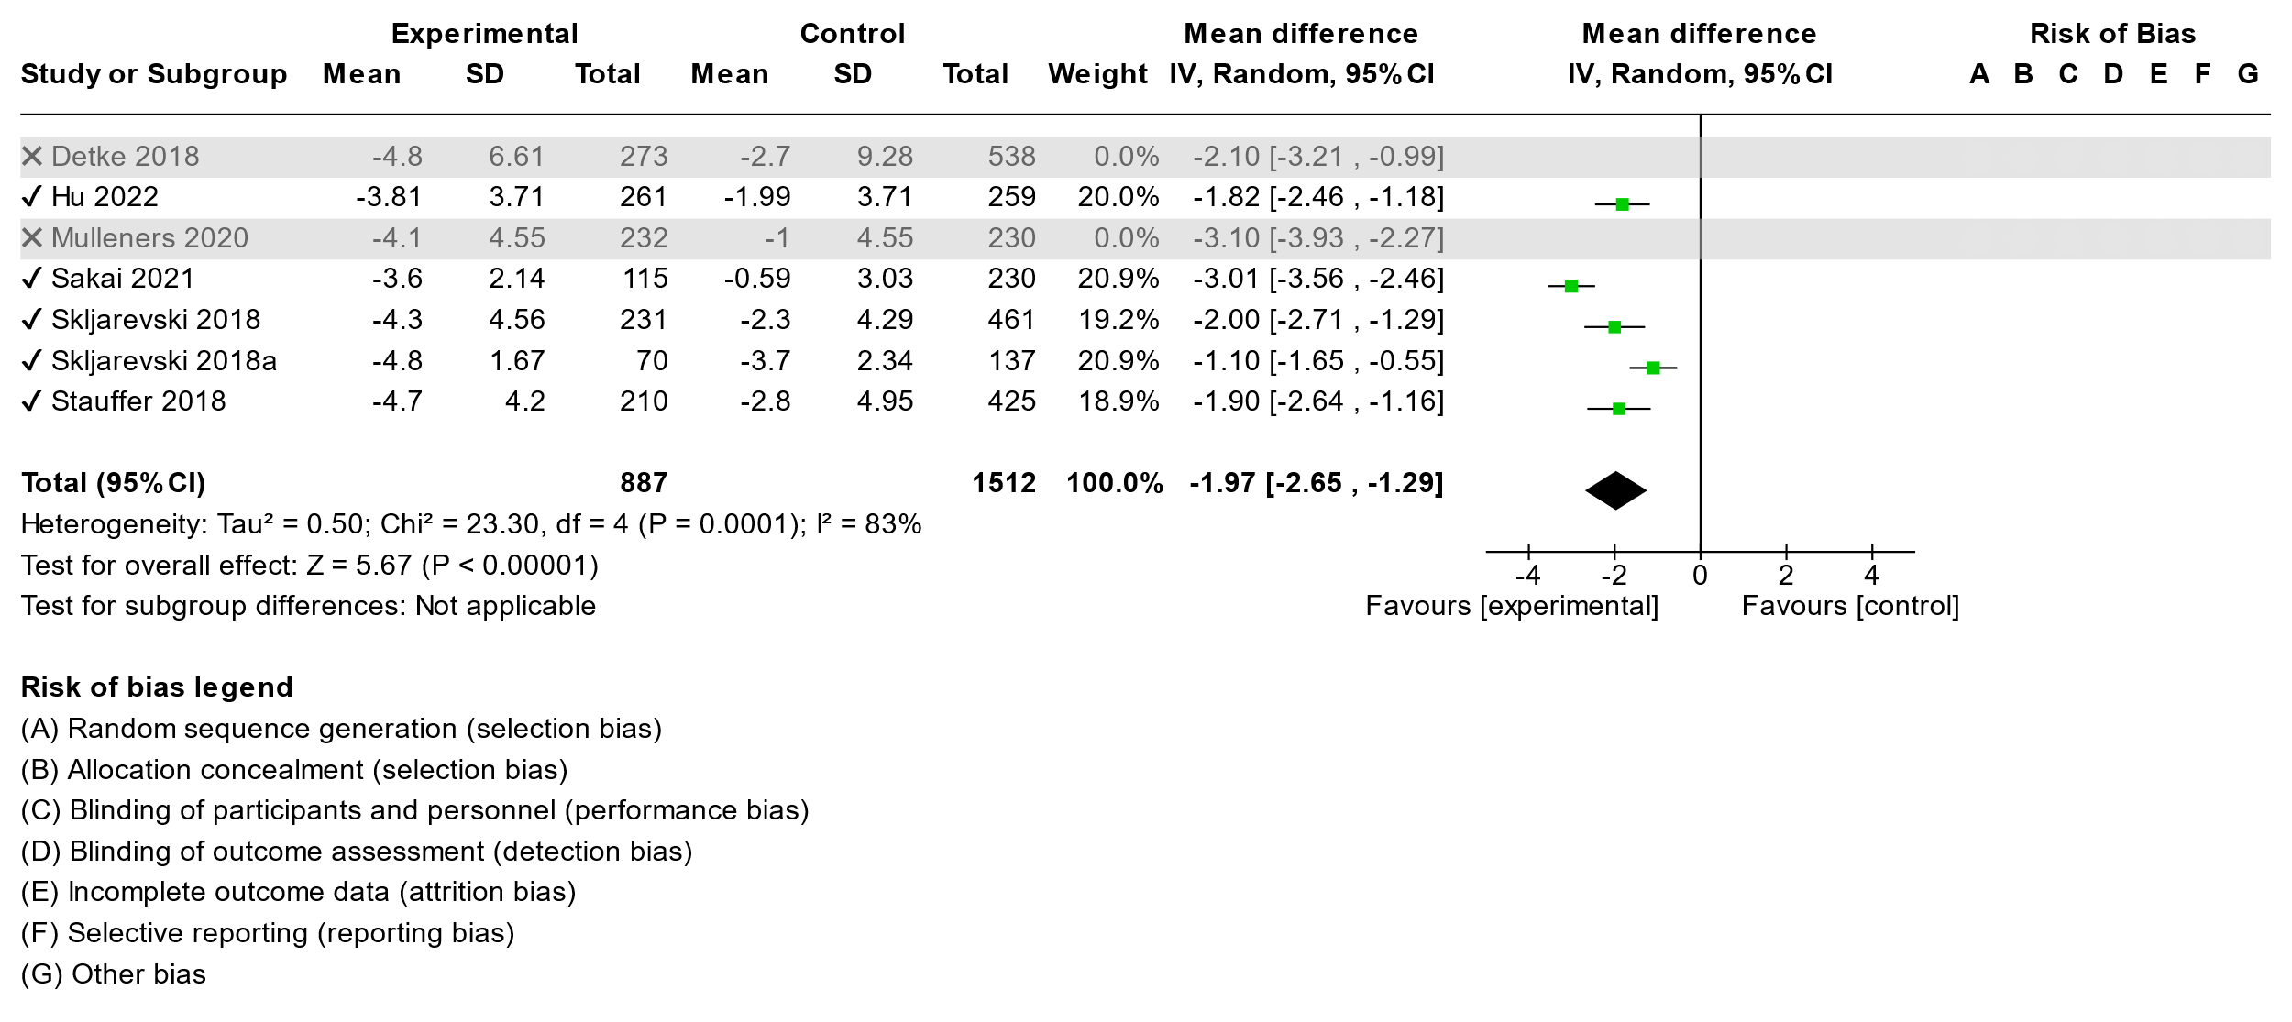

**50% Responder Rate**

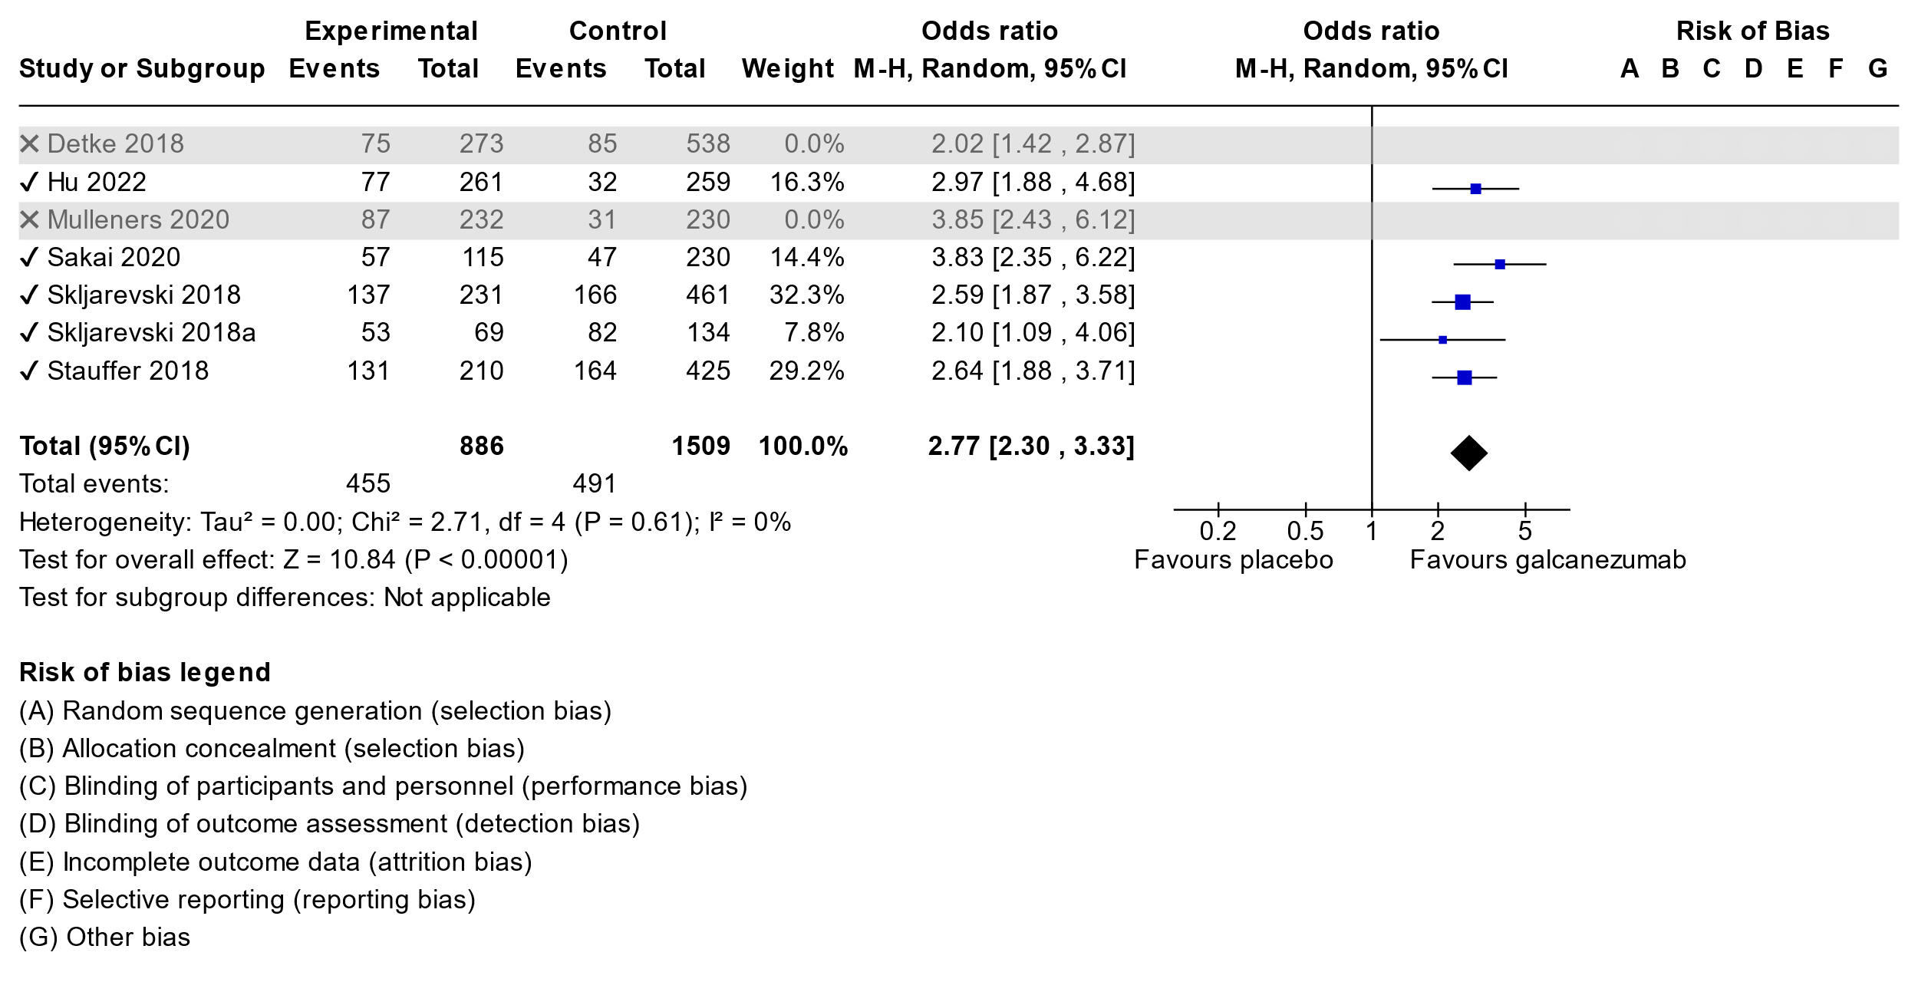

**Adverse Events**

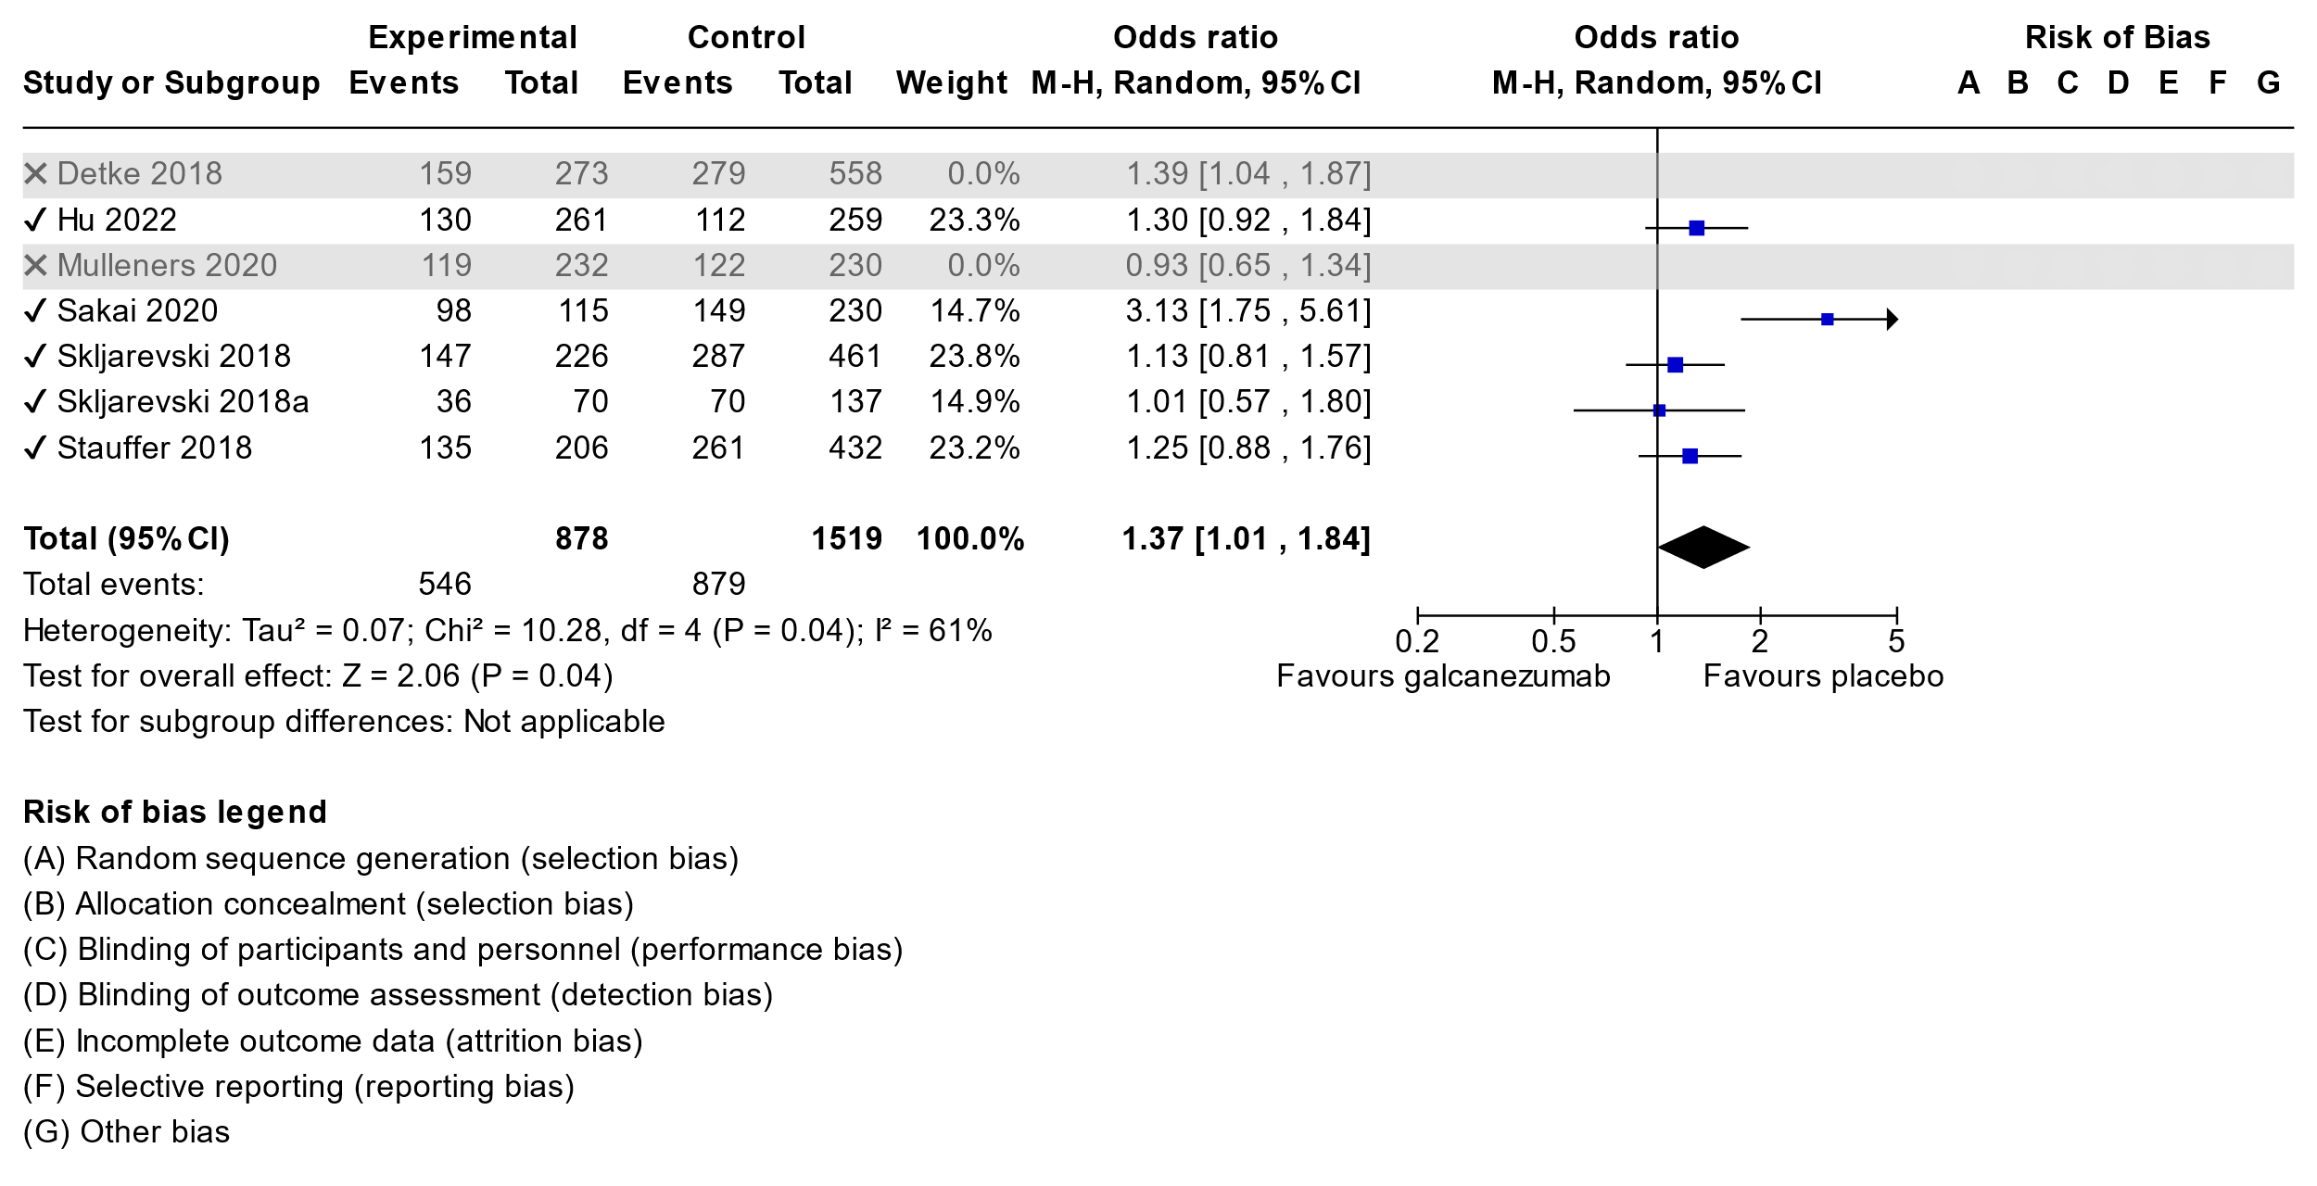**Summary of findings table for Galcanezumab in Episodic Migraine**

**Question:** Galcanezumab compared to placebo for episodic migraine

| **Certainty assessment** | | | | | | | **№ of patients** | | **Effect** | | **Certainty** | **Importance** |
| --- | --- | --- | --- | --- | --- | --- | --- | --- | --- | --- | --- | --- |
| **№ of studies** | **Study design** | **Risk of bias** | **Inconsistency** | **Indirectness** | **Imprecision** | **Other considerations** | **galcanezumab** | **placebo** | **Relative (95% CI)** | **Absolute (95% CI)** |
| **Migraine day reduction galcanezumab (follow-up: mean 12 weeks; Scale from: -10 to 10)** | | | | | | | | | | | | |
| 5 | randomised trials | not serious | seriousa | not serious | not serious | none | 887 | 1512 | - | MD **1.97 days lower** (2.65 lower to 1.29 lower) | ⨁⨁⨁◯ Moderate | CRITICAL |
| **50% responder rate (follow-up: mean 12 weeks)** | | | | | | | | | | | | |
| 5 | randomised trials | not serious | not serious | not serious | not serious | none | 455/886 (51.4%) | 491/1509 (32.5%) | **OR 2.77** (2.30 to 3.33) | **25 more per 100** (from 20 more to 29 more) | ⨁⨁⨁⨁ High | CRITICAL |
| **Adverse Events (follow-up: mean 12 weeks)** | | | | | | | | | | | | |
| 5 | randomised trials | not serious | seriousb | not serious | not serious | none | 546/878 (62.2%) | 879/1519 (57.9%) | **OR 1.37** (1.01 to 1.84) | **7 more per 100** (from 0 fewer to 14 more) | ⨁⨁⨁◯ Moderate | CRITICAL |

Explanations a. significant p value and high I2, Sakai 2020 and Sklkarevski 2018a studies are outside of other studies

b. p value significant and sakai 2020 is outlier with more events

**3.5.2 Galcanezumab in Chronic Migraine**

There was a single study found Detke et al 2018 (55)

**Summary of findings table for Galcanezumab in Chronic Migraine**

**Question:** Galcanezumab compared to placebo for chronic migraine

| **Certainty assessment** | | | | | | | **№ of patients** | | **Effect** | | **Certainty** | **Importance** |
| --- | --- | --- | --- | --- | --- | --- | --- | --- | --- | --- | --- | --- |
| **№ of studies** | **Study design** | **Risk of bias** | **Inconsistency** | **Indirectness** | **Imprecision** | **Other considerations** | **galcanezumab** | **placebo** | **Relative (95% CI)** | **Absolute (95% CI)** |
| **Migraine day reduction (follow-up: mean 12 weeks)** | | | | | | | | | | | | |
| 1 | randomised trials | not serious | not serious | not serious | not serious | none | 273 | 538 | - | MD **2.1 days lower** (3.21 lower to 0.99 lower) | ⨁⨁⨁⨁ High |  |
| **50% RR (follow-up: mean 12 weeks)** | | | | | | | | | | | | |
| 1 | randomised trials | not serious | not serious | not serious | not serious | none | 75/273 (27.5%) | 83/538 (15.4%) | **OR 2.02** (1.42 to 2.87) | **12 more per 100** (from 5 more to 19 more) | ⨁⨁⨁⨁ High |  |
| **Adverse events (follow-up: mean 12 weeks)** | | | | | | | | | | | | |
| 1 | randomised trials | not serious | not serious | not serious | not serious | none | 159/273 (58.2%) | 279/558 (50.0%) | **OR 1.39** (1.04 to 1.87) | **8 more per 100** (from 1 more to 15 more) | ⨁⨁⨁⨁ High |  |

**CI:** confidence interval; **MD:** mean difference; **OR:** odds ratio

**3.6.1 Rimegepant in Episodic Migraine**

A single study was found, Croop et al, 2021(57).

**Summary of findings table for Rimegepant in Episodic Migraine**

**Question:** Rimegepant compared to placebo for episodic migraine

| **Certainty assessment** | | | | | | | **№ of patients** | | **Effect** | | **Certainty** | **Importance** |
| --- | --- | --- | --- | --- | --- | --- | --- | --- | --- | --- | --- | --- |
| **№ of studies** | **Study design** | **Risk of bias** | **Inconsistency** | **Indirectness** | **Imprecision** | **Other considerations** | **rimegepant** | **placebo** | **Relative (95% CI)** | **Absolute (95% CI)** |
| **Migraine day reduction (follow-up: mean 12 weeks; Scale from: -10 to 10)** | | | | | | | | | | | | |
| 1 | randomised trials | not serious | not serious | not serious | seriousa | none | 348 | 347 | - | MD **0.8 day lower** (1.5 lower to 0.2 lower) | ⨁⨁⨁◯ Moderate | CRITICAL |
| **50% responder rate (follow-up: mean 12 weeks)** | | | | | | | | | | | | |
| 1 | randomised trials | not serious | not serious | not serious | seriousa | none | 171/348 (49.1%) | 144/347 (41.5%) | **OR 1.36** (1.01 to 1.84) | **8 more per 100** (from 0 fewer to 15 more) | ⨁⨁⨁◯ Moderate | CRITICAL |
| **Adverse eventa (follow-up: mean 12 weeks)** | | | | | | | | | | | | |
| 1 | randomised trials | not serious | not serious | not serious | not serious | none | 133/370 (35.9%) | 133/371 (35.8%) | **OR 1.00** (0.74 to 1.34) | **0 fewer per 100** (from 7 fewer to 7 more) | ⨁⨁⨁⨁ High | CRITICAL |

**CI:** confidence interval; **MD:** mean difference; **OR:** odds ratio

#### Explanations

1. close to null difference

**3.7.1 OnabotulinumtoxinA in Chronic Migraine**

A single study was found, Dodick 2010(58).

**Summary of findings table for OnabotulinumtoxinA in Chronic Migraine**

**Question:** OnabotulinumtoxinA compared to placebo for chronic migraine

**Author(s):**

**Question:** OnabotulinumtoxinA compared to placebo for chronic migraine

**Setting:**

**Bibliography:**

| **Certainty assessment** | | | | | | | **№ of patients** | | **Effect** | | **Certainty** | **Importance** |
| --- | --- | --- | --- | --- | --- | --- | --- | --- | --- | --- | --- | --- |
| **№ of studies** | **Study design** | **Risk of bias** | **Inconsistency** | **Indirectness** | **Imprecision** | **Other considerations** | **Onabotulinum Toxin A** | **placebo** | **Relative (95% CI)** | **Absolute (95% CI)** |
| **Migraine Day Reduction (follow-up: mean 24 weeks; Scale from: -10 to 10)** | | | | | | | | | | | | |
| 1 | randomised trials | not serious | not serious | not serious | not serious | none | 688 | 696 | - | MD **2 days lower** (2.67 lower to 1.27 lower) | ⨁⨁⨁⨁ High | CRITICAL |
| **50% Responder Rate (follow-up: mean 24 weeks)** | | | | | | | | | | | | |
| 1 | randomised trials | not serious | not serious | not serious | not serious | none | 324/688 (47.1%) | 244/696 (35.1%) | **OR 1.65** (1.33 to 2.05) | **12 more per 100** (from 7 more to 17 more) | ⨁⨁⨁⨁ High | CRITICAL |
| **Adverse events (follow-up: mean 24 weeks)** | | | | | | | | | | | | |
| 1 | randomised trials | not serious | not serious | not serious | not serious | none | 429/687 (62.4%) | 358/692 (51.7%) | **OR 1.55** (1.25 to 1.92) | **11 more per 100** (from 6 more to 16 more) | ⨁⨁⨁⨁ High | CRITICAL |

**CI:** confidence interval; **MD:** mean difference; **OR:** odds ratio

**3.8.1 Candesartan in Episodic Migraine**

We have found a new study Stovner 2014 et al (59)as outlined in our list, and also included previous study from Tronvik 2003 et al (60) included in the 2012 CHS guidelines.

**Migraine Day Reduction**

Data could not be meta-analyzed as we did not have confidence intervals or standard deviations for response in both trials.

Stovner et al 2014 MDR vs placebo was 0.58 days, p =0.02

10 MDR vs placebo was 1.2 days, p=0.001

**50% Responder Rate**

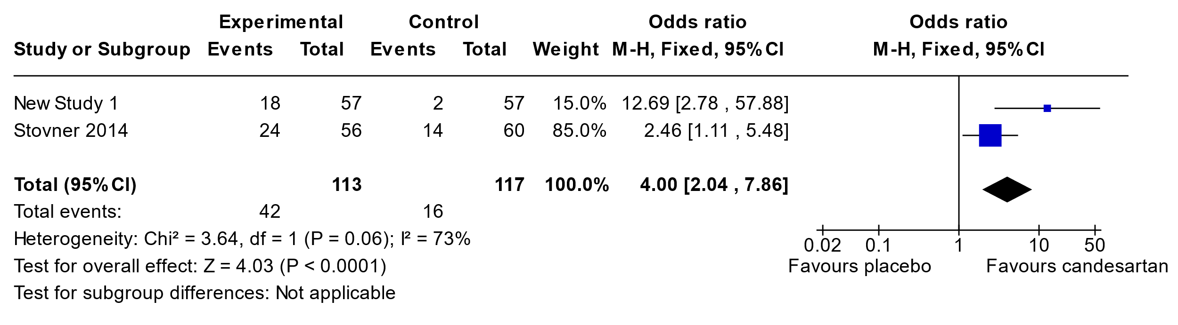**Summary of findings table for Candesartan in Episodic Migraine**

**Question:** Candesartan compared to placebo for episodic migraine

| **Certainty assessment** | | | | | | | **№ of patients** | | **Effect** | | **Certainty** | **Importance** |
| --- | --- | --- | --- | --- | --- | --- | --- | --- | --- | --- | --- | --- |
| **№ of studies** | **Study design** | **Risk of bias** | **Inconsistency** | **Indirectness** | **Imprecision** | **Other considerations** | **candesartan** | **placebo** | **Relative (95% CI)** | **Absolute (95% CI)** |
| **Migraine day reduction (follow-up: mean 12 weeks)** | | | | | | | | | | | | |
| 2 | randomised trials | not serious | not serious | not serious | seriousa | none | 113 | 117 | - | **0**  (0 to 0 ) | ⨁⨁⨁◯ Moderate | CRITICAL |
| **50% responder rate (follow-up: mean 12 weeks)** | | | | | | | | | | | | |
| 2 | randomised trials | not serious | seriousb | not serious | not serious | none | 42/113 (37.2%) | 16/117 (13.7%) | **OR 4.00** (2.04 to 7.86) | **25 more per 100** (from 11 more to 42 more) | ⨁⨁⨁◯ Moderate | CRITICAL |

**CI:** confidence interval; **OR:** odds ratio

#### Explanations

a. confidence intervals not provided but given p value is not very small and the values are very close to null difference there is an element of imprecision

b. Wide range in effect with p close to significance for inconsistency and two different rates of response

**3.9.1 Enalapril in Episodic Migraine**

We have found a new study from Sonbolestan et al, 2013 (61)

**Summary of findings table for Enalapril in Episodic Migraine**

**Question:** Enalapril compared to placebo for episodic migraine

| **Certainty assessment** | | | | | | | **№ of patients** | | **Effect** | | **Certainty** | **Importance** |
| --- | --- | --- | --- | --- | --- | --- | --- | --- | --- | --- | --- | --- |
| **№ of studies** | **Study design** | **Risk of bias** | **Inconsistency** | **Indirectness** | **Imprecision** | **Other considerations** | **enalapril** | **placebo** | **Relative (95% CI)** | **Absolute (95% CI)** |
| **Migraine day reduction (follow-up: mean 8 weeks)** | | | | | | | | | | | | |
| 1 | randomised trials | very seriousa | not serious | not serious | not serious | none | 21 | 19 | - | MD **4.42 days lower** (0 to 0 ) | ⨁⨁◯◯ Low |  |
| **50% Responder rate (follow-up: mean 8 weeks)** | | | | | | | | | | | | |
| 1 | randomised trials | very seriousa | not serious | not serious | seriousb | none | 10/21 (47.6%) | 2/19 (10.5%) | **OR 7.72** (1.41 to 42.17) | **37 more per 100** (from 4 more to 73 more) | ⨁◯◯◯ Very low |  |

**CI:** confidence interval; **MD:** mean difference; **OR:** odds ratio

#### Explanations

1. baseline group differences and no adequate description of allocation
2. very wide confidence intervals

**3.10.1 Propranolol in Chronic Migraine**

We found a single study Chowdhudry et al, 2022(62). Please consider review of table of Topiramate in Chronic Migraine while reviewing this data.

**Summary of findings table for Propranolol in Chronic Migraine compared to Topiramate**

**Question:** Propranolol compared to topiramate for chronic migraine

| **Certainty assessment** | | | | | | | **№ of patients** | | **Effect** | | **Certainty** | **Importance** |
| --- | --- | --- | --- | --- | --- | --- | --- | --- | --- | --- | --- | --- |
| **№ of studies** | **Study design** | **Risk of bias** | **Inconsistency** | **Indirectness** | **Imprecision** | **Other considerations** | **propranolol** | **topiramate** | **Relative (95% CI)** | **Absolute (95% CI)** |
| **Migraine Day Reduction (follow-up: mean 24 weeks; Scale from: -10 to 10)** | | | | | | | | | | | | |
| 1 | randomised trials | not serious | not serious | seriousa | not serious | none | 82 | 93 | - | MD **1.7 days lower** (3.82 lower to 0.39 higher) | ⨁⨁⨁◯ Moderate | CRITICAL |
| **50% Responder Rate (follow-up: mean 24 weeks)** | | | | | | | | | | | | |
| 1 | randomised trials | not serious | not serious | seriousa | not serious | none | 18/82 (22.0%) | 16/93 (17.2%) | **OR 1.35** (0.64 to 2.87) | **5 more per 100** (from 5 fewer to 20 more) | ⨁⨁⨁◯ Moderate | CRITICAL |
| **Adverse Events (follow-up: mean 12 weeks)** | | | | | | | | | | | | |
| 1 | randomised trials | not serious | not serious | seriousa | not serious | none | 30/82 (36.6%) | 32/93 (34.4%) | **OR 1.10** (0.59 to 2.05) | **2 more per 100** (from 11 fewer to 17 more) | ⨁⨁⨁◯ Moderate | CRITICAL |

**CI:** confidence interval; **MD:** mean difference; **OR:** odds ratio

#### Explanations

1. Comparison with topiramate is indirect as no placebo

**3.11.1 Gabapentin in Episodic Migraine**

We identified a new study since the previous guideline, Silberstein et al 2013(63). We were able to do meta-analysis on 50% RR with Mathew et al, 2001(64) study.

**Migraine Day Reduction** - Could not do meta-analysis

Silberstein et al, 2013 (low ROB) found a 0.3 MDR for gabapentin with a 95% CI of -0.6 to 1.1. This was a large study, well powered. **Likely no effect of gabapentin on migraine day reduction, given this was a negative study.**

The older studies were smaller and not as well powered.

Mathew et al, 2001 (64) (high ROB) found a 1.2 MDR for gabapentin

Di Trapani, 2000 (65) (some concerns for ROB) found a 1.24 MDR for gabapentin

**50% Responder Rate**

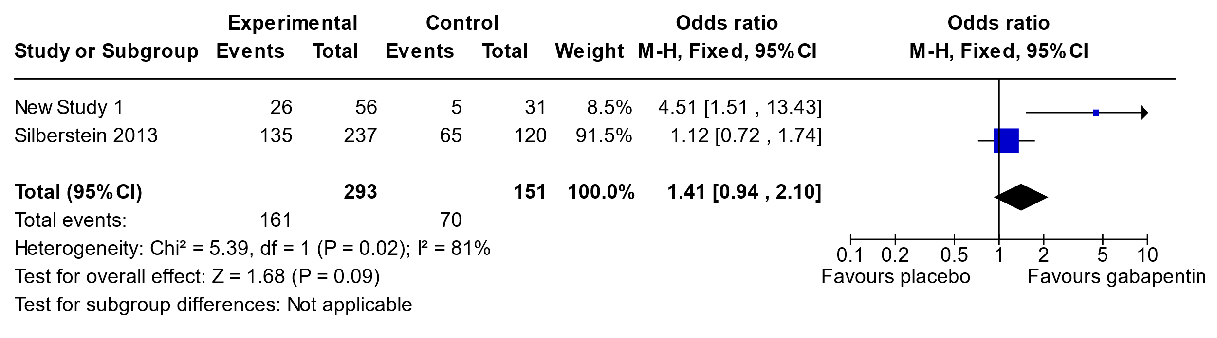

**Summary of findings table for Gabapentin in Episodic Migraine**

**Question:** Gabapentin compared to placebo for episodic migraine prevention

| **Certainty assessment** | | | | | | | **№ of patients** | | **Effect** | | **Certainty** | **Importance** |
| --- | --- | --- | --- | --- | --- | --- | --- | --- | --- | --- | --- | --- |
| **№ of studies** | **Study design** | **Risk of bias** | **Inconsistency** | **Indirectness** | **Imprecision** | **Other considerations** | **gabapentin** | **placebo** | **Relative (95% CI)** | **Absolute (95% CI)** |
| **Migraine day reduction (follow-up: mean 12 weeks; Scale from: -10 to 10)** | | | | | | | | | | | | |
| 3 | randomised trials | very seriousa | very seriousb | not serious | seriousb,c | none |  |  | - | **0**  (0 to 0 ) | ⨁◯◯◯ Very low |  |
| **50% responder rate (follow-up: mean 12 weeks)** | | | | | | | | | | | | |
| 2 | randomised trials | very seriousa | very seriousd | not serious | seriousb | none | 161/293 (54.9%) | 70/151 (46.4%) | **OR 1.41** (0.94 to 2.10) | **9 more per 100** (from 2 fewer to 18 more) | ⨁◯◯◯ Very low |  |
| **Adverse events (follow-up: mean 12 weeks)** | | | | | | | | | | | | |
| 3 | randomised trials | very seriousa | not serious | not serious | not serious | none |  |  | not estimable |  | ⨁⨁◯◯ Low |  |

**CI:** confidence interval; **OR:** odds ratio

#### Explanations

a. 2 of 3 studies were raising some concerns or high for ROB

b. 2 found effect of gabapentin but largest trial found no effect

c. older studies had high imprecision with large CIs

d. one study found an effect of gabapentin and the other study found no effect

**3.12.1 Levetiracetam in Episodic Migraine**

We found two studies Verma et al, 2013(66) and Sadeghian et al, 2015(67) which had a comparison against placebo. Another study by Kashipazha et al, 2017 was comparison against valproate(68).

**Migraine Day Reduction** – could not undertake a meta-analysis

Verma et al 2013 (High ROB), MDR of 2.25 versus placebo

Sadeghian et al, 2015 (High ROB) MDR of 4 versus placebo

Kashipazha et al, 2017 (Some Concerns for ROB) found a MDR 6.7+/-2.7 in intervention group, but significantly less than 14.4 +/- 5.3 in control group. This study suggests that levetiracetam is less effective than valproate.

**50% Responder Rate**

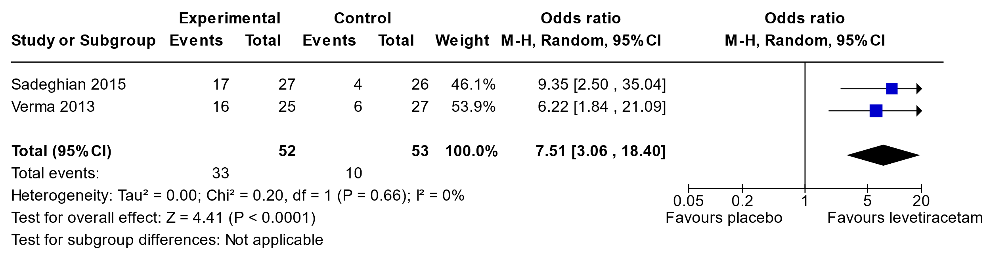

**Summary of findings table for Levetiracetam in Episodic Migraine**

**Question:** Levetiracetam compared to placebo for migraine prevention

| **Certainty assessment** | | | | | | | **№ of patients** | | **Effect** | | **Certainty** | **Importance** |
| --- | --- | --- | --- | --- | --- | --- | --- | --- | --- | --- | --- | --- |
| **№ of studies** | **Study design** | **Risk of bias** | **Inconsistency** | **Indirectness** | **Imprecision** | **Other considerations** | **levetiracetam** | **placebo** | **Relative (95% CI)** | **Absolute (95% CI)** |
| **Migraine day reduction** | | | | | | | | | | | | |
| 2 | randomised trials | very seriousa | not serious | not serious | not serious | none | 52 | 53 | - | **0**  (0 to 0 ) | ⨁⨁◯◯ Low |  |
| **50% responder rate** | | | | | | | | | | | | |
| 2 | randomised trials | very seriousa | not serious | not serious | not serious | none | 33/52 (63.5%) | 10/53 (18.9%) | **OR 7.51** (3.06 to 18.40) | **45 more per 100** (from 23 more to 62 more) | ⨁⨁◯◯ Low |  |

**CI:** confidence interval; **OR:** odds ratio

#### Explanations

a. both trials had high ROB

**3.13.1 Topiramate in Chronic Migraine**

We found three publications including two studies, Diener et al, 2007 (71), and the Silberstein et al, 2007(72) and 2009 (73)publications of the same study.

**Migraine Day Reduction**

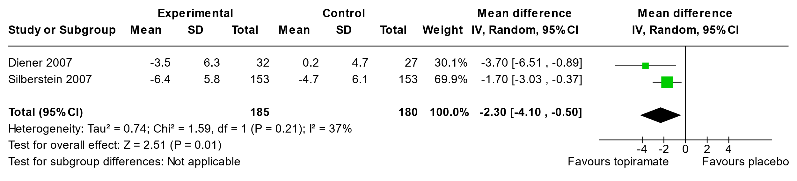

**50% Responder Rate**

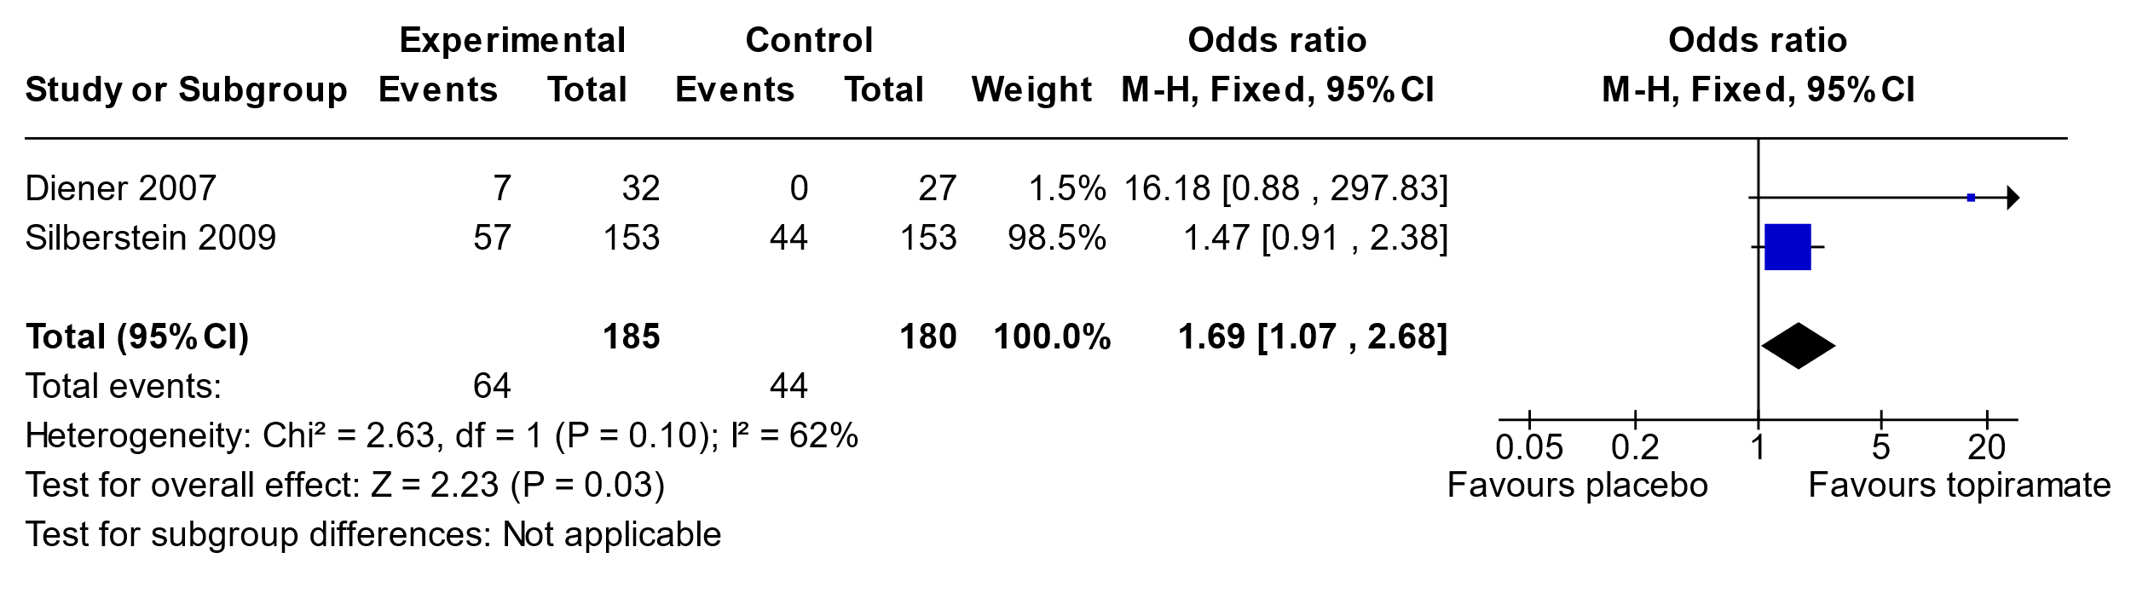

**Adverse Events**

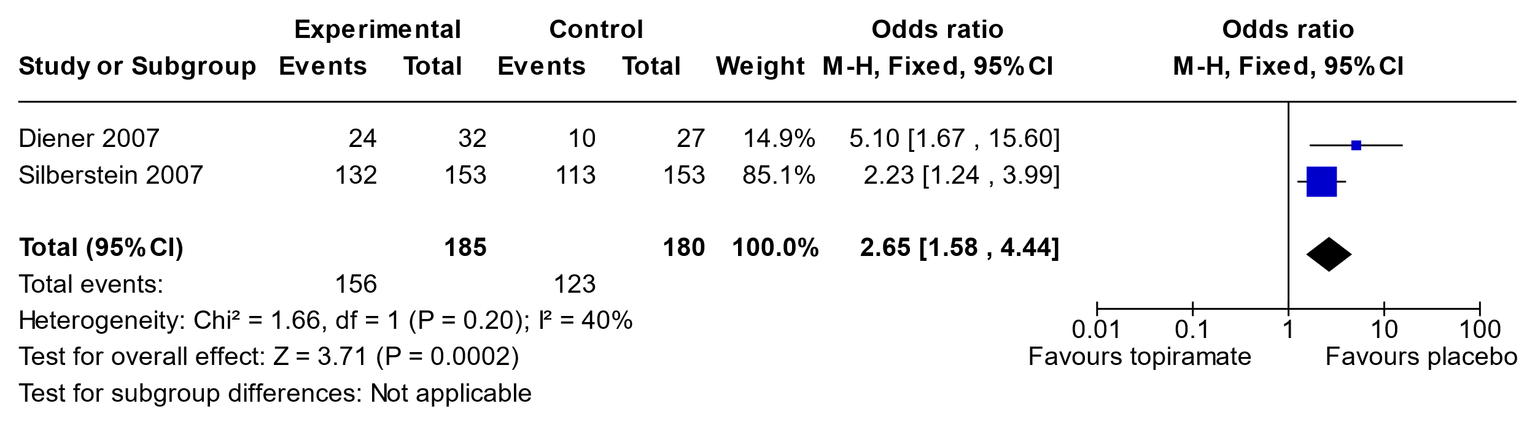

**Summary of findings table for Topiramate in Chronic Migraine**

**Question:** Topiramate compared to placebo for chronic migraine

**Setting:**

**Bibliography:**

| **Certainty assessment** | | | | | | | **№ of patients** | | **Effect** | | **Certainty** | **Importance** |
| --- | --- | --- | --- | --- | --- | --- | --- | --- | --- | --- | --- | --- |
| **№ of studies** | **Study design** | **Risk of bias** | **Inconsistency** | **Indirectness** | **Imprecision** | **Other considerations** | **topiramate** | **placebo** | **Relative (95% CI)** | **Absolute (95% CI)** |
| **Migraine day reduction (follow-up: mean 12 weeks; Scale from: -10 to 10)** | | | | | | | | | | | | |
| 2 | randomised trials | very seriousa | not serious | not serious | seriousb | none | 185 | 180 | - | MD **2.3 days lower** (4.1 lower to 0.5 lower) | ⨁◯◯◯ Very low |  |
| **50% Reduction Rate (follow-up: mean 12 weeks)** | | | | | | | | | | | | |
| 2 | randomised trials | very seriousa | not serious | not serious | seriousc | none | 64/185 (34.6%) | 44/180 (24.4%) | **OR 1.69** (1.07 to 2.68) | **11 more per 100** (from 1 more to 22 more) | ⨁◯◯◯ Very low |  |
| **Adverse Events (follow-up: mean 12 weeks)** | | | | | | | | | | | | |
| 2 | randomised trials | very seriousa | not serious | not serious | not serious | none | 156/185 (84.3%) | 123/180 (68.3%) | **OR 2.65** (1.58 to 4.44) | **17 more per 100** (from 9 more to 22 more) | ⨁⨁◯◯ Low |  |

**CI:** confidence interval; **MD:** mean difference; **OR:** odds ratio

#### Explanations

a. two studies with high ROB

b. At or close to 0.5 with confidence interval or MDR

c.. OR 95% confidence interval at 1.07 close to null

**3.14.1 Topiramate in Migraine**

**Migraine Day Reduction Topiramate Compared to Erenumab**

Compared to erenumab in Reuter et al 2022 study(69), migraine day reduction was less for topiramate.

MDR was 5.86 for erenumab and 4.02 for topiramate. The difference was 1.84 more headaches days with topiramate when compared to erenumab (95%CI 2.43 to 1.25).

50% Responder Rate Topiramate Compared to Erenumab and Amitriptyline

215/388 (55.4%) individuals responded to erenumab, versus 121/388 (31.2%)individuals responded to topiramate. This was an OR of 2.76 (2.06 to 3.71)

Adverse Events Topiramate Compared to Erenumab

315/388 (81.2%) individuals had side effects on topiramate, compared to 215/388 (55.4%) who started erenumab. This was an OR of 3.47 (2.51 to 4.80) of having side effects if on topiramate compared to erenumab.

It is also noted in study by Rodriguez-Leyva 2010 et al (70) that topiramate is significantly more likely to cause side effects when compared to amitriptyline.

**Summary of findings table for Topiramate in Migraine compared to CGRP modulation**

**Question:** Topiramate compared to other active for migraine

| **Certainty assessment** | | | | | | | **№ of patients** | | **Effect** | | **Certainty** | **Importance** |
| --- | --- | --- | --- | --- | --- | --- | --- | --- | --- | --- | --- | --- |
| **№ of studies** | **Study design** | **Risk of bias** | **Inconsistency** | **Indirectness** | **Imprecision** | **Other considerations** | **topiramate** | **other active** | **Relative (95% CI)** | **Absolute (95% CI)** |
| **Adverse events compared to erenumab, amitriptyline (follow-up: mean 12 weeks)** | | | | | | | | | | | | |
| 2 | randomised trials | seriousa | not serious | not serious | not serious | none |  |  | not estimable |  | ⨁⨁⨁◯ Moderate |  |
| **Migraine day reduction compared to erenumab** | | | | | | | | | | | | |
| 1 | randomised trials | not serious | not serious | not serious | not serious | none | 388 | 388 | - | MD **1.84 days higher** (2.43 higher to 1.25 higher) | ⨁⨁⨁⨁ High |  |
| **50% Responder rate compared to erenumab** | | | | | | | | | | | | |
| 1 | randomised trials | not serious | not serious | not serious | not serious | none | 121/388 (31.2%) | 215/388 (55.4%) | **OR 0.36** (0.27 to 0.49) | **25 fewer per 100** (from 30 fewer to 18 fewer) | ⨁⨁⨁⨁ High |  |

**CI:** confidence interval; **MD:** mean difference; **OR:** odds ratio

#### Explanations

a. one of two studies had high ROB

**3.15.1 Ginger in Episodic Migraine**

A single study was found Martins et al, 2020 (74).

**Migraine Day Reduction**

Was not significantly different as per study, figure but no numbers given.

**50% Responder Rate**

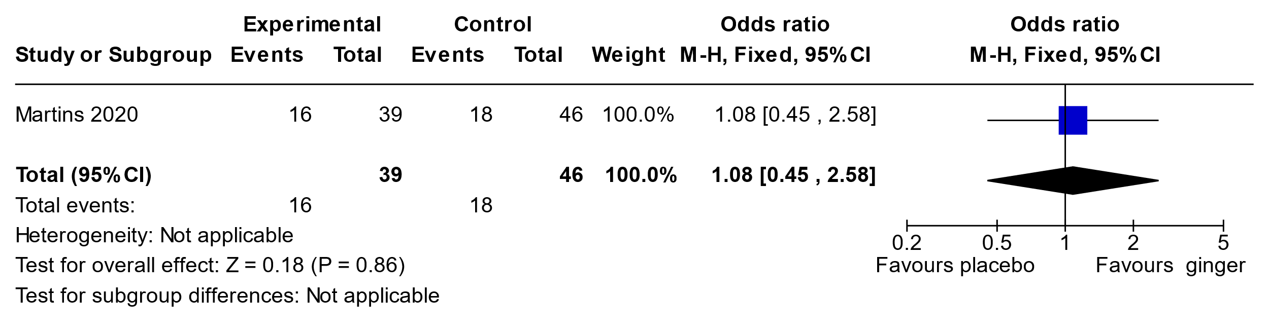

**Summary of findings table for Ginger in Episodic Migraine**

**Question:** Ginger compared to placebo for migraine prevention

| **Certainty assessment** | | | | | | | **№ of patients** | | **Effect** | | **Certainty** | **Importance** |
| --- | --- | --- | --- | --- | --- | --- | --- | --- | --- | --- | --- | --- |
| **№ of studies** | **Study design** | **Risk of bias** | **Inconsistency** | **Indirectness** | **Imprecision** | **Other considerations** | **ginger** | **placebo** | **Relative (95% CI)** | **Absolute (95% CI)** |
| **MDR** | | | | | | | | | | | | |
| 1 | randomised trials | not serious | not serious | not serious | not serious | none |  |  | not estimable |  | ⨁⨁⨁⨁ High |  |
| **50% RR** | | | | | | | | | | | | |
| 1 | randomised trials | not serious | not serious | not serious | not serious | none |  |  | not estimable |  | ⨁⨁⨁⨁ High |  |

**I:** confidence interval

**3.16.1 Melatonin in Episodic Migraine**

Two studies against placebo were found, Alstadhaug et al 2010 (75) (low ROB) used 2 mg melatonin, Goncalves et al 2016 (76) (high ROB) used 3 mg melatonin.

**Migraine Day Reduction**

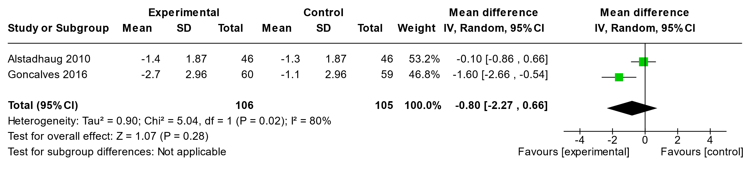

50% Responder Rate

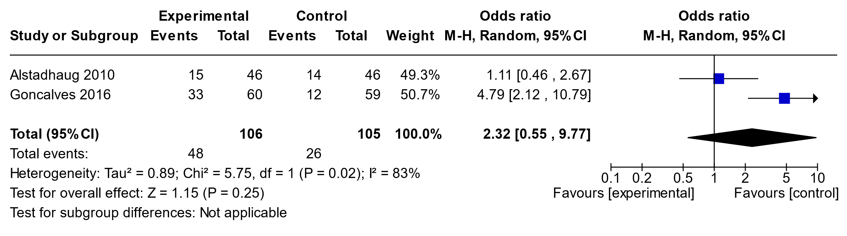

Adverse Events

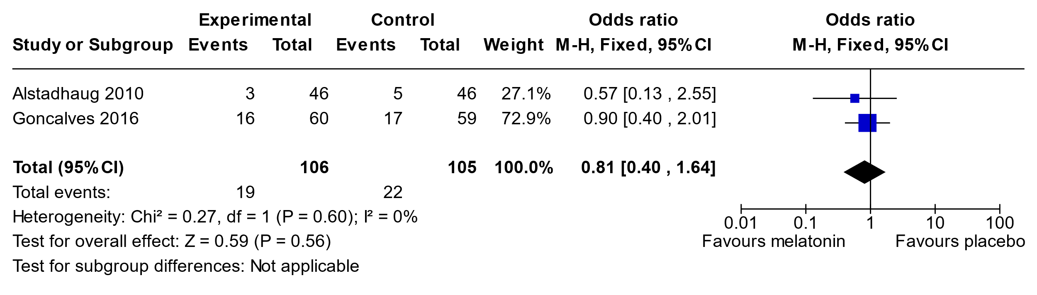

**Summary of findings table for Melatonin in Episodic Migraine**

**Question:** Melatonin compared to placebo for migriane prevention

| **Certainty assessment** | | | | | | | **№ of patients** | | **Effect** | | **Certainty** | **Importance** |
| --- | --- | --- | --- | --- | --- | --- | --- | --- | --- | --- | --- | --- |
| **№ of studies** | **Study design** | **Risk of bias** | **Inconsistency** | **Indirectness** | **Imprecision** | **Other considerations** | **melatonin** | **placebo** | **Relative (95% CI)** | **Absolute (95% CI)** |
| **Migraine Day Reduction** | | | | | | | | | | | | |
| 2 | randomised trials | seriousa | seriousb | not serious | seriousc | none | 106 | 105 | - | MD **0.8 days lower** (2.27 lower to 0.66 higher) | ⨁◯◯◯ Very low |  |
| **50% Responder Rate (follow-up: mean 12 weeks)** | | | | | | | | | | | | |
| 2 | randomised trials | seriousa | very seriousb | not serious | seriousc | none | 48/106 (45.3%) | 26/105 (24.8%) | **OR 2.32** (0.55 to 9.77) | **19 more per 100** (from 9 fewer to 52 more) | ⨁◯◯◯ Very low |  |
| **Adverse Events** | | | | | | | | | | | | |
| 2 | randomised trials | seriousa | not serious | not serious | not serious | none | 19/106 (17.9%) | 22/105 (21.0%) | **OR 0.81** (0.40 to 1.64) | **3 fewer per 100** (from 11 fewer to 9 more) | ⨁⨁⨁◯ Moderate |  |

**CI:** confidence interval; **MD:** mean difference; **OR:** odds ratio

#### Explanations

a. 1/2 studies high ROB, other study low

b. P=0.02 for heterogeneity and I2 >=80%

c. OR through null and wide confidence intervals

**3.17.1 Memantine in Episodic Migraine**

There were two studies looking at this question.

Noruzzadeh et al, 2016 (77) (low ROB)

Sahmugam et al, 2019 (78) (low ROB)

**Migraine Day Reduction**

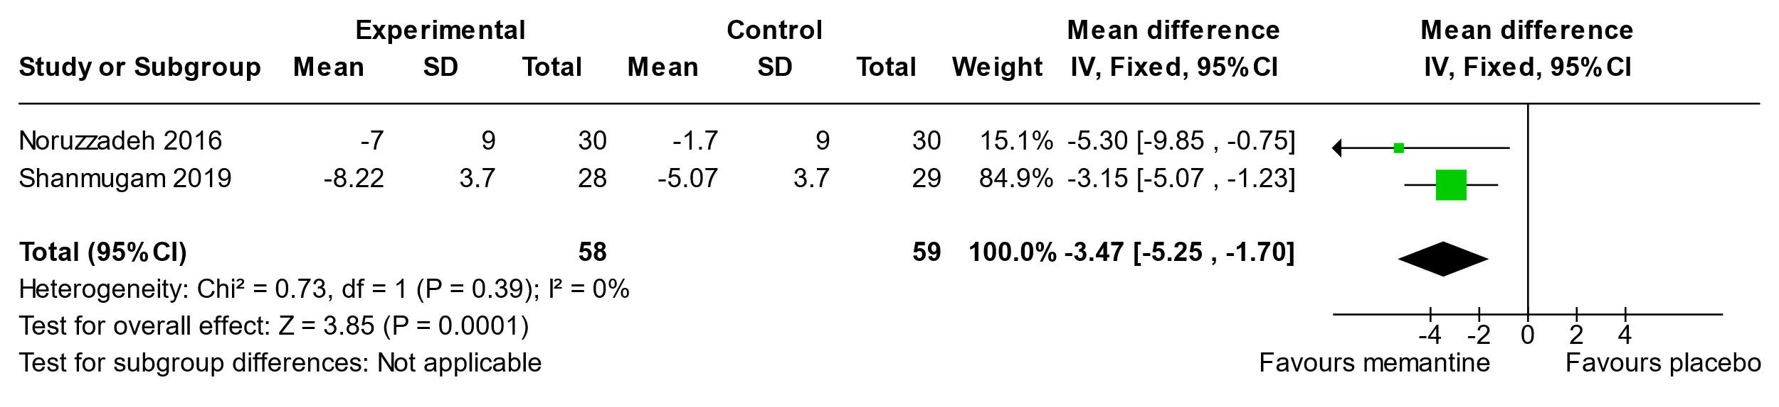

**50% Responder Rate**

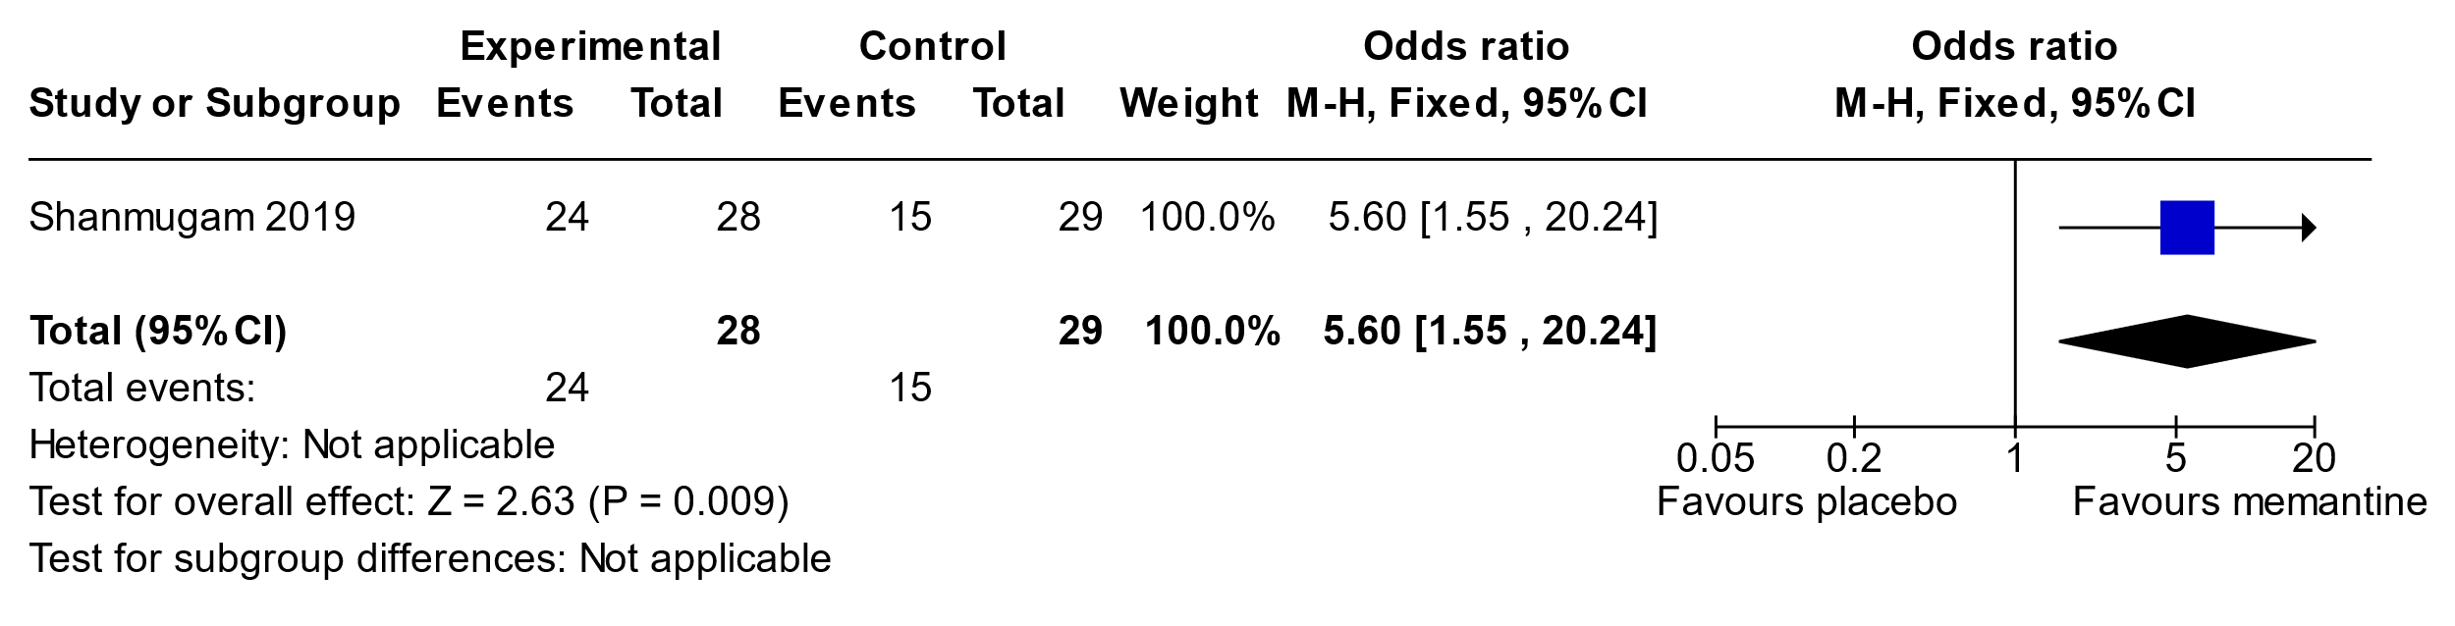

**Adverse Events**

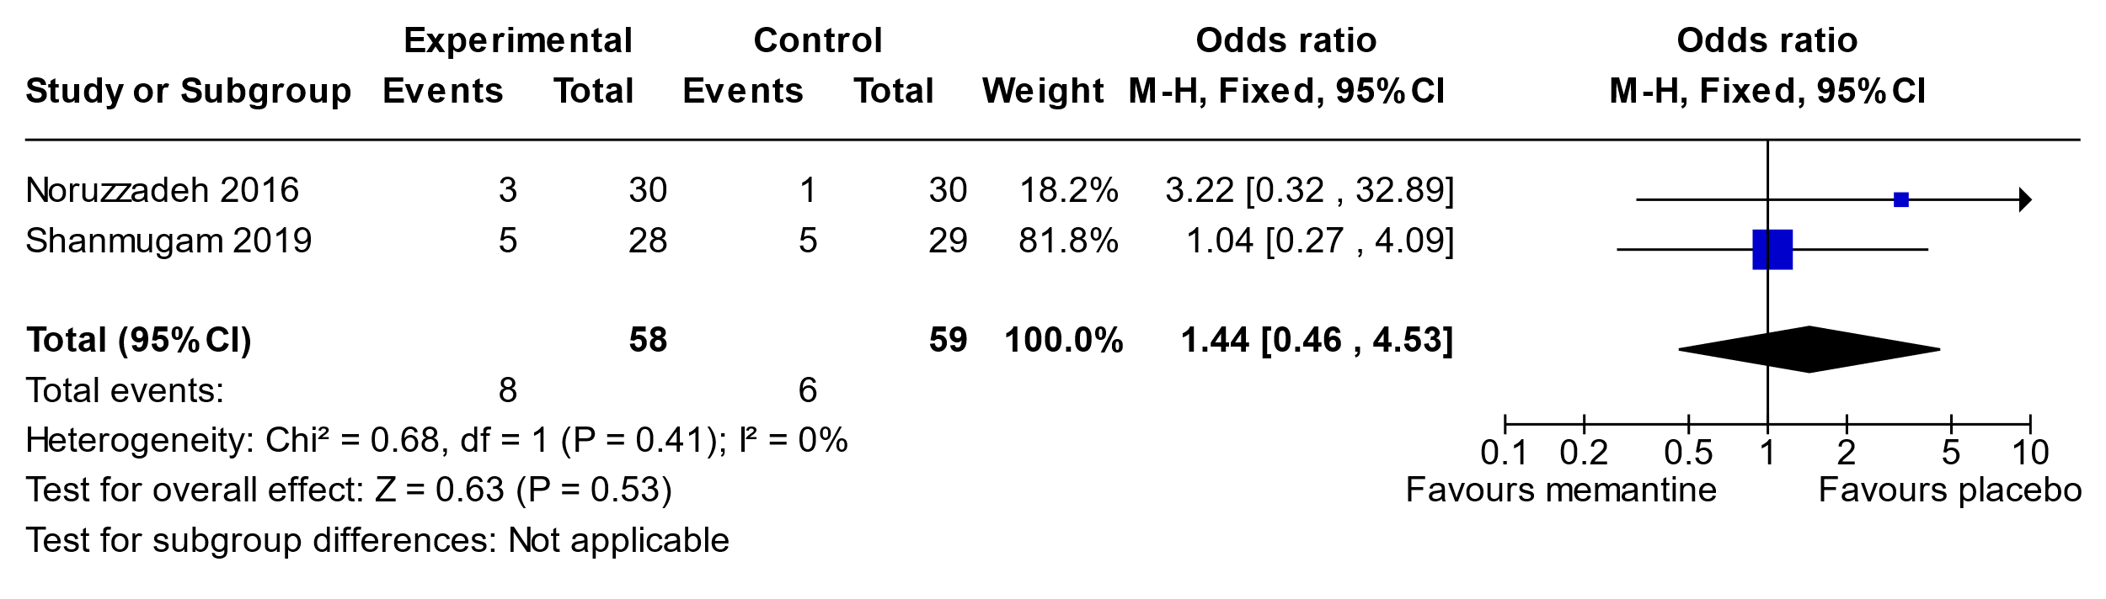

**Summary of findings table for Memantine in Episodic Migraine**

**Question:** Mementine compared to placebo for episodic migraine

| **Certainty assessment** | | | | | | | **№ of patients** | | **Effect** | | **Certainty** | **Importance** |
| --- | --- | --- | --- | --- | --- | --- | --- | --- | --- | --- | --- | --- |
| **№ of studies** | **Study design** | **Risk of bias** | **Inconsistency** | **Indirectness** | **Imprecision** | **Other considerations** | **mementine** | **placebo** | **Relative (95% CI)** | **Absolute (95% CI)** |
| **Migraine day reduction** | | | | | | | | | | | | |
| 2 | randomised trials | not serious | not serious | not serious | none | none | 58 | 59 | - | MD **3.47 days lower** (5.25 lower to 1.7 lower) | ⨁⨁⨁⨁  High |  |
| **50% responder rate** | | | | | | | | | | | | |
| 1 | randomised trials | not serious | not serious | not serious | seriousa | none | 24/28 (85.7%) | 15/29 (51.7%) | **OR 5.60** (1.55 to 20.24) | **34 more per 100** (from 11 more to 44 more) | ⨁⨁⨁◯ Moderate |  |
| **Adverse events** | | | | | | | | | | | | |
| 2 | randomised trials | not serious | not serious | not serious | seriousa | none | 8/58 (13.8%) | 6/59 (10.2%) | **OR 1.44** (0.46 to 4.53) | **4 more per 100** (from 5 fewer to 24 more) | ⨁⨁⨁◯ Moderate |  |

**CI:** confidence interval; **MD:** mean difference; **OR:** odds ratio

#### Explanations

a. small study size

**3.18.1 Statin Add On (with other active) For Prevention in Episodic Migraine**

We identified two studies with statin add on for prevention of migraine

1. Ganji et al, 2021 (79) where atorvastatin or placebo was added to valproate
2. Mazdeh et al, 2020 (80)where rosuvastatin or placebo was added to propranolol

**Migraine Day Reduction**

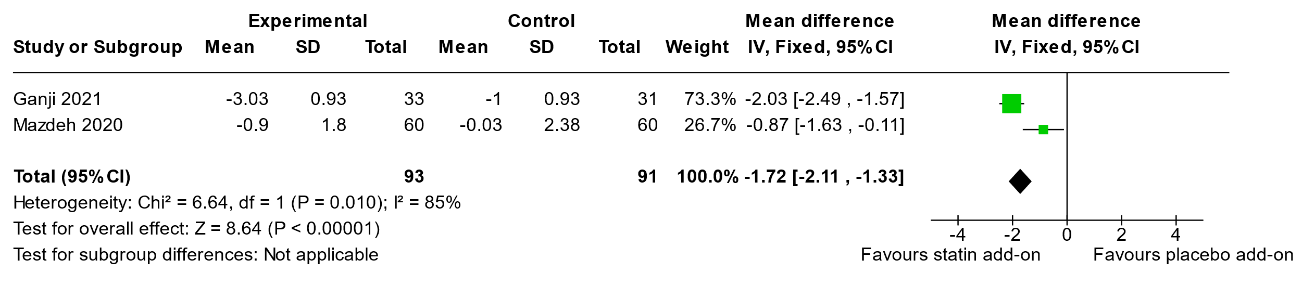

**50% Responder Rate and Adverse Events were not reported in these studies.**

**Summary of findings table for Add on Statin (atorvastatin or rosuvastatin) in Episodic Migraine**

**Question:** Add on statin compared to monotherapy for migraine prevention

| **Certainty assessment** | | | | | | | **№ of patients** | | **Effect** | | **Certainty** | **Importance** |
| --- | --- | --- | --- | --- | --- | --- | --- | --- | --- | --- | --- | --- |
| **№ of studies** | **Study design** | **Risk of bias** | **Inconsistency** | **Indirectness** | **Imprecision** | **Other considerations** | **add on statin** | **monotherapy** | **Relative (95% CI)** | **Absolute (95% CI)** |
| **Migraine day reduction** | | | | | | | | | | | | |
| 2 | randomised trials | not serious | very seriousa | not serious | not serious | none | 93 | 91 | - | **0**  (0 to 0 ) | ⨁⨁◯◯ Low |  |

**CI:** confidence interval

#### Explanations

a. I2>80% and P=0.01

**3.19.2 Statin (Atorvastatin or Simvastatin) in Episodic Migraine**

There were two studies looking at this question.

Hesami et al 2018 (82) (high ROB) compared atorvastatin 40 mg with valproate 500 mg oral.

Buettner et al 2015 (81) (low ROB) compared simvastatin 20 mg BID with placebo.

**Migraine Day Reduction**

Buettner et al, 2015 showed reduction of 2.67/mo in simvastatin as compared to increase 0.33/mo for placebo, for a 3 day difference in MDR.

**50% Responder Rate**

Buettner et al, 2015 showed that 8/28 (29%) in simvastatin group responded, and 1/29 (3%) were responders in placebo group.

Hesami et al, 2018 showed 30/46 (65%) responded to atorvastatin at 3 mo, and 26/36 responded to valproate at 3mo. There was no difference between groups, p=0.49

**Adverse Events**

Beuttner et al, 2015 had 2/28 (7%) with side effects in treatment group, less than 6/29 (21%) in placebo group.

**Summary of findings table for Statin in Episodic Migraine**

**Question:** Statin compared to placebo/active for migraine prevention

| **Certainty assessment** | | | | | | | **№ of patients** | | **Effect** | | **Certainty** | **Importance** |
| --- | --- | --- | --- | --- | --- | --- | --- | --- | --- | --- | --- | --- |
| **№ of studies** | **Study design** | **Risk of bias** | **Inconsistency** | **Indirectness** | **Imprecision** | **Other considerations** | **statin** | **placebo** | **Relative (95% CI)** | **Absolute (95% CI)** |
| **Migraine day reduction** | | | | | | | | | | | | |
| 2 | randomised trials | seriousa | seriousb | not serious | seriousc | none |  |  | - | **0**  (0 to 0 ) | ⨁◯◯◯ Very low |  |
| **50% responder rate** | | | | | | | | | | | | |
| 2 | randomised trials | seriousa | seriousd | not serious | seriousc | none |  |  | not estimable |  | ⨁◯◯◯ Very low |  |
| **Adverse Events** | | | | | | | | | | | | |
| 1 | randomised trials | not serious | not serious | not serious | seriousc | none |  |  | not estimable |  | ⨁⨁⨁◯ Moderate |  |

**CI:** confidence interval

#### Explanations

a. 1 high ROB and 1 low ROB study

b. Different effect size between studies

c. small study size

d. very different 50% rr between two studie