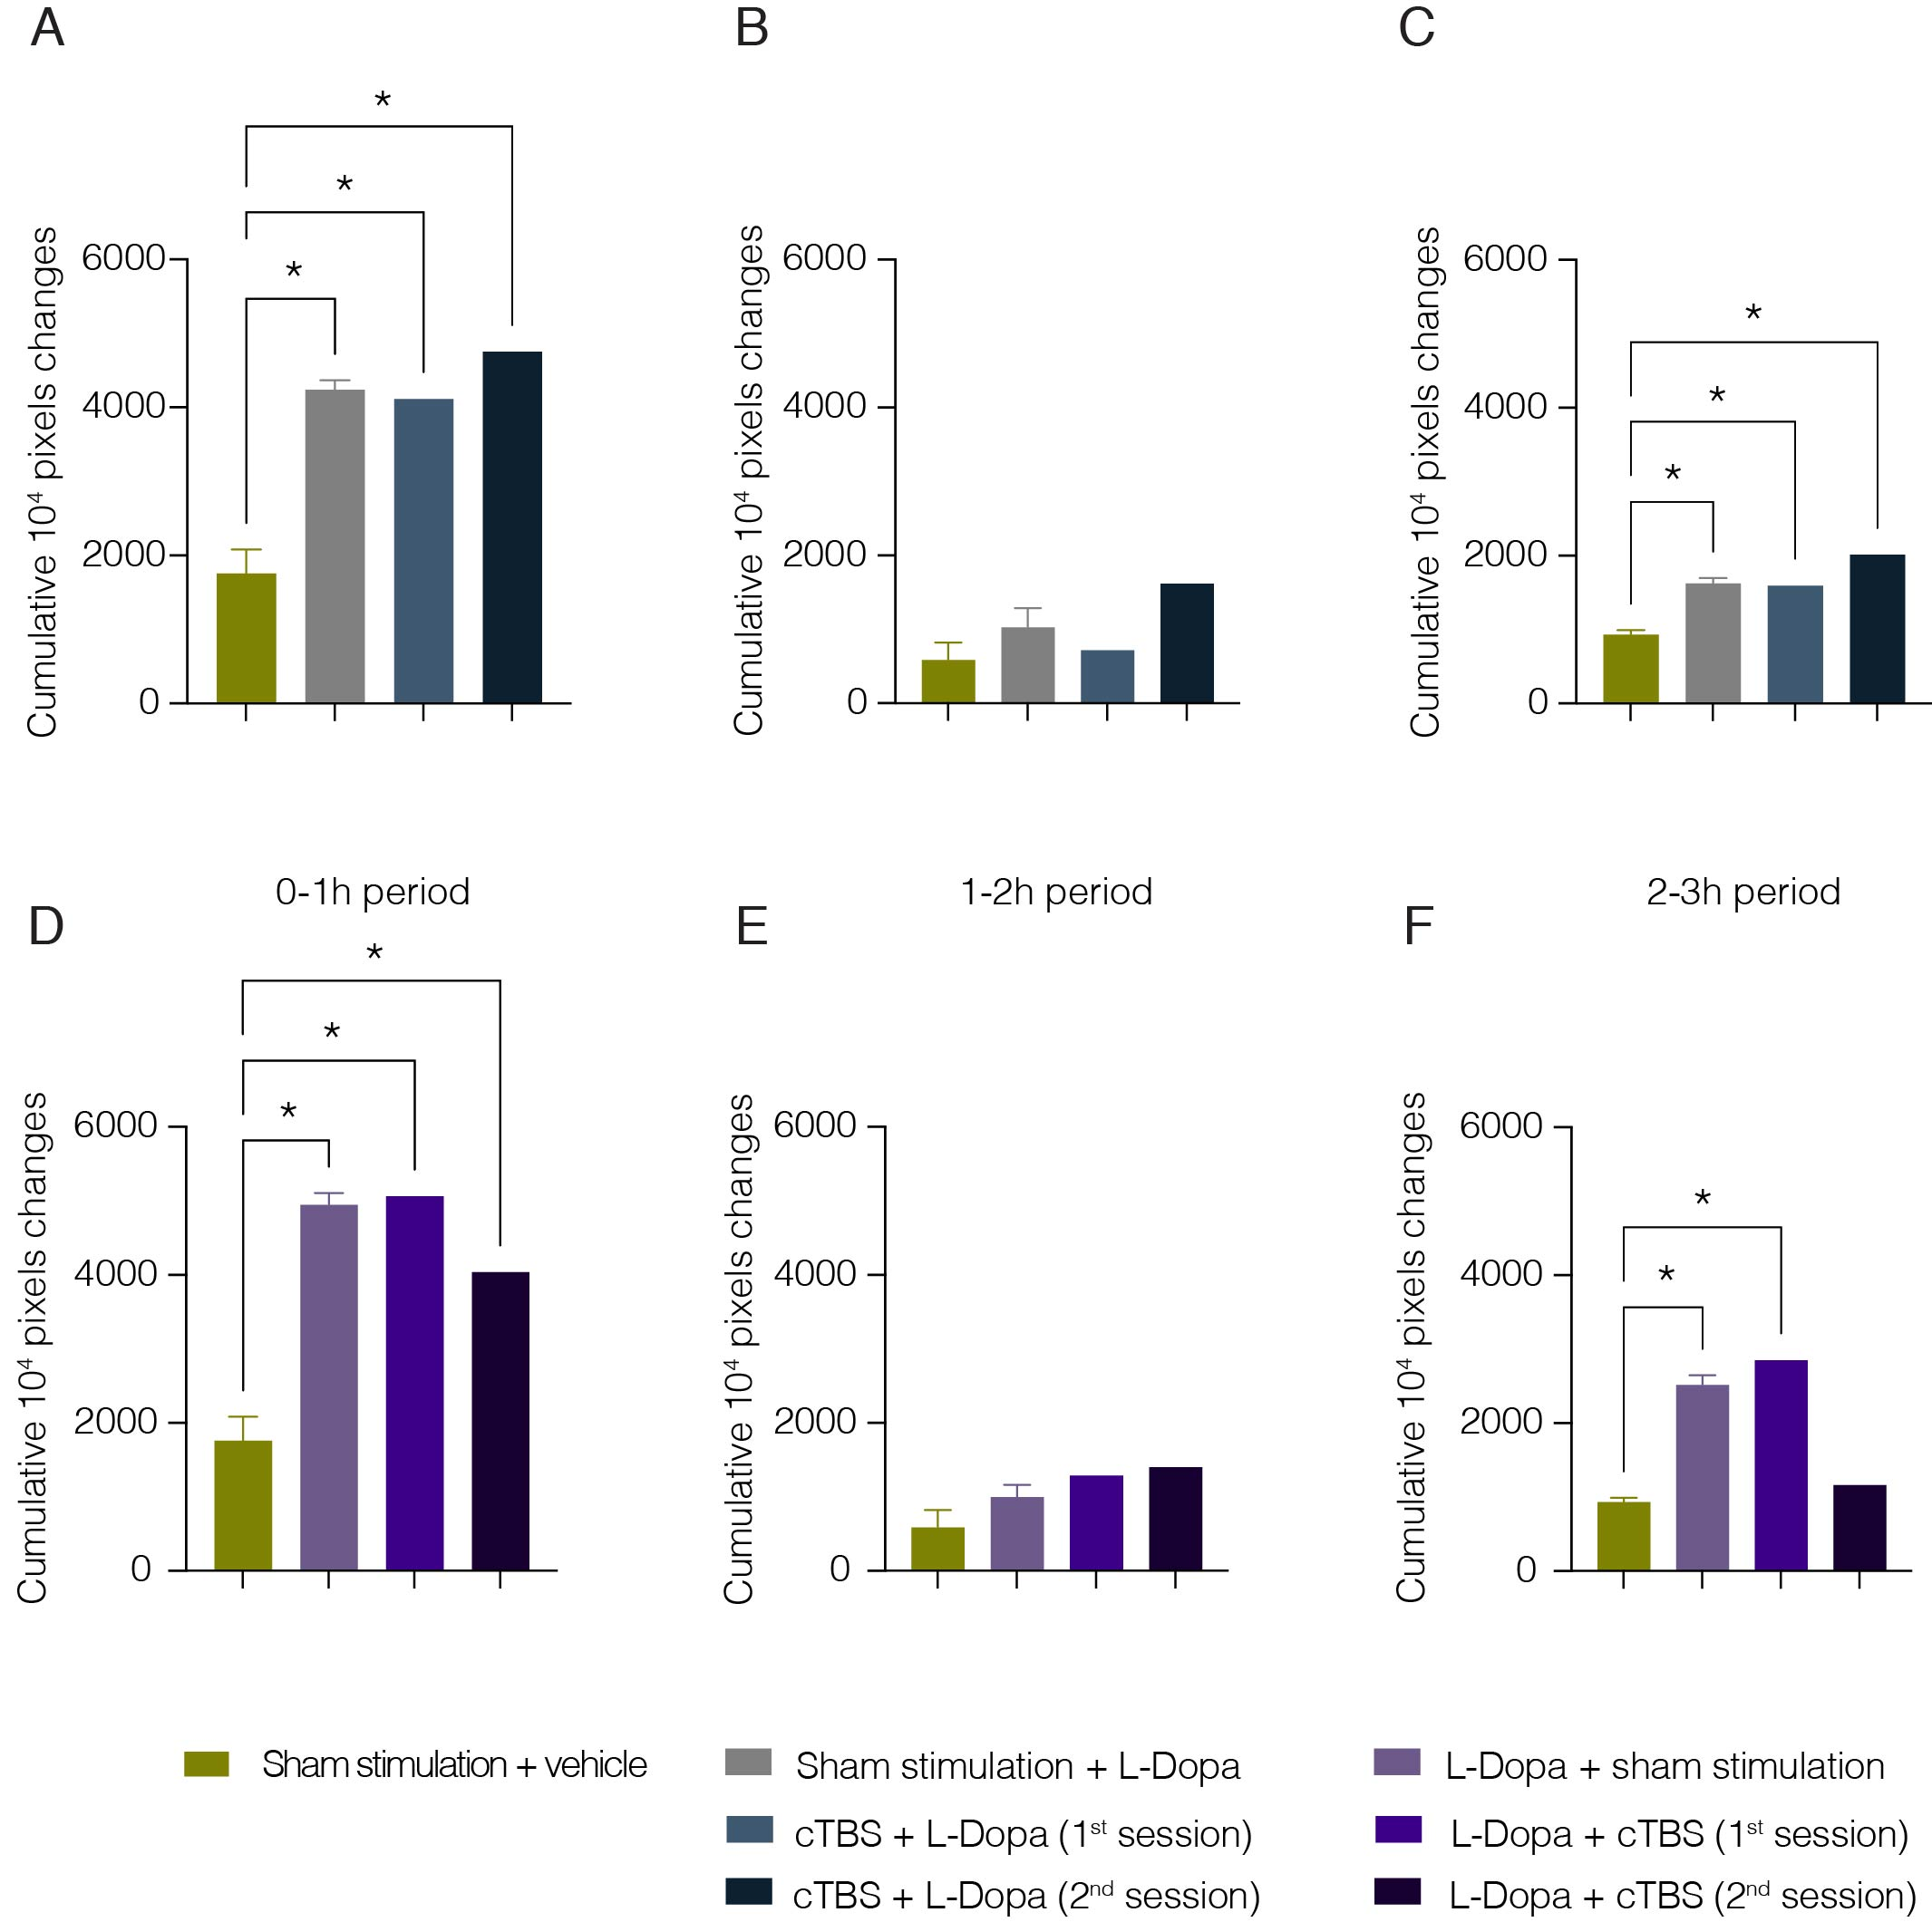

**Supplementary Figure 1 Global motor activity of cTBS with L-Dopa administered after or before stimulation.** A-F: Cumulative global motor activity over 0-1, 1-2 and 2-3h time periods with L-Dopa administration (after and before) and cTBS and Sham stimulation, Data presented are for Monkey 5 as the means and standard error of the mean (SEM) *P<0.05.