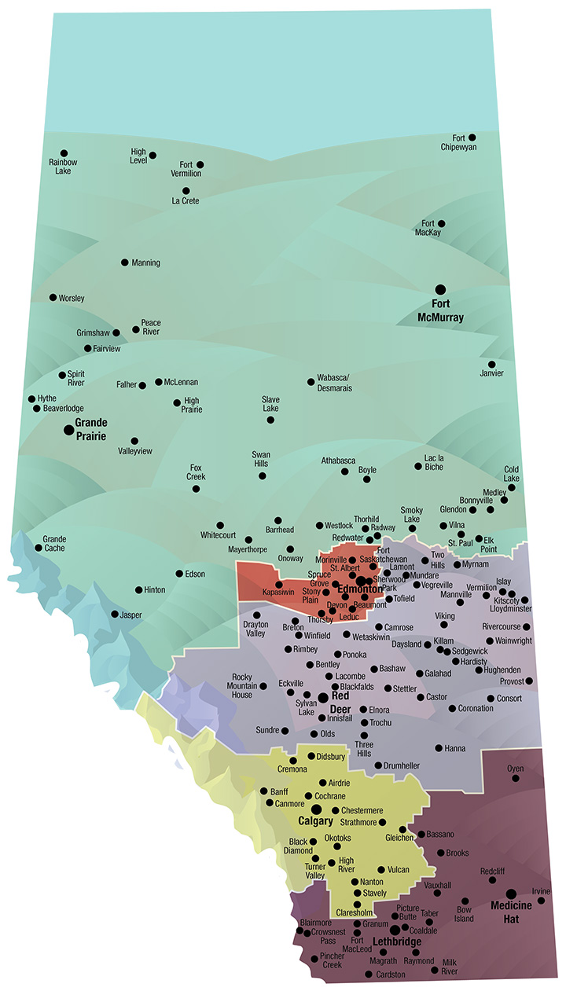

Supplementary Figure 1. Alberta Health Services health zone map. Figure legend: blue/green = North zone, red = Edmonton zone, purple = Central Zone, yellow = Calgary zone, brown = South zone. Reproduced with permission from Alberta Health Services.
Supplementary Table 1. Diagnostic codes of multiple sclerosis-related demyelinating disease of the central nervous system.
Disease or condition | ICD-9-CM | ICD-10-CA
Neuromyelitis optica | 341 | G36.0
Demyelinating disease of unspecified origin | 341.9 | G37.8
Acute disseminated encephalomyelitis | 323 | G36.9
Acute transverse myelitis | 323.82 | G37
Optic neuritis | 377.3 | H46
Abbreviations: International Classification of Disease – Version 9 – Clinical Modification: ICD-9-CM; International Classification of Disease – Version 10 – Canadian Enhancement: ICD-10-CA.

