Supplementary Table 1. Case definitions of pharmacotherapy treatments for spasticity.

|  |  |  |  |
| --- | --- | --- | --- |
|  | Drug Name | Route of Administration | Drug Identification Number |
| ***Tizanidine, baclofen, dantrolene*** | | | |
| *An outpatient community pharmacy dispensation (identified by the drug identification number in the PIN database) for one of the following anti-spastic medications:* | | | |
|  | Tizanidine | oral | 02272059, 02239170, 02259885, 02259893 |
|  | Baclofen | oral; injection; intrathecal | 02139332, 02139391, 02287021, 02287048, 02152584, 02152592, 00636576, 00455881, 02088398, 02088401, 02088401, 02063735, 02063743, 02242150, 02242151, 02138271, 02138298, 02244644, 02244645, 02442140, 02442159, 02371413, 02371421, 02136090, 02136104, 02147556, 02147564, 02230033, 02230034, 02238445, 02238446, 02084449, 02084457, 02229936, 02229937, 02236963, 02236964, 02236507, 02236508, 02239075, 02239076; 02413620, 02413639, 02413647, 02457059, 02457067, 02457075; 02485494, 02485508, 02485516, 02131048, 02131056, 02131064 |
|  | Dantrolene | oral | 00452521, 00452513, 01997602, 01997653 |
|  |  |  |  |
| ***Chemo-denervation*** | |  |  |
| *A health service procedure code (13.59K) for the injection of botulinum A toxin for the treatment of spasticity due to upper motor neuron injury or disease (from the Physician Claims database) OR an outpatient community pharmacy dispensation for botulinum toxin indicated for therapeutic use (identified by the drug identification number in the PIN database) and no health service procedure code for the injection of botulinum toxin for other conditions (procedure codes 13.59E, 13.59F, 13.59L, 13.59N, 13.59O, 23.99D, 43.0A, 43.0B) occurring on or within 7-days after the dispensation.* | | | |
|  | Botulinum toxin | injection | 01981501, 02456117, 02460203, 02324032, 02371081 |
|  |  |  |  |
| ***Phenol/alcohol nerve block injections*** | | |  |
| Phenol/alcohol nerve block injections were not included in drug treatments for spasticity. In Alberta, phenol/alcohol nerve block injections are not used in the contemporary era of spasticity treatment, and there is no reliable administrative-based method for identification of this treatment. | | | |

Abbreviations: PIN = Pharmaceutical Information Network.Supplementary Table 2. Diseases, and their associated codes and weights included in the Charlson Comorbidity Index.

| Disease | ICD-9-CM codes | ICD-10-CA codes | Weight |
| --- | --- | --- | --- |
| Myocardial infarction | 410, 412 | I21, I22, I25.2 | 1 |
| Congestive heart failure | 398, 402, 425, 428 | I09.9, I11.0, I13.0, I13.2, I25.5, I42.0, I42.5, I42.6, I42.7, I42.8, I42.9, I43, I50, P29.0 | 1 |
| Peripheral vascular disease | 440, 441, 443, 447, 557 | I70, I71, I73.1, I73.8, I73.9, I77.1, I79.0, I79.2, K55.1, K55.8, K55.9, Z95.8, Z95.9 | 1 |
| Cerebrovascular disease | 430, 431, 432, 433, 434, 435, 436, 437, 438 | G45, G46, I60, I61, I62, I63, I64, I65, I66, I67, I68, I69, H34.0 | 1 |
| Dementia | 290, 294, 331 | F00, F01, F02, F03, G30, F05.1, G31.1 | 1 |
| Chronic pulmonary disease | 416, 490, 491, 492, 493, 494, 495, 496, 500, 501, 502, 503, 504, 505 | J40, J41, J42, J43, J44, J45, J46, J47, J60, J61, J62, J63, J64, J65, J66, J67, I27.8, I27.9, J68.4, J70.1, J70.3 | 1 |
| Connective tissue disease | 446, 710, 714, 725 | M05, M32, M33, M34, M06, M31.5, M35.1, M35.3, M36.0 | 1 |
| Peptic ulcer disease | 531, 532, 533, 534 | K25, K26, K27, K28 | 1 |
| Mild liver disease | 070, 570, 571, 573 | B18, K73, K74, K70.0, K70.1, K70.2, K70.3, K70.9, K71.7, K71.3, K71.4, K71.5, K76.0, K76.2, K76.3, K76.4, K76.8, K76.9, Z94.4 | 1 |
| Moderate/severe liver disease | 456, 572 | K70.4, K71.1, K72.1, K72.9, K76.5, K76.6, K76.7, I85.0, I85.9, I86.4, I98.2 | 3 |
| Diabetes (without complication) | 250 | E10.0, E10.l, E10.6, E10.8, E10.9, E11.0, E11.1, E11.6, E11.8, E11.9, E12.0, E12.1, E12.6, E12.8, E12.9, E13.0, E13.1, E13.6, E13.8, E13.9, E14.0, E14.1, E14.6, E14.8, E14.9 | 1 |
| Diabetes (with complication) | 250 | E10.2, E10.3, E10.4, E10.5, E10.7, E11.2, E11.3, E11.4, E11.5, E11.7, E12.2, E12.3, E12.4, E12.5, E12.7, E13.2, E13.3, E13.4, E13.5, E13.7, E14.2, E14.3, E14.4, E14.5, E14.7 | 2 |
| Hemiplegia and paraplegia | 334, 342, 343, 344 | G81, G82, G04.1, G11.4, G80.1, G80.2, G83.0, G83.1, G83.2, G83.3, G83.4, G83.9 | 2 |
| Moderate or severe renal disease | 403, 582, 583, 585, 586, 588, V56 | N18, N19, N05.2, N05.3, N05.4, N05.5, N05.6, N05.7, N25.0, I12.0, I13.1, N03.2, N03.3, N03.4, N03.5, N03.6, N03.7, Z49.0, Z49.1, Z49.2, Z94.0, Z99.2 | 2 |
| Cancer | 140-165, 170-172, 174-176, 179-195, 200- 208, 238 | C00-C26, C30-C34, C37-C41, C43, C45-C58, C60-C76, C81-C85, C88, C90- C97 | 2 |
| Metastatic Carcinoma | 196, 197, 198, 199 | C77, C78, C79, C80 | 6 |
| HIV/AIDS | 042, 043, 044 | B20, B21, B22, B24 | 6 |

To be considered as having one of the listed diseases, an individual must have had ≥1 hospitalization (associated ICD-10-CA code listed in any diagnostic field) or ≥2 physician claims (associated ICD-9-CM codes listed in any diagnostic field) of the corresponding ICD within ≤2-years. Abbreviations: HIV/AIDS = Human immunodeficiency virus / acquired immunodeficiency syndrome; ICD-9-CM = International classification of diseases, ninth revision, clinical modification; ICD-10-CA = International classification of diseases, tenth revision, Canadian enhancement.

Supplementary Table 3. Case definitions used to identify common conditions other than stroke that cause spasticity.

| Disease | ICD-9-CM codes | ICD-10-CA codes | Algorithm |
| --- | --- | --- | --- |
| Traumatic brain injury |  | F07.2, S02.0-S02.3, S02.7-S02.9, S06, S07.1, T90.2, T90.5 | Any emergency department visit or hospitalization |
| Spinal cord injury |  | S14.0, S14.1, S24.0, S24.1, S34.1, S34.3, T91.3 | Any emergency department visit or hospitalization |
| Myelopathy |  | G95.1 | Any hospitalization |
| Multiple sclerosis | 340 | G35 | 1 hospitalization or 5 physician claims within 2 years |
| Transverse myelitis |  | G37.3 | Any hospitalization |

Cerebral palsy and hereditary spastic paraparesis can cause spasticity, but are pre-existing conditions and therefore are not considered to develop after a stroke. Case finding algorithms were applied between the index stroke event and initiation of PSS. Abbreviations: ICD-9-CM = International Classification of Diseases, Ninth Revision – Clinical Modification; ICD-10-CA = International Classification of Diseases, Tenth Revision – Canadian Enhancement.

Supplementary Table 4. Characteristics of those who received post-stroke spasticity treatment according to critical timepoints after stroke.

|  |  |  |  |  |  |
| --- | --- | --- | --- | --- | --- |
|  | **PSS treatment group** | | | | |
|  | Time to spasticity treatment initiation after the index stoke event | | | | |
|  | *<3 months* | *3-6 months* | *6-12 months* | *12-36 months* | *>36 months\** |
|  | *(N = 201)* | *(N = 198)* | *(N = 211)* | *(N = 314)* | *(N = 155)* |
| ***Baseline demographic characteristics*** |  |  |  |  |  |
| Age on index (years) |  |  |  |  |  |
| Mean (SD) | 61 (15) | 62 (14) | 61 (14) | 62 (15) | 61 (16) |
| Median (IQR) | 61 (17) | 63.5 (18) | 61 (19) | 62 (19) | 61 (22) |
| Age (years), n (%) |  |  |  |  |  |
| 18-29 | <10 (NA) | <10 (NA) | <10 (NA) | <10 (NA) | <10 (NA) |
| 30-39 | 17 (8.5) | <10 (NA) | 11 (5.2) | 13 (4.1) | 14 (9.0) |
| 40-49 | 25 (12.4) | 24 (12.1) | 23 (10.9) | 49 (15.6) | 15 (9.7) |
| 50-59 | 47 (23.4) | 50 (25.3) | 56 (26.5) | 65 (20.7) | 40 (25.8) |
| 60-69 | 58 (28.9) | 49 (24.8) | 55 (26.1) | 86 (27.4) | 34 (21.9) |
| 70-79 | 28 (13.9) | 40 (20.2) | 43 (20.4) | 60 (19.1) | 28 (18.1) |
| 80-89 | 16 (8.0) | 17 (8.6) | 17 (8.1) | 32 (10.2) | 20 (12.9) |
| 90+ | <10 (NA) | <10 (NA) | <10 (NA) | <10 (NA) | <10 (NA) |
| Sex: n (%) |  |  |  |  |  |
| Female | 97 (48.3) | 101 (51.0) | 97 (46.0) | 144 (45.9) | 78 (50.3) |
| Male | 104 (51.7) | 97 (49.0) | 114 (54.0) | 170 (54.1) | 77 (49.7) |
| Residence location, n (%) |  |  |  |  |  |
| Urban | 182 (90.6) | 174 (87.9) | 189 (89.6) | 277 (88.2) | 134 (86.5) |
| Rural | 19 (9.5) | 24 (12.1) | 22 (10.4) | 37 (11.8) | 21 (13.6) |
| ***Baseline Charlson Comorbidity Index*** |  |  |  |  |  |
| Score |  |  |  |  |  |
| Mean (SD) | 1.1 (1.7) | 1.1 (1.8) | 1.3 (2.0) | 1.3 (1.9) | 1.2 (1.6) |
| Median (IQR) | 0 (1) | 0 (2) | 1 (2) | 1 (2) | 1 (2) |
| Category, n (%) |  |  |  |  |  |
| CCI = 0 or no comorbid condition | 105 (52.2) | 110 (55.6) | 103 (48.8) | 142 (45.2) | 76 (49.0) |
| CCI = 1-2 or mild comorbidity | 66 (32.8) | 63 (31.8) | 71 (33.7) | 116 (36.9) | 54 (34.8) |
| CCI = 3-4 or moderate comorbidity | 18 (9.0) | 14 (7.1) | 19 (9.0) | 35 (11.2) | 14 (9.0) |
| CCI ≥5 or severe comorbidity | 12 (6.0) | 11 (5.6) | 18 (8.5) | 21 (6.7) | 11 (7.1) |
| ***Stroke*** |  |  |  |  |  |
| Previous stroke, n (%) |  |  |  |  |  |
| Experienced a previous stroke | 31 (15.4) | 28 (14.1) | 32 (15.2) | 30 (9.6) | 26 (16.8) |
| Index stroke, n (%) |  |  |  |  |  |
| Ischemic stroke | 144 (71.6) | 151 (76.3) | 176 (83.4) | 269 (85.7) | 135 (87.1) |
| Hemorrhagic stroke | 57 (28.4) | 47 (23.7) | 35 (16.6) | 45 (14.3) | 20 (12.9) |
| Subsequent stroke, n (%) |  |  |  |  |  |
| Experienced ≥1 subsequent stroke | 12 (6.0) | 14 (7.1) | <10 (NA) | 12 (3.8) | <10 (NA) |
| Days to earliest recurrent stroke, median (IQR) | 127 (256) | 443 (644) | 783 (1002) | 1150 (901) | 2190 (570) |
| Experienced ≥2 subsequent strokes | <10 (NA) | <10 (NA) | <10 (NA) | 0 (0) | 0 (0) |
| ***Mortality*** |  |  |  |  |  |
| Died after the index stroke, n (%) |  |  |  |  |  |
| Within 3-years after the index stoke event | 27 (13.4) | 25 (12.6) | 31 (14.7) | 23 (7.3) | 0 (0) |
| Up to March 31, 2020 | 44 (21.9) | 49 (24.8) | 56 (26.5) | 59 (18.8) | 25 (16.1) |
| Days to death, median (IQR) | 596 (1034) | 1078 (1006) | 1007 (1098) | 1242 (966) | 1874 (825) |

*The maximum number of years forward in time that any given individual(s) initiated spasticity treatment was 7-years. Abbreviations: CCI = Charlson Comorbidity Index; IQR = interquartile range; NA = not applicable; PSS = post-stroke spasticity; SD = standard deviation.

Supplementary Table 5. Pathway of care setting an individual was residing when post-stroke spasticity treatment was initiated.

|  |  |  |  |  |  |
| --- | --- | --- | --- | --- | --- |
|  | **PSS treatment group** | | | | |
|  | Time to spasticity treatment initiation after the index stoke event | | | | |
|  | *<3 months* | *3-6 months* | *6-12 months* | *12-36 months* | *>36 months\** |
|  | *(N = 201)* | *(N = 198)* | *(N = 211)* | *(N = 314)* | *(N = 155)* |
| Home, n (%) | 44 (21.9) | 64 (32.3) | 110 (52.1) | 181 (57.6) | 85 (54.8) |
| Long-term care, n (%) | 18 (9.0) | 27 (13.6) | 30 (14.2) | 33 (10.5) | <10 (NA) |
| Inpatient rehabilitation, n (%) | 82 (40.8) | 69 (34.9) | 25 (11.9) | 16 (5.1) | <10 (NA) |
| Acute inpatient care, n (%) | 20 (10.0) | <10 (NA) | <10 (NA) | <10 (NA) | <10 (NA) |
| Other, n (%) | 37 (18.4) | 30 (15.1) | 39 (18.5) | 80 (25.5) | 53 (34.2) |

*The maximum number of years forward in time that any given individual(s) initiated spasticity treatment was 7-years. Abbreviations: NA = not applicable; PSS = post-stroke spasticity.

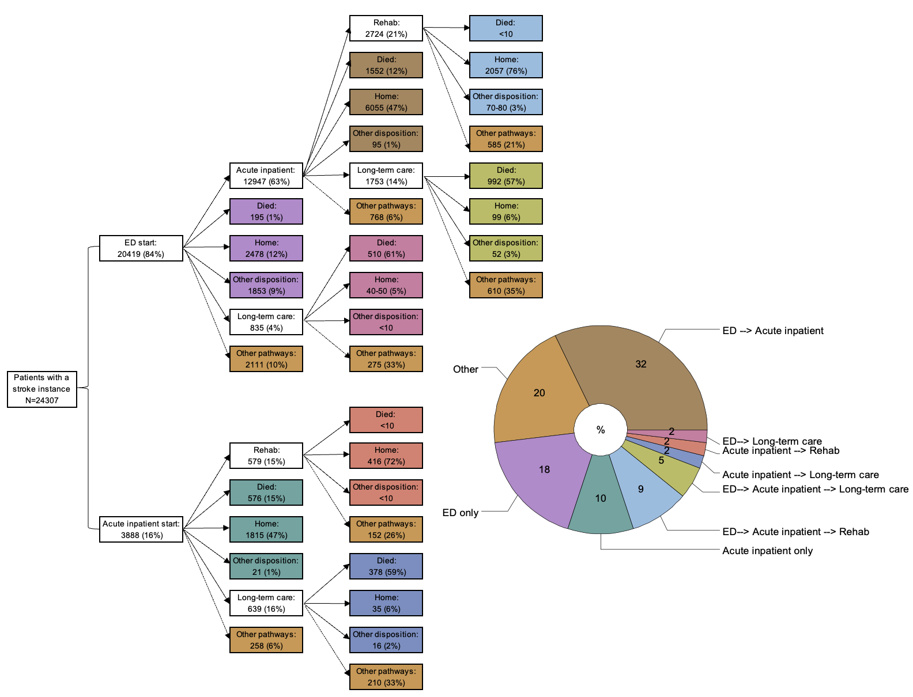

Supplementary Figure 1. Post-stroke pathways of care among the overall cohort. ''Other disposition” were discharges other than to home or deaths such as non-acute care or correctional facilities. "Other pathways" included a number of different and often complicated pathways that had very few episodes within each pathway; these included those who were still in the care setting at the end of observation period, continued their pathway with another stoke episode, experienced a pathway other than those listed, or was unknown. Abbreviations: ED = emergency department; Rehab = inpatient rehabilitation.

Supplementary Figure 2. Post-stroke pathways of care among the non-PSS treatment group. ''Other disposition” were discharges other than to home or deaths such as non-acute care or correctional facilities. "Other pathways" included a number of different and often complicated pathways that had very few episodes within each pathway; these included those who were still in the care setting at the end of observation period, continued their pathway with another stoke episode, experienced a pathway other than those listed, or was unknown. Abbreviations: ED = emergency department; Rehab = inpatient rehabilitation.

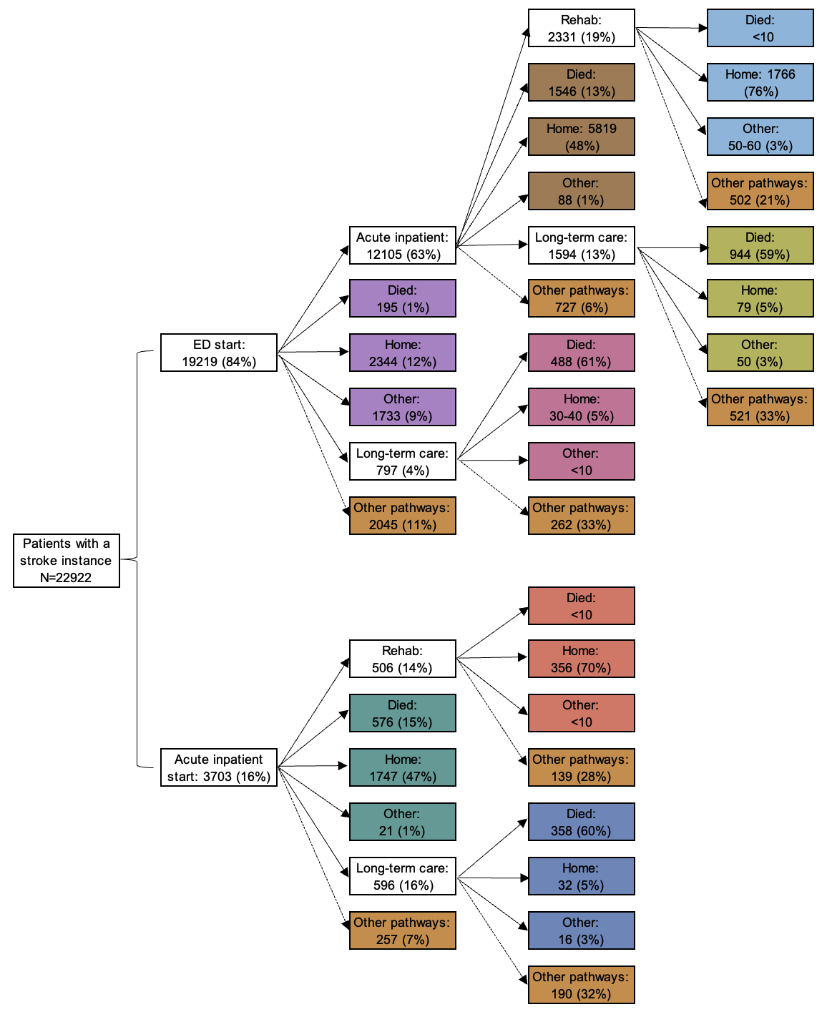



Supplementary Figure 3. Post-stroke pathways of care among the PSS treatment group. ''Other disposition” were discharges other than to home or deaths such as non-acute care or correctional facilities. "Other pathways" included a number of different and often complicated pathways that had very few episodes within each pathway; these included those who were still in the care setting at the end of observation period, continued their pathway with another stoke episode, experienced a pathway other than those listed, or was unknown. Abbreviations: ED = emergency department; Rehab = inpatient rehabilitation.