Supplemental Material A: Search Terms

Search terms included: “neurovascular”, “endovascular”, “contrast medium”, “contrast induced encephalopathy”, “encephalopathy”, “cortical blindness”, “cerebrovascular”, “neurological disease”, “blood brain barrier”, “blood-brain barrier dysfunction”, and “neurovascular unit”.

Supplemental Material B: Non-parametric statistical comparisons

Variable |  | Age | P-Value | BMI | P-Value
Sex | Men | 65.33±23.12 | 1.00 | 24.60±2.25 | 0.10
 | Women | 69.00±18.74 |  | 35.00±5.29
Diagnosis | Aneurysm | 47.50±9.19 | 0.13 | 33.40±10.75 | 0.80
 | Stroke | 77.00±13.49 |  | 28.00±4.97

Variable | Aneurysm | Stroke | P-Value
Men | 1 | 2 | 0.80
Women | 1 | 2

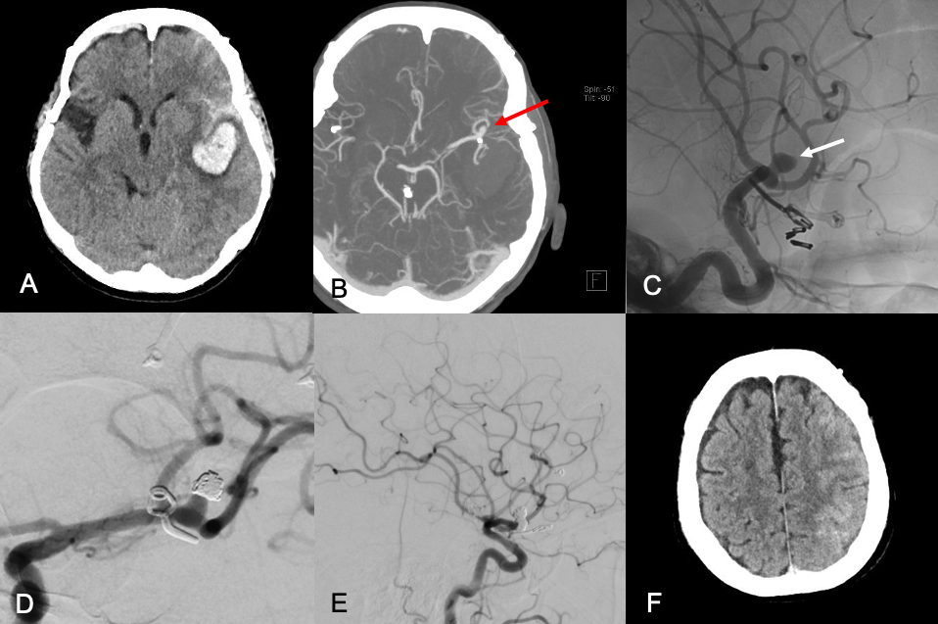

Supplemental Material C: Case 2. (A) Unenhanced axial CT demonstrates left hemispheric intracerebral and subarachnoid hemorrhage. (B) CTA revealed a ruptured saccular aneurysm of the left middle cerebral artery (MCA) (red arrow). The patient had a history of prior bilateral MCA aneurysm clippings and left MCA aneurysm coiling. Oblique lateral view cerebral angiogram of the left ICA demonstrating a saccular aneurysm of the left MCA (white arrow), pre- (C) and post- (D) stent-assisted coil embolization. A residual neck remnant was followed with serial imaging. (E) Right lateral view of the left ICA injection following repeat stent-assisted coil occlusion of the aneurysm neck. (F) Post-treatment unenhanced CT head showed left hemispheric contrast extravasation.
Supplemental Material D: Case 3. (A) Axial Computed Tomography Angiography (CTA) demonstrates thromboembolic occlusion of the right internal carotid artery (ICA) (red arrow). (B) Clot extension was detected intracranially. Cerebral angiography of the right ICA pre- (C) and post- (D) endovascular thrombectomy (EVT), demonstrating Thombolysis in Cerebral Infarction (TICI) Grade 3 result. (E) Unenhanced CT head demonstrates contrast extravasation over the frontal (F), temporal (T), and parietal (P) regions with effaced cortical sulci and parenchymal edema. (F) Repeat CT Head 14 hours later demonstrates resolution.
Supplemental Material E: Case 4. (A) Coronal CTA demonstrates atherosclerotic narrowing of the right ICA (red arrow). Tandem right middle cerebral artery (MCA) thromboembolism was identified (not shown). (B) CT perfusion demonstrated increased time to peak (TTP) in the right MCA territory. Cerebral angiography of the right ICA pre- (C) and post- (D) stenting and angioplasty. The patient also underwent EVT for the right MCA embolism (not shown). (E) Unenhanced CT head demonstrates contrast extravasation over the F, T, and P regions with effaced cortical sulci and parenchymal edema. (F) Repeat CT Head 24 hours later demonstrates resolution.
Supplemental Material F: Case 5. (A) Axial CTA demonstrates atherosclerotic narrowing of the right ICA (red arrow). B) CT perfusion demonstrated increased TTP in the right MCA territory. Cerebral angiography of the right ICA pre- (C) and post- (D) stenting. (E) Unenhanced CT head demonstrates contrast extravasation over the F, T, and P regions with effaced cortical sulci and parenchymal edema. (F) Repeat CT Head 24 hours later demonstrates resolution of contrast with infarcted parenchyma in the right temporal region.

