Age-specific association of co-morbidity with
home time after acute stroke

SUPPLEMENTAL MATERIALS
Supplemental Table I. Administration data codes and weighting of co-morbidities in the ischemic stroke-adapted Charlson Comorbidity Index
Condition* | ICD-9 | ICD-10 | Weight
Congestive Heart Failure | 398, 402, 425, 428 | I43, I50, I09.9, I11.0, I13.0, I13.2, I25.5, I42.0, I42.5, I42.6, I42.7, I42.8, I42.9, P29.0 | 2
Chronic Pulmonary Disease | 416, 490, 491, 492, 493, 494, 495, 496, 500, 501, 502, 503, 504, 505 | J40, J41, J42, J43, J44, J45, J46, J47, J60, J61, J62, J63, J64, J65, J66, J67, I27.8, I27.9, J68.4, J70.1, J70.3 | 2
Cancer | 140, 141, 142, 143, 144, 145, 146, 147, 148, 149, 150, 151, 152, 153, 154, 155, 156, 157, 158, 159, 160, 161, 162, 163, 164, 165, 170, 171, 172, 174, 175, 176, 179, 180, 181, 182, 183, 184, 185, 186, 187, 188, 189, 190, 191, 192, 193, 194, 195, 200, 201, 202, 203, 204, 205, 206, 207, 208, 238 | C00, C01, C02, C03, C04, C05, C06, C07, C08, C09, C10, C11, C12, C13, C14, C15, C16, C17, C18, C19, C20, C21, C22, C23, C24, C25, C26, C30, C31, C32, C33, C34, C37, C38, C39,  C40, C41, C43, C45, C46, C47, C48, C49, C50, C51, C52, C53, C54, C55, C56, C57, C58, C60, C61, C62, C63, C64, C65, C66, C67, C68, C69, C70, C71, C72, C73, C74, C75, C76, C81, C82, C83, C84, C85, C88, C90, C91, C92, C93, C94, C95, C96, C97 | 2
Diabetes with complications | N/A | E10.2, E10.3, E10.4, E10.5, E10.7, E11.2, E11.3, E11.4, E11.5, E11.7, E12.2, E12.3, E12.4, E12.5, E12.7, E13.2, E13.3, E13.4, E13.5, E13.7, E14.2, E14.3, E14.4, E14.5, E14.7 | 1
Dementia | 290, 294, 331 | F00, F01, F02, F03, G30, F05.1, G31.1 | 2
Metastatic Carcinoma | 196, 197, 198, 199 | C77, C78, C79, C80 | 5
Myocardial Infarction | 410, 412 | I21, I22, I25.2 | 2
Rheumatic Disease | 446 710 714 725 | M05 M32 M33 M34 M06 M31.5 M35.1 M35.3 M36.0 | 2
Hypertension | 401 402 403 404 405 | I10 I11 I12 I13 I15 | N/A**
Atrial fibrillation | 427.3 | I48 | N/A**
*Definition of condition requires 1 hospital record (DAD), 1 emergency visit (NACRS), and/or 2 physician claims within past 3 years
**Hypertension and atrial fibrillation not included in Charlson Co-morbidity Index

Supplemental Table II. Administration data codes for PaSSV Indicator and weights for calculating estimated CNS

Parameter | Details/codes | Estimate | 95% Lower  Confidence  Limit | 95% Upper  Confidence  Limit
Intercept | - | 9.1083 | 8.6770 | 9.5395
Male sex | - | Ref
Female sex | - | -0.3921 | -0.4492 | -0.3350
Age < 46 years | - | Ref
Age 46-65 | - | -0.1133 | -0.2588 | 0.0322
Age 66-75 | - | -0.3747 | -0.5210 | -0.2284
Age 76-85 | - | -0.7313 | -0.8752 | -0.5873
Age >85 | - | -1.3046 | -1.4569 | -1.1522
CTAS 5: Non urgent | From first NACRS record in episode of care | Ref
CTAS 1: Resuscitation | “ | -1.0212 | -1.4391 | -0.6034
CTAS 2: Emergency | “ | 0.3825 | -0.0306 | 0.7955
CTAS 3: Urgent | “ | 1.4732 | 1.0589 | 1.8876
CTAS 4: Less urgent | “ | 1.8469 | 1.3913 | 2.3024
Arrival by ambulance | From first NACRS record in episode of care | -1.1628 | -1.2251 | -1.1006
Transfer to stroke centre | Within 24 hours of index record in episode of care | -0.5957 | -0.6916 | -0.4998
Ataxia symptoms | From all NACRS and DAD records during episode of care  Code (DAD, NACRS): R26, R27 | 1.0125 | 0.8466 | 1.1784
Decreased level of consciousness | From all NACRS and DAD records during episode of care  Code (DAD, NACRS): R40 | -2.5710 | -2.7868 | -2.3553
Speech symptoms | From all NACRS and DAD records during episode of care  Code (DAD, NACRS): R47 | -0.1720 | -0.2516 | -0.0925
Visual symptoms | From all NACRS and DAD records during episode of care  Code (DAD, NACRS): H51, H47, H53, H54 | 1.0440 | 0.8797 | 1.2082
Motor symptoms | From all NACRS and DAD records during episode of care  Code (DAD, NACRS): G81, G82, G83 | -1.3946 | -1.4689 | -1.3203
Sensory symptoms | From all NACRS and DAD records during episode of care  Code (DAD, NACRS): R20 | 0.5117 | 0.2883 | 0.7352
Mechanical ventilation within 2 days | Within 2 days of index record in episode of care  Code (DAD, NACRS):  - 1GZ31CAND, 1GZ31CAEP, 1GZ31CRND, 1GZ31GPND  Code (Physician Claims):  - 10.04B, 10.04, 13.62A | -3.8195 | -3.9279 | -3.7111
*Coefficients derived from multivariable logistic regression models for 30-day mortality in original PaSSV publication (reference 7 in main text). Final estimate obtained from adding coefficients from intercept and all categories where codes were applicable to patient. CNS indicates Canadian Neurological Scale.

Supplemental Table III. Baseline characteristics stratified by age group
 | Total N=28,672 | Age <60 N=5,787 | Age 60-69 N=5,518 | Age 70-79 N=7,216 | Age 80+ N=10,151 | p-value
Female, N(%) | 13,464 (47.0%) | 2,216 (38.3%) | 1,976 (35.8%) | 3,222 (44.7%) | 6,050 (59.6%) | <0.001
ICH, N(%) | 3,498 (12.2%) | 856 (14.8%) | 651 (11.8%) | 855 (11.8%) | 1,136 (11.2%) | <0.001
CSC, N(%) | 15,133 (52.8%) | 3,528 (61.0%) | 3,050 (55.3%) | 3,816 (52.9%) | 4,739 (46.7%) | <0.001
Rural residence, N(%) | 11,148 (38.9%) | 2,237 (38.7%) | 2,249 (40.8%) | 2,914 (40.4%) | 3,748 (36.9%) | 0.033
Pre-stroke supportive living or long-term care, N(%) | 2,060 (7.2%) | 32 (0.6%) | 72 (1.3%) | 265 (3.7%) | 1,691 (16.7%) | <0.001
PaSSV score, mean (SD) | 7.7 (1.9) | 8.3 (2.1) | 8.1 (1.9) | 7.8 (1.8) | 7.1 (1.6) | <0.001
CCI 3+, N(%) | 6,496 (22.7%) | 577 (10.0%) | 993 (18.0%) | 1,767 (24.5%) | 3,159 (31.1%) | <0.001
Myocardial infarction, N(%) | 3,297 (11.5%) | 411 (7.1%) | 598 (10.8%) | 923 (12.8%) | 1,365 (13.4%) | <0.001
Congestive heart failure, N(%) | 4,605 (16.1%) | 408 (7.1%) | 579 (10.5%) | 1,089 (15.1%) | 2,529 (24.9%) | <0.001
Dementia, N(%) | 3,657 (12.8%) | 59 (1.0%) | 201 (3.6%) | 745 (10.3%) | 2,652 (26.1%) | <0.001
Chronic pulmonary disease, N(%) | 5,967 (20.8%) | 813 (14.0%) | 1,091 (19.8%) | 1,760 (24.4%) | 2,303 (22.7%) | <0.001
Rheumatic disease, N(%) | 1,123 (3.9%) | 174 (3.0%) | 207 (3.8%) | 319 (4.4%) | 423 (4.2%) | <0.001
Diabetes with complications, N(%) | 7,907 (27.6%) | 1,311 (22.7%) | 1,879 (34.1%) | 2,333 (32.3%) | 2,384 (23.5%) | 0.02
Cancer, N(%) | 3,241 (11.6%) | 284 (5.0%) | 518 (9.7%) | 970 (13.8%) | 1,469 (14.8%) | <0.001
Metastases, N(%) | 927 (3.2%) | 135 (2.3%) | 229 (4.2%) | 261 (3.6%) | 302 (3.0%) | 0.4
Hypertension, N(%) | 19,489 (68.0%) | 2,580 (44.6%) | 3,539 (64.1%) | 5,413 (75.0%) | 7,957 (78.4%) | <0.001
Atrial fibrillation, N(%) | 4,937 (17.2%) | 297 (5.1%) | 573 (10.4%) | 1,265 (17.5%) | 2,802 (27.6%) | <0.001
*CCI indicates Ischemic stroke-weighted Charlson co-morbidity index; PaSSV passive surveillance stroke severity indicator
*P-values are from tests of trend across age groups using the Cochran-Armitage test for categorical variables and Jonchkeere-Terpstra test for continuous variables

Supplemental Table IV. Mean 90-home time and 95% CI for each age group, with and without severe co-morbidity or individual co-morbidities

Age group/status | Severe co-morbidity | MI | CHF | Dementia | CPD | Rheum disease | Diabetes | Cancer | Mets
Age <60, without | 63.9 (63-64.8) | 62.9 (62-63.7) | 63 (62.1-63.9) | * | 62.8 (61.9-63.7) | 62.1 (61.2-63) | 63.9 (63-64.9) | 62.9 (62.1-63.8) | 62.7 (61.9-63.6)
Age <60, with | 49.7 (47.1-52.3) | 52.7 (49.2-56.2) | 50.5 (47-54) | * | 58.2 (55.9-60.6) | 63.4 (58.6-68.2) | 56.1 (54.2-58) | 56.2 (52.1-60.3) | 36.9 (30.9-42.9)
Age 60-69, without | 59.8 (58.8-60.8) | 57.5 (56.5-58.5) | 58 (57-58.9) | 60.1 (59.4-60.7) | 58.5 (57.5-59.5) | 56.8 (55.8-57.7) | 58.4 (57.3-59.6) | 57.9 (56.9-58.9) | 57.9 (56.9-58.8)
Age 60-69, with | 46.5 (44.5-48.6) | 51.2 (48.4-54.1) | 47.1 (44.1-50) | 37.7 (33.3-42.1) | 50.1 (47.9-52.2) | 58.2 (53.6-62.8) | 53.7 (52.1-55.3) | 54.4 (51.4-57.4) | 32.6 (27.9-37.3)
Age 70-79, without | 52.5 (51.5-53.5) | 49.6 (48.7-50.5) | 50.7 (49.8-51.6) | 50.9 (50-51.8) | 50.4 (49.4-51.4) | 49.1 (48.3-50) | 50.1 (49.1-51.2) | 49.9 (49-50.9) | 49.7 (48.8-50.5)
Age 70-79, with | 41.1 (39.5-42.6) | 45.5 (43.2-47.9) | 39.9 (37.8-42.1) | 33 (30.5-35.6) | 44.8 (43.1-46.6) | 47 (42.9-51.1) | 46.8 (45.3-48.3) | 46.4 (44.1-48.7) | 32.6 (28.3-37)
Age 80+, without | 36.7 (35.8-37.6) | 34.2 (33.5-35) | 35.8 (35-36.6) | 36.8 (36-37.7) | 34.2 (33.4-35) | 33.5 (32.8-34.2) | 34 (33.1-34.8) | 33.5 (32.7-34.2) | 33.7 (33-34.4)
Age 80+, with | 28.4 (27.3-29.5) | 29.2 (27.3-31) | 26.8 (25.4-28.1) | 24.3 (23-25.6) | 31.4 (29.9-32.8) | 34.8 (31.3-38.3) | 32.2 (30.8-33.7) | 34.4 (32.5-36.3) | 29 (25-33.1)
*For dementia, lower two age groups were combined so that “Age 60-69” represents Age <70.

Supplemental Table V. Mean 90-day and 1-year home time by sex and CCI score

 | CCI <3 | CCI 3+ | Difference*
90-day home time, mean (SD)
Total | 52.0 (36.8) | 36.6 (36.8) | -15.4
Male | 55.7 (35.8) | 40.2 (37.2) | -15.5
Female | 47.6 (37.5) | 32.7 (36.1) | -14.9
1-year home time, mean (SD)
Total | 251.2 (146.7) | 167.5 (159.3) | -83.7
Male | 268.7 (137.4) | 184.5 (159.2) | -84.2
Female | 231.2 (154.3) | 149.1 (157.5) | -82.1
>80 days of home time, N (%)
Total | 43.6% | 23.2% | -20.4%
Male | 48.2% | 26.5% | -21.7%
Female | 38.2% | 19.7% | -18.5%
CCI indicates Charlson Co-morbidity Index; CCI 3+ is defined as severe co-morbidity.
*Difference indicates the difference in means or proportions between CCI 3+ and CCI <3.

Supplemental table VI. Effect estimates for the association between severe co-morbidity and home time, overall and for each age group

 | Main effect | <60 | 60-69 | 70-79 | 80+
No adjustment for PASSV
90-day home time, days | -10.6 (-11.8 to -9.4) | -13.3 (-16.7 to 10.0) | -12.3 (-15.0 to -9.6) | -11.0 (-13.1 to -8.9) | -7.7 (-9.3 to -6.2)
1-year home time, days | -60.2 (-65.5 to -55.0) | -69.0 (-84.1 to -53.9) | -64.0 (-76.4 to -51.6) | -62.8 (-72.5 to -53.0) | -51.4 (-58.1 to -44.7)
probability of 80+ days (%) | -15 (-16.5 to -14.0) | -22.7 (-26.4 to -19.0) | -17.9 (-20.9 to -14.9) | -16.0 (-18.2 to -13.7) | -9.0 (-10.6 to -7.4)
Adjusted for PASSV
90-day home time, days | -8.8 (-9.9 to -7.6) | -9.9 (-13.1 to -6.7) | -10.6 (-13.1 to -8.0) | -9.3 (-11.3 to -7.2) | -6.8 (-8.2 to -5.3)
1-year home time, days | -54.0 (-59.0 to -48.9) | -57.7 (-72.2 to -43.1) | -58.0 (-69.9 to -46.0) | -56.4 (-65.8 to -47.0) | -48.0 (-54.4 to -41.5)
probability of 80+ days (%) | -13.5 (-14.7 to -12.2) | -19.0 (-22.6 to -15.4) | -16.0 (-19.0 to -13.1) | -14.4 (-16.7 to -12.1) | -8.3 (-9.8 to -6.7)
Death excluded
No adjustment for PASSV
90-day home time, days | -5.7 (-7.0 to -4.4) | -7.8 (-11.1 to -4.5) | -7.0 (-9.7 to -4.3) | -6.2 (-8.4 to -4.0) | -2.9 (-4.9 to -1.0)
1-year home time, days | -35.5 (-40.2 to -30.1) | -39.1 (-51.9 to -26.4) | -34.9 (-45.7 to -24.0) | -36.5 (-45.5 to -27.4) | -31.4 (-39.2 to -23.6)
probability of 80+ days (%) | -12.8 (-14.3 to -11.2) | -19.1 (-23.3 to -15.0) | -14.3 (-17.9 to -10.9) | -13.4 (-16.1 to -10.7) | -6.5 (-8.8 to -4.3)
Adjusted for PASSV
90-day home time, days | -4.5 (-5.7 to -3.3) | -5.6 (-8.7 to -2.4) | -5.8 (-8.4 to -3.2) | -5.0 (-7.2 to -2.9) | -2.4 (-4.3 to -0.54)
1-year home time, days | -31.9 (-36.8 to -27.0) | -33.6 (-46.0 to -21.3) | -31.4 (-41.9 to -20.8) | -33.2 (-42.0 to -24.4) | -29.9 (-37.5 to -22.3)
probability of 80+ days (%) | -11.5 (-13.0 to -9.9) | -16.5 (-20.5 to -12.5) | -12.9 (-16.2 to -9.6) | -12.1 (-14.8 to -9.5) | -6.1 (-8.3 to -3.9)

Supplemental table VII. Effect estimates for the association between individual co-morbidities and home time, overall and for each age group

 | Main effect | <60 | 60-69 | 70-79 | 80+
Death included
Myocardial infarction | -1.73 (-3.28 to -0.18) | -4.60 (-8.88 to -0.31 | -2.48 (-6.0 to 1.03) | 1.24 (-1.62 to 4.09) | -1.79 (-3.84 to 0.27)
Diabetes (complicated) | -4.23 (-5.27 to -3.19 | -8.24 (-10.79 to -5.70) | -5.54 (-7.83 to -3.23) | -3.33 (-5.32 to -1.34) | -1.87 (-3.49 to -0.25)
Diabetes (uncomplicated) | -5.48 (-6.88 to -4.08) | -8.47 (-11.86 to -5.09) | -6.83 (-9.89 to -3.77) | -6.12 (-8.85 to -3.39) | -2.58 (-4.88 to -0.29)
Diabetes (all) | -6.41 (-7.88 to -4.93) | -7.70 (-10.20 to -5.20) | -5.28 (-7.54 to -3.01) | -3.36 (-5.31 to -1.42) | -1.18 (-2.74 to 0.39)
Cancer | -3.65 (-5.11 to -2.20) | -8.54 (-12.9 to -4.13) | -5.81 (-9.21 to -2.41) | -3.68 (-6.21 to -1.15) | 0.31 (-1.64 to 2.27)
Heart failure | -5.08 (-6.58 to -3.58) | -5.40 (-9.67 to -1.14) | -5.81 (-9.40 to -2.22) | -5.02 (-7.67 to -2.38) | -4.54 (-6.19 to -2.89)
Pulmonary disease | -2.07 (-3.25 to -0.89) | -2.04 (-5.22 to 1.13) | -3.70 (-6.46 to -0.94) | -2.72 (-4.90 to -0.54) | -0.74 (-2.43 to 0.96)
Rheumatic disease | 0.91 (-1.56 to 3.37) | 0.40 (-6.28 to 7.09) | 3.10 (-2.86 to 9.06) | -0.75 (-5.34 to 3.84) | 1.19 (-2.34 to 4.71)
Dementia | -13.06 (-15.50 to -10.62) | * | -15.0 (-20.8 to -9.3)* | -14.5 (-17.3 to -11.7) | -9.9 (-11.4 to -8.4)
Death excluded
Myocardial infarction | -0.81 (-2.46 to 0.84) | -4.47 (-8.54 to -0.40) | -1.89 (-5.33 to 1.55) | 1.58 (-1.32 to 4.48) | 0.60 (-2.0 to 3.20)
Diabetes (complicated) | -4.49 (-5.98 to -3.79) | -8.51 (-10.9 to -6.11) | -6.26 (-8.47 to -4.04) | -3.64 (-5.64 to -1.64) | -2.33 (-4.31 to -0.35)
Diabetes (uncomplicated) | -3.84 (-4.85 to -2.81) | -8.37 (-11.57 to -5.16) | -7.10 (-10.08 to -4.13) | -6.71 (-9.49 to -3.94) | -4.22 (-7.01 to -1.43)
Diabetes (all) | -4.42 (-5.49 to -3.35) | -7.79 (-10.14 to -5.44) | -6.07 (-8.25 to -3.88) | -3.64 (-5.60 to -1.68) | -1.48 (-3.38 to 0.43)
Cancer | 1.21 (-0.42 to 2.84) | -2.14 (-6.68 to 2.39) | 2.17 (-1.45 to 5.79) | 1.26 (-1.43 to 3.95) | 2.98 (0.55 to 5.42)
Heart failure | -2.80 (-4.42 to 1.17) | -4.31 (-8.36 to -0.25) | -4.44 (-8.0 to -0.88) | -2.71 (-5.48 to 0.054) | -0.64 (-2.82 to 1.54)
Pulmonary disease | -1.58 (-2.83 to -0.33) | -1.80 (-4.78 to 1.19) | -3.37 (-6.06 to -0.69) | -1.66 (-3.88 to 0.57) | -0.12 (-2.22 to 1.99)
Rheumatic disease | 0.61 (-1.93 to 3.15) | 0.003 (-6.21 to 6.22) | 2.89 (-2.68 to 8.46) | -0.70 (-5.31 to 3.92) | 0.60 (-3.64 to 4.83)
Dementia | -12.5 (-15.2 to -9.99) | * | -15.2 (-20.8 to -9.5)* | -13.8 (-16.9 to -10.6) | -7.7 (-9.8 to -5.6)
* Due to small proportion with dementia in the <60 age group (1%), the <60 and 60-69 age groups were combined.

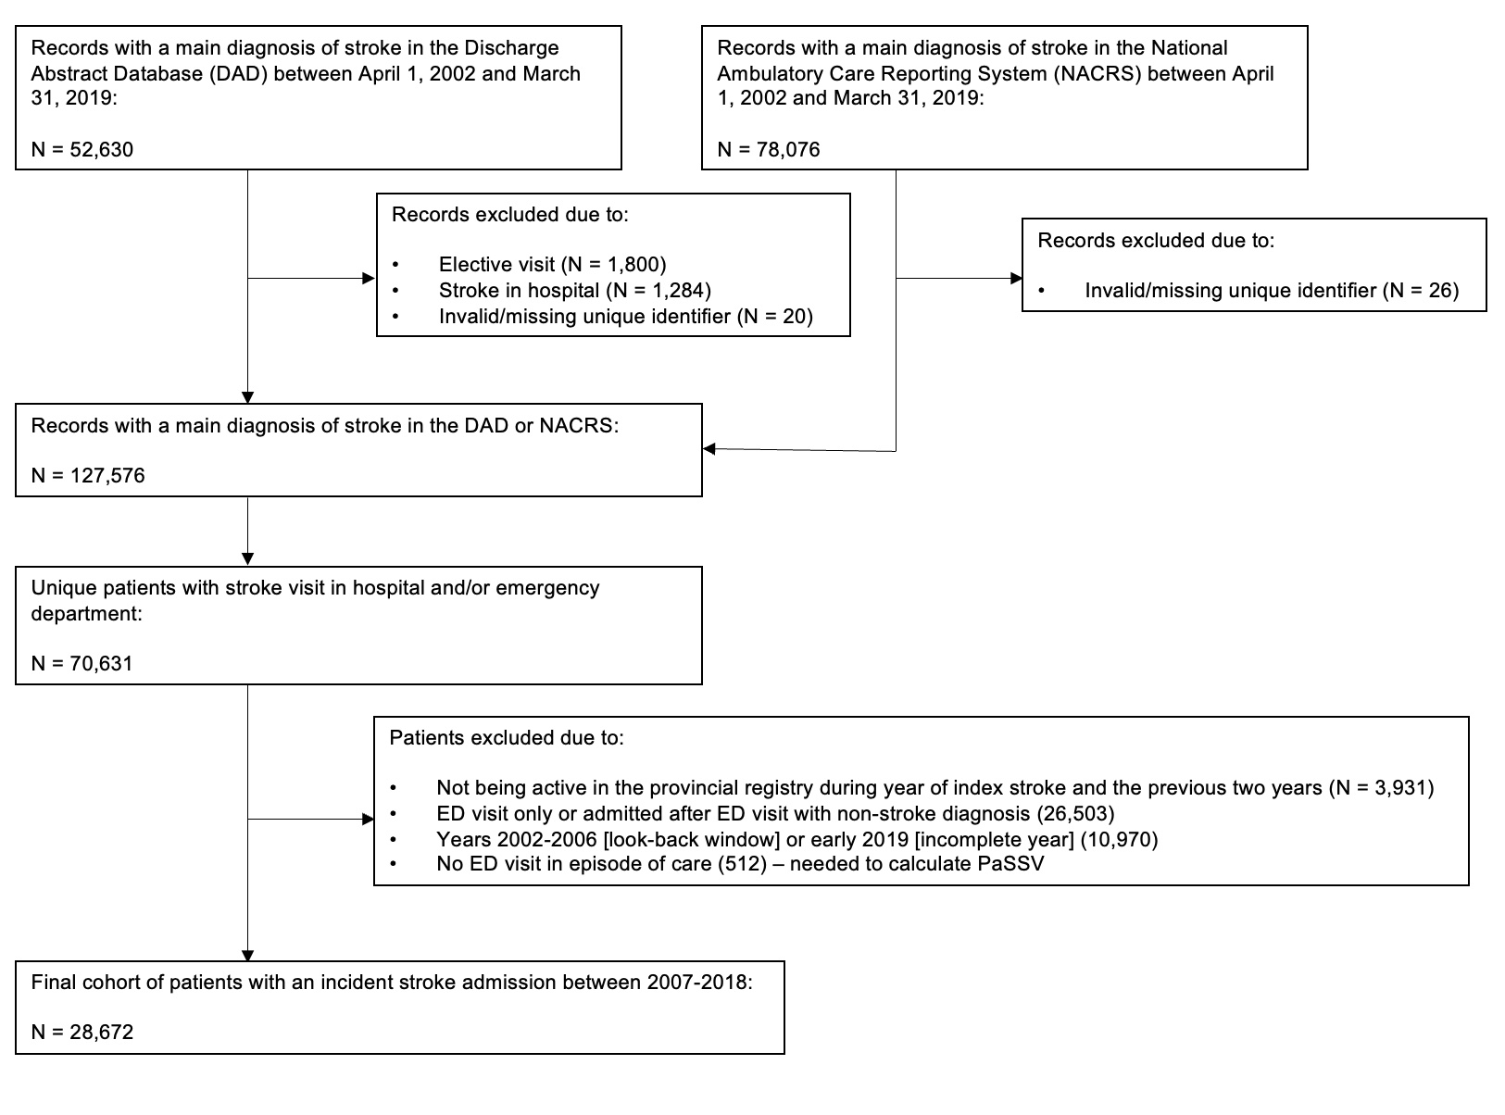
Supplemental Figure 1. Study flowchart
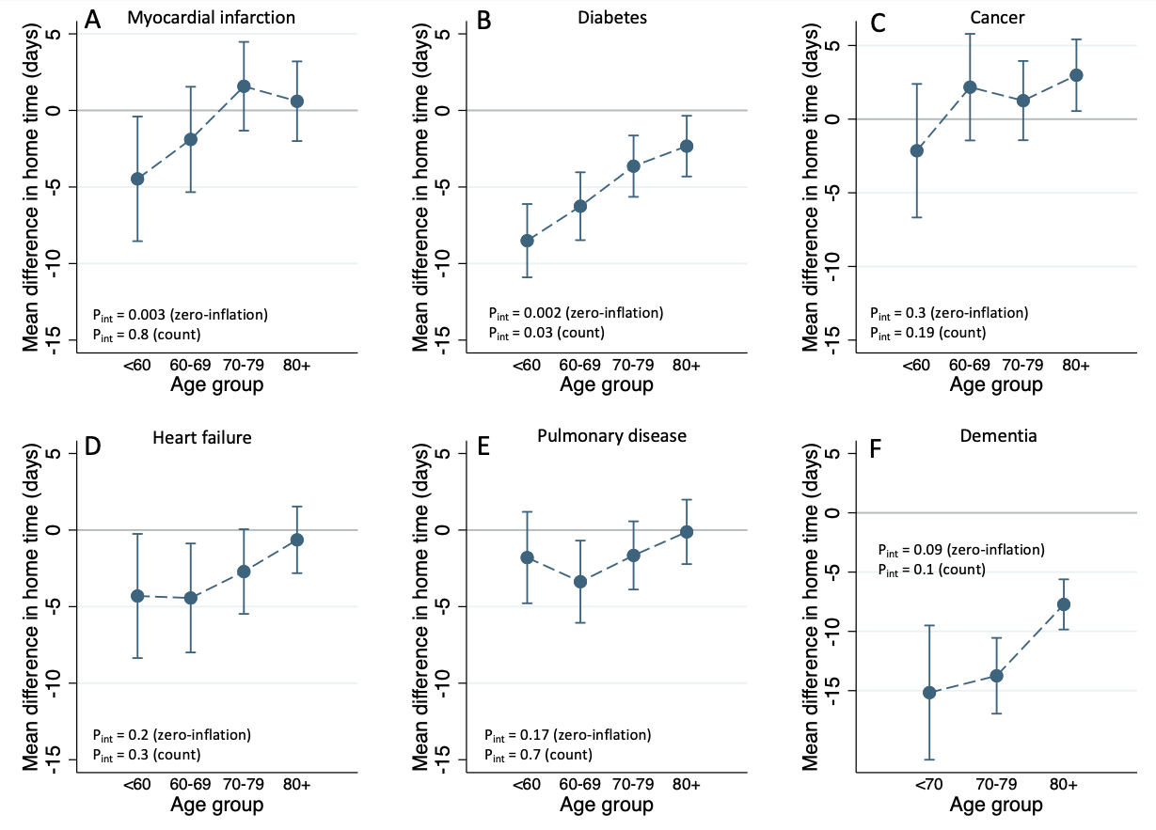
Supplemental Figure 2. Adjusted mean difference in 90-day home time with 95% confidence intervals for different co-morbidities, excluding people who died within 90 days of stroke. Models adjusted for sex, stroke type, comprehensive stroke centre admission, hypertension, atrial fibrillation year of study, and PaSSV (estimated stroke severity). Due to small proportion with dementia in the <60 age group (1%), the <60 and 60-69 age groups were combined.
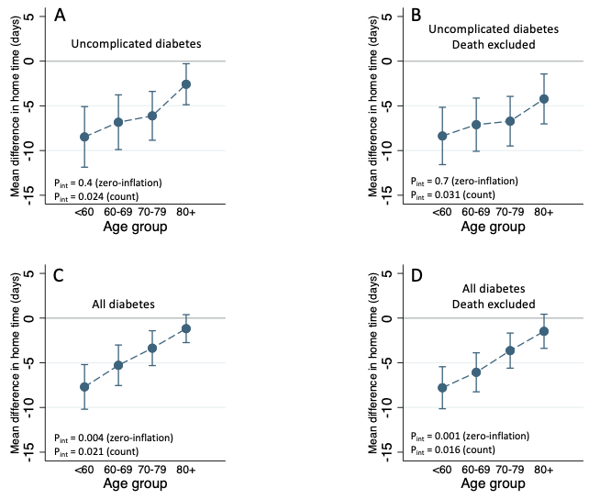
Supplemental Figure 3. Adjusted mean difference in 90-day home time with 95% confidence intervals for diabetes without chronic complications and all diabetes, with and without death excluded.

