Supplementary Material
Impact of Migraine on the Risk of Alzheimer’s disease: Evidence from Prospective studies and Genetic analyses

Supplemental Table 1. ICD-10 codes used to ascertain all-cause and cause-specific dementia cases.
ICD 10 Code | Code description | Alzheimer’s disease | Vascular dementia | All-cause dementia
A81.0 | Sporadic Creutzfeldt-Jakob disease | 0 | 0 | 1
F00 | Dementia in Alzheimer's disease | 1 | 0 | 1
F00.0 | Dementia in Alzheimer's disease with early onset | 1 | 0 | 1
F00.1 | Dementia in Alzheimer's disease with late onset | 1 | 0 | 1
F00.2 | Dementia in Alzheimer's disease, atypical or mixed type | 1 | 0 | 1
F00.9 | Dementia in Alzheimer's disease, unspecified | 1 | 0 | 1
F01 | Vascular dementia | 0 | 1 | 1
F01.0 | Vascular dementia of acute onset | 0 | 1 | 1
F01.1 | Multi-infarct dementia | 0 | 1 | 1
F01.2 | Subcortical vascular dementia | 0 | 1 | 1
F01.3 | Mixed cortical and sub-cortical vascular dementia | 0 | 1 | 1
F01.8 | Other vascular dementia | 0 | 1 | 1
F01.9 | Vascular dementia, unspecified | 0 | 1 | 1
F02 | Dementia in other diseases classified elsewhere | 0 | 0 | 1
F02.0 | Dementia in Picks disease | 0 | 0 | 1
F02.1 | Dementia in Creutzfeldt-Jacob disease | 0 | 0 | 1
F02.2 | Dementia in Huntington’s disease | 0 | 0 | 1
F02.3 | Dementia in Parkinson’s disease | 0 | 0 | 1
F02.4 | Dementia in HIV disease | 0 | 0 | 1
F02.8 | Dementia in other specified diseases classified elsewhere | 0 | 0 | 1
F03 | Unspecified dementia | 0 | 0 | 1
F05.1 | Delirium superimposed on dementia | 0 | 0 | 1
F10.6 | Mental and behavioural disorders due to use of alcohol - amnesic syndrome | 0 | 0 | 1
G30 | Alzheimer’s disease | 1 | 0 | 1
G30.0 | Alzheimer’s disease with early onset | 1 | 0 | 1
G30.1 | Alzheimer’s disease with late onset | 1 | 0 | 1
G30.8 | Other Alzheimer's disease | 1 | 0 | 1
G30.9 | Alzheimer's disease unspecified | 1 | 0 | 1
G31.0 | Circumscribed brain atrophy | 0 | 0 | 1
G31.1 | Senile degeneration of brain | 0 | 0 | 1
G31.8 | Other specified degenerative diseases of nervous system | 0 | 0 | 1
I67.3 | Binswanger's disease | 0 | 1 | 1
1=yes, 0=no.

Supplemental Table 2. Definitions and assessments of covariates.
Covariates | Definition | Assessment | UK biobank Data-Field ID
Age (years) | Age in years. | Interval between the date of baseline assessment and the date of birth recorded by NHS. | 21003
Sex | Men, Women. | NHS derived and/or touchscreen questionnaire. | 31
Ethnic background | White, Non-White (Mixed, Asian, Black, Chinese, Other). | Touchscreen questionnaire: “What is your ethnic group?”. | 21000
Education | Higher education (college or university degree, other professional qualifications), other than higher education. | Touchscreen questionnaire: “Which of the following qualifications do you have?”. | 6138
BMI | Body Mass Index. Units of measurement are Kg/m². | BMI value here is constructed from height and weight measured during the initial Assessment Centre visit. Value is not present if either of these readings were omitted. | 21001
SBP | Units of measurement are mmHg. | Blood pressure, automated reading, systolic. Two measures of blood pressure were taken a few moments apart. | 4080
DBP | Units of measurement are mmHg. | Blood pressure, automated reading, diastolic. Two measures of blood pressure were taken a few moments apart. | 4079
LDL-C | Units of measurement are mmol/L. | Measured by enzymatic protective selection analysis on a Beckman Coulter AU5800. | 30780
Current smoking | Yes, No. | Touchscreen questionnaire: “Do you smoke tobacco now?” and “In the past, how often have you smoked tobacco?”. | 20116
Alcohol intake | At least once per week, less than once per week. | Touchscreen questionnaire: “About how often do you drink alcohol?”. | 1558
Physical activity | Attending moderate or vigorous physical activity 10+ minutes at least twice per week, less than twice per week. | Touchscreen questionnaire: “In a typical WEEK, on how many days did you do 10 minutes or more of moderate physical activities like carrying light loads, cycling at normal pace? (Do not include walking).  In a typical WEEK, how many days did you do 10 minutes or more of vigorous physical activity? (These are activities that make you sweat or breathe hard such as fast cycling, aerobics, heavy lifting)”. | 884, 904
Hypertension | Yes, No. | Touchscreen questionnaire and verbal interview: self-reported hypertension or anti-hypertensive medication use.  Average SBP/DBP ≥ 140/90 mmHg at baseline. | 6150, 20002, 6177, 4079, 4080, 93, 94
Depressed mood | Yes (nearly every day or more than half the days), No (not at all or several days). | Touchscreen questionnaire: “Over the past two weeks, how often have you felt down, depressed or hopeless?”. | 2050
Stroke | Yes, No. | Touchscreen questionnaire and verbal interview: self-reported previous stroke or transient ischemic attack (TIA). | 6150, 20002
Coronary heart disease | Yes, No. | Touchscreen questionnaire and verbal interview: angina, heart attack/myocardial infarction. | 6150, 20002
Atrial fibrillation | Yes, No. | Touchscreen questionnaire and verbal interview: self-reported diagnosis of atrial fibrillation.  Date of the first occurrence of diseases according to ICD-10 codes: atrial fibrillation and flutter diagnosis prior to baseline assessment (ICD code I48). | 20002, 131350
Chronic obstructive pulmonary disease | Yes, No. | Touchscreen questionnaire and verbal interview: self-reported diagnosis of chronic obstructive airways disease.  Date of the first occurrence of diseases according to ICD-10 codes: chronic obstructive pulmonary disease diagnosis prior to baseline assessment (ICD code J44). | 20002, 131492
Chronic kidney disease | Yes, No. | Date of the first occurrence of diseases according to ICD-10 codes: chronic renal failure diagnosis prior to baseline assessment (ICD code N18). | 132032
Anemia | Yes, No. | Touchscreen questionnaire and verbal interview: self-reported diagnosis of iron deficiency anemia, pernicious anemia, aplastic anemia, anemia;  Date of the first occurrence of diseases according to ICD-10 codes: anemia diagnosis prior to baseline assessment (ICD code D50-D55, D58, D59, D61-D64) | 20002, 130622, 130624, 130626, 130628, 130630, 130636, 130638, 130642, 130644, 130646, 130648
Statin medication | Yes, No. | This category contains data obtained through a verbal interview by a trained nurse on prescription medications and includes data on type and number of medications taken. | 20003
ApoE4 status | Carriers, Non-carriers, Untyped. | ApoE4 status was derived using the ApoE SNPs rs429358 and rs7412, which were directly genotyped. | Affy snp ID: affy16020316, affy16020324
Abbreviations: BMI, body mass index; SBP, systolic blood pressure; DBP, diastolic blood pressure; LDL-C, low-density lipoprotein cholesterol.

Supplemental Table 3. Assessments of heart magnetic resonance imaging (MRI), brain MRI, and cognitive function measured in 2015.
Assessments | Methods | UK biobank Data-Field ID
left ventricular (LV) ejection fraction (%) | In the UK Biobank Cardiovascular MRI examination, the Siemens syngo InlineVF (Siemens Healthcare, Erlangen, Germany) fully automated analysis of LV volume was performed during acquisition. This software automatically identifies LV landmarks at the LV base (mitral valve) and apex in long-axis cine acquisitions, locates endocardial and epicardial contours at ED and ES in each short-axis cine slice, and performs volume calculations to determine ventricular function parameters. | 22420
LV end diastolic volume (mL) |  | 22421
LV end systolic volume (mL) |  | 22422
Volume of grey matter (cm³) | In the UK Biobank Brain MRI examination, all brain MRI data were acquired on a single standard Siemens Skyra 3T scanner with a standard Siemens 32-channel RF receiver head coil. The T1-weighted volumes were acquired in the sagittal plane using a three-dimensional magnetization-prepared rapid gradient-echo sequence at a resolution of 1×1×1 mm, with a 208×256×256 field of view. Volumes of specific brain structures, including the total brain, the white matter, the grey matter, and the peripheral cortical grey matter, were made available by the UK Biobank Imaging team as image-derived phenotypes. All volume measures were adjusted for head size using a SIENAX-style analysis. | 25005
Volume of white matter (cm³) |  | 25007
Volume of brain (cm³) |  | 25009
Fluid intelligence score | This category contains data on questions designed to assess “Fluid intelligence”(i.e. the capacity to solve problems that require logic and reasoning ability, independent of acquired knowledge). The participant has 2 minutes to complete as many questions as possible from the test. | 20191
Duration to complete numeric path (second) | Participants were presented with a series of labelled circles and instructed to touch them according to a particular ordering rule. | 20156
Duration to complete alphanumeric path (second) |  | 20157
Symbol digit substitution score | Participants were presented with a series of grids in which symbols were to be matched to numbers according to a key presented on the screen. | 20159
Incorrect pairs matching score, round 1 | This category contains data on 'pairs' matching tests. Participants are asked to memorize the position of as many matching pairs of cards as possible. The cards are then turned face down on the screen and the participant is asked to touch as many pairs as possible in the fewest tries. Either two or three rounds were conducted. The first round used 3 pairs of cards, the second 6 pairs of cards and the third 8 pairs of cards. Participants were only presented with the third round if they made 0 or 1 errors on the second round. | 20132
Incorrect pairs matching score, round 2 |  | 20132
Numeric memory score | This category contains data on a test designed to assess numeric short-term memory, as part of the touchscreen questionnaire. The participant was shown a 2-digit number to remember. The number then disappeared and after a short while they were asked to enter the number onto the screen. The number became one digit longer each time they remembered correctly (up to a maximum of 12 digits). Data collected include the number of digits and value of the number, the length of time the number was displayed, the time that the participant first entered and last entered a digit, the time taken to complete the test, the value of the number entered by the participant, whether or not the participant was correct, the maximum number of digits remembered, and whether the test was completed. This test is available for a subset of participants. | 20240

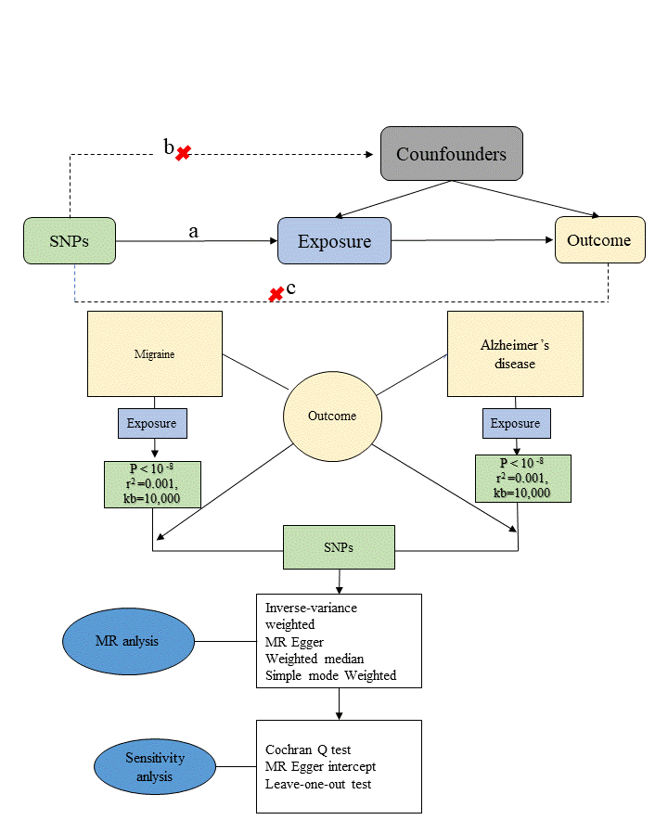

Figure S1 Flowchart of study. Three major assumptions of the MR analysis are as follows: a: the association hypothesis: genetic variant is associated with exposure; b: the independence hypothesis: genetic variant is not associated with confounding factors; c: the exclusivity hypothesis: genetic variables influence the outcome only through the exposure. SNPs: single nucleotide polymorphisms, MR: Mendelian randomization.
A
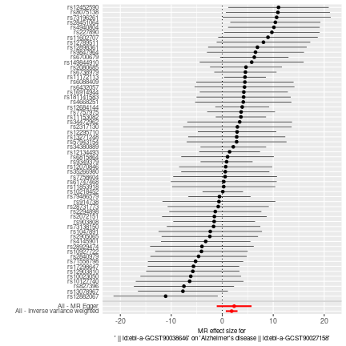
B
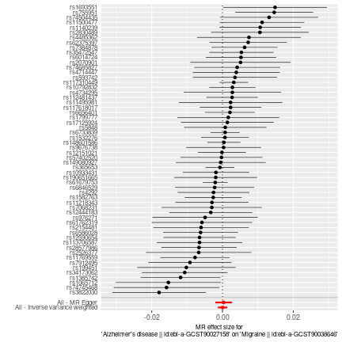
Figure S2： Funnel plots of the association between migraine and AD using four MR methods. A: Evaluation the effect of migraine on AD B: Evaluation the effect of AD on migraine. MR Mendelian randomization

A
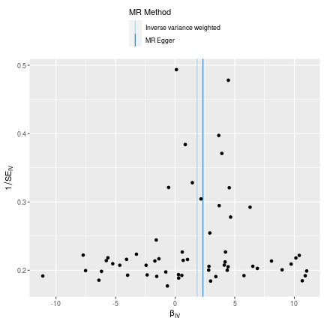
B
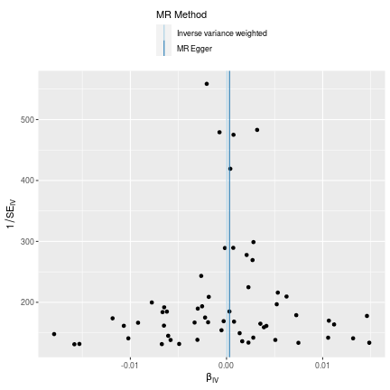
Figure S3：Forest plot of the MR results between migraine and AD using four MR methods. A: Evaluation the effect of migraine on AD B: Evaluation the effect of AD on migraine. MR Mendelian randomization

