**SUPPLEMENTARY MATERIAL**

**Table e-1: IgA Levels per Treatment**

|  |  |  |  |  |  |
| --- | --- | --- | --- | --- | --- |
| **IgA Absolute Value (g/L)** | | | | | |
| **Treatment #** | **Total number of patients** | **Mean** | **95% CI** | **Minimum Value** | **Maximum Value** |
| 1 | 224 | 1.9 | (1.80; 2.01) | 0.45 | 4.5 |
| 2 | 238 | 1.91 | (1.80; 2.01) | 0.27 | 4.51 |
| 3 | 199 | 1.84 | (1.73; 1.95) | 0.22 | 4.36 |
| 4 | 163 | 1.8 | (1.67; 1.92) | 0.22 | 4.23 |
| 5 | 93 | 1.75 | (1.61; 1.90) | 0.46 | 3.94 |
| 6 | 50 | 1.75 | (1.57; 1.92) | 0.7 | 3.1 |
| 7 | 23 | 1.49 | (1.22; 1.77) | 0.79 | 2.71 |
| 8 | 6 | 1.56 | (0.84; 2.27) | 0.84 | 2.54 |
| 9 | 1 | 2.05 |  | 2.05 | 2.05 |
| 10 | 2 | 1.77 | (0.63; 2.91) | 1.68 | 1.86 |

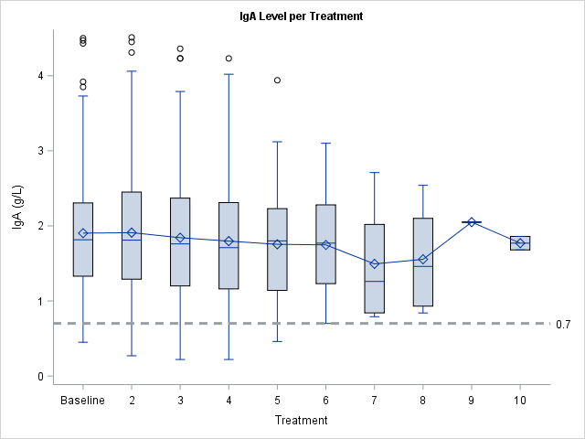

Average values for IgA (g/L) at each treatment time point. The dashed line in the graph indicates the hypogammaglobulinemia threshold of 0.7 g/L.

**Table e-2: IgG Levels per Treatment**

|  |  |  |  |  |  |
| --- | --- | --- | --- | --- | --- |
| **IgG Absolute Value (g/L)** | | | | | |
| **Treatment #** | **Total number of patients** | **Mean** | **95% CI** | **Minimum Value** | **Maximum Value** |
| 1 | 224 | 9.04 | (8.76; 9.32) | 1 | 16.4 |
| 2 | 237 | 9.22 | (8.97; 9.47) | 4.44 | 18.3 |
| 3 | 199 | 9.07 | (8.81; 9.34) | 3.22 | 15.4 |
| 4 | 163 | 8.69 | (8.44; 8.94) | 4.4 | 13.4 |
| 5 | 93 | 8.26 | (7.94; 8.59) | 4.07 | 11.62 |
| 6 | 51 | 8.14 | (7.70; 8.59) | 5.1 | 11.4 |
| 7 | 23 | 8.37 | (7.66; 9.07) | 5.55 | 11.07 |
| 8 | 6 | 7.66 | (5.28; 10.04) | 4.35 | 10.1 |
| 9 | 1 | 9.88 |  | 9.88 | 9.88 |
| 10 | 2 | 8.52 | (5.60; 11.44) | 8.29 | 8.75 |

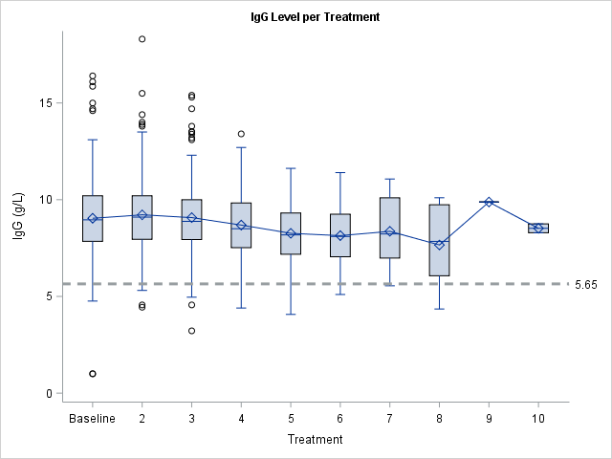

Average values for IgG (g/L) at each treatment time point. The dashed line in the graph indicates the hypogammaglobulinemia threshold of 5.65 g/L.

**Table e-3: IgM Levels per Treatment**

|  |  |  |  |  |  |
| --- | --- | --- | --- | --- | --- |
| **IgM Absolute Value (g/L)** | | | | | |
| **Treatment #** | **Total number of patients** | **Mean** | **95% CI** | **Minimum Value** | **Maximum Value** |
| 1 | 224 | 1.03 | (0.94; 1.11) | 0 | 4.9 |
| 2 | 238 | 0.81 | (0.73; 0.88) | 0.14 | 4.9 |
| 3 | 199 | 0.74 | (0.66; 0.82) | 0.05 | 4.6 |
| 4 | 163 | 0.67 | (0.59; 0.75) | 0.1 | 3.77 |
| 5 | 92 | 0.68 | (0.57; 0.79) | 0.1 | 3.85 |
| 6 | 50 | 0.55 | (0.46; 0.63) | 0.08 | 1.38 |
| 7 | 23 | 0.57 | (0.42; 0.73) | 0.07 | 1.36 |
| 8 | 6 | 0.64 | (0.34; 0.94) | 0.4 | 1.17 |
| 9 | 1 | 0.79 |  | 0.79 | 0.79 |
| 10 | 2 | 0.85 | (-1.06; 2.76) | 0.7 | 1 |

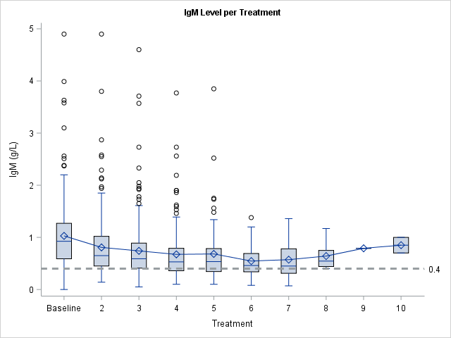

Average values for IgM (g/L) at each treatment time point. The dashed line in the graph indicates the hypogammaglobulinemia threshold of 0.4 g/L.

**Table e-4: IgA Hypogammaglobulinemia Associations with Demographics**

|  |  |  |  |  |  |  |  |  |
| --- | --- | --- | --- | --- | --- | --- | --- | --- |
| **Demographics in patients with and without one hypogammaglobulinemia event** | | | | | | | | |
|  | **No hypogammaglobulinemia** | | | **At least 1 Hypogammaglobulinemia Event** | | |  |  |
|  |  | **Number of patients** | **%** |  | **Number of patients** | **%** | **Odds Ratio (95% CI)** | **p value** |
|  | **Mean** | **Mean** |
| **Age** | 41. 4 (40.2; 42.6) | 250 | 96.5 | 40.7 (30.7;50.6) | 9 | 3.5 | 0.99 (0.93;1.06) | 0.8153 |
| **Duration of Disease** | 6.7 (5.8; 7.6) | 243 | 96.4 | 5.1 (0;10.46) | 9 | 3.6 | 0.97(0.87;1.08) | 0.527 |
| **EDSS** | 3.2 (3.0; 3.5) | 245 | 96.5 | 2.7 (2.1;3.3) | 9 | 3.5 | 0.82(0.54;1.26) | 0.3659 |
|  |  |  |  |  |  |  |  |  |
| **# of prior DMTs** | **At least one** | 182/189 | 96.3 | **At least one** | 7/189 | 3.7 | 1.29(0.26;6.36) | 0.7557 |
|  | **None** | 67/69 | 97.1 | **None** | 2/69 | 2.9 |  |  |
|  |  |  |  |  |  |  |  |  |
| **MS phenotype** | **PPMS** | 31/32 | 96.9 | **PPMS** | 1/32 | 3.1 | 0.88(0.11;7.30) | 0.9082 |
|  | **RRMS** | 219/227 | 96.5 | **RRMS** | 8/227 | 3.5 |  |  |
|  |  |  |  |  |  |  |  |  |
| **Hypogammaglobulinemia at baseline** | **No** | 209/211 | 99.1 | **No** | 2/211 | 0.9 | 0.00(0.00;0.05) | <.0001 *** |
|  | **Yes** | 1/4 | 25 | **Yes** | 3/4 | 75 |  |  |

Values for multiple demographics in those with and without at least one IgA hypogammaglobulinemia event after treatment initiation. Percentages indicate percent of patients with and without hypogammaglobulinemia among those with data points for each category. The p value is based on bivariate logistic regression with Wald confidence interval. Values in parentheses indicate the 95% confidence interval (CI). *** = statistically significant (p < 0.05).

**Table e-5: IgG Hypogammaglobulinemia Associations with Demographics**

|  |  |  |  |  |  |  |  |  |
| --- | --- | --- | --- | --- | --- | --- | --- | --- |
| **Demographics in patients with and without one hypogammaglobulinemia event** | | | | | | | | |
|  | **No hypogammaglobulinemia** | | | **At least 1 Hypogammaglobulinemia Event** | | |  |  |
|  |  | **Number of patients** | **%** |  | **Number of patients** | **%** | **Odds Ratio (95% CI)** | **p value** |
|  | **Mean** | **Mean** |
| **Age** | 41.3 (40.1;42.5) | 248 | 95.8 | 44.2 (38.8;49.6) | 11 | 4.2 | 1.03(0.97;1.10) | 0.3312 |
| **Duration of Disease** | 6.6 (5.7;7.6) | 241 | 95.6 | 5.9 (1.14;10.7) | 11 | 4.4 | 0.99(0.90;1.08) | 0.7421 |
| **EDSS** | 3.2 (3.0;3.4) | 243 | 95.7 | 3.8 (2.8;4.8) | 11 | 4.3 | 1.23(0.87;1.75) | 0.2338 |
|  |  |  |  |  |  |  |  |  |
| **# of prior DMTs** | **At least one** | 178/189 | 94.2 | **At least one** | 11/189 | 5.8 | 8.95(0.51;156.94) | 0.1337 |
|  | **None** | 69/69 | 100 | **None** | 0/69 | 0 |  |  |
|  |  |  |  |  |  |  |  |  |
| **MS phenotype** | **PPMS** | 32/32 | 100 | **PPMS** | 0/32 | 0 | 0.29(0.02;5.25) | 0.402 |
|  | **RRMS** | 216/227 | 95.2 | **RRMS** | 11/227 | 4.8 |  |  |
|  |  |  |  |  |  |  |  |  |
| **Hypogammaglobulinemia at baseline** | **No** | 203/206 | 98.5 | **No** | 3/206 | 1.5 | 0.02(0.00;0.11) | <.0001 *** |
|  | **Yes** | 5/9 | 55.6 | **Yes** | 4/9 | 44.4 |  |  |

Values for multiple demographics in those with and without at least one IgG hypogammaglobulinemia event after treatment initiation.

**Table e-6: IgM Hypogammaglobulinemia Associations with Demographics**

|  |  |  |  |  |  |  |  |  |
| --- | --- | --- | --- | --- | --- | --- | --- | --- |
| **Demographics in patients with and without one hypogammaglobulinemia event** | | | | | | | | |
|  | **No hypogammaglobulinemia** | | | **At least 1 Hypogammaglobulinemia Event** | | |  |  |
|  |  | **Number of patients** | **%** |  | **Number of patients** | **%** | **Odds Ratio (95% CI)** | **p value** |
|  | **Mean** | **Mean** |
| **Age** | 41.5 (40.1;42.9) | 174 | 67.2 | 41.3 (39.1;43.5) | 85 | 32.8 | 1.00(0.97;1.02) | 0.8645 |
| **Duration of Disease** | 6.6 (5.4;7.7) | 169 | 67.1 | 6.7 (5.3;8.1) | 83 | 32.9 | 1.00(0.97;1.04) | 0.9164 |
| **EDSS** | 3.2 (2.9;3.4) | 170 | 66.9 | 3.3 (3.0;3.7) | 84 | 33.1 | 1.05(0.90;1.22) | 0.5617 |
|  |  |  |  |  |  |  |  |  |
| **# of prior DMTs** | **At least one** | 124/189 | 65.6 | **At least one** | 65/189 | 34.4 | 1.28(0.70;2.34) | 0.4141 |
|  | **None** | 49/69 | 71 | **None** | 20/69 | 29 |  |  |
|  |  |  |  |  |  |  |  |  |
| **MS phenotype** | **PPMS** | 22/32 | 68.8 | **PPMS** | 10/32 | 31.3 | 0.92(0.42;2.04) | 0.8401 |
|  | **RRMS** | 152/227 | 67 | **RRMS** | 75/227 | 33 |  |  |
|  |  |  |  |  |  |  |  |  |
| **Hypogammaglobulinemia at baseline** | **No** | 147/197 | 74.6 | **No** | 50/197 | 25.4 | 0.02(0.00;0.15) | 0.0002*** |
|  | **Yes** | 0 | 5.6 | **Yes** | 17/18 | 94.4 |  |  |

Values for multiple demographics in those with and without at least one IgM hypogammaglobulinemia event after treatment initiation.

**Table e-7: Absolute Lymphocyte Count**

|  |  |  |  |  |  |
| --- | --- | --- | --- | --- | --- |
|  | **At 1st treatment** | | **Any time after 1st treatment** | |  |
| **Absolute Lymphocyte Count (109/L)** | **n/N** | **%** | **n/N** | **%** | **p Value** |
| ≥1 | 212/266 | 79.7 | 185/262 | 70.6 | 0.0156 |
| Grade 1: 0.8-0.999 | 14/266 | 5.3 | 43/262 | 16.4 |  |
| Grade 2: 0.5-0.799 | 16/266 | 6 | 31/262 | 11.8 |  |
| Grade 3: 0.2-0.499 | 21/266 | 7.9 | 3/262 | 1.1 |  |
| Grade 4: <0.2 | 3/266 | 1.1 | 0/262 | 0 |  |

Total number of patients in each lymphocyte category at first treatment and at any time after 1st treatment. For values after 1st treatment, only the lowest grade was identified per patient to avoid double counting.

**Table e-8: Absolute Neutrophil Count**

|  |  |  |  |  |  |
| --- | --- | --- | --- | --- | --- |
|  | **At 1st treatment** | | **Any time after 1st treatment** | |  |
| **Absolute Neutrophil Count (109/L)** | **n/N** | **%** | **n/N** | **%** | **p Value** |
| ≥2 | 252/266 | 94.7 | 239/262 | 91.2 | 0.1526 |
| Grade 1: 1.5-2 | 12/266 | 4.5 | 17/262 | 6.5 |  |
| Grade 2: 1-1.499 | 2/266 | 0.8 | 4/262 | 1.5 |  |
| Grade 3: 0.5-0.999 | 0/266 | 0 | 1/262 | 0.4 |  |
| Grade 4: <0.5 | 0/266 | 0 | 1/262 | 0.4 |  |

Total number of patients in each neutrophil category at first treatment and at any time after 1st treatment. For values after 1st treatment, only the lowest grade was identified per patient to avoid double counting.