Appendix

Modified RAND Methodology

A modified RAND methodology was used to achieve consensus on several areas where it was felt by the primary authors (CH, JM) that there was significant enough clinical equipoise or controversy to merit a consensus based decision. The primary authors created consensus statements related to those topics and went through an iterative modified RAND process to optimize the statements and achieve consensus.

For the modified RAND process, a self-identified subgroup consisting of 14 of the overall guideline authors was created. The membership of the group is listed in table 1.

Table 1 – RAND Process Voting Membership
Member Name | Practice Province
Ronak Kapadia | Alberta
Penny Smyth | Alberta
Katayoun Alikhani | Alberta
Gregg Blevins | Alberta
Adrian Budhram | Ontario
Jen McCombe | Alberta
Christopher Uy | British Columbia
Julien Hebert | Ontario
Grayson Beecher | Alberta
Ilia Poliakov | Saskatchewan
John Brooks | Ontario
Kim Williams | Alberta
Nasser Alohaly | Ontario
Robert Carruthers | British Columbia

Each member was invited to submit votes rating their level of agreement with each statement and provide suggestions for improvement remotely using a Google Forms survey link. Members were identified by the email address used to complete the survey. Every statement was rated on a Likert scale from 1 to 9 indicating level of agreement with 1 signifying strong disagreement and 9 signifying strong agreement. Consensus was considered achieved if 90% of respondents provided a rating of 7 or higher. After each round of voting the responses and comments were distributed to the voting members for review and opened to further comments/suggestions.

Following each vote the consensus statements were modified by the primary authors based on the voter comments and then submitted for a repeat round of voting. All statements where the level of agreement met the pre-specified cut off for consensus where removed from future voting unless the primary authors felt additional small changes could improve overall agreement.

Five total rounds of voting were required to achieve the pre-specified level of agreement on all consensus statements. The vote distribution for each statement is detailed in Figures 1 through 13 below. For the first two rounds of voting all initial participants registered a vote. For rounds 3 and 4 only 11 participants responded within the allotted time window and only 9 votes were received for the last round of voting on a single statement. Respondents who did not submit votes in later round were still provided with opportunity to comment on the updated consensus statements.

Figure 1 – Level of Agreement on Utility of Testing for Anti-Thyroid Antibodies
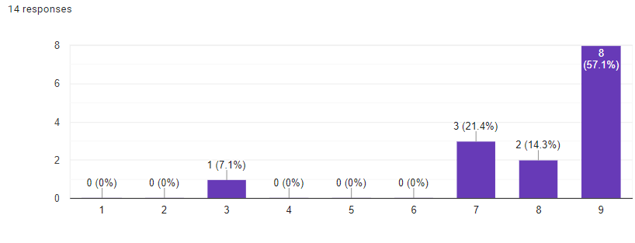
Figure 2 – Level of Agreement on First Line Treatment Protocol
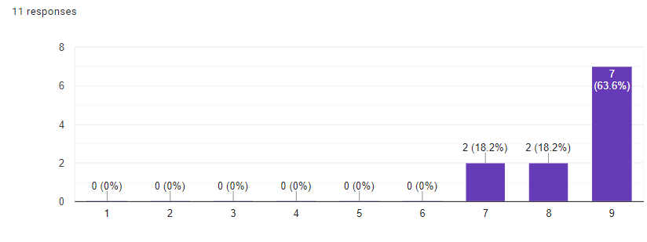
Figure 3 – Level of Agreement on Proposed Definition of Severity in AIE
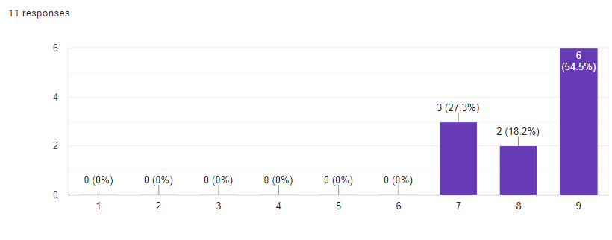
Figure 4 – Level of Agreement on use of Corticosteroid Taper after First Line Treatment
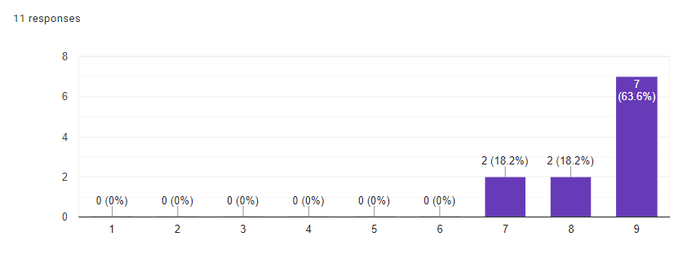
Figure 5 – Level of Agreement on Specific Corticosteroid Taper Regimen
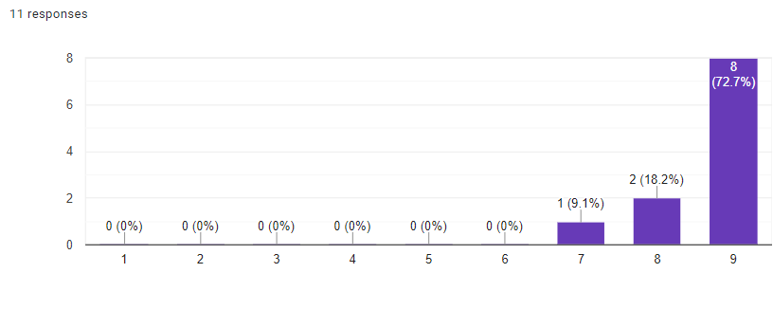
Figure 6 – Level of Agreement on Definition of Treatment Failure
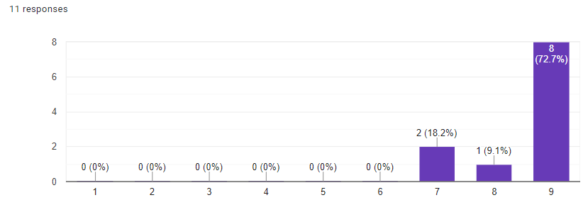

Figure 7 – Level of Agreement on Criteria for Whom Should Receive Second Line Therapy
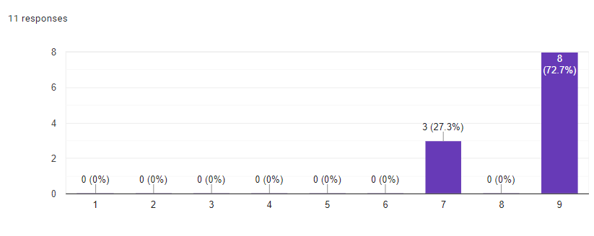
Figure 8 – Level of Agreement on Second Line Treatment Protocol for Cell Surface Antibody mediated AIE and Antibody Negative Patients
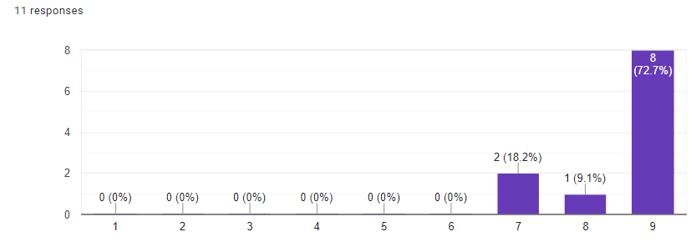
Figure 9 – Level of Agreement on Second Line Treatment Protocol in Patients with Intracellular Antibodies
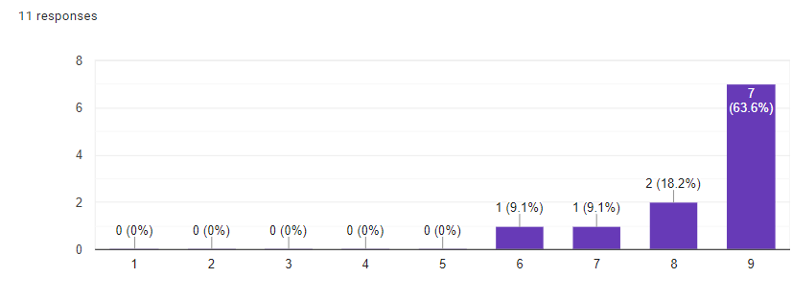
Figure 10 – Level of Agreement of Second Line Treatment Protocol in Patients with Associated Neoplasm
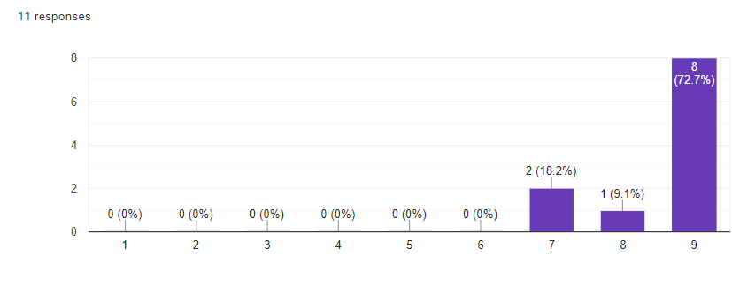

Figure 11 – Level of Agreement on Third Line Therapy Statement
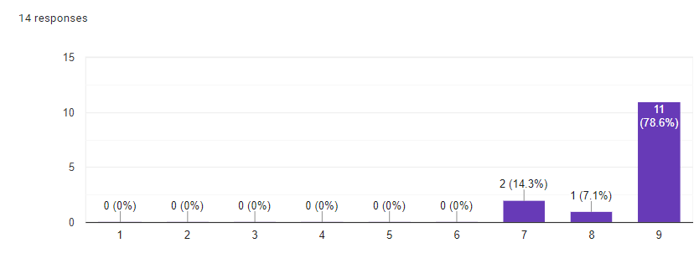
Figure 12 – Level of Agreement on Appropriateness of ‘Blind’ Oopherectomy in NMDAR-IgG AIE
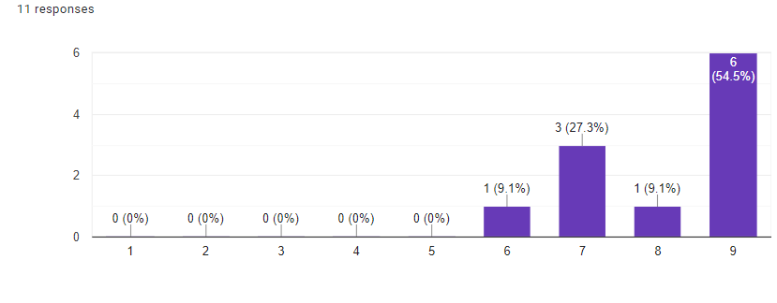
Figure 13 – Level of Agreement on Definition of Relapse in AIE
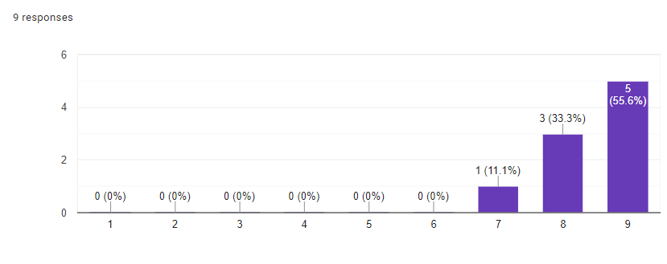

List of Clinical Centers with Expertise in Autoimmune Neurology

For an updated list of physicians/centers with expertise in Autoimmune Neurology please use the following link to the Anti-NMDA Receptor Encephalitis Foundation website: https://www.antinmdafoundation.org/country_cat/canada/

