**Online Appendix**

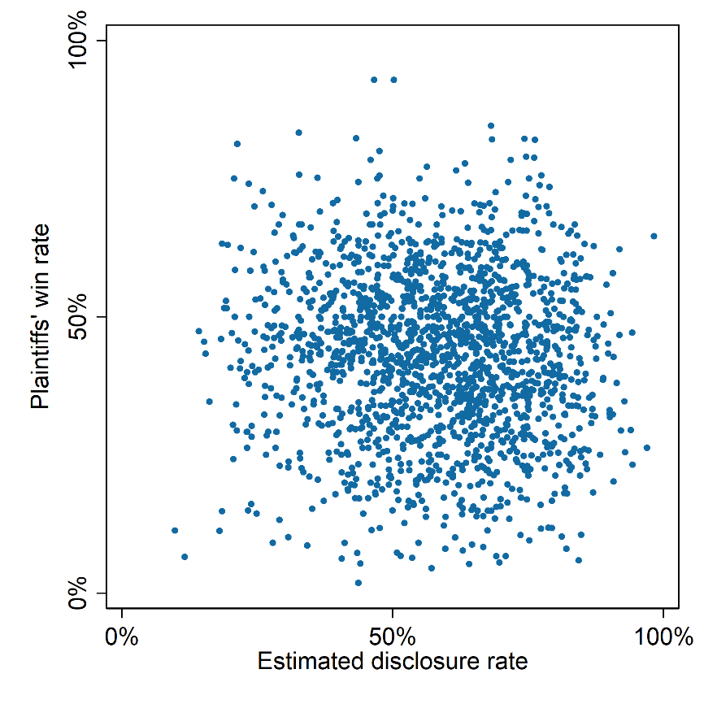

***Figure A1.*** *Estimated disclosure rate and plaintiffs’ win rate from 2014 to 2020*

1. **Examples of administrative cases**

We have included some examples of different types of cases in order to give readers who are not familiar with the Chinese legal system a more intuitive understanding of our categorization of cases.

The examples include: 1) a market supervision case (routine); 2) a case related to labor rights (routine); 3) an expropriation case (hard); 4) a police detention case (hard); 5) a case related to freedom of speech (political); 6) a case related to assembly (political); and 7) a case related to abnormal petition (political).

Certain cases, while not classified as “hard” in our study, may indeed have significant societal impact, such as those related to food safety or pollution. However, for the purposes of this paper, the distinction between routine and hard cases hinges on the degree of government interest involved. For instance, a food safety incident resulting in severe outcomes like food poisoning in a restaurant would constitute a serious civil infringement case. In contrast, administrative lawsuits involving food safety typically pertain to the market supervision bureau penalizing food manufacturers or restaurants for failing to uphold safety standards. These are part of the bureau’s regular obligations. In such instances, severe consequences may not have occurred yet, and the plaintiffs (the supervised entities) often simply express dissatisfaction with the administrative enforcement actions or discretionary standards of the market supervision bureau. We therefore do not categorize these as “hard” cases. To clarify, the government in such cases is merely experiencing minor complications in executing its statutory duties, not facing threats to its reputation or authority.

1. **A routine case of market supervision**

This market supervision case, which we categorize as routine, is from Jiangsu Province in 2016.[1] The case pertains to a company's flawed registration process, where the resolution of the shareholder meeting attended by all shareholders did not carry all necessary signatures and failed to meet statutory form requirements. The defendant, the market supervision bureau, failed to fulfill its duty of reasonable and prudent review in form and was overruled by the court. However, this case was merely a negligent mistake made by a lower-ranking clerk and was not a significant matter for the defendant to defend. The fact was clear enough, and the defeat was unlikely to undermine the authority of the market supervision bureau. A significant portion of market supervision cases are similar to this case.

The key part of this case is as follows (in Chinese):

本院认为：……本案中……申请人向被告提交的公司股东会决议显示，到会股东情况为全体股东，在全体股东签名处仅有陈某某签名，无另一股东的签名。尽管工商行政管理机关对公司登记申请材料以形式审查为主，但是形式审查不等于审查走形式。根据《中华人民共和国公司法》第四十二条第二款规定，股东会应当对所议事项的决定作成会议记录，出席会议的股东应当在会议记录上签名。而本案作为法定代表人变更依据的股东会决议并没有全体到会股东的签名，形式上不符合法定要求。被告作为公司登记机关未尽到形式上合理审慎的审查义务，以不符合法定形式的股东会决议为依据对第三人某某公司作出法定代表人变更登记主要证据不足，依法应予以撤销。

综上，依照《中华人民共和国行政诉讼法》第七十条第（一）项之规定，判决如下：

撤销被告徐州市云龙区市场监督管理局……的变更登记。

1. **A routine case of labor rights (work injury recognition)**

This labor rights case, which we categorize as routine, is from Guangdong Province in 2016. [2] The case pertains to the legitimacy of a work injury recognition issued by the human resource bureau. It is a typical case that appeared to be an administrative lawsuit but was actually a civil dispute between the plaintiff, the company, and the third party, the employee. The company refused to pay for the work injury, but the court held that the company bore the burden of proof since it claimed that the labor relation was invalid. Furthermore, the court confirmed the procedural legality of the human resource bureau. Ultimately, the court rejected the plaintiff's claim due to a lack of proper evidence.

The key part of this case is as follows (in Chinese):

本院认为：本案是人力社保行政确认纠纷。市人社局是中山市人民政府人力资源和社会保障行政部门，根据《工伤保险条例》第五条第二款、第二十条第一款的规定，具有负责本行政区域内工伤保险工作的主体资格，工伤认定是其法定职责。本案中，顺富建材厂对刘正军发生事故的时间和事实，以及将涉案工作交由莫华礼承包的事实以及对市人社局作出涉案认定工伤决定的法律依据没有异议。争议在于：一、刘正军与顺富建材厂是否存在劳动关系；二、市人社局作出涉案决定书的程序是否合法。

一、关于刘正军与顺富建材厂是否存在劳动关系的问题。根据市人社局对刘正军、顺富建材厂员工常世春的调查笔录、医院治疗资料以及法庭调查可知，刘正军的工资由顺富建材厂负责支付，工作由顺富建材厂统一安排，市人社局认定刘正军是顺富建材厂的员工，并无不当。顺富建材厂提出刘正军是由莫华礼雇请的主张，但在市人社局认定工伤期间至庭审期间，均没有提交实质证据证明。根据《工伤保险条例》第十九条第二款：“职工或者其近亲属认为是工伤，用人单位认为不是工伤的，由用人单位承担举证责任。”的规定，顺富建材厂应承担举证不能的责任。故对上述主张，本院不予采纳。

二、关于市人社局作出涉案决定书的程序是否合法的问题。市人社局向顺富建材厂厂内办公室送达举证通知书，协助通知书，由该厂员工梁伟生签收。根据市人社局对顺富建材厂的现场勘查图、梁伟生的参保证明以及法庭调查相互印证，该厂正常经营，梁伟生为该厂员工。在市人社局向顺富建材厂送达举证通知书及协助调查通知书时均在顺富建材厂厂区，并已代为签收上述通知书，该送达程序合法。顺富建材厂提出市人社局没有向该厂送达举证通知书及协助调查通知书的主张，本院不予支持。

综上所述，顺富建材厂要求撤销市人社局作出的中人社工认[2016]05009号认定工伤决定书的诉讼请求，理由不能成立，本院予以驳回。依照《中华人民共和国行政诉讼法》第六十九条的规定，判决如下：

驳回原告中山市黄圃镇顺富新型建材厂的诉讼请求。

1. **A hard case of expropriation**

This expropriation case took place in Jilin Province in 2013.[3] The plaintiff in this case was dissatisfied with the compensation amount of RMB 196,134 yuan for his house. The court supported his claim, stating that the property evaluation report, which served as the basis for the compensation amount, had expired, and therefore overturned the government's decision. It is worth noting that the court did not directly determine a revised price, as the plaintiff only requested the revocation of the initial decision. As a result of the judgment, the government was required to engage in further negotiations with the house owner to reach a new agreement. This case could have significant implications for the accused government, as it would involve the payment of additional funds, and may potentially lead to other house owners coming forward with similar complaints. Furthermore, the progress of the expropriation and subsequent real estate development could be disrupted as a result.

The key part of this case is as follows (in Chinese):

……综上，原告特依据《中华人民共和国行政诉讼法》、《国有土地上的房屋征收与补偿条例》的相关规定，依法诉至贵院，请求判令撤销被告作出的镇政征字（2012）003号国有土地上房屋征收补偿决定。

本院认为：《国有土地上房屋征收与补偿条例》第十九条规定：”对被征收房屋价值的补偿，不得低于房屋征收决定公告之日被征收房屋类似房地产的市场价格。被征收房屋的价值，由具有相应资质的房地产价格评估机构按照房屋征收评估办法评估确定”。本案针对原告被征收房屋作出的房地产估价报告，报告使用期限自2011年7月11日至2012年1月11日，而被告依据该房地产估价报告于2012年2月17日作出被诉征收补偿决定。可见被告在作出被诉征收补偿决定时其依据的房地产估价报告已超过估价使用期限。被告在该估价报告已超过使用期限的情况下，采纳其作为征收补偿决定的依据，应认定被诉的征收补偿决定证据不足，依法应予撤销。依据《中华人民共和国行政诉讼法》第七十条（一）的规定，判决如下：

撤销被告镇赉县人民政府作出的镇政征字（2012）003号国有土地上房屋征收补偿决定书。

1. **A hard case of police detention**

This police detention case is from Zhejiang Province in 2014.[4] The case concerns an excessive detention decision made by the police. The plaintiff was detained by the police (the defendant) for a violent act, kicking a door, during an argument over his deserved payment in the meeting room of the village committee, the third party in this case. Even the third party, who was the victim, admitted in court that the detention penalty was excessive. Ultimately, the court overturned the detention decision, stating that the detention was unnecessary due to the lack of severity of the plaintiff's actions.

The key part of this case is as follows (in Chinese):

……被告乐清市公安局认定原告……在向第三人乐清市大荆镇油岙村村民委员会索讨债款无果的情形下，故意脚踹油岙村会议室大门，导致门锁损坏，大门右下角处出现凹陷，不能正常关闭，影响了村委会正常办公。……决定对原告给予行政拘留五日的处罚。……

……

本院认为……本案系因第三人未能及时偿付原告工程款而引发，原告脚踹第三人会议室大门一下，导致门锁固定翼螺丝松动，这一损害后果轻微。作为被侵害人的第三人庭审表示，村委会大门的锁原本不牢固，其在案发后曾去派出所要求教育一下原告即可，被告对原告予以拘留处罚过重。综上……对其处以行政拘留五日的决定，明显存在过罚失当，属适用法律错误，应予以撤销。原告提出被告变相延长限制人身自由的时间并施加不当压力进行逼供的主张，因未能提供确凿证据，本院不予采信。但鉴于本案案情并不复杂，被告在调查取证完成后继续留置原告12个小时，有失妥当。据此，依照《中华人民共和国行政诉讼法》第五十四条第（二）项第2目的规定，判决如下：

撤销被告乐清市公安局于2014年4月16日作出的乐公行罚决字（2014）第2014号行政处罚决定。

1. **A political case of freedom of speech**

This free speech case is from Hebei Province in 2018,[5] and it is the only case where the plaintiff won, as mentioned in section 7.2 of the paper. The plaintiff argued for his right to free speech, citing articles from the Constitution, but was unsurprisingly ignored by the court. In the reasoning paragraph, the court acknowledged the plaintiff's illegal behavior and the appropriateness of the police's decision but pointed out a procedural flaw in the police's notification process. Ultimately, the court ruled the police decision as illegal based on this procedural flaw. Although the plaintiff won the case, it can hardly be interpreted as a victory for freedom of speech.

The key part of this case is as follows (in Chinese):

……本院认为，原告在网络上发布：“兄弟姐妹们好！经代表商量。下周二去省，北京上访。希望有上访经验的人员踊跃报名积极参与，误工费100元，包吃住，但要节省开支。有报名的加我微信。给报名的保密。为了维权有人出人有力出力”的信息并保管、支付信访资金的事实，有原告的询问笔录、微信红包转账明细、县联席办出具的说明等证据予以证实，原告的行为属于以其他方法故意扰乱公共秩序的行为，被告根据《中华人民共和国治安管理处罚法》第25条被告认定事实清楚，证据确实充分。第一项之规定，对原告处以“行政拘留10日，并处罚款500元”的行政处罚，适用法律正确。……但是被告提交的向原告送达传唤证的送达回证和被传唤人家属通知书两份证据与被告委托代理人当庭陈述明显矛盾，该两份证据不具有真实性，其送达和通知程序违法。……

综上，依照中华人民共和国行政诉讼法》第七十四条第一款、最高人民法院关于适用《中华人民共和国行政诉讼法》的解释第九十六条、《最高人民法院关于审理行政赔偿案件若干问题的规定》第二十八条之规定，判决如下：

一、确认被告肃宁县公安局对原告李彦平作出的肃公（城）行罚决字【2017】0318号行政处罚决定违法。

二、驳回原告李彦平其他诉讼请求。

1. **A political case of assembly**

This case is from Shanxi Province in 2016.[6] The plaintiff was alleged to have participated in an illegal assembly, and the court confirmed the illegality of the plaintiff's actions. However, the court also found that the police had violated statutory procedures and dismissed the plaintiff's request. It appears that the court considered the procedural violation to be acceptable.

The key part of this case is as follows (in Chinese):

……经审理查明……公司职工因单位欠薪、不缴纳养老金为由，既未向相关机关提出申请，也未经相关单位同意，自行在吕梁市委南大门附近非法聚集，并将横幅悬挂在路边栅栏上，原告参与其中。同日被告立案后经调查取证，履行相关程序后当日根据《中华人民共和国治安管理处罚法》第二十三条第一款第二项之规定，作出了行罚决字【2016】001452号行政处罚决定，决定对原告拘留七日（已执行）。

同时查明，被告对原告作出拘留七日的处罚决定未经过被告机关行政负责人集体讨论决定。

本院认为，原告单位职工因单位欠薪、欠养老金为由，到吕梁市委南大门附近静坐、拉横幅，原告参与其中，属于集会示威。集会示威应当依照《中华人民共和国集会游行示威法》的相关规定提出申请，经批准后才可进行，未经申请、未经同意进行集会示威显属违法。拘留七日属于较重的行政处罚，根据《中华人民共和国行政处罚法》的规定应当经过行政机关集体负责人讨论决定，被告未经此程序就对原告作出拘留七日的行政处罚属程序瑕疵。依照《中华人民共和国行政诉讼法》第六十九条的规定，判决如下：

驳回原告李某某的诉讼请求。

1. **A political case of abnormal petition**

This case is from Guangdong Province in 2015.[7] The plaintiff was alleged to have participated in an illegal petition to Beijing and was subsequently detained for 10 days by the local police. However, the police failed to provide sufficient evidence to support the severity of the plaintiff's illegal action. As a result, the court deemed the penalty imposed by the police to be inappropriate. In the judgment, the judge modified the penalty from 10 days of detention to a warning and also awarded compensation to the plaintiff for the 10 days of detention.

The key part of this case is as follows (in Chinese):

本院认为……可以认定原告存在扰乱其他公共场所（天安门地区）秩序，应当受到行政处罚。……本案原告的违法行为尚未造成较大影响，较严重后果，揭阳市公安局揭东分局也未举证证明存在“情节较重”的情形……揭阳市公安局揭东分局对原告处以10日行政拘留的处罚，明显违背了《中华人民共和国治安管理处罚法》第五条第一款规定的原则，属于明显不当的处罚，依法应予变更。结合具体案情，本院依法将该处罚结果变更为警告。被告揭阳市揭东区人民政府作出的复议决定，依法应一并予以撤销。

本案揭阳市公安局揭东分局对原告作出的行政处罚，已执行完毕，侵犯了原告的合法权益，根据《中华人民共和国国家赔偿法》第三条第一款（一）项的规定，揭阳市公安局揭东分局应承担相应的赔偿责任。揭阳市揭东区人民政府复议程序合法，依法不应承担赔偿责任。判决如下：

一、变更被告揭阳市公安局揭东分局作出的揭东公（城西）行罚决字[2015]00093号行政处罚决定书中行政拘留10日的处罚决定为警告。

二、撤销被告揭阳市揭东区人民政府作出的揭东府行复[2015]7号行政复议决定。

三、被告揭阳市公安局揭东分局应于本判决生效之日起15日内赔偿原告吴燕琴经济损失2197.2元。

四、驳回原告吴燕琴的其他诉讼请求。

1. **Estimating overall case volume**

The centralized publicity venue, China Judgements Online, does not publish all judicial opinions. To estimate the exact number of cases accepted each year, we employ the Minimum-Variance Unbiased Estimator (MVUE), famously used to solve the German Tank Model. MVUE is a statistical model that estimates the maximum number, N, of a monotonically increasing population, such as $\left\{1,2, 3, …, N\right\}$, using a series of random samples $\left\{k_{i}\right\}, i=1, 2, …, n$. The minimum-variance unbiased estimator for N is given by (Goodman, 1952):

$$\hat{N}=\frac{n+1}{n}\underset{i}{max⁡}{k_{i}}-1$$

With this model, we estimate the administrative caseload for all the courts in the dataset. Each administrative case has a unique case identity that contains the year of case acceptance, court label, case type, and a serial number. For example, the case "(2019)川0114行初32号" was accepted in 2019, labeled as "川0114," which represents Chengdu Xindu District People's Court. Furthermore, it is a first-instance administrative case (represented by "行初") with a serial number of 32. Therefore, we can use these serial numbers to construct random samples and estimate the total number of first-instance administrative cases accepted in Chengdu Xindu District People's Court in 2019. After accumulating all the estimates of all the courts, we can identify the national-wide caseload.

We compare our estimation with the official statistics of the SPC (Figure 3). The number of administrative first-instance cases closed every year is disclosed in the SPC's work report to the National People's Congress. Note that cases closed are different from cases accepted. When there is an upward trend in caseload, cases accepted would be ahead of cases closed, and vice versa. It is more accurate to use our estimates than the SPC’s official statistics to study case acceptance. As reported in Table A1, our estimation is very similar to the statistics of the SPC. The two data sources cross-validate each other, confirming the accuracy of our estimation.

|  |  |  |
| --- | --- | --- |
|  | Cases closed (reported by the SPC) | Cases accepted (estimation) |
| 2014 | 131,000 | 140,352 |
| 2015 | 199,000 | 230,940 |
| 2016 | 225,000 | 223,985 |
| 2017 | 237,000[8] | 241,729 |
| 2018 | 251,000 | 274,021 |
| 2019 | 284,000 | 292,664 |
| 2020 | 266,000 | 251,294 |

*Table A1. Comparation between SPC’s official statistics and our estimation*[9]

**A3. A brief introduction to the CFPS**

The CFPS, or China Family Panel Studies (中国家庭追踪调查 zhongguo jiating zhuizong diaocha), is a nationwide and biennial longitudinal survey conducted by the Institute of Social Science Survey at Peking University. The study covers 25 provinces, accounting for approximately 95% of mainland China's population, with the exception of Inner Mongolia, Xinjiang, Tibet, Hainan, Ningxia, and Qinghai provinces. It employs multistage probability sampling to gather information from individuals living in 14,960 sampled households, resulting in a total of 33,600 adult observations.[10]

The primary objective of the CFPS is to examine various aspects related to Chinese communities, families, and individuals. It is widely acknowledged as the most reliable social survey conducted in China, with research based on its data being published in numerous prestigious science and social science journals,[11] including the China Quarterly.[12]

**A4. A Note on judicial disclosure and our data**

In mid-2021, there were changes made to judicial publicity, and China Judgements Online began retracting cases, which include administrative cases, from public view. We have been closely monitoring the website and have noticed that administrative cases from 2021 onwards are rarely disclosed online. However, we do not see this as a significant threat to our study. We have been collecting data from China Judgements Online on a daily basis since 2017. Specifically, the data used in this study was gathered by mid-2021, prior to the onset of the withdrawal of cases. As a result, our dataset is even more extensive than what is currently accessible on the website. Furthermore, for our objective of examining the role of administrative litigation during the recent round of legal reform (spanning from 2014 to 2018 according to the SPC's five-year plan), the timeframe from 2014 to 2020 is adequate.

GOODMAN, L. A. 1952. Serial Number Analysis. *Journal of the American Statistical Association,* 47**,** 622-634.

1. Case No.: （2016）苏8601行初306号.
2. Case No.: （2016）粤2071行初653号.
3. Case No.: （2013）白洮行初字第3号.
4. Case No.: （2014）温乐行初字第53号.
5. Case No.: （2018）冀0926行初1号.
6. Case No.: （2016）晋1124行初176号.
7. Case No.: （2015）揭东法行初字第7号.
8. The SPC's work report in 2017 only disclosed the cumulative amount of the past five years, which was 913,000. Using this information, we can deduce the number of cases from 2013 to 2016 and infer that the number of cases in 2017 was 237,000.
9. Data are from the working reports of the SPC from 2014 to 2020.
10. See Xie, Yu, and Jingwei Hu. "An introduction to the China family panel studies (CFPS)." Chinese sociological review 47.1 (2014): 3-29.
11. For example, Xie Y, Zhou X. Income inequality in today’s China. Proceedings of the National Academy of Sciences, 2014,111(19)
12. For example, Liu, John Zhuang. "Public support for the death penalty in China: Less from the populace but more from elites." The China Quarterly 246 (2021): 527-544.