**Online Appendix**

**for “Anti-corruption Efforts, Public Perception of Corruption, and Public Evaluation of Local Government Performance in China”**

Table of Contents

Section I: Research Design 1

1-1 Chinese Translation of Survey Items 1

1-2 Measurements of Variables 4

1-3 Descriptive Statistics of Variables 5

1-4 Time Trends for Key Variables 6

1-5 The Mathematical Equations of the Model 8

Section II: Robustness Check of Baseline Results 8

Section Ⅲ: Mediating Effect of Public Perceptions of Corruption 11

4-1 Regression Results of Mediating Effect 11

4-2 Robustness Check of Mediating Effect 12

Section Ⅳ: The Regression Results After Excluding 2010 Samples 12

Section Ⅴ: Additional Analyses 15

5-1 Sub-samples with High versus Low Trust 15

5-2 Sub-samples with High and Low Pre-existing Provincial- and Individual- Level Perceptions of Corruption 16

5-3 Dynamic Effects of Anti-Corruption Efforts 18

# Section I: Research Design

## 1-1 Chinese Translation of Survey Items

**Table A1.** Chinese Translation of Survey Items

|  |  |  |
| --- | --- | --- |
| Variables | Survey items in English | Survey items in Chinese |
| Local Government Evaluation  (LGE) | Your overall evaluation of the work of the county or county-level city/district government in the past year is: ___  (1=Worse than before; 2= no good results; 3=not much good results; 4=some good results, 5=a considerable number of good results) | 您对去年本县或县级市/区政府工作的总体评价是：___  (1.比之前更糟了 2.没有成绩 3.没有多大成绩4.有一定成绩 5.有很大成绩) |
| Perception of Corruption Level  (CP) | How severe do you think government corruption is in our country?  (0 =not severe, 10 =very severe) | 您认为政府腐败问题在我国有多严重?  (0 代表不严重，10代表非常严重) |
| Interpersonal trust  (Itrust) | Generally speaking, do you think most people can be trusted, or do you have to be too careful with people?  (0 =as careful as possible, 1 =most people can be trusted.) | 一般来说，您认为大多数人是可以信任的，还是和人相处要越小心越好？  (0代表要越小心越好，1代表大多数人是可以信任的) |
| Please rate your trust in your neighbors on a scale of 0-10.  (0 =very distrust, 10 =very trust) | 请您根据对邻居的信任度在0-10的区间内打分。  (0代表非常不信任，10代表非常信任) |
| Please rate your trust in strangers on a scale of 0-10.  (0 =very distrust, 10 =very trust) | 请您根据对陌生人的信任度在0-10的区间内打分。  (0代表非常不信任，10代表非常信任) |
| Political trust (Ptrust) | Please rate your trust in your local government officials on a scale of 0-10.  (0 =very distrust, 10 =very trust) | 请您根据对本地政府官员的信任度在0-10的区间内打分。  (0代表非常不信任，10代表非常信任) |
| Have you had any of the following experiences with public officials?  You have a conflict with a public official, (2) you have been unfairly treated, (3) you have been unreasonably delayed, and (4) the public official has charged you.  (0 = no, 1 =yes). | 您与公职人员接触时是否有以下经历？  (1)您与公职人员产生冲突，(2)您受到不公平待遇，(3)您受到不合理延迟，(4)公职人员进行收费。  (0代表否，1代表是)。 |
| Age | What is your age? | 请问您的年龄是___? |
| Gender | What is your gender?  (0=female, 1=male) | 请问您的性别是___?  (0代表男性，1代表女性) |
| Level of Education  (Edu) | Please indicate your highest level of education.  (1=illiteracy or semi-illiteracy, 2 =primary school, 3 =junior high school, 4 =high school or technical secondary school or vocational high school, 5 =junior college, 6 = university undergraduate, 7 =master, 8 =Ph.D.) | 请问您的教育程度是？（1表示文盲、半文盲，2表示小学，3表示初中，4表示高中、中专、职业高中，5表示大专，6表示大学本科，7表示硕士，8表示博士） |
| Marital Status  (Marriage) | What is your current marital status?  (1 = unmarried, 2 =married (with a spouse), 3 =cohabiting, 4 =divorced and 5 =widowed) | 请问您目前的婚姻状况是___?  (1表示未婚，2表示已婚(有配偶)，3表示同居，4表示离婚，5表示丧偶) |
| Employment Status (Employ) | What is your current working status?  (0 = unemployed, 1 = employed, and 3 = lost labor ability) | 请问您当前的工作状态是___?  (0表示失业，1表示就业，3表示脱离劳动力) |
| Type of Residence  (Urban) | Where is your current residence?  (0 =rural, 1 =urban) | 请问您目前的居住地在___?  (0代表农村，1代表城市) |
| Religious Beliefs  (Religion) | Do you have any religious beliefs?  (0 =no, 1 =yes) | 请问您是否有宗教信仰?  (0代表无，1代表有) |
| Party Membership  (Party) | Are you a member of the CCP?  (0 =no,1 =yes) | 请问您是否是中共党员？  (0代表否，1代表是) |
| Internet Users  (Internet) | Do you surf the Internet?  (0 =no,1 =yes) | 请问您是否上网？  (0代表否，1代表是) |
| Household Income Per Capita  (Hincome) | What is the per capita income of your family? | 请问您家庭的人均收入有多少元？ |
| Political Fear | Whether the village public officials are present during the interviewer visits?  (0 =present, 1 =present) | 采访者访问时村官是否在场?  (0代表不在场，1代表在场) |

## 1-2 Measurements of Variables

**Table A2.** Variables

|  |  |
| --- | --- |
| Variables | Variable Definitions |
| Local Government Evaluation (LGE) | 1=worse than before; 2= no good results; 3=not much good results; 4=some good results, 5=a considerable number of good results |
| Anti-corruption  (AntiCorr) | The numbers of government official prosecuted were divided by the total number of government officials and then multiplied by 100 |
| Perception of Corruption Level[1]  (CP) | From 0=the corruption is not severe to 10 =the corruption is very severe |
| Age | Age of respondents |
| Gender | 0=female; 1=male |
| Level of Education  (Edu) | 1=illiteracy or semi-illiteracy; 2=primary school; 3=junior high school; 4=high school or technical secondary school or vocational high school; 5=junior college; 6=university undergraduate; 7=master degree, 8=Ph.D. |
| Marital Status  (Marriage) | 0=otherwise; 1=married |
| Employment Status  (Employ) | 0=otherwise; 1=employed |
| Types of Residence  (Urban) | 0= rural; 1=urban |
| Religious Beliefs  (Religion) | 0 =no; 1=yes |
| CPC Party Membership  (Party) | 0 =no; 1=yes |
| Internet Uers  (Internet) | 0 =no; 1=yes |
| Household Income Per Capita  (Hincome) | Ln (Household income per capita+1) |
| GDP | Ln (Provincial level GDP per capita) |

## 1-3 Descriptive Statistics of Variables

As shown in Table A3, the average value of respondents’ evaluation of local governments is 3.485 in a range of 1 to 5, indicating that a relatively positive evaluation of local government performance among Chinese public. However, the average rating of the severity of corruption in China stands at 6.529, on a scale of 0 to 10. This suggests that, on average, the Chinese public perceive existing corruption as severe. The average level of anti-corruption efforts in Chinese provinces is 0.242%, which means that about 24 out of every 10,000 civil servants have faced prosecution for corruption and bribery. Moreover, the maximum value (Max=0.399) and mean value of anti-corruption efforts are 5.47 times and 3.38 times of the minimum value (Min=0.073) respectively.

**Table A3.** Descriptive Statistics of Variables

|  |  |  |  |  |  |
| --- | --- | --- | --- | --- | --- |
| Variable | Obs | Mean | Std.Dev. | Min | Max |
| LGE | 74728 | 3.485 | 0.916 | 1 | 5 |
| AntiCorr | 69697 | 0.242 | 0.053 | 0.073 | 0.399 |
| CP | 59889 | 6.529 | 2.862 | 0 | 10 |
| Age | 79220 | 49.230 | 14.153 | 16 | 94 |
| Gender | 79220 | 0.478 | 0.500 | 0 | 1 |
| Edu | 78492 | 2.502 | 1.295 | 1 | 8 |
| Marriage | 79219 | 0.876 | 0.329 | 0 | 1 |
| Employ | 66351 | 0.663 | 0.473 | 0 | 1 |
| Urban | 78485 | 0.449 | 0.497 | 0 | 1 |
| Religion | 79214 | 0.020 | 0.140 | 0 | 1 |
| Party | 77,608 | 0.077 | 0.266 | 0 | 1 |
| Internet | 79,220 | 0.546 | 0.498 | 0 | 1 |
| Hincome | 77009 | 9.135 | 1.132 | 0 | 15.243 |
| GDP | 79217 | 9.098 | 0.547 | 7.703 | 10.622 |

## 1-4 Time Trends for Key Variables

We plotted the temporal trends of local government evaluation, anti-corruption, and perceived corruption in 25 Chinese provinces over the years (See Figure A1). Generally, local government evaluations improved and perceived corruption decreased as anti-corruption efforts increased over time.

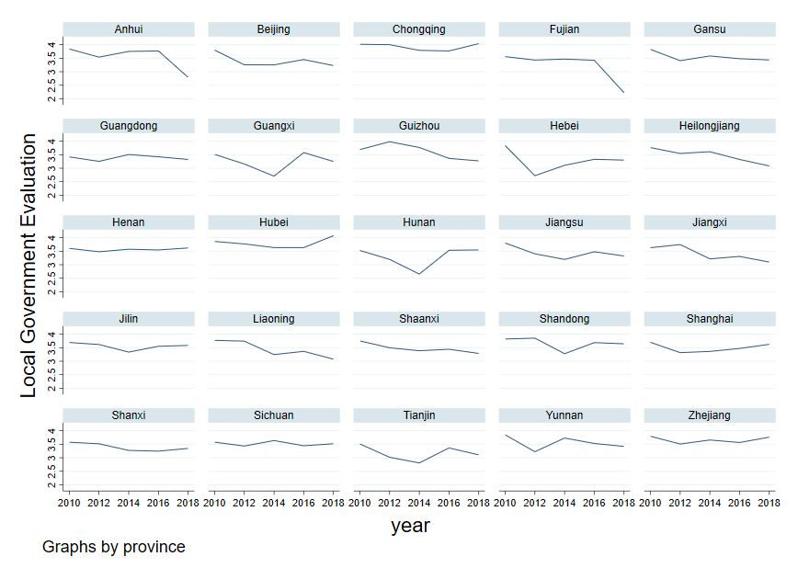

1. Trends of the Mean Value of Local Government Evaluation in 25 Chinese Provinces, 2010, 2012, 2014, 2016, 2018

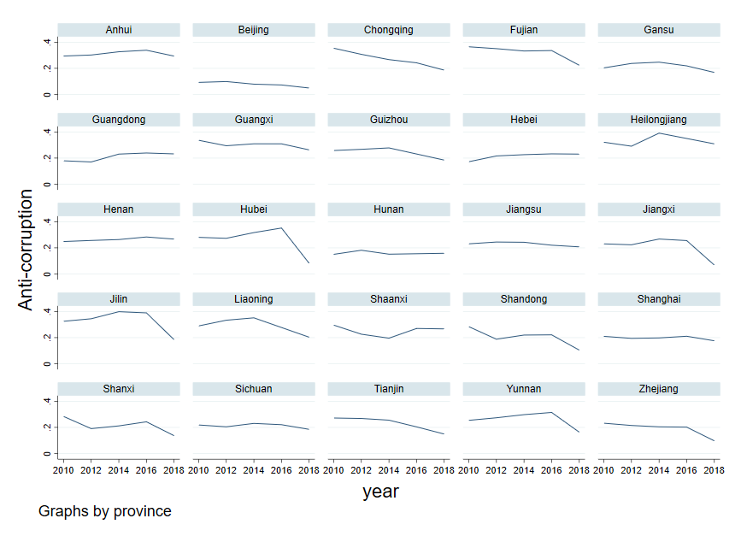

1. Trends of the Mean Value of Anti-Corruption Efforts in 25 Chinese Provinces, 2010, 2012, 2014, 2016, 2018

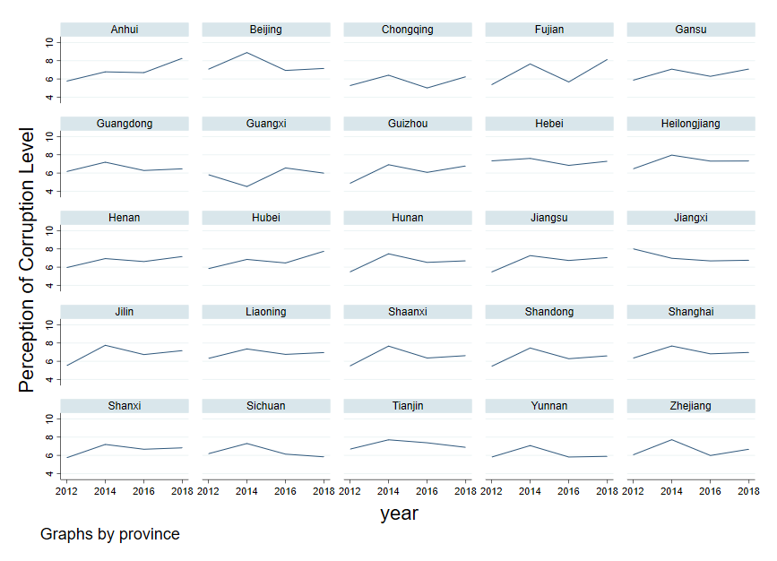

1. Trends of the Mean Value of Public Perception of Corruption in 25 Chinese Provinces, 2012, 2014, 2016, 2018

**Figure A1.** Trends of Key Variables over Years

## 1-5 The Mathematical Equations of the Model

Mathematical equations for our models were specified as follows. Model (1) regressed public evaluation on anti-corruption efforts while accounting for the inclusion of control variables. Models (2) and (3) are stepwise regressions[2] for testing whether public perception of corruption can mediate the relationship between anti-corruption efforts and local government evaluation.

${LGE}_{it}=α+β{AntiCorr}_{it-1}+φ{Control}_{it}+{Individual}_{i}+{Year}_{t}+{Province}_{i}+ε_{it}$ (1)

${CP}_{it}=α+β{AntiCorr}_{it-1}+φ{Control}_{it}+{Individual}_{i}+{Year}_{t}+{Province}_{i}+ε_{it}$ (2)

$${LGE}_{it}=α+β{AntiCorr}_{it-1}+γ{CP}_{it}+φ{Control}_{it}+{Individual}_{i}+{Year}_{t}+$$

${Province}_{i}+ε_{it}$ (3)

Where ${LGE}_{it}$ represents the evaluation of local government by respondent *i* in year *t*, ${AntiCorr}_{it-1}$ represents the scores of anti-corruption efforts in the year of *t-1* in the province where respondent *i* resides, ${CP}_{it}$ represents the perception of existing corruption by respondent *i* in year of *t*, ${Control}_{it}$ is the matrix of covariates that are controlled, $α$ is a constant term, ${Individual}_{i}$, ${Year}_{t}$ and ${Province}_{i}$ represent individual, year and province fixed effects, respectively, $ε_{it}$ is the random disturbance term.

# Section II: Robustness Check of Baseline Results

Four steps for robustness test were adopted to see whether the positive effects of anti-corruption efforts on public evaluation of local governments persist:

First, considering that respondents may be biased to support for the government due to political fear,[3] as shown in columns (1) to (2) in Table A4, we re-run our analyses first controlling for political fear and then excluding 282 respondents from the analysis in whom rural public officials were present during the interviewers’ visits. To measure political fear, interviewers were instructed to record “whether the village public officials were present during the interviewers’ visits” (1=Yes; 0=No).

Second, we employed an alternative measurement of anti-corruption. We replaced the numbers of governmental officials prosecuted by the procuratorate with the numbers of investigated corruption cases and calculated the ratio of numbers of investigated corruption cases to the numbers of public officials (*AntiCorr1t-1*). The results were shown in column (3) in Table A4.

Third, we adopted an alternative estimation model—Ordered Probit Model given that public evaluation of local government is an ordinal variable. The results were reported in column (4) in Table A4.

Fourth, we used 18th National Congress 2012 as an exogenous policy shock, and constructed the Difference-in-Differences (DID) model as follows:

${LGE}_{it}=α+β{Treat}_{i}*{Post}_{t}+φ{Control}_{it}+{Individual}_{i}+{Year}_{t}+{Province}_{i}+ε_{it}$ (4)

Where ${LGE}_{it}$ represents the evaluation of local government by respondent *i* in year *t*, ${ Treat}_{i}$ is a grouped dummy variable, which is grouped according to the mean value of the anti-corruption efforts in 2012: When the value of anti-corruption efforts of the province is lower than the mean value, the observations in this province are coded as 1 as treatment group (*Treat* = 1). Otherwise, *Treat* was coded as 0. ${Post}_{t}$ is a time dummy variable, which equals 1 for years of 2014-2018 as the post-treatment period (*Post* = 1) and 0 for years of 2010-2012 as the pre-treatment period. Therefore, the interaction variable (${Treat}_{i}*{Post}_{t}$) that equals 1 for observations in the treatment group (*Treat*=1) during the post-treatment period (*Post*=1) and 0 otherwise. This term captures the differential impact of the treatment and allow us to examine whether the policy change in anti-corruption efforts in the 18th CPC National Congress can significantly impact the local government evaluation of provinces with lower anti-corruption efforts. ${Control}_{it}$ is the matrix of covariates that are controlled, $α$ is a constant term, ${Individual}_{i}$, ${Year}_{t}$ and ${Province}_{i}$ represent individual, year and province fixed effects, respectively, $ε_{it}$ is the random disturbance term.

Results appear in the column (5) of Table A4. According to the results of the DID regression, compared to provinces with a higher level of anti-corruption efforts, the 18th CPC National Congress led to a more significant increase in local government evaluations in provinces with a lower level of anti-corruption efforts.

As shown in columns (1) to (5) of Table A4, our initial findings from Table 1 remain consistent across these alternative specifications and models.

**Table A4.** Results of Robustness Test

|  |  |  |  |  |  |
| --- | --- | --- | --- | --- | --- |
| Variable | LGE | | | | |
| (1)  OLS | (2)  OLS  (No Political Fear) | (3)  OLS | (4)  OProbit | (5)  DID |
| AntiCorrt-1 | 1.134*** | 1.167*** |  | 1.283*** |  |
| (0.230) | (0.233) |  | (0.205) |  |
| Political Fear | 0.169*** |  |  |  |  |
| (0.063) |  |  |  |  |
| AntiCorr1t-1 |  |  | 0.426* |  |  |
|  |  | (0.248) |  |  |
| Treat*Post |  |  |  |  | 0.062** |
|  |  |  |  |  | (0.031) |
| Controls | *Yes* | *Yes* | *Yes* | *Yes* | *Yes* |
| Individual | *Yes* | *Yes* | *Yes* | *Yes* | *Yes* |
| Year | *Yes* | *Yes* | *Yes* | *Yes* | *Yes* |
| Province | *Yes* | *Yes* | *Yes* | *Yes* | *Yes* |
| N | 37,144 | 36,862 | 44,223 | 51,038 | 59,284 |
| R2 | 0.007 | 0.007 | 0.026 |  | 0.022 |

Notes: Standard error in parentheses; \**p*<0.1\*\**p*<0.05\*\*\**p*<0.01; Due to missing value of variable of political fear, the sample size in columns (2) was decreased to 36,862. Column (3) replaced the anti-corruption variable with AntiCorr1t-1, and the sample size was reduced to 44,223.

# Section Ⅲ: Mediating Effect of Public Perceptions of Corruption

## 4-1 Regression Results of Mediating Effect

**Table A5.** Regress Public Perception of Corruption on Anti-Corruption Efforts

|  |  |  |
| --- | --- | --- |
| Variable | (1)  CP | (2)  LGE |
| AntiCorrt-1 | -3.777*** | 1.002*** |
| (0.675) | (0.223) |
| CP |  | -0.031*** |
|  | (0.002) |
| Controls | *Yes* | *Yes* |
| Individual | *Yes* | *Yes* |
| Year | *Yes* | *Yes* |
| Province | *Yes* | *Yes* |
| Constant | 12.65* | -0.491 |
|  | (6.704) | (2.106) |
| N | 39,708 | 38,786 |
| R2 | 0.040 | 0.017 |

Notes: Standard error in parentheses; \**p*<0.1\*\**p*<0.05\*\*\**p*<0.01; Due to the missing values for CP in 2010, the sample size in column (1) and column (2) were reduced to 39,708 and 38,786 respectively.

## 4-2 Robustness Check of Mediating Effect

**Table A6.** The Results of Controlling Omitted Variables

|  |  |  |  |  |
| --- | --- | --- | --- | --- |
| Variable | CP | | | |
| (1) | (2) | (3) | (4) |
| AntiCorrt-1 | -3.458*** | -4.160*** | -4.374*** | -3.434*** |
|  | (0.686) | (0.686) | (1.161) | (0.704) |
| Internet rate | 2.559*** |  |  |  |
|  | (0.919) |  |  |  |
| Cable |  | -0.054*** |  |  |
|  |  | (0.015) |  |  |
| Proportion of Users |  |  | -0.225 |  |
|  |  |  | (1.840) |  |
| L2.LGE |  |  |  | 0.026 |
|  |  |  |  | (0.022) |
| Controls | *Yes* | *Yes* | *Yes* | *Yes* |
| Individual | *Yes* | *Yes* | *Yes* | *Yes* |
| Year | *Yes* | *Yes* | *Yes* | *Yes* |
| Province | *Yes* | *Yes* | *Yes* | *Yes* |
| Constant | 18.30*** | 12.00* | -2.449 | 14.07** |
|  | (7.021) | (6.709) | (11.890) | (6.921) |
| N | 39,708 | 39,708 | 28,951 | 37,262 |
| R2 | 0.041 | 0.041 | 0.064 | 0.042 |

Notes: Standard error in parentheses; \**p*<0.1\*\**p*<0.05\*\*\**p*<0.01. Columns (1) - (4) respectively increase the Internet penetration rate (Internet rate), optical cable construction level (Cable), the proportion of Internet users (Proportion of Users) and the local government evaluation of the previous period (L2. LGE) to regress again.

# Section Ⅳ: The Regression Results After Excluding 2010 Samples

Since the 2010 CFPS did not include a corruption perception question, and to maintain the data consistency, we deleted all 2010 respondents and re-conducted our empirical analyses. The empirical results did not show any substantive changes (see Table A7 – A10).

1. Baseline regression result after excluding 2010 samples

**Table A7.** Regress Public Evaluation of Local Government Performance on Anti-Corruption Efforts

|  |  |  |
| --- | --- | --- |
| Variable | LGE | |
| (1) | (2) |
| AntiCorrt-1 | 1.194*** | 1.105*** |
| (0.153) | (0.221) |
| Age |  | 0.029 |
|  | (0.022) |
| Gender |  | -0.412* |
|  | (0.216) |
| Edu |  | -0.009 |
|  | (0.030) |
| Marriage |  | -0.083** |
|  | (0.039) |
| Employ |  | 0.008 |
|  | (0.018) |
| Urban |  | -0.011 |
|  | (0.034) |
| Religion |  | 0.085** |
|  | (0.042) |
| Party |  | 0.118 |
|  |  | (0.165) |
| Internet |  | -0.064*** |
|  |  | (0.018) |
| Hincome |  | 0.005 |
|  |  | (0.007) |
| GDP |  | 0.409** |
|  | (0.192) |
| Individual | *Yes* | *Yes* |
| Year | *Yes* | *Yes* |
| Province | *Yes* | *Yes* |
| Constant | 3.918*** | -1.128 |
| (0.191) | (2.130) |
| N | 53,123 | 39,582 |
| R2 | 0.006 | 0.007 |

Notes: Standard error in parentheses; \**p*<0.1\*\**p*<0.05\*\*\**p*<0.01; The sample size for column (2) was reduced to 39,582 due to missing values for control variables.

1. Robustness checks after excluding 2010 samples

**Table A8.** Robustness Check for Regressing Local Government Evaluation on Anti-Corruption Efforts

|  |  |  |  |  |  |
| --- | --- | --- | --- | --- | --- |
| Variable | LGE | | | | |
| (1)  OLS | (2)  OLS  (No Political Fear) | (3)  OLS | (4)  OProbit | (5)  DID |
| AntiCorrt-1 | 1.134*** | 1.167*** |  | 1.215*** |  |
| (0.230) | (0.233) |  | (0.280) |  |
| Political Fear | 0.169*** |  |  |  |  |
| (0.0632) |  |  |  |  |
| AntiCorr1t-1 |  |  | 0.213 |  |  |
|  |  | (0.334) |  |  |
| Treat*Post |  |  |  |  | 0.004 |
|  |  |  |  |  | (0.037) |
| Controls | *Yes* | *Yes* | *Yes* | *Yes* | *Yes* |
| Individual | *Yes* | *Yes* | *Yes* | *Yes* | *Yes* |
| Year | *Yes* | *Yes* | *Yes* | *Yes* | *Yes* |
| Province | *Yes* | *Yes* | *Yes* | *Yes* | *Yes* |
| N | 37,144 | 36,862 | 34,872 | 39,582 | 45,661 |
| R2 | 0.007 | 0.007 | 0.007 |  | 0.005 |

Notes: Standard error in parentheses; \**p*<0.1\*\**p*<0.05\*\*\**p*<0.01; Due to missing value of variable of political fear, the sample size in columns (2) was decreased to 36,862. Column (3) replaced the anti-corruption variable with AntiCorr1t-1, and the sample size was reduced to 34,872. After excluding the 2010 sample, the regression coefficients in column (3) using alternative explanatory variables and column (5) using the DID model became non-significant, though they remained positive.

1. Mediating effect regression results after excluding 2010 samples

**Table A9.** Robustness Check for Regressing Public Perception of Corruption on Anti-Corruption Efforts

|  |  |  |
| --- | --- | --- |
| Variable | (1)  CP | (2)  LGE |
| AntiCorrt-1 | -3.777*** | 1.002*** |
| (0.675) | (0.223) |
| CP |  | -0.031*** |
|  | (0.002) |
| Controls | *Yes* | *Yes* |
| Individual | *Yes* | *Yes* |
| Year | *Yes* | *Yes* |
| Province | *Yes* | *Yes* |
| Constant | 12.65* | -0.491 |
|  | (6.704) | (2.106) |
| N | 39,708 | 38,786 |
| R2 | 0.040 | 0.017 |

Notes: Standard error in parentheses; \**p*<0.1\*\**p*<0.05\*\*\**p*<0.01;

1. Moderating effect regression results after excluding 2010 samples

**Table A10.** The Moderating Effect of Interpersonal Trust and Political Trust

| Variables | CP | | | | | | | |
| --- | --- | --- | --- | --- | --- | --- | --- | --- |
| Itrust | | | | Ptrust | | | |
| (1)  Distrust | (2)  Trust | (3)  Distrust | (4)  Trust | （5）  Distrust | （6）  Trust | （7）  Distrust | （8）  Trust |
| AntiCorrt-1 | -3.495** | -2.700** | -2.431* | -4.286*** | -1.578 | -4.514** | -3.711 | -3.381*** |
| (1.460) | (1.283) | (1.279) | (1.510) | (1.051) | (1.944) | (2.538) | (0.914) |
| Controls | *Yes* | *Yes* | *Yes* | *Yes* | *Yes* | *Yes* | *Yes* | *Yes* |
| Individual | *Yes* | *Yes* | *Yes* | *Yes* | *Yes* | *Yes* | *Yes* | *Yes* |
| Year | *Yes* | *Yes* | *Yes* | *Yes* | *Yes* | *Yes* | *Yes* | *Yes* |
| Province | *Yes* | *Yes* | *Yes* | *Yes* | *Yes* | *Yes* | *Yes* | *Yes* |
| Constant | 17.74 | 31.49** | 21.93* | 32.79** | 32.19*** | 13.90 | -7.615 | 15.74* |
| (13.73) | (12.62) | (12.53) | (15.29) | (9.954) | (18.31) | (18.37) | (8.691) |
| N | 15,930 | 18,640 | 18,107 | 16,404 | 22,282 | 12,259 | 6,645 | 27,690 |
| R2 | 0.031 | 0.046 | 0.025 | 0.045 | 0.038 | 0.027 | 0.035 | 0.039 |

Notes: Standard error in parentheses; \**p*<0.1\*\**p*<0.05\*\*\**p*<0.01; Columns (1) and (2) tested the basic regression model on two sub-samples: respondents who distrust others (i.e., interpersonal distrust) vs. those who trust others (i.e., interpersonal trust). In Columns (3) and (4), interpersonal trust was measured by the interpersonal trust index. Columns (5) and (6) tested the basic regression model for two sub-samples: respondents who distrust cadres vs. those who trust cadres. Columns (7) and (8) replaced the variable of trust in cadres with the political trust index.

# Section Ⅴ: Additional Analyses

## 5-1 Sub-samples with High versus Low Trust

**Table A11.** The Moderating Effect of Interpersonal Trust and Political Trust

| Variables | CP | | | | | | | |
| --- | --- | --- | --- | --- | --- | --- | --- | --- |
| Itrust | | | | Ptrust | | | |
| (1)  Distrust | (2)  Trust | (3)  Distrust | (4)  Trust | （5）  Distrust | （6）  Trust | （7）  Distrust | （8）  Trust |
| AntiCorrt-1 | -3.495** | -2.700** | -2.431* | -4.286*** | -1.578 | -4.514** | -3.711 | -3.381*** |
| (1.460) | (1.283) | (1.279) | (1.510) | (1.051) | (1.944) | (2.538) | (0.914) |
| Controls | *Yes* | *Yes* | *Yes* | *Yes* | *Yes* | *Yes* | *Yes* | *Yes* |
| Individual | *Yes* | *Yes* | *Yes* | *Yes* | *Yes* | *Yes* | *Yes* | *Yes* |
| Year | *Yes* | *Yes* | *Yes* | *Yes* | *Yes* | *Yes* | *Yes* | *Yes* |
| Province | *Yes* | *Yes* | *Yes* | *Yes* | *Yes* | *Yes* | *Yes* | *Yes* |
| Constant | 17.74 | 31.49** | 21.93* | 32.79** | 32.19*** | 13.90 | -7.615 | 15.74* |
| (13.73) | (12.62) | (12.53) | (15.29) | (9.954) | (18.31) | (18.37) | (8.691) |
| N | 15,930 | 18,640 | 18,107 | 16,404 | 22,282 | 12,259 | 6,645 | 27,690 |
| R2 | 0.031 | 0.046 | 0.025 | 0.045 | 0.038 | 0.027 | 0.035 | 0.039 |

Notes: Standard error in parentheses; \**p*<0.1\*\**p*<0.05\*\*\**p*<0.01; Columns (1) and (2) tested the basic regression model on two sub-samples: respondents who distrust others (i.e., interpersonal distrust) vs. those who trust others (i.e., interpersonal trust). In columns (3) and (4), interpersonal trust was measured by the interpersonal trust index. Columns (5) and (6) tested the basic regression model for two sub-samples: respondents who distrust cadres vs. those who trust cadres. Columns (7) and (8) replaced the variable of trust in cadres with the political trust index.

## 5-2 Sub-samples with High and Low Pre-existing Provincial- and Individual- Level Perceptions of Corruption

We further explored whether the anti-corruption efforts had a differentiated impact on local government evaluation in provinces with different levels of pre-existing perceived corruption. We took the 18th National Congress, held at the end of 2012, as the marker for the strengthening of anti-corruption efforts. Based on whether the average of the public perception of corruption in each province in 2012 was above or below the mean level, the provinces were divided into two groups of high corruption perception and low corruption perception, and the regression analyses were conducted for each group.

As Table A12 shows, in areas with high perceptions of corruption, the effect of anti-corruption efforts on local government evaluation is positive. In areas with low perceptions of corruption, this effect remains positive but is not statistically significant.

**Table A12****.** Sub-samples with high and low pre-existing provincial-level perceptions of corruption

|  |  |  |
| --- | --- | --- |
| Variable | LGE | |
| CP in 2012 | |
| Low | High |
| (1) | (2) |
| AntiCorrt-1 | 0.236 | 1.223*** |
|  | (0.201) | (0.310) |
| Controls | *Yes* | *Yes* |
| Individual | *Yes* | *Yes* |
| Year | *Yes* | *Yes* |
| Province | *Yes* | *Yes* |
| Constant | -1.163 | 0.195 |
|  | (1.874) | (1.537) |
| N | 26,011 | 24,994 |
| R2 | 0.022 | 0.030 |

Notes: Standard error in parentheses; *p<0.1**p<0.05***p<0.01; Columns (1) and (2) divided the whole sample into two groups based on the provincial-level perception of corruption in 2012 and conducted regressions separately: one group with low perceived corruption in 2012 and the other with high perceived corruption in 2012.

Moreover, we have also observed whether the positive effects of anti-corruption efforts on local government evaluation vary with individual-level pre-existing perceptions of corruption. We did this because there are differences between individuals’ prior perceptions of corruption and the provincial-level perception of corruption within which they are situated. At the individual level, people tend to be biased towards their prior beliefs and thus update their attitudes based on their pre-existing positions. Therefore, we divided our respondents into two groups based on whether their perception of corruption in 2012 was above or below the mean value, and then re-ran our regression models. The results, shown in Table A13, support the positive effect of anti-corruption efforts on local government evaluation across two groups, although, unsurprisingly, the effect size is larger among respondents who perceived a lower level of existing corruption in 2012.

**Table A13.** Sub-samples with high and low pre-existing individual-level perceptions of corruption

|  |  |  |
| --- | --- | --- |
| Variable | LGE | |
| Respondents’ Perception of Corruption Level in 2012 | |
| Low | High |
| (1) | (2) |
| AntiCorrt-1 | 1.265*** | 0.745** |
|  | (0.468) | (0.318) |
| Controls | *Yes* | *Yes* |
| Individual | *Yes* | *Yes* |
| Year | *Yes* | *Yes* |
| Province | *Yes* | *Yes* |
| Constant | -1.326 | -0.379 |
|  | (4.043) | (3.244) |
| N | 14,652 | 24,134 |
| R2 | 0.015 | 0.009 |

Notes: Standard error in parentheses; *p<0.1**p<0.05***p<0.01; Columns (1) and (2) divided the whole sample into two groups based on the pre-existing individual-level perception of corruption in 2012 and conducted regressions separately: one group with low perceived corruption in 2012 and the other with high perceived corruption in 2012.

## 5-3 Dynamic Effects of Anti-Corruption Efforts

In this section, we used the advantages of longitudinal data to conduct three sub-sample regressions to examine the dynamic effects of anti-corruption efforts.

Firstly, during its 18th National Congress, the CPC reinforced its commitment to combating corruption by targeting both “tigers” and “flies”, aiming to “win the trust and hearts of the people”. As Kang and Zhu (2021) discussed, “although President Xi came into power in mid-November 2012, intensive crackdowns began from early 2013. Therefore, 2012 is a safe cutoff to ensure that the vast majority of respondents not yet received the treatment” (p.7). Previous studies have also showed that corruption investigations increased significantly after Xi Jinping assumed office in fall 2012[4] and used 2012 as a quasi-natural experiment for empirical research on anti-corruption.[5] Moreover, as our data shows, the number of arrested officials nationwide in 2014 increased by 13.95 percent from the previous period, compared to 9.93 percent in 2012, indicating a significant increase in anti-corruption efforts following the 18th National Congress. Therefore, we divided the samples into two periods: 2010 and 2012, and 2014, 2016 and 2018 (see Table A14). We found that prior to the 18th CPC National Congress (from 2010 to 2012), the impact of anti-corruption measures on local government evaluation was nonsignificant. However, following the 18th CPC National Congress (from 2014 to 2018), the impact of anti-corruption measures on local government evaluation became positive and statistically significant

Secondly, we explored whether there is a difference in the degree of impact of anti-corruption on local government evaluations and perceptions of corruption in the early stages of the crackdown (2014 and 2016) and the entire observation period (2010-2018). The results are shown in columns (3) and (4) in Table A14. The impact of anti-corruption efforts on the evaluation of local governments has not changed significantly. This may be because the crackdown on corruption since the 18th CPC National Congress has created and maintained a high-pressure anti-corruption environment. In addition, the effect size of anti-corruption efforts on public perception of corruption in the initial years (2014 to 2016) is much larger than over the entire observation period after 2012, reflecting that the anti-corruption efforts in the initial years had a greater impact on public perception of corruption.

Finally, we collected additional data to extend our research period to 2020. More specifically, we manually collected and sorted out the number of first-instance “corruption and bribery” cases tried in each province from 2014 onwards using data from the Supreme People’s Court of China[6] and Peking University websites[7]. We then used the ratio of first-instance corruption and bribery cases to the number of people in national institutions in each province at the end of the year, multiplied by 100, as an alternative measurement of our independent variable of anti-corruption efforts (Anticorr2) for regression analysis. As shown in columns (5) and (6) in Table A14, extending the sample period confirms that anti-corruption efforts continue to improve local government evaluations.

**Table A14.** Dynamic Effects of Anti-Corruption Efforts

|  |  |  |  |  |  |  |
| --- | --- | --- | --- | --- | --- | --- |
| Variable | LGE | | LGE | CP | LGE | CP |
| 2010  2012 | 2014  2016  2018 | 2014  2016 | | 2014  2016  2018  2020 | |
| (1) | (2) | (3) | (4) | (5) | (6) |
| AntiCorrt-1 | 0.348 | 0.890*** | 1.023** | -8.464*** |  |  |
|  | (0.785) | (0.268) | (0.519) | (1.498) |  |  |
| Anticorr2 |  |  |  |  | 0.336*** | -0.818** |
|  |  |  |  |  | (0.129) | (0.381) |
| Controls | *Yes* | *Yes* | *Yes* | *Yes* | *Yes* | *Yes* |
| Individual | *Yes* | *Yes* | *Yes* | *Yes* | *Yes* | *Yes* |
| Year | *Yes* | *Yes* | *Yes* | *Yes* | *Yes* | *Yes* |
| Province | *Yes* | *Yes* | *Yes* | *Yes* | *Yes* | *Yes* |
| Constant | 2.999 | -5.955** | 1.804 | 28.64* | -3.793** | 35.12*** |
|  | (2.165) | (2.617) | (5.203) | (15.520) | (1.799) | (5.070) |
| N | 15,561 | 35,477 | 24,667 | 24,949 | 49,285 | 49,529 |
| R2 | 0.045 | 0.009 | 0.012 | 0.061 | 0.053 | 0.030 |

Notes: Standard error in parentheses; *p<0.1**p<0.05***p<0.01; Columns (1) and (2) tested regressions in different periods: 2010 and 2012 were grouped together as one period, while 2014, 2016, and 2018 were grouped as another period. Columns (3) and (4) used the 2014 and 2016 samples to investigate the impact of anti-corruption efforts on local government evaluation and corruption perception. Columns (5) and (6) replaced explanatory variable with Anticorr2 and used the 2014, 2016, 2018 and 2020 samples to investigate the impact of anti-corruption efforts on local government evaluation and corruption perception.

**References:**

Baron, R. M, and Kenny, D. A. 1986. The moderator mediator variable distinction in social psychological-research-conceptual, strategic, and statistical considerations. *Journal of Personality and Social Psychology* 51(6), 1173-1182.

Kang, Siqin, and Zhu, Jiangnan. 2021. Do People Trust the Government More? Unpacking the Distinct Impacts of Anticorruption Policies on Political Tr- ust. *Political Research Quarterly* 74(2), 434-449.

Kuran, Timur. 1991. Now out of never: the element of surprise in the East Eu-ropean revolution of 1989. *World Politics* 44(1), 7-48.

Lee, Youngjoon. 2020. The rule of law, anti-corruption and land expropriation: Evidence from China. *China: An International Journal* 18(4), 85-101.

Wang, Yuhua, and Dickson, Bruce. 2022. How corruption investigations undermine regime support: evidence from China. *Political Science Research and Methods* 10(1), 33-48.

Zhang, Hongxia, Song, Yan, Tan, Shukui, Xia, Shiping, Zhang, Haitao, and Jiang, Chunhong, et al. 2019. Anti-corruption efforts, public perception of corruption, and government credibility in the field of real estate: an empirical analysis based on twelve provinces in China. *Cities* 90, 64-73.

Zhao, Xinshu, Lynch, Jr, John, G, and Chen, Qimei. 2010. Reconsidering Baro-n and Kenny: Myths and truths about mediation analysis. *Journal of Con-sumer Research* 37(2), 197-206.

Zhu, Jiangnan, Huang, Huang, and Zhang, Dong. 2019. "Big tigers, big data": learning social reactions to China’s anticorruption campaign through online feedback. *Public Administration Review* 79(4), 500-513.

Zhu, Yumei, Zhou, Yifan., Long, Cuihong, and Yi, Chengzhi. 2021. The relati-onship between internet use and health among older adults in China: The mediating role of social capital. *Healthcare* 9(5).

1. The perception of corruption level question was used in the surveys of 2012, 2014, 2016 and 2018 but not used in 2010.
2. Baron and Kenny 1986; Zhao et al. 2010; Zhu et al. 2021.
3. Kuran 1991.
4. Lee 2020.
5. Zhang et al. 2019; Zhu, Huang and Zhang 2019; Kang and Zhu 2021; Wang and Dickson 2022.
6. We utilized the Online Publication of Judgment Documents initiative by Chinese courts, implemented in July 2013 through the Interim Measures for Online Publication of Judgment Documents of the Supreme People’s Court. According to these Measures, most legally effective judgments, orders, and written decisions are published online, barring special circumstances.
7. “Peking University Magic Weapon” is an intelligent one-stop legal information retrieval platform launched by Peking University. It is the most mature, professional and advanced legal information retrieval system in China, including the “judicial case” retrieval system.