Appendix

Table A1. Summary Statistics on Cities with and without Missing Values on Explanatory and Control Variables

 | Cities without Missing Values (N=240) | Cities with Missing Values (N=53) | t-test/ Chi-Squared
Unified urban–rural threshold by 2019 | 20.0% | 17.0% | 0.25
Economic development | 6.50 (6.83) | 5.95 (8.36) | -0.51
Population size | 4.40 (3.34) | 3.06 (2.48) | -2.74**
Ethnicity | 7.19 (15.57) | 20.79 (30.56) | 4.69 **
Age dependency level | 35.43 (7.94) | 33.80 (7.37) | -1.36
Region |  |  | 0.01
-central and western region | 66.7% | 56.0%
-eastern region | 33.3% | 44.0%

Notes: Only variables that do not have any missing values on full sample (N=293) were included for comparison. * p < 0.05; ** p < 0.01

Table A2. Variable Description and Source

Variable name | Description | Source
Internal fiscal factors
Initial gaps between urban and rural dibao thresholds | The ratio between urban dibao threshold and rural dibao thresholds in 2010; time-invariant variable | Ministry of Civil Affairs
Number of rural dibao recipients | Number of rural dibao recipients in 2010 (1,000s); time-invariant variable | Ministry of Civil Affairs
Social expenditure burden | Ratio between social expenditure and budgetary fiscal expenditure; time-variant variable | Municipal statistical bureaus in each city, 2010–2018; China City Statistical Yearbooks, 2010–2018
Fiscal capacity | Ratio between fiscal revenue and GDP; time-variant variable | China City Statistical Yearbooks, 2010–2018
Fiscal dependency | (Fiscal expenditure − fiscal revenue) / fiscal expenditure; time-variant variable | China City Statistical Yearbooks, 2010–2018
Top-down pressure
Provincial directive with lower coercive power | Whether a city’s province had issued a directive encouraging the unification of urban and rural dibao thresholds; time-variant | Social assistance-related directives in each province, 2010–2018
Provincial directive with higher coercive power | Whether a city’s province had issued a directive setting specific targets or a timetable to narrow and finally unify the thresholds; time-variant variable | Social assistance-related directives in each province, 2010–2018
Horizontal competition
General competition | Percentage of cities within the same province that adopted the unification policy; time-variant variable | Author’s coding and calculation
Specific competition | Whether a city with a similar economic ranking (within the same province) has adopted the unification policy; time-variant variable | Author’s coding and calculation
Control variables
Urbanization rate | Proportion of urban population in 2010; time-invariant variable | 2010 Chinese Census
Urban–rural income gap | Ratio between urban and rural household disposable incomes in 2010; time-invariant variable | Provincial Statistical Yearbook in each province, 2010
Economic growth | Annual GDP growth; time-variant variable | China City Statistical Yearbooks, 2010–2018
Level of economic development | Density of night-time light measured by satellite in 2010; time-invariant variable | US Air Force’s Defense Meteorological Satellite Program, 2010
Party secretary in early stage of tenure | Whether Party secretary was appointed within the past three years; time-variant variable | Online source  (https://www.hotelaah.com/index.html)
Mayor in the early stage of tenure | Whether mayor was appointed within the past three years; time-variant variable | Online source  (https://www.hotelaah.com/index.html)
Population size | Number of permanent residents in 2010 (mil); time-invariant variable | 2010 Chinese Census
Ethnicity | Proportion of ethnic-minority population in 2010; time-invariant variable | 2010 Chinese Census
Age dependency level | Proportion of dependent population (aged 15 and below and 65 and above) in 2010; time-invariant variable | 2010 Chinese Census
Education level | Proportion of population with tertiary education in 2010; time-invariant variable | 2010 Chinese Census
Region | 0 (western and central regions) or 1 (eastern region); time-invariant variable

Table A3. Provincial Directive on the Unification of Urban and Rural dibao Thresholds

Panel A. Provincial Directive with Lower Coercive Power
Year | Province | Number of provinces | Cumulative number of provinces
2011 | N/A | 0 | 0
2012 | N/A | 0 | 0
2013 | Hunan, Henan, Fujian, Jiangsu, Jiangxi | 5 | 5
2014 | Shandong, Qinghai, Zhejiang | 3 | 8
2015 | Inner Mongolia | 1 | 9
2016 | N/A | 0 | 9
2017 | N/A | 0 | 9
2018 | N/A | 0 | 9
2019 | N/A | 0 | 9
Panel B. Provincial Directive with Higher Coercive Power
2011 | N/A | 0 | 0
2012 | N/A | 0 | 0
2013 | N/A | 0 | 0
2014 | Shandong, Zhejiang | 2 | 2
2015 | Jiangsu | 1 | 3
2016 | N/A | 0 | 3
2017 | Fujian, Anhui | 2 | 5
2018 | N/A | 0 | 5
2019 | N/A | 0 | 5

Table A4. Descriptive Statistics of Variables

 | Observations | Mean (SD)/Percentage | Min | Max
Internal fiscal factors
Initial gaps between urban and rural dibao thresholds | 240 | 2.22 (0.56) | 0.87 | 3.70
Number of rural dibao recipients | 240 | 154.84 (148.22) | 0.71 | 1168.80
Social expenditures burden (%) | 2,071 | 13.11 (4.35) | 1.09 | 41.99
Fiscal capacity | 2,071 | 7.64 (2.73) | 1.84 | 20.40
Fiscal dependency (%) | 2,071 | 54.13 (21.05) | -11.56 | 98.17
Top-down pressure
Provincial directive with lower coercive power | 2,045 | 23.13% | 0 | 1
Provincial directive with higher coercive power | 2,045 | 8.75% | 0 | 1
Diffusion mechanism
General peer pressure (%) | 2,045 | 3.84 (9.22) | 0 | 77.78
Specific peer pressure | 2,045 | 3.77% | 0 | 1
Control variables
Urbanization rate | 240 | 49.23 (15.24) | 19.11 | 93.32
Urban–rural income gap | 240 | 2.62 (0.59) | 1.48 | 4.62
Economic growth (%) | 2,071 | 9.71 (4.13) | -19.38 | 25.10
Level of economic development | 240 | 6.50 (6.83) | 0.21 | 44.50
Party secretary in early stage of tenure | 2,071 | 62.9% | 0 | 1
Mayor in early stage of tenure | 2,071 | 59.5% | 0 | 1
Population size (millions) | 240 | 4.43 (3.33) | 0.23 | 28.85
Ethnicity (%) | 240 | 7.19 (15.57) | 0.01 | 88.11
Age dependency level (%) | 240 | 35.43 (7.94) | 20.95 | 68.75
Education level (%) | 240 | 8.16 (5.25) | 0.74 | 38.47
Region | 240
Central and western region |  | 66.67% | 0 | 1
Eastern region |  | 33.33% | 0 | 1

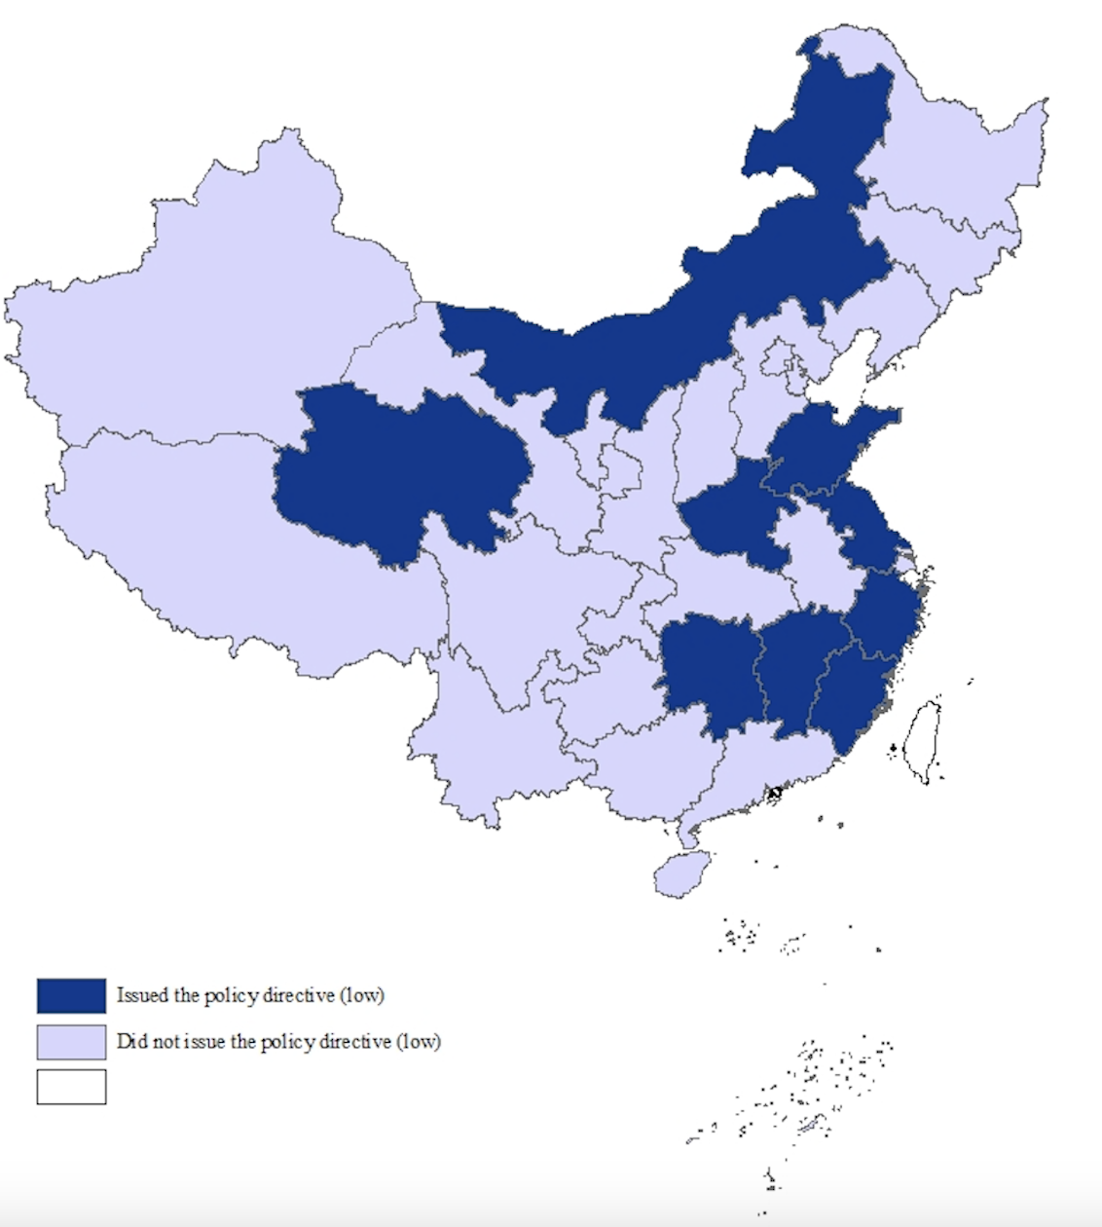
Panel A. Provincial directive with lower coercive power

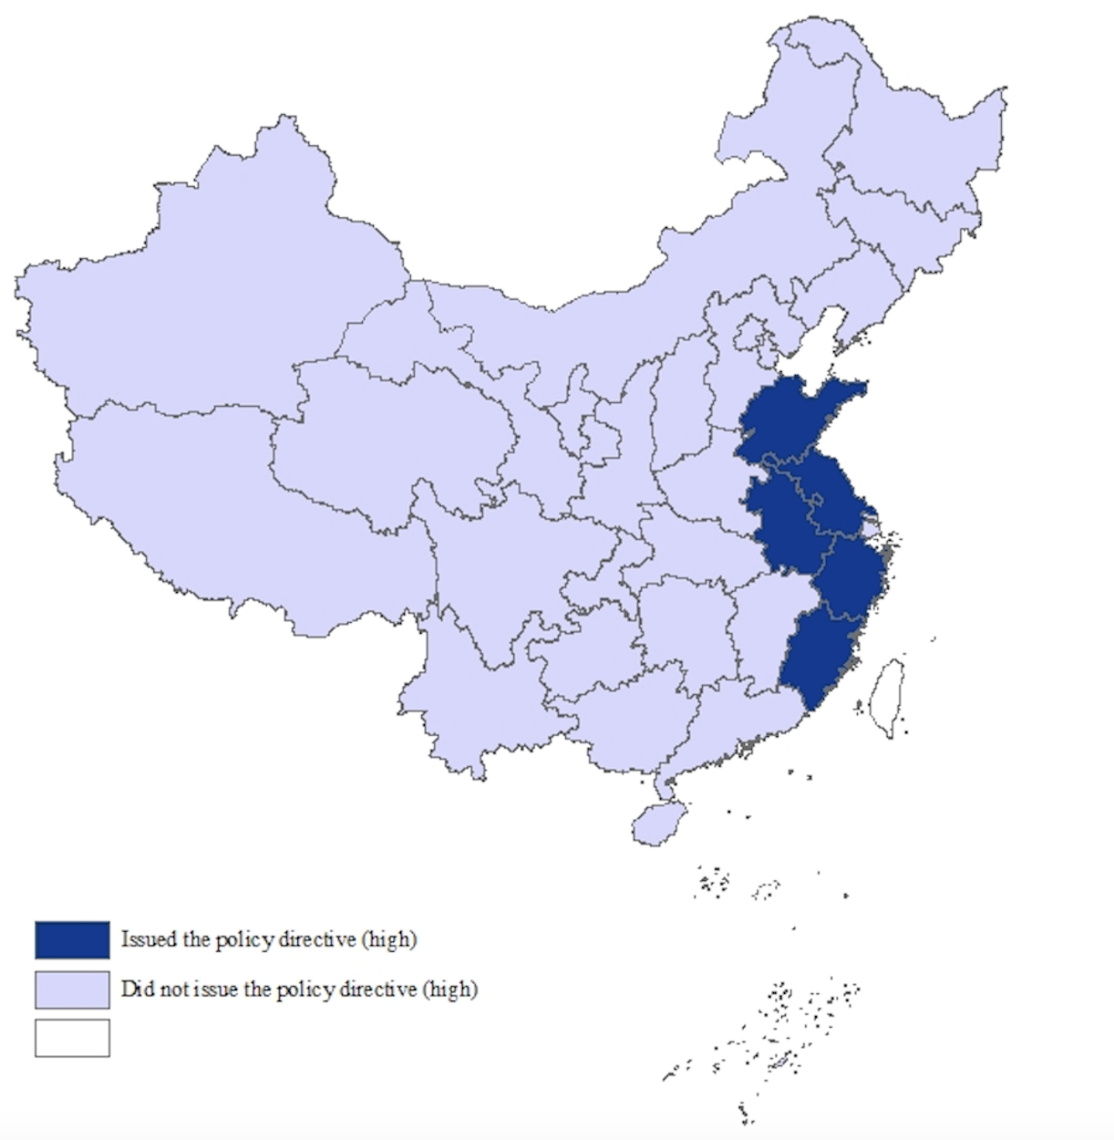
Panel B. Provincial directive with higher coercive power

Figure A1. Spatial Distribution of Provincial Directive on the Unification of Urban and Rural dibao Thresholds, 2019

